Inclusive Practice Assessment

Write a 2,000 word portfolio that explains, explores and evaluates your practical workshop or demonstrated class.

In this assessment I am going to explain, explore and evaluate the half an hour practical session which I led in a group setting. I will look at the current debates underpinning inclusive practice at this time, including learning styles and diversity within a movement context. I intend to show how I incorporated these into the practical session, with a focus on wellbeing and active participation. I will then consider what else I feel I could’ve included in the session to make it more inclusive, before evaluating my performance as a group session leader.

I chose to situate my group session within a secondary school context, working with teenagers who had previous knowledge of each other, and who would be representative of the broader cultural spectrum which is inherent in the United Kingdom. To this end, I researched data from the Office of National Statistics in relation to culture (https://www.ons.gov.uk/peoplepopulationandcommunity/culturalidentity , accessed 06/05/2022). The Office of National Statistics groups culture into Ethnicity, Language, Religion and Sexual Identity, although I would like to note that this does not comprise a complete picture of the diversity of the UK as it does not take into consideration other aspects of the Equalities Act (2010) such as disability (both physical and mental health), age and sex and gender identity, which are applicable to the group session I led. I researched Implementing inclusive education (Schuelka, 2018, https://assets.publishing.service.gov.uk/media/5c6eb77340f0b647b214c599/374_Implementing_Inclusive_Education.pdf, accessed 06/05/2022) which informed my lesson planning for the session.

I chose to work with a group of secondary school age teenagers who had already attended several sessions, and therefore I did not include an “ice-breaker” as such; I made this choice as I wanted to run through the workshop contract which was already present in the space. I did this as I felt it was important for the participants to voice which aspects of this contract were most important to them on the day, keeping in mind that this may change when working with a group over a longer time frame. It allowed the group participants the ability to focus on their immediate needs within the context of a larger framework. It also acted as a reminder to the group of agreed upon behaviours expected of all participants. Preistley (2015) notes the importance of group contracts on https://ventureteambuilding.co.uk/group-agreement/#.YnS7LNPMJPY (accessed 06/05/2022).

I also introduced physical feedback systems, which I used throughout the session. This was the use of thumbs up to indicate everyone was comfortable and happy, thumbs at a horizontal point to show confusion/wariness and pointed down to indicate that the participant was uncomfortable/unhappy and needed some “time out”. This feedback device was introduced to us by Sarah Jones of Mess Up the Mess in a tutorial session. It provides all participants with the “voice” to feedback their feelings, and includes people who may be unable or unwilling to engage in verbal feedback.

I followed by introducing a warm up involving walking around the room, with various activities introduced which included stretching up and reaching down. I noted that participants ought to be careful if they had any mobility issues, and to only reach as far as they were comfortable. Warm ups are important when undertaking physical activity as they lower the risk of injury by increasing blood flow to the muscles, as noted in https://www.mayoclinic.org/healthy-lifestyle/fitness/in-depth/exercise/art-20045517 (author and date unknown, accessed 06/05/2022). This warm up could have been adapted to people with physical disabilities as they were performed at the ability of the individual, as noted above. It also created an awareness of both the space in which we were working, as well as orienting us all to each other’s presence in the space.

I then introduced the basic task of the session, which was based on a game introduced to us by one of the workshop leaders, John DK. This task involved the use of chairs in a line (although there was scope for wheelchair users to be involved, which was written into my lesson plan. This made us of a one way system of moving, allowing all participants to safely navigate the space. I included using space markers rather than chairs as an adaptation). The activity included the days of the week as an organizing factor, allowing the participants to move into different spaces based on which day of the week I announced to be at the front of the line. The participants then had to organize themselves according to the sequence based on their given day of the week. As part of my original lesson plan, I included signs for the days of the week (which would have been inclusive for members with hearing impairments), however I rejected this idea for the final session as I felt it may have overwhelmed some participants in this particular group.

As part of the task, I asked participants to create their own individual movement to represent their day of the week. The overall aim of the session was to introduce the movement characteristics of unison (moving together) and cannon (moving one after the other). To this end, I asked the participants to wait until everyone was in their place, then perform their individual movement (which we did several times, until everyone was comfortable). This then progressed to performing movements one after the other in sequence. I continually checked in with the group to ensure they were comfortable using the physical gestures outlined above. Although I feel this is an interesting way to introduce participants to movements involving unison and cannon, I feel upon reflection that the task may have been somewhat complicated. I would change this aspect of the session if I were to do it again, or with a younger group. I feel that it worked out okay with the group participants, however I am aware that they knew of the game beforehand as we were introduced to it together by John DK. One way I could’ve altered the activity is to have spent longer on the basics of the activity, or I could’ve introduced it in a more measured way over a period of weeks.

This activity made use of various learning styles as outlined by Howard Gardner in the 1970’s and 1980’s. Please see the diagram below for a basic outline of these styles:-

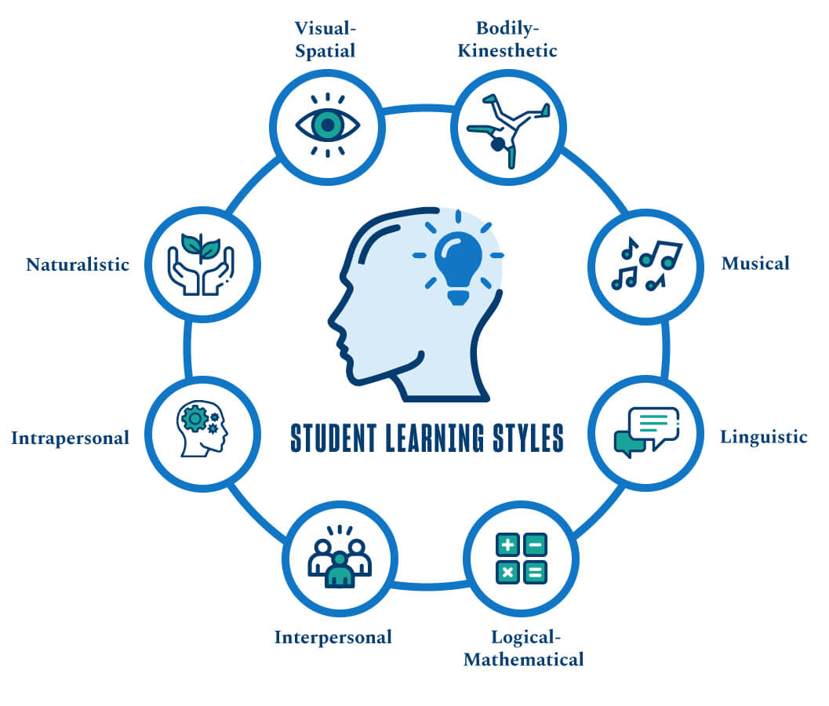https://onlinedegrees.sandiego.edu/teaching-to-every-students-unique-learning-style/ (Lathan, J., date unknown, accessed 06/05/2022).

The activity included bodily-kinesthetic learning through the use of movement both in the individual and whilst moving around the space. I did not use music during the session, therefore this learning style was not utilized. Linguistic learning was used as the task was introduced and led through language, as well as some physical demonstrations. It was logical in the sense that the participants had to organize themselves in the space in response to the changing days of the week at the front of the line. It started as intrapersonal, in that the participants created movements on their own, but become interpersonal as they needed to respond to the whereabouts and movements of other participants in the space. This also adhered to the visual-spatial learning style. However, the task did not employ naturalistic aspects. Therefore, I feel that the activity adhered to six out of the eight possible learning styles and would have appealed to many of the participants in the group. As Lathan, J. notes “The idea behind multiple intelligence theories is not that people learn in only one way, but that people are stronger in different areas and can demonstrate their knowledge and abilities in different ways.” (ibid.). As such, I feel that the task would’ve touched on at least one stronger learning area for each participant.

As part of my lesson planning I included a development of the aforementioned activity, which took it from a more individualized task to group tasks. I asked the group, who were divided into two groups, to work on building a piece of unison movement. They each developed their own, new phrase and then built this together into a longer piece. They used the chairs as props and were focused on performing together. This developed further into building another piece in cannon. I moved between the two groups to offer support if needed, although this group were very self-sufficient and therefore needed very little in the way of support. I did this based on my research into lesson planning as outlined in Singapore Management University’s guide to lesson planning (author and date unknown, https://cte.smu.edu.sg/approach-teaching/integrated-design/lesson-planning ,accessed 06/05/2022).

I then asked the groups if they were comfortable sharing their work, which both groups were. This allowed both a performative aspect to come into the workshop, and also allowed for constructive feedback from both myself and the other group. Feedback is an important part of the lesson planning process as it allows participants the opportunity to feel a sense of accomplishment and to develop further in their work (ibid.). We then went through a cool down together which built on the theme from the warm up of stretching, thereby lowering the risk of injury and completing the session.

Throughout the session I tried to use inclusive language as introduced throughout the module and from my research. This includes language which focuses on ability and identity, as outlined in The University of Manchester’s website (author and date unknown, https://www.staffnet.manchester.ac.uk/equality-and-diversity/training/inclusive-language/, accessed 06/05/2022). As noted above, during the session I tried to create an inclusive environment for all which was underpinned by the teaching on the module and by my own research. I also considered my privilege as a facilitator, whilst taking into account potential difficulties which could arise due to my disability. Looking further into the intersectionality of both myself and the participants has led me to consider whether I would change my facilitator style if I were in a different group. Although I wrote the lesson plan and led as though the participants were a group of mixed gender teenagers, I retain an awareness that I know the participants (and they know me). As this was a simulated environment, I find I have questions about how much this may have subconsciously influenced me.

I researched the University of Edinburgh’s outlook on intersectionality on Intersectionality and Privilege (author and date unknown, https://www.ed.ac.uk/equality-diversity/students/intersectionality , accessed 06/05/2022). The webpage focuses on Kimberlé Crenshaw’s outlook on intersectionality, stating “She wanted to remind people that when thinking about equality, we need to think beyond unique attributes like skin colour and gender and recognize that humans often have more than one characteristic that is subject to discrimination or hostility.” (Ibid.). This helped me consider the affects my workshop may have on participants who may be neurodivergent. Research from the National Autistic Society includes a section on education which I found helpful in this regard. Honeybourne, V. (2018) wrote a piece on Neurodiversity in education (https://www.autism.org.uk/advice-and-guidance/professional-practice/neurodiversity-education, accessed 06/05/2022). I looked at examples from this site, which included:-

- “having a clutter-free environment free of auditory and visual distractions
- ensuring all staff communicate clearly and consistently, allowing additional processing time and different ways of responding
- giving all students the opportunity to work in quiet areas when needed and to spend social times in quieter areas when required
- recognising that there are different – but equally valid – ways of doing things, and promoting acceptance of individuality and difference within the classroom
- having policies and practices which do not discriminate or place neurodivergent students at a disadvantage.” (Ibid.).
I believe I took the above into consideration, including the use of signals for participants to use if they needed time to themselves during the session if they felt overwhelmed.

Overall, I feel that I led an inclusive workshop taking into consideration learning through the module and personal research. However, I recognize that there are factors which could be improved or changed in order to facilitate a different approach and that this may change depending on the participants and their needs.

(word count: 1988)

References and Bibliography

Honeybourne, V. (2018) Neurodiversity in education https://www.autism.org.uk/advice-and-guidance/professional-practice/neurodiversity-education

Lathan, J. (date unknown) Sandiego University https://onlinedegrees.sandiego.edu/teaching-to-every-students-unique-learning-style/

Office for National Statistics, https://www.ons.gov.uk/peoplepopulationandcommunity/culturalidentity

Preistley (2015) https://ventureteambuilding.co.uk/group-agreement/#.YnS7LNPMJPY

Schuelka (2018) Implementing inclusive education https://assets.publishing.service.gov.uk/media/5c6eb77340f0b647b214c599/374_Implementing_Inclusive_Education.pdf

Singapore Management University (author and date unknown), https://cte.smu.edu.sg/approach-teaching/integrated-design/lesson-planning

The Mayo Clinic, https://www.mayoclinic.org/healthy-lifestyle/fitness/in-depth/exercise/art-20045517

University of Edinburgh (author and date unknown) Intersectionality and Privilege, https://www.ed.ac.uk/equality-diversity/students/intersectionality

University of Manchester (author and date unknown) https://www.staffnet.manchester.ac.uk/equality-and-diversity/training/inclusive-language/

