Understanding the importance of critical diameter and critical density in the detonation process
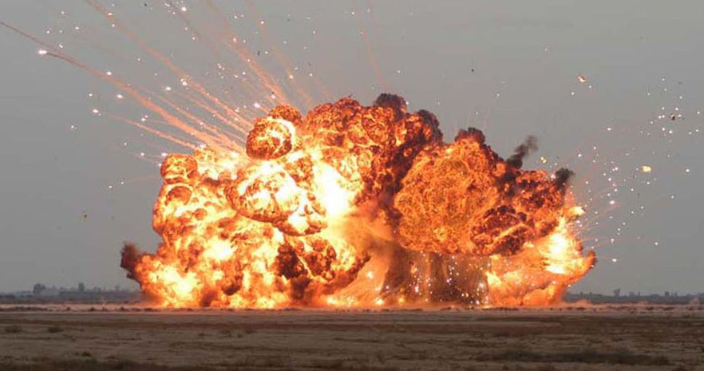
Name: Kieran Wusthoff
Student Number: 2217671
Module: Principles of OME
Module Code: ACDA 4019
Lecturer: Gareth Collett
Table of Contents
Introduction 3
Types of Explosives 3
Explosive Train 4
Selected Primary: Lead Azide 5
Selected Secondary: TNT 5
Critical Diameters & Densities 6
Stimulus applied to Primary explosive 6
Confinement affecting critical diameters. 7
Velocity changes with increasing densities. 8
Explosive train for chosen explosives. 10
Conclusion 11
Bibliography 12

Introduction
The author will explain the importance of critical diameter and density concerning successful detonation in this assignment. To do so they will consider one primary explosive and one secondary explosive. An explanation of what a primary and secondary explosive is will be provided. The author will give a literature review on each explosive discussing their performance and characteristics.
The author will the discuss what critical diameters and critical densities are. Followed by an explanation of the critical diameter and densities of each primary and secondary explosive in an unconfined state. They will explain what is required to achieve a successful detonation transition from one explosive to the other as part of the explosive train. They will also discuss the different types of stimulus and which stimulus will be suitable for the specific explosive train.
The author will then carry out research as to how confinement would alter and affect the critical diameters. And how this can be of benefit to the OME professional. The author will go into the specifics of their chosen secondary explosive. Explaining how a change in density could change the velocity of detonation.
Finally, the author will include a clear diagram highlighting the diameters, densities and velocities that can achieve a successful detonation.

Types of Explosives
In the defence industry, there are known to be two different types of explosives. These are low explosives and high explosives. Low explosives can consist of Propellants and Pyrotechnics. Propellants are mostly found in small arms ammunition such as firing cartridges, and rocket motors. Their purpose is to propel a projectile whether that be explosive or a continuous burn. Propellants contain the chemicals nitrocellulose, nitro-glycerine and nitroguanidine. The most well-known example of a pyrotechnic is fireworks. Flares are another great example of a pyrotechnic. The chemicals used in pyrotechnics consist of potassium perchlorate and potassium nitrate.
There are then three subcategories of high explosives. These include primary, secondary and tertiary explosives. Primary explosives are explosives which are readily initiated by a small stimulus. They are mostly used to initiate reactions where the chemistry produces a shockwave of sufficient magnitude to deflagrate or detonate a less sensitive explosive. It’s important to note that they are used in small quantities. Three examples of primary explosives are lead aside, mercury fulminate and TATP. They are commonly used in detonators, fuses and blasting caps [1].
Secondary explosives are considered “less sensitive” and are used as a main filling in explosive articles. Secondary explosives usually require a large stimulus such as a shockwave to initiate a detonation. This shockwave comes from the detonation of a primary explosive. The primary explosive reaction has sufficient energy to detonate the less sensitive secondary explosive. A few examples of secondary explosives are as follows: RDX, TNT, HMX and PETN [2].
The third type of high explosives is the tertiary explosive. Tertiary explosives are similar to secondary in that they require a large stimulus to detonate. Unlike primary explosives, they are much more stable too. They are so insensitive that they require a “boost” from a secondary explosive. Hydrogen peroxide, guanidine nitrate, and ammonium nitrate are explosives that are recognised as tertiary explosives [3].

Explosive Train
“An explosive train is an assembly of combustible and explosive elements arranged in the order of decreasing sensitivity, inside a fuse, projectile, bomb, gun chamber, or the like” [4].
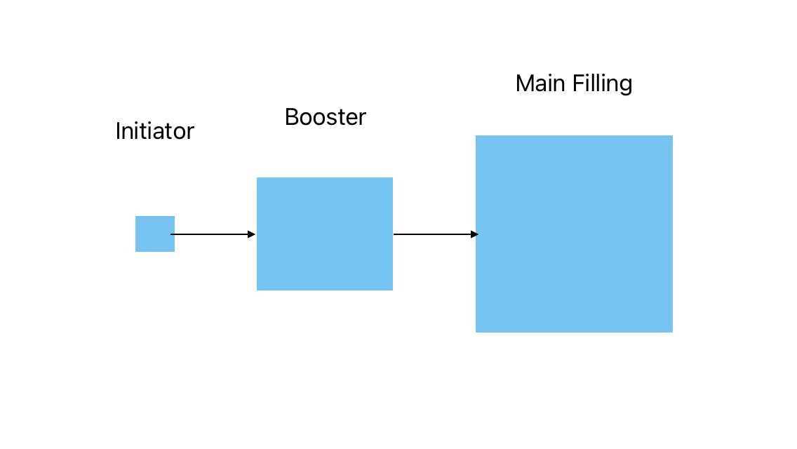
To form an explosive article there must be an explosive train in place. An explosive train is a sequence of explosive events culminating in an overall detonation. For example, when lighting a fire, you wouldn’t hold a flame to coal as that would simply not light. Instead, you would light newspaper, which would then light kindlin which would then light the coal. The same process applies to explosive articles. Holding a flame to a block of RDX would not cause a detonation (however it is not recommended). This is where an explosive train would be used. An initiator (detonator or fuse) will contain a primary explosive such as lead azide. Once this explosion has occurred it causes a seismic shockwave sufficient to detonate a booster. The booster is a secondary explosive in this case it could contain either TNT / Wax or Tetryl. The detonation from the booster causes a detonation to the main charge which could consist of TNT / RDX or TNT / Polyurethane. An example of an explosive train can be found below in Figure 1.
Primary Explosive:
Lead Azide
Lead Styphnate
Secondary Explosive:
Tetryl
RDX / Wax
Secondary Explosive:
RDX
TNT
PBX
Figure 1: Example of explosive train

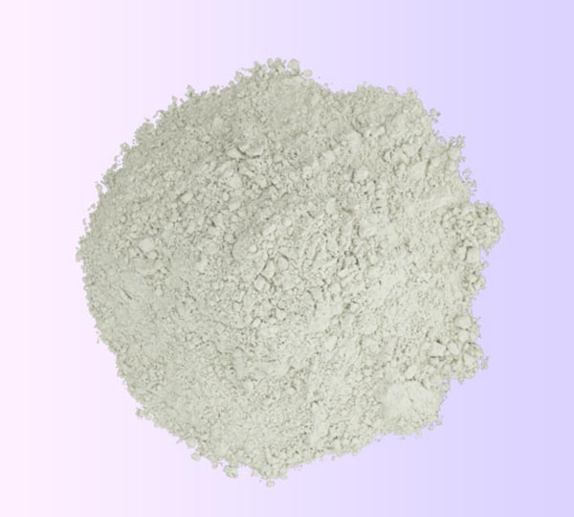
Selected Primary: Lead Azide
Figure 2: Lead azide, powder form
The primary explosive that the author has selected to conduct a review on is Lead Azide. Lead Azide is one of the most common and well-known primary explosives. With this being the case there are likely to be several secondary sources. Making this explosive great to research. It is a “crystalline explosive compound Pb(N₃)₂ used as a detonating agent” [5] mainly found in detonators and fuzes. Lead azide was founded in 1891 by Theodor Curtis, a chemist born in the Kingdom of Prussia. It was then brought onto the production line in 1907 by a man called F. Hyronimus who secured the (French) patent for using lead azide in detonators [6]. Its appearance consists of colourless needles. But for its practical use, it is in white powder form as seen in Figure 2. Lead Azide is an extremely sensitive chemical that must always be handled and stored carefully. It is possible that if dropped from a height of just 150mm it has the potential to detonate. It can also be easily detonated if exposed to heat, friction, or shock [7]. Lead Azide also has a 0% oxygen balance making it a very efficient explosive. According to JSP 333, [8] there are only 2 other chemicals that share this characteristic, and they are Silver Azide and EGDN.

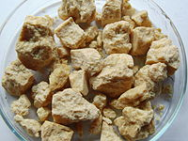
Selected Secondary: TNT
Figure 3: Solid TNT rocks
The secondary explosive that the author has selected to review is TNT. This is also a very well-known secondary explosive used in many different applications. It was discovered by Julius Wilbrand, a German chemist, in 1863. During the First and Second World Wars, it was one of the widely used explosives [9]. Its more technical name is Trinitrotoluene. Such a long history of use and research makes it a great secondary explosive to study and explore. Its chemical formula is C₇H₅N₃O₆. It is commonly used as a booster and a main filling within an explosive article. It is considered a high explosive however it is also an insensitive (less sensitive) explosive. A primary explosive (e.g. lead azide) would be required to detonate this. TNT can be recognised as pale yellow, in the form of needles/flakes or a solid after being poured into a cast. Figure 3 shows solid TNT blocks. It’s also important to note that as TNT degrades it becomes very sensitive. TNT’s oxygen balance is -73.6%. From this, we know that the explosive is less efficient than others.

Critical Diameters & Densities
Critical diameters and densities can be described as the dimensions or parameters required for a desired explosive to detonate. If the dimensions or parameters are not met, then you may have a poor or unsuccessful detonation. For example, if the charge diameter of an explosive is decreased to a certain value, the explosive will no longer detonate. The critical diameter is the minimum diameter value for an explosive to detonate. The same idea applies to the density. This is where a desired explosive must have a minimum density value for detonation. If this density is not achieved the explosive may not have a successful detonation. Figure 4 below shows the critical diameters and densities of both Lead azide (primary) and TNT (secondary) in an unconfined state. It is also important to note that if a charge diameter is further increased, the velocity of detonation isn’t necessarily increasing further [10].

Type of explosive | Density (g/cm³) | Critical Diameter (mm)
Trinitrotoluene (TNT, cast) | 1.61 | 15
Lead Azide | 3.14 | 0.4 - 0.6
Figure 4: Critical Diameters and densities of primary and secondary explosives [11]

Stimulus applied to Primary explosive
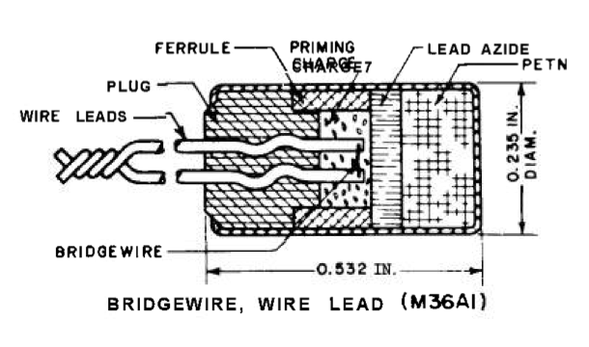
For a primary explosive to initiate there needs to be a stimulus applied. A few examples of detonators and their required stimulus are as follows: Stab initiator, flash detonator, electrical detonator and percussion primers. The previously mentioned initiators and detonators are all the first types of components to start the explosive train. Each of these will require a stimulus to initiate.
Figure 5: Electrical detonator, bridgewire
“The stab initiator is a rather simple item consisting of a cup loaded with explosives and covered with a closing disk. It is sensitive to mechanical energy”.
Another example is flash detonators. Flash detonators are similar to stab detonators, but they are instead very sensitive to heat. This heat can be supplied via an electrical current.
Electrical detonators are different from Stab and flash detonators in that they contain the mechanism which starts the initiation. For example, hot wire bridge and exploding bridge wire. These detonators/initiators allow the transfer of electrical energy to become heat energy. This heat energy causes the start of the explosive train. Figure 5 shows an example of an electrical bridgewire detonator [4].

Confinement affecting critical diameters.
By confining an unconfined explosive, we can alter the critical diameters to have the same (if not better) effect. For example, if TNT is detonated in an unconfined state (see Figure 4) there would need to be a critical diameter of 15mm [11]. However, by confining this explosive a detonation will still occur with a diameter of 7mm. From this we can see by confining TNT we can have just over half of the required critical diameter needed for a detonation. It is possible to do more with less. The reason for this is due to energy losses. When an explosive is unconfined, the shockwaves from the detonator can be lost along the outside of the TNT. Waves are not reflected in the TNT. When TNT is confined, and a detonation occurs, the shock waves reflect off the walls of the material confining the explosive. This means there are next to no energy losses when detonating the secondary explosive. This principle applies to primary, secondary and tertiary explosives. Confining an explosive material will require less of a diameter when detonating. Figure 6 below shows how shockwaves perform when confined and unconfined.
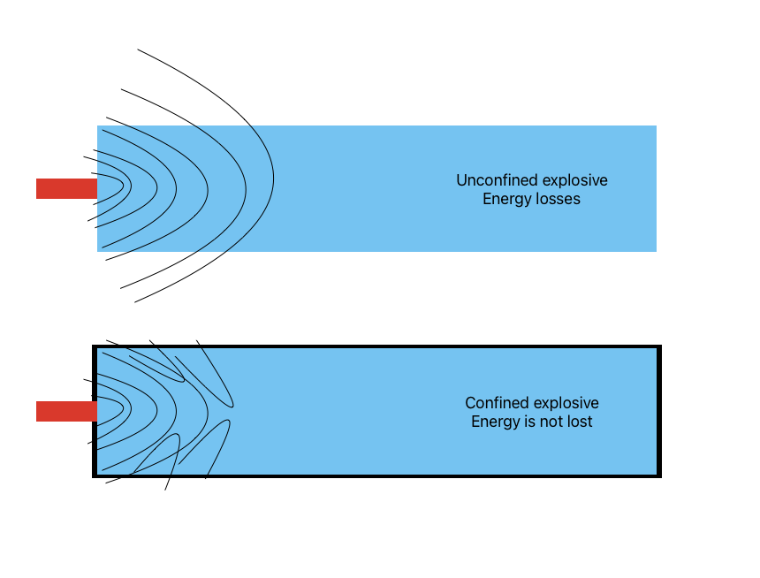
Figure 6: Unconfined & Confined explosives example

Velocity changes with increasing densities.
The density of an explosive has a direct influence on the detonation velocity. In general, as the density of the explosive increases, so does the velocity of detonation. Whilst this is the case, we must also be aware that there is a point at which the explosive will reach a maximum detonative velocity, no matter how dense the explosive is. It is also known that if the explosive is too dense then the velocity of detonation slows down or completely stops. If the explosive goes beyond the theoretical maximum density it will cease to function.
The graph below (Figure 7) shows as density is increased so does the velocity of detonation. It’s important to note that the velocity of detonation peaks and begins to plateau at around the 1.61g/cm³ mark (Density indicated in Figure 4). This is the theoretical maximum density. Upon analysis, the author can see that at 1.0g/cm³, the velocity of detonation is 5000m/s. Whereas at 1.61g/cm³ it is just under 7000m/s [12].

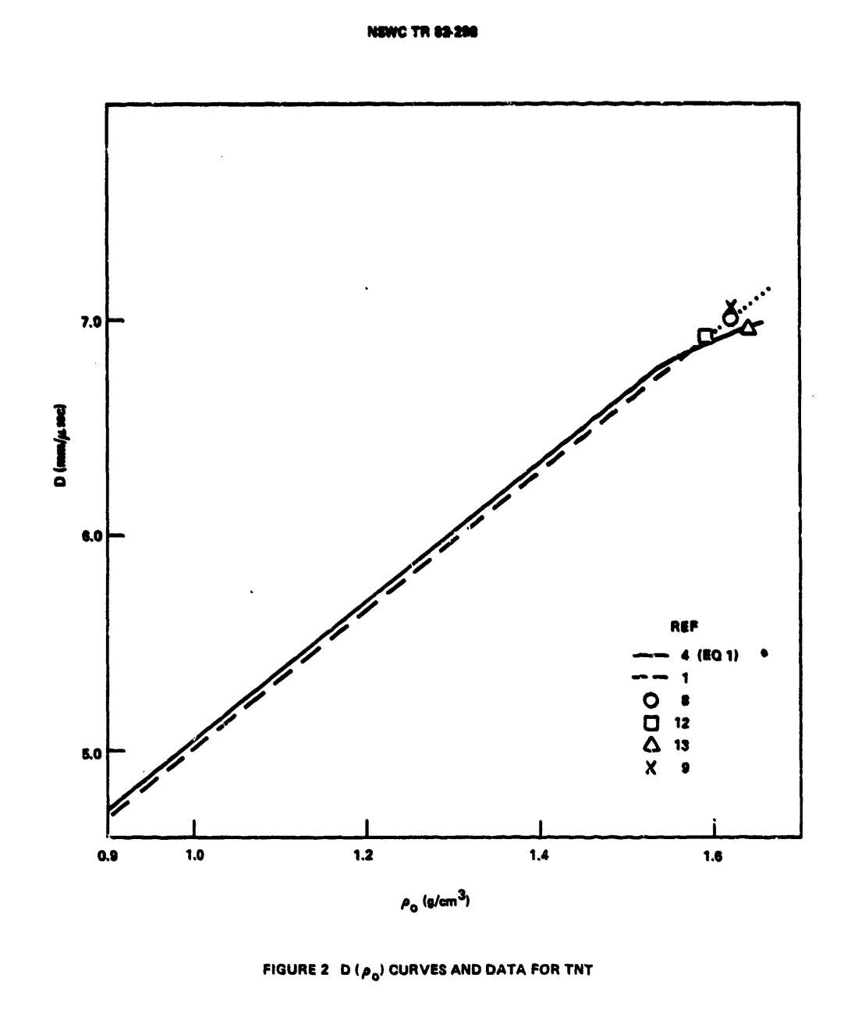
Figure 7: Graph displaying how increasing density of TNT can increase its detonation velocity

Explosive train for chosen explosives.
To demonstrate the authors’ understanding of critical densities and diameters, Figure 8 shows what is required for a successful detonation in a munition system. This would be a similar explosive train found in the 81 mm HE Mortar Ammunition with a booster coating Lead Azide as a primary and TNT as a secondary.
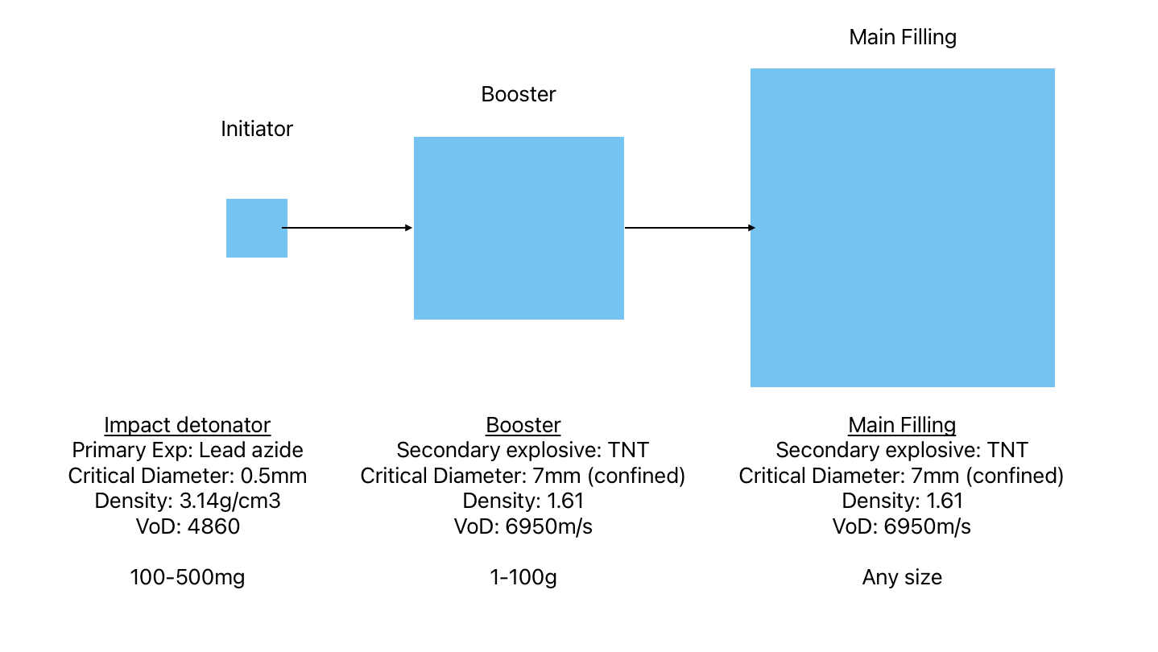
Figure 8: Authors explosive train with selected primary and secondary explosives

Conclusion
During this assignment, the author was able to describe what high and low explosives are and give examples and definitions for each. They demonstrated their understanding of an explosive train whilst giving examples of explosives that would be used. TNT & Lead azide were the selected primary and secondary explosives on which they conducted a literature review. The author discussed critical diameters and densities and how they can affect an explosives’ performance. For initiating stimulus, they talked about the different types of stimulus that can be applied to a primary explosive. And how each stimulus functions.
They then discuss the importance of confining an explosive and how by confining the explosive you may need a smaller critical diameter. A diagram created by the author was added to explain this. They then discussed how a change in density can increase or decrease the velocity of detonation. They used secondary sources to support their answers including a graph illustrating how densities alter velocities. Finally, from the research that was carried out with critical diameters, densities, and velocities they could design an explosive train using the primary and secondary explosives selected. All work carried out was supported referenced/cited and contained figures to support their findings.

Bibliography

[1] | “navsea.navy.mil,” 2022 Navy ManTech Project Book, [Online]. Available: https://www.navsea.navy.mil/Portals/103/Documents/NSWC_Indian_Head/EMTC/EMTC_Energetics_Projects_2_Primaries.pdf?ver=-ny79c-fFeC3F435l383Bw%3D%3D#:~:text=Primary%20explosives%20are%20required%20as,arms%20to%20missiles%20and%20bombs.. [Accessed 8 July 2024].
[2] | “NIST,” National Institute of Standards and Technology, US Department of Commerce , 6 December 2023. [Online]. Available: https://www.nist.gov/glossary-term/31696. [Accessed 8 July 2024].
[3] | “Storemasta.com,” 2024 Storemasta, 29 May 2023. [Online]. Available: https://blog.storemasta.com.au/dangerous-goods-class-1-explosives#:~:text=Tertiary%20explosives%20are%20sometimes%20also,amount%20of%20primary%20explosive%20alone.. [Accessed 8 July 2024].
[4] | 15 January 1974. [Online]. Available: https://apps.dtic.mil/sti/pdfs/AD0777482.pdf. [Accessed 8 July 2024].
[5] | “Merriam-Webster,” © 2024 Merriam-Webster, Incorporated, [Online]. Available: https://www.merriam-webster.com/dictionary/lead%20azide. [Accessed 10 July 2023].
[6] | R. L. Wagner, January 1960. [Online]. Available: https://apps.dtic.mil/sti/tr/pdf/AD0231089.pdf. [Accessed 10 July 2024].
[7] | “ChemicalBook.com,” 17 October 2023. [Online]. Available: https://www.chemicalbook.com/ChemicalProductProperty_EN_CB0851554.htm. [Accessed 10 July 2024].
[8] | “JSP 333 SERVICES TEXTBOOK OF EXPLOSIVES,” Ministry of Defence, 2020.
[9] | “German Maritime Museum,” Leibniz Institute of Maritime History , [Online]. Available: https://www.dsm.museum/en/museum/exhibitions/north-sea-wrecks-exhibition/the-hazards-of-war-remnants/why-is-tnt-dangerous#:~:text=TNT%20was%20developed%20in%201863,form%20of%20old%20munitions%20shells.. [Accessed 10 July 2024].
[10] | J. Kohler, J. Leone and W. Leone, “PennState College of earth and mineral sciences,” The Pennsylvania State University © 2023, [Online]. Available: https://www.e-education.psu.edu/geog000/node/866#:~:text=Critical%20diameter%3A%20the%20minimum%20diameter,the%20explosion%20may%20not%20propagate.. [Accessed 18 July 2024].
[11] | P. W. Cooper, Explosives Engineering, WILEY-VCH, 1967.
[12] | D. Price, 26 August 1982. [Online]. Available: https://apps.dtic.mil/sti/tr/pdf/ADA121975.pdf. [Accessed 17 July 2024].

