
Management Accounting for Managers LCBB5010
Raluca Selena Stanciu 2132773

Table of Contents
1. Introduction 3
2. Cost Analysis and Business Model 4
2.1 Discussing the revenue model of the company 4
2.2 Discussing the key cost structure of the company 5
3. Budgeting And Financial Planning 5
3.1 The Role Of Budgeting In The InPost Operations 5
3.2 Review Of Oeprating Expenses And Decisions Made By Management To Influence This Change 6
4. Performance Measurement and Decision-Making 8
4.1 Financial or non-financial KPIs 8
4.2 Discussing the strategic decision of the company regarding the KPIs 9
5. Sustainability and ethical consideration 9
6. Conclusion and recommendations 11
References 13

1. Introduction
InPost Group is a European e-commerce logistics company, and it was founded in the year 1999 in Poland, by Rafal Brzoska. The company specialises in OOH (out-of-home) parcel delivery, all through its network of APMs (Automated Parcel Machines) (InPost, 2025b). It has placed the first locker, in the year 2009, in Krakow, and over the years, it has now grown into a leading OOH delivery platform, that operates across 9 countries, with more than 94,500 of pick-up points, as well as more than 61,000 APMs, by 2025 (InPost, 2025a).
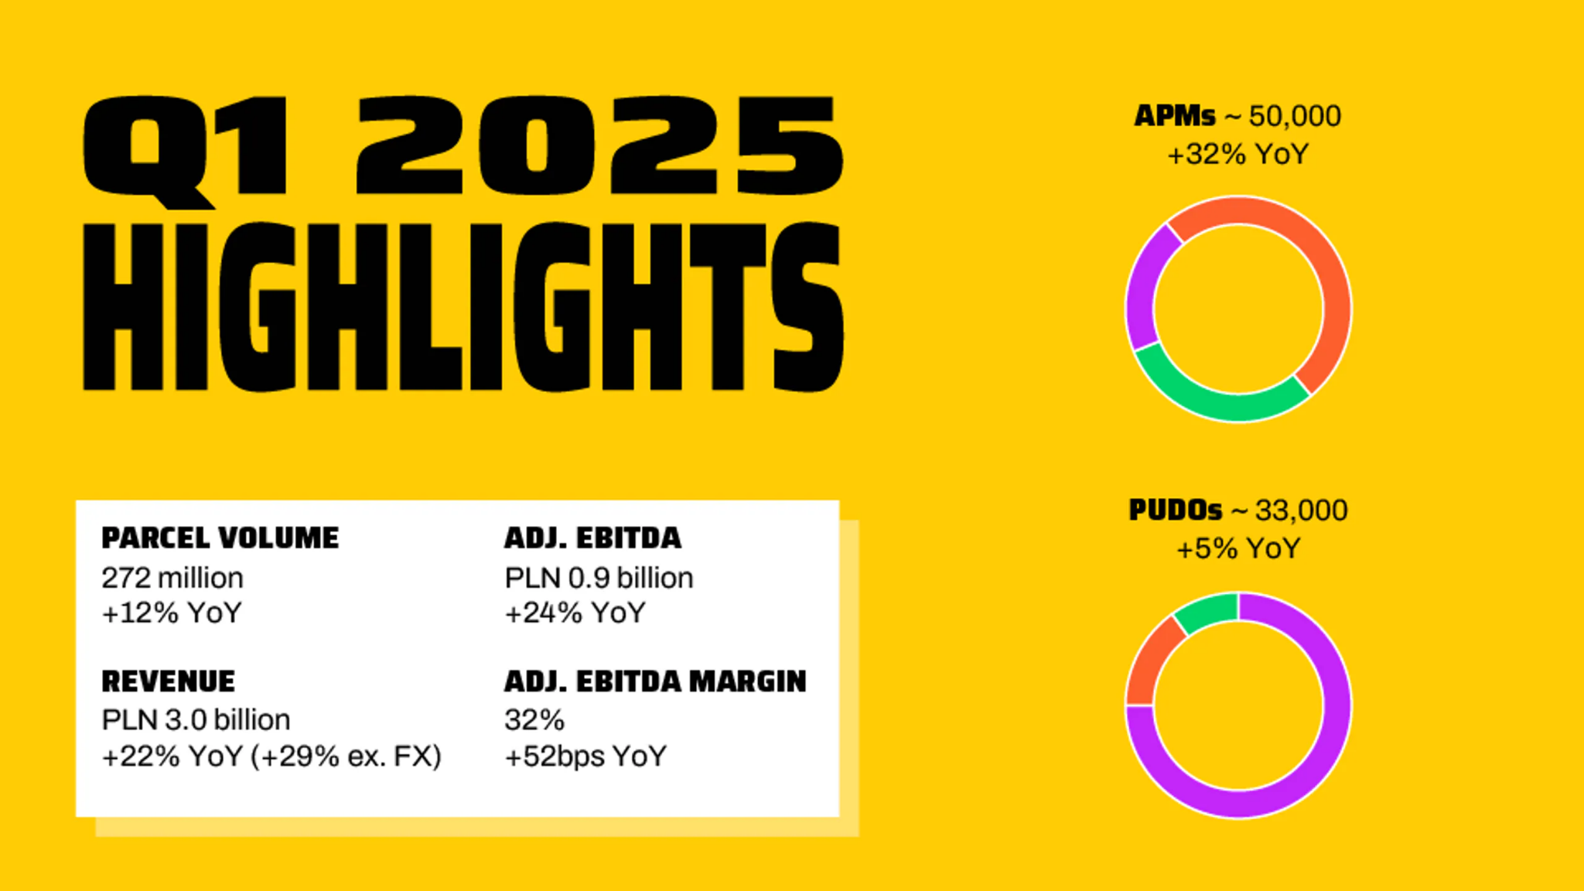
Figure 1: 2025 company highlights
Source: (InPost, 2025b)
InPost Group has delivered 1,364.8m of parcels, in the year 2025, and generated PLN 14,711.2 of revenue (InPost, 2025a). This indicates a 34% increase on year-on-year. In the first quarter of 2025, InPost Group observed a double-digit growth of group revenue, resulting in PLN 2,951.9 million of revenue generation, showing a 21.7% year-on-year improvement (InPost, 2025b).

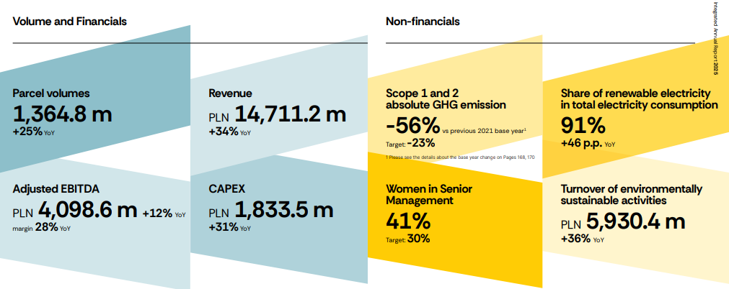
Figure 2: 2025 company highlights
Source: (InPost, 2025a)
Management accounting involves the “provision of information and analysis” to the managers in the organisation (Prowle, 2020). For Inpost, management accounting is core to its decision-making, and it allows capital allocation, margin tracking and profitability analysis.

2. Cost Analysis and Business Model

2.1 Discussing the revenue model of the company
The selected company, InPost, is a logistics company that supplies and tracks products all around the world. InPost has managed to consider implementing an automated parcel machine model in which an online website is used for both logistics and tracking products so that customers can be able to track their goods properly during their entire delivery journey. Regarding that, as per the report presented by King, H. (2026), it has been clearly recognised that a substantial amount of money, namely, 14,711.2 million GBP, has been collected by the revenue collection machinery in the hands of the management of revenue. With respect to that, the financial performance of the company can be developed at a constant rate. The automated parcel machines model can directly contribute to improving the company's performance by concentrating on various sources of generating revenue for the company. As per the views of Odonkor et al. (2024), it is very valuable for the management to be able to do the financial activities in an efficient manner in the future, and reach the expected result. The company can also invest in creating various services, such as parcel tracking services that can help realise the desired result. In this way, the financial results of the performance can grow, and sustainable business activity can be ensured, which can result in a higher crisis in the future and give a competitive advantage in the future times.

2.2 Discussing the key cost structure of the company
With respect to the financial statement of the company, the cost structure of InPost variable costs, such as Selling & marketing expenses, administrative expenses, impairment loss and so on, are taken into consideration (InPost, 2025). The company has been experiencing cost changes all the time based on various factors like productivity, financial stability, etc. Based on that, there is a possibility of corrupting the financial performance of the company, which is not advantageous for the business in the future times. In addition to that, the financial information presented in the annual report is not capable of showing any fixed costs, which is not beneficial for the business. The financial stability of the company can be directly affected by a continuous increase in costs, and it cannot convey the expected outcome (Ozil and Iorember, 2024). It is crucial for the management of InPost to save unnecessary expenses in the future in order to prevent the possibility of losing money. Therefore, the financial stability of the company is easy to maintain, and the company will be able to achieve its future goals.

3. Budgeting And Financial Planning

3.1 The Role Of Budgeting In The InPost Operations
Budgeting is one of the tactical implementations of the business plan (Schmidt, 2020). In-InPost, budgeting seems to be playing a crucial role in aligning the growth goals with pressures on operational costs. Overall the financial information shows that total operating expenses went up from £1,715.8 million in 2024 to £2,120.0 million in 2025 (InPost, 2025a), which is an increase of £403.8 million or 23.53%. This significant jump proves that budgeting cannot simply be about sticking to budgets – it has to be about achieving operational results from the spending.
General&admin expenses were the biggest cost driver, rising by £339.2 million to £1,779.7 million in 2025 (InPost, 2025a). This class was responsible for about 84% of the overall increase in operating costs. This growth implies that management budgeting decisions were dominated by the growth of the organisation and the ensuring of infrastructure and administrative capacities. But how much more difficult is it to assess for cost efficiency and the possibility of expanding overheads at a higher rate than the growth of productivity?
Selling and marketing costs rose higher by 25.18% to reach £321.2m (InPost, 2025a) from £256.6m. This reflected budgeting priorities in line with market penetration/customer acquisition, as higher growth than Tote compared to TOTE. The allocation seems to align with the cash flow data as operating cash inflows increased during the periods of 2021 to 2025 despite the rising level of operating cash outflows.
Moreover, impairment charges for trade and other receivables rose by only £18.7 million to £19.1 million, representing an increase of only 2.14% (InPost, 2025a). The relatively consistent level of impairment indicates that despite business growth, budgeting processes and procedures for credit management and receivable monitoring were effective.

3.2 Review Of Oeprating Expenses And Decisions Made By Management To Influence This Change
Operating expenses increased from £1,715.8 million in 2024 to £2,120.0 million in 2025 (InPost, 2025a), representing a rise of £403.8 million or 23.53%. This is mainly due to a £339.2 million (23.55%) increase in General and Administrative (G&A) expenses, representing around 84% of the operating expense increase. In this pattern, management followed an aggressive expansion strategy with increased investment in operating equipment, technology, manpower/human resources and administration of network operations.
The whole sales and marketing expenses rose by £64.6 m, or 25.18% (InPost, 2025a), more than the increase in total operating expenses. The increase is due to management action that has led to faster customer acquisition, parcel volume growth and market penetration.
But the increasing cost should be looked into with the associated cash flow. The cash generated from operations rose from c. £2.8 billion in 2024 to c. £3.0 billion in 2025, representing growth of c. £0.2 billion or 7.1% (Google Finance, 2026). Operating cash generation continued at positive levels and increased but at a significantly lower rate as compared to operating expenses, which increased by 23.53% upward. Also, higher costs, presumably driven by external macroeconomic factors such as wage inflation, logistics costs, and investments in technology as well as ongoing pressure on prices in European markets, were a factor contributing to costs.
Particulars | Amt in GBP million
Particulars | 2024 | 2025 | Change | % Change
General and Administrative Expenses | 1440.5 | 1779.7 | 339.2 | 23.55%
Selling&Marketing Expenses | 256.6 | 321.2 | 64.6 | 25.18%
Impairment Gain or Loss on Trade and Other Receivables | 18.7 | 19.1 | 0.4 | 2.14%
Total Operating Expenses | 1715.8 | 2120 | 403.8 | 23.53%
Table 1: Operating Expenses Analysis
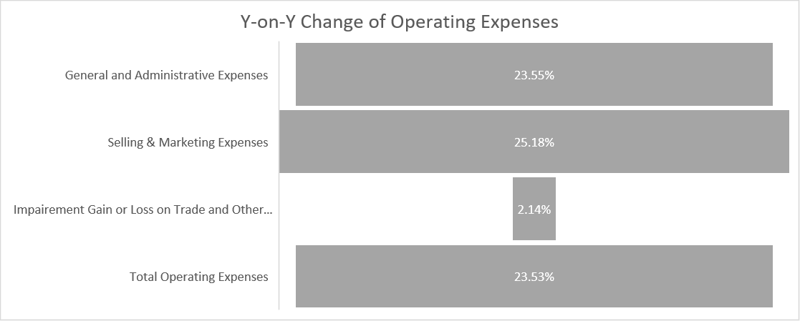
Figure 3: Y-on-Y Change in Operating Expenses
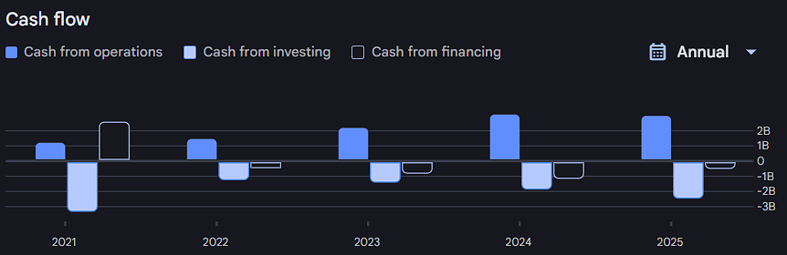
Figure 4: Y-on-Y Change in Cashflow Including Operating Cashflow
(Source: Google Finance, 2026)

4. Performance Measurement and Decision-Making

4.1 Financial or non-financial KPIs
KPIs | Elaboration
Revenue of the company | Growth of 14,711.2 has been seen in 2025 compared to 10,945.2 in 2024 (InPost, 2025).
Gross profit | A growth of 3,729.1 has been seen in 2025 compared to 3,675.8 in 2024 (InPost, 2025).
Total assets | The total assets have been 16,911.1 in 2025, which is comparatively higher than in 2024, of 12,892.8, and it has helped to provide a better service strategy (InPost, 2025).
Advance supply chain | Using the e-commerce model, the company has managed to enhance its supply chain process, which can eventually help to mitigate unnecessary tasks in the future.
Effective corporate responsibility | The company has considered a relevant corporate responsibility to reduce carbon emission has been taken in consideration, which can eventually lead to higher social benefits.
Table 2: KPIs

4.2 Discussing the strategic decision of the company regarding the KPIs
It has been clearly identified that the current KPI can directly help to take effective, relevant investment decisions for the business in the future. It has been well established that the company has been able to create financial stability, and it has grown due to the increased profits. According to Gleißner et al. (2022), it has been definitely established that the monetary inflow is beneficial for the business, and it can directly help the business to manage its finances in an effective way for years and to run its business activities without any kind of delay. This is important because the overall performance of the business can be enhanced in the future, depending on the profit increment in the coming times.
Apart from that, there is another related decision that can be taken into consideration, which is to develop a new product or a new product line, for example, to supply logistics services for the customers. In this process, the company's financial profits are constantly increasing, which is good for the development of the company performance.

5. Sustainability and ethical consideration
InPost Group integrates sustainability in both its operational and financial decision-making, by implying the ESG structured framework. This is built on four core pillars of the company, including “planet”, “people”, “customer”, and “trust”.
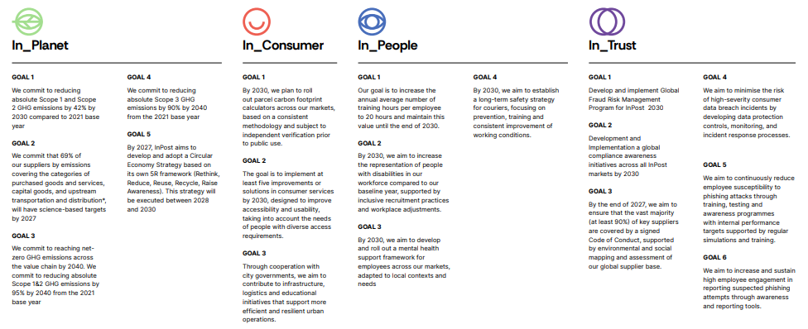
Figure 5: The four core pillars of InPost and their goals
Source: (InPost, 2025a)
The most financially-significant sustainability initiative of the company is the introduction of the “APM first delivery model”, as this has the capability of producing low carbon emissions per parcel (InPost, 2025a). In 2025, in Poland, the “carbon footprint” of the “whole route APM Delivery” was 0.137 kg CO2e, compared to about 0.418 kg CO2e in the case of door delivery, showing a 67% reduction. This is an environmental advantage and this is also embedded in the commercial strategy of InPost, for reducing Scope 1 and Scope 2 GHG emissions by about 42% by the end of 2030 (InPost, 2025a).
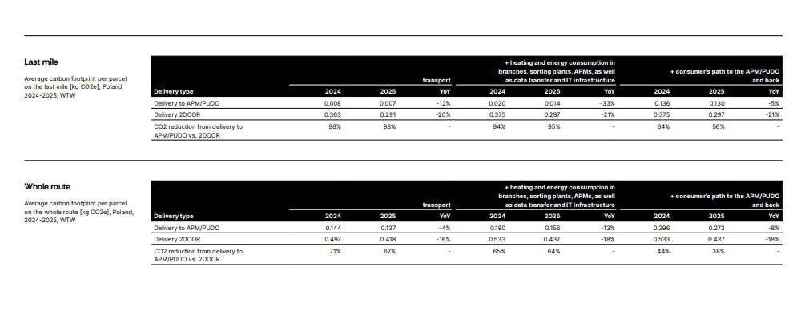
Figure 6: Sustainability strategy
Source: (InPost, 2025a)
Moreover, renewable electricity now accounts for about 91% of the total consumption (InPost, 2025a). Regarding ethical cost management, as well as pricing, the approach of InPost has reflected a conscious effort of balancing market expansion, and treating the stakeholders in a fair way across the value chain. As per Thun et al. (2024), if a company integrates sustainability into the stakeholder management, and corporate strategy, it can address the interests of the stakeholders in a better way. The article of Kalyeena Makortoff (2025) noted that the Yodel acquisition has been structured to be the “£106m” of debt to equity conversion, instead of just another cash purchase. Besides, InPost operates the “Parcel Carbon FootPrint Calculator”, and this has been verified by the “Deloitte Advisory”. This has helped the merchants to properly incorporate their delivery emissions into the reporting of Scope 3. This is a transparent and ethical tool for pricing-adjacent.

6. Conclusion and recommendations
With respect to the above discussion, it is well established that a significant sum of money, that is 14,711.2m GBP, has been generated by the revenue collection mechanism in the hands of the revenue collection machinery (RCM) of the MR. With respect to that, the financial performance of the company can be developed at a constant rate. The automated parcel machines model can directly contribute to the company's performance improvement by focusing on various sources of the company's income. As all of the costs vary with different factors such as productivity, financial stability, etc., there is a chance of tampering with the financial performance of the company in a way that it is not beneficial for the business in the future times. Furthermore, roughly 91% of the total consumption is from renewable electricity. Regarding ethical cost management, as well as pricing, the approach of InPost has reflected a conscious effort to balance market expansion and treat the stakeholders in a fair way across the value chain. If a company integrates sustainability into stakeholder management and corporate strategy, it can address the interests of the stakeholders in a better way.

References
Gleißner, W., Günther, T. and Walkshäusl, C. (2022). ‘Financial sustainability: measurement and empirical evidence’. Journal of Business Economics, 92(3), pp.467-516.
Google Finance (2026). InPost SA Stock Price&News - Google Finance. [online] Google.com. Available at: https://www.google.com/finance/beta/quote/INPST:AMS [Accessed 9 Jun. 2026].
InPost (2025). Annual Report 2025. [online] InPost. Available at: https://inpost.eu/sites/default/files/2026-03/InPost_Group_IAR_2025_0.pdf [Accessed 8 June 2026].
InPost (2025a). InPost Group Integrated Annual Report 2025. [online] Available at: https://inpost.eu/sites/default/files/2026-03/InPost_Group_IAR_2025_0.pdf. [Accessed 9 June. 2026].
InPost (2025b). InPost Group Q1 2025 results. [online] Available at: https://inpost.co.uk/resources/inpost-group-q1-2025-results [Accessed 9 June. 2026].
Kalyeena Makortoff (2025). Polish parcel locker network InPost buys UK delivery firm Yodel for £106m. [online] the Guardian. Available at: https://www.theguardian.com/business/2025/apr/17/polish-parcel-locker-network-inpost-buys-uk-delivery-firm-yodel. [Accessed 9 June. 2026].
King, H. (2026). InPost achieves record parcel volumes and revenue in Q4 2025. [online] Parcel. Available at: https://www.parcelandpostaltechnologyinternational.com/news/lockers-pudo/inpost-achieves-record-parcel-volumes-and-revenue-in-q4-2025.htm [Accessed 8 June 2026].
Odonkor, B., Kaggwa, S., Uwaoma, P.U., Hassan, A.O. and Farayola, O.A. (2024). ‘The impact of AI on accounting practices: A review: Exploring how artificial intelligence is transforming traditional accounting methods and financial reporting’. World Journal of Advanced Research and Reviews, 21(1), pp.172-188.
Ozili, P.K. and Iorember, P.T. (2024). ‘Financial stability and sustainable development’. International Journal of Finance&Economics, 29(3), pp.2620-2646.
Prowle, M.J. (2020). Management Accounting in Public Service Decision Making. Taylor&Francis, p.282.
Schmidt, J. (2020). Budgeting. [online] Corporate Finance Institute. Available at: https://corporatefinanceinstitute.com/resources/fpa/budgeting/ [Accessed 6 Jun. 2026].
Thun, T.W., Schneider, A., Kayser, C. and Zülch, H. (2024). ‘The role of sustainability integration into the corporate strategy – A perspective on analysts’ perceptions and buy recommendations’. Heliyon, 10(3), pp.e25008–e25008.

