Report for Strategic Management Assignment 1 2019 –
The analysis of the Lidl Strategy



November 2019

MODULE NAME: SM&s
Name: Liang ZAHO
Student Number: 1900201

1.0 EXCUTIVE SUMMARY 4
2.0 INTRODUCTION 5
2.1 Report Remit 5
2.2 Background of Lidl 5
2.2.1 History of Lidl 5
2.2.2 Products and Service of Lidl 5
2.2.3 Organizational composition of Lidl 5
2.2.4 News of Lidl 5
2.3Definitions of Major Concepts 6
2.3.1 Strategy 6
2.3.2 Business Level Strategy 6
2.3.3 Competitive Advantage 6
2.3.4 Porter’s Generic Strategies 7
3.0 MAIN BODY 8
3.1 Implementation of The Strategy 8
3.1.1 Reduced decorating costs 8
3.1.2 Reduced labor costs 8
3.1.3 Control product categories 8
3.1.4 Control the area of the warehouse 9
3.1.5 A large number of Private-label brands 9
3.1.6 Control opening hours 9
3.2 Advantages & Disadvantages of the Strategy 9
4.0 CONCLUSION 11
5.0 RECOMMEDATION 12
REFERENCES 13

List of Figures
Figure 1 Porter’s Generic Strategies 9

Appendices
Apendix1- Lidl’s Award

Appendix 2 PEST Analysis for Lidl in UK

1.0 EXCUTIVE SUMMARY
This report will analyze:
1. Lidl's strategy of successfully operating and occupying the market in the UK.
2. Lidl's history and business content in the UK.
3. The definition of Strategy, Business-level strategy and competitive advantage and their relationship.
4. The content of Porter's general strategy.
5. The strengths and limitations of this strategy.

All sources of information in the report include academic journal articles, textbooks, current news articles, organisational documents, and websites. The article has found a wealth of evidence that Lidl use the cost leadership strategy. Every piece of evidence shows that Lidl effectively controls costs and lowers prices. Lidl mainly reduces its own costs from 6 aspects, they are reduced decorating costs, reduced labor costs, control product categories, control the area of the warehouse, a large number of Private-label brands, control opening hours.

The cost leadership strategy has a lot of good impact in business:
1. Make the company more competitive
2. Reduce operating costs directly and indirectly

The cost leadership strategy also has some limitations:
1. The cost leadership strategy is only suitable for large companies.
2. Low price strategies are easily imitated.

In general, Lidl's use of cost leadership strategy is very suitable and successful. But it will be better to avoid the shortcomings and limitations of this strategy and maximize its advantages.

2.0 INTRODUCTION

2.1 Report Remit
This report is aimed at identifying the competitive strategy applied by Lidl to improve market share across the UK. Then, the advantages and limitations will be evaluated respectively. Lidl experienced a fast-paced growth in the UK during the opening decade of the 21st century, and its competitive strategy always attracts attention for study for its relation to its historical success and future development. In order for enhanced market competitiveness and increased market share, it is essential to conduct analysis of the advantages and limitations shown by competitive strategies. After this study, some recommendations suited to the current environment will be made for Lidl.

2.2 Background of Lidl

2.2.1 History of Lidl
Lidl is well known as a German discount supermarket, which is a global leader in food retailing. Back in 1994, Lidl launched its first store in the UK. Through a decade of development and growth, Lidl has opened over 760 stores and set up 13 distribution centers across the UK. At present, it has more than 22,000 employees. Lidl stays focused on the provision of high quality and low prices product for consumers. Besides, Lidl also enters into cooperation with local suppliers and two thirds of the products it sells are sourced from UK suppliers. To ensure the high quality of products, Lidl keeps contact with its suppliers closely and the quality of its product has received a widespread recognition as evidenced by various prestigious awards. (Lidl, 2019)

Appendix 1: Lidl's awards (source from Lidl, UK)

2.2.2 Products and Service of Lidl
Lidle offers 16 types of ranges for sale across the UK, which include fruit &vegetable, fresh meat, fresh fish, bakery, chilled, deluxe, eggs, frozen, wines, beer & spirits, food cupboard, gluten-free foodstuff, cleaning &household, health &beauty, baby and pet and flower market. (Lidl, 2019) Apart from that, Lidl offers five major services, which are service on product, service in-store, service on work chances, service on buyers' data protection and service on shopping. (Lidl, 2019)

2.2.3 Organizational composition of Lidl
Lidl is a large-sized company operated by five teams, each of which has its own leaders with a clear division of labor, including the warehouse team, the head office teams, the family and the regional office teams. (Lidl, 2019)

2.2.4 News of Lidl
As revealed by the data sourced from Kantar Worldpanel, Lidl underwent a continued growth in the previous year. The sales jumped by as much as 10% compared with the same period. In contrast, one of the biggest supermarkets in the UK, Tesco, saw its sales grew by merely 0.9%. (BBC, 2018)

Over the 3 years to come, Lidl has made a plan to open an extra 12 stores, which is estimated to create 500 jobs in Scotland. (BBC, 2019). As the regional director of Lidl in Scotland department, Ros Millar said, "Since opening our very first store in Scotland 25 years ago, we've opened up our doors to towns and cities up and down the country, employing over 2,200 people." (BBC, 2019)

In 2016, Gray sold by Lidl in the UK was found to contain poisonous xylene. It took more than two weeks after the problem was discovered that Lidl took action to recall unqualified gravy. (Katie Forster, 2016)

Appendix 2 PESTEL Analysis for Lidl

2.3Definitions of Major Concepts

2.3.1 Strategy
There are various ways to define strategy and four most common way to explain 'strategy'. In the first statement, it is indicated that the strategy provides a means to achieve a certain goal. According to the second explanation, it is an appropriate pattern developed over time. Strategy is regarded as status by the third explanation, which means that it can indicate the position of particular goods and services offered on a market. According to the fourth explanation, strategy is prospective, suggesting that strategy relates to the vision and the direction of the future. (Mintzberg, 1994)

2.3.2 Business Level Strategy
As a sub-project of strategy, business level strategy refers to a mechanism for a business to create and preserve a competitive advantage. It guides an individual company to direct its core capability at satisfying customer demands, which could help generate above-average returns. (Albany, 2019)

As argued by Gerry (2014), business-level strategy concerns how the individual businesses or a business unit within a large corporation ought to compete under the context of their specific markets. Normally, the business-level strategy involves issues associated with innovation, appropriate scale and response to the actions taken by the market rivals.

2.3.3 Competitive Advantage
Competitive advantage is defined as the advantageous position and characteristics that an individual company seeks to obtain in order for higher profitability compared with its rivals. It requires a company to show a clearly different value from its rivals and deliver all its advantages to the target market. For example, if a company set a lower price for a product compared to a similar competitive product offered by another company, that company could gain a competitive pricing advantage. (Porter, 1989)

2.3.4 Porter’s Generic Strategies
Being the first to study the strategies applied by businesses to survive competition, Michael Porter wrote a book titled "competitive advantages" in 1985. Known as Porter's Generic Strategies, the strategies are applicable to all businesses depending on the exact category of product and service. The Generic Strategies proposed by Porter are comprised of four different strategies, as shown below. These strategies are frequently called Business Level Strategies which are conducive to creating a competitive advantage over all industry rivals. (Albany, 2019)

According to the crucial analysis of Porter’s Generic Strategic conducted by Porter (1985), only use one of the four strategies can be applied by a company, otherwise it would cause a waste of resources and increased risk for the business.

Figure 1 Porter’s Generic Strategies
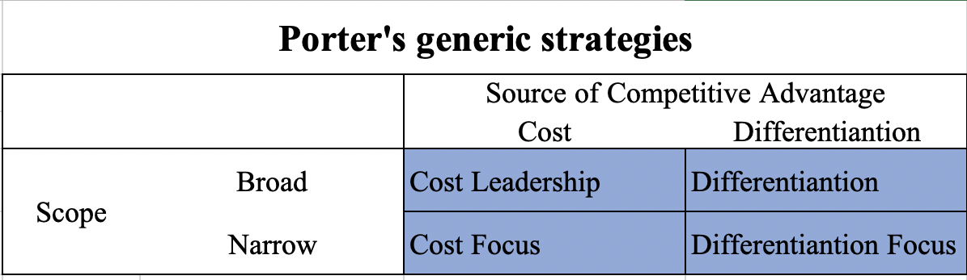
source from: adapted by the authors from Porter (1990)

Cost Leadership
The cost leadership strategy is conducive to stimulating consumer demand, generating more profits and increasing market share by reducing cost and price. Low price means that the price is possibly low under the context of industry-wide competition, or that the price is lower compared to the actual price expected by the customer. (Porter,1989)

Differentiation
The differentiation strategy relies on differences in products and services rather than their price as they are hardly replicable. These distinctions could involve technology patents, intellectual property, R&D innovation or novel services. (Gamble and Strickland, 2010)

Cost Focus
Under cost focus leadership strategy, an enterprise is required to offer possibly low prices while targeting niche markets. In order to ensure low prices, it is also required to pay close attention to market trends and consumer expectations. (Porter, 2004)

Differentiation Focus
Under cost focus leadership strategy, a company is required to offer distinctive products and services and target niche markets at the same time. In this process, it needs to ensure not only the distinctiveness of products and services but also customer loyalty in the target market. (Porter, 2004)

3.0 MAIN BODY
In the previous section, an explanation has been made as to Lidl and Porter’s Generic Strategy. In this part, an analysis is conducted of how Lidl applies the strategy to dominate the market.

3.1 Implementation of The Strategy
Since 2011 Lidl's sales has doubled, as their 'no frills' strategy has triggered resonance with consumers following the global financial crisis. (The University of Warwick, 2019) A no-frills or no-frills service or product requires the removal of all non- Essential features for low prices to be maintained. (Cambridge advanced learner's dictionary, 2008) By simplifying the way goods are stored in supermarkets, scaling back the variety of toppings and reducing the number of employees, Lidl achieves its success in cost reduction.

3.1.1 Reduced decorating costs
In Lidl, plenty of pallets carrying products are parked near the aisles. Lidl frequently goes directly to the carton for sale, with the products that are not placed in the freezer in particular. No dedicated shelves are prepared for these products. The identical types of goods are stacked vertically. After being sold out, items on the old pallet will be replaced by new ones. The overall cost of decorating each store will be reduced if the need for decoration of aisles and shelves can be removed. (Mary Hanbury, 2017)

3.1.2 Reduced labor costs
There is no necessity for Lidl to employ extra staffs for the goods to be placed on the shelves, which leads to zero waste. A large proportion of the products are stored in their original cartons, and customers could pick items from the carton straightaway, which minimizes staffing. It is enough for the clerks to fresh empty boxes on a regular or irregular basis. In addition, Lidl have cross-trained employees. Apart from cleaning empty boxes, they can work regardless of the section. As a discount supermarket, Lidl has a significantly smaller number of checkouts compared with the UK's Big Four, which is beneficial to control the number of cashiers. Besides, the number of open checkouts is determined by the number of customers waiting for payment. Some cashiers could be arranged to work in other positions if there are fewer customers needing check-out, such as sorting out goods and cleaning. “Therefore, staffing is more flexible and efficient,” as stated by Paglia. (Business Insider, 2019)

3.1.3 Control product categories
As stated by Doug Koontz, the head of content at the research firm Planet Retail RNG, each Lidl store sells as many as approximately 2,000 kinds of products in 2017. (Mary Hanbury, 2017) There is usually an absence of a butcher shop, bakery or deli counter in most of Lidl stores, for which meat, and cold meats are precut for sale in chilled vacuum packs. Besides, the same grocery store is usually filled with 6,000 items. Lidl's product category has a significant impact on the size of the Lidl store. Therefore, their stores are comparatively small and normally range between 14,000 and 26,500 sq. Ft. In comparison, the area covered by Tesco' stores are usually in excess of 80,000 sq. ft. With reduction in the variety of goods, not only does Lidl boost sales of a single commodity, it also lowers logistics costs, management costs and housing overhead. (Bristollive, 2019)

3.1.4 Control the area of the warehouse
They stick to the Pareto principle for decision-making over which goods to put on sale, which suggests that in most supermarkets, 20% of products on sale make up 80% of what customers purchase. The ordinary discount supermarkets are restricted to 600-1000 stock-keeping units (SKUs), while the hypermarkets in Europe could own as many as 50,000 SKUs. In comparison, Lidl's warehouse area and volume are below the industry level, which makes the cost of the warehouse lower compared to other market rivals. This provides an effective way to cut down on costs. (Europe Grocery Discounter: Small Stores– Big Threat?, 2015)

3.1.5 A large number of Private-label brands
Accounting for 90% of the entire store, private-label brands of Lidl are made up of the products Lidl has sourced from high quality UK local suppliers directly. Private-label brands are beneficial for Lidl to prevent the extra profits from being earned by distributors. Meanwhile, suppliers can find approaches to reducing costs, and Lidl can also offer own-brand products. When costs are reduced to the minimum without compromise on quality, Lidl can achieve higher profitability. (Business Insider, 2019)

3.1.6 Control opening hours
Across the UK, Lidl opens only at peak times, e.g., 8 am to 10 pm Monday to Saturday. (Lidl, 2019) In comparison, Tesco open 24 hours a day from Tuesday to Friday. (Tesco, 2019) The number of customers shopping at off-peak hours is limited, However, if Lidl continues operation, it will have to pay the same bill and a certain labor cost as they do during the peak period. Lidl achieves efficient operations and focuses on peak times. This not only generates enough profits during peak hours, but also avoids the waste of labor costs, energy costs and operating costs.

3.2 Advantages & Disadvantages of the Strategy
Advantages
Under the cost leadership strategy, the company enhances its competitiveness across the industry. When industry competition is intensified on a continued basis, and companies initiate price war, companies adopting cost leadership strategies can offer lower prices than their competitors. (Duica, M.C. and Duica, A., 2014)

Cost leadership strategies are also effective in lowering direct and indirect operating costs. By applying cost leadership strategies, companies frequently offer customers plenty of standardized products and limited tailor-made services. This is conducive to reducing operating costs. In addition, companies tend to cut down on all sorts of costs, for example, labor costs, research and development costs, and advertising costs. This contributes to the reduction of operating costs indirectly. (Wright, 1987)

A cost leadership strategy can attract investors' capital. Lidl has low operating costs, so it has more funds to upgrade technology and expand other businesses. For example, Lidl announced that it will invest £ 15 billion in the UK's grain, agriculture and production sectors within five years. This investment not only enhances Lidl's own business capabilities, but also supports local UK suppliers. (Nazir, 2019) In this way, investors realize that the company's proceeds will be used to invest in upgrading technology and expanding business to make the company better. Investors will be more willing to invest in such companies.

Disadvantages
The cost leadership strategy is exclusively suited to large-sized companies with a massive production volume and the scale of economy. Customers attracted by the cost leadership strategy tend to have less loyalty. Customers may shift to other alternatives when cheaper options emerge. (Wright, 1987)

It is easy for market rivals to replicate Lidl's low-price strategy. For example, Lidl reduce costs to generate more profits, and its competitors can do so as well. For example, in 2018 Tesco opened a new discount store, Jack’s, for competition against Aldi and Lidl. Jack’s also sells various Private-label brands, with a limited selection of products and fewer product lines offered. (Evans et al., 2019)

The disadvantage of cost leadership is the lack of innovation. The cost leader ship requires companies to control costs. Excessive cost savings may cause Lidl to reduce new product releases. For example, Lidl has launched far fewer new products than Tesco. For example, at Christmas 2019, Tesco released 74 Christmas delicacies including Christmas vegetarian food and Christmas queuing food. (Tesco, 2019) Lidl only released 33 kinds of Christmas food. (Lidl, 2019)

4.0 CONCLUSION
With reference made to various academic articles and current affairs, the article collects information about the British Lidl company and the Business Level Strategy it applies. It is believed that Lidl has snatched more market share due to a cost leadership strategy. Lidl Carried out the no-frills strategy to reduce costs, maintain low prices, and generate more profits. However, it can result in some unfavourable operations, such as excessive cost reduction. Moreover, the size of Lidl's company in the UK is not as large. However, the cost leadership strategy is more appropriate for large-sized companies. This strategy will generate more profits for the company if its current growth rate can be sustained. Lidl is expected to apply his strategy in a flexible way to reach the maximum level of profitability.

5.0 RECOMMENDATION
Lidl can develop its online shopping service, which will save time compared to opening a new store. Saving time is also a cost-saving way.

Lidl can add a membership system to attract and retain more customers through the membership system.

Lidl is still mainly low-end products, although there are a few luxury products but not many. So Lidl can consider increasing the variety and quantity of Lidl Deluxe products.

REFERENCES
Albany (2019) Business-Level Strategy. https://www.albany.edu/faculty/es8949/bmgt481/lecture4.html (Accessed: 17 November 2019)

BBC (2018) Aldi and Lidl included in Sainsbury's-Asda competition probe. https://www.bbc.co.uk/news/business-45876628 (Accessed:13 November 2019)

BBC (2019) Lidl plans 500 jobs at 12 new stores in Scotland. https://www.bbc.co.uk/news/uk-scotland-scotland-business-48907818 (Accessed:13 November 2019)

Benwell, S. (2019). ‘Lidl launches new USA food range including marshmallow cereal and a giant cookie dough pie.’ https://www.thesun.co.uk/money/9361307/lidl-launches-usa-food-range/ (Accessed 20 November 2019)

Bristollive (2019) The secrets, tips and tricks every Lidl customer needs to know. https://www.bristolpost.co.uk/whats-on/shopping/secrets-tips-tricks-lidl-customer-1197573 (Accessed: 18 November 2019)

Business Insider (2019) How Lidl keeps its prices down. https://www.albany.edu/faculty/es8949/bmgt481/lecture4.html (Accessed: 17 November 2019)

Cambridge advanced learner's dictionary. (2008). 1st ed. Cambridge: Cambridge University Press.

Duica, M.C. and Duica, A. (2014), “Organizational Implications of the Cost Leadership Strategies.” Valahian Journal of Economic Studies, (5) 2, p33-40.

Europe Grocery Discounter: Small Stores– Big Threat? (2015). European Grocery Discounters report Nov. 2015. London: Fung Business Intelligence Centre, p.25.

Evans, T., Knapman, H., Evans, T. and Knapman, H. (2019). ‘First look inside Tesco's new budget chain Jack's as it takes on Aldi and Lidl.’ https://www.thesun.co.uk/money/7294387/tesco-jacks-new-store-opening-first-look-inside/ (Accessed 21 November 2019).

Gamble, Arthur A. Thompson, Jr., A.J. Strickland III, John E. (2010). Crafting and executing strategy: the quest for competitive advantage: concepts and cases. 17th ed. Boston: McGraw-Hill/Irwin. p. 149.

Katie Forster, (2016) Lidl alerted to paint thinner in gravy 'two weeks before warning public'. https://www.independent.co.uk/news/uk/home-news/lidl-gravy-recall-paint-thinner-stripper-wales-dogs-knew-two-weeks-a7482936.html (Accessed:25 November 2019)

Lidl (2019) About US. https://www.lidl.co.uk/about-us (Accessed:12 November 2019)

Lidl (2019) Christmas recipes. https://recipes.lidl.co.uk/Collections/Christmas-recipes?_ga=2.253526922.264099700.1574788315-1269830358.1573783950 (Accessed: 25 November 2019)

Lidl (2019) HELP TOPICS. https://customer-service.lidl.co.uk/SelfServiceUK/s/?language=en_GB&_ga=2.184786089.1650576113.1573783950-1269830358.1573783950 (Accessed:12 November 2019)

Lidl (2019) Meet the Team. https://careers.lidl.co.uk/en/5212.htm (Accessed:12 November 2019)

Lidl (2019) Our Product. https://www.lidl.co.uk/our-products (Accessed:12 November 2019)

Mary Hanbury, (2017) A German grocery chain that's coming to America is already dominating Walmart on prices — here's why it's so cheap. https://www.businessinsider.com/how-lidl-keeps-its-prices-down-2017-6?r=US&IR=T (Accessed:25 November 2019)

Mintzberg, H. (1994). Rise and fall of strategic planning. 1st ed. Great British: Prentice Hall Europe, p.44.

Nazir, S. (2019). ‘Lidl to invest £15bn in British food, farming & production - Retail Gazette.’ https://www.retailgazette.co.uk/blog/2019/10/lidl-invest-15bn-british-food-farming-production/ (Accessed 22 November 2019].

Nils-Gerrit, W. (2019). 'Turnover of Lidl in the United Kingdom (UK) from 2012 to 2018' https://www.glassdoor.co.uk/Salaries/london-supermarket-assistant-salary-SRCH_IL.0,6_IM1035_KO7,28.htm?countryRedirect=true (Accessed:20 November 2019)

Porter M.E. (1989) From Competitive Advantage to Corporate Strategy. 1st ed. London: Palgrave, pp. 234-255

Porter, M.E. (1990). "New global strategies for competitive advantage." Plan. Rev. 18(3), pp.4–14

Porter, M. E. (2004). Competitive advantage. 3rd ed. New York: The Free Press, pp.11-16.

Porter, M. E. (2004). Competitive advantage. 3rd ed. New York: The Free Press, pp.1-4.

Stevens, B. (2019). Tesco launches largest own-brand vegan range - Retail Gazette. https://www.retailgazette.co.uk/blog/2018/01/tesco-launches-largest-brand-vegan-range/ (Accessed 20 November 2019)

Tesco (2019) Christmas food. https://www.tesco.com/groceries/en-GB/zone/vegetarian-christmas (Accessed: 25 November 2019)

The University of Warwick (2019) Why are Aldi and Lidl currently so successful? https://www.futurelearn.com/courses/supply-chains/0/steps/23702 (Accessed:16 November 2019)

Wright, P. (1987). A refinement of Porter's strategies. Strategic Management Journal, 8(1), pp.93-101.

Wright, P. (1987), “A refinement of Porter's strategies.” strategic management journal, (8)1, p93-101.

Appendices
Apendix1- Lidl’s Award
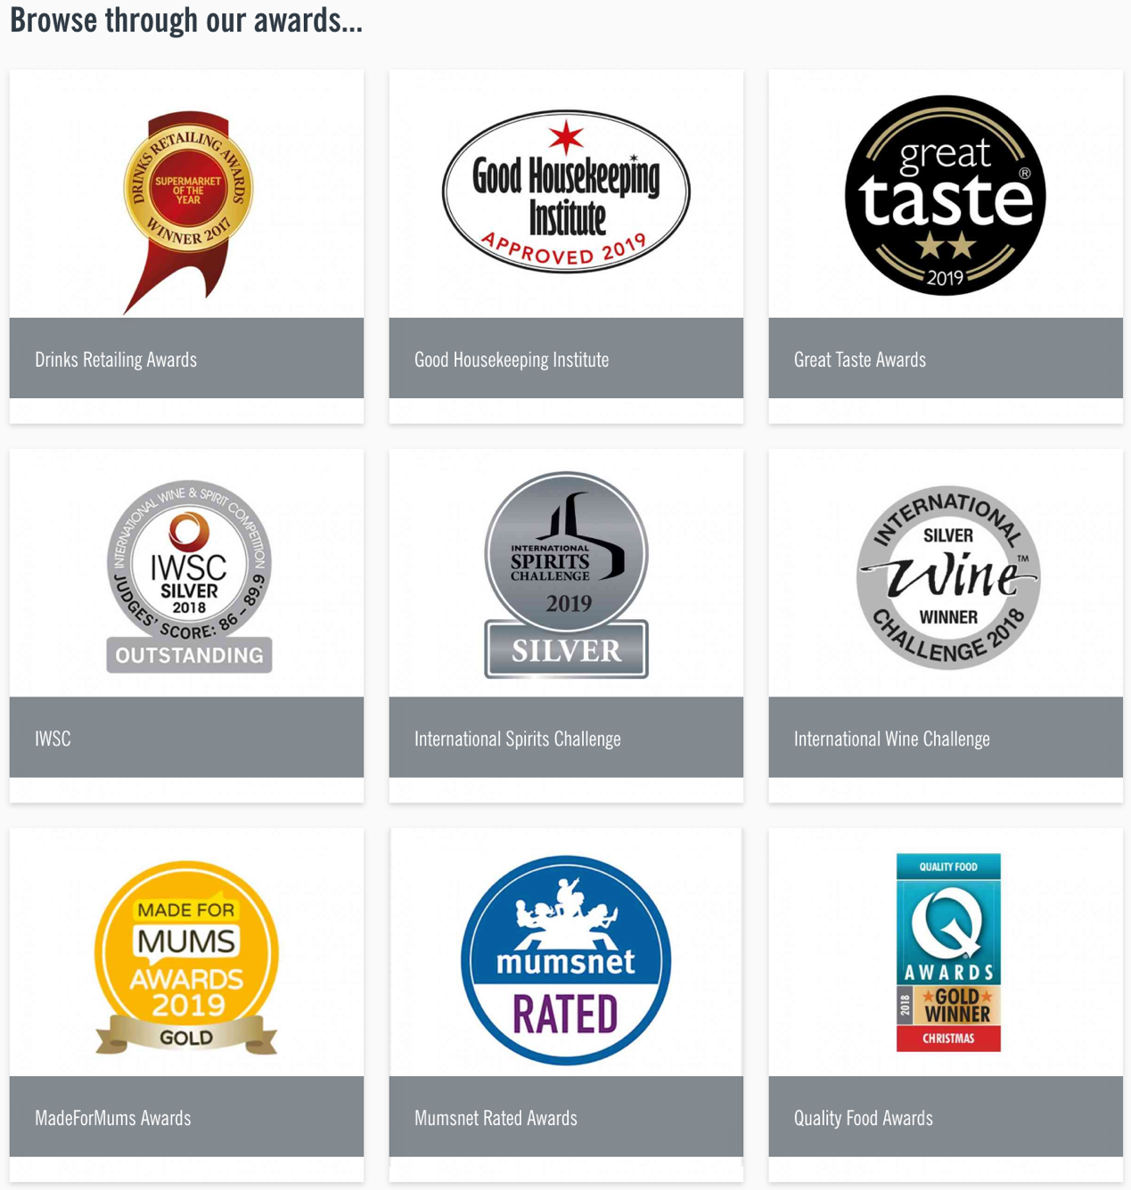
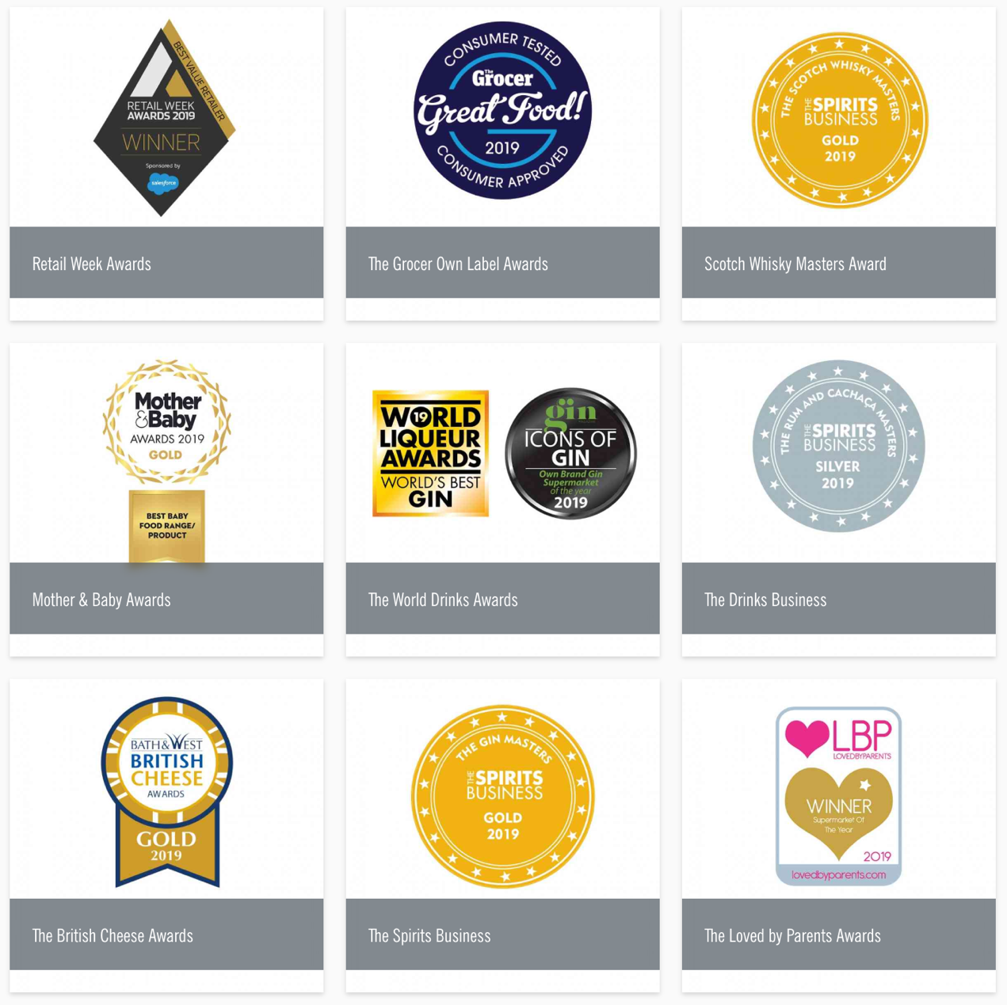

Appendix 2 PESTEL Analysis for Lidl in UK
Political | Britain is about to leave the European Union. Once Brexit, Lidl as a company from the European Union may face additional fees.
Economic | The UK's economy is sluggish, and more people are willing to buy lower-priced goods.
Society | The state of the UK’s dwindling middle
Technology | With the development of the network, consumers can easily compare the prices of the same goods in different stores. Consumers are well aware of which supermarket's merchandise is guaranteed to be of lower quality at a lower quality.

