EFFECTIVE TEAM WORKING AND COMMUNICATION

NELLY MYLES 1710690

UNIVERSITY OF WALES TRINITY ST DAVIDS

26 November 2018

EXECUTIVE SUMMARY
The team that was in place in the case study is a very ineffective team. Many problems occurred and in turn accumulated to a point where complete restructuring was needed. The first problem that was identified within the team initially is the Lack of participation. Team members fail to complete assignments. There was poor attendance at team meetings. This caused for other problems to arise such as smaller teams are forming and as a result underperforming. Lack of real leadership meant that decisions weren’t being made and ones that were made were overturned by other social workers. There was no permanent manager to oversee the decision that were made. This also means that the team was unable to resolve conflicts. There is a lack of critical thinking and debate over ideas. This consistently happened because the team was constantly changing. Furthermore, Members did not feel mutually accountable to one another, or the team’s objectives. There was a lack of collaboration, due to the constant change of the team and no real team leader to introduce new comers to the team, Also the fact that ideas weren’t being able to be communicated to senior management employee became demotivated. The team was kept in a closed loop and work was not being effectively monitor or evaluated. There was no team meetings to discuss the team’s performance or air concerns. The report outlines shortfalls , impact and recommendation of effective team.

- TERMS OF REFERENCE

This report was requested by University of Wales Trinity St David. The purpose of this report is to identify the impact of communication and the effects on the team work. The work is submitted on 13th July 2018.

- Procedure

The used to get this report is from books, websites , journal and moodle handouts.

- FINDINGS

  - Andrea is new head of Social services in the local council. There are 96 social workers making 8 teams of 12 each. Each team has a manager, Deputy Manager, a consultant and 9 social workers. There are 4 area teams , an adoption team ,fostering ,early intervention team, and an auditing team
  - Two teams are out of the main building and are always feeling left out and complain about surprise changes. So there are barriers to communication due to location.
  - Teams are forming and underperforming, and some do not have team leaders or are constantly changing. No permanent team leader.

  - Managers are not addressing poor performance.
  - Informal instructions resulting in messages being diluted, due to no formal ways of communication.
  - No team meetings to discuss teams performance or air concerns
  - No appropriate induction procedure and newer staff given bigger case loads.
  - The Head of Service is hands off, and only uses email for communication. Normally this is only a one way and he does not reply them if staff requested for information.
  - The head of service only had one way communication and occasional face to face.
  - Relationship with social workers was poor and created distrust among them.
  - The team does not have mechanism to communicate their ideas

3.3.1 The following are some of the impact experienced due to the communication issues above.
Teams have different standards one social worker might find a case at risk and the other might rule it out. So quality issues.
Distrust between members of the team because they do not spend enough time together or they are new and the team has not formed they are working as a group and not a team.
Absence of members of the team due to stress and work over load this is sign of passive conflict .

Team managers felt unappreciated they felt stressed and not happy.
Poorly written reports and cases being open for longer.
The are working as a group and not a group.

4.0 Conculsion

following the findings high performing teams need a shared vision, trust continuous development collaboration commitment the work which will avoid newer recruited to be over worked. They need to be a team and not a group using the Tuckman model to recruit will be beneficial.

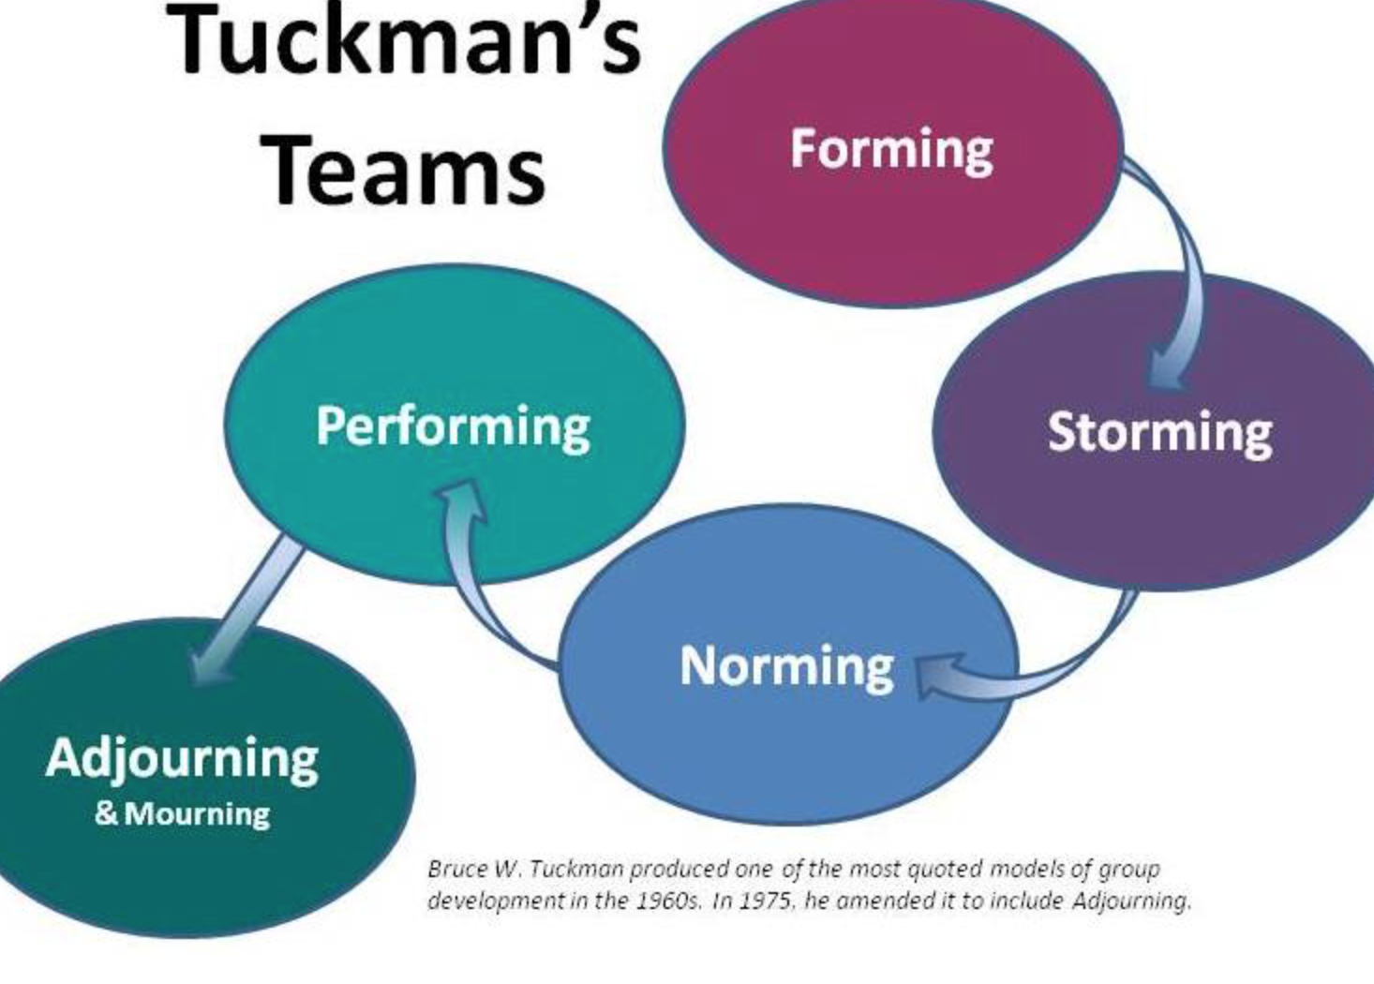

Open communication is also essential by providing the team with regular meetings to air their view and team building activities so that that the team build more trust and respect for each other .

This will reduce staff absence Using the personality quiz will help the team to maximum their potential according to Belbin model

Team Manager need to be given incentives like holiday Pay, more feedback on their performance . bonus or appropriate reward schemes.

The head of Service used the one way method of communication also known as the Shannon Weaver mathematical model of 1949. This is a one-way method of communication.

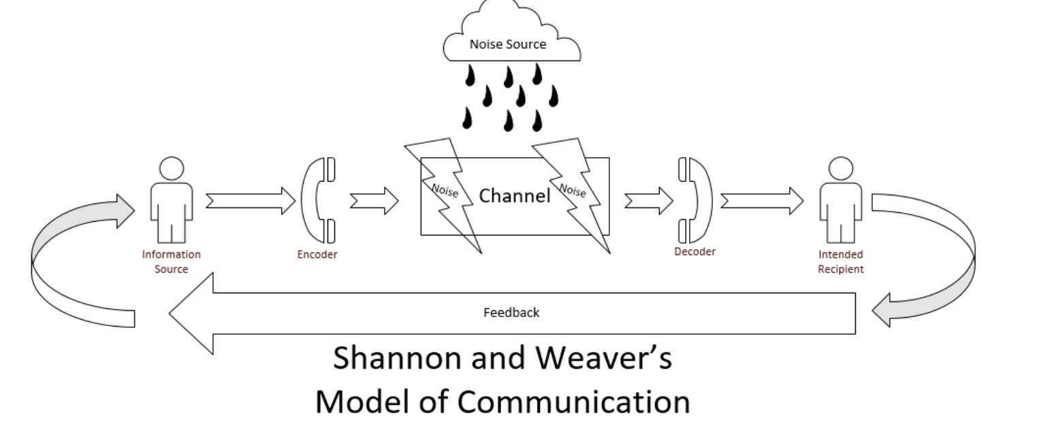

The CIPD, shaping the future research particularly noted the importance of communication.
Unfortunately the research also noted not all senior Leadership are not giving enough of their attention nor considering employee communication as something that should regularly occupy their time.(Quirke 2008) effective communication should be two way as in the scram’s model of communication, 1954(google scholar)

Teams are forming and underperforming because of lack of leadership and there is no sufficient time to grow as the Bruce Tuckman’s model which goes through the inception to successful completion of the project. The forming, storming norming performing and adjourning so the cycle is not being completed creating distrust and underperformance a team needs continuity to succeed efficiently.

The team should have written form of communication that reaches everyone. in this way, the message is not distorted this increases transparency which is important in team work to avoid distrust.

The team members where disgruntling and not coming forward with their thoughts. Effective teams need to voice their opinions without fear.

Recommendations

The team needs to meet regularly to discuss issues without leaving the it to pent up and this can be resolved more amicably when not left for long periods.
The teams need to be updated of the objectives with the correct channel of communication.
There should be a policy on conflict resolution to enable staff to respect and air their grievous needs. With a two way communication cycle.

They need regular events with the head of service.
The team also needs a support system to help in times of staff shortages or cases that have big caseloads.

The personalities of the team can also be identified using the Belbin method to help the team work more effectively.

Communication barriers such as location should be removed.

Staff need to have an induction process and training to avoid over load this will give more confidence when dealing with caseloads. And more opportunities to develop skills in supportive environment

Introduction mission, vision and objectives (common goals)

5.references

https://academic.oup.com/heapro/article/15/3/259/551108 assessed on July 2018
www.coaching culture at work,com

you tube . effective teams

- Morgan, P. (2017) The Business Student’s Guide To Study And Employability. London: Sage Publications Ltd.
- www.belbin.com/link assessed in November 2018

