Component 1 – Individual Report
Student Name: Mariana Acris
Student Number:2239619
Lecturer Name: Muno Zuwirai
Module code: LCBB4001BIRM
Accounting Fundamentals

Contents
1. Introduction 3
1.1. Cost Accounting– Concept, Objectives, Types & Method 3
1.1.2.Smith’s Groceries Cooper’s Income Statement, for the year ending 31st December 2023: 4
1.1.3.Smith’s Grocery Balance of Sheet for the year ended 31st December 2023. 5
2.Maria’s Business ,,T’’ Accounts: 6
Maria’s Business acc. 6
Capital/ Equity Account 7
2.1.MBS Trial Balance for the ended of period 28.02.24: 10
2.1.1. Calculate the depreciation and profit or loss arising from the sale of this asset: 10
3. What Is Going Concern? 11
3.1. Understanding Going Concern 11
4. Conclusion. 13
Bibliography 14

Introduction
This report aims to provide a comprehensive understanding of T accounts, ledger entries, and the construction of the trial balance in accounting. These concepts are fundamental to maintaining accurate financial records and assessing the financial health of a business. The report will delve into the theoretical underpinnings of these concepts and their practical application in real-world scenarios.

Cost Accounting– Concept, Objectives, Types & Method
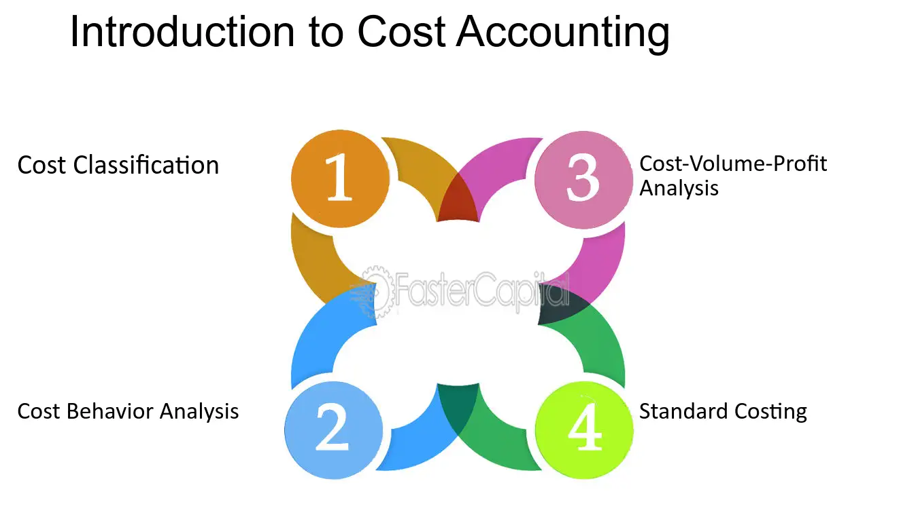
Cost accounting is a branch of accounting that deals with the process of recording, analyzing, and reporting costs associated with production, operations, or other activities within an organization (Narsis, 2009). Its primary objectives are to provide management with relevant information for decision-making, cost control, and performance evaluation. Cost accounting involves various types and methods tailored to suit different organizational needs and objectives (Narsis, 2009).

The core concepts of cost accounting, including cost classification, behavior analysis, cost-volume-profit analysis, and standard costing, provide a robust foundation for businesses to accurately track and allocate costs across different facets of operations. Moreover, the diverse methods of costing, such as job order costing, process costing, activity-based costing, and standard costing, offer flexibility in adapting to the unique needs and characteristics of various industries and organizational structures. By leveraging cost accounting practices, businesses can achieve a myriad of objectives, ranging from cost control and performance evaluation to profit planning and inventory valuation. These objectives align with overarching organizational goals, enabling businesses to optimize resource allocation, enhance operational efficiency, and maximize profitability.

1.1.2. Smith’s Groceries Cooper’s Income Statement, for the year ending 31st December 2023:

Details: | £ | Details: | £
Opening Stock | £3000 | Sales | £160 000
Purchase | £95 000 | Sales return | (£4000)
Purchase return | (£5000) | Closing stock | £5000
Balance: | £161 000 | Balance: | £161 000
Rent | £2500 | Gross profit | £70 000
Less: prepaid | £300 | Discount received | £200
Wages | £28 000 | Provis. For bad debt. | £500
Sal. Accrued | £3000
Total | £29 000
Vehicle main. | £800
Interest on loan | £1000
Discount allow | £700
Expenses(gas + electric) | £1500
Outstanding | £150
Total | £950
Bad debt | £800
Provision for bad debt | £810
Depreciation | £5025
Net profit | £26715
Total | £70 700 |  | £70 700
Cooper’s profit or loss statement for the year ending 31 st of December 2023 is £70 700.

1.1.3. Smith ’s Grocery Balance of Sheet for the year ended 31st December 2023.

Details: | £ | Details: | £
Capital | £25 000 | Stock (furniture) | £15 000
Net Profit | £24 715 | Accumulated depreciation | (£5000)  =  £10 000
Total | £49 715 | Less depreciation  (£15 000 x 12% = £1800) | £1800
Drawing | £13 000 | Vehicle | £8200
Total | £36 715 | Accumulated depreciation | £28 500
Loan | £10 000 | Less depreciation  (£28 500 - £7000) x £15%=£3225 | £3225
Salaries accrued | £3000
Vehicle maintenance | £150
Payable | £2300
 |  | Closing stock | £18 775
 |  | Trade receivable | £5000
 |  | Less bad debt | £17 000
 |  | Less Provision | £800
 |  | Bank | £15 890
 |  | Rent prepaid | £5000
Total: | £49 200 | Total: | £49 200

The fundamental principles of accounting, encompassing double-entry accounting, T-accounts, ledger entries, and the trial balance, form the cornerstone of accurate financial record-keeping and reporting (Friis, 2023). These principles provide a systematic framework for organizing and summarizing financial transactions, ensuring transparency, reliability, and compliance with regulatory standards.
Double-entry accounting, with its foundational concept of every transaction having equal and opposite effects on at least two accounts, ensures that financial records accurately reflect the economic reality of business activities. Assets = Liabilities + Equity
T-accounts serve as visual representations of ledger accounts, aiding in the recording and tracking of transactions in a clear and organized manner.
Ledger entries provide detailed records of individual transactions, creating an audit trail that supports the preparation of financial statements and facilitates analysis.
The trial balance, as a summary of all ledger account balances, serves as a crucial tool for verifying the accuracy of financial records by ensuring that total debits equal total credits. Through the trial balance, discrepancies and errors in recording and posting transactions can be identified and corrected, contributing to the reliability and integrity of financial reporting.
Together, these fundamental principles of accounting uphold the principles of accuracy, reliability, and transparency, enabling businesses to make informed decisions, meet regulatory requirements, and maintain the trust of stakeholders (Akpan, 2023). By adhering to these principles, accounting professionals can effectively manage financial information and support the long-term success and sustainability of businesses.

2.Maria’s Business ,,T’’ Accounts:

Maria’s Business acc.

Debit Credit
1 Feb. 2000 Balance b/d ; 3 Feb. 1000 Computer;
2 Feb. 700 Capital; 4 Feb. 800 Supplies;
9 Feb. 3000 Sales; 7 Feb. 700 Supplies;
15 Feb. 2600 Sales; 11 Feb. 350 Transport;
21 Feb. 2400 Sales; 18 Feb. 450 Insurance;
27 Feb. 8000 Vehicle sale; 20 Feb. 1200 Supplies;
28 Feb. 6000 Bank; 25 Feb. 800 Wages;
26 Feb. 500 Marketing;
28 Feb. 1200 Withdraws;
28 Feb. Balance c/d 47700;

£54700 £54700

1 March Balance b/d £47700

Capital/ Equity Account

Debit Credit
1 Feb. Balance b/d 32000
2 Feb. 700 Capital
28 Feb. Balance c/d 38700 28 Feb. 6000 Capital

£38700 £38700

1 March Balance b/d £38700

Sales Account
Debit Credit

9 Feb. 3000 sales
28 Feb. 15 Feb. 2600 sales
Balance c/d (statement of profit) 16000 21 Feb. 2400 sales
27 Feb. 8000 Van sale

£16 000 £16 000
1 March Balance b/d £16 000

Equipment Account
Debit Credit
3 Feb. 1000 Equipment
Balance c/d 1000

£1000 £1000

1 March Balance b/d £1000

Inventory Account
Debit Credit
4 Feb. 800
7 Feb. 700 Balance c/d 2700
20 Feb. 1200

£2700 £2700

1 March Balance b/d £2700

Motor Expenses Account
Debit Credit
11 Feb. 350 transport Balance c/d 800
18 Feb. 450 insu rances

£800 £800

1 March Balance b/d £800

Wages Account
Debit Credit

25 Feb. 800 Balance c/d 800

£800 £800

1 March Balance b/d £800

Marketing Account
Debit Credit

26 Feb. 500 Balance c/d 500

£500 £500

1 March Balance b/d £500

Withdraws Account
Debit Credit

28 Feb. 1200 Balance c/d 1200

£1200 £1200
1 March Balance b/d £ 1200

2.1.MBS Trial Balance for the ended of period 28.02.24:

Details: | Debit | Credit
Banck | £47 700
Capital/Equity |  | £38 700
Sales |  | £16 000
Equipment | £1000
Stock | £27 000
Motor Expenses | £800
Wages | £800
Marketing | £500
Withdraws | £1200
Total: | £54 700 | £54 700

2.1.1. Calculate the depreciation and profit or loss arising from the sale of this asset:

- 1st February – cash balance £2000
- 3rd February – computer purchase £1000
- 27th February – Maria loss through sale of van at £8000
- 28th February – Cash Withdraw £1200
- 26th February – Marketing £500
- 25th February – Maria pays wages £800.

1 Feb. 2024 Van Value - 15000
27 Feb. 2024 Van Sold – 14000
Net Book Value = Cost – Accumulated depreciation =£14000- £8000= £6000
NBV= £14000- £8000=£6000

What Is Going Concern?

The going concern concept in accounting assumes that the business will continue to operate for the foreseeable future, allowing it to use its assets fully (Lombardi, 2021). This means that assets are expected to be utilized in the normal course of business operations rather than being sold off or liquidated. It also implies that the entity will have sufficient time to realize the benefits of its investments, fulfill its obligations, and generate profits.

Understanding Going Concern

The going concern principle holds significant importance for several reasons, all of which contribute to the integrity and reliability of financial reporting. Let's explore why this concept matters:
- Financial Statement Reporting:
Accountants use the going concern principle to determine how assets and liabilities should be reported on financial statements. For companies considered as going concerns, long-term assets are typically reported at historical cost rather than at current or liquidating values (Kati, 2022).
- Continuation of Operations:
A company is considered a going concern when it is expected to continue its operations for the foreseeable future without the need for liquidation (Venuti, 2004). This includes scenarios where certain actions, like closing a branch office, do not impair the company's ability to operate as a whole.

- Asset Management:
Accountants who view a company as a going concern believe that the company is managing its assets effectively and doesn't need to liquidate them to continue operating (Baruch Lev, 2016). Therefore, decisions regarding asset sales, expense reductions, or product shifts are made with the expectation of ongoing operations.
- Decision-Making:
For stakeholders such as investors, creditors, employees, and suppliers, the going concern assumption provides essential information for decision-making. Investors rely on financial statements to assess the company's financial health and potential for future growth (Burke, 2024). Creditors use this information to evaluate the company's creditworthiness and repayment capacity. Employees and suppliers assess the company's stability and reliability as business partners.
The importance of the going concern principle matters because it underpins the integrity of financial reporting, ensures the accuracy of financial statements, facilitates informed decision-making by stakeholders, and fosters stability and confidence in the business environment. By assuming that the company will continue operating, this principle helps maintain transparency, reliability, and trust in financial markets, ultimately contributing to the efficient allocation of resources and sustainable economic development.

Conclusion.
In conclusion, this report has explored the fundamental concepts of T-accounts, ledger entries, and the construction of the trial balance in accounting. It has outlined the essential components of a T-account, emphasizing the placement of credits and debits, as well as the inclusion of an account title at the top. Additionally, it has discussed ledger entries, which are records of business transactions compiled either through the double-entry or single-entry system.
The report has also detailed the purpose and construction of the trial balance, which serves as a worksheet to compile the balances of all ledger accounts into credit and debit sums, ensuring they are equal and providing a preliminary check on the accuracy of the accounting records.
Furthermore, the significance of the going concern concept in accounting, under both General Accepted Accounting Principles (GAAP) and International Financial Reporting Standards (IFRS), has been highlighted. The going concern principle assumes that a business will continue to operate indefinitely, which is crucial for the integrity and reliability of financial reporting.
Overall, this report has underscored the importance of understanding and applying these concepts in accounting practices, emphasizing their role in preparing accurate financial statements and ensuring compliance with accounting standards and regulations.

Bibliography
Akpan, J. U. O. O. I. a. A. Y. M., 2023. Conflicts of Interest in Accounting: Implications and Solutions. Journal of Accounting and Financial Management, Volume 9, pp. 158-184.
Baruch Lev, F. G., 2016. The End of Accounting and the Path Forward for Investors and Managers. s.l.:John Wiley & Sons.
Burke, C., 2024. Swoop. [Online]
Available at: https://swoopfunding.com/uk/business-glossary/going-concern/
Friis, B., 2023. The complete guide to double-entry accounting. [Online]
Available at: https://www.quadient.com/en/blog/the-complete-guide-to-double-entry-accounting
Kati, E., 2022. Legalvision. [Online]
Available at: https://legalvision.co.uk/startups/what-going-concern/
Lombardi, R., 2021. The Going-Concern in Accounting Research. In: SIDREA Series in Accounting and Business Administration. s.l.:s.n., pp. 1-29.
Narsis, I., 2009. Theory in Cost Accounting. s.l.:Atlantic Publishers & Dist.
Venuti, E. K., 2004. The Going-Concern Assumption Revisited: Assessing a Company's Future Viability. The CPA Journal, May , 74(5), pp. 40-43.

