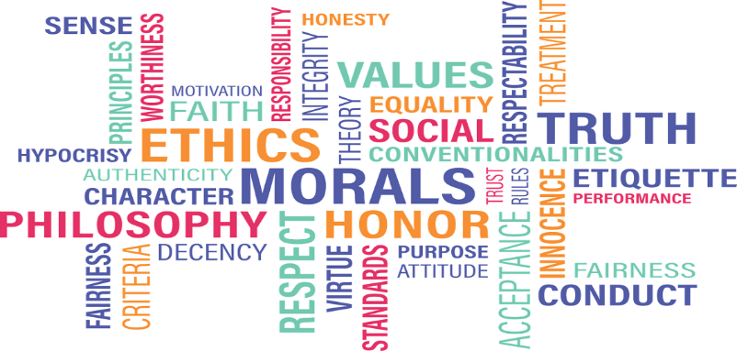
As a part of the module BMSW5001 Developing workplace critical thinking we have been allocated into groups, to create a poster and present it in class.

I have been giving the part of beliefs in organisational management, I will discuss the following points in regard to beliefs:

- Distinguish and Analyse the difference between beliefs, attitudes and values within a workplace context Critically assess their own beliefs, attitudes and value systems and their impact on workplace behaviour

Beliefs
Beliefs are things that we hold to be true which underpin our values. Our experience and view of the world
What is a belief?

- A belief is an idea that is held by a person to be true.
- Belief based upon certainties, probabilities or matters of faith.
- A belief can come from different sources: experiences, cultural and societal norms, what other people say (e.g. education)

People have different personal beliefs such as:
Spiritual
Moral
Social
Intellectual
Economical
Political

Organisational Beliefs

The most basic element of organisational behaviour, a belief is your assumed truth.
A deep moral or positional view that reasons our identity, beliefs are generated through experience, experimentation, reflection or generalisation.
One’s beliefs can also be affected by external agents who are authorities that hold a principle in specific areas.
Beliefs are fundamental positions rooted deep within our being. They influence our entire world view and shape everything else that we do. As such, changing one’s beliefs do require considerable work.

How beliefs can contribute to organisational success
Employees belief is quite often vital to the success of the company if the employees believes that they are valued they will do more for the company which will result in happy customers and a successful business. An employee that feels valued at the workplace will use critical thinking strategies and values to help the organisation in whatever way they can. For example, a salesperson that believes in honesty will only promote the benefits of the product and company to a customer. This employee will continue to evaluate and analyse their own performance and aim to improve consistently.
An organisation may decide to incorporate management theories in order to establish their beliefs. This could result in overall productivity improvements. Management theories are responsible for promoting motivation, leadership and change.
There are 4 major schools of management theory: scientific, classical, behavioural and modern. Each has its own advantages and disadvantages. And each may work better in certain industries. An example of a management theory is Peters and Waterman (1982) modern management theory. One of the main principles of this theory is “stay close to the customer”. This means that the employees and the business must learn the preferences and likes/dislikes of the customer in order to maximise selling potential.





References

Peters, T.J. and Waterman, R.H. (1982) In Search of Excellence: Lessons from America’s Best-Run Companies. Harper & Row, New York.

Apostolou, B. and N. Apostolou: 1997, 'Heroes as a Context for Teaching Ethics', Journal of Education for Business (November), 121–125.

https://josephsononbusinessethics.com/2010/12/12-ethical-principles-for-business-executives/

https://coolerinsights.com/2012/11/the-basics-of-organisational-behaviour/https://www.fastcompany.com/90334069/these-are-amazons-38-rules-for-success

