

INVESTIGATION AND IMPLEMENTATION OF A HEALTH APPLICATION SUITABLE FOR NEURODIVERGENT INDIVIDUALS

by
Michelle Chalmers

Supervisor: Gaynor Thomas
Second Marker: Mike Dacey

Project submitted as part of the requirements for the award of BSc(Hons): Computing (Software Engineering)

September 2023

Declaration FORM AND FORM OF CONSENT

DECLARATION

I, Michelle Chalmers declare that I am the sole author of this Project; that all references cited have been consulted; that I have conducted all work of which this is a record, and that the finished work lies within the prescribed word limits.

This work has not previously been accepted as part of any other degree submission.

Signed: ....M Chalmers................

Date: .....19th September 2023.......

FORM OF CONSENT

I Michelle Chalmers hereby consent that my Project, submitted in candidature for the BSc(Hons): Computing (Software Engineering)degree, if successful, may be made available for inter-library loan or photocopying (subject to the law of copyright), and that the title and abstract may be made available to outside organisations.

Signed: ....M Chalmers................

Date: .....19th September 2023.......

Abstract
A review of lifestyle trackers indicates that neuro-divergent individuals are not being adequately catered for. Those that are available have been found, during this research, to be unsuitable for anyone with non-standard needs.
Additionally it was confirmed that some conditions associated with neuro-diversity increase the possibility that a tracker might be needed.
The objectives of the report were to understand who might be ‘neuro-diverse’, why that might cause physical health problems, what support is available digitally, and whether it can be improved upon.
As a result of the research a prototype app suitable for this use was released and tested. Tester feedback was positive with a score of 4.26 out of 5 on the question ‘If the app was fully developed, how likely is it that you would recommend it?’
In conclusion this report offers insights and supporting information to validate the need for the development, and a prototype app that can be considered suitable for further development.

Objectives
Research the need for, and potentially develop an app capable of providing information for users, parents, carers, or medical experts that could help identify gastrointestinal, bowel issues or allergies. This may also help identify lifestyle choices that have an influence on health.
- Develop an understanding of neurodiversity, and an appreciation of the challenges that may be faced by those that are neurodiverse
- Establish an understanding of the different needs of neurodiverse people who may have a requirement to track their food and lifestyle choices
- Research the options currently available for food and lifestyle tracking
- Assess the suitability of currently available options for those that are neuro-diverse
- Involve health professionals and carers to better understand what they believe would be a suitable product
- Design a prototype application with the potential to provide a suitable tool
- Review the feedback from testers

Contents
Declaration FORM AND FORM OF CONSENT i
Abstract ii
Contents iv
Table of figures vi
1 Introduction 7
2 Aim 7
3 Ideation 7
4 Objectives 7
5 Understanding Neurodiversity 8
5.1 Mental Health Conditions 10
5.2 Brain injury and neurodegenerative diseases 11
5.3 Temporary Cognitive Impairment 12
5.4 Learning Disabilities and Learning Difficulties 12
5.5 Illiteracy and dyslexia 13
5.6 Autism Spectrum Disorders (ASD) 14
5.7 Down Syndrome 15
5.8 Attention deficit hyperactivity disorder (ADHD) 15
6 Physical Impairment 17
7 Neurodivergence association with health problems 18
7.1 ASD and ADHD 19
7.2 Neurodegenerative disease 20
7.3 Down Syndrome 20
8 Lifestyle trackers 21
9 Tracking diet and lifestyle habits 21
9.1 Potential issues using a tracker 23
9.2 Currently available Apps 24
9.2.1 MyFitnessPal 24
9.2.2 Health Infinity 25
9.2.3 Poop Tracker 26
9.2.4 Poop Tracker - Log & Analysis 26
9.2.5 Conclusion 27
10 The design process 27
10.1 Problem Formulation 28
10.2 Design 28
10.3 Initial sketches and wireframes 29
10.3.1 Sketches 30
10.3.2 The Wireframe 31
10.4 The Implementation 32
10.5 How it was made 32
10.6 The Database 33
10.6.1 The Tables 34
10.7 The Webpages 35
10.7.1 Interesting Code 41
11 Research Methodology 42
12 Development Methodology 44
13 Gantt chart 46
14 Evaluation 49
14.1 Evaluation Survey 49
15 Conclusions 55
16 Further development 55
16.1 Users and carers 55
16.2 Medical professionals 55
17 Value of Further Development 56
18 Reflection 57
19 References 58
20 Appendices 62
20.1 Data Dictionary 62
20.2 Using the APP - instructions 63

Table of figures
Figure 1 The Make-up of Neuro-Diversity 10
Figure 2 Learning Disabilities in the UK [6] 13
Figure 3 The Bristol Stool Chart 23
Figure 4 MyFitnessPal [22] 24
Figure 5 Health Infinity [22] 25
Figure 6 Poop Diary [22] 26
Figure 7 Poop Tracker - Log & Analysis [22] 27
Figure 8 The First Sketch 29
Figure 9 Second Sketches 30
Figure 10 Wireframe Design 31
Figure 11 Wireframe - the menu links 32
Figure 12 The Database 33
Figure 13 The Research Onion [23] 50
Figure 14 Waterfall Development Model [24] 51
Figure 15 Incremental Development Model [25] 52
Figure 16 Original Gantt Chart 53
Figure 17 Revised Gantt Chart 54
Figure 18 Condensed Gantt Chart 55

Introduction
This research into the potential development of a health and well-being specialist application is being done as part of the authors bachelor of science software engineering degree, final year.

Aim
The main aim of this report is to review the current availability of lifestyle trackers suitable for non-neurotypical people, and design a prototype application (app) if nothing suitable is already available.

Ideation
The creation of a user-friendly app that allows those with cognitive impairment or limited communication abilities to keep track of their eating and lifestyle choices.

Objectives
Research the need for, and potentially develop an app capable of providing information for users, parents, carers, or medical experts that could help identify gastrointestinal, bowel issues or allergies. This may also help identify lifestyle choices that have an influence on health.
- Develop an understanding of neurodiversity, and an appreciation of the challenges that may be faced by those that are neurodiverse
- Establish an understanding of the different needs of neurodiverse people who may have a requirement to track their food and lifestyle choices
- Research the options currently available for food and lifestyle tracking
- Assess the suitability of currently available options for those that are neuro-diverse
- Involve health professionals and carers to better understand what they believe would be a suitable product
- Design a prototype application with the potential to provide a suitable tool
- Review the feedback from testers

These objectives will be:
Specific
- Review the need, availability, and potential development of a lifestyle tracker suitable for people who are not neuro-typical
Measurable
- Examine the suitability of currently available lifestyle tracker apps for people who are neuro-divergent.
- Document the issues specific to neuro-divergent individuals in using a lifestyle tracker app.
- Understand the need for a lifestyle tracker, in particular on whether some groups within the neuro-divergent community may have a greater need for one.

Achievable
- There is enough available information to be able to present supporting data within the time limits specified in the project plan.
Relevant
- Confirm whether there is a need for the application, if there is nothing already available.
Time Specific
- The project plan is available in order to review the dates of the project stages.

Understanding Neurodiversity
The term neurodivergent is commonly used to describe people who have been diagnosed with attention-deficit hyperactivity disorder (ADHD), autism spectrum disorder, or developmental coordination disorder (DCD), also known as dyspraxia. However here, for ease of expression, I use the terms ‘neurodiverse’ or ‘neurodivergent’ as a general umbrella term for anyone who does not have a neurotypical brain (a ‘normal’ brain).
An estimated 15% to 20% of people in the UK fall into the neurodiverse category. Additionally there are people who are not formally diagnosed, or not diagnosed as neurodivergent, that may have other issues which affect the way their brain processes information:
- A learning disability or learning difficulty
- Brain injury and neurodegenerative diseases
- Illness (temporary) causing reduced cognitive function
- Functional illiteracy
- Dyslexia
- Mental health conditions
- ADHD
- Autism
There are other conditions within the neurodivergent category, and people may have more than one.
We may also include the young and very elderly under the umbrella, as these groups are more likely to have an undeveloped or reduced cognitive function.
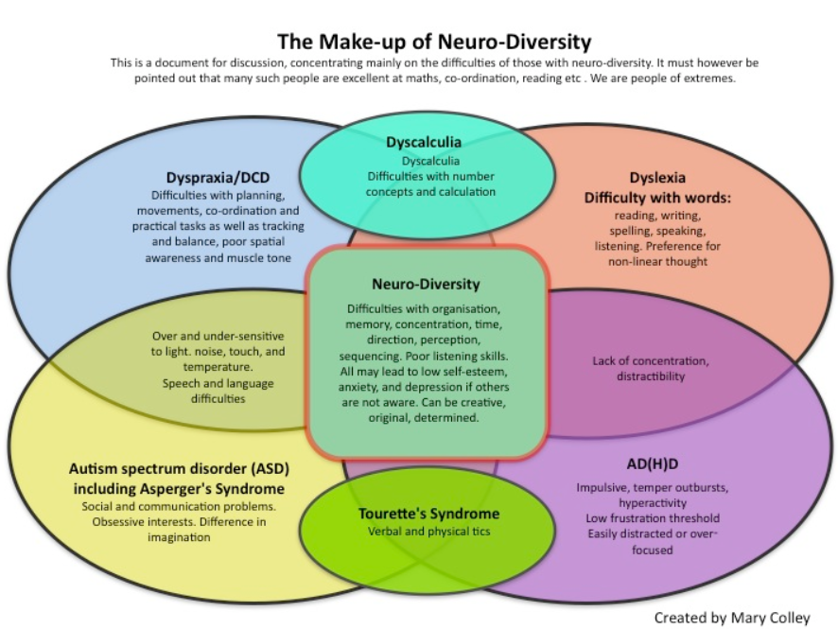
Figure 1 The Make-up of Neuro-Diversity

Mental Health Conditions
As many as 1 in 4 people are suffering with a mental health condition at any one time. Just like physical health conditions some are easily treatable and some are very difficult to manage. They can come and go depending on your life at the time, or they can be with you constantly and require continuous treatment. Not all will affect your cognitive function but many will, and in some cases is the treatment or medication that may cause cognitive function issues rather than the illness itself. Whilst this can make it difficult to remain organised in life it is likely to be an improvement on a serious mental health problem. Illnesses such as bipolar disorder and schizophrenia have a significant negative impact on your life, and if left untreated have strong associations with suicide in the long term. Therefore the inconvenient side effects of medications and treatments are likely to be an improvement in quality of life.
Depression is a mental health illness, and both the illness and sometimes the treatment can affect an individual’s ability to remain organised and in control of their life. Because symptoms of depression often include a lack of interest in self-care, food, and exercise, it is not unusual for the sufferer to have a poor diet, and poor gut and bowel health.
People with bipolar disorders or schizophrenia are known to stop taking their medication despite the advice of medical professionals. A study in 2014 [1] identified the major reasons for this non-compliance with their treatment, and amongst these are:
- alcohol or recreational drug abuse
- dislike of the side effects of medication
The same study indicates that 87% of people having their first episode of schizophrenia will relapse within five years if they cease their medication [1]. Persistent non-compliance with treatment is also seen frequently amongst individuals with bipolar disorders. In the case of those with bipolar disorder the study suggests that this group is more likely to feel they are not really as unwell as they are told and they may even refuse to acknowledge the illness.
This is known as anosognosia and studies have shown that when this impaired awareness of illness is compared with other reasons for medication nonadherence, it is invariably found to be the single most important reason. [2]
Concurrent recreational drug misuse represents the second most significant factor contributing to medication nonadherence among patients diagnosed with major mental illnesses. The existence of this connection has been documented in numerous investigations. It was found that “substance-abusing patients with schizophrenia were 13 times more likely than non-substance-abusing patients to be noncompliant with antipsychotic medication.” [3]
It is therefore important for a health provider to be aware of whether their patient is taking their medication properly, and whether that medication might be the cause of digestive upset or mood swings.

Brain injury and neurodegenerative diseases
Conditions that cause a slow cognitive degeneration, destroying the brain and nervous system. The commonly known ones are dementia, which is a term covering several types of dementia diseases, Parkinsons, epilepsy and motor neuron disease. But there are less common ones such as prion diseases and Creutzfeldt-Jakob disease (CJD).
In the UK there are over 1 million people living with one of these diseases. [4]
Brain injuries are usually permanent and can cause significant cognitive change:
- Inability to process language (aphasia)
- Reduced motivation
- Memory problems
- Reduced concentration span
- Reduced information processing ability
The Trauma Audit and Research Network analysed data collected on patients with brain injuries between April 2014 and June 2015 within England and Wales. 1.4 million patients per year attend hospital following a head injury, of which 15,820 were identified as a traumatic brain injury (TBI). [5]

Temporary Cognitive Impairment
Cognitive impairment can cause problems focusing on tasks, confusion, agitation and occasionally issues with verbal communication and understanding language.
Unlike the permanent impairment caused by brain injury or degenerative disease, this can be temporary and caused by:
- Anxiety and/or depression
- Alcohol and/or recreational drugs
- Concussion
- Serious illness and/or recovery from serious illness
- Reactions to medication
- Chemotherapy
- Infections
- Dehydration
This group needs to be included here as they may have an increased need to monitor their habits and diet, particularly in regards to medications and chemotherapy treatments. These are known to frequently cause digestive problems or a reduced interest in food.

Learning Disabilities and Learning Difficulties
A person with a learning disability experiences generalised intellectual impairment in all facets of their life. An individual with a learning difficulty will struggle harder to pick up a certain skill, like math, reading, or writing.
Learning disabilities, which are always permanent, come in a variety of forms and can be minor, moderate, severe, or profound. There are many reasons that a child may be born with one, and also some conditions and syndromes that are associated with having a learning disability :
- Down Syndrome. All people with downs will also have a learning disability
- Autism. Approximately 40% of people with autism also have a learning disability
- Epilepsy. About 1 in 5 people with a learning disability will also develop epilepsy

The latest figures published by Mencap indicate that there are about 1.5 million people with a learning disability in the UK:
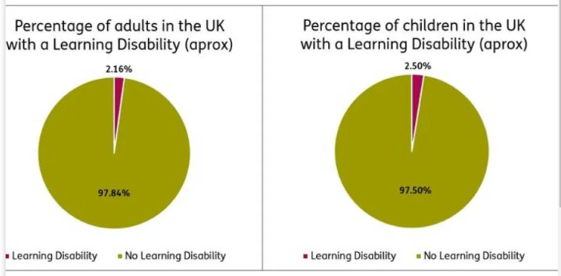
Figure 2 Learning Disabilities in the UK [6]
There are no published figures for the number of people with learning difficulties. This may be because it is such a broad group that it may be difficult to be definitively decide what to include within the classification of a learning difficulty.

Illiteracy and dyslexia
Illiteracy does not necessarily mean the inability to read or write, although with some people their condition may limit their ability to do so. Functional illiteracy is having inadequate skills to manage daily tasks requiring more than the most basic level of literacy. This can be related to developmental issues, neurodivergence, or limited cognitive ability due to brain injury or dementia. People using a language that is not their first language may also be classed as functionally illiterate, depending on their ability in the second language. Ordering dinner in a new language is a lot different to completing a health and food diary.

According to the National Literacy Trust [7]:
- England (assessed in 2012)
1 in 6 (16.4% / 7.1 million people) adults in England have very poor literacy skills.
- Scotland (assessed in 2009)
1 in 4 (26.7% / 931,000 people) adults in Scotland experience challenges due to their lack of literacy skills.
- Wales (assessed in 2010)
1 in 8 (12% / 216,000 people) adults in Wales lack basic literacy skills.
- Northern Ireland (assessed in 2012)
1 in 5 (17.4% / 256,000 people) adults in Northern Ireland have very poor literacy skills.
Comparisons between the countries are not possible since basic literacy skills are defined differently in each.
Dyslexia is a learning difficulty that causes people to have problems with reading and writing, and therefore learning. It's a lifelong problem but the impact can be reduced with allowances and alternatives being available to those with it.
Figures from 2022 indicate that about 10% of the UK population is dyslexic; 4% severely so. [8]

Autism Spectrum Disorders (ASD)
Despite the fact that ASD primarily affects the brain, links to physical health issues have recently been confirmed. Specifically, there appears to be a clear correlation between gastrointestinal (GI) issues and ASD, with GI issues appearing to impact ASD patients more frequently than the general population. One study found that GI symptoms such bloating, constipation, and diarrhoea were six to eight times more common in children with ASD than those without.

It was found that there is a higher probability of gastrointestinal issues in people with ASD, such as:
- Celiac disease
- Inflammation of the colon
- Crohn’s disease
- Gastritis
- Acid reflux
These GI issues can manifest as behavioural issues, and sometimes violence, especially in children that are non-verbal. Researchers also found that pain during bowel movements, constipation, diarrhoea, bloating, belching, and stomach discomfort were associated with increased levels of hyperactivity and irritability. [9]

Down Syndrome
The prevalence of Down syndrome is estimated to be approximately 1 in 800-1000 live births, making it the most prevalent genetic factor contributing to developmental delay.
Down syndrome is a spectrum, from mild to severe. Those with a mild affliction may develop almost in line with their peers, and develop skills that help them to become independent and employable adults. Those with a severe impairment however will struggle with basic skills such as speech, language recognition and reading ability, and in general are unable to develop independence in adulthood.
The extent of cognitive impairment often falls within the mild to moderate range, with fewer than 10% of individuals being classified as seriously developmentally delayed. [10]

Attention deficit hyperactivity disorder (ADHD)
Attention deficit hyperactivity disorder (ADHD) is a neurodevelopmental illness characterised by atypical patterns of behaviour. Individuals diagnosed with Attention-Deficit/Hyperactivity Disorder (ADHD) often exhibit symptoms such as restlessness, difficulties in maintaining focus, and impulsive behaviour.
ADHD is typically diagnosed in children, often when they start school and their behaviour is noted to be different to their peers. The majority of cases are diagnosed during the pre-adolescent period and according to Thomas et al. (2015) [11], ADHD affects 7.2% of children under the age of 18 globally, making it one of the most common childhood diseases today (Barkley, 2015) [12]. Gender variations among children with ADHD are little understood, despite the fact that gender has long been recognised as an important element in ADHD. In general, boys are referred to, diagnosed with, and treated for signs of ADHD more often than girls. Previously, referral bias (Rucklidge, 2008, 2010; Ohan and Visser, 2009) [13] and gender differences in ADHD manifestation were blamed for these findings. Boys are more likely to be noticed as unruly, unfocused and boisterous, whereas as girls tend to be quiet and withdrawn.
A considerable proportion of people, about 65%, who received a diagnosis of ADHD during their formative years persistently encounter challenges associated with the illness throughout their life. They may also exhibit comorbidities, including sleep issues and anxiety disorders.
Medications may ease the symptoms but have side effects that some people cannot tolerate. The benefits of the medication can be temporary, and those diagnosed as adults tend to find that the benefits are limited. The reason for this is still not known, but is assumed to be because the adult has developed coping mechanisms and strategies to help them over the years.
Typical symptoms that can affect the individuals ability to cope effectively with daily tasks can include:
- A short attention span and being easily distracted
- Poor time management (time blindness)
- Being forgetful
- Unable to complete tasks that are tedious or time-consuming
- Frequently changing activity or task due to boredom
- Difficulty organising tasks
- Problems concentrating on tasks
Poor organisation and forgetfulness are major problems for people with ADHD. Many develop ways to cope, such as a digital calendar that they use religiously. They can become hooked on a game, application, even a food, for weeks…and then just forget its existence. This is what can make it difficult for this group of people to consistently keep an accurate lifestyle, health or food diary, simple loss of interest. In order to continue using an app consistently it is likely that it needs to be designed to ask very little of the user.
The ADHD UK organisation, using figures from 2022, believes the best data for the UK is from the Lancet and NICE giving a childhood incidence rate of 5% and an adult incidence rate of 3-4%. That provides for a total estimate of 2.6million people in the UK with ADHD (708,000 children, 1,9m adults) [14]

Physical Impairment
Not a cognitive issue, but one of physical ability or comfort when using an app on a phone or tablet. Whilst those with a physical impairment or disability are not affected with a cognitive disorder, they may struggle with the physicality of handling a mobile device for extended periods of time. An impairment can be temporary, such as an injury, or it can be permanent and related to illness such as:
- Multiple sclerosis
- Parkinson's disease
- Arthritis
All of these can create difficulties for the individual when interacting with a mobile application or device as they impact the flexibility of the hands, and the motor skills required to handle the device. Individuals within this group may still use a mobile device but for reduced periods and with reduced interaction. Applications may need to be simplified for them to benefit from their use, reducing the amount of clicks and swipes in order to minimise the physical stress.

In a survey about mobile phone use amongst people with multiple sclerosis participants highlighted [15] :
- Problems with their vision – 12%
- Hand weakness – 29%
- A small number reported fatigue, numbness of the fingers, and hand tremors
Therefore this group cannot be overlooked when we are looking into creating an app. Not only might their impairment affect their ability to prepare food, but they're also likely to require regular medication, some of which may cause side effects that need to be monitored.

Neurodivergence association with health problems
Research on the relationship between neurodiversity and physical health is limited, but some studies have suggested that individuals with autism and other neurodevelopmental disorders may be at an increased risk for certain physical health conditions. For example, studies have found that individuals with autism may be more likely to have sleep disorders, gastrointestinal issues, and seizures. Individuals with Down Syndrome have a higher incidence of congenital heart defects, respiratory problems, and gastric health issues.
However, it's important to note that the relationship between neurodiversity and physical health is complex and may be influenced by a variety of factors, such as access to healthcare, lifestyle choices, and environmental factors. Additionally, research in this area is still ongoing and the findings are not conclusive, so there are currently no firm statistics regarding the number of the neurodiverse people who have an associated physical illness or syndrome.
Amongst the physical effects of a cognitive difference may be:
- Those with ASD may have a limited diet as they will not eat or drink certain things. It could be the colour, taste, small or texture that bothers them. Some will not eat ‘mixed up’ foods such as stews. A limited diet may, over time, become a nutritional deficiency.
- People with mental health issues may struggle with meal planning, food preparation and cooking, or forget to eat. Sometimes they lose interest in eating.
- Those with ADHD can struggle with organising and planning, and become unable to organise food for the day, relying on snacks and takeaways instead. They often struggle to track time and have poor memory.
- Addicts may be unable recall their day, may prioritise alcohol or drugs over food, or may have a food addiction. A food addict seeks high sugar foods which offer little nutrition, despite the potential of health conditions such as diabetes, heart disease and obesity.
Whilst the exact statistics are not available there is a lot of research indicating that people with learning disabilities or neurodivergence often also have issues around eating, digestion, bowel health and lifestyle choices.
A young child has a parent to feed them, and monitor their bathroom habits and bowel movements. They do not have to make choices or monitor their health and bathroom habits. But as they grow up and start to become independent, how do parents and carers continue to monitor them? Especially as the growing child may have communication problems. Some may be unable to read or write, or have dyslexia.

ASD and ADHD
Ferguson 2019 [16] discovered that gastrointestinal (GI) problems such constipation, nausea, diarrhea, and stomachaches are common in children and adolescents with autism spectrum disorder (ASD), which frequently co-occurs with ADHD. The impact of GI anomalies on the neuropathological and behavioral characteristics of ASD, including symptoms of ADHD, is covered in Hsiao (2014) [17] According to Kedem 2020 [18], compared to young individuals without ADHD, those with ADHD had a greater prevalence of functional GI problems like dyspepsia, persistent constipation, and irritable bowel syndrome. The idea of a "overlap syndrome" between GI illnesses and ASD is put out by Wasilewska (2015) [19], who suggests that the co-occurrence of GI problems with ASD could represent a different clinical endophenotype. In conclusion, these studies show that there is a connection between digestive problems and ADHD, with GI symptoms and diseases being more common in those with ADHD.

Neurodegenerative disease
Sheard 2014 [20] looked into the relationship between poor diet and neurodegenerative disease. It was discovered that 14.1–55.9% and 0–12.6% of individuals with mild Alzheimer’s disease and 17.2–23.5% and 0–40% of individuals with mild to severe Parkinson’s disease, are at risk of malnutrition and malnourishment. He suggests that nutrition intervention is needed for both diseases.

Down Syndrome
Gastrointestinal issues (GI) are more common in those with Down Syndrome than in the general population. In children with Down syndrome, gastrointestinal issues represent about 20% of admissions to hospital.
Approximately 10% of children will present with a form of intestinal abnormality that need surgical intervention for correction. Celiac disease manifests in approximately 15% of children with Down syndrome, necessitating a gluten-free diet.
Down Syndrome brings with it a myriad of physical anomalies, affecting around 10%, that are responsible for this increased level. Although there will be a range of severities most are permanent. Many present as standard ailments such as constipation, acid reflux and diarrhoea. Gall stones are common and will present later in life.
Individuals with Down syndrome may experience constipation due to same factors that contribute to constipation in individuals without Down syndrome – a poor diet and little or no exercise or physical activity. However, individuals with Down syndrome are also susceptible to three disorders that typically do cause frequent and severe constipation [21] :
- Hypothyroidism
- Celiac Disease
- Hirschsprung disease
2% of those with Down syndrome are born with Hirschsprung disease – 100 times more than the general population. Hirschsprung disease occurs when too few nerves are created within the colon during foetal development. It causes all of the usual GI symptoms and in particular very severe constipation. It can be deadly and surgery to remove sections of the affected digestive tract may be required.

Lifestyle trackers
There are so many lifestyle trackers on the market these days that it would seem there is no requirement for another, but are they suitable for use by everyone? Has their development considered the needs of those people who struggle with technology or communication?
Not everyone is comfortable with technology or apps, and not everyone has the ability to use complex apps. Some people may prefer simplicity for personal reasons, as not everyone enjoys using apps or smartphones.
Here we will be looking at whether the currently available lifestyle and/or health trackers are suitable for use by everyone, or just the majority. As software and apps cost a significant amount to develop and release, are the minority being overlooked?. It may be assumed that the limited market is unlikely to return profits on the app development, but if it offers a valuable tool for diagnosis there may be value in it other than money.

Tracking diet and lifestyle habits
Most people would benefit from tracking their diet habits. In order to understand your overall intake and subsequent potential health problems, you first need to understand what your actual consumption is. This needs to encompass everything you consume, including alcohol and drugs [prescribed or recreational]. You need to monitor you digestive and bowel habits as you should ensure you aware of any changes in these. This is particularly important as we age, when changes in your bowel habits may indicate serious illness.
People who are neurodivergent may have a greater need to monitor their lifestyle, particularly those who have a condition that has a known association with digestive or dietary disorders. Doing so allows them and their healthcare professionals to spot patterns, possible allergies, and potential serious illness. It additionally may assist them in being aware of when there may be a need to involve other professionals in order to ensure the individual is getting any extra assistance they may need, in order to attain what may be regarded as a healthier diet and lifestyle.
There are times when it is essential to track your diet, lifestyle and bowel habits, In order to resolve health issues. Anyone presenting to a medical professional with issues around digestion or bowel habits will be required to keep a food tracker. This may be to track just food but most will also include fluid intake and medications. In order to diagnose what may be causing ongoing gastric or bowel problems you need to be able to recognise whether the symptoms can be related to the patients diet or lifestyle.
For those that are neurotypical this probably will not be particularly difficult as there are a myriad of lifestyle trackers available for mobile devices. Anyone that does not use a mobile device, or does not want to use an app, can use a physical diary or notebook.
With this type of medical investigation it is critical for the medical professional to be able to get a clear picture of anything that might be contributing to their patients illness. In the case of gastric or bowel symptoms it is essential to record not just food and drink, but also physical symptoms such as bloating, discomfort, nausea, vomiting and waste elimination. The patient may be required to keep a record of their bowel movements with details such as time, date, colour, size, texture, and potentially the score from the Bristol stool chart.

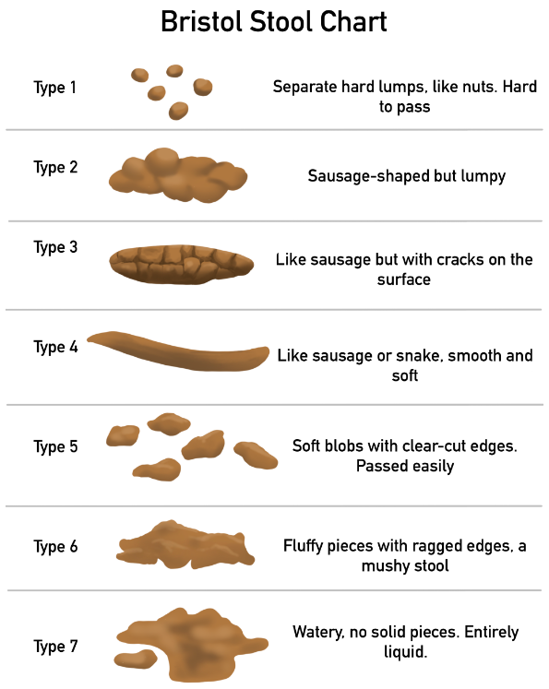

The Bristol Stool Chart is a globally recognised standard used to ‘score’ bowel movements. Your stools are a major indicator of bowel health and can also indicate other health problems. For instance pale stools are strongly associated with gallstones, but not bowel disease.

Figure 3 The Bristol Stool Chart

Potential issues using a tracker
Given what this research has revealed about neurodivergent individuals and the issues they might face when record keeping, would the currently available options accommodate their specialised needs? Could they describe and score a bowel movement accurately?
If they were non-verbal how would they communicate to a carer or medical practitioner how they feel in themselves? If they were also illiterate how can they share the information effectively?
When considering what would be a suitable app to use, individuals who are neurodivergent face challenges that others do not:
- Unable to read or unable to comprehend language
- Struggle to cope with a signing-up process
- Cannot navigate a complex menu
- Forgetting to input data
- Being expected to judge, score or assess, ie. the stool chart score
- Memory issues may cause a user to forget how to use a complex app

Currently available Apps
Here we have several apps that are popular on the android and Apple app stores, and some user feedback about them. These are being reviewed to assess whether they are suitable for neurodivergent people.

MyFitnessPal
Rated as 4.1 out of 5 stars on Google Play, this is one of the most well-known and popular calorie tracking apps currently available. As well as resources and tools to help with weight management, it also has hydration tracking, food diaries and nutritional analysis.
Because it is able to synchronise with a wide range all third party apps and wearables IE a Fitbit or smartwatch it is additionally appealing to anyone on a health and diet overhaul.
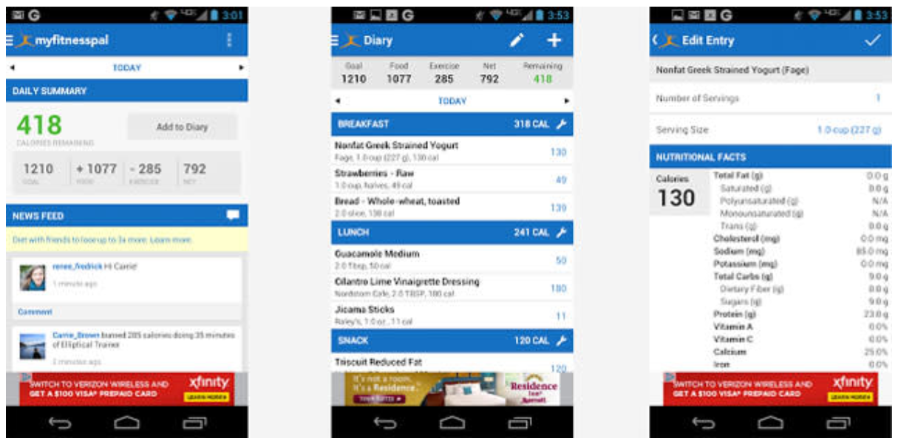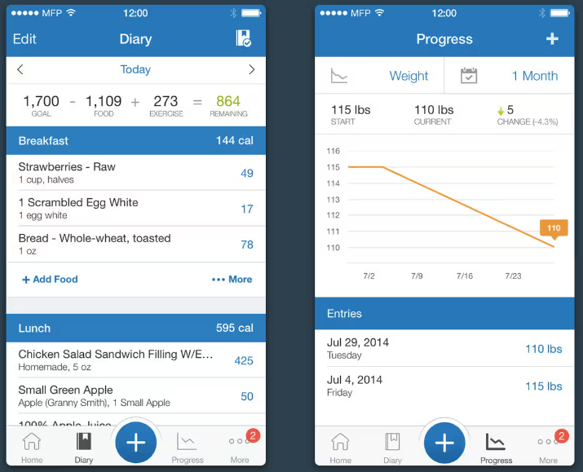
Figure 4 MyFitnessPal [22]

Comments and feedback from users [22]:
- ‘Year after year, I come back on to MyFitnessPal to continue my journey.’
- ‘…the free version sucks. It's cumbersome and slow’
- ‘… takes forever to find a certain food to log in, and sometimes it has the wrong calories/ macros…’
- ‘… app isn't very user friendly.’
- ‘…you can track progress, see nutrients, adjust goals, create/copy meals, enter recipes, and sync w fitbit..’
- ‘…searching for your food…is infinitely harder. I rarely find exactly what im looking for these days…’
The overall user feedback is predominantly positive on Google Play and the above feedback comments were selected as being of interest when considering the app’s ease of use.
In general this app looks to be quite difficult for someone with a cognitive disability or learning difficulty to use:
- It relies entirely on text and users input with details of their food or drink.
- The screens are very ‘busy’ and colourful.
- Choosing a food requires selecting from a list.

Health Infinity
Touting itself as ‘Weight loss tracker, water intake with reminders, calorie counter, activities, exercises & workout tracker, sleep tracker, heart rate monitor, step counter (pedometer), medication reminder and so much more in a single app’ [22] this is rated as 3.8 out of 5 stars.
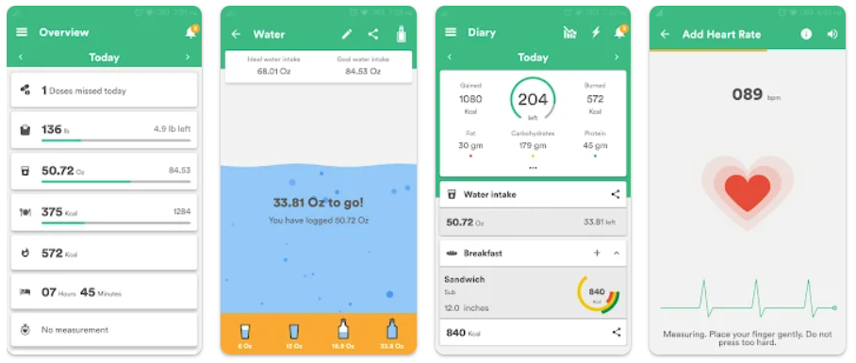
Figure 5 Health Infinity [22]
Comments and feedback from users [22] :
- ‘… Inputting food intake could be easier. It's annoying having to input ingredients in order to track dishes you had during a meal….’
- ‘…Food takes a bit to find. I had to Google some foods. I like it reminding me to drink water….’
- ‘…Some areas are cluttered & the data you get back from searching for meals is cluttered with garbage kcal values for the same foods…’
The common theme amongst the available apps is that they are calorie and exercise trackers. As the focus here is gastric and bowel concerns these offer only part of what we need – recording food and drink. We also need a ‘poop diary’.

Poop Tracker
There are a few of this type of tracker. All rely on the user to be able to assess size, shape and colour, and all require several selections to complete a diary entry.
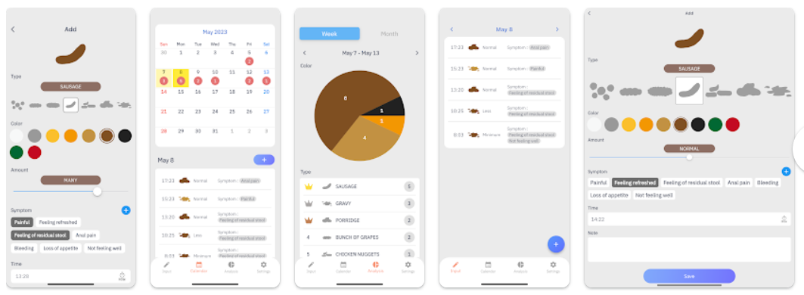
Figure 6 Poop Diary [22]
This app is quite new and there is currently no feedback.

Poop Tracker - Log & Analysis
Rated 4.1 out of 5 on Google Play with one user providing an informative review:
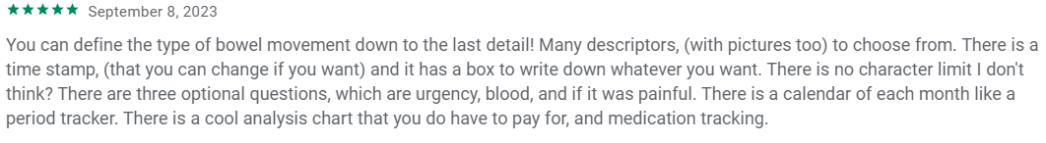
[22]
This looks to be an excellent app, it even includes a medications log, but it does not include food and drink. Like the other available poop diaries it requires the user to manually interact with it a lot.
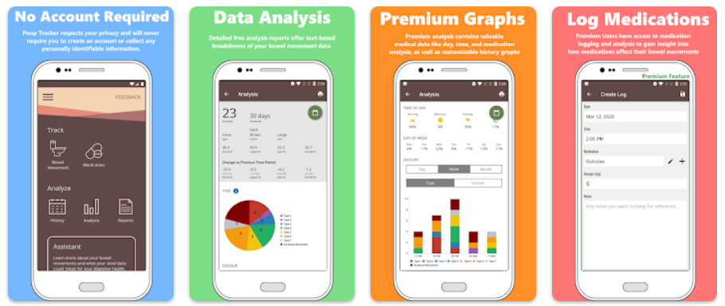
Figure 7 Poop Tracker - Log & Analysis [22]

Conclusion
Currently there is no app available that can track intake and output, and no diet or poop trackers that do not require a lot of screen interaction from the user.

The design process
Several steps took place to arrive at the design that was released as the prototype. There is a design for the appearance of the app, then a design for the database. The app appearance and menus are done first as the database is based on the physical design.
App appearance:
- Understand the task
- Initial design
- Design review
- Secondary design
- Review
- Create design for release

The database:
- Understand how the menus link in order to create the correct keys
- Create suitable variables
- Review how the camera will upload pictures
- Consider where pictures should be stored

Problem Formulation
The challenge is to create an app that collects the data required to be useful as a tracker, and potentially a tool to assist diagnosis, whilst asking as little as possible from the user.

Design
Before designing it, it was essential to understand what people needed it to do, that other apps do not offer.
This was done via conversations with a wide variety of potential users:
- Neurodivergent adults
- Parents of neurodivergent children
- Medical staff specialising in bowel health and also children’s health
Those who are neurodiverse themselves, or have a child that is, wanted:
- Something that was simple to use, needing minimal abilities to use
- Easy to log in, no complex multiple choice logon screens
- Limited buttons – provide only what is absolutely necessary
- Include medication, as many people with these issues also have conditions requiring medication. Medication can also mean self-medication in the form of alcohol and recreational drugs
- Mood – we want to see if mood changes after intake, whether the food may cause feeling unwell
- No reading should be required
- Parent or carer should be able to access the diary in order to review the data

As the researcher works within the NHS they were able to instigate conversations with diet and general health professionals asking for their feedback about the general idea of the app. In addition they were also able to discuss the potential of the application with a child health specialist dietitian. As a result these were the areas that the specialists thought to be important to assist with diagnosis:
- Check whether someone has taken their medication
- Know if someone maybe using alcohol or recreational drugs
- Patients bowel movements
- Mood log, to see whether there is a pattern of moods that may be associated with intake during the preceding hours
- Where patients have a food allergy or a disease such as celiac the medical staff can see from the pictures what their patient is actually consuming, as opposed to what they may be declaring on a written food diary or from memory
These conversations produced a wealth of ideas and suggestions from the professionals, who were keen to have an application that someone with limited ability could use effectively. The application could potentially provide data to assist with the diagnosis of ongoing or intermittent gastrointestinal or bowel problems, where the patients have been unable to keep an accurate diary. They enthused about the initial idea behind the prototype and offered several advanced options but they would find valuable.

Initial sketches and wireframes
The focus was on simplicity:
- Avoid using text
- No ‘busy’ or colourful screens
- Obvious menu buttons
- Minimal menus

Sketches
It started with some rough sketches to show to people and ask their opinion:
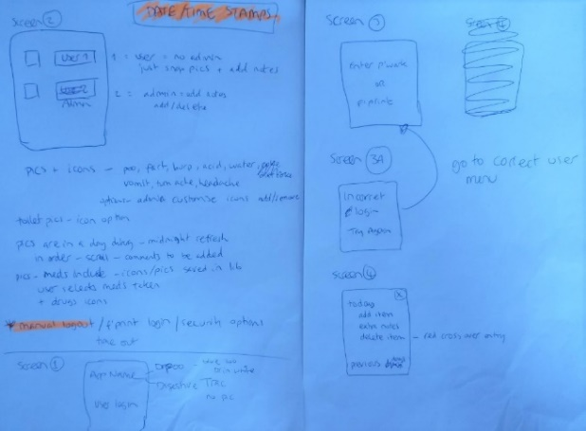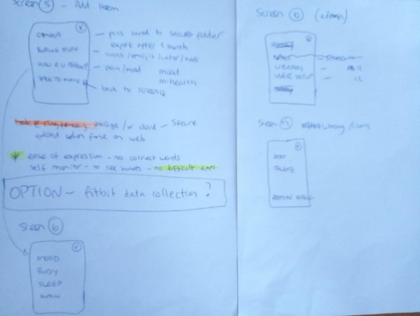
Figure 8 The First Sketch

A more substantial set of images was created, which was the design that became a wireframe:
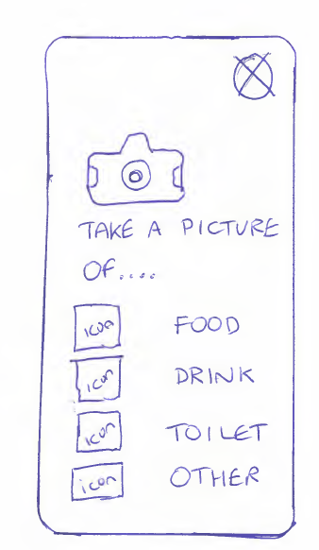
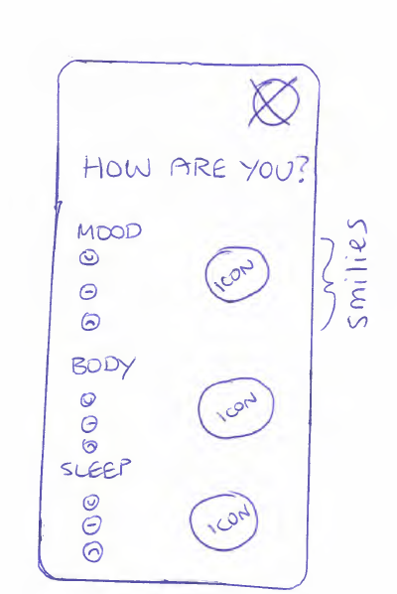
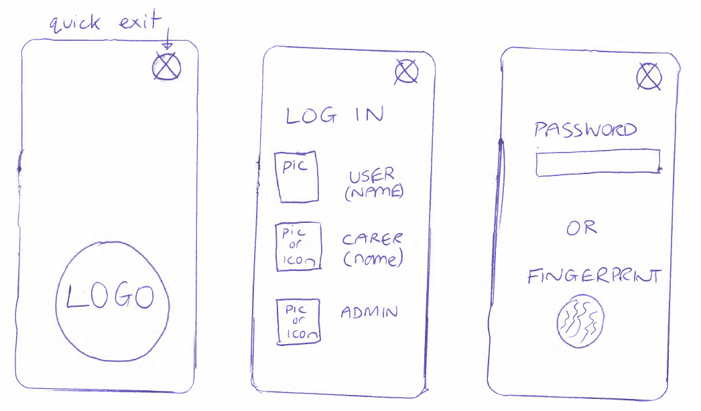
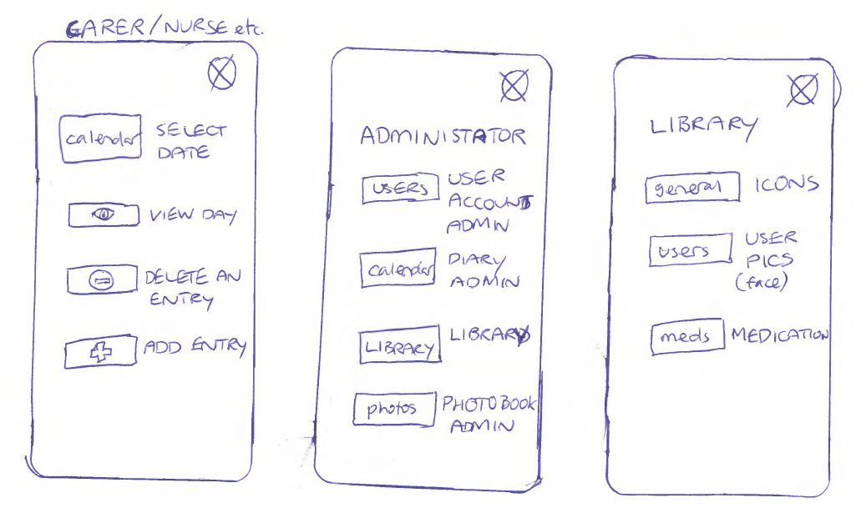
Figure 9 Second Sketches

The Wireframe
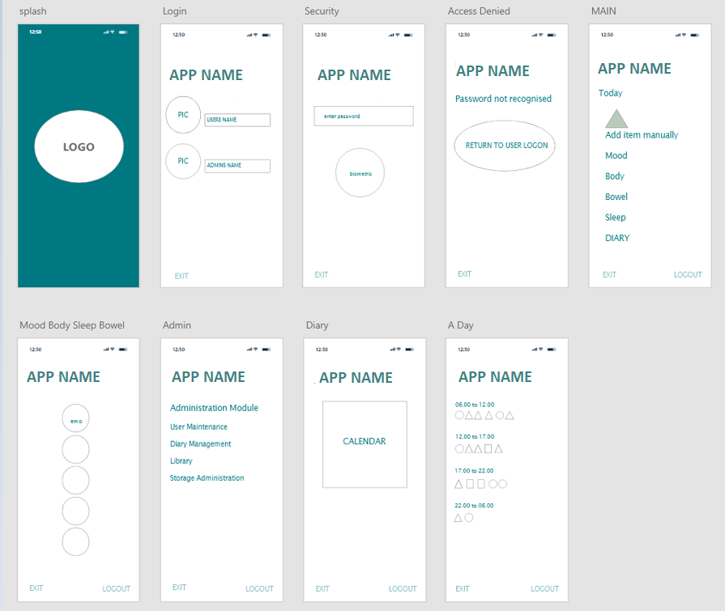
Figure 10 Wireframe Design
The wireframe can also display how the menus link together: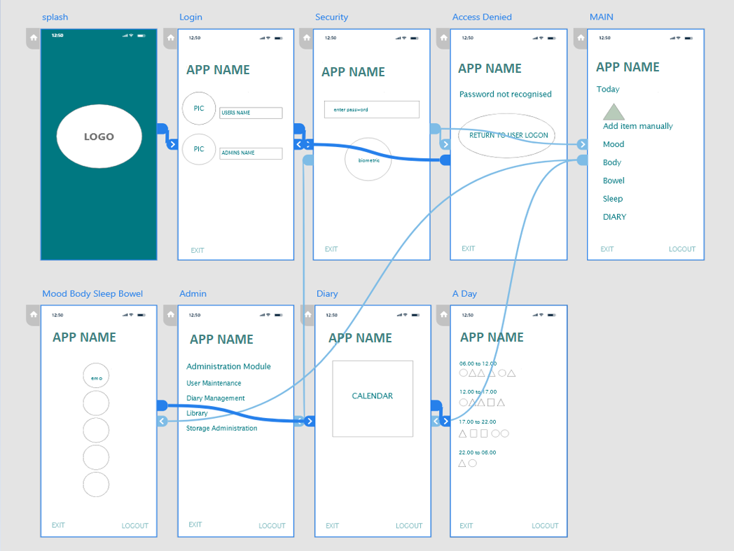
Figure 11 Wireframe - the menu links
The screens are simple and clear, but there was discussion around simplifying further by using icons rather than text, and having the administration tasks separated from the main application. Additionally, the feedback indicated that there was little to gain by breaking the diary into time slots, when a running diary of ‘the most recent first’ type would better serve the purpose of seeing how the users day went.

The Implementation
It was decided that the prototype should be a webapp, rather than a mobile app. Although the app is for use on a phone or tablet, there are several reasons to develop as a webapp initially, as this allows it be a cross-platform application and accessible to all users/testers:
- Mobile applications are designed to be specific to a particular platform, necessitating the development of separate applications for each platform. At this prototype stage we cannot know who will be testing it and what technology they are using, so a more generic approach is required.
- Web applications are capable of functioning across multiple platforms, devices, and system versions. The only systems expected to differ is the testers choice of web browser, and the camera permissions.
- The construction of mobile apps relies on platform-specific technologies, thereby requiring expertise in a specific technology. In contrast webapps can be created using a variety of technologies already familiar to the developer, in this case JavaScript, HTML, PHP and MySQL.

How it was made
The pages for the app were created using HTML for style, and PHP for database interactions. The camera function uses JavaScript and was adapted from code found on GitHub (https://github.com/jhuckaby/webcamjs).

The Database

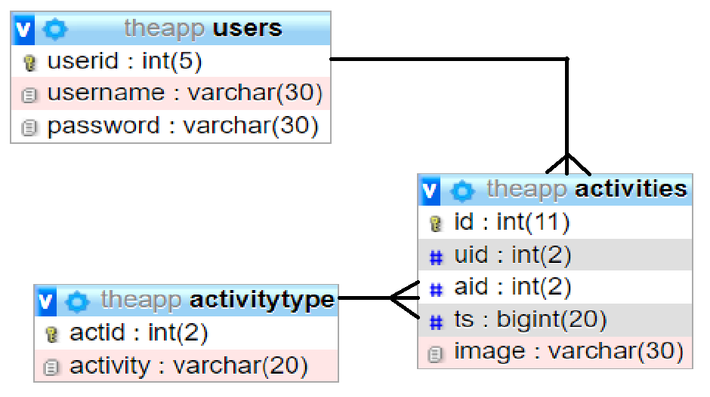
Figure 12 The Database
Composite keys have been used on the activities table to allow an individual user to conduct the same activity at different times on the same day providing that the time is different. The users and activity type table could be considered as lookups for individual users and categorised activities each of which can be identified by a single primary key.
Consideration was made as to whether to make a more complex schema; however, the developer decided that a simpler approach would be more appropriate to a prototype while acknowledging that complexity would increase should the project be taken to full implementation.
In a full implementation the users table would contain full user details, such name and address etc. However the developer wanted to make the prototype as anonymised as possible and as such excluded these details. It is acknowledged that these details would be required in the final solution, as it would be necessary to have fields such as email address in the case that any given user forgot their logon credentials.
It would also be necessary to implement security, allowing users to set their own password which would be encrypted on the database. This is a proof of concept prototype and security has not been implemented.

The Tables
In order simplify the database at this initial stage it was decided not to create separate tables for the different activities. Here you can see the integer ‘aid’, which is ‘activity ID’. Each activity such as eat or drink has an integer associated with it. When the user selects that activity, the activity is added to the database with the appropriate activity ID. By creating it in this way no additional tables are required, but when we view the entries on the report they will display titled with the activity type, which the activity ID has been used to generate.
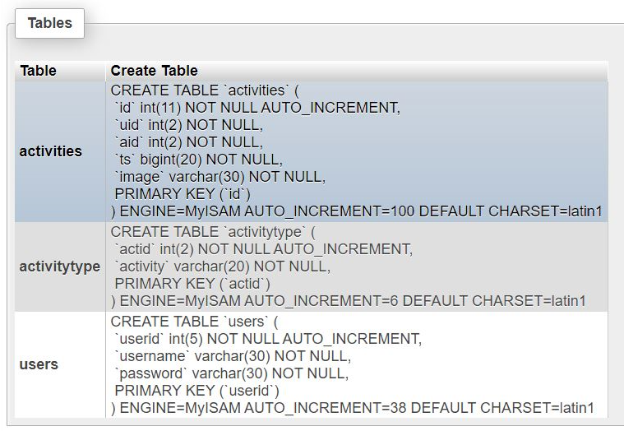
The users are identified by an integer. This auto-increments for ease.
‘image’ is a varchar as it uses a mix of letters and numbers. An image file is created when a picture is taken and the unique name of that is:
$query="INSERT INTO activities(uid,aid,ts,image)VALUES($uid,$sid,$ts,'$filename')"
This query will insert (the image) into the ‘activities’ table. A unique filename is created by using:
- uid = the user ID. Each user has an integer ID
- aid = activity ID. Eat, drink etc. have a set integer as their ID
- ts = timestamp
- image = the photo
By using a timestamp + a user ID we have created a unique identifier. This allows us to use one database to hold all of the users pictures, and keep them separated from each other’s feed.
The report function uses the users session user ID to return with the activities for only that users ID:
$uid=$_SESSION["uid"];
The mood log uses coloured icons to represent how a user feels, and these translate into an integer:
href="uploadmood.php?mid=1"><img src="images/green.jpg”
href="uploadmood.php?mid=2"><img src="images/amber.jpg"
href="uploadmood.php?mid=3"><img src="images/red.jpg"

The Webpages
MySQL is used for the database, PHP and HTML for the web pages, and JavaScript (JS) to utilise the camera.
A walkthrough of using the App:
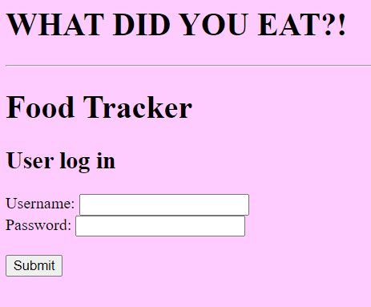

Landing page. Enter your logon.

Your logon is unique to you – no one else can see your data.

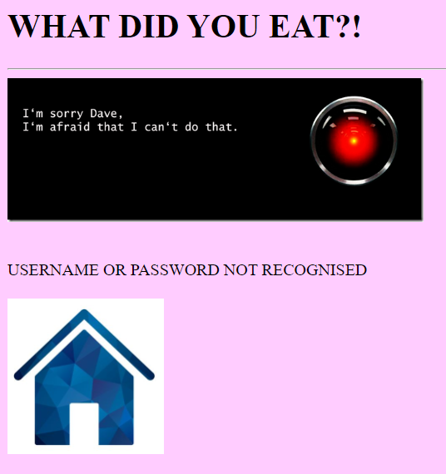

If you get your logon wrong, Hal will tell you off!

The Home icon returns to the logon page.

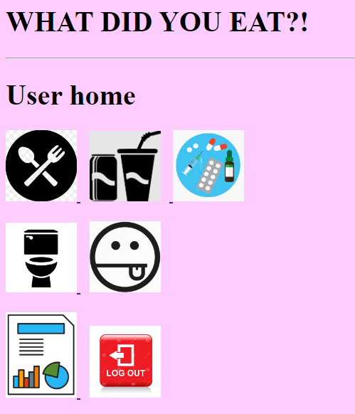

Main page – where users can add to their diary, review diary entries, or logout.

 Food
Drink

 Drugs

Toilet/sickness

Food, drink, drugs and toilet icons lead to the camera.

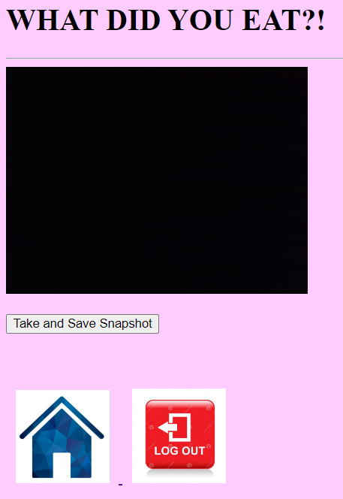

Your camera will take a second or two to respond, then you can take a picture…..

You can also return to the homepage from here, or log out.
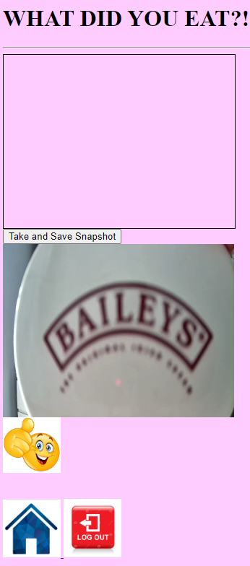

A thumbs up to confirm the photo has uploaded.

Select to return to the homepage or log out.



Mood – how are you feeling?

You can use this for how you feel physically if you prefer – use it to suit what you need.

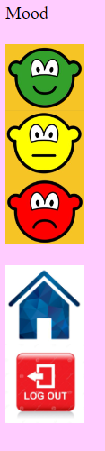

Select one of the faces

OR

Return to homepage

Logout

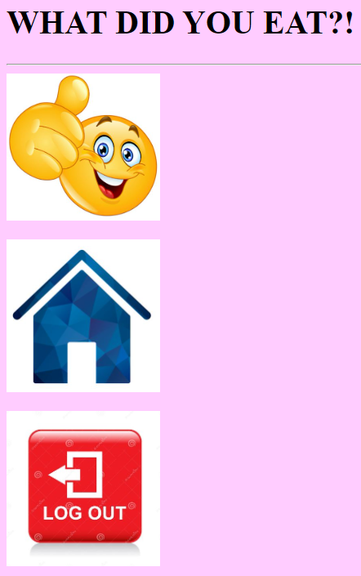

You get a thumbs up to confirm that your choice was logged.

Return to the homepage or log out.

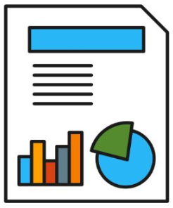

View Report.

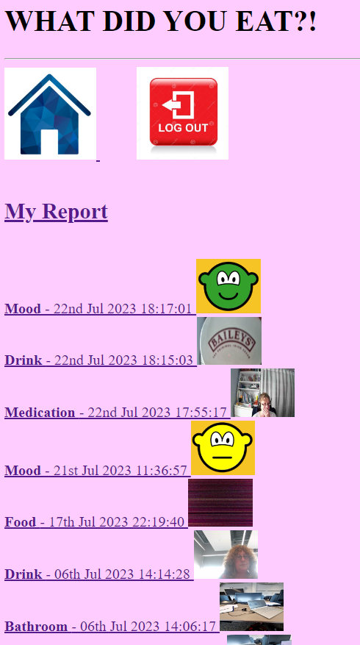

The report runs in order for easy scrolling through.

Interesting Code
This is a basic implementation but there are three pages of interest:
takephoto.php this is the JavaScript that takes the photo:
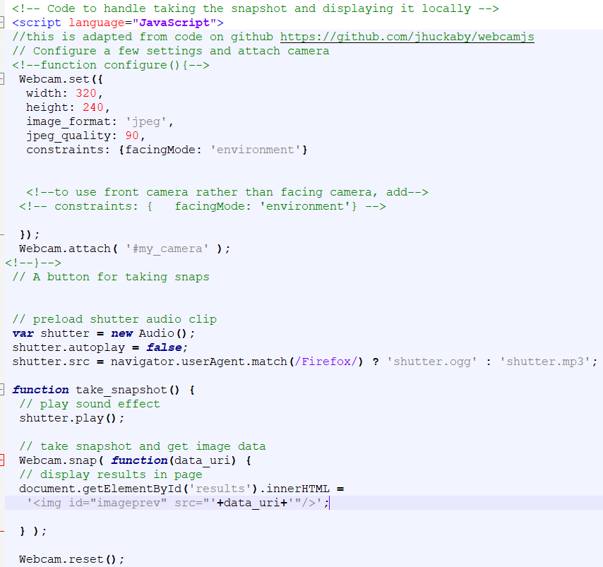
Upload2.php collects the photo and inserts it into the database:
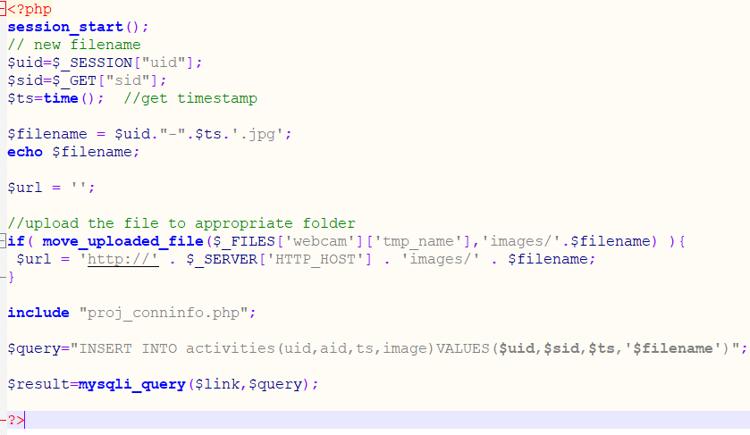
Proj_conninfo.php:
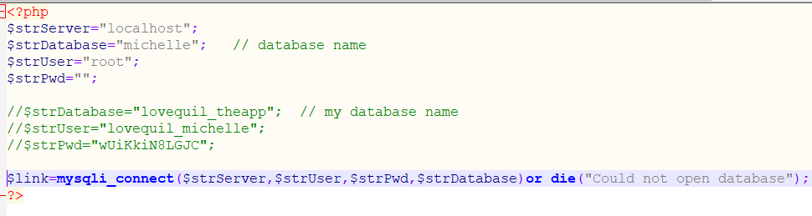
This is configured for running locally and uses the local database details. In order to use the live version the commented out text needs to be active, not the local database parameters.

Research Methodology
Saunders, Lewis, and Thornhill introduced the research onion model in their publication entitled "Research Methods for Business Students." The objective of this model is to highlight the various phases involved in the process of writing a dissertation, with the intention of assisting students in developing a more structured technique. The Research Onion model depicted below is a visual representation of the various components within the research process, highlighting the potential avenues for research.
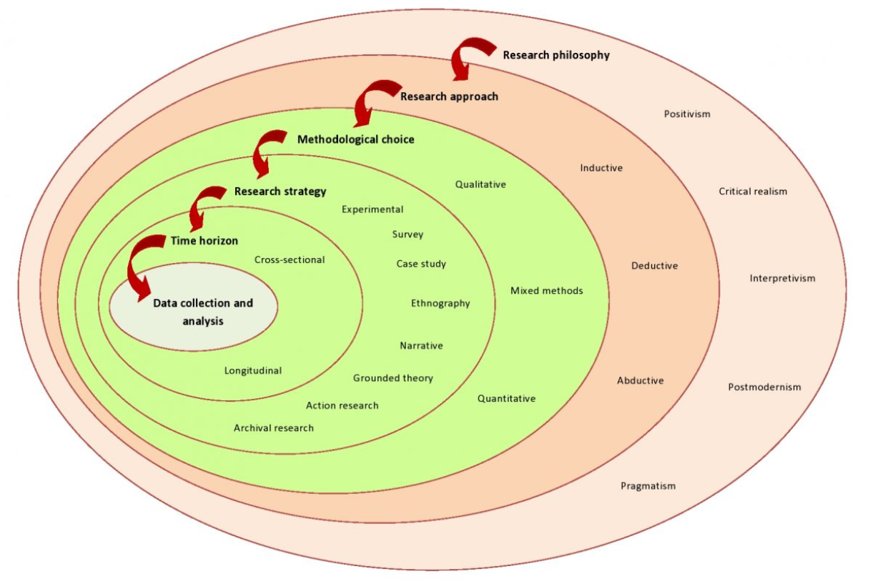
Figure 13 The Research Onion [23]

The research in this paper uses quantitative and qualitive data, with positivism philosophy:
- Research Philosophy : Positivism
Use of information that is unbiased.
- Approach : Qualitive and quantitative
Interviews and surveys.
- Strategies
Case Study, surveys and interviews.
- Method : Hybrid
Using qualitative and deductive thinking.
- Procedures and Techniques
Examining the data collected to clarify or negate the facts as initially assumed.

Development Methodology
This plan was to initially create a webapp for usability testing, rather than move straight into developing any mobile apps. Because this is a new concept, and aimed at a small group of users, it was important to gauge the potential for developing further.
For the initial development methodology the waterfall model is ideally suited and has been used. This takes a linear, sequential approach and because each stage of the development process flows into the next like a cascading waterfall, it is known as a "waterfall."
The following steps make up the conventional waterfall model:
- Gathering and analysing needs:
The requirements for the project are acquired from stakeholders during this phase of the waterfall model, and they are then examined to make sure they are precise, attainable, and unambiguous.
- Design:
During this stage, a thorough project plan is prepared together with the system architecture and design.
- Implementation:
After the design is finished, the software's real coding and development get started. This step of the waterfall model takes the longest and entails turning the design into a functional system.
- Testing:
During this stage, the programme is rigorously tested to make sure it satisfies the specifications and is error-free.
- Deployment to the production environment, where it is made accessible to end users, is the last stage of the waterfall paradigm.
- Software maintenance, which includes bug patching and change in accordance with new needs, is a continuing step.
The Waterfall model's ease of use and comprehension is one of its key advantages. It is simple to monitor progress and spot issues early on because each phase of the process has clear deliverables and a review mechanism. The initial webapp is a simple development, depending on nothing external, and fits very well into this model as it has clear steps that must be completed before the next can begin.

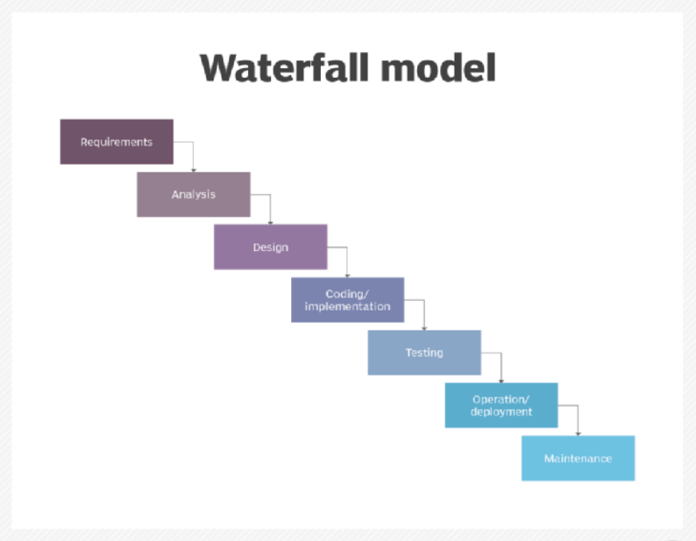
Figure 14 Waterfall Development Model [24]
One drawback of the waterfall model is that it does not allow for much iteration as it is assumed that all criteria will be known in advance. It can therefore be difficult and costly to make changes once the project has reached the final deployment.
Should this project have moved beyond the webapp, and development started on a mobile app, a more suitable development method would use the Incremental Model. This model involves developing the product in iterations, or versions, which would be ideal for developing this webapp into an android then and apple app.

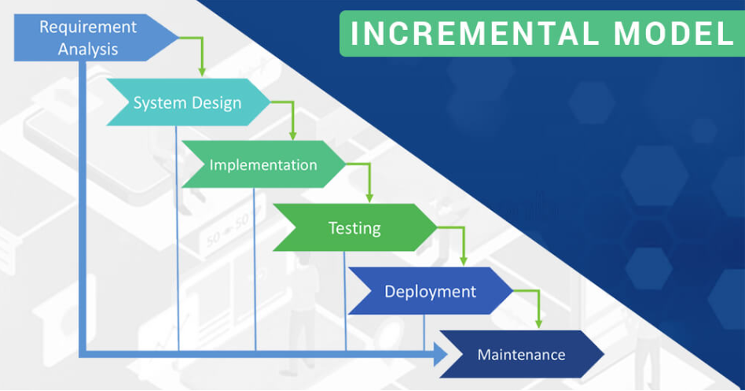
Figure 15 Incremental Development Model [25]

Gantt chart
The initial project plan, as presented in the Viva, with the completed tasks displayed in grey:
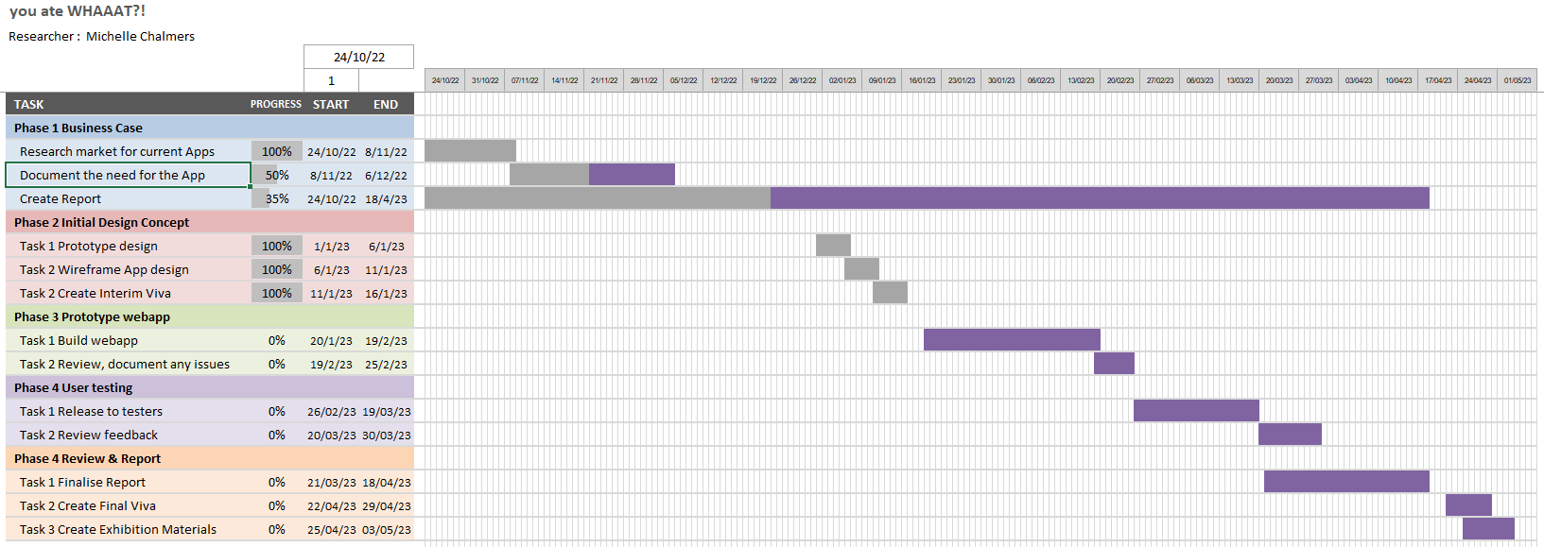
Figure 16 Original Gantt Chart

Unfortunately due to other projects and commitments taking priority this had to be amended:
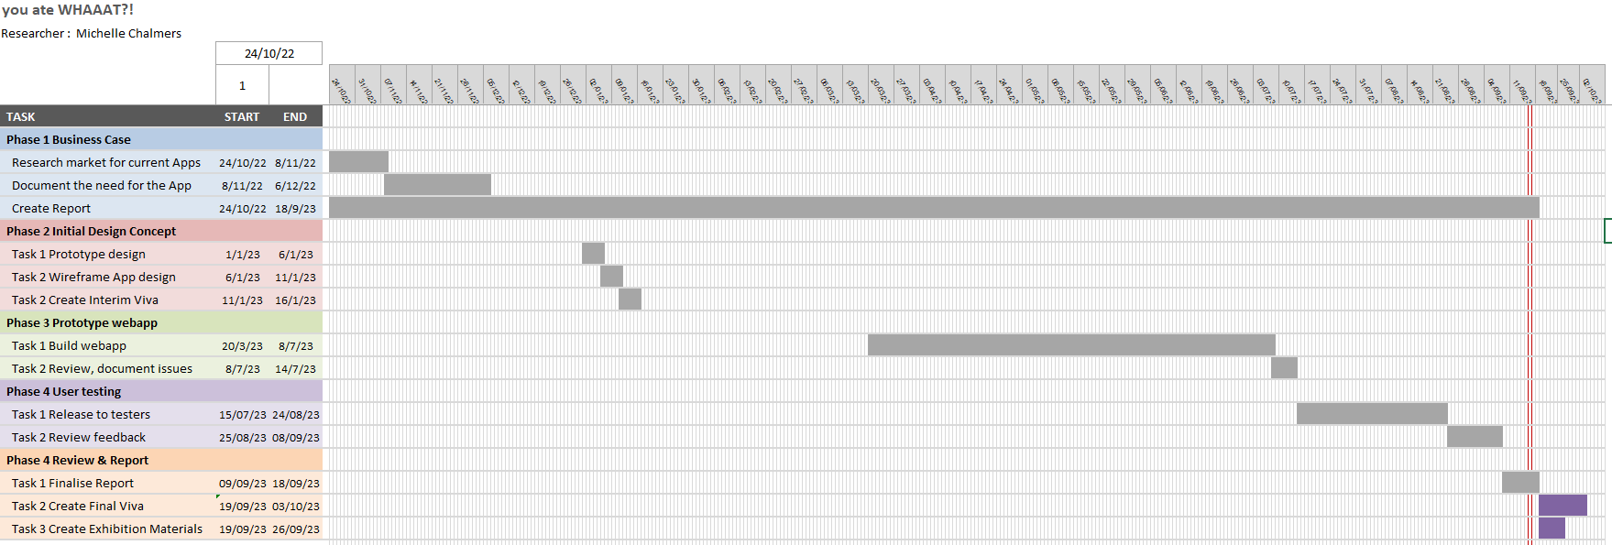
Figure 17 Revised Gantt Chart
As this covers an extensive time period, during some of which there was little or no activity, the above chart can be difficult to read and understand.
Therefore the periods where little activity occurred have been condensed and the amended Gantt chart below produced. This chart has had some weeks hidden, but the dates remain unchanged.
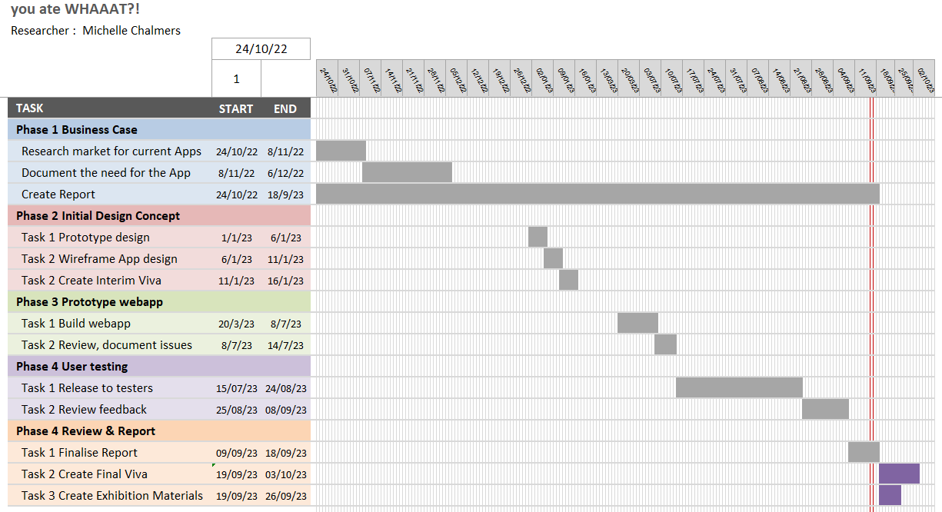
Figure 18 Condensed Gantt Chart

Evaluation
The objectives were met as a prototype application was created, tested and the project evaluated.
An understanding of the challenges faced by this group has been formulated, and whether they may have a greater need to monitor their diet than anyone else has been confirmed through research.

Evaluation Survey
Several testers had a problem with the camera functionality. Those that contacted me were advised to switch to a different browser and check their camera settings. Everyone that made contact were able to get the camera working successfully.
1. How much do you agree with the following statements?
Extremely disagree Somewhat disagree
Neutral
Somewhat agree
Strongly agree
%
100
%
0
100
%
I feel the app worked well
I like the general look and feel of it
I think it's a good idea/concept
I like the simplicity and lack of text
I found the reporting page useful
I found the limited text was easy to read
I think the clickable options were obvious
I believe it has potential for use if fully developed
I think it would suit people with special needs
I found the icons confusing
- Was there anything you particularly liked or found useful?
I liked the reporting functionality, but this could have been enhanced by allowing different views or searchable elements. The interface was user friendly and intuitive. as a prototype this system shows great potential
I thought it was pretty self-explanatory
I like the idea.
Easy to upload pictures
Picture capabilities
Mostly my inability to remember to use it, however I feel that like any other app, there must be an acclimatisation period, and that this should be taken into account by the user.
it was quick and easy to keep track
it was good that i didn’t have to go to lots of menus

- What OS are you using?
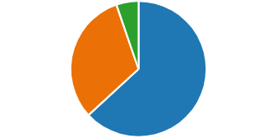
Android
12
iOS
6
Microsoft
1

- Did the camera function work without having to use a different browser?
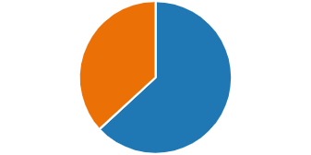
Yes
12
No
7
- Did you have to use an alternative browser to your usual for the app to work?
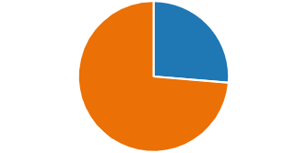
Yes
5
No
14
- What browser did you use for running the app successfully?
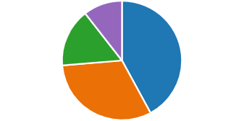
Chrome
8
Edge
6
Safari
3
Firefox
0
Other
2

- What problems or bugs did you experience, if any?
all worked well with the exception of the camera error under andriod chrome the inbuilt mobile browser mitigated this and the app worked fine via the laptop running windows
It wouldn't let me enter a written report of what I'd eaten it kept taking me back to log in
I am afraid that I couldn't get the camera to work at all. Just a black square.
Not always clear what to do eg it says "What did you eat" at the top, but there are other things which can be uploaded too, so that was a little confusing
Every now and again the page would need to be refreshed for the camera to work.
camera function was glitchy

8. If the app was fully developed, how likely is it that you would recommend it?
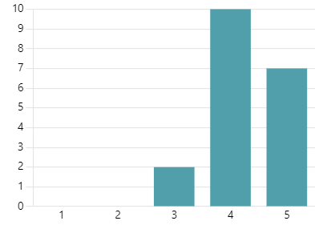
4.26
Average Rating

- This version is very simple by design. If it was to be expanded, what would be the 3 things you would choose?
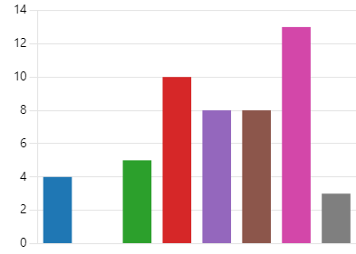
Steps walked
4
Blood sugar
0
Hours slept
5
Customisable icons
10
Choice of colour scemes
8
Gamification
8
Searchable diary
13
None
3
- Is there anything you think should be added, that isn't listed above?
better security
User could input their own targets and then compare these to actual activities in a full version
More instructions to link to camera, it needs to just activate and press to take the pic.
Some improvements to design - although I'm probably not the intended target audience!
Make the camera view much bigger. Perhaps customisable link to alarm so that users are reminded on wakeup in morning ( I find using it on wakeup means i am more likely to remember to use it for the rest of the day )
a quick camera button. so you dont need to open app, yuo can just click a button to take a pic.
could it integrate with a steps app?
- Do you have any chronic health conditions or disabilities?
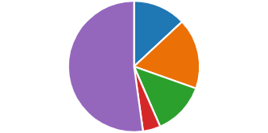
Physical health problem and/or
…
3
Mental health problems and/or
…
4
Learning or developmental disa
…
3
Prefer not to say
1
None
12
- What age group are you in?
16-30 31-40 41-55 Over 55 Prefer not to say
100% 0% 100%

Conclusions
Scoring 4.26 out of 5 on the question ‘If the app was fully developed, how likely is it that you would recommend it?’ there appears to be potential for further development.
Of the comments received it is clear that not everyone read the instructions I sent (attached in the appendix). If they couldn’t work out how the app worked it does suggest that the app may need to be further simplified, as the intention is for it to be very simple. The individuals this is aimed at almost certainly would not read instructions.
The research supports the need for a suitable app as this group is not catered for at present in this area of health monitoring.
The researcher concludes that the prototype confirms validity of the need for the app.

Further development
During initial discussions several ideas were put forward that were not suitable for a prototype but it was felt should be offered if the app goes forward.

Users and carers
A ‘view only’ version, where a carer or parent could actively monitor the daily progress.
Colour change options. This was considered in the early stages of development as some people struggle with certain colour schemes. This is usually due to dyslexia or colour blindness.
Unfortunately no simple way to offer this was found. Potentially the app could be coded with different colour schemes such as bright, greyscale, subdued etc., but no matter how many options are offered, it is unlikely that it would suit all users. Therefore a better solution would be to provide a link to download TintVision, a free app that provides the ability to apply a colour overlay and use a draggable underliner tool. It is designed for those with dyslexia and other visual impairments.

Medical professionals
Of particular interest was the ability to send a text or voice message via the app in order to remind the patient of any appointments, upcoming tests, or tips and words of support or advice. For instance they may be required to prepare for certain tests by drastically changing their diet, fasting, taking additional medications, or completing a ‘bowel preparation’ routine (a severe cleansing of the bowel prior to surgery or camera examinations). Currently the only way to communicate these reminders to patients is a phone call. Unfortunately due to pressures and workload within the NHS this is not a practical solution, and staff have confirmed that they cannot do this as standard. At present medical professionals need to trust that the patient can either cope with new routines or have a carer who can assist them.

Value of Further Development

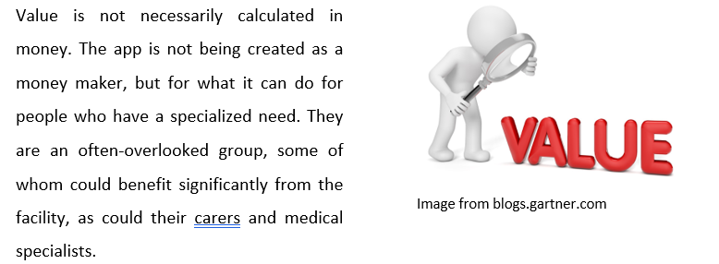

“Money as the sole ambition has no value.”
― Habeeb Akande

With the app being aimed at a small target audience it has to be considered whether there is adequate value in completing it. However, given the value that it could have to an individual it is a valid product for the general market.
In addition, it has potential for developing further to enable it’s use in healthcare. This would be a significantly more complex development as data storage, security, GDPR and maintenance would need to be considered.

Reflection
When the idea first occurred for this type of application the extent of its potential value was unknown. It has been a surprise, even to the developer who initially suggested the possibility that this application was needed, to discover how much it could offer if fully developed.
It can be assumed that unless you, or someone you know, falls into the neurodivergent category, that you are unaware of the challenges experienced by this broad ranging group. Until researching neurodiversity, and the potential physical and psychological problems that may be experienced, it was thought that this application might offer a small group of people some additional assistance. Having researched the impact that neurodiversity has on the individuals it has become apparent that the application could have notable value to those impacted in person by illness, their carers, and their supporting medical professionals.
It is disappointing that the author was not able to complete further development, with a view to possibly releasing an improved version for testing by a large group of the individuals that the application is designed for.
This assignment had the potential to produce a test version of an application that could benefit many people. Sadly, due to time blindness, as the author themselves has ADHD, inadequate time was spent at the beginning of the assignment to develop the prototype for release. So whilst there is feedback to review, we do not have a full test version ready for release to a large group.
Because this is an area that has had little research it has been difficult to find a substantial amount of verified data within research papers and publications. Therefore statistics and evidence has frequently been extracted from the official websites for the conditions. These provide extensive information and are often involved with research, and therefore are the most likely source of accurate data at present.

References

[1] | www.treatmentadvocacycenter.org, “Treatment Advocacy Center,” March 2014. [Online]. Available: https://www.treatmentadvocacycenter.org/storage/documents/why%20do%20some%20individuals%20with%20serious%20mental%20illness%20refuse%20to%20take%20medication%20final.pdf. [Accessed 11 September 2023].
[2] | A. M. O. R. e. a. Faruqui RA, “Clinical correlates of adherence to antipsychotic treatment in pre-discharge patients with schizophrenia,” 2003.
[3] | R. L. R. D. e. a. Kashner TM, “Family characteristics, substance abuse, and hospitalization patterns of patients with schizophrenia.,” Hospital & Community Psychiatry, vol. 42, no. 2, pp. 195-197, 1991.
[4] | “MRC Clinical Trials Unit,” MRC Clinical Trials Unit, 08 February 2022. [Online]. Available: https://www.mrcctu.ucl.ac.uk/our-research/neurodegenerative-diseases/. [Accessed 13 June 2023].
[5] | A. H. O. B. M. W. F. L. a. P. J. H. T Lawrence, “Traumatic brain injury in England and Wales: prospective audit of epidemiology, complications and standardised mortality,” BMJ Open, vol. 6, no. 11, 24 November 2016.
[6] | “mencap,” Post 2020. [Online]. Available: https://www.mencap.org.uk/learning-disability-explained/research-and-statistics/how-common-learning-disability. [Accessed 11 August 2023].
[7] | “National Literacy Trust,” Unknown. [Online]. Available: https://literacytrust.org.uk/parents-and-families/adult-literacy/. [Accessed 24 May 2023].
[8] | “The British Dyslexia Association (BDA),” Unknown. [Online]. Available: https://www.supportincornwall.org.uk/kb5/cornwall/directory/service.page?id=ojBwETPjWUs#:~:text=Ten%20percent%20(10%25)%20of,dyslexic%3B%204%25%20severely%20so. [Accessed 24 May 2023].
[9] | “Family Medicine Austin,” 01 September 2022. [Online]. Available: https://familymedicineaustin.com/autism-spectrum-disorder-and-gastrointestinal-issues/#:~:text=In%20comparison%20to%20the%20general,gastrointestinal%20problems%20than%20neurotypical%20individuals. [Accessed 10 July 2023].
[10] | “MN Department of Health,” 24 March 2023. [Online]. Available: https://www.health.state.mn.us/diseases/cy/downsyndrome.html#:~:text=Common%20Associated%20Conditions,that%20exceed%20their%20cognitive%20skills.. [Accessed 15 June 2023].
[11] | C. S. S. C. H. A. H. L. Maja Dobrosavljevic, “Prevalence of attention-deficit/hyperactivity disorder in older adults: A systematic review and meta-analysis,” Neuroscience & Biobehavioral Reviews, vol. 118, pp. 282-289, 2020.
[12] | R. B. Kevin M. Antshel, “Chapter 3 - Attention deficit hyperactivity disorder,” in Handbook of Clinical Neurology Volume 174, Elsevier, 2020, pp. 37-45.
[13] | O. S. a. M. Davidovitch, “Gender Differences in Objective and Subjective Measures of ADHD Among Clinic-Referred Children,” Frontiers in Human Neuroscience, vol. 13, 2019.
[14] | “ADHD UK,” Unknown. [Online]. Available: https://adhduk.co.uk/adhd-incidence/. [Accessed 7 August 2023].
[15] | B. M. P. a. D. R. B. B. P. e. a. Kirsten Van Kessel, “Mobile Technology Use by People Experiencing Multiple Sclerosis Fatigue: Survey Methodology,” JMIR Mhealth Uhealth , vol. 5, no. 2, 2017.
[16] | K. D. ,. N. T. ,. D. Q. B. Bradley J Ferguson, “The Relationship Among Gastrointestinal Symptoms, Problem Behaviors, and Internalizing Symptoms in Children and Adolescents With Autism Spectrum Disorder,” Front Psychiatry, 2019.
[17] | E. Y. P. Hsiao, “Gastrointestinal Issues in Autism Spectrum Disorder,” Harvard Review of Psychiatry, vol. 22, no. 2, pp. 104-111, 2014.
[18] | S. S. Y.-K. D. C. Z. L. R. K. A. D. S. D. a. L. H. K. Kedem, “Attention deficit hyperactivity disorder and gastrointestinal morbidity in a large cohort of young adults,” World Journal of Gastroenterology, vol. 26, pp. 6626-6637, 2020.
[19] | M. K. J. Wasilewska, “Gastrointestinal symptoms and autism spectrum disorder: links and risks – a possible new overlap syndrome,” Pediatric Health, Medicine and Therapeutics, vol. 6, pp. 153-166, 2015.
[20] | J. M. Sheard, “Malnutrition and Neurodegenerative Diseases,” Neurological Disease and Cognitive Function (G Logroscino, Section Editor), 2014.
[21] | “National Down Syndrome Society,” Unknown. [Online]. Available: https://ndss.org/resources/gastrointestinal-tract-syndrome. [Accessed 05 July 2023].
[22] | “Google Play,” [Online]. Available: https://play.google.com/store/apps/details?id=com.myfitnesspal.android&hl=en&gl=US.
[23] | P. L. a. A. T. Mark Saunders, Mark Saunders, Philip Lewis and Adrian Thornhill 2007, 2007.
[24] | B. Lutkevich, “TechTarget,” November 2022. [Online]. Available: https://www.techtarget.com/searchsoftwarequality/definition/waterfall-model?ad=semD&an=msn_s&am=broad&q=Waterfall+Methodology&o=28799&qsrc=999&l=sem&askid=d5e8db54-bd21-47f1-a05c-ebac549d6ad0-0-ab_msb. [Accessed 09 July 2023].
[25] | A. Shergil, “TopDevelopers,” 8 Augusy 2023. [Online]. Available: https://www.topdevelopers.co/blog/top-software-development-process-models/. [Accessed 10 July 2023].
[26] | [Online]. Available: https://www.techtarget.com/searchsoftwarequality/definition/waterfall-model?ad=semD&an=msn_s&am=broad&q=Waterfall+Methodology&o=28799&qsrc=999&l=sem&askid=d5e8db54-bd21-47f1-a05c-ebac549d6ad0-0-ab_msb. [Accessed 10 Jan 2023].

Appendices

Data Dictionary
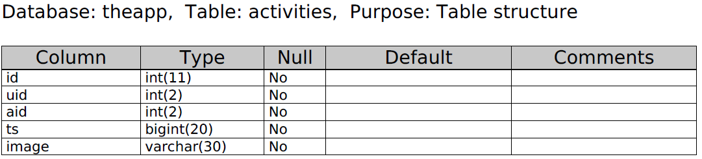
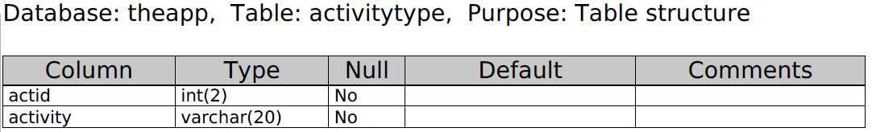

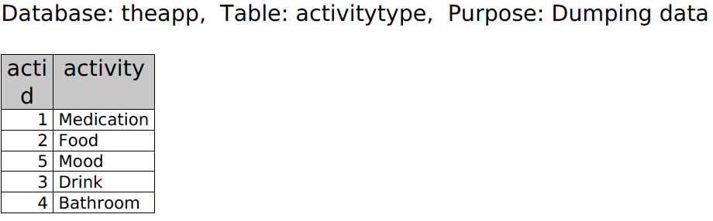
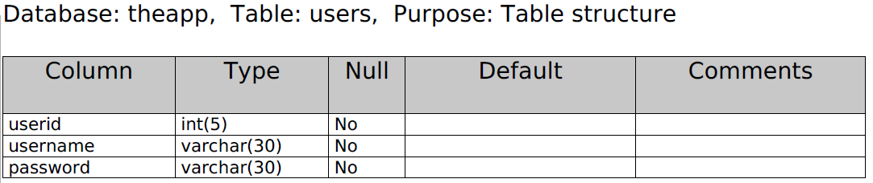
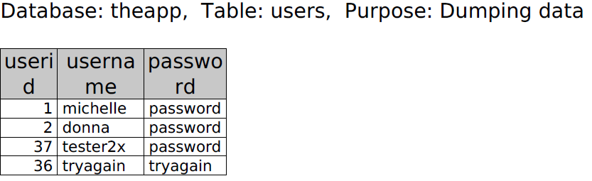

Using the APP - instructions
These were sent to all those that did testing.
This is designed for android and hasn’t been tested on Apple. The camera may not function properly on Apple.
Thank you for agreeing to help me in testing this app I really appreciate your help with the testing and the feedback afterwards. This is my last assignment in order to graduate.
INVESTIGATION AND IMPLEMENTATION OF A HEALTH APP SUITABLE FOR NEURODIVERGENT INDIVIDUALS
App name is currently undecided. For now I am using What Did You Eat?!
It looks childish and a bit telly-tubby, and this is intentional as it is primarily aimed at kids. There is no typing. You don’t even need to read – just use the icons to do what you need to.
It creates a photo diary of your day. Every time you eat, drink, smoke, take medication, use drugs, vomit, use the toilet etc. – take a picture.
If you are feeling really upbeat or really rotten, select a mood.
The pictures stay in the order you took them. So you can see if there are patterns, such as always feeling low after a Coke, or vomiting after certain meds.
The initial idea was to create a health diary for people who cannot use a standard app, which was primarily children with cognitive or learning disabilities. To allow their parents and caregivers to monitor their habits without invading their independence.
It is also suitable for people who are neurodivergent, disorganised, busy, or just wanting a very simple solution to tracking their intake/output. Yes I know the toilet part is an unpleasant subject, but if you are having health/gut issues and struggle to keep an accurate diary, or communicate effectively, this is the solution.
Because the app runs on a browser it is also accessible on any device. Child could use the app, and parent can check the uploads.
There is a lot of scope for expansion, and I will ask about that in the feedback form.

You will find it at:
https://www.lovequiltsuk.com/michelle/proj_land_page.php
I will send you an anonymous logon. I will know it but will not access it unless you have a query and want me to check your diary. I am not interested in your actual habits

Landing page. Enter your logon.

Your logon is unique to you – no one else can see your data.

If you get your logon wrong, Hal will tell you off!

Click the Home icon to return to the logon page.

Main page – where you can add to your diary, review your diary entries, or logout.

Food
Drink
DrugsToilet/sickness

Food, drink, drugs and toilet icons lead to the camera.

Your camera will take a second or two to respond, then you can take a picture…..

You can also return to the homepage from here, or log out.

There it is…your picture! A thumbs up to confirm it has uploaded.

Select to return to the homepage or log out.

Mood – how are you feeling?

You can use this for how you feel physically if you prefer – use it to suit what you need.

Select one of the faces

OR

Return to homepage

Logout

You get a thumbs up to confirm that your choice was logged.

Return to the homepage or log out.

View Report.
This icon apparently doesn’t look like a report. But it is. But yes, I will find something better if I can.

Your report runs in order for scrolling through. As you can see here my pictures are just whatever I snapped with the camera. Yours can be too – I will not be reviewing the data, just asking for feedback

