Title Of The Report | A critical review on business structure and business model changes in the UK retail (Clothing) sector.
Module Name | Visions For the Future :Theoretical Perspective On Management
Tutor Name | Dr. John Lang
Module Code | LCDB7006
Student Number | 1812015
Submission Deadline | 13-05-2019

Executive summary
Through technological development and innovation business model and the structure of the business is changing rapidly. Business model innovation is about delivering existing products that are produced by existing technologies to existing market. The UK clothing sector is believed to be one of the most sophisticated e-commerce market and technologically advanced. E-commerce through technology has reshaped the structure of current business platform. Moreover, companies structural and model change not only happen through the internal managerial change but also through technological advancement, market competition and changes of consumer demands. Mainstream blockchain apps, machine learning for customer service, more al- enabled platforms for automated work, new security measures are some of the key innovation has great significance on business model change. Furthermore, there are 11455 clothing retail store in the UK an increase of 363 store in the previous year and the number is predicted it increase rapidly in near future. . The current trend of the customers towards online shopping hence company is changing their business model accordingly. Undoubtedly, as time goes, digitalisation helped specially clothing retailer a newer way to engage and reach with the customers. Statistics suggests United Kingdom is the third largest e-commerce market in the world. Forecast also suggests until 2013 e-commerce fashion revenue in the UK is expected to grow to 31.5 billion U.S dollar.

Table of Contents
Executive summary 2
Introduction 4
Business Model innovation 4
Business model Mapping 5
Portfolio creation and organisation and organisational design 6
Business model implementation 6
Business structure model 6
Innovate 7
Implement and transform 7
Business structure model change (Example of M&S) 8
Technological innovation and E-commerce in clothing sector 8
Cost management 9
Cost elimination 10
Offshoring, on -shoring and outsourcing 11
Change management model 11
Unfreezing 12
Change 12
Refreezing 13
Conclusion 13
Reference list 15

Introduction
This report analyses the changes of business model and the structure in the clothing sector. Appropriate models and theories has been used to evaluate the topic of this report. In addition, relevant example and the statistics has been shown to identify the business structural change in the UK clothing sector. Moreover, business innovation model has been applied to understand business model mapping, portfolio creation, organisation design, and implementation to new model to the business. Additionally, the relationship between technological advancement and the business model innovation has been clearly distinguished. Business structure model has been described to identify the digital innovation and its impact on the clothing sector business structure.
Furthermore, through the business structure model, technological innovation, business transformation and implementation of new changes to the clothing sector has been analysed. Example of one of the UK’s leading clothing retailer M&S included to provide the practical besides the theories and models. The impact of technological innovation and the e-commerce into the business model change has been investigated. Current trend of the E-commerce and future potential changes has been articulated. To analyse the driven factor of the structural changes in the clothing sector, cost management has been analysed. Cost elimination through technological advancement has been articulated. Offshoring, on shoring and outsourcing described to examine the current trend of clothing retailer cost reduction strategy. Finally, Lewin change management model is describe to identify the three steps of change model such as: Unfreeze change and refreeze and their impact into the clothing sector during the change management process.

Business Model innovation
This part of the analysis elaborates the business model innovation in the UK. In addition, the adoption of changes in business model in the UK clothing sector will be also analysing in this part of the analysis. Moreover, according to Harvard business review (2018) business model innovation is about delivering existing products that are produced by existing technologies to existing market. Business model innovation focuses on product differentiation, market differentiation, risk mitigation, increasing revenue and offering new services and products to the consumer. As per the UK business model innovation concern, following business model innovation can be applied.
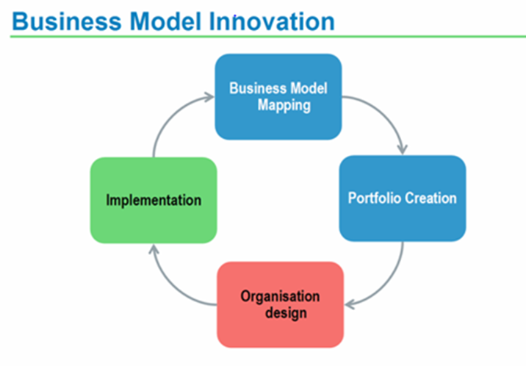
Figure 1: Business model innovation.
Source: Carayannis et al. (2015)

Business model Mapping
Business model Mapping is one of the important aspects in business model innovation. According to Carayannis et al. (2015) business model mapping is maximising the value by creating new business model or restructuring the existing model. In addition, França, et al. (2017) have added that although business model mapping is all about maximising the value but business model mapping has three purposes three key purpose, such as: To extract from the maximum value from an existing business, to understand how a product or services concept becomes a business, to understand how a new process within an organisation would operate. As per the UK clothing sector concern UK is believed to be one of the most sophisticated e-commerce market and technologically advanced. Hence in the UK clothing sector shaping more towards in e-commerce and the model and the structure of the business are changing.

Portfolio creation and organisation and organisational design
Evans et al. (2017) believe that there is a positive relationship between technological innovation and business innovation. As an example from the UK’s one of the departmental chain, Debenhams which has over 170 stores and through its websites. Their annual report (2018) shows that through technological advancement their business design is going to change. E-commerce could reshape the design of their business structure. Similar results has also found in Marks & spencer and John Lewis according to both of their current annual report.

Business model implementation
As per the new business model implementation concern, competition is an unavoidable factor in the clothing sector. In addition, Teece (2018) believes that when one company adopt or invent a new technology in the market other competitors are also need to peruse the same to sustain in the market. This suggest companies structural and model change not only happen through the internal managerial change but also through technological advancement and market competition and changes of consumer demands. In the case of UK clothing sector, companies have either restructured their model or developing the business completely e-commerce based. As 90% of the UK clothing is imported from the outside of the country, many of the significant impacts are occurring overseas, for instance social impacts, particular child labour and working conditions. Therefore, implementing a new business model e-commerce become comparatively easier for the new clothing retailer.

Business structure model
As per the UK business structure concern rising globalisation, digital innovation, changes in consumer spending behaviour are compelling specially clothing sector to change their structure of the business model.

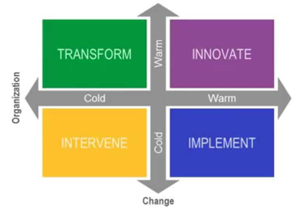
Figure 2: Business structure model.
Source: Andersson et al (2016)

Innovate
Zhu (2019) suggests that innovation in technology has significant impact in changing business structure and business model. Mainstream blockchain apps, machine learning for customer service, more al- enabled platforms for automated work, new security measures are some of the key innovation has great significance on business model change.
According to Andersson et al (2016) innovation in technology allows retail industry to rethink, reimagine and reinventing the business model. The results of innovation in business models, new product and services, customer relationship are significant.

Implement and transform
Antikainen and Valkokari (2016) explains that once the innovation take place transformation stared to take place into the industry. Innovation and the transformation are important factors in the in the management life cycle. Moreover, one of the significant transformation in the UK clothing industry is reforming the business into the online services. As an example there are 11455 clothing retail store in the UK an increase of 363 store in the previous year. This suggest that there is a clear relation between innovation in technology, business transformation and business model change. According to the Harvard business review (2018) there are three types of business transformation changes, those are: operational, core transformational, and strategic. Through operational transformational changes industry make changes things to make operation better, faster and cheaper. Through core transformation business fundamentally moves different way of operating.
Once the transformation completed into the business it started to implement different strategy into the market. As an example second largest grocer in the UK Sainsbury’s, which nearly £1 billion annual sales comes from the clothing. The company took acquisition of Argos through which it allows shoppers free click and collect from 1100 Sainsbury’s and Argos stores. Through technological innovation and business transformation it has implemented new business strategy.

Business structure model change (Example of M&S)
As an example from one of UK’s largest retail industry Marks &Spencer have closed down their 17 branches. According to the Guardian (2019) analysis this is as part of their business restructure model policy. Moreover, the company rather focusing on online and trying to merge their product together. The current trend of the customers towards online shopping hence company is changing their business model accordingly. Furthermore, according to the BBC analysis (2019) Marks &Spencer shops closer is part of their business transformation plan restructuring the business plan due to innovation, competition and the trend of the global market.

Technological innovation and E-commerce in clothing sector
Technological innovation become an ever more essential part of fashion retail in the UK (Thompson and McLarney, 2017). In the field of online business technological development started from the early 1990s. At that point, only less excremental and only structural goods could be experienced in e-commerce. As time goes, digitalisation helped specially clothing retailer a newer way to engage and reach with the customers. Statistics suggests United Kingdom is the third largest e-commerce market in the world. Forecast also suggests until 2013 e-commerce fashion revenue in the UK is expected to grow to 31.5 billion U.S dollar (ONS, 2019). Furthermore, in current year online sale in clothing is £16.2 billion which has increased by 17. 2%. The online clothing industry will continue to see double digit growth, over the next five years. According to Ft.com (2019) analysis the forecast growth for the clothing sector E-commerce is expected to grow by 10.4%. Although same research suggest it could slowed down due to inflation and Brexit uncertainty. According to the UK fashion and textile association (UKFT) 60.9% of the UK shoppers purchased an item online in the past years. This figures suggest that not only the clothing sectors that are the taking advantages of e-commerce but also consumer buying behaviour have also changed due to technological innovation.

Cost management
In general terms, cost management is the process of controlling and planning the budget of a business (Cooper, 2017). As per the topic of this report concern there is a positive relationship between cost management and business model change. According to the The Guardian (2019) analysis one of the main focus of UK clothing sector is to maximising the profit through reducing the cost. A net 2481 store in the high street disappeared from in year 2018 which is 40% more than year 2017. Additionally, only 3372 shops has opened and 5833 has been closed down. This figures suggests how companies are focusing on online trading to maximise the profit through reducing the cost. Furthermore, cost management model will elaborate how UK clothing sector using cost management model in changing their business model.
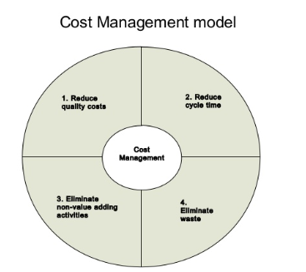
Figure 3: Cost management model.
Source: Cooper (2017).
In changing the business model and the business structure reducing the quality cost is one of the important factor. Quality cost associates with detecting, preventing and remediating product issue related to product quality. As per the UK clothing sector concern there are two factors co - related on this subject. Firstly the quality of the product must retain high standard, secondly cost needs to reduce in order to maximise the profit. This compel business to find an alternative way or change the business model to ensure the good quality of the product through minimum price.

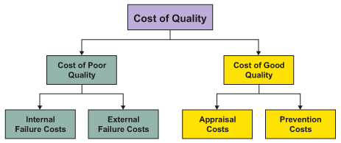
Figure 4: Cost of quality.
Source: Xue and Pe (2018)

Cost elimination
Eliminating cost is also one of the important factor in cost management model. In addition, this has a significant impact on changing business model and business structure. Moreover, Xue and Pe (2018) investigated that in modern business structure advance technology and E-commerce are two of the important factors for the cost elimination. The development of current cross border E- commerce is significant. According to the current statistics UK had third largest E-commerce market in the world. Changing the structure of the business became another phase to eliminate the cost of the business. The above analysis suggests that, clothing retailer have two choice either increasing the price of product due to inflation or change the business the business model through innovation and technology as low cost strategy. If the price of the product goes up compare to competitors company will fall behind in the market, hence company is changing the business model as low cost strategy.

Offshoring, on -shoring and outsourcing
Offshoring and outsourcing is a familiar and important concept in the UK clothing sector. Considering the low cost strategy UK clothing sector mostly rely on offshoring and outsourcing. According UK fashion and textile association (UKFT) (2019) most of the UK garments comes from outside the country, as it is cheaper to import from outside the country considering the cheap labour cost. Although this has been the trend in the UK clothing industry for many years but this practice still continues. According Ft.com (2019) despite offshoring and outsourcing practice in the UK companies like John Lewis and Debenhams are not on-shoring considering the local demands. Figure confirms that manufacturing in the UK has been enjoying something of a revival. A report from office of national statistics (ONS), UK fashion and textile association (UKFT) in recent years 7.6% more companies more companies are producing textile and clothing in the UK than previous year. The biggest increase come from a rise in the number of garment manufacturing which up by 10.7% to 3830 companies. These figures suggests that clothing industries are adopting business changes considering the current trend and innovation in technologies.

Change management model
This part of the analysis elaborate the change management model and its effect on the changes in business model and business structure. In addition, change management can highly influence different organisational factors in changing business model and structure. Moreover, in changing organisational structure through change management, change manager at all levels have to be competent at identifying the need for change (Hayes, 2019).
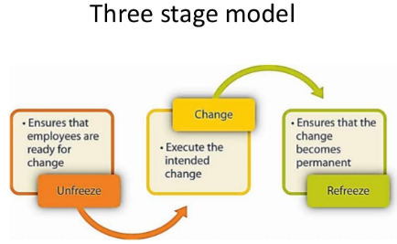
Figure 5: Lewin change management model.

Unfreezing
Lewin suggested that successful change management requires a three step process that involves the stags of unfreezing, change and freezing. In the first stage change management needs to ensure employees are ready for changes. As per the changes in business structure and business model changes in the UK clothing sector, ensuring the employees ready for the changes. As explained earlier most the changes in clothing sector is influenced by the innovation of technology therefore it is extremely important to ensure that employees are ready for the technological changes. According to the UK fashion and textile association (UKFT) (2019) over 50% organisational changes was towards E-commerce and technology is one of the key factor behind those changes.

Change
Executing the changes is the second phase of the Lewin change model. In this level where the balance of driving and restraining forces is modified to shift the equilibrium to a new level. Cameron, and Green (2015) defines at his stage organisation implements to planed changes on structure, technology and procedure. As per the clothing sector executing change concern, trend of the market and the consumer choice changing rapidly. As an example from the UK clothing sector, there has been a significant changes in e-commerce in clothing sector. This could make extremely difficult for the management to execute the changes.

Refreezing
Lewin last stage of the change management model is refreezing which involves reinforcing new behaviours in order to maintain new level of performance and avoid regression. In addition, this level defines to ensure that the change become permanent. Tudor (2018) has argued that technology and e-commerce is changing rapidly specially in clothing sector due to market trend and consumer buying behaviour. Therefore freezing the changes especially in the clothing will not be an ideal option. Alternatively, Cummings et al. (2016) suggest that as vast majority of the clothing sector is rely of the e-commerce. There technological innovation could compel them to re-execute the change after any changes has been made.

Conclusion
In the sum up it is important to conclude whatever has been analysed above. Changes in business model and structure has become a trend in recent years. Like any other sector, clothing sector in the UK has been restructuring their business model through technological development and e-commerce. Clothing sector are adopting all the possible new development and technologies to maximise their profit through reducing their cost. Some of the leading clothing retailer in the UK: such as M&S, Debenhams, and John Lewis has been restructuring their clothing sector business model through technological advancement and E-commerce. Rapid globalisation, digital innovation, changes in consumer spending behaviour are compelling specially clothing sector to change their structure of the business model. Moreover, technology and E-commerce are progressing together and the more advancement on technology the more rapid development in e-commerce. Furthermore, in current year online sale in clothing is £16.2 billion which has increased by 17. 2%.This shows the current trend of the business innovation and the shape of the future. Subsequently, cost management is an important factor in business model changes. One of the main focus of UK clothing sector is to maximising the profit through reducing the cost. Cost management is compelling business to find an alternative way or change the business model to ensure maximum profit through reducing price. Offshoring and outsourcing is a familiar and important concept in the UK clothing sector. This allows to meet consumer needs through outsourcing the right product from the right place. In contrast, completely depending on outsourcing could risk the business. Change management model suggest it could be challenging for the employees to be familiarise with all the changes. Job could be risk if technological advancement take over operation process rapidly.

Reference list
Andersson, U., Dasí, Á., Mudambi, R. and Pedersen, T., 2016. Technology, innovation and knowledge: The importance of ideas and international connectivity. Journal of World Business, 51(1), pp.153-162.
Ayers, J.B. and Odegaard, M.A., 2017. Retail supply chain management. CRC Press
Antikainen, M. and Valkokari, K., 2016. A framework for sustainable circular business model innovation. Technology Innovation Management Review, 6(7).
BBC News. (2019) Marks & Spancer Closer: A tale of two stroes . [Online] Available At: https://www.bbc.co.uk/news/av/business-48154367/ms-closures-a-tale-of-two-stores. [Accessed date: 15 April 2019]
Burke, W.W., 2017. Organization change: Theory and practice. Sage Publications.
Bradley, G., 2016. Benefit Realisation Management: A practical guide to achieving benefits through change. Routledge.
BBC News. (2019) Marks & Spancer Closer: A tale of two stroes . [Online] Available At: https://www.bbc.co.uk/news/av/business-48154367/ms-closures-a-tale-of-two-stores. [Accessed date: 15 April 2019]
Cameron, E. and Green, M., 2015. Making sense of change management: A complete guide to the models, tools and techniques of organizational change. Kogan Page Publishers.
Carayannis, E.G., Sindakis, S. and Walter, C., 2015. Business model innovation as lever of organizational sustainability. The Journal of Technology Transfer, 40(1), pp.85-104.
Cooper, Robin 2017.. Supply chain development for the lean enterprise: interorganizational cost management. Routledge.
Cummings, S., Bridgman, T. and Brown, K.G., 2016. Unfreezing change as three steps: Rethinking Kurt Lewin’s legacy for change management. Human relations, 69(1), pp.33-60.
De Vries, H. and Van der Poll, H.M., 2016. The influence of Lean thinking on organisational structure and behaviour in the discrete manufacturing industry. Journal of Contemporary Management, 13(1), pp.55-89.
E-commerce statistics (2019) The UK Ecommerce. [Online] Available At:https://www.statista.com/topics/2333/e-commerce-in-the-united-kingdom/ /. [Accessed date: 22 April 2019]
Evans, S., Vladimirova, D., Holgado, M., Van Fossen, K., Yang, M., Silva, E.A. and Barlow, C.Y., 2017. Business model innovation for sustainability: Towards a unified perspective for creation of sustainable business models. Business Strategy and the Environment, 26(5), pp.597-608.
E-commerce statistics (2019) The UK Ecommerce. [Online] Available At:https://www.statista.com/topics/2333/e-commerce-in-the-united-kingdom/ /. [Accessed date: 22 April 2019]
Ft.com (2019) UK Clothing Manufacturing. [Online] Available At: https://www.ft.com/content/0c44301e-5459-11e9-a3db-1fe89bedc16e[Accessed date: 11April 2019]
Ft.com (2019) UK E-commerce. [Online] Available At: https://www.ft.com/content/0c44301e-5459-11e9-a3db-1fe89bedc16e[Accessed date: 07 April 2019]
Ft.com (2019) UK Clothing Manufacturing. [Online] Available At: https://www.ft.com/content/0c44301e-5459-11e9-a3db-1fe89bedc16e[Accessed date: 07 April 2019]
França, C.L., Broman, G., Robèrt, K.H., Basile, G. and Trygg, L., 2017. An approach to business model innovation and design for strategic sustainable development. Journal of Cleaner Production, 140, pp.155-166.
Global data (2019) UK Clothing Sector [Online] Available At: https://www.globaldata.com/store/report/vr0152sr--the-uk-clothing-market-2018-2023/[Accessed date: 1 May 2019]
Hornstein, H.A., 2015. The integration of project management and organizational change management is now a necessity. International Journal of Project Management, 33(2), pp.291-298.
Harvard Business Review. (2018) Four Path to Business Model Innovation. [Online] Available At: https://hbr.org/2014/07/four-paths-to-business-model-innovation. [Accessed date: 07 April 2019]
Hayes, J., 2018. The theory and practice of change management. Palgrave.
Lasserre, P., 2017. Global strategic management. Macmillan International Higher Education.
Lozano, R., Ceulemans, K. and Seatter, C.S., 2015. Teaching organisational change management for sustainability: designing and delivering a course at the University of Leeds to better prepare future sustainability change agents. Journal of Cleaner Production, 106, pp.205-215.
Offie Of National Statistics. (2019) UK Fasion and textile Accociation. [Online] Available At : https://uk.linkedin.com/in/uk-fashion-and-textile-association-a2530527 [Accessed date: 255 April 2019]
Online Clothing retailer. (2019) UK clothing Sector Cost Management. [Online] Available At: https://www.insider-trends.com/15-of-the-uks-fastest-growing-retailers/. [Accessed date: 21 April 2019]
Oshri, I., Kotlarsky, J. and Willcocks, L.P., 2015. The Handbook of Global Outsourcing and Offshoring 3rd Edition. Springer.
Online Statistics Of UK Ecommerce (2019) The UK Ecommerce. [Online] Available At:https://www.statista.com/topics/2333/e-commerce-in-the-united-kingdom/ [Accessed date: 27 April 2019]
Radlo, M.J., 2016. Offshoring and Outsourcing in Economic Theories. In Offshoring, Outsourcing and Production Fragmentation (pp. 41-97). Palgrave Macmillan, London.
Retail Clothing retailer. (2019) UK clothing Sector Cost Management. [Online] Available At: https://www.insider-trends.com/15-of-the-uks-fastest-growing-retailers/. [Accessed date: 29 April 2019]
Thompson, J. and McLarney, C., 2017. What effects will the strategy changes undertaken by next Plc have on themselves and their competition in the UK Clothing Retail Market?. Journal of Commerce and Management Thought, 8(2), p.234.
The Times. (2019) Marks & Spancer 17 Stores closed down. [Online] Available At: https://www.thetimes.com/business/2019/jan/15/marks-and-spencer-stores-close-m-and-s-hull. [Accessed date: 07 April 2019]
Pugh, L., 2016. Change management in information services. Routledge.

The Guardian. (2019) Marks & Spancer 17 Stores closed down. [Online] Available At: https://www.theguardian.com/business/2019/jan/15/marks-and-spencer-stores-close-m-and-s-hull. [Accessed date: 07 April 2019]
Tate, W.L. and Bals, L., 2017. Outsourcing/offshoring insights: going beyond reshoring to rightshoring. International Journal of Physical Distribution & Logistics Management, 47(2/3), pp.106-113.
Statistics Of UK Ecommerce (2019) The UK Ecommerce. [Online] Available At:https://www.statista.com/topics/2333/e-commerce-in-the-united-kingdom/ /. [Accessed date: 27 April 2019]
The Guardian. (2019) [Online] Available At: Marks & Spancer shop Closure https://www.theguardian.com/business/2019/jan/15/marks-and-spencer-stores-close-m-and-s-hull [Accessed date: 29 April 2019]
The Guardian. (2019) UK clothing Sector Cost Management. [Online] Available At:https://www.theguardian.com/fashion/2019/jan/31/six-uk-fashion-retailers-fail-to-cotton-on-to-sustainability-environment. [Accessed date: 25 April 2019]
The Guardian. (2019) [Online] Available At: Marks & Spancer shop Closure https://www.theguardian.com/business/2019/jan/15/marks-and-spencer-stores-close-m-and-s-hull
The Online Clothing retailer. (2019) UK clothing Sector Cost Management. [Online] Available At: https://www.insider-trends.com/15-of-the-uks-fastest-growing-retailers/. [Accessed date: 21 April 2019]
Uhl, A. and Gollenia, L.A. eds., 2016. A handbook of business transformation management methodology. Routledge.
UK E-commerce statistics (2019) The UK Ecommerce. [Online] Available At:https://www.statista.com/topics/2333/e-commerce-in-the-united-kingdom/ /. [Accessed date: 21 April 2019]
UK Fasion and textile Accociation. (2019) [Online] Available At: https://uk.linkedin.com/in/uk-fashion-and-textile-association-a2530527 [Accessed date: 255 April 2019]
UK Fashion and Textile Industry (2019) [Online] Available At: https://fashionunited.uk/uk-fashion-industry-statistics/[Accessed date: 25 April 2019]
UK E-commerce statistics (2019) The UK Ecommerce. [Online] Available At:https://www.statista.com/topics/2333/e-commerce-in-the-united-kingdom/ /. [Accessed date: 21 April 2019]
Tudor, L., 2018. Change in Textile and Clothing Industry. Industria Textila, 69(1), pp.37-43.
Teece, D.J., 2018. Business models and dynamic capabilities. Long Range Planning, 51(1), pp.40-49.
The Guardian. (2019) Retail Shops closure in the UK. [Online] [Online] Available At https://www.theguardian.com/business/2019/apr/10/more-than-2400-shops-lost-from-top-500-uk-high-streets-in-2018-banks [Accessed date: 26 April 2019]
Xue, W., Li, D. and Pei, Y., 2016. The Development and Current of Cross-border E-commerce. WHICEB 2016 Proceedings, 53.
Zhu, Z. and Lin, S.F., 2019. Understanding entrepreneurial perceptions in the pursuit of emerging e-business opportunities: The dimensions and drivers. Computers in Human Behavior, 95, pp.252-261.

