

Predictive Modelling and Analysis of Biologics Drug Usage in Secondary Healthcare

by
Thomas Sellwood

Supervisor: Mark Huntly

Project submitted as part of the requirements for the award of
BSc (Hons) Computing (Data and Information Systems)

July 2026

DECLARATION

I, Thomas John Edward Sellwood declare that I am the sole author of this Project; that all references cited have been consulted; that I have conducted all work of which this is a record, and that the finished work lies within the prescribed word limits.

This work has not previously been accepted as part of any other degree submission.

Date : 24/07/2026

FORM OF CONSENT

I Thomas John Edward Sellwood hereby consent that my Project, submitted in candidature for the B.Sc.(Hons) Computing (Data and Information Systems) degree, if successful, may be made available for inter-library loan or photocopying (subject to the law of copyright), and that the title and abstract may be made available to outside organisations.

Date : 24/072026

Abstract 5
Introduction 6
Literature Review 7
Biologics and NHS Medicines Management 8
Factors Influencing Biologics Usage 10
Current Forecasting Practice in NHS Medicines Management 11
Requirements for an Effective Forecasting Framework 12
Machine Learning in Healthcare Forecasting 13
Explainable Artificial Intelligence in Healthcare Forecasting 14
Research Gaps in Biologics Usage Forecasting 15
Justification for Selection of XGBoost and SHAP 15
Justification for XGBoost 16
Comparison with Traditional Statistical Models 16
Comparison with Other Machine Learning Approaches 16
Summary 16
Justification for SHAP 17
Comparison with Other Interpretability Approaches 17
Summary 17
Methodology 17
Introduction 17
Research Philosophy and Approach 18
Research Philosophy 18
Research Approach 18
Research Strategy and Experimental Design 19
Case Study Strategy 19
Experimental Design 20
Implementation of Project 21
Data Sources and Scope 21
Data Cleaning and Transformation 22
Feature Engineering 24
Selection of XGBoost 25
Training and Validation Strategy 25
Model Evaluation Framework 27
Statistical Comparison of Forecasting Models 28
SHAP Analysis 29
Governance and Ethical Considerations 29
Results and Evaluation 30
Forecasting Performance 30
1-Month Forecast 30
3-Month Forecast 31
6-Month Forecast 32
Model Evaluation Metrics 33
Comparison with Naïve Forecast 34
Statistical Comparison of Forecasting Models 35
SHAP Model Interpretation 36
Local SHAP Interpretation 40
Discussions 42
Overview of Findings 42
Discussion of Forecasting Performance 42
Comparison with Existing Literature 42
Interpretation of Forecasting Performance 43
Discussion of SHAP Findings 44
Sensitivity Analysis 45
Comparison of Forecasting performance 46
Comparison of Prediction Plots 47
Statistical Comparison 48
Comparison of SHAP Outputs 50
Practical Implications 53
Medicines Procurement 53
Supporting Medicines Management Decisions 53
Explainability in Artificial Intelligence 54
Limitations 54
Dataset Scope 54
Data Availability and Feature Selection 55
External Influences on Medicines Demand 55
Methodological Considerations 55
Future Work 56
Expansion of Data Sources 56
Evaluation of Alternative Forecasting Techniques 56
Integration into NHS Digital Decision Support Systems 56
Conclusion 58
Reflection 59

Figure 1: Excerpt from BNF for cost of Ciclosporin capsules [10] 8
Figure 2: Excerpt from BNF for cost of Amgevita HCF 80mg [11] 9
Figure 3: Cleaning of Data and unit derivation 23
Figure 4: Monthly aggregation of data 23
Figure 5: Feature engineering of rolling statistical features 24
Figure 6: Time series split of data. 26
Figure 7: Parameter grid for GridSearch 27
Figure 8: Actual usage vs predicted usage for 1-month horizon 31
Figure 9: Actual usage vs predicted usage for 3-month horizon 32
Figure 10: Actual usage vs predicted usage for 3-month horizon 33
Figure 11: Performance metric output for all horizons 34
Figure 12: Performance metrics compared to naïve benchmark for all horizons 34
Figure 13: Diebold-Mariano test results for forecast comparison. 35
Figure 14: Diebold-Mariano test results for forecast comparison to naïve benchmark. 36
Figure 15: SHAP Global Output 1-month horizon 37
Figure 16: SHAP Global Output 3-month horizon 38
Figure 17: SHAP Global Output 6-month horizon 39
Figure 18: SHAP Local Output for specific forecast 41
Figure 19: Top medicines usage actual vs predicted 46
Figure 20: Performance metrics without high usage medicine 46
Figure 21: Performance metrics with high usage medicine 46
Figure 22: Prediction Graph for model with high usage medicine 47
Figure 23: Prediction Graph for model without high usage medicine 48
Figure 24: Diebold-Mariano test output for model without high usage medicine compared to other horizons. 49
Figure 25: Diebold-Mariano test output for model without high usage medicine compared to naïve benchmark. 49
Figure 26: SHAP Global Output for model with high usage medicine 3-month forecast 51
Figure 27: SHAP Global Output for model without high usage medicine 3-month forecast 52
Figure 28: Proposed Model Cycle for use in NHS environment 57

Abstract

The increasing use of biologic medicines within NHS secondary healthcare has contributed to rising medicines expenditure and created growing challenges for medicines management, procurement and financial planning. The current approaches taken to forecasting medicines demand are largely retrospective and provide limited capability to anticipate future usage. This project investigated whether machine learning could provide an accurate and interpretable approach for forecasting biologic medicines usage using historic pharmacy issues data.

Historic dermatology medicines issue data was extracted from the Welsh Hospital Pharmacy Stock Management System, was cleaned, transformed and aggregated into a structured monthly forecasting dataset. Temporal feature engineering techniques, including lag variables and rolling statistical features, were applied before developing Extreme Gradient Boosting (XGBoost) models to predict medicines usage across 1-month, 3-month and 6-month forecasting horizons. The model’s performance was assessed using Mean Absolute Error (MAE), Root Mean Squared Error (RMSE), Mean Absolute Percentage Error (MAPE), Weighted Mean Absolute Percentage Error (WMAPE), Symmetric Mean Absolute Percentage Error (SMAPE) and the coefficient of determination (R²). In addition to the performance metrics, a naïve forecasting benchmark, Diebold-Mariano statistical testing, and Shapley Additive Explanations (SHAP) analysis and sensitivity analysis were also undertaken to evaluate the predictive performance, statistical significance and model interpretability.

The developed forecasting framework demonstrated strong predictive performance across all forecasting horizons and generally outperformed the naïve forecasting benchmark. SHAP analysis identified historic usage and rolling statistical features as the most influential predictors of future biologic medicines usage, providing transparent explanations of the developed models behaviour. The sensitivity analysis undertaken further demonstrated that although a single high usage medicine influenced several evaluation metrics, the overall forecasting framework remained robust and continued to identify meaningful patterns within the dataset.

These findings demonstrate that machine learning can provide an accurate, interpretable and operationally relevant approach for forecasting the usage of biologic medicines within NHS secondary healthcare. The proposed framework has the potential to support medicines management, procurement and financial planning by enabling the early identification of future usage while providing transparent predictions that complement professional decision-making.

Introduction

Biologic medicines represent one of the fastest-growing areas of drug expenditure within secondary healthcare systems [1][2]. In the NHS, increased reliance on biologic therapies has placed sustained financial pressure on hospital medicines budgets, particularly within high-cost therapeutic areas such as oncology, immunology, and dermatology [1][2]. While these medicines deliver significant clinical benefit, their complex pricing structures, expanding indications, and long-term treatment pathways present ongoing challenges for financial planning and medicines management within secondary care.

Expenditure on biologic medicines is influenced by a range of interrelated factors beyond simple price and volume. Prescribing behaviour, therapeutic area, biosimilar uptake, formulation changes, and evolving patient demand all contribute to expenditure patterns. As a result, traditional approaches to financial analysis, which are typically retrospective and descriptive in nature, offer limited ability to anticipate future cost pressures. This lack of insight restricts the ability of health boards and trusts to plan proactively, manage risk, and allocate resources effectively.

Despite the availability of detailed pharmacy issues and purchases data within secondary care systems, forecasting practices remain limited. Conventional statistical methods often struggle to capture the non-linear relationships, and temporal dynamics present in biologic medicines data. Consequently, there is growing interest in the application of predictive modelling and machine learning techniques within healthcare analytics, where such methods have demonstrated potential to improve forecasting accuracy and support operational decision-making [3]. When applied appropriately, predictive models offer an opportunity to move beyond descriptive reporting by identifying historical patterns and generating reliable forecasts of future usage.

This project focuses on the analysis of biologic medicines usage within a secondary care setting, using historic pharmacy issues and purchases data from a single NHS health board. The scope is intentionally constrained to biologic medicines within dermatology to examine a high-impact area of hospital drug spend while maintaining appropriate and sufficient analytical depth. By leveraging pharmacy data stored in the national pharmacy system, the project seeks to explore whether predictive modelling approaches can provide actionable insight to support medicines management and financial planning in secondary care.

To analyse the drivers and implications of biologic medicine usage in secondary care healthcare settings and to develop predictive models to forecast future usage. The project pursues the following objectives:

- To undertake a literature review of existing research on predictive modelling of biologics usage in secondary healthcare, identifying methodological approaches, limitations, and gaps to inform model development and further research.
- To prepare and explore historic secondary care biologic medicines issues data by cleaning, transforming, and performing exploratory data analysis to identify key trends, seasonality, and variability relevant to usage forecasting.
- To develop and validate a predictive model for biologic medicines usage using machine learning techniques, with forecasting performance evaluated using established error metrics such as RMSE and MAE.
- To apply explainable AI techniques to the predictive model to identify and quantify the key factors influencing forecasted biologic drug usage.
- To critically evaluate the predictive model and dashboard in relation to existing literature and stakeholder requirements, assessing their usefulness for medicines management and financial planning in secondary healthcare

Literature Review

Biologic medicines have become essential to modern secondary healthcare, particularly in oncology, immunology, dermatology and inflammatory disease management. While clinically beneficial for patients, these therapies represent one of the highest components of hospital medicines expenditure[1][2].

Within NHS secondary care settings, biologics are characterised by high acquisition costs, evolving additional clinical indications, and increasing biosimilar market entry [4].Combined, these factors create a dynamic environment for medicines management teams.

Despite the importance of biologics, much of the existing literature focuses on cost containment mechanisms such as biosimilar adoption, pharmaceutical policy reform, and procurement strategies, rather than through proactive lens of usage forecasting [1][2][5]. Traditional retrospective financial analyses provide descriptive insight into past spending patterns but offer limited predictive capability [1]. As financial pressures intensify across UK health systems, there is a growing need for analytical approaches capable of anticipating future biologics usage and identifying its key drivers.

Whilst developments have been ongoing in pharmaceutical policy research, the field of healthcare analytics has made significant advancements. Time-series modelling, statistical forecasting, and machine learning techniques such as ARIMA, Prophet, random forests, gradient boosting, and long short-term memory (LSTM) networks have demonstrated effectiveness in forecasting pharmaceutical sales, hospital resource utilisation, and healthcare demand [6][7][8][9].

Through comparison of methodologies, findings, and limitations, this review identifies a research gap in biologics usage forecasting within secondary care. While predictive modelling is increasingly applied in adjacent healthcare domains, there is limited empirical research evaluating forecasting models for biologics usage within UK secondary care. Addressing this research gap forms the foundation of the present project, highlighting the need for research into interpretable forecasting approaches for biologics utilisation within NHS secondary care, capable of supporting proactive usage planning in NHS Wales.

Biologics and NHS Medicines Management

Biologic medicines are increasingly forming a significant proportion of NHS medicines expenditure. Over the past two decades, advances in biotechnology have enabled the development of complex therapeutic agents such as monoclonal antibodies, fusion proteins, and recombinant cytokines, which are now widely used across multiple clinical specialties including oncology, dermatology, gastroenterology, and rheumatology. As clinical evidence accumulates and regulatory approvals expand, many established biologic molecules continue to receive additional therapeutic indications, allowing them to be used in broader patient populations [2]. From this, the range of treatment options involving biologic medicines has expanded considerably, further contributing to growth in their utilisation within secondary care settings.

Alongside expanding clinical use, biologic medicines are also associated with substantially higher acquisition costs compared to traditional small-molecule pharmaceuticals.

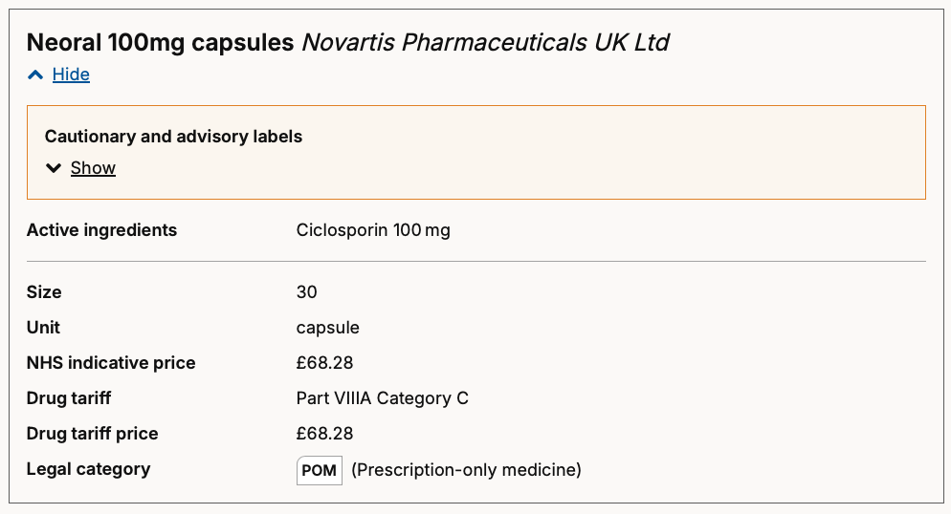
Figure 1: Excerpt from BNF for cost of Ciclosporin capsules [10]

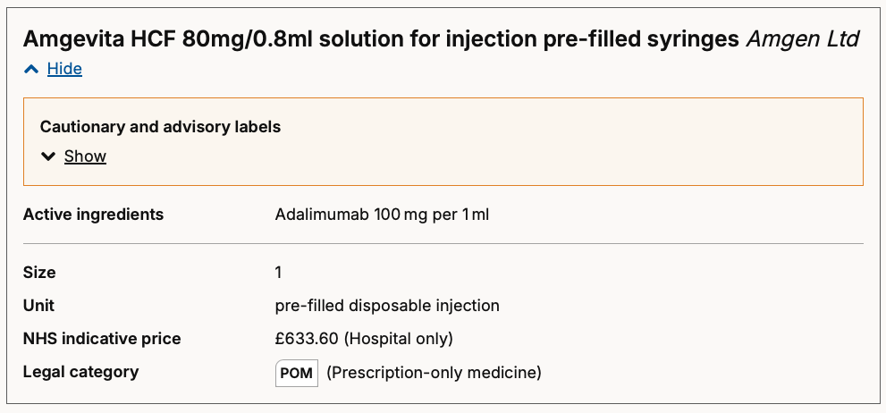
Figure 2: Excerpt from BNF for cost of Amgevita HCF 80mg [11]
This reflects both the complexity of their manufacturing processes and the regulatory requirements surrounding biological therapies. As a result, biologics have become one of the most significant drivers of medicines expenditure across NHS secondary care [4].

Within the United Kingdom, several national strategies and policy frameworks have been introduced to support the management of high-cost medicines, particularly biologics and other specialised therapies. In Wales and across the wider UK, guidance has been issued through national bodies to promote the safe, effective, and economically sustainable use of these medicines [4] [10] [11]. Such policies often include frameworks for clinical prioritisation, biosimilar adoption, and structured commissioning arrangements for specialised services [12].

These developments reflect broader trends occurring across the global pharmaceutical environment [1]. Worldwide pharmaceutical expenditure has been steadily increasing, with specialty medicines representing one of the fastest-growing segments of the market. Biologic therapies, particularly monoclonal antibodies and targeted immune modulators, now account for a substantial share of global pharmaceutical spending due to their high cost per treatment course and expanding range of clinical indications [2]. At the same time, the pharmaceutical industry has experienced a shift away from traditional small-molecule drugs toward increasingly complex biologic therapies, many of which are designed to target specific molecular pathways involved in disease progression.

This transition has also coincided with increased regulatory scrutiny and growing emphasis on cost-effectiveness within healthcare systems. Health technology assessment bodies such as the National Institute for Health and Care Excellence (NICE) play a central role in determining whether new biologic medicines are recommended for NHS use based on clinical effectiveness and value for money [13].In parallel, advances in precision medicine and personalised healthcare have encouraged the development of highly targeted biologic treatments that are tailored to specific patient subgroups, further shaping prescribing patterns and usage trends [14].

Within the NHS context, these global developments translate into significant challenges for medicines management teams. Hospital medicines budgets have grown substantially in recent years, with an increasing proportion of expenditure attributable to biologic medicines and other high-cost therapies. In secondary care settings, biologics are often concentrated within specialised clinical areas such as oncology, immunology, and inflammatory disease management, where treatment regimens may involve long-term therapy for chronic conditions [2]. This concentration of high-cost treatments contributes to ongoing financial sustainability concerns for both NHS England and NHS Wales [2][4].

In Wales, the commissioning and oversight of specialised medicines is influenced by organisations such as the Welsh Health Specialised Services Committee (WHSSC), which coordinates access to specialised treatments across Welsh health boards. At the UK level, commissioning decisions and prescribing guidance from NICE also influence biologic uptake and funding decisions. Furthermore, national biosimilar policies have been introduced as a key cost-containment strategy, encouraging switching from originator biologics to lower-cost biosimilar alternatives where clinically appropriate. These policies have demonstrated potential to generate significant savings while maintaining equivalent clinical outcomes [4] [15][12][1].

These trends highlight the strategic importance of understanding and anticipating biologics usage within NHS secondary care. The rapid growth in biologic prescribing, combined with the complexity of factors influencing their uptake, which includes the expanding clinical indications, biosimilar adoption, and evolving commissioning policies. This creates a highly dynamic expenditure landscape for NHS bodies.

Accurate forecasting of biologic medicines usage and associated costs therefore represents an important capability for healthcare organisations. By identifying emerging trends and predicting future demand, forecasting models can provide medicines management teams with actionable insights that support financial planning, resource allocation, and long-term sustainability of services for patients.

Factors Influencing Biologics Usage

Forecasting biologics utilisation involves predicting future patterns of medicine use and associated expenditure using historical utilisation data. Within secondary healthcare systems such as the NHS, biologics usage is shaped by a range of interacting clinical, organisational, and economic factors [2].

As a result, biologic medicines are typically used in specialised therapeutic areas such as dermatology and are associated with complex prescribing pathways, high acquisition costs, and evolving treatment guidelines [16][17]. As a result, predicting future biologics spending requires consideration of multiple drivers beyond simple usage volumes.

Biologic therapies are now widely used across several therapeutic areas. Biologic therapies are now widely used in specialties such as oncology, dermatology, rheumatology, and gastroenterology, where they provide targeted treatment options for complex or chronic conditions [2].

Another important factor influencing usage is the adoption of biosimilars and the associated switching behaviour within healthcare systems. In the UK, national policy has encouraged the uptake of biosimilar alternatives as a mechanism to control rising biologics costs [4][18]. While biosimilars can reduce unit costs, their introduction also introduces dynamic changes in usage patterns, procurement strategies, and market competition. These shifts can produce complex and sometimes unpredictable usage trajectories and trends as health systems transition between originator biologics and biosimilar alternatives.

In addition to clinical drivers, organisational and financial structures within the NHS also influence biologics usage patterns. Budget cycles, procurement contracts, and high-cost drug commissioning arrangements can introduce temporal variation in spending. For example, biologics supplied through homecare services may be subject to different funding mechanisms compared to medicines supplied through hospital pharmacy stock systems [19] [20] . Changes in how services are configured, treatment pathways for patients, or national commissioning guidance may therefore create structural shifts in usage patterns that cannot easily be captured by simple time-series trends.

The forecasting of biologics usage presents a complex analytical challenge. Traditional univariate forecasting approaches, which rely solely on historical spending trends, may be insufficient to capture the multi-dimensional nature of biologics utilisation. Instead, more advanced forecasting methods that incorporate multiple explanatory variables and account for non-linear relationships may provide more accurate predictions.

Current Forecasting Practice in NHS Medicines Management

Across NHS Wales and the wider UK NHS, data use within medicines management remains predominantly retrospective, with limited integration of advanced analytics and machine learning into operational decision-making.

The Welsh Government’s Digital and Data Strategy for Health and Social Care in Wales [21] highlights fragmentation across health data systems and that analytical capability is still developing rather than embedded in regular practice. Furthermore, the strategy highlights that improvements in data quality, accessibility and standards are required.

Limitations with data and reporting are observed in the English NHS. The report created from the Carter review [22], highlights that hospital pharmacy systems continue to rely on varying levels of manual data handling and locally developed reporting processes, with limited standardisation and digital integration. This reliance on basic data tools constrains the ability of organisations to perform advanced analytics or predictive modelling at scale. While national strategies and organisations such as the Digital Health and Care Wales (DHCW) organizational plan [23] outline ambitions to enhance data infrastructure and analytical capability, this work remains ongoing.

This evidence indicates that current NHS practice is largely centred on descriptive retrospective reporting rather than predictive modelling. The limited maturity of data infrastructure, combined with reliance on fragmented systems and manual processes, presents a significant barrier to the adoption of machine learning approaches within pharmacy and medicines management. There remains limited published evidence describing the routine application of predictive machine-learning techniques to medicines management within NHS secondary care, particularly for high-cost biologic medicines.

Requirements for an Effective Forecasting Framework

The existing approaches that have been taken to forecasting medicines usage demonstrate important limitations when applied to complex healthcare domains such as biologic medicines. Traditional forecasting methods have frequently relied on univariate time-series models or retrospective descriptive analysis, which are insufficient for capturing the multidimensional nature of healthcare utilisation. Evidence from hospital drug utilisation and pharmaceutical forecasting studies shows that demand is influenced by a combination of clinical, operational, and external factors, resulting in patterns that are inherently non-linear and dynamic [24] [6].

One of the key requirements of an improved forecasting framework is the ability to incorporate multiple interacting variables. Healthcare demand is shaped by a range of variables which include, patient need, the configuration of the service, prescribing behaviour, and policy interventions either nationally or locally, which interact in complex ways [25]. Research into pharmaceutical forecasting demonstrates that multivariate models significantly improve predictive performance by capturing these interactions, particularly when compared to traditional univariate models [26] [6]. This is especially relevant in the context of biologics, where usage is not only driven by volume and price, but also by factors such as biosimilar uptake, clinical guideline changes, and therapeutic indication expansion.

In addition to a multivariate capability, improved forecasting approaches must account for the non-linear relationships that exist within healthcare data. Machine learning models, including gradient boosting methods such as XGBoost [27], have been shown to outperform conventional statistical techniques in modelling complex, non-linear patterns in pharmaceutical sales and healthcare demand [27][6]. These findings highlight the need for forecasting frameworks that can accommodate complex functional relationships between variables rather than relying on simplified linear structures [7].

Another important consideration that must be accounted for is the requirement to model temporal dynamics and variability. Healthcare demand is subject to seasonality, long-term trends, and sudden structural changes, such as those caused by external events or changes to policies. Studies analysing prescription trends and hospital medicine usage have demonstrated that failing to account for such temporal dynamics can lead to significant forecasting inaccuracies [5] [3]. Furthermore, research into temporal hierarchies suggests that demand patterns may vary across different time resolutions, reinforcing the importance of flexible approaches that can adapt to changing temporal structures [7].

There have been advances in machine learning have improved predictive accuracy, the literature consistently highlights the importance of interpretability in healthcare forecasting. There is a requirement for the outputs of models to be transparent and interpretable in healthcare decision making, this ensures that predictions can be understood and trusted by clinicians. Research into interpretable analytics and explainable artificial intelligence emphasises that models must provide insight into the drivers of predictions, not simply produce accurate outputs [28]. Techniques such as SHAP [29][30] and other explainability methods have been shown to enhance understanding of complex models by identifying the contribution of individual variables to forecast outcomes [28] [30]. This is particularly important in the context of medicines usage, where decisions informed by forecasts from these models could have significant financial and clinical implications.

To summarise, this literature indicates that an improved forecasting framework must go beyond traditional approaches that have already been taken by integrating several important characteristics. These include the ability to incorporate multiple influencing factors, model non-linear relationships, account for temporal variability, and provide interpretable outputs. Rather than relying on a single modelling technique, effective forecasting in healthcare requires a more holistic approach that reflects the complexity of the system being analysed.

Machine Learning in Healthcare Forecasting

Machine learning is becoming an increasingly important approach for forecasting in healthcare, offering capabilities that beyond those offered by traditional statistical methods. Unlike traditional methods, which often rely on linear assumptions and limited variables, machine learning techniques are designed to capture complex, non-linear relationships within large and high-dimensional datasets. This makes them particularly well-suited to healthcare environments, where medicines usage is influenced by multiple variables [25].

There are a growing number of research articles which highlight the effectiveness of machine learning models in forecasting healthcare demand and pharmaceutical utilisation. Studies focusing on drug sales and hospital medicine usage demonstrate that machine learning approaches can achieve improved predictive performance compared to traditional methods, particularly when modelling complex and variable datasets [6][25][31]. These improvements are largely attributed to the ability of machine learning algorithms to automatically identify patterns and relationships within the data [31].

Among the various machine learning techniques applied in healthcare forecasting, ensemble methods such as gradient boosting have gained prominence [31]. Models such as XGBoost [27] have been widely used due to their strong predictive performance, scalability, and ability to handle missing or irregular data [31][27]. These models can capture interactions between variables and modelling non-linear effects, which as highlighted above are common in healthcare datasets. As a result, they have been successfully applied to forecasting pharmaceutical demand and healthcare utilisation, where traditional models often struggle to accurately represent the underlying patterns within the data.

In addition to ensemble methods, other machine learning approaches, including neural networks and hybrid models, have also been explored in healthcare forecasting. Research comparing stochastic models with machine learning techniques indicates that machine learning models generally provide greater flexibility in capturing complex temporal and structural relationships within healthcare data [32]. This is an aspect which is particularly important in pharmaceutical forecasting, where demand may be influenced by a combination of clinical, operational, and external factors such as policy changes and introduction of new drug formulations that vary over time.

Machine learning also enables the incorporation of a broader range of input variables into forecasting models. Healthcare demand is shaped by diverse factors, including demographic characteristics, clinical needs, and system-level influences. These could all be integrated into machine learning models to provide a more comprehensive representation of the system [25]. This contrasts with more traditional approaches, which often rely on a limited number of variables and may therefore fail to capture the full complexity of the data within a healthcare environment.

One of the challenges presented for the use of these models is the balance between model performance and the practical application. While machine learning models can achieve high levels of predictive accuracy, they may also introduce additional complexities compared to more traditional approaches. Research comparing forecasting techniques suggests that the most accurate model is not always the most suitable for operational use, particularly in a healthcare setting where simplicity and usability may be important considerations [32]. This highlights the need to carefully evaluate the trade-offs between the sophistication of the model and its practical implementation especially when dealing with non-technical clinicians.

Healthcare systems are inherently dynamic areas, with medicines usage patterns influenced by evolving clinical practices, policy changes, and external factors. Machine learning models must therefore be capable of adapting to these changes to remain effective. Studies examining healthcare utilisation during periods of disruption, such as the COVID-19 pandemic, demonstrate the importance of flexible forecasting approaches that can accommodate structural shifts in data patterns [5].

Explainable Artificial Intelligence in Healthcare Forecasting

The increasing application of machine learning in healthcare forecasting has highlighted a challenge which is the need for transparency in the workings of predictive models. While advanced algorithms can improve forecasting accuracy, the complexity of the models themselves often limits interpretability, in turn this creates barriers to adoption in healthcare environments. In the context of the NHS, where forecasting outputs inform financial planning, resource allocation, and clinical decision-making, the ability to understand and justify predictions is essential [33].

Healthcare forecasting differs from many commercial applications in that decisions must be clinically and operationally accountable particularly within the public sector. NHS organisations operate within highly regulated environments, where decisions must be supported by clear evidence and rationale. As a result, models that function as “black boxes” such as artificial neural networks may be less suitable, regardless of their predictive performance [34]. Research into healthcare analytics emphasises that predictive models must not only generate accurate forecasts but also provide insight into the factors influencing those predictions [34] . This requirement is particularly important when forecasting areas such as medicines usage, where outputs may directly influence commissioning strategies and prescribing policies.

Explainable artificial intelligence (XAI) has emerged as a response to these challenges, providing methods that enable greater transparency in complex models. XAI approaches aim to make machine learning outputs more interpretable by identifying and quantifying the contribution of input variables to predictions [35]. This allows an understanding of how different factors influence forecast outcomes, thereby improving trust and supporting informed decision-making [35].

The literature highlights several techniques that have been developed to enhance interpretability in forecasting models. Methods such as SHAP (Shapley Additive Explanations)[29] [30] and LIME (Local Interpretable Model-Agnostic Explanations) [28] provide a framework for decomposing model predictions into contributions from individual variables, allowing for detailed analysis of model behaviour [36]. These approaches are particularly relevant in healthcare settings, where stakeholders require both accuracy and clarity to act on predictive insights.

The integration of XAI into healthcare forecasting is not without challenges. There is often a trade-off required between the complexity of the model and the interpretability given by the model, with more complex models requiring additional techniques to make their outputs understandable [36]. Furthermore, while XAI methods can provide insights into model behaviour, they may introduce additional layers of analysis that require careful interpretation [36]. As a result, the use of XAI must be approached in a way that balances transparency with usability, ensuring that outputs remain accessible to non-technical stakeholders.

Research Gaps in Biologics Usage Forecasting

The literature demonstrates that biologic medicines represent one of the fastest-growing medicines in use in NHS secondary care. This increased use is driven by increasing clinical use, the expansion of therapeutic indications, and the introduction of biosimilars to the market [1][2][4]. While existing research has largely focused on cost-containment strategies such as biosimilar adoption and pharmaceutical policy reform, there is comparatively limited emphasis on proactive forecasting of biologics usage [1][2][5]. Current reporting practice with the NHS remains for the majority retrospective, relying on descriptive reporting and fragmented data systems, this restricts the ability of teams to leverage data to anticipate future demand and upcoming financial pressures [6][23].

In recent years significant advances have been made in healthcare analytics and machine learning has demonstrated improved predictive performance in pharmaceutical demand and resource utilisation forecasting [7][8][9], these approaches are rarely applied specifically to biologics usage within NHS secondary care.

Traditional forecasting methods, including univariate time-series models, are insufficient for capturing the complex and multi-dimensional drivers of biologics usage, which include clinical demand, usage behaviour, policy changes, and organisational factors [25][26]. While machine learning models such as gradient boosting techniques have shown strong capability in modelling non-linear relationships within healthcare data [3][7][27], their practical adoption is limited by challenges related to interpretability and transparency especially for non-technical clinicians.

The literature further highlights the importance of explainable artificial intelligence (XAI) in addressing these limitations, enabling insight into the factors that influence the predictions of the models and then to support evidence-based decision-making from those predictions [30][34]. However, there remains limited research integrating both advanced predictive modelling and interpretability within a unified framework for biologics forecasting.
From this, a clear research gap exists for the development of an interpretable, multivariate forecasting approach tailored to biologics usage in NHS secondary care. This project seeks to address this gap by applying machine learning techniques alongside explainability methods to produce accurate, transparent, and actionable forecasts to support medicines management decision-making.

Justification for Selection of XGBoost and SHAP

Justification for XGBoost

The selection of an appropriate model is critical for healthcare forecasting, where both predictive performance and practical applicability must be considered. In the context of forecasting biologics usage, the modelling approach must be capable of capturing complex, non-linear relationships, handling high-dimensional data, and providing outputs that are both accurate and interpretable. Based on these requirements, this research adopts XGBoost [27] as the primary predictive model, supported by SHAP [29][30] for model interpretation.

Comparison with Traditional Statistical Models

Traditional statistical approaches such as ARIMA and other time-series models have been widely used in pharmaceutical and healthcare forecasting. These models are effective in capturing temporal trends and seasonality. However, the drawback with this approach is that they are inherently limited by their reliance on linear assumptions and their focus on univariate or low-dimensional data structures. Research in pharmaceutical forecasting demonstrates that such models struggle to incorporate multiple interacting variables and often fail to capture the complexity of healthcare demand [26][7].

In the context of biologics usage, where it is influenced by factors such as prescribing behaviour, biosimilar uptake and usage, and clinical pathway changes, these limitations are particularly significant. As highlighted in broader healthcare demand modelling, usage is shaped by multiple interdependent variables, which cannot be adequately represented using purely statistical approaches [25]. While traditional models provide a useful baseline, they are insufficient as a standalone solution for this research problem.

Comparison with Other Machine Learning Approaches

Machine learning models offer greater flexibility in modelling complex and non-linear relationships, and a range of approaches have been applied in healthcare forecasting. Neural networks, including Long Short-Term Memory models [37], can capture temporal dependencies and complex patterns within time-series data [6].

These models often require large volumes of data, are computationally intensive, and can be difficult to tune effectively. Additionally, their lack of transparency makes them less suitable for healthcare environments where interpretability is important [33][32].

Other machine learning techniques, such as random forests, offer improved performance over other traditional models and these are less sensitive to overfitting when compared to single decision trees [38]. However, research comparing machine learning approaches indicates that gradient boosting methods often achieve superior predictive accuracy due to their ability to iteratively refine the model’s performance and reduce errors [6][3].

Summary

When compared to other machine learning models, XGBoost offers a balance between predictive performance and practical usability. While more complex models such as deep learning approaches could offer some gains in accuracy, XGBoost provides strong performance with lower computational cost and greater ease of implementation, making it more appropriate for forecasting of biologic medicines usage [32].

Justification for SHAP

While XGBoost [27] provides strong predictive capability, its complexity necessitates the use of interpretability techniques to ensure that model outputs can be understood and trusted. SHAP (SHapley Additive Explanations) [29][30] is adopted in this research as a method for interpreting model predictions.

SHAP [30] is based on cooperative game theory and provides a consistent framework for quantifying the contribution of each input variable to a model’s predictions. Research in healthcare analytics highlights the importance of such techniques in enabling transparency and supporting decision-making, particularly in environments such as the NHS [7][13].

The use of SHAP [29][30] allows for both global and local interpretability. At a global level, it enables identification of the most important variables influencing biologics usage, providing insight into key cost drivers. At a local level, it allows for explanation of individual predictions, which is valuable for understanding specific forecasting outputs. This dual capability makes SHAP [29][30] particularly suitable for healthcare forecasting, where both overall trends and case-specific insights are important.

Comparison with Other Interpretability Approaches
Alternative interpretability methods, such as feature importance measures or partial dependence plots, provide some insight into model behaviour but are often limited in their ability to fully explain complex interactions between variables [39]. In contrast, SHAP [29][30] offers a theoretically grounded and consistent approach to interpreting model outputs, making it more robust and informative than simpler techniques [11][12].

Summary
In summary, the selection of XGBoost [27] and SHAP [29][30] is justified by their ability to address the key challenges of healthcare forecasting. Traditional statistical models are limited in their ability to capture complex, multivariate relationships, while alternative machine learning approaches either lack interpretability for non-technical users or can introduce unnecessary complexity. XGBoost [27] provides a strong balance of predictive performance, scalability, and robustness, making it well-suited to modelling biologics usage. SHAP [29][30] complements this by enabling transparent interpretation of model outputs, supporting informed and accountable decision-making within an NHS context.

Methodology

Introduction

This section outlines the methodological framework that has been adopted for the development and evaluation of predictive models for biologics medicine usage within secondary healthcare. The methodology was designed to support the research question of assessing the extent to which machine learning techniques can accurately forecast future biologics demand using historical pharmacy data.

This section discusses the research philosophy, research approach, and experimental design used throughout the project. It also details the processes involved in data collection, preprocessing, feature engineering, predictive model development, and model evaluation. In this section focus is given to the application of Extreme Gradient Boosting (XGBoost) [27] and Explainable Artificial Intelligence (XAI) techniques using SHAP [29][30] to improve interpretability of model outputs for clinical users.

The project adopted structured experimental framework to ensure the research remained transparent, reproducible, and aligned with established healthcare analytics practices. The methodology further incorporates statistical evaluation metrics, comparative forecasting approaches, and governance considerations associated with the use of healthcare data within NHS secondary care environments.

Research Philosophy and Approach

Research Philosophy

This research adopts a positivist research philosophy due to the project’s reliance on structured quantitative data and statistical analysis. The positivist research approach is appropriate for research seeking to identify objective patterns, relationships, and measurable outcomes from observable data [40][41]. Within this project, the historic usage of biologic medicines data is used to analyse and to identify trends and generate predictive forecasts using machine learning techniques.

The use of a positivist approach aligns with the projects usage of structured pharmacy issues datasets extracted from NHS secondary care systems. These datasets contain quantifiable variables, including medicine usage volumes, cost centre usage, temporal patterns, and location usage which are suitable for objective analysis [42]. The projects use of predictive modelling techniques, including XGBoost, further supports this position through the application of repeatable statistical and machine learning processes to evaluate forecasting performance for biologics medicines usage.

An advantage of the positivist philosophy within this research is the ability to generate reproducible and measurable results through consistent analytical procedures [40]. This supports objective comparison between forecasting approaches using statistical evaluation metrics such as Root Mean Squared Error (RMSE), Mean Absolute Error (MAE), and Mean Absolute Percentage Error (MAPE). However, a limitation of positivism is that it does not fully capture the subjective clinical or organisational factors influencing usage behaviour of these medicines [40]. To mitigate this limitation, findings are interpreted within the context of existing healthcare and forecasting literature.

Research Approach

This research project adopts a deductive research approach, whereby existing theory and established analytical principles are used to formulate and test a research hypothesis. Deductive research is often commonly associated with positivist studies and quantitative analysis, as it focuses on testing theories through measurable observations and structured evaluation [40].

The central hypothesis of this research is that historical biologics usage patterns and organisational variables can be utilised to generate accurate forecasts of future biologics demand within NHS secondary healthcare settings. To test this hypothesis, historical pharmacy issues and expenditure data are analysed using machine learning techniques, with forecast outputs evaluated against known historical outcomes.

The deductive approach is appropriate for this research project due to the structured and objective nature of predictive modelling. Existing literature demonstrates that machine learning techniques can successfully identify patterns within healthcare and pharmaceutical datasets to support forecasting and operational planning [6] [8]. Utilising this existing theoretical foundation, the research applies XGBoost forecasting models to determine whether similar predictive performance can be achieved within biologics medicines usage for dermatology.

The advantage offered by using a deductive approach is that it provides a clear and systematic framework for model evaluation through predefined performance metrics and comparative analysis [40]. This supports the objective assessment of forecasting accuracy across different prediction horizons identified using metrics such as RMSE, MAE, and MAPE. However, a limitation of deductive research is that unexpected relationships or emerging patterns may not always align fully with the original hypothesis [40]. To mitigate this limitation, exploratory data analysis techniques are incorporated within the research process to identify additional patterns and relationships within the medicines issue dataset.

Research Strategy and Experimental Design

Case Study Strategy

This research adopts a case study strategy focused on dermatology biologic medicines usage within an NHS secondary healthcare environment in Wales. A case study approach is appropriate where research seeks to investigate a contemporary issue within a real-world operational setting while retaining the contextual complexity associated with that environment [43]. Within this research, the case study strategy enables detailed investigation of biologics usage and expenditure patterns using operational pharmacy data derived from NHS systems.

The research project utilises historical pharmacy issues data extracted from systems managed within Digital Health and Care Wales (DHCW). These datasets contain operational information relating to biologics medicine usage, usage trends, cost centre activity, and organisational variables within secondary care. The use of real-world operational healthcare data increases the practical relevance of the research, allowing predictive models to be developed and evaluated against realistic demand patterns rather than using simulated datasets.

Utilising a case study strategy is particularly suitable for healthcare analytics research due to the complexity of healthcare operational environments and the variability that exists in usage behaviour, treatment pathways, and medicines management processes [40] [5]. Biologics medicines represent a complex forecasting problem influenced by multiple organisational and temporal factors, including biosimilar uptake, prescribing trends, and service demand [1]. Examining these variables within a real-world NHS setting supports the development of forecasting models that are operationally relevant to medicines management and financial planning activities.

An advantage of the case study approach is that it allows detailed analysis of a specific operational healthcare environment while maintaining contextual understanding of the data and organisational processes [43]. However, a limitation of this is that findings may not be fully generalisable across all Welsh NHS organisations due to differences in local prescribing practices, formulary adoption, and operational structures. To mitigate this limitation, the findings will be interpreted alongside wider healthcare forecasting literature and existing research relating to pharmaceutical demand forecasting.

Experimental Design

This research project adopts an experimental design to evaluate the effectiveness of machine learning techniques for forecasting dermatology biologics medicine usage within NHS secondary healthcare. Experimental research is appropriate where the hypotheses are tested through structured analytical procedures, a controlled evaluation process, and measurable outcomes [40]. Within this project, a predictive forecasting model is developed and evaluated using historical pharmacy usage data to determine the extent to which future biologics demand can be accurately predicted.

The central experimental hypothesis of this project is that the historical biologics usage patterns and variables can be utilised to generate accurate forecasts of future biologics usage within dermatology NHS secondary healthcare settings. To evaluate this hypothesis, a supervised machine learning framework is implemented using historical pharmacy issues data extracted from operational NHS systems. Existing healthcare forecasting research demonstrates that machine learning approaches are increasingly capable of identifying temporal patterns and supporting operational decision-making within healthcare environments [25][6].

The experimental framework utilises historical time-series data to train forecasting models capable of predicting future biologics usage across multiple forecasting horizons. The research evaluates monthly, 3-monthly, and 6-monthly forecast periods to assess how predictive performance changes over varying temporal ranges. Forecast horizon comparison is particularly important within medicines management and healthcare financial planning, as shorter forecasting windows may provide greater operational precision while longer forecasting periods may better support strategic resource allocation and procurement planning in the longer term [8].

The forecasting framework incorporates the following steps:
- Structured data preprocessing.
- Feature engineering.
- Model training.
- Validation.
- Comparative evaluation procedures.

Historical data is separated chronologically into training and validation datasets to preserve temporal ordering and reduce the risk of data leakage. This approach is considered best practice for forecasting and time-series machine learning practice, as randomised splitting techniques may unintentionally expose to the model future observations during model training and artificially inflate predictive performance [44] [45].

The experimental design additionally incorporates the development of lag-based and temporal predictor variables to support supervised learning. Feature engineering techniques are widely used within machine learning forecasting to capture historical behavioural patterns, seasonality, and temporal dependencies within operational datasets [45]. The use of structured pharmacy operational data containing variables such as medicine usage volumes, issue timing, and historical usage trends provides an appropriate basis for predictive modelling within secondary healthcare environments.

The forecasting performance of the model is evaluated using multiple statistical and forecasting-specific evaluation metrics, including Root Mean Squared Error (RMSE), Mean Absolute Error (MAE), Mean Absolute Percentage Error (MAPE), Weighted Mean Absolute Percentage Error (WMAPE), Symmetric Mean Absolute Percentage Error (SMAPE), and coefficient of determination (R²). RMSE and MAE provide measures of absolute forecasting error, while MAPE, WMAPE, and SMAPE are particularly valuable within forecasting research due to their ability to assess relative predictive performance of models across varying demand magnitudes [46] [47]. WMAPE is particularly suitable for operational healthcare forecasting because it reduces distortion caused by low-volume to zero observations and places greater weighting on higher-volume medicines usage [48]. SMAPE is additionally incorporated to reduce the instability associated with traditional percentage-based error metrics when actual values are close to zero [46].

The research additionally incorporates a naïve baseline forecasting approach using historical lag values to assess whether the machine learning models provide meaningful predictive improvement beyond simple trend continuation. This baseline comparison is recognised as an important component of forecasting evaluation, as it ensures that increased model complexity produces measurable operational benefit rather than overfitting from historical data [45].

An advantage of the experimental design is that this supports systematic and reproducible evaluation of forecasting performance through structured analytical procedures and measurable outcomes [40]. However, there are limitations that remain due to the complexity of healthcare operational environments and the potential influence of external factors not fully represented within the dataset used, including policy changes, biosimilar adoption strategies, supply shortages, and the changes in prescribing guidance at health board level. To reduce the impact of these limitations, findings are interpreted alongside existing healthcare forecasting literature and wider NHS operational context.

Implementation of Project

Data Sources and Scope

The dataset utilised within this project consisted of the historical issues of the identified biologics medicines extracted from the Welsh Hospital Pharmacy Stock Management System which is managed by Digital Health and Care Wales. The data was selected as it represents real life operational historic usage data of medicines in secondary care. This data is routinely used by finance and medicines management departments for their financial planning and fits in with the wider Digital Health and Care Wales and Welsh Government strategies of utilising digital and analytical techniques effectively [23][21].

The data extracted from the dataset included the historical records of the issues of medicines including the issue date, medicine name, quantity of the issue and organisational, cost centre and location identifiers. This dataset was selected as it contained the historic usage patterns of medicines, these historical patterns are recognised as a key input for healthcare demand forecasting and have previously been used with success in other forecasting studies [7][25][3]. The use of historic medicines issue data directly supports the research objective of determining whether biologics demand can be accurately predicted using machine learning techniques.

The scope of this project was restricted to biologics medicine used in dermatology in secondary healthcare. This focus was selected due to increasing financial significance of biologic medicines and the growing importance of effective forecasting to support medicines optimisation and budget planning [4][10]. Previous research has highlighted the substantial expenditure that is associated with biologics medicines and the opportunities presented to healthcare organisations to improve resource utilisations using the data available [1][22].

Prior to the analysis of the data, the extracted data underwent pseudonymisation to remove identifiable operational information while preserving the relationships between the variables required for forecasting [49]. The resulting dataset provided a practical balance between upholding data governance requirements and its analytical utility.

Data Cleaning and Transformation

Following the extraction of the dataset, it underwent a series of cleaning and transformation steps. This aimed to improve the data quality and to prepare it for use within the XGBoost algorithm. Data pre-processing is a critical step within the machine learning process as at this stage inconsistencies such as missing values and variations in data formats can be addressed so that it does not adversely affect the model performance [25][45].

The original dataset contained medicine issue records recorded at a transaction level. Before modelling could occur, the dataset was assessed to identify missing values, inconsistent quantities and anomalies that could affect the accuracy of the forecast. Data quality assessment is particularly important within healthcare forecasting studies due to the operational nature of the source systems and the potential for variation in recording practices across varying healthcare organisations [24][25].

One of the key transformation steps in the process was the standardisation of the medicine usage quantities. The data contained quantity information recorded as both containers and dose units, to ensure consistency across the dataset these fields were transformed into a common usage measure that represented the total units used. This approach allowed demand to be measured in a standardised metric suitable for comparative analysis and forecasting. The use of consistent measurement units is widely recognised and recommended within the forecasting research, as variation in the input scales can obscure underlying demand patterns and reduce the model accuracy [45]. Figure 3 below shows the steps taken to clean the data.

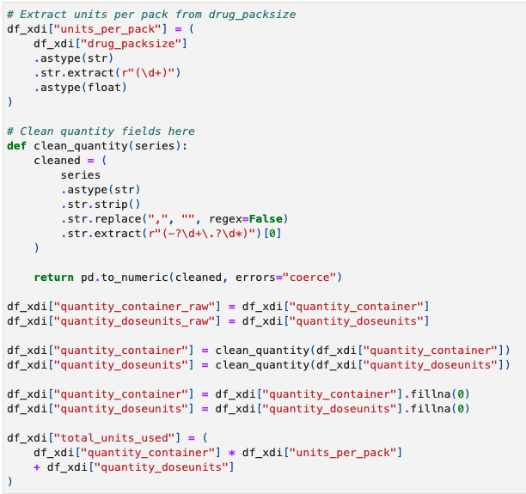
Figure 3: Cleaning of Data and unit derivation

Following on from this standardisation, the transaction level records were aggregated into monthly observations as demonstrated in figure 4.
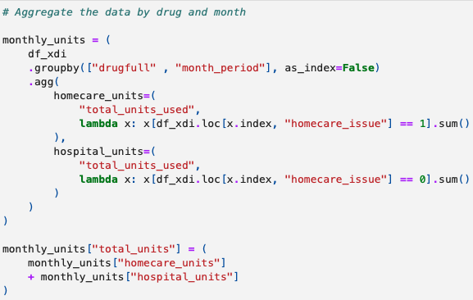
Figure 4: Monthly aggregation of data
Monthly aggregation was selected as the objective of the research was to support medium-term forecasting for medicines management and planning activities, rather than day-to-day operational stock control. Previous hospital pharmacy forecasting studies have similarly used aggregated temporal periods to reduce short-term variability and improve the identification of the underlying demand [7][3]. Forecasting literature further highlights that performing aggregation can reduce noise within operational datasets and improve the stability of forecasting models to analyse longer-term demand trends [45].

The transformed dataset was then ordered chronologically to prepare it for time series forecasting. Maintaining a temporal order is considered essential within forecasting studies, as predictive models must be trained using only information available at the time of prediction. Ordering in this way stops information leakage and ensures a realistic performance [44].

Feature Engineering

Feature engineering was undertaken to transform the cleaned operational dataset into a structured format which is suitable for supervised machine learning. Feature engineering is key step of predictive modelling, as the quality and relevance of input variables can significantly influence forecasting performance [45]. The objective at this stage of the model was to create features capable of temporal patterns and demand behaviours that are associated with the usage of biologics medicines in dermatology [6]. The features created in figure 5 provide additional context that could not be captured through historical demand alone.

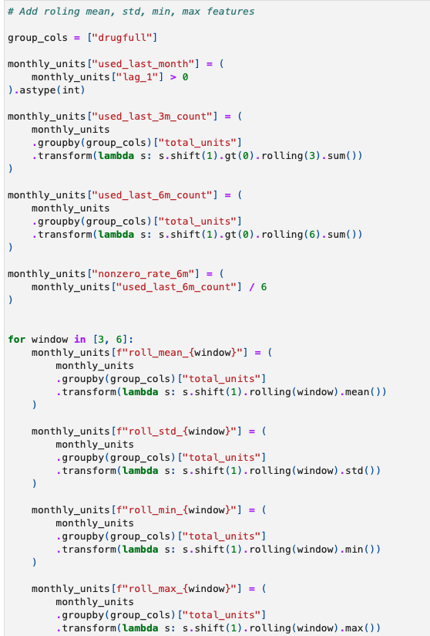
Figure 5: Feature engineering of rolling statistical features
Lag-based featured were generated to represent previous medicine usage levels. The historical demand is frequently identified as one of the strongest predictors of future demand and is widely used within healthcare and pharmaceutical forecasting studies as a method to capture the temporal dependencies that exist within the data [6][7][3]. Lag variables were then created to provide the model with recently observed utilisation levels when generating the future forecasts. The inclusion of lagged observations facilitates models to learn relationships between past and future demand; this is considered an essential feature engineering technique within time series forecasting [45].

To facilitate evaluations across the varying different forecasting horizons, separate target variables were created, representing 1-, 3- and 6-month future demand. The creation of multiple forecasting targets enabled comparative assessment of predictive performance across multiple forecasting timescales. This approach aligns with healthcare forecasting literature, which highlights that different planning activities may require forecasts that cover varying time periods [8][25].

To further support the development of the model, sample weighting was incorporated during training to increase the influence of observations associated with higher-volume medicines [50]. This approach was adopted to reflect the greater operational and financial significance of forecasting errors associated with high-usage biologics. Given the substantial expenditure associated with biologic therapies and the importance of efficient medicines management within healthcare organisations, prioritising accuracy for high-volume medicines was considered operationally appropriate [4][10][22].

The resulting feature set provided a structured representation of historical usage patterns, temporal trends, and future demand targets. These engineered features formed the foundation of the predictive modelling framework and enabled subsequent evaluation of forecasting performance across the multiple time horizons of 1,3 and 6 months.

Selection of XGBoost

Extreme Gradient Boosting (XGBoost) [27] was selected as the predictive modelling algorithm for this study. As established in the literature review, XGBoost [27] has demonstrated strong predictive performance within healthcare forecasting and pharmaceutical demand prediction due to its ability to model complex non-linear relationships while maintaining computational efficiency when applied to structured tabular datasets [6][25][27][31][32][34]. Consequently, XGBoost [27] was considered an appropriate modelling technique for forecasting dermatology biologics medicine utilisation using historical NHS pharmacy issues data.

The pharmacy dataset used within this study consisted of structured historical medicines issues data containing temporal variables and engineered lag features. XGBoost [27] was therefore well suited to this forecasting task due to its ability to model interactions between predictor variables without requiring assumptions of linearity or data distribution, whilst also incorporating regularisation techniques to reduce overfitting and improve generalisation to unseen data [27]. In addition, the algorithm provides native handling of missing values and supports feature importance analysis, making it appropriate for operational healthcare datasets and subsequent model interpretation using SHAP [29][30].

The implementation of XGBoost [27] within this study, including feature engineering, hyperparameter optimisation, model training, and validation, is described in the following sections.

Training and Validation Strategy

A structured training and validation strategy was implemented to ensure that the forecasting performance of the model was robustly evaluated to minimise the chances of overfitting. Forecasting models differ from conventional machine learning applications as future observations are unavailable at the point of prediction. Thus, the validation period must preserve the temporal order to ensure that the model performance is reflective of realistic forecasting conditions [44] [45].

The dataset was partitioned chronologically into training and validation subsets. Unlike traditional machine learning applications where the observations can be randomly allocated to training and testing datasets, random sampling is not an appropriate technique due to the time-series nature of the data. Introducing a random split may introduce data leakage to the model and expose future observations, which could artificially inflate the model performance [44][45]. To mitigate this, the historical observations were used for model training, while the more recent observations were retained for validation.

To further strengthen the model’s evaluation, time series cross validation was implemented using a rolling validation framework. TimeSeriesSplit was selected as it preserves the temporal order while allowing the models performance to be assessed across the multiple forecasting periods as discussed, this is shown in figure 6.

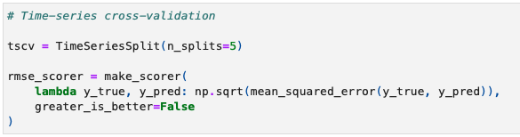
Figure 6: Time series split of data.
Using this approach gives a more robust estimate of predictive performance than a single train-test split [45][51]. By repeatedly training on the historical observations and then validating these against the subsequent periods the methodology ensured that the performance of the model was evaluated under conditions consistent with real world forecasting applications.

For the varying horizons of 1-month, 3-months and 6-months a separate model was developed for each of these horizons. The use of the multiple horizons enabled assessment of how predictive performance changed as the forecasting horizon was increased. This approach is supported by healthcare forecasting literature, which demonstrates that the model accuracy often varies across the horizons, and that users may require forecasts over various timescales [8][25][3].

Hyperparameter optimisation was undertaken using GridSearchCV [52] to identify the model configuration that provided the strongest predictive performance. A range of hyperparameters including tree depth, learning rate, number of estimators, subsampling rate and regularisation values were systematically evaluated as demonstrated in figure 7.
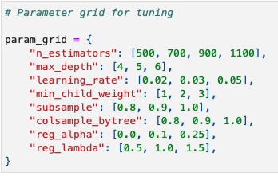
Figure 7: Parameter grid for GridSearch
Hyperparameter optimisation is recognised as an important component of machine learning model development because model performance can be highly sensitive on the parameters that are selected for use [27][31].

Sample weighting was also incorporated during the model training to increase the influence of observations associated with medicines of higher volume usage. This approach was adopted to reflect the greater operational consequences of forecasting errors involving frequently utilised biologic medicines [50].

Model Evaluation Framework

An evaluation framework was implemented to assess the forecasting accuracy of the forecasting performance across the various prediction horizons. Forecasting literature recommends the use of multiple evaluation metrics, as there is no single measure which provides a complete assessment of model performance [47][48].

Root Mean Squared Error (RMSE) and Mean Absolute Error (MAE) were used to measure the forecasting accuracy. RMSE places a greater emphasis on larger forecasting errors, making it particularly useful for identifying substantial deviations between the predicted demand and the demand that is observed [47]. In contrast to RMSE, MAE provides a direct measure of average forecasting error and is less sensitive to extreme observations [47]. The combined use of RMSE and MAE enabled assessment of both the overall forecasting accuracy and the impact of large errors.

Percentage -based metrics were additionally incorporated to allow comparison across medicines with differing usage volumes. Mean Absolute Percentage Error (MAPE) was included due to its widespread use within forecasting research and ease of interpretation [47][48]. A limitation of MAPE, is that it may become unstable when actual values are close to zero, with the potential to distort assessment of the model’s performance [47] [53].

To address the limitation, Weighted Mean Absolute Percentage Error was adopted as the forecasting metric. WMAPE weights errors according to the magnitude of observed demand [53]. This places a greater emphasis on the forecasting performance of the higher volume medicines, which is appropriate for biologics medicines usage as higher use medicines may have a greater financial impact than the equivalent errors lower volume medicines.

Symmetric Mean Absolute Percentage Error (SMAPE) was also calculated to provide a more balanced percentage-based assessment of the forecasting performance. By incorporating both the actual and predicted values within the denominator SMAPE reduces the sensitivity to extreme values and provides a more stable measure of the forecast accuracy across the demand levels [54].

In addition to the forecasting specific error measures the coefficient of determination (R² ) was utilised to assess the proportion of variation in medicine usage explained by the model. Although it is not used as the primary metric, the R² provides additional insights into the model’s ability to capture the underlying demand patterns.

Finally, the model performance was also compared against the naïve forecasting benchmark using the previous observed usage value as the forecast. The inclusion of a benchmark model is widely recommended, within forecasting research to determine whether increased model complexity provides meaningful predictive improvement over simple forecasting approaches [46].

Statistical Comparison of Forecasting Models

Whilst the forecasting accuracy metrics provide measures of model performance ultimately, they do not determine whether the observed differences between the competing forecasting models are statistically significant. From this, the Diebold-Mariano (DM) test [55] was employed to the compare the predictive accuracy of the 1-month, 3-month and 6-month forecasting models. The DM test is widely recognised within forecasting research as a method of evaluating whether the differences in forecast error between models are statistically distinguishable [55].

The Diebold-Mariano test compares forecast error series generated by alternative forecasting models and then evaluates whether one model demonstrates significantly superior predictive performance. Unlike traditional accuracy metrics, which provide descriptive measures of the quality of the forecasts produced, the DM test enables formal statistical assessment of whether observed differences are meaningful [55].

For this project the DM test was applied to forecast errors generated during the model validation. Pairwise comparisons were conducted between the 1-month, 3-month and 6-month forecasting horizons to determine whether differences in predictive performance were statistically significant. The null hypothesis stated that no difference existed in forecast accuracy between the models being compared, whilst the alternative hypothesis stated that a statistically significant difference in predictive performance was present.

A significance level of 0.05 was adopted throughout the analysis. Where the resulting p-value was below this threshold, the null hypothesis was rejected, indicating evidence of statistically significant difference in forecasting accuracy. Conversely where the p-values were greater than 0.05 suggested that any observed differences in performance may have occurred due to the random variation within the forecast error series.

The inclusion of the Diebold-Mariano test strengthens the evaluation of the model by supplementing traditional forecasting measure with formal statistical testing. This enables the assessment of not only which forecasting model achieved the strongest predictive performance, but also whether the differences between competing models were sufficiently large to be considered statistically meaningful.

SHAP Analysis

While the predictive accuracy of the model is an importantly measure of its performance, healthcare forecasting applications also require transparency and interpretability for clinical users to help support their decision-making. The increasing adoption of machine learning within healthcare has resulted in growing interest in explainable artificial intelligence (XAI) techniques that enable users to understand how the predictions are generated [28][35][36]. This aspect is of particular importance within healthcare environments, as forecasting outputs may influence operational and financial planning decisions.

Traditional machine learning models, including ensemble methods such as XGBoost [27], are often described as black box algorithms due to the difficulty of directly interpreting the relationships learned during model training [33]. While these models may achieve strong predictive performance, limited interpretability can reduce the trust in the models and hinder their adoption within healthcare [28][34]. XAI techniques are increasingly recommended to improve the transparency and support the practical implementation of machine learning techniques [36].

To address the challenges presented by machine learning interpretability, Shapley Additive Explanations (SHAP) was selected as the primary explainability technique within this project. SHAP [29] is an explainable artificial intelligence model based on cooperative game theory that quantifies the contributors of individual features to model predictions [30]. Previous healthcare research has demonstrated SHAP’s [29] effectiveness at improving transparency and interpretability while maintaining the predictive performance advantages associated with machine learning [30][34].

SHAP [29] was selected due to its ability to provide both global and local explanations of the model’s behaviour. Global explanations enable the identification of the features overall influence to the models’ forecasts. For this project global SHAP [29] analysis was used to identify the variables most strongly associated with future biologic usage, providing insights into the drivers of the forecasting outcomes and supporting understanding of the model’s decision-making process.

The incorporation of SHAP [29] analysis strengthened the interpretability of the forecasting framework by supplementing the predictive performance me metrics with explainable insights. Taking this approach aligns with current healthcare artificial intelligence literature which places great emphasis on the importance of predictive accuracy with the trustworthiness and practical usability of machine learning models [28][35][36].

Governance and Ethical Considerations

The project utilised historical issues data of biologics medicines, prior to analysis the dataset underwent pseudonymisation to remove identifiable information such as the drug name, location and cost centre. The pseudonymisation of data is an effective technique as it reduces the privacy risks whilst also maintaining the analytical utility of the dataset [49].

The dataset contained no patient-identifiable information and did not include personal demographic clinical or diagnostic data. The research also did not involve direct patient participation, or the processing of sensitive health information. The forecasting models developed within this project were intended solely to support operational medicines management and financial planning, rather than clinical decision-making.

Several limitations should be considered when interpreting the findings of the project. The study was conducted using data originating from a single NHS health board and focussed specifically on biologic medicines used in dermatology. Although this enabled investigation of the defined are of dermatology the findings may not be fully generalisable to other NHS organisations, specialities due to the differences in governance and usage behaviour that exists.

The forecasting framework relied on historical medicines usage data as the primary data source. Although historical demand is recognised as a strong predictor of future usage [6][7], there are other external factors such as medicines shortages, policy changes, biosimilar adoption [4] and changes in guidance which can impact future demand.

A further limitation is the exclusion of patient-level data, whilst the approach supported compliance with the data governance and reduced the requirements with the analysis, additional variables such as patient demographics, disease prevalence, indications of use could be of value and could be considered for future work.

Despite the limitations described above the methodology provides a robust framework for evaluating the application machine learning techniques for the forecasting of biologic medicine usage within secondary healthcare.

Results and Evaluation

Forecasting Performance

The below section presents the performance of the XGBoost [27] forecasting models across the 1-month, 3-month and 6-month horizons. The model’s performance is first assessed visually using the actual versus predicted plots before quantitative evaluation using the forecasting metrics.

1-Month Forecast

The below figure 8 demonstrates the relationship between the observed and predicted biologic medicines usage generated by the 1-month XGBoost [27] model. Most of the observations are clustered around the line of perfect prediction, indicating that the model accurately captured the demand for lower-volume medicines. Greater deviation from the reference is evident for several higher volume observations, where the model can be seen to generally underpredict the actual medicines demand. Despite these deviations there was an overall positive relationship between the actual and predicted values, indicating that the model successfully identified the underlying demand patterns with the validation dataset.

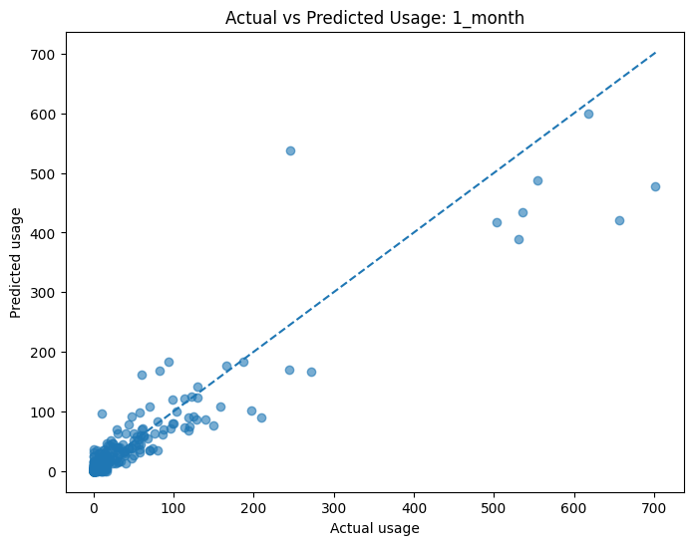
Figure 8: Actual usage vs predicted usage for 1-month horizon

3-Month Forecast

The below figure 9 demonstrates the relationship between the observed and predicted biologic medicines usage generated by the 3-month XGBoost [27] model. Most of the observations are clustered around the line of perfect prediction, indicating that the model accurately captured the demand for lower-volume medicines. In comparison to 1-month model there is greater clustering around this line for the low volume medicines. Greater deviation from the reference is evident for several higher volume observations much like the 1-month model, where the model can be seen to generally underpredict the actual medicines demand. Despite these deviations there was an overall positive relationship between the actual and predicted values, indicating that the model successfully identified the underlying demand patterns with the validation dataset.

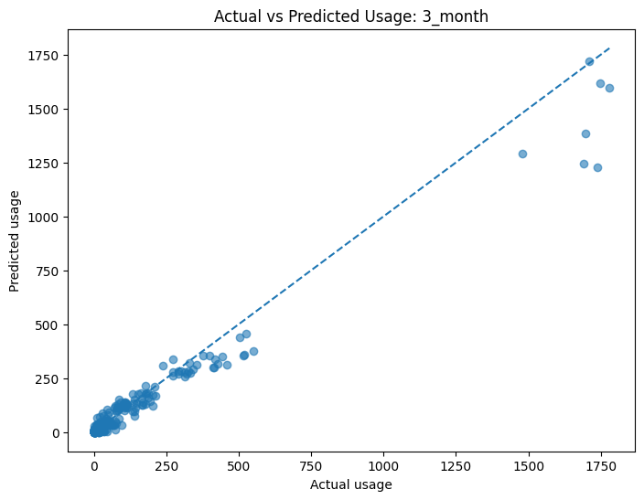
Figure 9: Actual usage vs predicted usage for 3-month horizon

6-Month Forecast

The below Figure 10 demonstrates the relationship between the observed and predicted biologic medicines usage generated by the 6-month XGBoost [27] model. Like the 3-month model, most observations are clustered closely around the line of perfect prediction, indicating that the model accurately captured the demand for lower-volume medicines. The clustering of observations around the reference line remains consistent across the lower and medium usage ranges, demonstrating strong agreement between the observed and predicted values.

As with the previous forecasting horizons, greater deviation from the reference line is evident for several of the higher-volume medicines, where the model generally underpredicts the actual demand. However, despite these deviations, the model continues to closely follow the overall demand trend, with predictions remaining well aligned to the observed values. This demonstrates a strong positive relationship between the actual and predicted medicines usage and indicates that the 6-month XGBoost model [27] successfully captured the underlying demand patterns within the validation dataset.

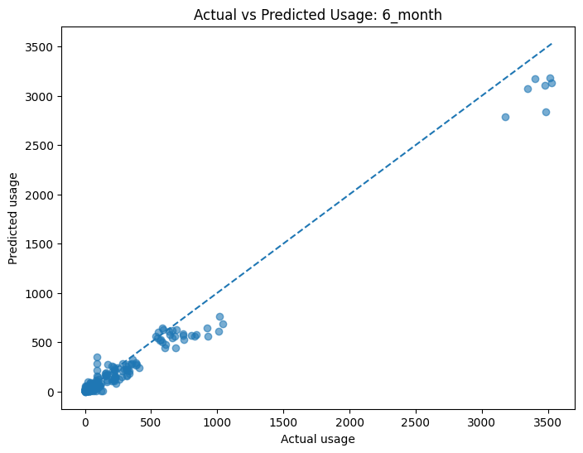
Figure 10: Actual usage vs predicted usage for 6-month horizon

Model Evaluation Metrics

The forecasting performance of the developed XGBoost [27] models was evaluated across the three horizons, 1-month, 3-month and 6-month using the evaluation framework described in the methodology. The model’s performance was assessed using the below measures:

- Mean Absolute Error (MAE)
- Root Mean Squared Error (RMSE)
- Mean Absolute Percentage Error (MAPE)
- Weighted Mean Absolute Percentage Error (WMAPE)
- Symmetric Mean Absolute Percentage Error (SMAPE)
- The Coefficient of Determination (R²)

Figure 11 below summarise the overall performance of the model for each of the forecasting horizons.

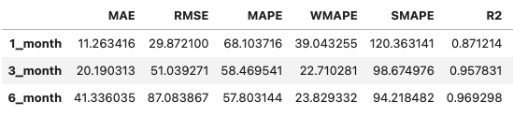
Figure 11: Performance metric output for all horizons

The results demonstrate variation in forecasting performance across the three horizons. The 1-month forecasting model achieved the lowest MAE of 11.26 and RMSE of 29.87. As the forecasting horizon increases both the MAE and RMSE increased, the 6-month model showed the largest forecasting errors.

The percentage-based performance measures showed a different trend. The 1-month model produced a WMAPE of 39.04%, where the 3-month and 6-month models achieved SMAPE of 22.71% and 23.83% respectively. This trend was similarly observed for the SMAPE measure which decreased from 120.36% for the 1-month model to 98.67% for the 3-month model and 94.21% for the 6-month model. These results of this evaluation indicate differences in model performance depending on the evaluation metric employed.

The R² increased across all the forecasting horizons ranging from 0.871 for the 1-month model to 0.969 for the 6-month model. This gives an indication that the longer horizons explained a greater variation that is present within the validation dataset.

The XGBoost [27] model demonstrates the ability forecast biologic medicines usage across all three of the prediction horizons. While the absolute forecasting errors increased as the forecast horizon increased, the percentage-based measures and R² values demonstrated differing trends.

Comparison with Naïve Forecast

To determine whether the XGBoost [27] models provided meaningful predictive value, the forecasting performance was compared against a naïve forecasting benchmark. The naïve model utilised the previously observed medicines usage value (lag1) as the prediction of future demand.

Figure 12 compares the naïve forecast results to the results obtained from the XGBoost models [27].

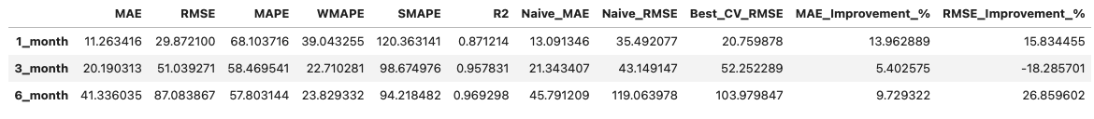
Figure 12: Performance metrics compared to naïve benchmark for all horizons

The results demonstrate that the XGBoost [27] model consistently outperformed the naïve benchmark when evaluated MAE. The greatest improvement was observed for the 1-month model where the MAE was reduced by 13.96%, while improvements of 5.4% ad 9.73% were achieved for the 3-month and 6-month models respectively.

A similar trend was also observed when RMSE was concerned, the 1-month and 6-month forecasting horizons showed reductions of 15.83% and 26.86% respectively in comparison to the naïve benchmark. The 3-month model produced a higher RMSE than the naïve forecast produced, this resulted in a decrease of 18.29% in performance according to this metric. This indicates that although the 3-month model achieved lower average forecasting errors that within the validation period several large prediction errors occurred.

The comparison with the naïve benchmark demonstrates that the XGBoost model provides improved predictive performance that a simple persistence-based forecasting approach. This indicates that the machine learning model could extract meaningful temporal relationships from the historic biologic medicine’s usage.

Statistical Comparison of Forecasting Models

To determine whether the observed differences in the forecasting performance between the 1-month, 3-month and 6-month models and the naïve benchmark were statistically significant, the Diebold-Mariano [55] was applied to the forecast error series generated during the model validation.

The below figure 13 shows the results of the pairwise Diebold-Mariano comparisons of the three forecasting horizons.

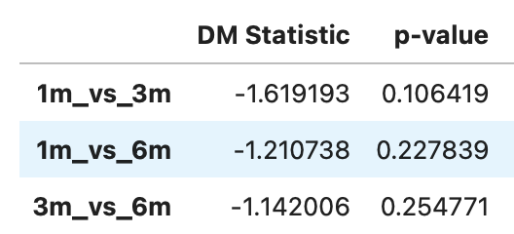
Figure 13: Diebold-Mariano test results for forecast comparison.
The Diebold-Mariano [55] test identified no statistically significant differences in forecasting accuracy between any of the forecasting horizons, as all the p-values exceeded the significance threshold. The comparison between the 1-month and 3-month forecasting models produced the lowest p-value, however those remained above the threshold required to reject the null hypothesis.

The findings give an indication that although differences were observed in the forecasting performance of each of the horizons, the variations in forecasting accuracy between each of them was not enough to be considered statistically significant. No individual forecasting horizon demonstrated statistically superior predictive performance over the other based on the forecast error distributions analysed.

To provide further analysis and evaluation of the practical benefits of the machine learning approach, the Diebold-Mariano test [55] was applied to compare the XGBoost [27] models against the corresponding naïve forecast. The results are presented below in figure 14.

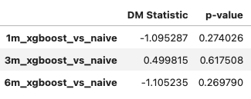
Figure 14: Diebold-Mariano test results for forecast comparison to naïve benchmark.
Like the comparisons between the forecasting horizons in figure 14, none of the XGBoost [27]models demonstrated statistically significant improvements over the naïve forecast, all the p-values exceeded the significance threshold of 0.05. Although the quantitative metrics presented in the forecasting performance section, indicated that the XGBoost [27] models generally achieved lower forecasting errors that then the naïve approach. The Diebold-Mariano test suggests that these improvements were not large or consistent enough to demonstrate a significant statistical superiority over the naïve forecast.

Overall, the statistical analysis indicates that whilst differences in forecasting performance were observed between the competing models and the naïve benchmark, these differences demonstrated no significant statistical differences. Therefore, the null hypothesis could not be rejected for any of the comparisons undertaken.

SHAP Model Interpretation

To improve the transparency and interpretability of the developed XGBoost [27] forecasting models, Shapley Additive Explanations (SHAP) [29][30] were applied to examine the contributions of features to the models’ predictions. SHAP [29][30] provides a global explanation of model behaviour, by quantifying the impact of each feature on the forecasted output, this allows the most influential predictors to be identified across the entire validation dataset. This supports greater understanding of the underlying decisions taken by the machine learning model.

Figures 15-17 present the SHAP [29][30] plots of the 1-month, 3-month and 6-month models. Each plot has the features ordered according to their contribution to the models’ prediction, with features positioned at the top of the plot having the greatest influence. The colour gradient represents the magnitude of the feature values.

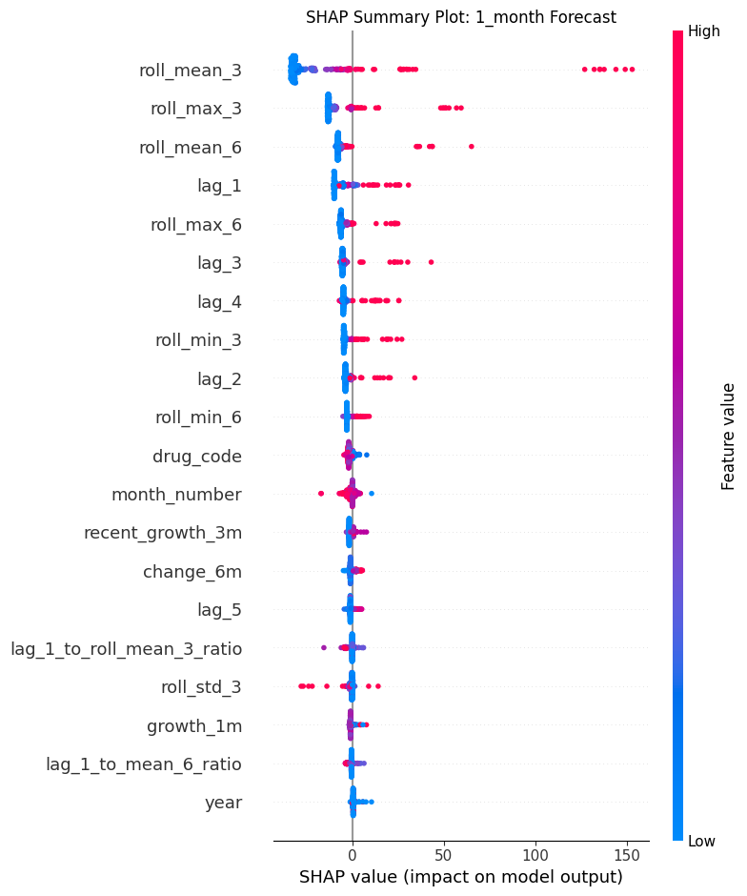
Figure 15: SHAP Global Output 1-month horizon

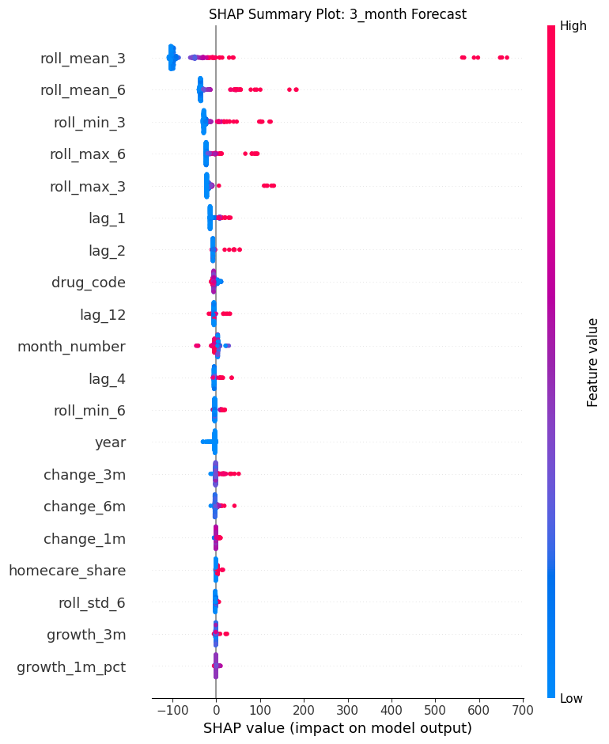
Figure 16: SHAP Global Output 3-month horizon

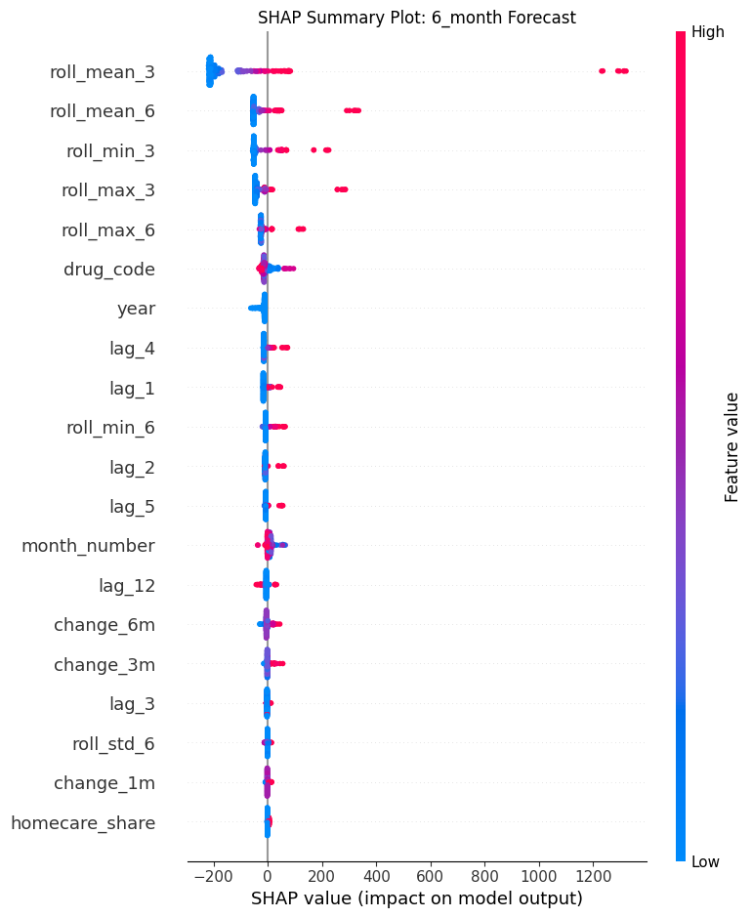
Figure 17: SHAP Global Output 6-month horizon
The SHAP [30] model analysis demonstrated a high degree of consistency across the three forecasting horizons. The rolling historical utilisation features were identified as the dominant predictors if future biologics demand, with the feature roll_mean_3 the 3-month rolling mean was consistently shown to be the most influential feature across each of the forecasting models. Similarly, the features, roll_mean_6, roll_max_3, rol_max_6 and roll_min_3 were also ranked among the higher contributors to model predictions. This indicates that individual observations do not provide as great a predictive value as aggregated historical usage.

The second set of influential features were the lag-based features, these also contributed to the model-performance. The features lag_1, lag_2, lag_3 and lag_4 consistently appeared as the most influential predictors to model performance. Their contribution is lower than that of the statistical rolling features. This suggests that whilst the recent utilisation remains an important indicator of future demand, the summarisation of historical behaviour over multiple time periods provides a more informative representation of usage trends.

In contrast to the previous sets of features, the calendar variables month_number and year demonstrated limited influence on the models. This was seen also with the derived growth variables and the homecare-specific features which contributed very little to the models’ overall predictions. This suggests that the forecasting models has relied primarily on the historical utilisation behaviour rather than seasonal or temporal characteristics when generating the predictions.

Comparison of the three forecasting horizons demonstrated consistency in feature importance rankings. Although the magnitude of the SHAP [29][30] values increased for the longer forecasting horizons, this reflects the longer prediction targets, the relative ordering of the influential features remained for the most part unchanged. This consistency provides additional confidence in the robustness of the forecasting framework, indicating that the similar historic demand characteristics underpin predictions regardless of the horizon considered.

Local SHAP Interpretation

Whilst the global SHAP [29] analysis provides an understanding of the overall feature importance of the dataset, local SHAP [29] explanations enable interpretation of individual forecasts by quantifying the contributions of each feature to a specific prediction. This provides greater transparency regarding why a particular forecast was generated and supports the practical application of machine learning in healthcare [36].

The below figure 18 presents as SHAP [29] waterfall plot for an individual prediction.

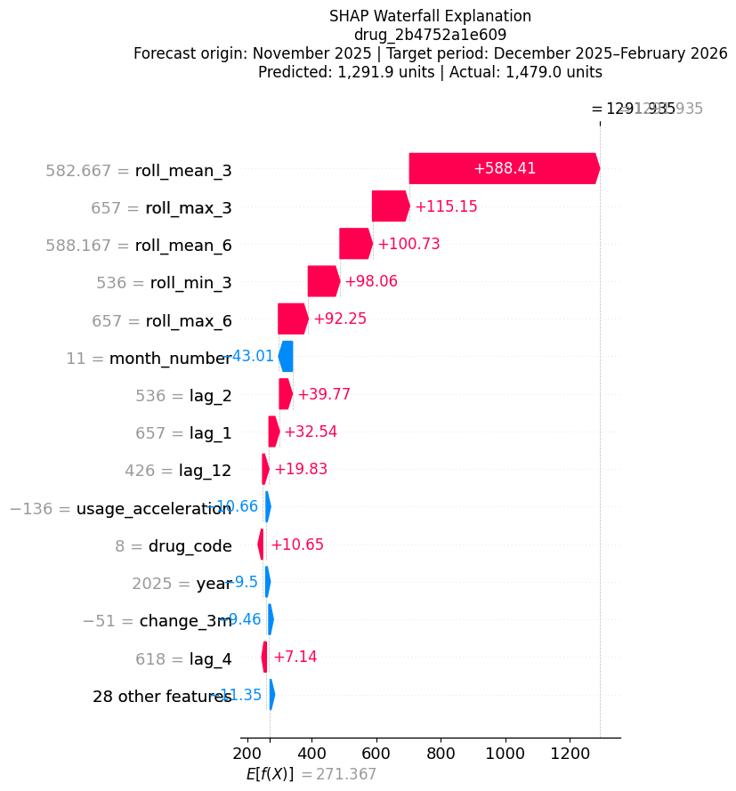
Figure 18: SHAP Local Output for specific forecast

Figure 18 presents the local SHAP [29][30] explanation for a forecast generated from a November 2025 forecast origin. The model predicted 1291.9 units whereas the observed utilisation was 1479 units, representing an underprediction of 187.1 units. SHAP [29][30] indicates that the prediction was drive predominantly by recent historic usage, particularly the 3-month rolling mean, together with other rolling statistics and lagged demand features. These variables correctly indicated that usage would remain high, but the model did not fully capture the subsequent increase in usage observed in the forecast period. This suggest that factors not represented in the training data, such as accelerated patient uptake or clinical policy changes, could have contributed to the higher-than-expected demand.

The incorporation of both global and local SHAP [29][30] explanations strengthen the interpretability of the forecasting framework by demonstrating not only which of the features was the most influential but also how the features combine to produce an individual forecast. This level of explainability increases confidence in the forecasting model and supports its potential application within healthcare [36].

Discussions

Overview of Findings

This chapter discusses the findings presented in the Results chapter and evaluates their significance in relation to the research objectives and existing literature. The primary aim of this research was to investigate whether machine learning techniques specifically XGBoost [27], could accurately forecast the future biologics medicines usage within NHS secondary healthcare using historical pharmacy usage data. This chapter also considers the practical implications of the forecasting framework, evaluates the strengthens and limitations of the proposed research approach, and identifies the opportunities for future development.

The results demonstrated that the developed XGBoost [27] models could forecast biologics medicines usage across periods of 1-month, 3-month and 6-months. Visual assessment of the forecasting models demonstrated a strong relationship between observed and predicted utilisation, whilst the quantitative evaluation indicated good predictive performance across all forecasting horizons. The models also generally outperformed the naïve forecasting benchmark when assessed using the selected forecasting metrics, demonstrating the potential value of machine learning supporting medicines usage forecasting.

The models were compared statistically using the Diebold-Mariano test [55] for the different forecasting horizons and naïve benchmark, from the test these were not statistically significant. These findings suggest that although the numerical differences in the forecasting performance were observed, no individual forecasting horizon demonstrated statistically superior predictive accuracy based on the validation data that was analysed.

The SHAP [29][30] analysis further demonstrated that the historical utilisation characteristics such as the lag-based features and rolling statistical features, were the dominant contributing features for model prediction. This supports the importance of historical demand behaviour when forecasting biologics medicines usage and provides greater transparency [36] regarding the decisions taken by the XGBoost [27] models.

The overall results demonstrate the potential of machine learning to support biologics usage forecasting, additional analysis also identified factors that influenced the forecasting performance. These findings provide further insight into the robustness of the forecasting framework and are explored later in this chapter alongside comparisons with previous research, consideration of practical implication within NHS secondary healthcare, and recommendations for future development.

Discussion of Forecasting Performance

Comparison with Existing Literature

The findings of this research demonstrate that XGBoost [27] can be successfully applied to forecast biologics medicines usage within NHS secondary healthcare using historical pharmacy usage data. Across all forecasting horizons, the developed models demonstrated strong predictive capability, supporting the growing body of evidence that machine learning techniques can effectively model complex healthcare demand [6][8][25].

Previous research has reported that machine learning algorithms outperform traditional statistical forecasting methods when modelling pharmaceutical demand due to their ability to capture complex, non-linear relationships within the data [6][31][32]. The findings of this project support the conclusions identified within the research. The XGBoost [27] models across all horizons showed good predictive performance and generally produced lower forecasting errors than the naïve benchmark. This suggests that incorporating historical utilisation behaviour and engineered temporal features enabled the model to learn meaningful patterns beyond simple persistence forecasting.

The importance of the historical usage measures was further reinforced by the findings of the SHAP [29][30] analysis. This analysis demonstrated the importance of not only the historical usage measures but also the lag-based features, these were shown across the three forecasting horizons as the most influential features. This aligns with previous healthcare forecasting studies such as Barrow et al [7] and Xu et al [3] which identify historic medicines usage as strong determinants of future demand. The relatively limited contribution of calendar-based variables also suggests that recent usage behaviour was more informative than seasonality alone within the data analysed.

An interesting finding discovered during this project was that the percentage-based forecasting metrics demonstrated relatively consistent performance across the three horizons. Whilst the absolute forecasting errors increased as expected for the longer forecasting periods, WMAPE and SMAPE indicated comparatively stable proportional forecasting performance. This suggests that XGBoost [27] was able to maintain robust predictive capability over medium-term forecasting horizons, this finding is consistent with other healthcare forecasting research [25][3].

Despite the numerical improvements observed across the forecasting metrics, the Diebold-Mariano [55] comparisons identified no statistically significant differences between the forecasting horizons or between the XGBoost [27] models and the naïve benchmark. This indicates that although the machine learning models generally achieved lower forecasting errors, the magnitude of these improvements was insufficient to show statistical superiority.

These findings demonstrate that XGBoost provides a robust framework for modelling biologic medicines usage, although the statistical evidence indicates that differences between competing forecast approaches should be interpreted with appropriate caution.

Interpretation of Forecasting Performance

The forecasting results demonstrates that the developed XGBoost [27] models could identify meaningful relationships within historical biologics usage data and applying these relationships to predict future medicines usage across the three forecast horizons. The consistently high R² values and relatively low WMAPE value indicate that the models were able to successfully capture the underlying demand patterns within the dataset, despite increasing uncertainty associated with longer forecast horizons. These results suggest that machine learning provides a suitable framework for modelling biologics usages within NHS secondary care.

One of the more notable findings was the differing behaviour observed between the absolute and percentage-based forecasting metrics. While MAE and RMSE increased as the forecasting horizon extended, the WMAPE and SMAPE demonstrated relatively consistent performance across the three prediction horizons. This difference reflects the characteristics of the evaluation metrics themselves. MAE and RMSE quantify the magnitude of the forecasting errors in absolute terms and therefore naturally increase as forecast values become larger. In contrast to this, WMAPE and SMAPE assess the forecasting performance relative to the magnitude of the observed demand, this provides a more representative assessment of proportional forecasting accuracy across medicines with varying usage volumes. Although the longer horizons produced larger absolute errors, their proportional forecasting performance remained comparatively stable.

The comparison with the naïve forecast benchmark further demonstrated that the XGBoost [27] models generally achieved lower forecasting errors that the simple persistence-based forecasting model. This suggests that the incorporation of engineered historic usage features enables the model to learn the temporal relationships that extend beyond simple continuation of previous demand. However, the Diebold-Mariano [55] analysis indicated that these improvements from the naïve forecast benchmark were not statistically significant. This finding highlights the importance of distinguishing between numerical improvements in forecasting metrics and formal statistical evidence of superior predictive performance. While the XGBoost [27] models generally produced lower forecasting errors, the variability present within the forecast error series meant that the observed improvements were insufficient to reject the null hypothesis of equal predictive accuracy.

Visual assessment of the forecasting outputs also demonstrated that the models accurately captured the overall trend in biologics usage across all the horizons. Most observations remained closely aligned with the line of perfect prediction, indicating strong agreement between the observed and predicted values. There was increased dispersion for a small number of high usage medicines, this suggests that the forecasting errors became more pronounced for medicines with larger usage.

The forecasting framework demonstrated good predictive capability whilst maintaining a consistent performance across the three horizons. Although statistical comparison indicated no significant differences between the models, the combination of quantitative metrics, visual assessment and explainability analysis suggests that XGBoost [27] provides a robust and practically applicable approach for forecasting the use of biologic medicines.

Discussion of SHAP Findings

The SHAP [29][30] analysis provided valuable insights into the factors influencing the forecasting models and complemented the evaluation of the quantitative metrics by improving the interpretability of the XGBoost [27] models. While the forecasting metrics demonstrated that the models were capable of accurately predicting the usage of biologic medicines, SHAP [29][30] explains how each of the features contributed to the model’s prediction. This address recognised limitations of machine learning techniques, which have been criticised for limited transparency [36].

The SHAP [29][30] analysis of the three horizons consistently identified rolling historic usage measures as the most influential features of future medicines usage. In particular, the 3-month and 6-month rolling averages contributed more strongly to model prediction than individual lag observations. This suggests that recent usage trends provide a more stable representation of future demand than isolated historic values.

The lag-based variables also demonstrated consistent importance across the three horizons. The contribution of these variables confirm that previous usage remains an important predictor of the future biologic’s usage. The combination of lag variables and rolling statistical features therefore enabled the model to capture both short-term fluctuations and longer-term usage patterns.

In contrast to the lag and statistical rolling features, the temporal features including month number and year, contributed little to the forecasting models. This finding suggests that the biologics medicines included within this project showed demand patterns that were driven primarily by historic usage rather than by strong seasonal effects. Given that these medicines are used in the management of dermatological conditions, this finding is clinically plausible as prescribing behaviour is generally influenced by ongoing treatment requirements rather than seasonal variation [18].

An important observation from the SHAP [29][30] was the consistency of the feature importance across all three of the horizons. Although the magnitude of the SHAP [29][30] values increased as the prediction horizon was extended, this reflected the larger forecast values, the ranking of the most influential features remained for the most part unchanged across those horizons. This suggests that the underlying drivers of biologic demand remain unchanged and stable regardless of the forecasting horizon.

The inclusion of SHAP [29][30] analysis demonstrates the potential value of explainable artificial intelligence within medicines management. While high predictive accuracy is essential, healthcare organisations increasingly require machine learning models to provide transparent and interpretable outputs before they can support operational decisions [33][36].

Sensitivity Analysis

During the evaluation of the forecasting models, visual inspection of the prediction plots identified that a single biologic had substantially higher usage than the remainder of the dataset. As biologic medicines exhibit highly skewed usage, it was considered important to investigate whether this medicine was masking the underlying performance of the forecasting models.

The figure 19 below shows the disproportionate usage of this medicine.

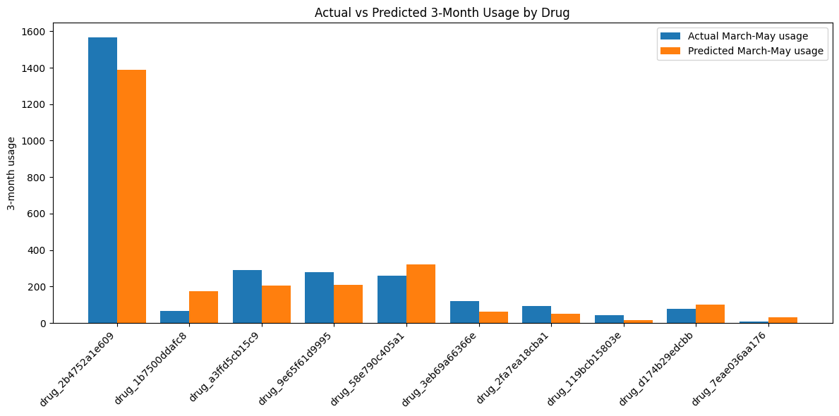
Figure 19: Top medicines usage actual vs predicted
To assess the robustness of the model, the high usage medicine was removed from the dataset, and the complete modelling pipeline was repeated. This analysis was not intended to improve the reported forecasting performance but rather to determine the extent to which a single influential medicine affects the evaluation metrics and the overall interpretation of the framework.

Comparison of Forecasting performance

The figures 20 and 21 below compare the forecasting metrics produced.

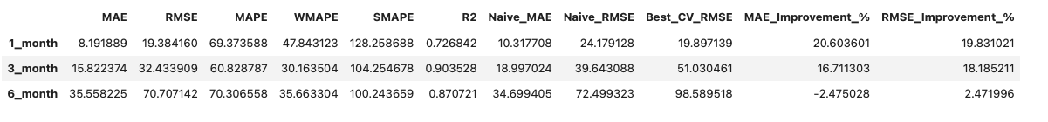
Figure 20: Performance metrics without high usage medicine

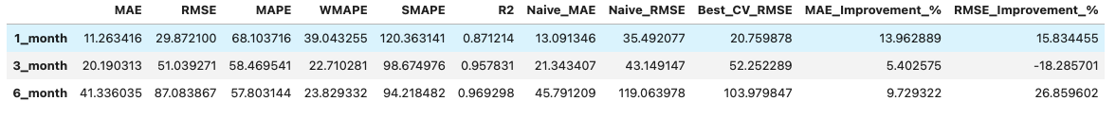
Figure 21: Performance metrics with high usage medicine
The comparison shows that excluding the medicine produced mixed effects across the evaluation metrics, indicating that different measures of forecasting performance responded differently to changes in the underlying demand distribution.

Across the three horizons, removal of the high usage medicine resulted in lower MAE and RMSE values. This indicated that the largest absolute forecasting errors were associated with the excluded medicine. These findings suggest that a relatively small number of observations with exceptionally high usage contributed disproportionately to the overall forecast error.

In contrast the percentage-based forecasting metrics demonstrated a different pattern. WMAPE increased from 39.04% to 47.84% for the 1-month model, from 22.71% to 30.16% for the 3-month model and from 23.83% to 36.66% for the 6-month model. Similar increases were observed for SMAPE, while R² declined across all the horizons. These findings indicate that although the exclusion of the highest-volume medicine reduced absolute prediction errors, it also altered the overall demand distribution within the dataset.

Comparison of Prediction Plots

To determine whether the medicine with disproportionate high usage affected the graphical representation of forecasting performance, the predicted versus observed plots were compared before and after its removal.

Figure 22 shows the original prediction graph.
Figure 22: Prediction Graph for model with high usage medicine
The original model demonstrated a strong positive relationship between the observed and predicted values, although several high usage observations exhibited noticeable deviation from the line of perfect prediction. These observations were generally positioned below the reference line indicating that the model tended to underpredict medicines with exceptionally high demand.

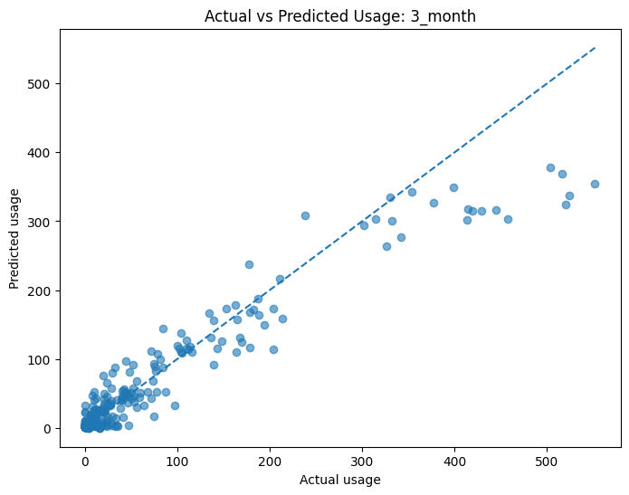
Figure 23: Prediction Graph for model without high usage medicine
Following the exclusion of the highest-volume biologic medicine, the remaining observations exhibited tighter clustering around the line of perfect prediction, with fewer extreme deviations from the line. This visual improvement is consistent with the reductions observed in MAE and RMSE, suggesting that the largest absolute forecasting errors were associated with the excluded medicine. This reduced dispersion indicates that the forecasting framework was able to model the usage patterns of the remaining medicines with greater consistency.

Whilst the graphical comparison demonstrates improved agreement between observed and predicted values, this does not necessarily indicate that the model had superior overall forecasting performance but rather reflects the influence that one high usage medicines have on the original plots and metrics.

Overall, the comparison of the prediction plots indicates that the original model’s tendency to underpredict was largely driven by the inclusion of the single high usage medicine. Following the exclusion of this medicine the remaining observations were notably closer in agreement with line of prediction. However, it must be noted that a degree of underprediction remained indicating that accurately predicting extreme demand continues to be a challenge.

Statistical Comparison

Whilst the evaluation metrics demonstrated that exclusion of the high usage medicine influenced the forecasting performance, t remained necessary to determine whether these changes altered the statistical comparison between the horizons.

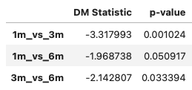
Figure 24: Diebold-Mariano test output for model without high usage medicine compared to other horizons.
Thes sensitivity analysis produced notably different Diebold-Mariano [55] results compared with the original forecasting models. Following the exclusion of the high usage medicine, statistically significant differences were identified between the 1-month and 3-month horizon and the 3-month and 6-month horizon. The 1-month and 6-month approached statistical significance but remained marginally above the threshold. These finding indicate that removal of the high usage medicine removed variability within the forecast error series, allowing statistically significant differences ion predictive accuracy between the horizons to become apparent.

To further investigate the exclusion of the medicines effect on the performance of the machine learning model, the Diebold-Mariano [55] test was again repeated against the naïve benchmark.

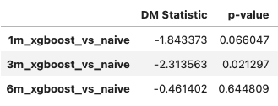
Figure 25: Diebold-Mariano test output for model without high usage medicine compared to naïve benchmark.
The comparison with the naïve benchmark demonstrated that only the 3-month XGBoost [27] model achieved a statistically significant improvement over the persistence-based forecasting. Although the 1-month model approached statistical significance the null hypothesis could not be rejected. Similarly, no statistically significant difference was identified with the 6-month XGBoost [27] model. These findings suggest that, following the removal of the high usage biologic the 3-month horizon retained the greatest predictive advantage over a simple persistence-based forecasting method.

Overall, the repeated Diebold-Mariano [55] analysis demonstrates that exclusion of the high-volume biologic medicine altered the statistical interpretation of the forecasting results. Whereas the original analysis identified no statistically significant difference between the competing forecasting horizons or between the XGBoost [27] models and the naïve benchmark., the sensitivity analysis revealed statistically significant differences involving the 3-month horizon. This suggests that the high usage medicine increased the variability within the original forecast error series, masking the differences in predictive performance.

Comparison of SHAP Outputs

Whilst the repeated Diebold-Mariano [55] analysis demonstrated that exclusion of the highest-volume biologic medicine altered the statistical interpretation of forecasting performance, it was also important to determine whether removal of this influential observation affected the underlying behaviour of the XGBoost [27] models. SHAP [29][30] analysis was therefore repeated to compare the relative importance of the predictor variables following exclusion of the medicine.
Figure 26: SHAP Global Output for model with high usage medicine 3-month forecast

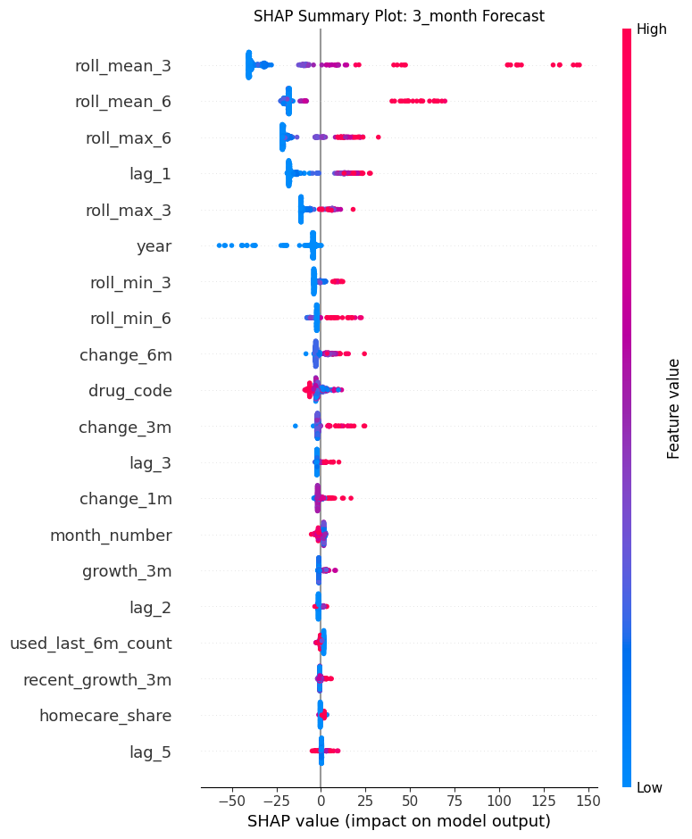
Figure 27: SHAP Global Output for model without high usage medicine 3-month forecast
Comparison of the SHAP [29][30] summary plots demonstrated that the overall ranking of the feature importance remained largely consistent following removal of the high usage medicine. Rolling historic usage measures continued to represent the most influential predictors of future usage, with roll_mean_3 remaining the dominant feature for both models.

Although minor changes were observed in the importance of several lower-ranked features, the overall SHAP [29][30] patterns remained largely consistent. Rolling averages and lag-based features continued to be the dominant features for the prediction of future biologics usage. This indicated that the removal of the high usage medicine influenced the evaluation metrics more than the underlying behaviour of the XGBoost [27] model. This suggest that the forecasting framework remained robust and continued to identify meaningful patterns rather than becoming dependent on a single influential medicine.

Practical Implications

The findings of this study demonstrate that machine learning can provide an accurate and interpretable approach for forecasting biologics medicines utilisation within NHS secondary healthcare. Whilst the primary objective of the research was to evaluate the predictive performance of an XGBoost [27] forecasting framework, the outcomes extend beyond model accuracy and have several practical implications for medicines management. Accurate forecasting of biologics demand has the potential to support financial planning, procurement activities, operational decision-making and the wider digital transformation of pharmacy services [22]. Furthermore, the inclusion of explainable artificial intelligence through SHAP [29] [30] analysis improves the transparency of model predictions, increasing their potential acceptability within clinical and operational settings [36].

Medicines Procurement

Beyond financial planning, accurate forecasting has practical applications within medicines procurement and supply chain management. Procurement teams must ensure sufficient medicine availability whilst avoiding unnecessary stock holding and waste. Underestimating demand may contribute to supply shortages or delays in treatment, whereas overestimating demand may increase inventory costs and medicine wastage [4][20].

Forecasting future utilisation using historical prescribing patterns could support more proactive procurement decisions by identifying anticipated increases or decreases in demand before they occur. This may be particularly valuable for biologic medicines supplied through homecare services or medicines requiring longer procurement lead times, where advanced planning can improve service continuity.

Although procurement decisions will always require professional judgement alongside forecasting outputs, predictive models may provide an additional evidence source to support users in making decisions rather than replacing existing procurement processes altogether.

Supporting Medicines Management Decisions

The forecasting framework may also provide valuable decision support for pharmacy and medicines management teams. Traditional reporting methods are primarily retrospective, describing medicines utilisation after activity has already occurred [1]. In contrast, predictive analytics provides an opportunity to anticipate future trends, allowing organisations to adopt a more proactive approach to medicines management [6].

Forecasts generated by the proposed model could assist medicines management teams in identifying medicines experiencing sustained increases in utilisation, monitoring usage trends, evaluating the impact of formulary changes and supporting service planning. Where forecasts differ substantially from expected demand, these outputs may also prompt further clinical or operational investigation to determine whether changes reflect genuine usage behaviour or emerging service pressures.

The integration of forecasting into routine reporting therefore has the potential to complement existing business intelligence by providing forward-looking insights that support earlier intervention and more informed operational decision-making.

Explainability in Artificial Intelligence

One of the principal advantages of the proposed forecasting framework is the incorporation of SHAP [29][30] analysis to explain individual model predictions. Whilst machine learning algorithms are often criticised for functioning as black box systems, explainable artificial intelligence provides greater transparency regarding the factors influencing model outputs [28].

The SHAP [29][30] analysis undertaken within this study demonstrated that historical utilisation, rolling averages and recent prescribing patterns consistently exerted the greatest influence on forecasting performance across all prediction horizons. These findings align with established understanding of medicines utilisation, increasing confidence that the model is learning clinically plausible relationships rather than relying upon spurious correlations.

Providing interpretable explanations alongside forecast values may improve user confidence, facilitate validation by pharmacy professionals and support governance requirements associated with the implementation of artificial intelligence within healthcare [34]. Rather than requiring users to accept predictions without explanation, SHAP [29][30] enables forecasting outputs to be interpreted within the context of historical prescribing behaviour.

Collectively, these findings demonstrate that machine learning has the potential to support a more proactive approach to medicines management within NHS secondary healthcare. By combining accurate forecasting with interpretable explanations, the proposed framework could complement existing reporting processes and provide additional evidence to support financial planning, procurement and operational decisions. Forecasts should not replace professional judgement but, they may provide valuable decision support that enables pharmacy teams to anticipate future demand and respond more effectively to changing medicines usage.

Limitations

Although the proposed forecasting framework demonstrated strong predictive performance and provided valuable insight into biologics medicines usage, there are several limitations which should be considered while interpreting the findings. These limitations relate to the scope of the dataset, the variables available for modelling, the influence of external factors on medicines demand, and the methodological decisions adopted throughout the research. Recognising these limitations provides important context for the interpretation of the results and identifies opportunities for future development.

Dataset Scope

The forecasting framework was developed using historical pharmacy issues data relating to dermatology biologic medicines from a single NHS organisation in Wales. Whilst the use of a real-world operational dataset increased the practical relevance of the research, the findings may not be fully generalisable to other Health Boards, clinical specialties or medicine groups that exhibit different usage behaviours and business practices. Restricting the study to dermatology biologics enabled detailed evaluation of a clinically important and high-cost group of medicines but inevitably limited the breadth of the investigation. Future studies incorporating data from multiple Health Boards and additional therapeutic areas would enable broader assessment of the forecasting framework and improve confidence in applying it for the forecasting across a wider range of medicines.

Data Availability and Feature Selection

The forecasting models were developed using routinely collected pharmacy issues data, with historical utilisation and derived temporal variables forming the primary predictors of future demand. Whilst these variables proved effective for forecasting, additional factors that may influence medicines utilisation were not available for use either within the dataset or were excluded from the study for information governance reasons.

Patient demographics, disease severity, treatment pathways, seasonal variation in clinical activity, and prescribing indication were outside the scope of the available data. Incorporating these variables may improve predictive performance by allowing the model to capture additional clinical and operational factors that influence biologic medicines usage.

External Influences on Medicines Demand

This forecasting framework assumes that future demand can largely be inferred from historical utilisation patterns. However, biologics prescribing within NHS organisations may be influenced by external factors that cannot be readily captured using historical medicines issue data alone. Changes in national prescribing guidance, biosimilar adoption programmes, commissioning policies, medicine shortages, supplier availability, new molecules, new formulations of existing medicines, and redesign of services may all result in sudden changes in demand that differ from established historical trends. Although these events were not explicitly modelled within this project, they should be considered when interpreting the forecasting results and represent potential opportunities for future model improvement.

Methodological Considerations

Finally, this research focused exclusively on XGBoost [27] as the predictive modelling technique. XGBoost [27] was selected following the literature review due to its strong performance on structured tabular datasets, ability to model complex non-linear relationships, and compatibility with explainable artificial intelligence techniques such as SHAP [29][30][31]. However, alternative forecasting approaches, including recurrent neural networks [37], Prophet [44], or hybrid models [56], were not evaluated within the scope of this project. Whilst comparison with a naïve forecasting benchmark provided an appropriate baseline for assessing predictive performance, evaluation against a wider range of forecasting algorithms may provide additional insight into the relative strengths and limitations of the proposed framework.

Despite the limitations discussed above, the study demonstrates that machine learning provides a practical and interpretable approach for forecasting biologics medicines usage within NHS secondary healthcare. The use of operational NHS data, comprehensive model evaluation, statistical comparison, SHAP [29] explainability, and sensitivity analysis provides a robust foundation for future research and demonstrates the potential of predictive analytics to support medicines management and financial planning within NHS Wales.

Future Work

Whilst this study demonstrates the potential of machine learning for forecasting biologics medicines utilisation, opportunities exist to develop this further and extend the proposed framework. The findings within this project provide a foundation for future research aimed at improving the generalisability of the model, the predictive performance and the practical implementation n a business environment.

Expansion of Data Sources

The forecasting framework developed within this study was evaluated using historical pharmacy issues data relating to dermatology biologic medicines from a single NHS Health Board. Future research should investigate the performance of the proposed approach using larger and more diverse datasets, incorporating multiple Health Boards, additional therapeutic specialties and a wider range of medicines. Such expansion would improve the generalisability of the findings and determine whether the forecasting framework performs consistently across different organisational settings [57].

Where appropriate governance and data protection arrangements permit, future research could investigate the inclusion of additional patient-level or service-level information, such as demographic characteristics, disease prevalence, treatment pathways or clinic activity. Incorporating these variables may allow the forecasting model to better account for the clinical and operational factors that influence medicines demand.

Evaluation of Alternative Forecasting Techniques

This research focused on XGBoost [27] due to its demonstrated performance on structured tabular datasets, ability to model complex non-linear relationships and compatibility with explainable artificial intelligence techniques. Whilst the results demonstrated strong predictive performance across all forecasting horizons, future research should compare the proposed framework with alternative machine learning and deep learning approaches.

Potential candidates include LightGBM [58], CatBoost [59], Long Short-Term Memory (LSTM) networks [37] and other modern time-series forecasting techniques [8][32][56]. Comparative evaluation would enable a more comprehensive assessment of forecasting accuracy, computational efficiency and model interpretability across different healthcare forecasting scenarios. Such comparisons would establish whether XGBoost remains the most appropriate approach for biologics forecasting or whether alternative methods provide meaningful improvements under different operational conditions.

Integration into NHS Digital Decision Support Systems

Building upon the findings of this research, future work should investigate the integration of predictive forecasting within existing NHS digital infrastructure. Historical pharmacy issues data could be extracted routinely from pharmacy information systems, processed through an automated forecasting pipeline and presented within interactive reporting platforms such as Power BI [21][23].

A potential implementation pathway would involve automated extraction of medicines utilisation data, scheduled feature engineering and model retraining, generation of forecasting outputs and SHAP [29] explanations, followed by visualisation through interactive dashboards accessible to pharmacy managers, procurement teams and finance departments. Such an approach would provide timely forecasting information whilst maintaining transparency through explainable artificial intelligence.

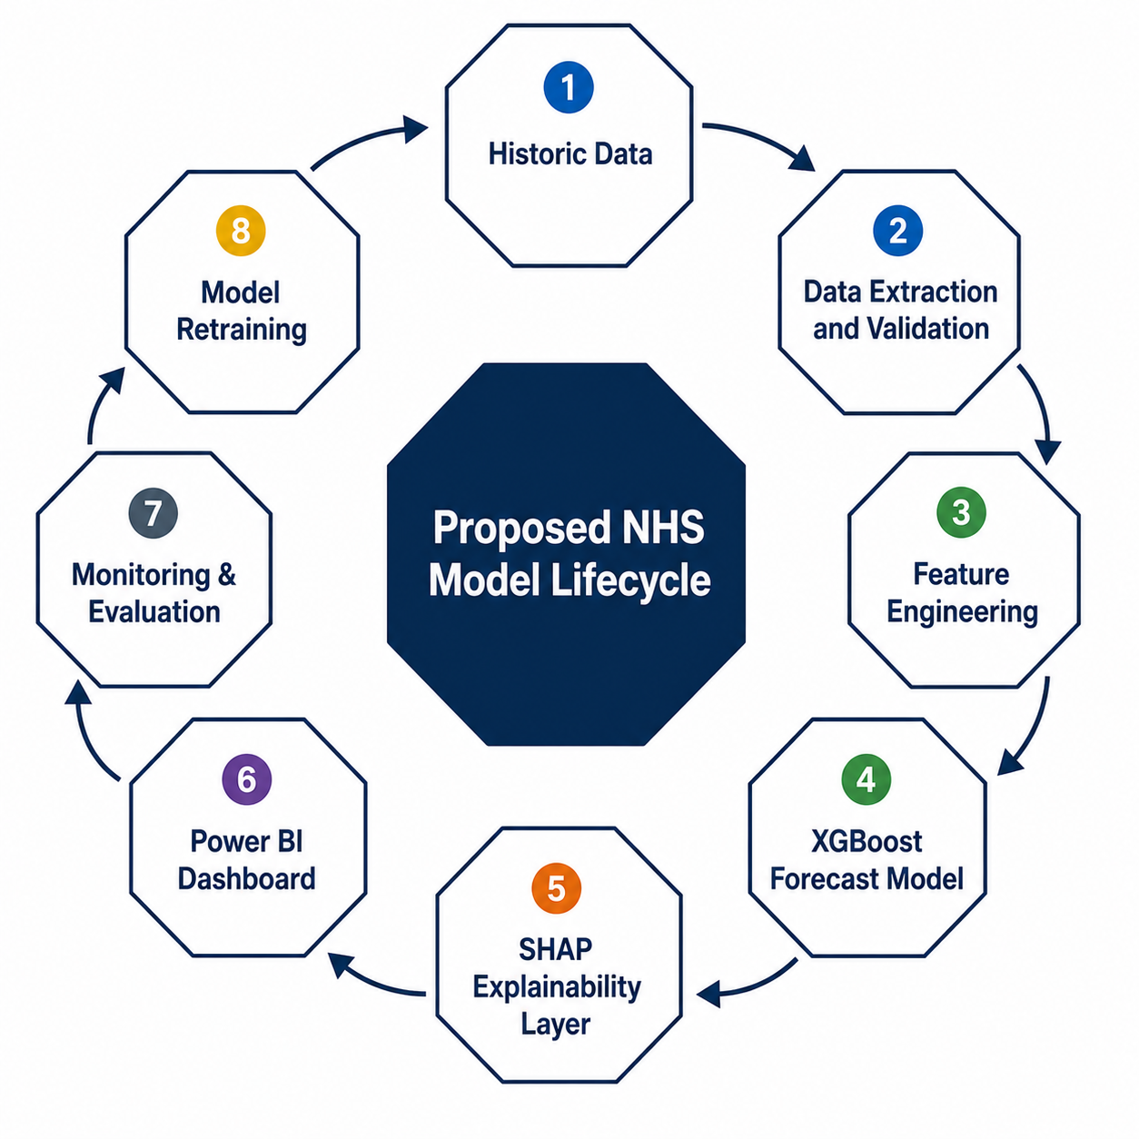
Figure 28: Proposed Model Cycle for use in NHS environment
Implementation within operational healthcare environments would require robust governance, comprehensive validation and ongoing monitoring of model performance to ensure forecasts remain accurate as prescribing patterns evolve. Future research should therefore investigate not only the technical feasibility of deployment but also the organisational, governance and user adoption considerations associated with embedding artificial intelligence within routine medicines management processes [34].

Future research should focus on expanding datasets available for model development, evaluating alternative forecasting techniques and investigating the practical implementation of predictive analytics within NHS pharmacy services. Collectively, these developments would improve the generalisability, robustness and real-world application of the proposed model, all the while supporting the continued adoption of data informed decision making [33].

Conclusion

The project investigated the application of machine learning techniques for forecasting the usage of biologic medicines within NHS secondary healthcare. The primary aim was to develop and evaluate an XGBoost [27] forecasting framework capable of predicting future medicines demand using routinely collected pharmacy issues data.

Historical pharmacy issues data was transformed into a structured forecasting dataset using standardised utilisation measures and engineered temporal features. Separate XGBoost [27] models were developed for 1-month, 3-month and 6-month horizons and evaluated using multiple performance metrics alongside a naïve forecasting benchmark. SHAP [29] [30] analysis was used to improve the model’s interpretability, whilst sensitivity analysis and Diebold-Mariano [55] testing provided additional assessment of model robustness.

The results demonstrated that the proposed forecasting framework achieved strong predictive performance across all the horizons. The forecasts closely reflected the observed usage patterns within the data. Comparing the XGBoost [27] models to the naïve benchmark highlighted the value of using machine learning as a forecasting approach, with SHAP [29] [30]complemented this approach by identifying the historic usage and rolling statistical features as the strongest contributors to model predictions. The sensitivity analysis that was undertaken further demonstrated that, although a single high usage medicine influenced several of the valuation metrics used, the underlying behaviour of the model remained stable.
Beyond the forecasting accuracy, this project demonstrated the practical potential of machine learning within NHS medicines management. The accurate forecasting of biologic medicines usage may support financial planning, procurement activities and operational decision-making by providing earlier visibility of future medicines demand. Furthermore, the inclusion of SHAP [29][30] explainability increases the transparency, allowing pharmacy professionals to better understand the factors that influence the model’s predictions.

This project contributes to the growing application of machine learning within healthcare by demonstrating an end-to-end forecasting framework using routinely collected pharmacy issues data. It also highlights the value of explainable artificial intelligence for improving the interpretability of forecasting models and provides a practical foundation for future research into predictive analytics for medicines management.

While further work is required to evaluate the framework using larger datasets, additional explanatory variables and alternative forecasting techniques, the findings that machine learning provides an accurate, robust and interpretable approach for forecasting biologics medicines usage.

Reflection

One of the most significant learning experiences through this project was developing an understanding and appreciation of explainable artificial intelligence (XAI). Prior to undertaking this project, my experience of machine learning focused primarily on producing accurate predictive models, with limited consideration of how model decisions can be interpreted. Through the implementation of SHAP, I developed a greater appreciation of the importance of model transparency, particularly within healthcare where decisions must be understandable and justifiable. Learning how individual features contributed to the predictions demonstrated that explainability is not simply an additional feature of the model, but going forward in a healthcare environment is a key feature for building trust and confidence in AI-assisted decision making.

The project also considerably also considerably strengthened my understanding of the XGBoost algorithm. Although I was initially familiar with the theoretical concepts of gradient boosting, implementing the model in practice required a much deeper understanding of hyperparameter optimisation, regularisation techniques and feature interactions and model validation. Experimenting with different parameter combinations and analysing their impact on model performance enabled me to move beyond using machine learning algorithms as black boxes and develop a stronger appreciation of the underlying principles governing their predictive performance.

One of the greatest personal lessons was recognising that developing an accurate forecasting model is a highly iterative process. At the outset of the project, I naively expected that selecting an appropriate algorithm and supplying the historic issues data would produce accurate forecasts with relatively little refinement. Instead, I quickly discovered that model performance is heavily dependent upon the quality of the underlying data and the suitability of the engineered features. This experience fundamentally changed my understanding of machine learning demonstrating that a substantial proportion of development time is dedicated to data preparation, experimentation, and continuous improvement rather than model training alone.

Feature engineering proved to be one of the most challenging aspects of the project. Determining which historical variables were likely to influence the future predictions of the model required extensive experimentation, with many features providing little or no improvement to forecasting performance. Developing lag variables, multiple forecasting horizons and sample weighting strategies highlighted how domain knowledge and iterative experimentation are often more influential than simply selecting increasingly complex algorithms. Reflecting on this process has reinforced the importance of adopting a systematic and evidence-based approach when developing predictive models.

Beyond the technical aspects of the project, I developed a greater appreciation of the organisational challenges associated with implementing a machine learning framework within healthcare. Producing an accurate model represents only one component of successful adoption within the NHS. The long-term sustainability of predictive analytics for service users also depends upon the availability of appropriately skilled staff who can maintain models, interpret their outputs and refine them as healthcare systems evolve. This project has highlighted the importance of investing in technical capability, multidisciplinary collaboration and ongoing professional development to ensure that advanced analytical methods can be successfully embedded into routine NHS practice.

Overall, this project has significantly developed both my technical competence and my approach to solving problems. I have gained practical experience in machine learning, explainable AI and predictive modelling while also developing a more realistic understanding of the iterative nature of data science projects. The greatest less has been recognising that successful machine learning is rarely achieved through a single model of algorithm, rather it is the result of continuous learning, experimentation and refinement. These experiences have strengthened my confidence in applying advanced analytics within healthcare and have provided a strong foundation for my future professional development in health informatics.

References
[1] M. L. Marino, B. Bellini, A. Cangini and F. Trotta, "Savings From Biosimilars Use in the Italian National Health Service," vol. 49, pp.101142, 2025, doi: 10.1016/j.vhri.2025.101142.
[2] A. Angelis, J. Lomas, B. Woods and H. Naci, "Promoting Population Health through Pharmaceutical Policy," 2023. [Online]. Available: https://www.lse.ac.uk/lse-health/assets/documents/Reports/23-0275-Pharma-Report-V10.pdf
[3] T. Xu, H. Bos, E. Byon, M. S. Lavieri, K. Renius and B. V. Sweet, "Forecasting hospital drug demand for demand patterns with changepoints," vol. 15, no. 3, pp.269–286, 2025, doi: 10.1080/24725579.2025.2538009.
[4] AWTTC, "Maximising the
opportunity presented
by biosimilar
medicines," 2023. Accessed: Apr 13, 2026. [Online]. Available: https://awttc.nhs.wales/files/guidelines-and-pils/maximising-the-opportunity-presented-by-biosimilar-medicines-a-national-strategy-for-walespdf/
[5] J. S. Frazer and G. R. Frazer, "Analysis of primary care prescription trends in England during the COVID-19 pandemic compared against a predictive model," Fam.Med.Community Health., vol. 9, no. 3, pp.e001143. doi: 10.1136/fmch–001143, Aug 2021, doi: 10.1136/fmch-2021-001143.
[6] K. P. Fourkiotis and A. Tsadiras, "Applying Machine Learning and Statistical Forecasting Methods for Enhancing Pharmaceutical Sales Predictions," vol. 6, no. 1, pp.186, 2024, doi: 10.3390/forecast6010010.
[7] D. Barrow, N. Kourentzes, M. Utleyand H. Kirkland, "Drug Demand Forecasting for Hospital Pharmacies using Temporal Hierarchies," 06/02 2026, [Online]. Available: https://tandf.figshare.com/articles/journal_contribution/Drug_demand_forecasting_for_hospital_pharmacies_using_temporal_hierarchies/31282859?utm_source=chatgpt.com&file=62083543
[8] M. Motamedi, J. Dawson, N. Li, D. G. Down and N. M. Heddle, "Demand forecasting for platelet usage: From univariate time series to multivariable models," vol. 19, no. 4, pp.e0297391, 2024, doi: 10.1371/journal.pone.0297391.
[9] S. B. Ekanayake, G. Lakmal, A. Perera, M. Nasmeen, P. Vimanshani and M. Chandrasena, "Predicting Medical Drug Sales in a Specific Area for Categorical Drugs using Time Series Forecasting", inpp. 1–6. doi: 10.1109/SCSE65633.2025.11031056.
[10] M. D. Russell and J. B. Galloway, "Driving down the cost of biologics: lessons from a nationalised health-care system," vol. 404, no. 10464, pp.1723–1724, 2024, doi: 10.1016/S0140-6736(24)02151-2.
[11] N. H. S. England. "NHS England » Commissioning framework for best value biological medicines." Accessed: Apr 13 2026. [Online]. Available: https://www.england.nhs.uk/long-read/commissioning-framework-for-best-value-biological-medicines/
[12] K. Saxby et al., , "A novel approach to support implementation of biosimilars within a UK tertiary hospital," Br.J.Clin.Pharmacol., vol. 86, no. 1, pp.23–28, Jan 2020, doi: 10.1111/bcp.14150.
[13] "What is technology appraisal guidance?" Accessed: Jul 18 2026. [Online]. Available: https://www.nice.org.uk/what-nice-does/our-guidance/about-technology-appraisal-guidance/what-is-technology-appraisal-guidance
[14] R. Heine et al., , "Health Economic Aspects of Chimeric Antigen Receptor T-cell Therapies for Hematological Cancers: Present and Future," Hemasphere, vol. 5, no. 2, pp.e524, Jan 28 2021, doi: 10.1097/HS9.0000000000000524.
[15] S. Willis. "Switching to biosimilars could save £1bn over five years, says NHS England" The Pharmaceutical Journal. (-02-07, 2025). Accessed: Apr 13, 2026. [Blog]. Available at: https://pharmaceutical-journal.com/article/news/switching-to-biosimilars-could-save-1bn-over-five-years-says-nhs-england
[16] NICE, "Adalimumab, etanercept
and ustekinumab for
treating plaque psoriasis in
children and young people," 2017. Accessed: Apr 15, 2026. [Online]. Available: https://www.nice.org.uk/guidance/ta455/resources/adalimumab-etanercept-and-ustekinumab-for-treating-plaque-psoriasis-in-children-and-young-people-pdf-82604846770117
[17] "Medicinal forms | Adalimumab | Drugs | BNF content published by NICE." Accessed: Apr 14 2026. [Online]. Available: https://bnf.nice.org.uk/drugs/adalimumab/medicinal-forms/
[18] T. Raine et al., , "Maintaining Clinical Freedom Whilst Achieving Value in Biologics Prescribing: An Integrated Cross-Specialty Consensus of UK Dermatologists, Rheumatologists and Gastroenterologists," BioDrugs, vol. 35, no. 2, pp.187–199, Mar 2021, doi: 10.1007/s40259-020-00464-5.
[19] National Homecare Medicines Committee, "Good Practice Principles:
Provision of Manufacturer Funded
Homecare Medicines Services," 2018. Accessed: Apr 15, 2026. [Online]. Available: https://www.sps.nhs.uk/wp-content/uploads/2018/03/NHMC-Good-Practice-Principles-Provision-of-Manufacturer-Funded-Homecare-....pdf
[20] S. George and S. Elrashid, "Inventory Management and Pharmaceutical Supply Chain Performance of Hospital Pharmacies in Bahrain: A Structural Equation Modeling Approach," vol. 13, no. 1, pp.21582440221149717, 2023, doi: 10.1177/21582440221149717.
[21] Anonymous "Digital and data strategy for health and social care in Wales," 2023. Accessed: Apr 15, 2026. [Online]. Available: https://www.gov.wales/digital-and-data-strategy-health-and-social-care-wales-html
[22] Lord Carter of Coles, "Operational productivity
and performance in English
NHS acute hospitals:
Unwarranted variations," 2016. [Online]. Available: https://assets.publishing.service.gov.uk/media/5a80bdfae5274a2e87dbb8f5/Operational_productivity_A.pdf
[23] DHCW, "Digital Health and Care Wales Organisational Plan," 2024. Accessed: Apr 16, 2026. [Online]. Available: https://dhcw.nhs.wales/files/dhcw-strategies-and-frameworks/digital-health-and-care-wales-organisational-strategy-2024-2030/?ts=1776367079735
[24] W. S. Alruqayb, V. Paudyal, P. Malcolm, A. Sarwar, J. Aston and A. R. Cox, "Drug utilisation study in hospitalised chronic kidney disease patients, using World Health Organisation prescribing indicators: an observational study," vol. 17, no. 1, pp.2430436, 2024, doi: 10.1080/20523211.2024.2430436.
[25] F. Orhan and M. N. Kurutkan, "Predicting total healthcare demand using machine learning: separate and combined analysis of predisposing, enabling, and need factors," vol. 25, no. 1, pp.366, 2025, doi: 10.1186/s12913-025-12502-5.
[26] K. Nikolopoulos, S. Buxton, M. Khammash and P. Stern, "Forecasting branded and generic pharmaceuticals," Int.J.Forecast., vol. 32, no. 2, pp.344–357, 2016, doi: 10.1016/j.ijforecast.2015.08.001.
[27] C. Tianqi and Carols Guestrin, "XGBoost | Proceedings of the 22nd ACM SIGKDD International Conference on Knowledge Discovery and Data Mining," 13/08 2026, [Online]. Available: https://dl.acm.org/doi/10.1145/2939672.2939785
[28] A. Carriero et al., , "Explainable AI in healthcare: to explain, to predict, or to describe?" Diagn Progn Res, vol. 9, no. 1, pp.29–8, 2025, doi: 10.1186/s41512-025-00213-8.
[29] S. M. Lundberg and S. Lee, "A unified approach to interpreting model predictions", in Proceedings of the 31st International Conference on Neural Information Processing Systems, Long Beach, California, USA, pp. 4768–4777.
[30] G. Feretzakis et al., , "Integrating Shapley Values into Machine Learning Techniques for Enhanced Predictions of Hospital Admissions," vol. 14, no. 13, 2024, doi: 10.3390/app14135925.
[31] M. Kamboj, D. Kamboj, K. Naveed, S. R. Das, B. Hassan and T. Tahir, "State-Level Drug Retail Sales Forecasting Using XGBoost and Facebook Prophet", in 2025 IEEE International Conference on Technology Management, Operations and Decisions (ICTMOD), pp. 1–6. doi: 10.1109/ICTMOD66732.2025.11371982.
[32] A. Manna, K. Kolpe, A. Mhalungekar, S. Pattewar, P. Kaloge and R. Patil, "Comparative Study of Various Machine Learning Algorithms for Pharmaceutical Drug Sales Prediction", in 2023 International Conference on Signal Processing, Computation, Electronics, Power and Telecommunication (IConSCEPT), pp. 1–6. doi: 10.1109/IConSCEPT57958.2023.10169964.
[33] M. A. Ahmad, C. Eckert and A. Teredesai, "Interpretable Machine Learning in Healthcare", inpp. 559–560. doi: 10.1145/3233547.3233667.
[34] A. R. Rao, R. Jain, M. Singh and R. Garg, "Predictive interpretable analytics models for forecasting healthcare costs using open healthcare data," vol. 6, pp.100351, 2024, doi: 10.1016/j.health.2024.100351.
[35] M. Nazar, M. M. Alam, E. Yafi and M. M. Su’ud, "A Systematic Review of Human–Computer Interaction and Explainable Artificial Intelligence in Healthcare With Artificial Intelligence Techniques," vol. 9, pp.153316–153348, 2021, doi: 10.1109/ACCESS.2021.3127881.
[36] S. S Band et al., , "Application of explainable artificial intelligence in medical health: A systematic review of interpretability methods," vol. 40, pp.101286, 2023, doi: 10.1016/j.imu.2023.101286.
[37] I. D. Mienye, T. G. Swart and G. Obaido, "Recurrent Neural Networks: A Comprehensive Review of Architectures, Variants, and Applications," vol. 15, no. 9, 2024, doi: 10.3390/info15090517.
[38] L. Breiman, "Random Forests," Mach.Learning, vol. 45, no. 1, pp.5–32, 2001, doi: 10.1023/A:1010933404324.
[39] C. Molnar, G. Casalicchio and B. Bischl, "Interpretable Machine Learning – A Brief History, State-of-the-Art and Challenges," in 2021. pp. 417–431. doi: 10.1007/978-3-030-65965-3_28.
[40] M. N. K. Saunders, P. Lewis and A. Thornhill,Research methods for business students, Harlow, England: Pearson, 2023.
[41] J. W. Creswell and J. D. Creswell,Research design : qualitative, quantitative, and mixed methods approaches, Thousand Oaks, California: SAGE Publications, Inc, 2023.
[42] Y. S. Park, L. Konge and A. R. Artino, "The Positivism Paradigm of Research," vol. 95, no. 5, pp.690–694, 2020, doi: 10.1097/ACM.0000000000003093.
[43] S. B. Merriam and E. J. Tisdell,Qualitative research : a guide to design and implementation, 4th Ed. San Francisco, CA: Jossey-Bass, 2016.
[44] S. J. Taylor and B. Letham, "Forecasting at Scale," vol. 72, no. 1, pp.37–45, 2018, doi: 10.1080/00031305.2017.1380080.
[45] Hyndman, R.J., & Athanasopoulos, G, Forecasting: principles and practice, 3rd edition, Third Ed. Otext: 2021.
[46] S. Makridakis, E. Spiliotis and V. Assimakopoulos, "The M4 Competition: Results, findings, conclusion and way forward," Int.J.Forecast., vol. 34, no. 4, pp.802–808, 2018, doi: 10.1016/j.ijforecast.2018.06.001.
[47] R. J. Hyndman and A. B. Koehler, "Another look at measures of forecast accuracy," Int.J.Forecast., vol. 22, no. 4, pp.679–688, 2006, doi: 10.1016/j.ijforecast.2006.03.001.
[48] A. de Myttenaere, B. Golden, B. Le Grand and F. Rossi, "Mean Absolute Percentage Error for regression models," vol. 192, pp.38–48, 2016, doi: 10.1016/j.neucom.2015.12.114.
[49] K. El Emam, S. Rodgers and B. Malin, "Anonymising and sharing individual patient data," BMJ, vol. 350, pp.h1139, 2015, doi: 10.1136/bmj.h1139.
[50] M. Steininger, K. Kobs, P. Davidson, A. Krause and A. Hotho, "Density-based weighting for imbalanced regression," Mach Learn, vol. 110, no. 8, pp.2187–2211, 2021, doi: 10.1007/s10994-021-06023-5.
[51] K. B. Prakash, Machine Learning for Industrial Applications, 1st Ed. Newark: John Wiley & Sons, Incorporated, 2024.
[52] P. Supakar, M. Sarkar and B. Sarkar, "Forecasting grocery item sales using gradient boosting models: A study of GridSearchCV, RandomizedSearchCV, and optuna optimization approaches," vol. 17, no. 3, pp.104012, 2026, doi: 10.1016/j.asej.2026.104012.
[53] B. S. Nathan, P. M. Aravinth, B. V. Reddy, C. C. Sastry, S. Salunkhe and R. Cep, "Primacy of feature engineering over architectural complexity for intermittent demand forecasting," Sci Rep, vol. 16, no. 1, pp.4792–20, 2026, doi: 10.1038/s41598-026-35197-y.
[54] S. Kolassa, "The Symmetric Mean Absolute Percentage Error: Unnecessary or Dangerous," vol. 8, no. 2, pp.24, 2026, doi: 10.3390/forecast8020024.
[55] F. X. Diebold, "Comparing Predictive Accuracy, Twenty Years Later: A Personal Perspective on the Use and Abuse of Diebold-Mariano Tests," vol. 33, no. 1, pp.1, 2015, doi: 10.1080/07350015.2014.983236.
[56] L. B. Sina, C. A. Secco, M. Blazevic and K. Nazemi, "Hybrid Forecasting Methods—A Systematic Review," vol. 12, no. 9, 2023, doi: 10.3390/electronics12092019.
[57] R. D. Riley et al., , "Evaluation of clinical prediction models (part 2): how to undertake an external validation study," vol. 384, pp.e074820, 2024, doi: 10.1136/bmj-2023-074820.
[58] G. Ke et al., , "LightGBM: A Highly Efficient Gradient Boosting Decision Tree", in Advances in Neural Information Processing Systems, [Online]. Available: https://proceedings.neurips.cc/paper_files/paper/2017/file/6449f44a102fde848669bdd9eb6b76fa-Paper.pdf
[59] L. Ostroumova, G. Gusev, A. Vorobev, A. V. Dorogush and A. Gulin, "CatBoost: unbiased boosting with categorical features", in Neural Information Processing Systems, [Online]. Available: https://api.semanticscholar.org/CorpusID:5044218

