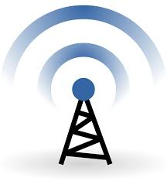

Wireless Networks and Simulation
  - Design and Evaluation of Wireless Sensor Networks
Paul Weaver | 1903439 | 10/05/2020

Abstract
The following report goes into detail about QAM and a wireless security system to help farmers in the Caribbean from being affected by local organize criminal gangs by implementing a wireless security system.

Table of Contents
Abstract 1
1.0 Introduction 3
2.0 QAM Research 4
2.1 Modelling and Recreation of Computer Systems and Frameworks: 4
2.2 Key Features 5
2.3 Fundamentals of QAM 5
2.4 QAM theory basics 5
2.5 Explanation of modulation technique 6
2.6 QAM advantages and disadvantages 8
2.7 Examples of implementations. 8
2.8 Pros and cons of using simulations over other methods 9
3.0 NETWORK SIMULATION 9
3.1 Concepts and operational Scenarios 9
4.0 EXPERIMENT 10
5.0 Bibliography 14

Introduction
The speculation behind the utility of open surveillance systems for wrongdoing expectation purposes is that potential transgressors will go without criminal development within the occasion that they know they are being watched and acknowledge they are at a more critical chance of dread. Video film announcing criminal development and recognizing offenders and witnesses may also offer assistance in examinations and arraignments, extending police and prosecutorial efficiency, benefitting wrongdoing casualties whose cases can be closed through the utilize of video demonstrate, and weakening a more critical number of guilty parties from committing future infringement [1].

QAM Research
Quadrature Adequacy Tweak, QAM may be a flag in which two carriers moved in stage by 90 degrees (i.e., sine and cosine) are balanced and combined. As a result of their 90° stage contrast, they are in quadrature, and this gives rise to the title. Regularly one flag is called the In-phase or "I" flag, and the other is the quadrature or "Q" flag. The resultant in general flag comprising of the combination of both I and Q carriers contains both adequacy and stage varieties. In see of the reality that both plentifulness and stage varieties are shown, it may moreover be considered as a blend of plentifulness and stage tweak. Inspiration for the utilize of quadrature sufficiency balance comes from the reality that straight adequacy tweaked flag, i.e., twofold sideband indeed with a smothered carrier, involves twice the transmission capacity of the tweaking flag. Typically, exceptionally inefficient of the accessible recurrence range. QAM re-establishes the adjust by putting two independent twofold sidebands stifled carrier signals within the same range as one conventional twofold sideband smothered carrier flag [2].

2.1 Modelling and Recreation of Computer Systems and Frameworks:
• Strategies and Applications present you to a wide cluster of modelling and recreation issues related to computer systems and frameworks. It centres on the hypotheses, instruments, applications, and employments of modelling and recreation in arrange to optimize systems successfully. It portrays techniques for modelling and recreation of modern eras of remote and mobile systems and cloud and lattice computing frameworks.
• computer systems and structures were counting but not constrained to; demonstrating, re-enactment, examination, and security of remote and mobile systems, particularly as they relate to another era remote networks.
• Methodologies, techniques and devices, and techniques required to construct computer systems and frameworks displaying and re-enactment from the foot up.
• Different arrange execution measurements counting, portability, clog, quality of benefit, security, and more.
Demonstrating and Recreation of Computer Systems and Frameworks could be a must-have an asset for organizing planners, engineers, and analysts who need to pick up knowledge into optimizing hold execution through the utilize of demonstrating and re-enactment [3].

2.2 Key Features
•Modelling, re-enactment, investigation, and security of remote and mobile systems, particularly as they relate to the following era remote systems.
•Provides the essential strategies, methodologies, and devices required to construct computer systems and frameworks demonstrating and re-enactment from the foot up.
•Includes comprehensive survey and assessment of re-enactment devices and techniques and distinctive organize execution measurements counting versatility, clog, quality of benefit, security, and more.

2.3 Fundamentals of QAM
The fundamental QAM hypothesis points to precise the operation of QAM, quadrature plentifulness balance using some numerical formulae.
Fortunately, it is conceivable to precise a few of the fundamental QAM hypothesis in terms of moderately straightforward conditions that give a few understandings into what is happening inside the QAM flag.

2.4 QAM theory basics
The elemental way in which a QAM flag can be made is to make two signals that are 90° out of stage with each other and after that entire them. This will produce a signal that's the whole of both waves, which contains a specific sufficiency coming about from the whole of both signals and a stage which once more is subordinate upon the whole of the signals [3].
If the adequacy of one of the signals is balanced at that point, this influence both the stage and plentifulness of the in the general flag, the stage tending towards that of the flag with the higher plentifulness substance [3].
As two RF signals can be tweaked, these are alluded to as the I - In-phase and Q - Quadrature signals.
The I and Q signals can be spoken to by the conditions below:
The I and Q components are spoken to as cosine and sine.
This is since the two signals are 90° out of stage with one another.

Using the two conditions, it is conceivable to precise the flag as Using the expression, A cos (2πft + Ψ) for the carrier signal.
Acos(2πft) =Icos (2 ft) −Qsin(2πft)
Where f is the carrier frequency.
This expression appears the coming about waveform could be an intermittent flag for which the stage can be balanced by changing the amplitude either or both I and Q. This may too result in a plentifulness alter as well [3].
QAM, quadrature adequacy balance gives a few unique benefits for information transmission. As 16QAM moves to 64QAM, 64QAM to 256 QAM, and so forward, higher information rates can be accomplished, but at the taken a toll of the commotion edge. Many information transmission frameworks move between the distinctive orders of QAM, 16QAM, 32QAM, etc., subordinate upon the interface conditions. On the off chance that there's a significant edge, higher orders of QAM can be utilized to pick up a quicker information rate, but on the off chance that the connect break down, lower orders are utilized to protect the clamour edge and guarantee that a moo bit blunder rate is protected [4].

2.5 Explanation of modulation technique
Quadrature Adequacy Balance may be a digital tweak strategy that uses the information to be transmitted to differ both the plentifulness and the phase of a sinusoidal waveform, whereas keeping its recurrence consistent. QAM could be a normal expansion of double stage move keying (BPSK) and quadrature stage move keying (QPSK), both of which shift as it were the stage of the waveform. The number of distinctive waveforms (special combinations of adequacy and phase) utilized in QAM depends on the modem and may shift with the quality of the channel. With 16-QAM, for illustration, 16 diverse waveforms are accessible. 64-QAM and 256-QAM are also common. 16,384-QAM is conceivable in ADSL modems. In all cases, each distinctive waveform, or amplitude-phase combination, could be a balanced image that speaks to a bunch of bits—the LVCT Quadrature Plentifulness Balance application employments 16-QAM. Within the modulator, sequential information bits are gathered four at a time to create quadbits, and each quadbit is spoken to by a diverse modulation symbol. Within the demodulator, each distinctive balance image within the gotten flag is translated as a unique design of 4 bits [4]. All 16 QAM balance images superposed on the same tomahawks. Four diverse colours are utilized within the figure, and each colour is being used for four distinctive waveforms. Each waveform includes a unique combination of stage and amplitude.

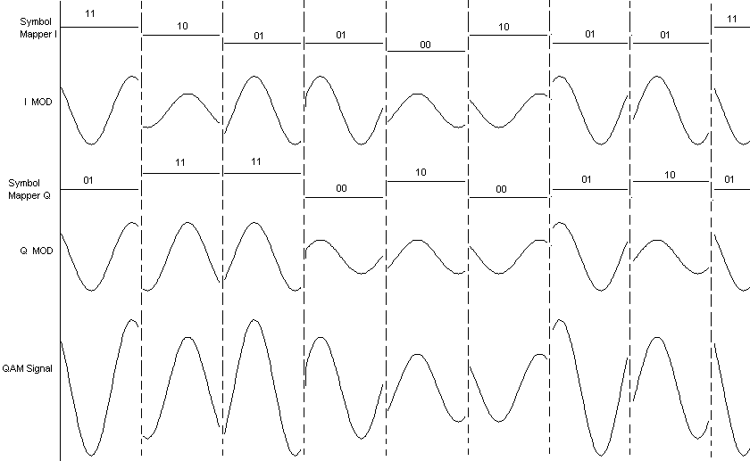

2.6 QAM advantages and disadvantages
Even though QAM shows up to extend the proficiency of transmission for radio communications frameworks by using both sufficiency and phase varieties, it includes several disadvantages. The primary is that it is more vulnerable to commotion since the states are closer together so that a lower level of commotion is required to move the flag to a diverse choice point. Recipients for utilization with stage or recurrence tweak are both able to utilize restricting intensifiers that can remove any plentifulness clamor and, in this manner, progress the commotion dependence. The moment impediment is additionally related to the adequacy component of the flag. When a stage or recurrence balanced flag is intensified in a radio transmitter, there's no ought to utilize straight speakers. However, when utilizing QAM that contains a sufficiency component, linearity must be kept up. Shockingly, direct speakers are less effective and expend more control, and this makes them less appealing for portable applications [4].

2.7 Examples of implementations.
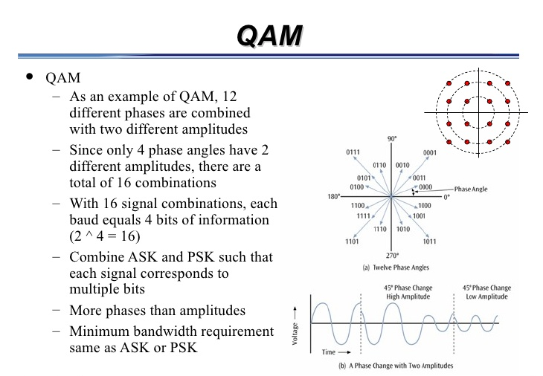

2.8 Pros and cons of using simulations over other methods
Unused strong organized test systems are required to empower the advancement of progressed organize innovations. Arrange Re-enactment is the result of a significant advancement of organizing re-enactment and an unused era test system. It offers numerous highlights for making profoundly versatile re-enactments to fulfil the wants of the developing number of organized analysts and developers. Even though NS3 may be an exceptionally progressed organize test system, it falls flat to overcome a few confinements all organize test systems have in common [5].

3.0 NETWORK SIMULATION
An organized re-enactment is the usage of a re-enactment that endeavours to mimic the real-world behaviour of a computer arrange or certain angles of a computer organize to analyse the captured data and transmitted information. This data can, at that point, be utilized to draw conclusions Agreeing to the official NS3 a recreation comprises a portrayal of a organize and how the components connected, fundamental control capacities for overseeing the recreation and a few sorts of logging usefulness to capture information [5].

3.1 Concepts and operational Scenarios
They are based on either one of them taking after two concepts. The primary one is an immaculate re-enactment. This implies that each component and each angle of the organize is mimicked, and the parcels or messages that are made inside the recreation are not one or the other exchanged to a genuine organize, nor handled as genuine arrange activity exterior of the re-enactment. One illustration for such a re-enactment is the execution and integration of a test arrange convention in a arrange re-enactments. The re-enactments originator can make circumstances for its innovation that might not be conceivable on a real-world testbed. Another application for arranging recreation is the modern investigate field of car-to-car systems, which is exceptionally expensive and indeed hazardous when executing models and testing them. The moment concept is to arrange to imitate [5].
The improvement of innovation or an item with the assistance of organized re-enactment is an iterative preparation. A re-enactment is modelled on the thoughts and ideas of the re-enactment architect. The comes about, and estimations of the simulation are utilized to change it in arrange to make diverse re-enactments behaviour and comes about until the required result can be finished. In comparison to executing a convention on a good testbed, re-enactment is, in most cases, more adaptable and less cost-intensive [5].
Pros of simulation include:
•Study the conduct of a framework without building it.
•Results are precise in common, compared to the explanatory model
•Help to discover un-expected wonder, the conduct of the system.
•Easy to perform ``What-If'' analysis.
Cons of simulation include:
•Expensive to construct a re-enactment model.
•Expensive to conduct a simulation.
•Sometimes it is troublesome to translate the recreation results.

4.0 EXPERIMENT
The different positions for the state's completely distinctive shapes of QAM are talked to a gathering of stars charts. The number of centres on the QAM gather of stars chart increases as the course of action of the balance increases. Square bunches of stars of QAM do not allow perfect reflection, as there cannot be the foremost extraordinary isolating of the centres for a given imperativeness. On the converse side, they show the advantage of being successfully gotten as two burst signals, which have been plentifulness adjusted by quadrature conveyers, and they can be demodulated uncommonly effortlessly. On the other side, non-rectangular charts offer a stronger bit-error-rate but aren't as essential to change and demodulate. In theory, the credibility of utilizing QAM with higher-order for exchanging a more significant number of bits/image (higher-order star groupings) may be a solid one. But, in sharpening, this would emerge a faithful quality issue. Higher-order star gathering infers a gather of stars centres outstandingly close to one another within the occasion that we anticipated to protect the brutal imperativeness data, it in realities conveys the information with distant improved and a much better fit goof rate, in this way causing it to be less reliable than lower-order QAM. At the figure underneath, there are a gather of stars charts for different plans of change [6[.
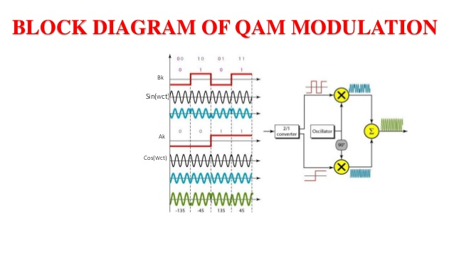
It presents a reenactment of QAM utilizing Simulink (case of 16-QAM hail) with flag direction and a bunch of stars plots. It is compared the theoretical and mirrored Bit Botch Rate (BER) for 16-QAM with Gray coding in an AWGN channel. The commotion which can be included within the signals can be measured by the evacuation between the centers of the gotten flag and the focuses of the transmitted (planning)signal. In case the commotion affected amid transmission is small, the point that compares to the gotten flag looks like a small spot around the point that compares to the anticipating flag. Inside the case that we have enormous clamor, the point of the gotten flag may be found any were inside the chart. On the off chance that some person must require the information passed on from the gotten flag, to begin with, they need to clarify the point of the indented flag inside the chart and after that to encode from the same point the information. Several calculations are doing this work, that analysts and engineers have made them for recognizing the arranging flag point. Assessing the briefest conceivable expel between the seen flag and one of the stars gathering centers leads the calculation to the affirmation of the first understandable point anticipating by the gotten flag. The estimation of the expulsion may be a handle that takes time and produces delays. Few calculations go up against this issue in a palatable way. For the briefest isolated between centers may be made an (execution) plan based on a combinational basis. This design must be as small as conceivable inside the run, so the small estimations in silicon can finish the foremost extraordinary speed and execution. At that point, the QAM beneficiary can be arraigned with high-velocity and less bundling consistency circuitry to diminish the coded information at the most elevated rate conceivable. QAM finishes a more prominent evacuation between star gathering centers. By and huge, there's a non-quadratic start gathering that's best utilized for a specific. But this non-quadratic star gathering isn't habitually actualized since the quadratic QAM is much less requesting to adjust and demodulate [6].
What WMSs Comprises of?
The building of the WMSs system comprises of a set of sensor center points, perception workplaces, and a base station that communicate with each other and collect information to make choices around the circumstance at hand. The system overcomes the hindrance of building divider utilizing sticks, which can be especially much disquieting [7]
System:
To arrange a developed watching system based on farther sensor frameworks (WMS), several of the components required are processor board, interference revelation sensors, cameras, and buzzer cautions, etc. In our work and inaccessible interference, discoverer was utilized as a sensor. When people, animals, or winged animals meet the visualization of the cameras, the circuit will be grounded and will get early on input hail that appears the closeness of people, animals, or fowls on the development arrives. The system will be incited, one of the unused highlight included inside the work, which is a caution will be raised to startle the intruders to require off the develop premises when the interloper stay for more than 30 seconds on the develop arrive, the GSM module is utilized for sending SMS to the develop proprietor appearing the nature of the intrusion The other highlight consolidates, the metallic sensor which teaches the developed proprietor in case a human being who is meddling the developed is outfitted (with metallic objects such as cut, cutlass, weapon, etc.) [8].
Model:
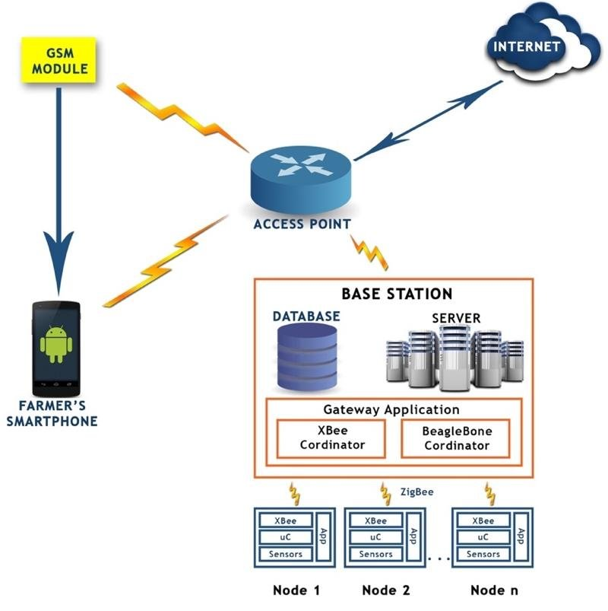

Figure 1 shows up for the most part system designing of the Develop Watching and Security System. The system joins a base station. Several scattered blocked off sensor centers, several buzzer cautions, predefined cameras that capture pictures and GSM modules. The base station is the field position where all the gear is passed on. Each sensor center may be a combination of sensors, microcontrollers, and a ZigBee radio handset (i.e., the XBee module) with the joining of a client application program on each sensor center, which handles data from sensors in a certain well-defined way and communication with the base station. Diverse sensors like intrusion area, metallic sensor, are joined to recognizing hub. Recognizing the center will look at the values at standard between times and forward it, particularly to the facilitator. Identifying Centers are XBee contraptions that are configurable for distinctive sensors. XBee contraptions are able to work on Sun-powered Control as well as capacity batteries. These contraptions are remotely configurable. The XBee module on the base station is planned as a facilitator, and the XBee modules on the sensor center points are orchestrated as switches that recognize values from diverse recognizing centers. The facilitator is related to Beagle Bone, which is related to the internet. Beagle Bone may be a small, low-power open-source hardware single-board computer. It can perform all operations which can be performed utilizing any computer contraption. BB communicates with the gateway/coordinator by the serial interface, and all recognized values will be sent to BB for handling. The sharp phone application laid out in Android is related to Web, i.e., especially to a web server. From smartphones, takes note can be gotten based on the events enveloping the developed parameters. Other contraptions like a buzzer caution that will sound amid the course of the interference; this makes a startling discuss for the intruder(s) in organize to drive them truant from the development parameters. Also, the CCTV system is presented to recognize the nature of the intrusion, either being human or animal. These checking frameworks ought to moreover be connected to the closest police station of each cultivate [8]. See appendices 1.A.

5.0 Bibliography
- Liptak, Bela G, (2005), Instrument Engineers' Handbook: Process Control and Optimization, CRC Press. https://www.researchgate.net/publication/285582879_Design_and_Implementation_of_Security_Based_ATM_theft_Monitoring_system. Last accessed 10/05/2020.
- John Burke, (2000), Teach Target, USA https://searchnetworking.techtarget.com/definition/QAM. Last accessed 10/05/2020.
- Kunal Bayazit, (1880), An information Analytics business, Netherland
https://www.elsevier.com/books/modeling-and-simulation-of-computer-networks-and-systems/obaidat/978-0-12-800887-4. Last accessed 10/05/2020.
- Ian Poole, (2006), Incorporating Radio electronics, Netherlands https://www.electronics-notes.com/articles/radio/modulation/quadrature-amplitude-modulation-qam-theory-formulas-equations.php. Last accessed 10/05/2020.
- Nicola Baldo, (2010), In Proceedings of SIMU Tools Conference https://www.net.in.tum.de/fileadmin/TUM/NET/NET-2013-08-1/NET-2013-08-1_08.pdf. Last accessed 05/10/2020.
- J. G. Proakis, (2001), Digital Communications, New York, https://www.researchgate.net/publication/321176321_Performance_Analysis_Characteristics_and_Simulation_of_Digital_QAM. Last accessed 05/10/2020.
- Abhinav, V. D, (2016), Design and Implementation of an Intelligent Security System for Farm Protection from Wild Animals, International Journal of Science and Research (IJSR) https://www.researchgate.net/publication/327141586_Design_and_Implementation_of_Farm_Monitoring_and_Security_System. Last accessed 10/05/2020.
- Willig, A. and Karl, H, (2005), Protocols and the Architectures for Wireless Sensor Networks, John Wiley and Sons Ltd.
https://www.researchgate.net/publication/327141586_Design_and_Implementation_of_Farm_Monitoring_and_Security_System. Last accessed 10/05/2020.
- Maheswari R, (2016), Development of Embedded Based System to Monitor Elephant Intrusion in Forest Border Areas Using Internet of Things, International Journal of Engineering Research https://www.researchgate.net/publication/327141586_Design_and_Implementation_of_Farm_Monitoring_and_Security_System. Last accessed 10/05/2020

6.0 Appendices
1.A. Continued assignment.

