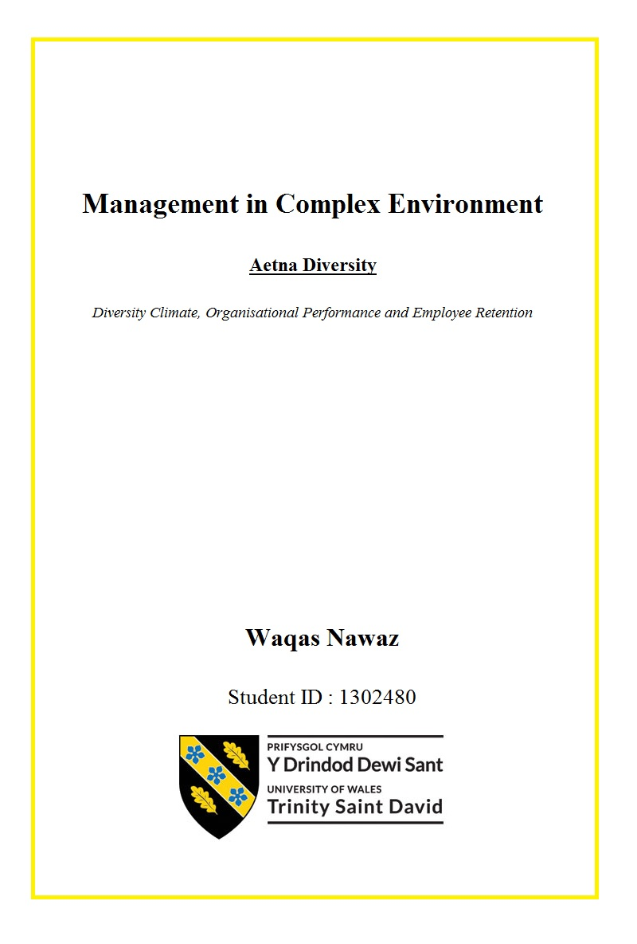

Executive Summary
Diversity is a widely discussed and researched topic and research shows that if managed properly it allows organisational performance to increase while if not managed properly it may backfire. It allows increase in creativity and innovation but also can be a reason behind people holding each other back. This means that diversity management is complex and should be carefully managed. There are many issues listed down by researchers that can play a negative role when implementing diversity policies such as prejudice, discrimination, ethnocentrism, and stereotyping. There can be difficulties in recruiting employees and there can be an increase in employee turnover.
The report uses secondary data from pre-published work of previous researchers related to diversity, diversity climate, ethics, ethical climate, impact of diversity on performance, and impact of diversity on employee turnover, and utilises it to analyse the diversity in Subject Organisation Aetna Corporation. This report does not collect primary data in any shape or form and therefore completely relies on the work of other researchers.
The report concludes with many findings: Firstly, the report concludes that there is a positive correlation between organisational performance and diversity climate provided the diversity policies are well-developed and well-implemented. Secondly, the report found that well-implemented diversity policies can reduce the overall employee turnover, and thirdly, the report concludes that there is a positive correlation between diversity climate and ethics climate, and collectively on the employee turnover. The report also concludes that the Subject Organisation Aetna Corporation has a well-implemented diversity policy, however, enhancements can be made to it in order to develop it further.

TABLE OF CONTENTS
1. Introduction 1
2. Diversity Climate 1
2.1. Diversity Climate and Performance 3
2.2. Diversity Climate and Employee Turnover 7
3. Diversity at Aetna 10
4. Strategy for workplace diversity 12
4.1. Improve employee knowledge 13
4.2. Improve workplace diversity 13
4.3. Remove barriers to workforce diversity 14
4.4. Make diversity part of organisational ethics 14
4.5. Integrate diversity in Organisational culture 15
4.6. Increase awareness about diversity policies 15
5. Recommendation 16
6. Conclusion 17
References I
Appendix 1: Jyoti et al. (data) V

LIST OF FIGURES AND TABLES
Figure 1.1: Diversity and ethics climate correlation 9
Figure 1.2: Common stock performance 11
Figure 1.3: The Aetna’s way 12
Figure 1.4: conceptual framework for workplace diversity 13

Table 1.1: Frequently Encountered Barriers 4
Table 1.2: Correlation Matrix for age, education, independent directors, and gender 6

1. Introduction
The report analyses the case study of Aetna Corporation and analyses their existing diversity policy in relation to employee development and management of their relationship with suppliers, providers, clients, and stakeholders. The report also evaluates the existing and potential benefits of “The Aetna Way”, a set of core values composed of four elements – integrity, employee engagement, excellence and accountability, and quality services and values, in the challenging environment that the company works within.
Diversity is a widely discussed and researched topic and research shows that if managed properly it allows organisational performance to increase while if not managed properly it may backfire (Ellison and Mullin, 2014). It allows increase in creativity and innovation but also can be a reason behind people holding each other back (Scott et al., 2011). This means that diversity management is complex and should be carefully managed. There are many issues listed down by researchers that can play a negative role when implementing diversity policies such as prejudice, discrimination, ethnocentrism, and stereotyping (Patrick and Kumar, 2012). There can be difficulties in recruiting employees and there can be an increase in employee turnover (Stewart, 2011).
This report specifically discusses two issues that arise from having diverse workforce. Firstly, the report discusses issue of diversity climate and its impact on performance, and secondly, the report discusses issue related to diversity climate and its impact on employee retention. The report then provides a new model of diversity implementation within the organisation. It then aims to provide recommendations to the company for future diversity policies based on its findings with evidence from secondary sources as well as the conclusions derived from investigation conducted in this report. It is so that the company mitigate probable risk of the above-mentioned diversity related issues in future.

2. Diversity Climate
The main idea behind diversity is the respect and acceptance of people from unfamiliar background, values, norms, race, colour, religion, sexual orientation, socio-economic status, physical abilities, ideologies, political beliefs, ethnicity, and other ideologies. It relies on understand that everyone is unique in his or her own sense and there exist differences between person to person which are to be accepted.
It further propagates that these differences are to be explored in a fostering, positive, and safe environment and moving beyond simple tolerance more towards celebrating and embracing the richness and versatility offered by every individual. Aetna’s values tend to embrace and utilise these versatilities and richness offered by their diverse workforces and company has been capitalising on this to expand and develop since early 2000. Their rise from a net loss of $280 million in 2001 (Aetna, 2001) to a net profit of $1831 million in year ending 2007 (Aetna, 2007).
As a set of conscious practices, diversity involves appreciating and understanding inter-dependence of natural environment, cultures, and humanity, mutual respect for experiences and qualities that vary from person to person and culture to culture (Stewart, 2011). It is to understand that it is just not the way of being but also the ways of knowing by understanding discrimination in the shape of cultures, personalities, values, beliefs, and norms (Patrick and Kumar, 2012). It makes one understand that there can be institutionalised discrimination in which some people are given privileges while others may suffer disadvantages due to them being ‘different’ (King et al., 2008). This helps build bridges across differences to create alliances that bring people with differences, together thus removing discrimination in all kinds and forms (Patrick, 2010).
When diversity is taken in the context of workplaces, it refers to many differences that exist between people working for an organisation (CIPD, 2018). Although it sounds extremely simple, however the area it encompasses is large as it refers to differences in ethnic group, personalities, tenure, race, age, cognitive style, gender, organisational function, backgrounds, level of education, and workload distribution (Patrick, 2010). It is more towards how people not only perceive others, but also how they perceive themselves against others because such perceptions influence the way people interact with each other (CIPD, 2018). Aetna’s drive to understand people by keeping them at the core of all its activities (Aetna¹, 2019) and therefore create new opportunities for itself in marketplace.
Due to complexities of diversity however, there are many issues that occur within organisations that employ multi-cultural workforces and have diversity in their employees (Scott et al., 2011). However, studies show that if proper diversity policies are successfully implemented then the bottom line of businesses can be improved by having a diverse workforce (Ellison and Mullin, 2014), teams become more productive and happier (Scott et al., 2011), and innovation and creativity drive increases (Forbes Insight, 2019). In the following sections, two different issues are being discussion that, while discussed separately, are closely linked with each other.

2.1. Diversity Climate and Performance
In today’s multi-cultural environment where movement across national borders has become easier than what it was in the past, and when the cost of travelling has reduced considerably, people travel across countries and even continents to seek better work opportunities (Scott et al., 2011). This has increased the multi-cultural workforces, especially in Western countries such as USA who came for better future and job opportunities from across the globe (Ellison and Mullin, 2014). This has also increased the complexities in managing this multi-cultural workforce for the companies and has also increase the importance of having well-prepared, and well-implemented diversity policies (Scott et al., 2011).
Forbes Insight (2019) noted that as diversity became important in organisational context, most organisations, academics, and researchers have started researching on diversity and organisational culture link, the influence of organisational cultures on diversity openness, and the influence such policies have on the performance of individuals from different cultural backgrounds and the performance of organisation itself.
A research conducted by Patrick (2010) found that not only the influence of diversity is found within the organisation, but also on its culture, work groups, and other organisational members where its shows different levels of dissimilarities of openness. A whitepaper issued by Robert Walters (2019) stated that 85% of their respondent companies showed interest in increasing diversity in their workforces, however, 45% do not have any means or measures to analyse or increase diversity in their workforces.
Many issues related to diversity have been identified by researchers such as King et al. (2008) and Patrick and Kumar (2012) who found many barriers exist in accepting workplace diversity in which discrimination was the top most reason followed by prejudice and ethnocentrism (see table 1.1). Patrick and Kumar (2012) also listed other barriers such as blaming the victim, stereotypes, and harassment.
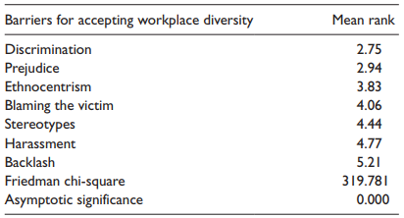
Table 1.1: Frequently Encountered Barriers
(Source: Patrick and Kumar, 2012)
Although there have been marvellous developments in the field of technology and thus the communication, and cultures have started to merge, relations between people representing different backgrounds and cultures is still on one-to-one basis(Patrick and Kumar, 2012). This is the reason why certain stereotypes and language barriers are still visible when interpersonal relations are observed. These barriers are required to be addressed by the organisations through their diversity policies. Moreover, the mental perception within one group about others being ‘alien’ due to the reason that they are unfamiliar with dissimilar background is the main reason behind barriers to diversity (Mulki et al., 2008).
A study conducted by Simlin (2006) concluded that age plays a vital role in restricting workforces from different cultural backgrounds to integrate with each other smoothly. He found that with the increase in age of the respondents, their perception regarding diversity openness decreases. It is important therefore that the organisations arrange trainings, workshops, gatherings, and group discussions to ensure that older employees accept the diversity openness (CIPD, 2018).
Moreover, Hofstede (1994) is of the view that it is responsibility of the leadershipto ensure that new ideas and behaviours are accepted, and for this they are required to learn more about custom, courtesies, and business values of other countries and cultures. Hofstede (1994) believes that understanding other cultures may influence on the strategic policy making and thus diversity policies can observe positive impact on diversity of employees. Aetna’s annual report of 2007 shows that its diversity and ideas created due to it had a large part in its turn-around from a loss-bearing company to a profit-generating company (Aetna, 2007) over the period of six years. This shows that the company accepts its rise in performance was linked with large talent pool it developed from people representing diverse backgrounds and cultures who brought in fresh ideas and innovations.
It is suggested by researchers that organisations perform better when they have diverse workforces because a diverse workforce broadens the overall group’s perspectives (Rodriguez, 2006). Empirical studies strongly confirm that there is positive correlation between improvement in organisational performance and successful diversity management (Ozbilgin and Tatli, 2008). Differences, empirical studies also found, should be sought in moderation (Reagans and Zuckerman, 2001). Findings of empirical studies also confirm that as the members of diverse workforce become more familiar with each other, their capabilities to find and understand other member’s perspective gets better and they start developing transitive memory (Kinppenberg et al., 2004). Aetna’s employee resource groups programme is a prime example of it as people in the group share their experiences and ideas, and learn from each other (Aetna¹, 2019)
This shows that while diversity does improve individual as well as organisational performance, the workforces require to be together for extended tenures with an extended time for the start-up (Knippenberg et al., 2004). It can be observed from Aetna’s employee resource groups programmes that Asians, Hispanics, White Americans, British, Canadians, Arabs, and people representing many other backgrounds work together. These people have different backgrounds, different educational standards, and different knowledge set that gets shared over long periods of interactions (Aetna², 2019).
Ozbilgin and Tatli (2008) stated that this start-up phase for heterogenous group of diverse people is lot longer than what is required for the homogeneous groups. The study of Gilbert et al. (1999) noted that positive spill over effect can be found due to diversity management in the workplaces and that those organisations who valued diversity had demonstrated, for example,that their women workforce is more capable and performs at higher standards. Cox and Blake (1991) conducted a study in which they analysed the creativity and innovative level of homogenous and heterogenous workforces and found that, provided the level of acceptance in diverse groups was high, their creativity levels were found to be higher than homogenous groups.
Moreover, Singh and Winkel (2011) stated that leadership needs to be educated in cultural differences, who then take charge in employee management, and look after the way care is being provided to the customers. Aetna runs an “Executive-in-residence” programme in which it partners with various universities and their foreign students. The executive from Aetna delivers a presentation to the students thus creating a pool of students that can be brought in to the company in the future (Aetna, 2005).
When dealing with diverse workforces, while intrinsic acceptance is necessary (McKay et al., 2007), extrinsic incentives can be used to promote closeness and address cultural disparities (Shore et al., 2009). Additionally, increased communication is required between people representing different cultures to ensure they understand each other (Singh and Winkel, 2011). This can be done by means of multicultural workgroup meetings, events, incentivised outings, closely knitted job descriptions, and trainings in-house and outside (Singh and Selvarajan, 2013). While Aetna has an extremely attractive pay structure, it also offers intangible incentives, for instance, providing trainings for new skills, financial support services, flexible hours, part-time working, job sharing, compressed work weeks, and telecommuting (Aetna⁶, 2019).
The work of Jyoti et al. (2012) showed a clearer picture of impact of diversity on performance within an organisation. They conducted their study in Mauritius with 42 respondent companies that were publicly listed by requesting and analysing their annual report for the year 2007. They analysed the performance of companies based on age, gender, director status, independent directors, and board size (see Appendix 1).
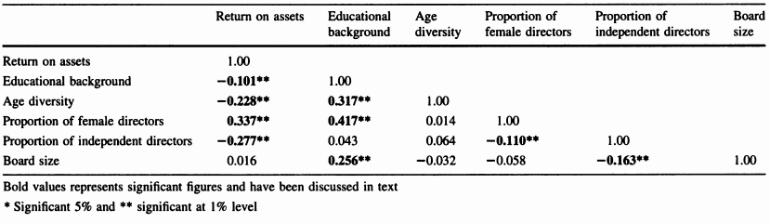
Table 1.2: Correlation Matrix for age, education, independent directors, and gender
(Source: Jyoti et al., 2012)
Significant differences were found based on education, gender, and independent directorship (see table 1.2) where it was noted that board size is positively correlated with education stating that educationally diverse board can only be accommodated by larger boards. Furthermore, negative correlation was identified between gender and independent directors. However, it is vital to mention that these two correlations are found to be positive by Kang et al. (2007, p.202). There is a strong possibility that it is due to the recruiting independent directors at the cost of reducing female representatives.
A study conducted by King et al. (2008) on healthcare services concluded that with increasing multiculturalism it is vital for the healthcare organisations to not only have workforces representing different cultures, but also should gather and maintain data of different elements, for instance, race, ethnicity, and values etc. that can support both patients as well as employees. Moreover, they should develop tools to analyse and evaluate disparities in healthcare as well as the workforce performance and develop strategic plans and policies to address and improve these disparities (Rothbard and Dumas, 2006).

2.2. Diversity Climate and Employee Turnover
Diversity climate is defined by McKay et al. (2008) as “degree to which a firm advocates fair human resource policies and socially integrates underrepresented employees” (p. 350). Employee turnover refers to the percentage of employees that leave organisations and are replaced by new employees. High employee turnover rate has a detrimental effect on not only overall organisational performance but also on the level of profits as new employees are required to be found, selected, recruited, and then trained. Moreover, organisations gain a loss of investment that they had invested on outgoing employees if their tenure has not produced enough profits since their recruitment.
Aetna works closely with its suppliers and universities to generate a pool of possible recruits, however, retaining capable, skilled, and experienced employees is considered as first priority of the company. It not only offers attractive salary structure and intangible rewards, it also provides its employees with development opportunities (Aetna⁶, 2019). Hackman and Oldham (1980) stated these training and development programmes to be one of the strongest points for retaining employees as it offers them opportunity for advancement.
Researchers such as Steel et al. (2002) and Holtom et al. (2005) stated that when an employee leaves, it costs organisations through money spent on recruiting and training new employees, severance pay, exit interviews, and administrative expenses. Stewart (2011) based on the work of Barkman et al. (1992) estimated a $9,000 loss for replacing an employee that has worked for 5 years, and a loss of $47,000 when the employee has been working with the organisation for only 3 years. A study conducted by Sagie et al. (2002) noted that 27% of the 16.5% that a company loses from its income before tax is related to employee turnover.
It is therefore important, looking at the cost of employee turnover, that organisations identify ways in which employee turnover rate can be reduced. Protecting employees from leaving the organisation after short-term employment decreases high cost associated with process of recruiting new employees on one side, and on the other, it provides benefits of having an experienced, organisation’s culturally aware, and well-trained employee working for the organisation (Hackman and Oldham, 1980).
Study conducted by McKay et al. (2008) found that there is a close relationship between how the employee perceive about diversity climate in their workplace, and that their job behaviours and attitudes are significantly impacted by this perception. McKay et al. (2008) related this to “degree to which a firm advocates fair human resource policies and socially integrates underrepresented employees” (p. 350) and according to Hicks-Clarke and Iles (2000) this impacts psychologically on involvement and job satisfaction of employees, and performance (McKay et al., 2008).James et al. (1990) stated that owing to identification perception due to diversity climate in an organisation employee satisfaction and loyalty could be negatively or positively impacted. McKay et al. (2007) found significant negative association between turnover intentions and diversity climate based on work of many researchers.
However, Steward (2011) stated that diversity climate is only one element in many that are linked with employee retention, for instance, the ethical values and the ethical codes implemented by the organisation. Furthermore, he argued that although ethics are separately discussed, inherently, it is linked with the way ethical values within an organisation deal with diversity, or impact on diversity climate perception. This is the reason why his study interlinked ethics and diversity climate and analysed them concurrently. Based on the work of Ostroff et al. (2003) it can be argued that these distinct but related perception are needed to be aligned in order to achieve a positive outcome.
Based on the work of many researchers (Griffeth et al., 2000; Luchak and Gellatly, 2007; Yang, 2008) many antecedents leading to employee turnover have been identified. It was noted that job satisfaction and commitment to organisation were strong predictors of employee turnover with commitment, out of the two, was noted to be stronger predictor. Moreover, perception of justice within the organisation (Luchak and Gellantly, 2007) and the way in which work is distributed between employees (Yang, 2008) has also been found to influence employee turnover.
However, researchers such as McKay et al. (2007) argue that although these are valid predictors of the reasons behind employee turnover, the best way to predict turnover is through the lens of psychological climate. James et al. (1990) defined psychological climate as “cognitive appraisals of environmental attributes in terms of their acquired meaning and significance to the individual” (p. 54). Parker et al. (2003) discussed many researchers who linked psychological climate with the employees showing intentions of either staying with the organisation or leaving it altogether. They stated that employee perception about organisational policies, for instance, those related to placement, promotion, and development influence the way employees view organisations and help develop their psychological climate that engender turnover levels. Aetna has successfully developed a perception within its employees for being a company that encourages diversity (Aetna⁶, 2019) which is the reason why not only more capable people from diverse background apply to join the company, but also people from diverse background tend to stay longer with Aetna (Aetna⁵, 2019).
Based on the work of James et al. (1990) and Parker et al. (2003), Steward (2011) developed their study by focusing on two dimensions of perceived ethics climate and perceived diversity climate. Their study can be considered vital in understanding the impact diversity climate perception can have on the overall employee turnover. Steward (2011) finalised their study by concluding that “turnover intentions were lowest among workers perceiving both a pro-diversity and highly ethical climate. These results reinforce the need to communicate both diversity values and ethical standards to the employees” (p. 453).
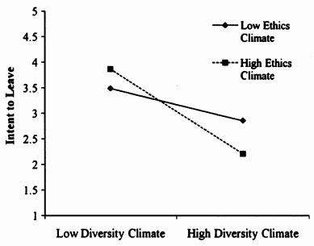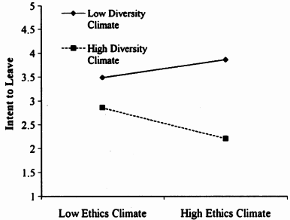
Figure 1.1: Diversity and ethics climate correlation
(Source: Stewart, 2011)
The result of their study showed that employees perceive ethics climate to be closely related to diversity climate, and the positive perception about ethics and diversity reduces the chances of high employee turnover (see figure 1.1). It can be noted that organisations having high diversity climate with high ethics climate, the intention to leave for employees is low.

3. Diversity at Aetna
Aetna Corporation already has a well-formulated system of keeping their employees informed in place. Moreover, their Employee Resource Groups that has more than 10,000 diverse employees share their expertise, network, and experiences with each other (Aetna¹, 2019) and because these groups contain people from across the globe and representing all kinds of demographic groups, therefore, everyone within them is well-aware of the importance of diversity and the issues related to it. Emphasising on the value of diversity, the company has successfully implemented inclusion approach thus bringing value offered by diversity in creating new opportunities and new marketplaces, for instance, it has started its business in Dubai, the hub of foreigners (Aetna⁷, 2019).
It became possible for the company to open this new avenue due to its strength in diverse workforce and due to its goodwill gained by means of dealing with its diverse workforce on equality basis. Due to this, employees of the company are also becoming aware of the possibilities and opportunities that are offered in the future by the company. They are increasingly becoming aware that the benefits of diverse workforce is not limited to the area they are working in, but that it can also offer them opportunities to work in other geographical regions if need or opportunity arises.
In Aetna, out of more than 35,000 employees, 31% are people of colour and 76% are women. A total of 16% of management/supervisory positions are held by people of colour while 11% of them are in the senior management posts (Aetna², 2019). Along with this 30% of senior management represents women. With this diversity in their workforces, and as has been confirmed by the work of Ozbilgin and Tatli (2008) ins section 2.1 of this report, the company has performed better even during the period of economic recession (Aetna², 2019). Its performance can be observed from Aetna’s common stock from December 2000 through November 2008 with its common stock falling in 2008 due to economic recession (see figure 1.2). However, this fall is not linked with diversity related issue in any way.
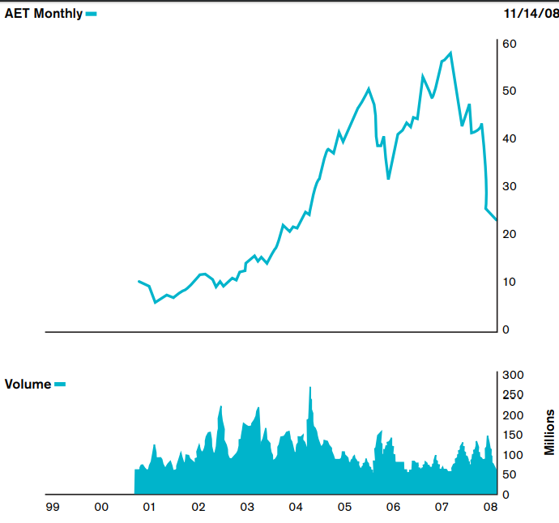
Figure 1.2: Common stock performance
(Source: Aetna², 2019)
Its four core values of diversity including integrity, employee engagement, excellence and accountability, and quality services and value, generally known as the ‘Aetna Way’ (see figure 1.3) allow employees to be at the core of everything the company does. However, it is visible that the company needs to increase its overall diversity as with only 31% non-local people, the diversity ratio is still low. Even though the company requires further increase in its diversity ratio, its capabilities to serve customers from different backgrounds due to its diverse workforce has given it an additional edge over its clients (Aetna⁷, 2019).
Aetna’s diversity implications encompass building a workforce that understands the racial/ethnic, gender, sexual orientation and generational diversity of the marketplace. Create an inclusive work environment that maximises each employee’s contributions and productivity, attract potential candidates to Aetna and choose from a broader and deeper pool of candidates (Aetna³, 2019). True to its nature, the company has striven to recruit and retain employees with different disabilities, sexual orientations, and religious backgrounds. It has also striven in providing them with empowering work environments, for instance, facilities that can support people with disabilities. With 35,000 employees and 31% of them from coloured background, the diversity policy of Aetna can be considered partially successful. However, further aggressive recruitment of diverse employees is required.
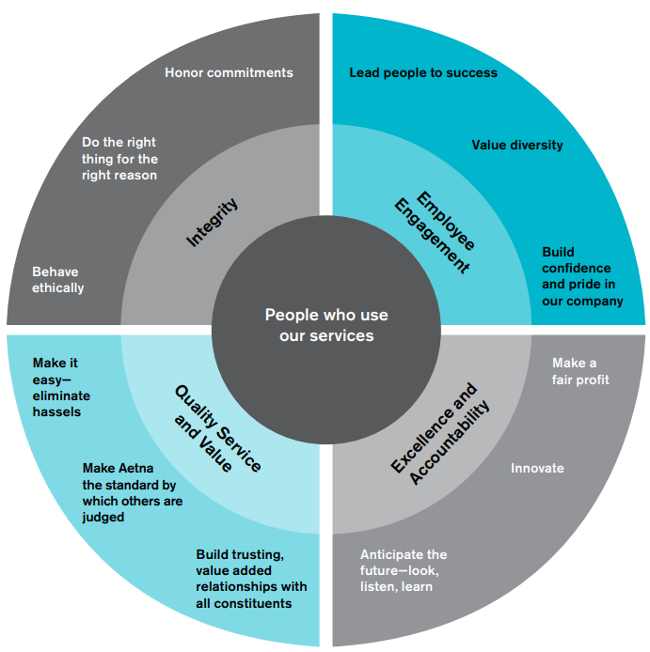
Figure 1.3: The Aetna’s way
(Source: Aetna², 2019)

4. Strategy for workplace diversity
Discussion in the above two sections of this report shows that how important it is for organisations to deal with diversity and develop policies to address the issues related to diversity. Organisational performance and employee retention are two main areas for any organisation to develop (Stewart, 2011). Reduced performance or high employee turnover may result in negative impact on overall profitability and thus sustainability of organisations in today’s highly competitive marketplace (Yang, 2008). It is therefore important that diversity policies are developed and strategies to successfully implement these policies are implemented.
The diversity policy should emphasise on two different elements. Firstly, a diversity policy should address the issues that become barriers for diverse workforces to perform together (Yang, 2008), and secondly, it should define the waysin which awareness about workplace diversity is increased (Njenga et al., 2011). Taking help from the work of Stewart (2011) and Patrick and Kumar (2012) discussed in above sections, a conceptual framework can be developed for workplace diversity (see figure 1.4).
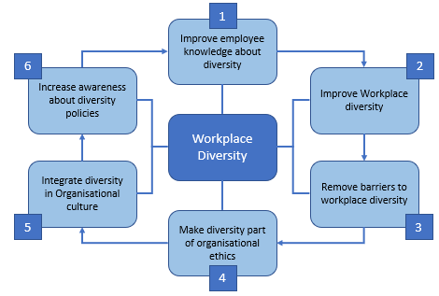
Figure 1.4: conceptual framework for workplace diversity
(Source: Self-made)

4.1. Improve employee knowledge
First and foremost, the important aspect of implementing workplace diversity successfully is to ensure that all employees working within the organisation are aware of the importance of diversity, its meaning, and the benefits it brings to the overall organisation (Njenga et al., 2011). Their acceptance of people representing other groups, for instance, those representing different cultures thus having different values, norms, beliefs, and behaviours plays a vital role in successfully implementing diversity policy.
Social events, mentoring programmes, diversity trainings, workgroup gatherings, and other such events can be used to improve employee knowledge about diversity and issues related to it. Robert Walters (2019) reported that 78% respondents from their study showed positive response and understanding towards diversity through company’s social events, 53% through mentoring programmes, and 34% through diversity training. Their study found that three departments are more responsible for development of diversity compared with others. These included senior management, human resource, and marketing department.

4.2. Improve workplace diversity
Workplace diversity must be improved for increased performance as has been discussed in section 2.1 of this report. However, as has been noted by Robert Walters (2019), although 85% of organisations consider it a priority to increase workforce diversity, 45% do not have any programme in place to increase diverse candidates. It is therefore important that strategies are made to attract more diverse candidates for available jobs. Organisations can use quota system to encourage employees from diverse backgrounds to ensure they meet their diversity standards however care should be taken when evaluating their professional capabilities.
This can also improve corporate culture and encourage innovation and creativity by bringing in new ideas (Njenga et al., 2011). It is therefore also important that new employees are given opportunities for advancement. Moreover, as has been suggested by Stewart (2011), the senior leadership needs to improve their relationship with newly recruited diverse employees, empower them, increase their morale, and motivate them for perform at their peak performance levels through tangible and intangible rewards and benefits. It is vital to remember that 61% of respondents in survey conducted by Robert Walters (2019) believed that they can reach broader talent pool because of encouraging diversity.

4.3. Remove barriers to workforce diversity
Barriers to workforce diversity must be removed, or at least reduced as much as possible. There are many barriers to diversity identified in the above sections of this report from the work of Stewart (2011) and Patrick and Kumar (2012) along with others, for instance, prejudice which represent unfair or unfounded opinion, mostly wrong, is developed about people representing certain group. Discrimination is the most widely reported barrier in which people representing certain backgrounds or groups are barred from holding certain posts or working in certain environment.
Another barrier to workforce diversity is ethnocentrism in which people representing certain group deem themselves to be superior from other which, as a result, produce a sense of authority in them while not considering others as their equals. Lastly, care should be taken in ensuring that certain group of people are not suffering from stereotyping, a condition in which a feeling or opinion about someone is developed without understanding him or her as an individual.

4.4. Make diversity part of organisational ethics
The work of Stewart (2011) specifically analyses the impact of ethical climate of an organisation in collaboration with diversity climate towards employee retention. It has been discussed above that ethical climate and diversity climate are positively correlated with each other, therefore it is important that all diversity elements are integrated with the ethical elements and employees are informed about it. It is vital to remember, as has been stated by Matrin and Cullen (2006), that empirical studies show ethical climate to be closely linked with employee satisfaction and their commitment to the organisation. This means that making diversity as part of organisational ethics will reduce the employee turnover rate thus the organisation will retain their employees for longer periods thus saving them different costs discussed in section 2.2 of this report.

4.5. Integrate diversity in Organisational culture
Every organisation has its own culture, and traditionally, these cultures are largely influenced by the national culture of the country that the companies are in (Riivari and Lamsa, 2014). This means that they are closely linked with the values, norms, beliefs, and behaviours of people that belong to the same cultures (Njenga et al., 2011). However, when multicultural workforces are considered, they are formed from combination of people representing different cultures, mostly, not belonging to the local culture of the country. It is therefore important for organisations in today’s globalised marketplace to change their organisational cultures into more flexible forms to ensure that they can integrate people representing different backgrounds, beliefs, norms, and values into them.
Hofstede (2019) developed his cultural dimensions framework which helps in understand difference in national cultures of countries across the globe. It can be used to understand how people from different countries behave in similar environment and circumstances, and how they perceive others to behave towards them. Integrating flexibility in organisational culture allows organisations to support diversity in their workforce.

4.6. Increase awareness about diversity policies
Once diversity policies are developed and implemented, it is vital that all employees within the organisation are informed about them. It is important because, as has been stated by Malki et al. (2008), without the employees being communicated, informed and notified of what is required of them, the diversity policies will not implement successfully. Like first step mentioned in section 3.1, seminars, workgroup gatherings, social events, trainings, and other kind of communication methods can be used to inform and train employees regarding newly implemented diversity policies. It is also the time that employees are again made aware of why these changes are being brought in the organisation, answer their inquiries, and respond to their questions. This is to increase their knowledge about diversity and diversity policies.

5. Recommendation
The analysis of Aetna’s diversity policy shows that they have a well-developed and well-implemented policy which is carefully implemented. However, like all policies, there is always a room for improvement. The published data shows that only 14% of their employees have worked for more than 15 years while a large number, 38% have worked for less than five years and only 2.4% of its employees are identified as veterans (Aetna⁴, 2019). This shows that there is a moderate employee turnover within the company. There are two different aspects to the turnover which Raymond should be concerned about. Firstly, as has been discussed in section 2.2 of this report, it increases the overall cost of business for the company, and secondly, with employees leaving the company, it also looses the pool of experts that had worked for it and are well-versed in working procedures.
While the cost stays the same, it is important for Raymond to analyse whether the leaving employees are high performance or bottom level workers. For instance, as has been stated by Njenga et al. (2011), a high rate of employee turnover in which low-performing employees are leaving, may not impact highly on the overall company’s productivity, however, a low turnover of high-performing employees may result in large negative impact.
It is therefore recommended that firstly, the company should analyse the reasons behind employee turnover as there are 38% of employee who have been recruited within past five years. For this purpose, the workplace diversity model suggested in section 4 of this report can be utilised as part of survey along with Hackman and Oldham’s model of Job Characteristics (Lunenburg, 2011). This will allow Raymond to analyse reasons behind Aetna’s turnover rate. Moreover, Raymond should closely communicate with company employees to understand reasons behind the turnover. Although the survey will provide statistical data related to reasons, explanation can only be available through verbal communication as it allows the employees to explain themselves better and not be taken as only numbers.
Secondly, the company is recommended to analyse if the leavers are high-performers or low-performers. This would allow the company to ensure that it protects itself from losing best-performers by taking initiatives and corrective measures. It is vital for Raymond to ensure that the company does not is not losing in the longer run as low-performing employees can be replaced easily while those with high experience and expertise are difficult to be replaced in today’s highly competitive market. Lunenburg (2011) stated that irrespective of industry or sector, companies are expending large efforts to recruit capable employees due to the which skilled employees are difficult to find, and difficult to retain because they are continuously offered better opportunities from competing firms.
It is also recommended to Raymond that work placement overseas can also act as an attractive option for high-performing employees. A change in work environment, and attraction of working overseas can act as a trigger to develop high satisfaction and motivation level and can influence the commitment towards organisation. Moreover, work of Hackman and Oldham (1980) has shown that a change in job description can keep the employees satisfied as the feeling of boredom, that may influence them for a change in work environment, can reduce.
The Aetna Way of the company is a good model that is composed of four elements that ensure considerable support for diversity. It propagates integrity, employee engagement, excellence and accountability, and quality service and value. The specific section of employee engagement is vital as it refers to being closely linked with employees in which they are valued, irrespective of their diversity, and shows continuous support for them thus generating confidence and loyalty. Raymond should keep this model intact and promote the four pillars of Aetna in their overseas endeavours, for instance, in Dubai.
Applicants representing other cultures, for instance, those coming from developing countries such as Pakistan, India, Bangladesh, China, and African countries are attracted towards a sense of integrity, care, commitment from organisation, and closeness to senior management. It is because research has shown low involvement of lower-level employees in decision making process of organisations in these countries (Jingjit and Fotaki, 2010). A large and well-reputed Western company offering integrity and employee engagement is highly-attractive for those that had no say in organisations within their countries.

6. Conclusion
The report intended to analyse diversity and its impact in two different elements: its impact on organisational performance and its impact on employee turnover. Diversity climate was discussed in detail and it was found that due to the large influence from globalisation, reduction in cost of travelling, and opening of borders, societies are becoming more heterogeneous. This is especially the case with Western countries where people from across the globe are coming in search of better opportunities. This increase in foreign individuals has developed a diverse workforce that has to work with locals. However, these people come with their own set of beliefs, norms, values, and behaviours.
Discussing work of different researchers in section 2.1 and 2.2 of this report, it can be concluded that complexities have arisen in the working environments as response of people from local workforce may differ from those coming from abroad. Issues such as clashes in opinion, acts of discrimination, stereotyping, and ethnocentrism develop. It was also noted that diversity management has become a widely researched topic and researchers, academics, and organisations are spending considerable effort in finding ways in which these issues can be reduced.
It can also be concluded that while there are complexities in handling diverse workforces, the opportunities a diverse workforce brings are large. For instance, researchers agree that diverse workforce brings new and fresh ideas, increase the innovative and creative drive, and allow each other to expand personal horizons. Moreover, it was also found that organisational performance increases due to diverse workforce. It was however also noted that for gaining these benefits, organisations have to ensure that their diversity climate is empowering and supporting for all their employees.
Review of the work of different researchers in section 2.1 and 2.2 showed that organisations that have implemented well-developed diversity policies have performed better than those that fail to explore the possibilities offered by diversity. The review of pre-published literature also showed that ethical climate is closely linked with diversity climate as employees perceive ethics to correlate with diversity. Failing to have an ethical climate, it was noted, can reduce the efficiency of diverse workforce while increasing the overall employee turnover.
During the analysis of Subject Organisation Aetna, it was noted that the company has a well-planned and well-implemented diversity policy and is perceived positively by its employees. However, it was also noted that the employee retention of the company is lower than expected. With 38% of its employees leaving before the end of 3rd year, the company has been recommended to analyse the reasons and develop mitigation strategies to reduce the risk of high turnover in the future.
The company was noted to be well aware of the requirements of diversity. Its Employee Resource Group programme that has more than 10,000 members is an attraction for new employees on one side, and on the other, it helps retain the current employees by offering them opportunity to learn new skills by expanding their network and gaining from the experience of other group members. Moreover, this programme also helps Aetna’s employees to understand other cultures, and values and beliefs of people representing different backgrounds.

References
Aetna (2001). Annual Report – Financial Report [Online]. Retrieved from: http://library.corporate-ir.net/library/11/110/110617/items/179916/Financial%20Annual%20Report%202001.pdf. [Retrieved on: 01/01/2019]
Aetna (2007). Annual Report – Financial Report [Online]. Retrieved from: http://media.corporate-ir.net/media_files/irol/11/110617/proxy/AR_finrpt.pdf. [Retrieved on: 01/01/2019]
Aetna¹ (2019). Employee Resource Groups & Profiles [Online]. Retrieved from: https://www.aetna.com/about-us/diversity-inclusion/employee-resource-groups-profiles.html. [Retrieved on: 06/01/2019]
Aetna² (2019). Current Economic Environment [Online]. Retrieved from: https://www.shrm.org/academicinitiatives/universities/teachingresources/Documents/Aetna%20Diversity%20Case_Final.pdf. [Retrieved on: 06/01/2019]
Aetna³ (2019). Linking Aetna’s Strategic Business Goals to Diversity Outcomes [Online]. Retrieved from: https://www.shrm.org/academicinitiatives/universities/teachingresources/Documents/Aetna%20Diversity%20Case_Final.pdf. [Retrieved on: 06/01/2019]
Aetna⁴ (2019). Workplace Diversity - Years of Service [Online]. Retrieved from: https://www.aetna.com/about-us/diversity-inclusion/workplace-diversity.html. [Retrieved on: 06/01/2019]
Aetna⁶ (2019). Join us in our mission – Reasons to work at Aetna [Online]. Retrieved from: https://www.aetnacareers.com/about#perks-at-aetna. [Retrieved on: 03/01/2019]
Aetna⁷ (2019). 2010 Diversity Annual Report [Online]. Retrieved from: http://www.aetna.com/diversityannualreport/mobile/index.html. [Retrieved on: 03/01/2019]
Barkman, A., Sheridan, J. E., and Peters, L. H. (1992). Survival Models of Professional Staff Retention in Public Accounting Firms. Journal of Management Issues. Vol. 4: 339-353
Cox, T. H., and Blake, S. (1991). Managing cultural diversity: Implications for organizational competitiveness. Academy of Management Executive. Vol. 5: 45-56.
Ellison, S. F., Mullin, W. P. (2014). Diversity, Social Goods Provision, and Performance in the firm. Journal of Economics & Management Strategy. Vol. 23(2): 465-481
Forbes Insight (2019). Global Diversity and Inclusion: Fostering Innovation through a Diverse Workforce [Online]. Retrieved from: https://images.forbes.com/forbesinsights/StudyPDFs/Innovation_Through_Diversity.pdf. [Retrieved on: 03/01/2019]
Gilbert, J. A., Stead, B. A., and Ivancevich, J. M. (1999). Diversity management: A new organizational paradigm. Journal of Business Ethics. Vol. 21(1): 61-76.
Griffeth, R. W., Hom, P. W., and Gaertner, S. (2000). A Meta-Analysis of Antecedents and Correnlates of Employee Turnover: Update, Moderator Tests, and Research Implications for the Next Millennium. Journal of Management. Vol. 26: 463-488
Hackman, J. R., and Oldham, G. R. (1980). Work redesign. Reading, MA: AddisonWesley
Hicks-Clarke, D., and Iles, P. (2000). Climate for Diversity and its effects on Career and Organizational Attitudes and Perceptions. Personnel Review. Vol. 29: 324-346
Hofstede, G. (1994). Cultures and organisation: Intercultural cooperation and its importance for survival: software of the mind. London, England: HarperCollins.
Hofstede, G. (2019). National Cultures [Online]. Retrieved from: https://www.hofstede-insights.com/models/national-culture/. [Retrieved on: 02/01/2019]
Holtom, B. W., Mitchell, T. R., Lee, T. W., and Inderrieden, E. J. (2005). Shocks as Causes of Turnover: What They Are and How Organizations can Manage Them. Human Resource Management. Vol. 44: 337-352
James, L., R. James, L. A., and Ashe, D. K. (1990). The meaning of organizations: The role of cognition and values. In B. Schneider (ed.), Organizational Climate and Culture. San Francisco: Jossey-Boss.
Jingjit, R. and Fotaki, M. (2010). Confucian Ethics and the Limited Impact of the new public management reform in Thailand. Journal of Business Ethics. Vol. 97(1): 61-73
Jyoti, D. M., Soobaroyen, T. and Hanuman, V. O. (2012). Board composition and financial performance: Uncovering the effects of Diversity in an Emerging Economy. Journal of Business Ethics. Vol. 105(3): 375-388
King, R. K., Green, A. R., Tan-McGrery, A., Donahue, E. J., Kimbrough-Sugick, J., and Betancourt, J. R. (2008). A Plan for action: Key Perspectives from the Racial/Ethnic Disparities Strategy Forum. The Milbank Quarterly. Vol. 86(2): 241-272
Knippenberg, D. V., de Dreu, C. K. W., and Homan, A. C. (2004). Work group diversity and group performance: An integrative model and research agenda. Journal of Applied Psychology, 89, 1008-1022.
Luchak, A. A., and Gellatly, I. R. (2007). A Comparison of Linear and Nonlinear Relations between organizational commitment and work outcomes. Journal of Applied Psychology. Vol. 92: 786-793
Lunenburg, F. C. (2011). Motivating by Enriching jobs to make them more interesting and challenging. International Journal of Management, Business, and Administration. Vol. 15(1): 1-11
McKay, P. F., Avery, D. R., and Morris, M. A. (2008). Mean racial-ethnic differences in employee sales performance: The moderating role of diversity climate. Personnel Psychology. Vol. 61: 349-374
McKay, P. F., Avery, D. R., Tonidandel, S., Morris, M., Hernandez, M., and Hebl, M. R. (2007). Racial differences in employee retention: Are diversity climate perceptions the key? Personal Psychology. Vol. 60: 35-62
Mulki, J., Jaramillo, J., and Locander, W. (2008). Effect of Ethical Climate on Turnover Intention: Linking Attitudinal and Stress Theory. Journal of Business Ethics. Vol. 78: 559-574
Njenga, M., Karanja, N., Prain, G., Lee-Smith, D., and Pigeon, M. (2011). Gender mainstreaming in organisational culture and agricultural research processes. Development in Practice. Vol. 21(3): 379-391
Ostroff, C., Kinicki, A. J., and Tamkins, M. M. (2003). Organizational Climate and Culture, in W. C. Borman, D. R. Ilgen, and R. J. Klimoski (eds). Comprehensive handbook of psychology. Volume 12: Industrial and Organisational Psychology. New Jersey: Erlbaum Mahwah.
Ozbilgin, M., and Tatli, A. (2008). Global diversity management: An evidence-based approach. London, England: Palgrave.
Parker, C. P., Baltes, B. B., Young, S. A., Huff, J. W., Altmann, R. A., Lacost, H. A., and Roberts, J. E. (2003). Relationships between psychological climate perceptions and work outcomes: A Meta-Analytic review. Journal of Organizational behaviour. Vol. 24: 389-416
Patrick, H. A. (2010). Organization culture and its impact on diversity openness in the information technology organizational context. Dimensions. Vol. 1(1): 67-72
Patrick, H. A. and Kumar, V. R. (2012). Managing Workplace Diversity: Issues and Challenges. Sage Open
Reagans., R., and Zuckerman, W. (2001). Networks, diversity, and productivity: The social capital of corporate R&D teams. Organization Science. Vol. 12: 502-517.
Riivari, E., and Lamsa, A. M. (2014). Does it pay to be ethical? Examining the relationship between organisations’ ethical culture and innovativeness. Journal of business ethics. Vol. 124(1): 1 - 17
Robert Walters (2019). Diversity and Inclusion in Recruitment – Whitepaper [Online]. Retrieved from: https://www.robertwalters.co.uk/content/dam/robert-walters/country/united-kingdom/files/whitepapers/Diversity-In-Recruitment-Whitepaper-web.pdf. [Retrieved on: 01/01/2019]
Rothbard, N. P., and Dumas, T. L. (2006). Research perspectives. In F. Jones, R. Burke, & Westman, M. Work-life balance: A psychological perspective. New York: Psychology Press.
Sagie, A., Birati, A., and Tziner, A. (2002). Assessing the Costs of Behavioral and Psychological Withdrawal: A New Model and an Empirical Illustration. Applied Psychology: An International Review. Vol. 51: 67-90
Scott, K. A., Heathcote, J. M., and Gruman, J. A. (2011). The diverse organization: Finding gold at the end of the rainbow. Human Resource Management. Vol. 50(6): 735-755
Shore, L., M., Chung-Herrera, B. G., Dean, M. A., Ehrhart, K. H., Jung, D. I., Randel, A. E. (2009). Diversity in organizations: Where are we now, and where are we going? Human Resource Management Review. Vol. 19: 117-133
Simlin, J. (2006). Organization culture and impact of diversity openness in the IT-ITES sector (Unpublished MBA dissertation thesis). Christ College Institute of Management, Karnataka.
Singh, B., and Selvarajan, T. T. (2013). Is it Spillover or Compensation? Effects of Community and Organizational Diversity Climates on Race Differentiated Employee Intent to Stay. Journal of Business Ethics. Vol. 115(2): 259-269
Singh, B., and Winkel, D. (2011). Racial differences in helping behaviors: The role of respect, safety and identification. The Journal of Business Ethics.
Steel, R. P., Griffeth, R. W., and Hom, P. W. (2002). Practical Retention Strategy for the Practical Manager. Academy of Management Executive. Vol. 16: 149-162
Stewart, R. W. (2011). You support diversity, but are you ethical? Examining the interactive effects of Diversity and ethical climate perception on turnover intentions. Journal of Business Ethics. Vol. 99(3): 453-465
Yang, J. (2008). Effect of Newcomer Socialisation on Organizational Commitment, Job Satisfaction, and Turnover Intention in the Hotel Industry. Service Industries Journal. Vol. 28: 429-443

Appendix 1: Jyoti et al. (data)



