Hotel standards, reputation management,
building and retaining customer loyalty.

Student: Vasile-Alexandru Vasile
Student ID number: 2207749
The module title: Hospitality and Guest Service Management (BMIH4003)
Lecturer: Charlotte Joyner
Date: 08 March 2023
Word count: 1625

Executive summary
This essay explores the importance of hotel standards, reputation management, and building and retaining customer loyalty in the hospitality industry. The essay begins by highlighting the significance of maintaining high standards in hotel operations. It then discusses the role of reputation management in the hospitality industry, including the impact of online reviews and the need to proactively address negative feedback. The essay also examines the key factors that contribute to building and retaining customer loyalty. It emphasizes the importance of creating a positive emotional connection with guests, which can lead to repeat business and positive word-of-mouth recommendations. Throughout the essay, case studies and real-world examples are used to illustrate the practical applications of these concepts.

Introduction
All hospitality sectors must develop their services as well as their guest service, to attract various guests for their better profitability, within the global competitive market. Guest service mainly sheds light on rendering assistance as well as addressing various customer requirements. Both guest service and hospitality services are required for running a business successfully, within the hotel industry.
First, the presentation will briefly introduce the concepts. Afterwards, the focus will move on the importance of brand standards within the hotel industry by giving proper examples of Hilton Hotels and Marriott International. In addition to that, the segment will define how reputation helps in developing the overall business and this will also demonstrate the essentiality of guest review management and the effect of negative customer reviews on the reputation and business of the hotel. Finally, the context will illustrate certain ways to attract customers as well as retain customer loyalty in favour of the hospitality industry.

Hotels standards refer to a set of guidelines or criteria that are established to ensure that hotels meet certain minimum requirements for comfort, safety, cleanliness, and other key factors. Some common hotel standards refers to star rating, the amenities on offer, safety and security, the level of cleanliness, accessibility, and many others. Overall, hotel standards are designed to ensure that guests have a safe, comfortable, and enjoyable stay, and that hotels operate in a responsible and ethical manner.
Reputation management is crucial in the hotel industry because the reputation of a hotel can have a significant impact on its success. Good reputation can lead to increased bookings and repeat customers, while a bad reputation can lead to a decrease in bookings and negative word-of-mouth publicity. Some ways to effective manage reputation in the hotel industry, are represented by constant monitoring of online reviews, Respond to both positive and negative reviews, Address any specific concerns raised in negative reviews, Encourage feedback: Train your staff: Address issues quickly: Build relationships with guests: Go above and beyond to create a positive experience for guests. Use social media: Respond to comments and messages promptly.
Building and retaining customer loyalty in the hotel industry is essential to creating a sustainable business. Here are some strategies that hotels can use to build and retain customer loyalty: Personalization: Personalization is key to building customer loyalty. Exceptional service: Providing exceptional service is crucial in creating a memorable experience for customers. Loyalty programs: Loyalty programs, offers and discounts are a great way to encourage repeat business. Feedback and communication: Encourage customers to provide feedback on their experience, and respond promptly to any issues they may have. Consistency: Consistency in excellent service and experience is essential in building and retaining customer loyalty. Special offers: Offer special promotions to loyal customers to show your appreciation. This can include discounts on future bookings or exclusive access to hotel amenities. By focusing on personalization, exceptional service, loyalty programs, feedback and communication, consistency, and special offers, hotels can build and retain customer loyalty.

The essentiality of brand consistency standards
The hotels need to focus on developing their brand standards, to gain a competitive advantage within the global market. These standards also ensure a proper and consistent guest experience. The guests can then recognise their expectation levels and this is leading to building trust and brand loyalty.
Purpose of brand standards
Enhancing customer experience: When the guests acquire a positive brand experience, they start to trust the particular brand. The brand standard reassures all customers that they have made the right choice by trusting their specific business and enjoying their service (O’Gorman, 2010).
Developing team experience: Hospitality sectors must focus on improving their brand standards because this will also aid in improving the team experience. The job will be less stressful for all the team members and this will lead to job satisfaction and better productivity.
Gaining competitive advantage: Developing brand reputation and standard helps overall hospitality sectors to gain competitive advantage within the international market. Hotels and other hospitality sectors are constantly competing with each other for attracting more customers and reach their target audience (Radley, 2021).
Multiple hotels acquire multiple kinds and levels of brand standards and brand reputations. For instance, Hilton Hotel is considered one of the best hospitable worldwide, as this hotel focuses on generating heartfelt experiences for all of its customers, providing multiple opportunities for all the employees, promoting high value for its owners, and affecting the overall communities in a positive manner (Hilton, 2023). Hilton Hotel utilises an amalgamation of family branding and individual branding strategies for marketing purposes and brand development. Figure 1 (Appendices) is displaying the percentage sequence of how many people within the US prefer this particular hotel, based on awareness, popularity, loyalty, and buzz.
Marriott International is another popular international brand that allows its overall guests to choose the suitable brand as per their travel requirements. By experiencing and celebrating the originality of each brand, the hotel is capable of rendering unmatched numbers of travel experiences based on the mood, travel purpose, and intent of the guests (Marriot, 2023). Figure 2 (Appendices) is showcasing the brand’s popularity within the country of the United States.
The importance and the ways to develop reputation management
There are multiple ways that hotel industries can focus on, to manage their reputation by monitoring how their reputation is perceived offline, as well as online. This includes keeping proper track of overall customer review sites, regularly posting on social media sites, and optimising their official sites. First, the hotels are required to stay active on multiple online platforms to illustrate their brand visually as well as provide their brands with a voice while connecting with followers. Second, hospitality sectors can develop their engagement with customers in real-time because communication, as well as authentic interaction, helps the industry in building brand loyalty (Swarbrooke and Horner, 2011).
Essentiality of guest reviews
Guest reviews aid in enhancing bookings, as well as traffic, and make all the guests feel free and confident regarding their decision to choose the service of a particular establishment. Hotels must be looking for useful ways to develop their business by securing more positive reviews on online platforms. Assessing all the reviews left by guests can aid the hotel sectors to acquire e better understanding of customer satisfaction. Moreover, after assessing the reviews, the hotels can truly acknowledge the consumers’ requirements (Tesone, 2014).
Negative customer reviews
A negative review can definitely affect the business in a negative manner because these reviews can drive away the customers and as a result, the hotel industry can face losses. Whenever negative reviews come out after searching about a specific hotel, the customers start to doubt the particular hotel’s services. The negative reviews can also damage the reputation and brand name of the company. Companies must consider those negative reviews as their learning experience and focus on developing certain grounds for improvement Figure 3 and 4 (Appendices) portrays certain negative reviews of Hilton and Marriott Hotel (Heppell, 2015).

Importance of customer loyalty
Customer loyalty defines an emotional connection between hotels and their overall guests, manifesting the engagement of the customers. Loyalty is the outcome of a positive experience by the customers with the specific hotels. Customer loyalty helps hotel businesses to cultivate and promote repeat high-standard services to overall customers. Successful hotels like Hilton and Marriott International focus on retaining existing guests as well as attracting multiple new customers (Wood, 2015). When guests choose to experience the same hotel’s service, repeatedly, this allows all the employees to develop connections with customers and gains an advantage from boosted occupancy as well as enhanced profit margins. Such hotel sectors are looking for various ways to construct customer loyalty and escalate guest retention by developing hotel service, feedback and perceptions of guests, and their overall experience. These hotels can construct customer loyalty in multiple ways, which include exceeding customer expectations, building connections with frequent guests, responding to reviews-specifically negative ones, making daily commitments to development, understanding the requirements and demands of the guests, and rendering customers with an enjoyable and personalised experience. Figure 5 and 6 (Appendices) are portraying the revenue margins of Hilton Hotel and Marriott International and this represents the fact that the customers are preferring their services, and that the majority are loyal and choose their service over other hotels (Walker, 2013).
Recommendation
Hotels must focus on developing their customer service as well as operational efficiency for strengthening their customer base. The hotels must survey their overall guests, acknowledge their guests and make them feel comfortable, utilise omni channel communication, properly train their employees, and exceed their service expectations. Hotels must improve their services to allow the customers to return and enjoy their service. As a result, their customer base will be getting stronger and profit margins will escalate.

Conclusion
In conclusion, maintaining high standards, managing reputation, building and retaining customer loyalty are crucial for the success of any hotel. Hotels that prioritize maintaining high standards, reputation management, and building customer loyalty will have a competitive advantage in the market and generate greater returns in the end.

References
Consumeraffairs, (2023). HILTON HOTELS. Available at: https://www.consumeraffairs.com/travel/hilton.html?#sort=helpful&filter=1 Accessed: 26.02.2023
Consumeraffairs, (2023). Marriott Hotels. Available at: https://www.consumeraffairs.com/travel/marriott.html?#sort=helpful&filter=1 Accessed: 26.02.2023
Heppell, M. (2015) Five Star Service: How to deliver Exceptional Customer Service, Pearson, London. Available at: https://ebookcentral.proquest.com/lib/trinity/reader.action?docID=5174530 Accessed: 03.03.2023
Hilton, (2023). Welcome TO HILTON. Available at: https://www.hilton.com/en/corporate/ Accessed: 27.02.2023.
Marriott, (2023). Marriott International. Available at: https://www.hotel-development.marriott.com/brands Accessed: 26.02.2023.
Netcials, (2022). Marriott International's (MAR) Net Profit Margin at 7.93% (2012-2022 History). Available at: https://www.netcials.com/financial-net-profit-margin-usa/1048286-MARRIOTT-INTERNATIONAL-INC/ Accessed: 27.02.2023.
O’Gorman, K. (2010) The Origins of Hospitality and Tourism, Goodfellow, Oxford. Available at: https://ebookcentral.proquest.com/lib/trinity/reader.action?docID=835797 Accessed: 03.03.2023
Radley, M., (2021). How to maintain brand standards in hospitality. Available at: https://trailapp.com/blog/brand-standards-in-hospitality#:~:text=Brand%20standards%20ensure%20a%20consistent,chains%20with%20hundreds%20of%20sites Accessed: 27.02.2023.
Statista, (2022). Hilton brand awareness, usage, popularity, loyalty, and buzz among hotel customers in the United States in 2022. Available at: https://www.statista.com/forecasts/1335754/hilton-hotels-brand-profile-in-the-united-states Accessed: 27.02.2023.
Statista, (2022). Marriott brand awareness, usage, popularity, loyalty, and buzz among hotel customers in the United States in 2022. Available at: https://www.statista.com/forecasts/1335722/marriott-hotels-brand-profile-in-the-united-states Accessed: 26.02.2023.
Statista, (2022). Revenue of Hilton Worldwide Holdings from 2009 to 2021, by business segment. Available at: https://www.statista.com/statistics/297761/revenue-of-hilton-worldwide-holdings-inc-by-business-segment/#:~:text=Published%20by%20Statista%20Research%20Department%2C%20Apr%2021%2C%202022,from%20the%20previous%20year%27s%20total%20of%200.42%20billion. Accessed: 26.02.2023.
Swarbrooke J & Horner S (2011) Consumer Behaviour in Tourism 2nd Ed, Oxford, Butterworth.
Tesone, V. (2014) Principles of Management for the Hospitality Industry. Butterworth Heineman, Oxford. Available at: https://web-s-ebscohost-com.ezproxy.uwtsd.ac.uk/ehost/ebookviewer/ebook/bmxlYmtfXzQ1OTczN19fQU41?sid=8d65e86a-de6c-4768-8ab9-f2cb77478efe@redis&vid=0&format=EB&rid=1 Accessed: 06.03.2023
Walker, J. (2013) Introduction to Hospitality Management, Pearson, London. Available at: https://ebookcentral.proquest.com/lib/trinity/reader.action?docID=5173591 Accessed: 05.03.2023
Wood, R.C., (2015). Hospitality Management: a brief introduction. Sage, London. Available at: https://sk-sagepub-com.ezproxy.uwtsd.ac.uk/books/hospitality-management-a-brief-introduction Accessed: 04.03.2023

Appendices
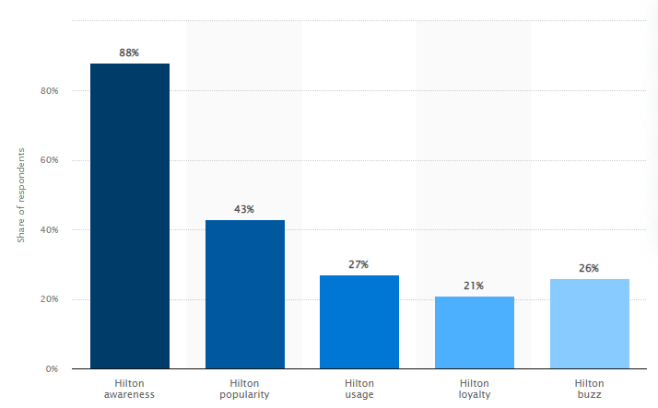
(Figure 1: Brand standard and popularity of Hilton Hotel)
Source: (statista, 2022)
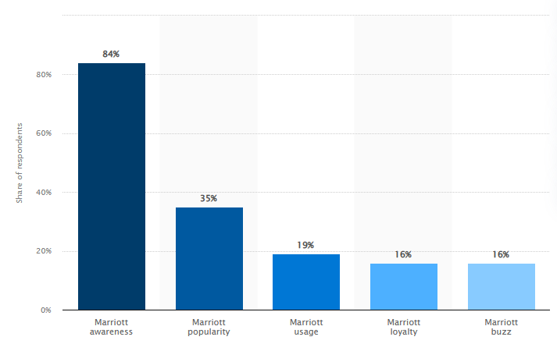
(Figure 2: Brand standard and popularity of Marriott Hotel)
Source: (statista, 2022)

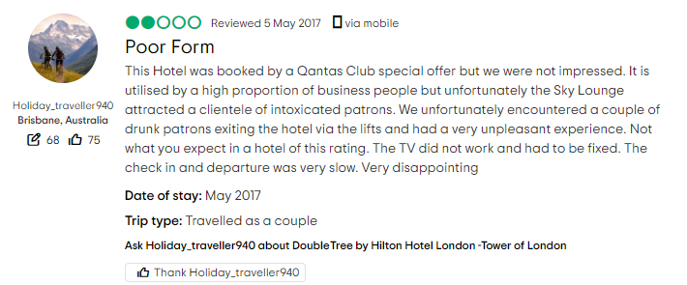
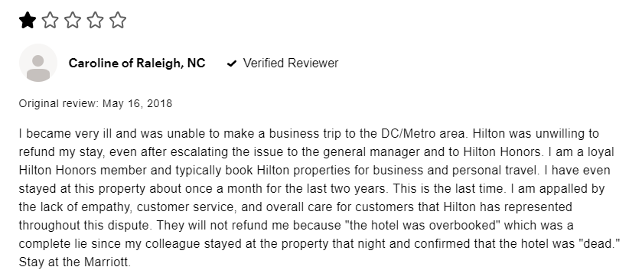
(Figure 3: Negative reviews on Hilton Hotel)
Source: (consumeraffairs, 2023)

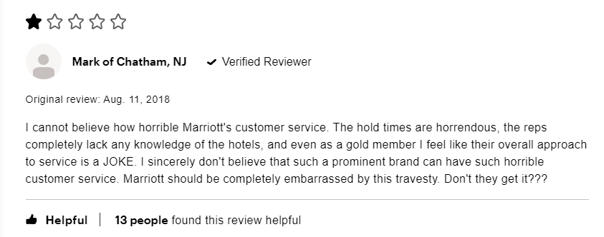
(Figure 4: Negative reviews on Marriott Hotel)
Source: (consumeraffairs, 2023)

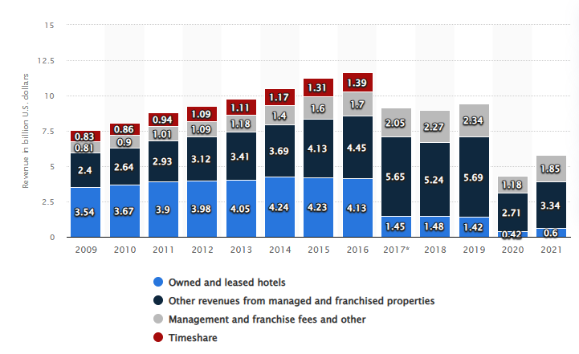
(Figure 5: Revenue Margin of Hilton)
Source: (statista, 2022)

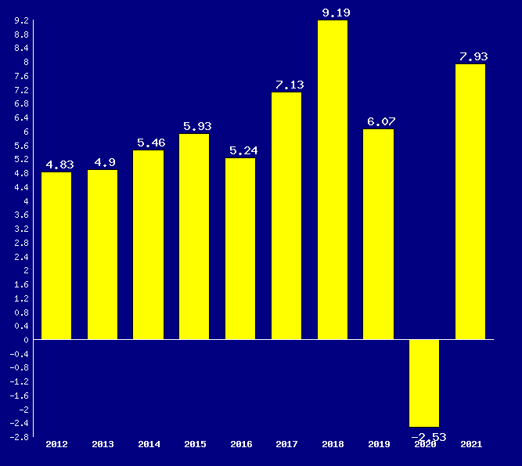
(Figure 6: Gross Profit margin of Marriott)
Source: (netcials, 2022)

