Impact of Virtual Learning Environment Moodle On- Student's learning experience at the University of Wales Trinity Saint David London Campus

Name | OLAMIDE BOBBY ERINOSHO
Student ID | 2008390
Module | BMSW4003
Lecturer | SUNETH FERNANDO

Table of Contents
INTRODUCTION 3
AIM OF RESEARCH 3
OBJECTIVE OF RESEARCH 3
RATIONALE OF RESEARCH 4
LITERATURE REVIEW 5
RESEARCH METHODOLOGIES 6
QUALITATIVE 6
QUANTITATIVE 6
SAMPLE AND SAMPLE SIZE 6
DATA COLLECTION TOOLS 6
ETHICAL CONSIDERATION 6
ANALYSIS AND DISCUSSION 6
DESIGN QUESTIONNAIRE 6
TABULATION OF DATA 7
GRAPHICAL VISUALISATION AND DISCUSSION OF FINDINGS 9
LIMITATIONS OF RESEARCH 10
RECOMMENDATIONS FOR FUTURE RESEARCH 11
CONCLUSION 12
REFERENCES 13
APPENDICES 14
APPENDIX 1: QUESTIONNAIRE 14
APPENDIX 2: GRAPHS 18
APPENDIX 3: THEMATIC FINDINGS 21

INTRODUCTION
Virtual Learning environments (VLEs) is highly introduced to provide the progress of students from passive to active learners (Phungsuk et al., 2017). It has been addressed that the VLE forms are raising critical development into the range of personal development. It is believed that active learners would promote the skills through which the essential use of the classroom activities and acquisition to learn the language along with critical thinking might take place. The research enables the discussion of the virtual learning environments on the students at Saint David London Campus.

AIM OF RESEARCH
The research aims at analyzing the impact of the Virtual learning environment over the students.

OBJECTIVE OF RESEARCH
The objectives are listed:
- To improve students’ digital skills within the workplace based on VLE
- To develop awareness associated with effective analysis and its importance to gather the information as well as a translation it to knowledge
- To improve the readiness of the learning environment of the University of Wales Trinity Saint David London Campus among students
- To recommend the ways for overcoming the limitations of the research based on the VLE and addressing future practices

RATIONALE OF RESEARCH
With the changing learning environment, the cultural issue among the students arises. It has somehow directed towards the training offered to the teachers and advancement in the technology using the university (Vaganova et al., 2017). It has been ensured that the students have the materials through which the things that are given on net are administered. It has been addressing that VLE enhances assessment for learning by offering instant feedback and feedforward to the students that are responsibly addressing to their learning and motivating needs to correct the work (Martelloni et al., 2018).

LITERATURE REVIEW
VLE
According to Ryan and Poole (2019), VLE is the encompassing on the entire mapping of the Eight-Dimensional E-learning Framework. It has segmented on the technological advancement and alignment of students. It accounts on the active learning promoting the critical thinking skills that are essential for the transfer of knowledge in the workplace settings. It has been directed on improving the digital quality and skills among the students in the settings.
On the other hand, the Martelloni et al (2018) provide the comparative analysis of the two components where modelling implementations based on DSDE and Multicomponent formalism is utilizing the VLE framework to attain the cellular models. Online communities are likely to become independent of the ways to carry out the communications that are in realistic form along with the students and teachers to gain the learning aspects.
Impact of VLE on the students
According to Herrera (2017), the massive interest in the advanced technologies has benefited in the improvement of the educational process and foster on the use of technology in language classrooms. It has been advised that the perceptions and attitudes of students in ALE courses would aim at the different perception toward the use of the technology. It can somehow provide the virtual spaces to the teachers and students along with sharing the resources and activities. It can provide a way to teach a completely online course or supporting features for face-to-face courses. This can help in motivating and gaining the learning experiences in a better way.

RESEARCH METHODOLOGIES

QUALITATIVE
Qualitative or Secondary method is essential for the research for gathering the perception of the humans towards the use of the VLE concepts. The qualitative data collection method would include the interviews comprise of open-ended questions (Mohajan, 2018). It might highlight on the illustration of the quantitative information. This might represent the drawback of gathering the information based on experiences that mislead the conclusion of the current research sometimes.

QUANTITATIVE
The quantitative or Primary method is providing the statistical analysis of the opinions and perception through which the survey of the classroom or any of the quantitative details will be taken place. It means that the survey needs to be inducted where the extremely beneficial ways to address the small-scale research and exemplifying research outcomes can be taken place. It can help in gathering quick information for the collection (Snyder, 2019).

SAMPLE AND SAMPLE SIZE
For the current study, the data collection method anticipates on the number of the sample size of the students are 11 that are undertaken in considerations. The non-probability sampling technique is involved to gain the perception for the impact of VLE on students learning experiences (Jani et al., 2018). The partial opinions are undermined with the evaluation of non-probability sampling techniques within the justified set of the implementation of the research.

DATA COLLECTION TOOLS
The tools are highly contributing based on the Likert Scale and Closed-ended questions which are comprised of 10 questionnaires in the study. Before the distribution of questions, the consent form is duly signed by the students to carry out the survey (Snyder, 2019).

ETHICAL CONSIDERATION
The voluntary participation of the respondents would help in accomplishing the data collection process. It can also address the personal credentials through which the participants are bound to meet the maintained purposes and following GDPR

ANALYSIS AND DISCUSSION

DESIGN QUESTIONNAIRE
For the questionnaire {Refer to Appendix 1}

TABULATION OF DATA
Question 1
Options | Participants Population %
Very Frequently | 50%
Frequently | 16.7%
Rarely | 8.3%
Not at all | 8.3%
Other | 8.3%
Total | 100

Question 2
Options | Participants Population %
Very Frequently | 27.3%
Frequently | 36.4%
Rarely | 18.2%
Not at all | 9.1%
Other | 9.1%
Total | 100

Question 3
Options | Participants Population %
Yes | 1%
No | 66.7%
Not sure | 1%
Fair | 16.7%
Excellent | 8.3%
Total | 100

Question 4
Options | Participants Population %
Yes | 9.1%
No | 18.2%
Not sure | 18.2%
Fair | 18.2%
Excellent | 18.2%
Very Fair | 9.1%
I like to use VLE as well as classroom | 9.1%
Total | 100%

Question 5
Options | Participants Population %
Strongly disagree | 0%
Disagree | 30%
Neutral | 50%
Agree | 10%
Strongly agree | 10%
Total | 100

Question 6
Options | Participants Population %
Strongly disagree | 0%
Disagree | 27.3%
Neutral | 63.6%
Agree | 9.1%
Strongly agree | 0%
Total | 100

Question 7
Options | Participants Population %
Very satisfied | 54.5%
Satisfied | 9.1%
Neutral | 9.1%
5 | 18.2%
4 | 9.1%
Total | 100

Question 8
Options | Participants Population %
Very satisfied | 18.2%
Satisfied | 45.5%
Neutral | 9.1%
5 | 9.1%
4 | 9.1%
3 | 9.1%
Total | 100

Question9
 | Participants Populations %
Microsoft Teams | 100%
Google Classroom | 0
None of the above | 0
Total | 100%

GRAPHICAL VISUALISATION AND DISCUSSION OF FINDINGS
From the above analysis, 100% of Microsoft teams feel that the students at the UWTSD need to be provided with the VLE facilities. It has somehow anticipated on the Virtual learning platform usage with the academic requirements holds 45.5%. The reading materials that are offered for individual subjects might be accounted with the easier way for students to meet the responses. This can analyze on the fact where 18.2% of the respondents agree to exemplar contribution in the teaching modules. This is highly supported with the provisioned information on the VLE Moodle of UWTSD (Farrelly et al., 2018). This has somehow accord on the perceptions of the students related to the lecture details and ease going communication with college. Virtual learning has become more effective than classroom teaching as it has provided ways to meet the student’s requirement fruitfully.
From the analysis, the provisions to the academic materials in the VLE Moodle is considered to the best type of learning rather than class learning with near about 50% of the respondents. Since the pandemic issues have led to the lecture receiving from the university VLE has been drawing the e-learning experience to 54.5% in a very satisfied manner (Vaganova et al., 2017). The provisions for supporting the materials from the academic subjects has provided the prevalence of transforming the information over the e-learning platform VLE. The analysis has also provided ways where the VLE might project on the positive impact on the learning experience of the students. It is highly satisfying for the university and lecturers to resume their duties during this pandemic situation and provide better information for the learning needs of the students. It has been supported that Microsoft teams have provided the facilitative implications of VLE on students learning experience, where the VLE has realized on the UWTSD, needs to improve on the grounds of the new technological form of the e-portal activities (Kumar, 2018).
VLE operating system services positive or negative is integrated with environment facilities of the university. It turns out to be challenging as well as administered features. The internet, enrol classes are some of the information offered by VLE after admission. It undertakes the complete access to the courses, tests and intent to change the things that profess with the ways to perform the supports and goals of a virtual university (Farrelly et al., 2018). It can somehow help in implementing the specific modules to which the routine administration might subject on the functions of the students with the effective course of the VLE over the lectures and access the study material for each topic within the course. The students need to provide the times where the answers and questions are transmitted to professor automatically through communication hub (Vaganova et al., 2017). This can help in developing the course of material which is offered to meet the validated range of the day-to-day activities once the course is ready for the delivery to the students.

LIMITATIONS OF RESEARCH
The research limits on the foremost issue of shortage of time to block more data from the other participants. It has some relevance to the research literature where the information was not evaluated as per the requirement in some areas. The funding issues due to the pandemic situation has created the foremost barrier for the research during the project (Snyder, 2019). Due to this, the concept was not properly documented and understood as it is closely made resolved by extensive classroom-based activities. It has somehow directed on the government authorities for raising this kind of situation. Other than this, the articles available online were not in an accessible manner. This has somehow resulted in cost-effectively but needs to spend a lot of time in regards to the research process (Mohajan, 2018).

RECOMMENDATIONS FOR FUTURE RESEARCH
It is highly recommended that the research team needs to understand the estimate of the funds required for researching so that the project expenses can be met at the expected levels. Other than this, the permission from the authorities was not managed by leading to any type of barriers (Jani et al., 2018). It can direct on the online survey process which could be applied more appropriately and managed the cost for the same. The secondary research process is applied through which the proper gathering of the information and existing literature needs to be evaluated in a more effective manner (Kumar, 2018).

CONCLUSION
It can be concluded that due to the pandemic issue, the university has focused on improving its active platform of VLE to provide the knowledge to their students at the University of Wales Trinity Saint David London. This has somehow helped in processing the information regarding what exact impact does the VLE would have on the student’s knowledge. The primary and secondary research process is carried out to meet the authenticity and reliability of the data from the students. This can subjectively direct on the secondary research process extensively as the information can help in meeting the requirement to the overall situation of the specific environment in the entire sessions.

REFERENCES
Farrelly, T., Raftery, D. and Harding, N., 2018. Exploring lecturer engagement with the VLE: findings from a multi-college staff survey. Irish Journal of Technology Enhanced Learning.
Herrera, L., 2017. Impact of implementing a virtual learning environment (VLE) in the EFL classroom. Íkala, 22(3), pp.479-498.
Jani, J., Muszali, R., Nathan, S. and Abdullah, M.S., 2018. Blended learning approach using frog vle platform towards students’ achievement in teaching games for understanding. Journal of Fundamental and Applied Sciences, 10(5S), pp.1130-1141.
Kumar, R., 2018. Research methodology: A step-by-step guide for beginners. Sage.
Martelloni, P.H., Quesnel, G., Innocenti, E., Bisgambiglia, P.A., Gonsolin, P.R. and Bisgambiglia, P., 2018, April. Component-based simulation for spatial complex systems in VLE environment. In Proceedings of the 4th ACM International Conference of Computing for Engineering and Sciences (pp. 1-12).
Mohajan, H.K., 2018. Qualitative research methodology in social sciences and related subjects. Journal of Economic Development, Environment and People, 7(1), pp.23-48.
Phungsuk, R., Viriyavejakul, C. and Ratanaolarn, T., 2017. Development of a problem-based learning model via a virtual learning environment. Kasetsart Journal of Social Sciences, 38(3), pp.297-306.
Ryan, E., and Poole, C. 2019. Impact of Virtual Learning Environment on Students' Satisfaction, Engagement, Recall, and Retention. Journal of medical imaging and radiation sciences, 50(3), 408–415. https://doi.org/10.1016/j.jmir.2019.04.005
Snyder, H. 2019. Literature review as a research methodology: An overview and guidelines. Journal of Business Research, 104, 333-339.
Vaganova, O.I., Smirnova, Z.V., Mukhina, M.V., Kutepov, M.M., Kutepova, L.I. and Chernysheva, T.L., 2017. THE ORGANIZATION OF THE TEST CONTROL OF STUDENTS'KNOWLEDGE IN A VIRTUAL LEARNING ENVIRONMENT MOODLE. Journal of Entrepreneurship Education, 20(3), pp.1-4.

APPENDICES

APPENDIX 1: QUESTIONNAIRE
RESULT
Question Q1 a
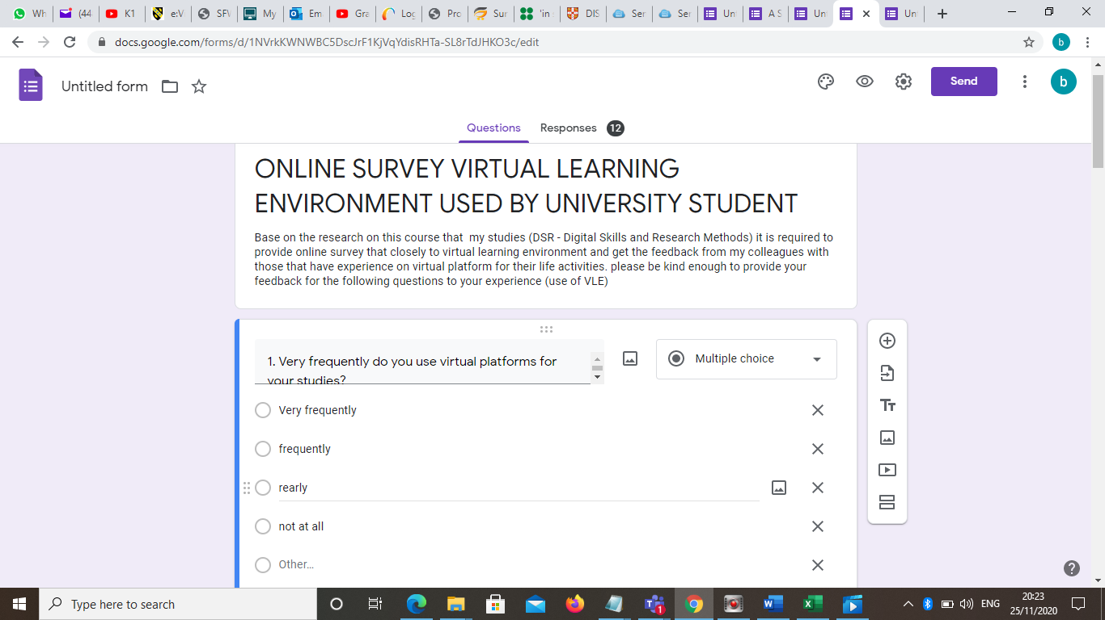

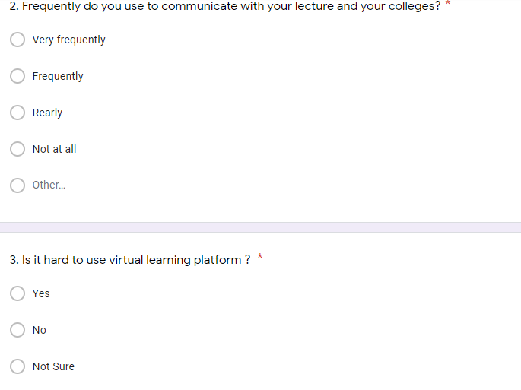

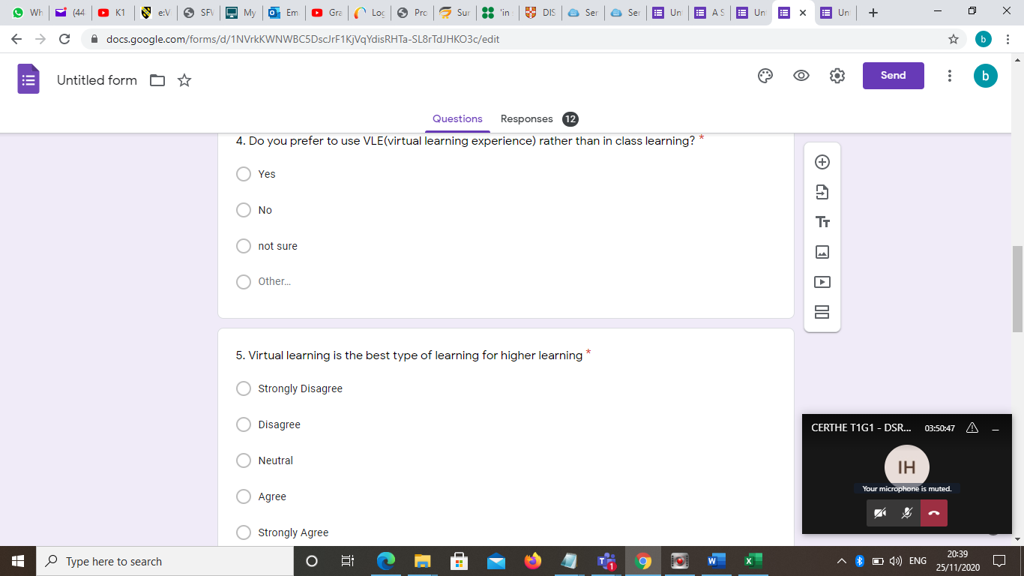

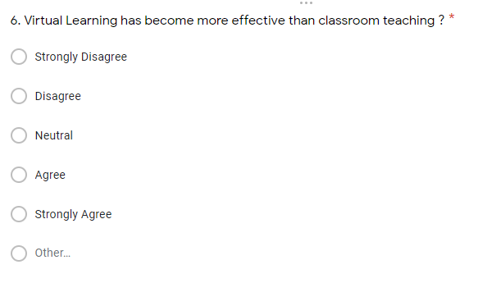

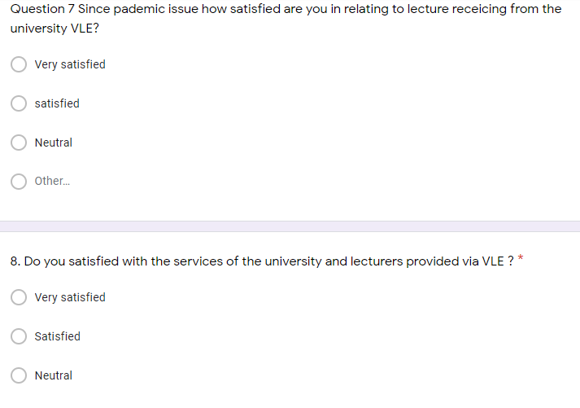
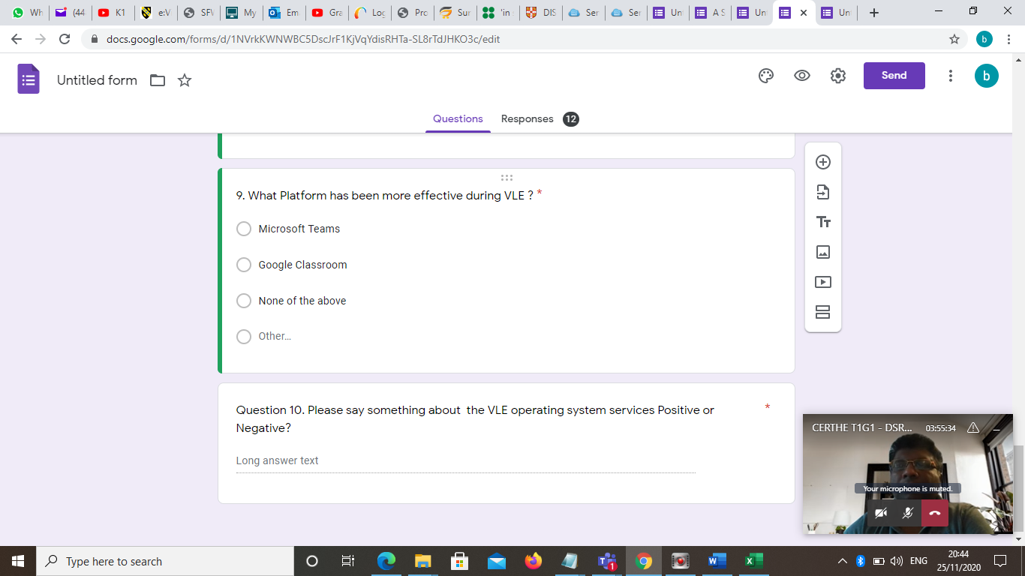

APPENDIX 2: GRAPHS
RESULTS
Questions | Very frequently | frequently | Not at all
Question 01 | 6 | 1 | 0
Question 02 | 3 | 4 | 0

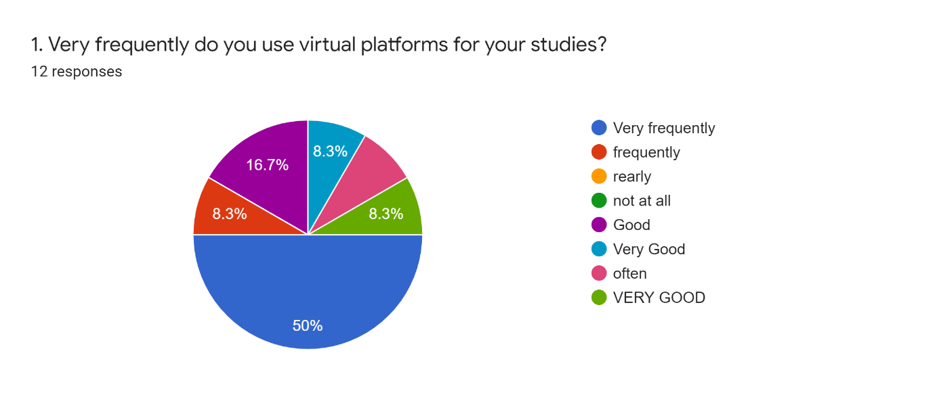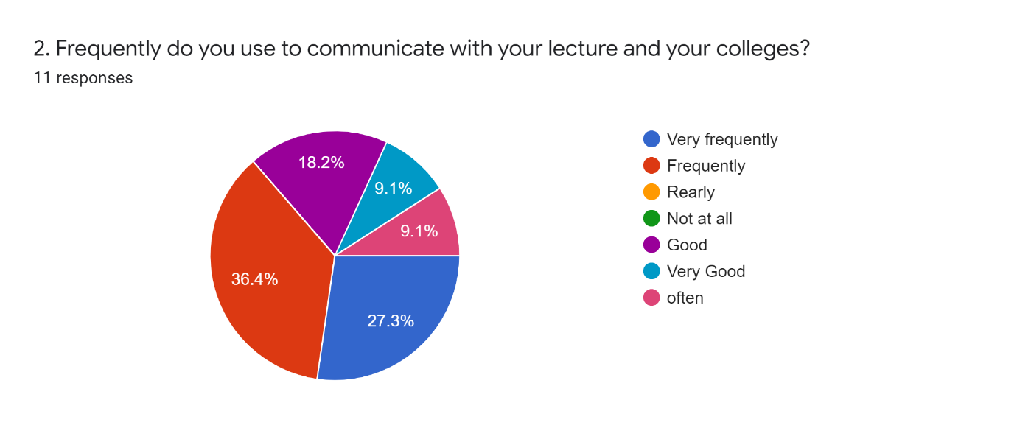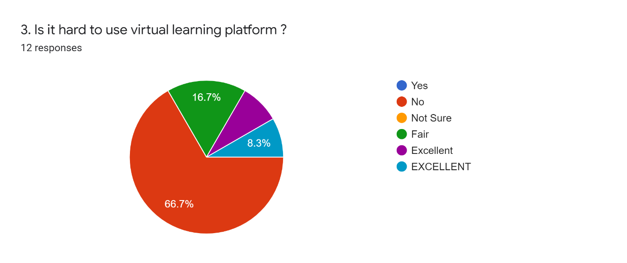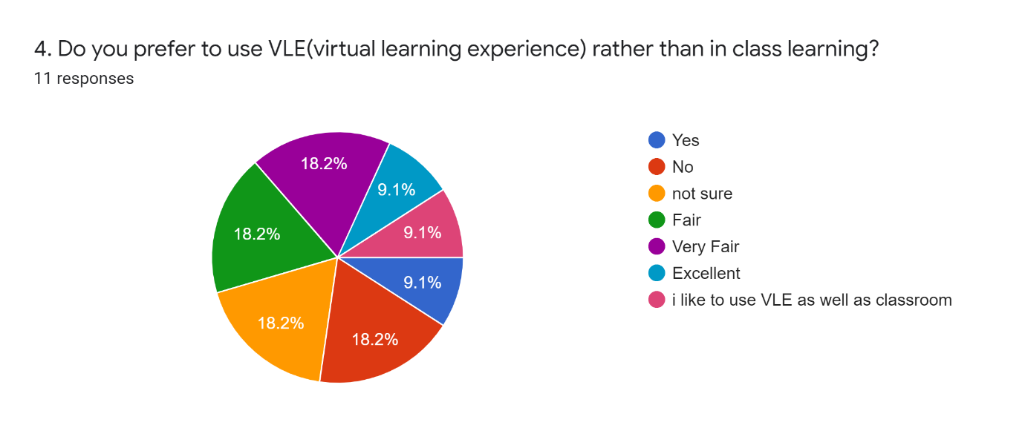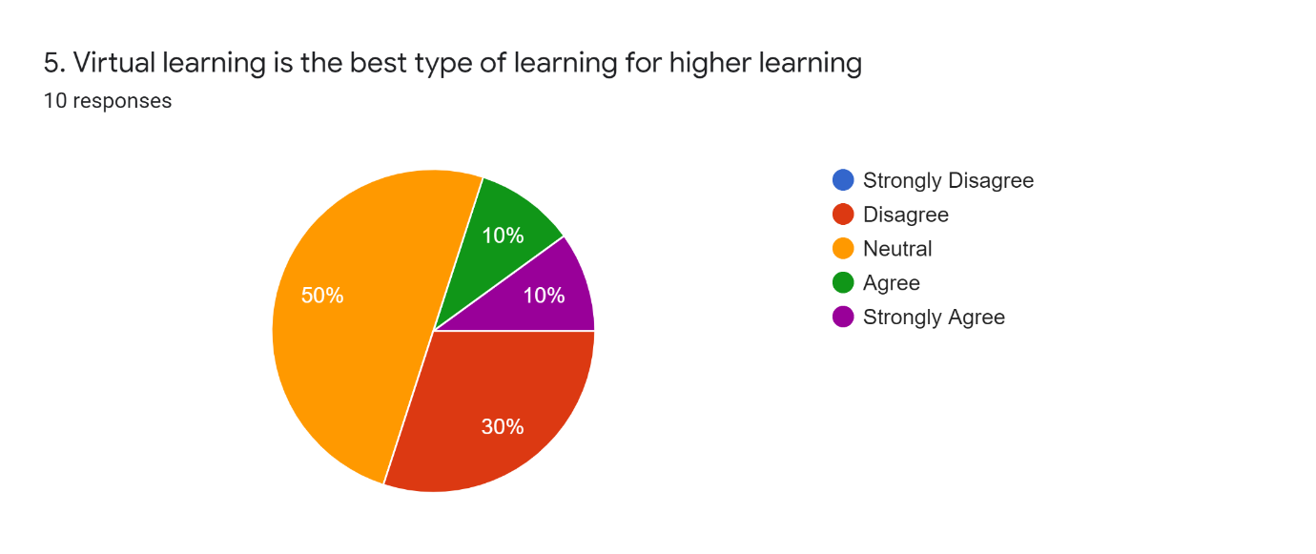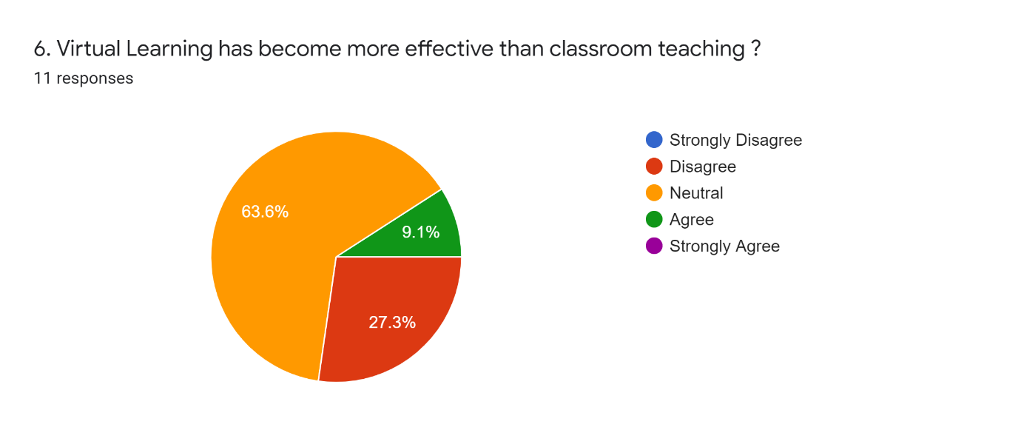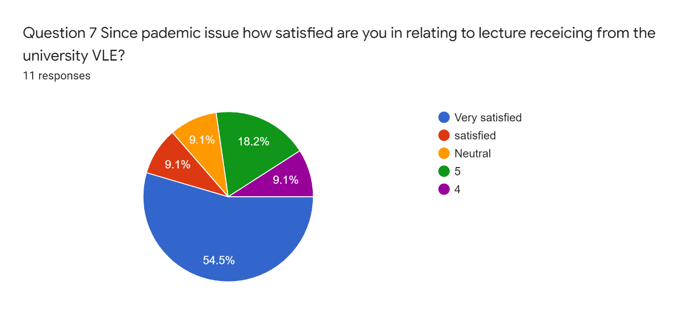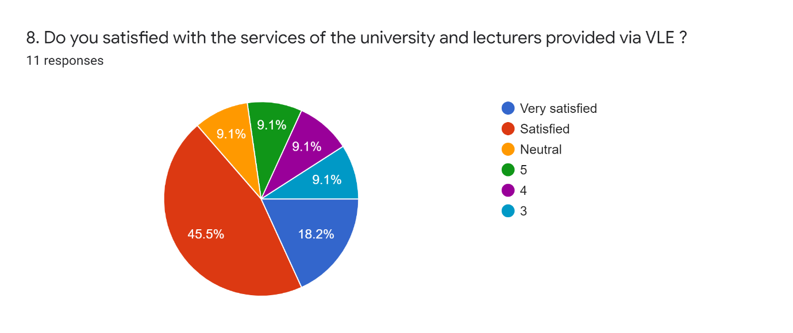
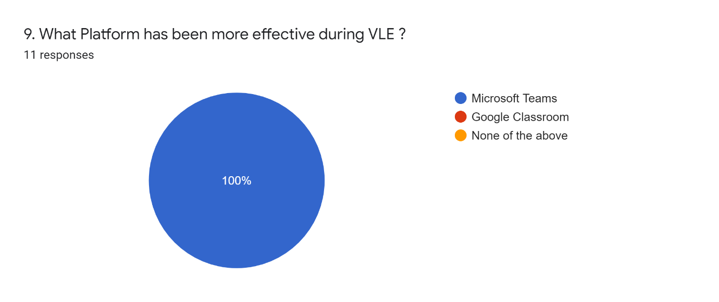

APPENDIX 3: THEMATIC FINDINGS
The secondary analysis is performed on the two themes
Theme 1: Component of VLE
Under this, the component of VLE has been mapped with the curriculum mapping and education portals. It has responded on the ways where tackling of students has been supported with the teachers and students. This can also direct on the electronic level of communication through e-mail in the current study.
Theme 2: Impact of VLE on student
The traditional form of the learning which is Face-to-Face learning is however being ignored as the digital natives have extensively grown in the learning environment. The students might utilize the entire digital era-based learning practices which would help in the digital realm to the useful measures of the students. It can help in the comprehensive discussion to make the students engage in the learning off-class using internet services.

