

Advancing to Doctoral Research Stage
(LCDB7012_LON)
Task 1: Portfolio
The Evolution of a Study on Perceived Digital Payment Dispute Resolution Quality and Customer Trust in Nepalese Banking

DBA Level 7

Student Name: Sobita Adhikari
Student Number: 2508627
Professor Name: Alireza Nazaria

2026

Abstract
The development of a proposed doctoral project that looks at customer trust in Nepalese banking and perceived digital-payment dispute resolution quality is critically reflected in this portfolio. A pilot study with banking professionals, critical literature synthesis, methodological learning, and reflection on research philosophy all helped to enhance the research, which had its foundation in professional banking experience. Digital payment disputes were initially framed primarily as operational issues related to timeliness, coordination, and settlement. The focus changed to customer psychological assessments through engagement with service-recovery, justice, trust, and Protection Motivation Theory (PMT) literature. With Perceived Fairness serving as an explanatory mechanism and Fraud Concern as a suggested boundary condition on the fairness to trust relationship, the resulting study investigates the relationship between Perceived Digital Payment Dispute Resolution Quality (PDRQ) and Customer Trust among young digital-payment users aged 18–35 in Nepalese banks. The portfolio demonstrates that the research of whether fairness is similarly related with trust while fraud fear stays high is more important than simply adding mediation and moderation. A cross-sectional survey and statistical analysis are used in a positivist-leaning, deductive quantitative methodology that acknowledges the limitations of generalizability and causal inference. Rather than being a declaration of a scientific revolution, Kuhn's concept of paradigm is carefully applied as a reflective lens for conceptual reframing. Measurement validation, ethical approval, pilot testing, and empirical evaluation are listed as the following steps in the portfolio's integrated, practical research plan.

Keywords: Perceived digital payment dispute resolution, perceived fairness, customer trust, fraud concern, service recovery, Protection Motivation Theory; Nepalese banking

Table of Contents
Abstract ii
1. Introduction 1
2. Inciting Incident: From Banking Practice to a Research Problem 2
Figure 1. Evolution of the doctoral research journey 2
3. Rising Action: Building the Theory-Informed Model 3
3.1 Service recovery and perceived dispute-resolution quality 3
3.2 Justice theory and perceived fairness 3
3.3 Trust theory and the final outcome 4
3.4 Fraud concern as a boundary condition 4
4. Crisis: Testing Coherence and Defensibility 5
4.1 Population, perception and the rejected vignette 5
4.2 Measurement quality and common-method risk 5
4.3 Cross-sectional design and causal restraint 5
4.4 Philosophical reflection and Kuhn 6
Figure 2. Evolution of conceptual thinking through Kuhn's reflective lens 6
5. Climax: The Final Integrated Research Position 6
Figure 3. Final conceptual framework of the proposed study 7
5.1 Proposed contribution 7
5.2 Aim, research questions and objectives 8
6. Denouement: Consolidating a Feasible Doctoral Plan 9
7. Next Steps and Conclusion 9
Figure 4. Proposed doctoral research execution plan 10
7.1 Refinement Following Task 2 Feedback 10
7.2 Critical alignment and feasibility 11
References 11
Appendix 1: Summary of CRP Pilot Study 12

1. Introduction
Although digital payment services are now essential to modern banking, users may face financial uncertainty due to transaction failures, delayed settlement, and security issues. Because customers rely on organizations and systems that they are unable to completely inspect or control, trust is especially crucial in financial transactions. According to foundational research, trust is characterized by assurance, optimistic expectations, and a readiness to embrace vulnerability (Morgan and Hunt, 1994; Mayer, Davis, and Schoorman, 1995). According to more recent FinTech research, users may rely on institutions, technologies, and governance structures at the same time, making trust conceptually difficult (Devlin et al., 2025).
Therefore, the bank's responsiveness to a digital payment issue is more important than technical fixes. Research on service recovery shows that organizational responses to failure have an impact on later customer assessments (Tax, Brown and Chandrashekaran, 1998; Smith, Bolton and Wagner, 1999; Van Vaerenbergh and Orsingher, 2016). Customers assess recovery through distributive, procedural, and interactional fairness, according to justice studies. These justice characteristics influence post-recovery happiness and downstream relationship outcomes, such as trust, according to recent online-banking data (Abdelkader Ali et al., 2025). While demonstrating that contextual factors like legal awareness can influence dispute-resolution outcomes, financial alternative dispute resolution research also connects perceived fairness with institutional trust (Lin and Liu, 2025).
My professional experiences in Nepalese banking and a previous Converting Research into Practice (CRP) module pilot study on digital payment dispute resolution sparked my interest in this area of inquiry. At first, I mostly used operational metrics like timeliness, communication, cooperation, and settlement to assess the issue. This conceptualization was called into question by critical engagement with the literature. Customers' interpretations of the response, whether they believe it to be fair, and how strongly that judgment is linked to trust are not always explained by operationally competent resolution. Another question was raised by the literature on fraud and cybersecurity: positive assessments of a bank may co-exist with ongoing perceptions of a digital threat. Although recent banking-security data indicates that their effects can be context-dependent, PMT offers a theoretical foundation for analyzing severity and vulnerability as threat-appraisal processes (Rogers, 1975; Naseer, Wijayanayake, and Jayasinghe, 2025). Therefore, the ensuing study issue is not a lack of understanding regarding recovery, justice, trust, or digital risk on an individual basis. Customer trust in the particular context of perceived digital-payment dispute-resolution competence is explained by the inadequate integration of various streams.
The research gap is considerable evidence on service recovery, perceived fairness, trust, and digital payment risk as distinct or somewhat related streams is provided by current research. However, there is insufficient data to explain how customer trust is linked to perceived dispute-resolution quality through perceived fairness and whether the relationship between fairness and trust is conditioned by fraud concerns, especially among young digital payment users in the Nepalese banking context.
The proposed study looks at PDRQ to Perceived Fairness to Customer Trust; a direct PDRQ to Customer Trust connection is kept, but Fraud Concern is suggested to reduce the Perceived Fairness to Customer Trust relationship. The portfolio details how this model came to be, the conceptual and methodological conflicts that arose, and the choices that were necessary to make the research viable and defendable.

2. Inciting Incident: From Banking Practice to a Research Problem
I began with a practical approach. I ran into transaction-related issues in Nepalese banking that called for coordination with other organizations and internal departments or payment service providers, client communication, and verification. At first, I thought the key to solving the issue would be a quicker and more efficient approach. My CRP pilot study, which looked at digital payment dispute resolution procedures from the viewpoint of forty banking professionals in Nepal, was influenced by this premise (Adhikari, 2026).
The pilot attested to the existence of operational limitations. The most common dispute type (77.5%) was unsuccessful transactions with the amount deducted. Manual verification, technology restrictions, external and internal coordination, and delayed internal response were all cited as reasons for delay, with 50% of respondents identifying cooperation with banks or payment-service providers as the longest resolution stage. Crucially, 67.5% of respondents thought that prompt resolution significantly boosts consumer trust, whereas 45% agreed that delays significantly diminish it (Adhikari, 2026). These results reinforced the practical significance of the topic but did not establish the relationship at the customer level, as the evidence reflected the perspectives of banking professionals rather than customers. A summary of the key findings from this pilot study is provided in Appendix 1.
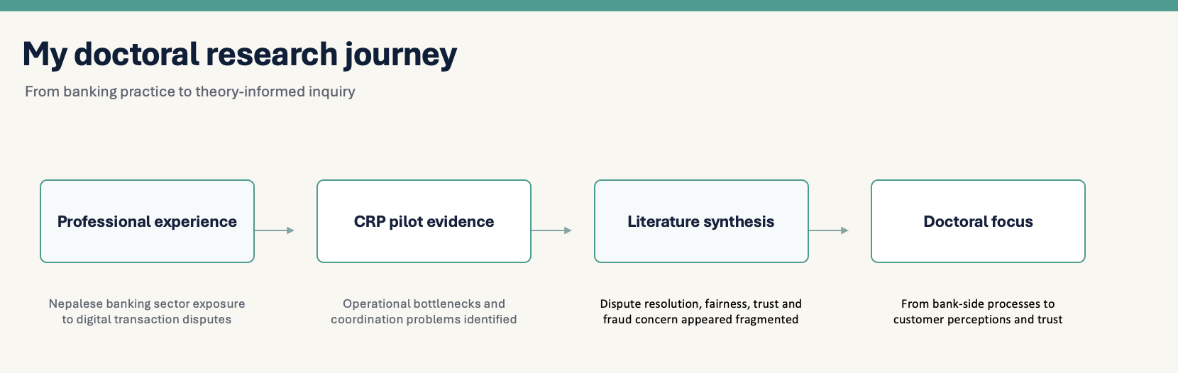

Figure 1. Evolution of the doctoral research journey
Source: Author's own development (2026).
The pilot's limitations turned out to be more instructive than its descriptive results. Research on service recovery and justice reveals that clients assess not just results but also the processes and interpersonal care related to rehabilitation (Tax, Brown, and Chandrashekaran, 1998; Smith, Bolton, and Wagner, 1999). Customers' opinions of quality, fairness, and trust could therefore not be replaced by expert evaluations of effective dispute resolution. Therefore, rather than serving as proof for the suggested theories, the pilot serves in this portfolio as a developmental artifact. The research question was changed from "How successfully do banks manage disputes along the direction of "How do customers perceive dispute-resolution capability, and how are those perceptions associated with fairness and trust?"

3. Rising Action: Building the Theory-Informed Model

3.1 Service recovery and perceived dispute-resolution quality
Service Recovery Theory stated the first bridge between the operational issues and customer evaluation. According to traditional research, recovery is multifaceted: customers' assessments of service failures are influenced by speed, reaction, explanation, compensation, and corrective action (Tax, Brown, and Chandrashekaran, 1998; Smith, Bolton, and Wagner, 1999). More recent meta-analytic evidence confirms the ongoing significance of complaint processing in shaping distributive, procedural and interactional justice evaluations in online service recovery (Das et al., 2026). In a similar vein, Van Vaerenbergh and Orsingher (2016) synthesize service recovery as a process as opposed to a singular corrective event. Rao et al. (2024) demonstrates the relationship between recovery satisfaction and loyalty throughout organizational levels in retail banking and recovery systems, employee’s performance, complaint monitoring, and standardized procedures.
My independent variable's meaning was modified by this literature. The study measures consumer impressions rather than analyzing actual processing times or refund records. Thus, the construct is Perceived Digital Payment Dispute Resolution Quality (PDRQ), which is the customer's assessment of the bank's capacity to resolve disputes, especially in terms of promptness, transparency, and communication. In addition to aligning an idea with the survey evidence that can actually be gathered, this language avoids suggesting objective operational measurement.

3.2 Justice theory and perceived fairness
The psychological mechanism was explained by Justice Theory. Procedural justice is the fairness of decision-making procedures, distributive justice is the fairness of results, and interactional justice is the fairness of hoe people are treated. In addressing complaints and recovering services, these characteristics are well-established (Tax, Brown, and Chandrashekaran, 1998; Smith, Bolton, and Wagner, 1999). Using data from 445 Egyptian online banking clients who have experienced service failure, Abdelkader Ali et al. (2025) discover that all three justice dimensions have a favorable impact on post-recovery satisfaction, which in turn promotes commitment, trust, and behavioral intentions. Although their methodology differs from mine, it shows how important justice assessments are to the recovery of online banking.
Lin and Liu (2025) offer more detailed evidence of financial conflict resolution. They demonstrate that perceived fairness is linked to institutional trust in Alternative Dispute Resolution (ADR) and that certain relationships are conditioned by legal understanding using 1,620 financial service consumers. The study's findings do not directly support my hypothesis because they deal with ADR engagement rather than a bank's management of digital payment disputes. Nevertheless, it offers compelling evidence for the relationship between fairness and trust as well as the more general notion that the impacts of dispute settlement are conditional.
It is crucial to understand the theoretical differences between PDRQ and perceived fairness. PDRQ inquire about customers' perceptions of the bank's ability to respond quickly, communicate effectively, and manage the process skillfully. How consumers evaluate those actions whether the processes, treatment, and results are fair is known as perceived fairness. Regardless of statistical significance, mediation becomes conceptually weak if questionnaire items obscure these meanings. This turned into one of the main measuring concerns as the study progressed.

3.3 Trust theory and the final outcome
Another significant adjustment was necessary for trust theory. Previous concepts of my research employed "trust restoration" or "post-dispute trust." Only if every respondent had previously experienced a conflict and a breach of trust would those descriptions be appropriate. However, young people who use digital payments, both with and without past conflict experience, are included in the projected group. Thus, the more justifiable result is customer trust. It refers to having faith in the bank's dependability, honesty, and capacity to operate in the best interests of the client without presuming that trust has already been harmed. According to Mayer, Davis, and Schoorman (1995) and Devlin et al. (2025), basic conceptualizations of trust and current FinTech work emphasize the importance of precisely defining the aim and measurement of trust.

3.4 Fraud concern as a boundary condition
The last theoretical element was presented by PMT. Rogers (1975) uses threat appraisal and coping appraisal to explain protective motivation. Threat assessment, namely perceived susceptibility/vulnerability and severity, is the main source of information for this study's Fraud Concern. Threat-appraisal effects are inconsistent and context-dependent, but efficacy beliefs are more consistently linked to security awareness, according to Naseer, Wijayanayake, and Jayasinghe is (2025) systematic study of 38 Scopus-indexed banking-security studies. This warns against asserting that PMT automatically validates the suggested moderation.
The theoretical claim is more limited. Even if a consumer believes that a bank handles disputes fairly, they may still worry about being vulnerable to fraud in the future. The plausibility of such conditionality is supported by adjacent digital-payment evidence: Aljaradat and Shukla (2025) discover that while prior cybercrime experience limits the behavioral effects of positive evaluations, grievance redressal enhances favorable trust/cybersecurity ratings. Fraud Concern multiply by Perceived Fairness(FC → Customer Trust is not tested in their study. Therefore, it does not support the assertion that my moderation is already established, but rather the need for looking into a border condition.
The justification behind the concept of fraud concern as a moderator instead of a mediator is that perceived fairness serves as a means of evaluating how customer trust may be related to perceived dispute-resolution quality. Fraud Concern is not an assessment that is inevitably generated by dispute-resolution quality, but rather a unique threat appraisal. As a result, it is hypothesized as a boundary condition that could change how strong the relationship between perceived fairness and customer trust is. Even if they have a positive opinion of the bank's reaction, customers who are more concerned about fraud might still be wary.
The integrated problem can now be described more precisely the literature currently in publication provides compelling evidence for the component notions that recovery is important, customers assess recovery through fairness, fairness is related to trust, and perceptions of digital threats influence financial behavior. The question of whether these processes work in tandem to explain a portion of the PDRQ-Customer Trust link and if Fraud Concern alters the strength of the fairness-trust correlation is less clearly defined. This is not a contention that the individual constructs have been overlooked, but rather a mechanism-and-boundary gap.

4. Crisis: Testing Coherence and Defensibility

4.1 Population, perception and the rejected vignette
There was impact in the design when clients without any prior dispute experience were included. Although it would limit access and transform the study into an experience-specific rehabilitation project, limiting the sample to experienced complainants would enable retrospective evaluation of real recovery. Regardless of past dispute experience, the selected population continues to be youthful digital payment customers in Nepalese banks between the ages of 18 and 35. As a result, respondents assess perceived capabilities; seasoned users may base their answers on real-world occurrences, while others base their answers on their present perceptions of their primary bank. Because it may provide a common point of reference for all responders, a standardized hypothetical conflict vignette was taken into consideration. I rejected it since the object of measurement would no longer be naturally held perceptions of the respondent's bank, but rather a situation devised by the researcher. This is not an argument that vignette research is bad practice; rather, it is a trade-off. As a result, there is a clear interpretation boundary: for respondents who have never had a dispute, the results cannot be used as proof of real post-conflict healing.

4.2 Measurement quality and common-method risk
The most significant validity risk is caused by the conceptual closeness of PDRQ and perceived fairness. It cannot be solved by reliability statistics alone. High internal consistency may be produced by a set of overlapping objects, although the constructs may not be distinguished. Therefore, theoretical definitions and established scales must come first in the measurement development process, followed by expert review, pilot testing, and factor analysis. Before interpreting structural correlations, the later doctorate study can employ confirmatory component analysis to assess convergent and discriminant validity more rigorously. Exploratory factor analysis may be helpful during instrument building.
The same self-report questionnaire is used to gather all of the key components, which may lead to common-method bias. Therefore, impartial wording, anonymity, clear build instructions, and avoiding items that expose the predicted hypotheses are procedural precautions that should come before statistical diagnostics. While statistical tests can offer additional proof, they are unable to demonstrate that common-method variance is completely absent. The sampling approach and its consequences must be openly disclosed because non-probability recruiting also restricts statistical generalizability. Age, gender, digital literacy, prior fraud experience, education, income, and frequency of use of digital payments are examples of potential control factors. Instead of relying only on statistical significance, their inclusion in the final models will be supported theoretically.
The final analytical model, not just simplified regression, will be used to justify the sample size. The end goal will take into account statistical power, model complexity, and measurement needs prior to data collection because the planned study incorporates mediation, moderation, and maybe CFA/SEM at the thesis stage.

4.3 Cross-sectional design and causal restraint
A cross-sectional observational survey assesses constructs at a single point in time, whereas the conceptual framework is directional. Although they cannot prove temporal precedence or rule out reverse explanations, mediation and moderation analysis can demonstrate whether observed relationships are congruent with the theoretical model. For instance, consumers who already have faith in their bank may see its anticipated dispute resolution capabilities more favorably. Therefore, theory-derived impact must be distinguished from empirically proven causation in the thesis's wording. For causal assertions, longitudinal, experience-based, or experimental designs would be more persuasive and may still be expanded upon in the future.

4.4 Philosophical reflection and Kuhn
The study adopts a quantitative design to measure subjective perceptions. As a result, I take a positivist-leaning rather than strictly positivist stance. The study's ontological premise is that, despite the fact that individual assessments differ, significant trends in consumer views can be methodically examined. According to epistemology, constructs drawn from theory, observable indicators, and statistical testing are used to develop knowledge. From an axiological perspective, I acknowledge that the problem was chosen with consideration for transparency and methodological rigor in measurement and interpretation.
Although it should not be stated, Kuhn (1962/2012) is helpful in this situation as a reflective lens. My project does not replace a disciplinary paradigm or represent a scientific revolution. Conceptual reframing is a helpful analogy: an original operational frame experienced anomalies that it was unable to explain, especially consumer fairness judgments and ongoing fraud concerns. As a result, while adhering to a well-established quantitative research tradition, the study shifted toward a customer-centered theoretical explanation.
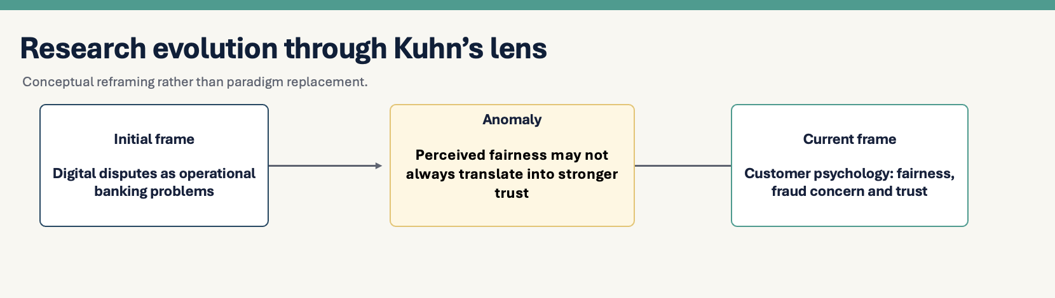

Figure 2. Evolution of conceptual thinking through Kuhn's reflective lens
Source: Author's own development (2026).
Figure 2 illustrates this conceptual reframing from an operational interpretation of digital-payment disputes towards a customer-centric explanation that incorporates perceived fairness, fraud concern and customer trust.

5. Climax: The Final Integrated Research Position
Alignment, not the addition of a new variable, was the development's pinnacle. Perceived organizational response is explained by service-recovery literature; the customer's fairness assessment is explained by justice theory; the relational outcome is clarified by trust theory; and PMT offers a foundation for ongoing threat appraisal. As a result, each theory serves a certain purpose in explanation. The quantity of theories does not strengthen the model; rather, what matters is whether or whether their integration fills in the gaps left by each stream alone.
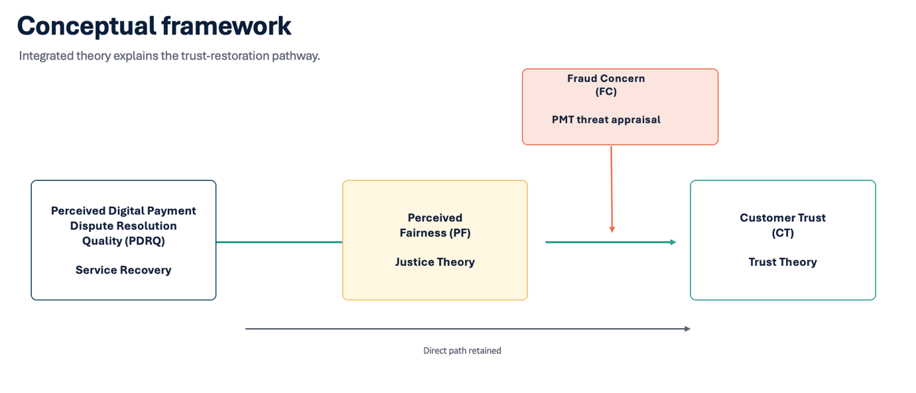

Figure 3. Final conceptual framework of the proposed study
Source: Author's own development (2026)
The final framework places Customer Trust as the dependent variable, PDRQ as the independent variable, Perceived Fairness as the mediator, and Fraud Concern as a moderator of the link between Perceived Fairness and Customer Trust. In order to avoid assuming full mediation beforehand, the direct PDRQ to Customer Trust path is kept. Higher perceived dispute-resolution quality may be linked to trust in part through positive fairness assessments but, when fraud concern is strong, the association between fairness and trust may be less.

5.1 Proposed contribution
By investigating whether this association weakens when fraud concern is high, my suggested addition challenges the idea that positive fairness assessments translate uniformly into customer trust.
It is necessary to separate the suggested contribution from the statistical method. Testing moderation and mediation is an analytical technique, not a doctoral contribution in and of itself. Similarly, while performing the study in Nepal has contextual relevance, theoretical innovation is not always produced. The most compelling argument focuses on a possible limit to fairness as a means of fostering trust. Fairness is expected to foster positive relational outcomes, according to service-recovery and justice studies; PMT suggests that the degree to which that positive judgment is linked to trust may be limited by ongoing threat assessment.
Therefore, the contribution is presented as a question rather than a final conclusion: is perceived fairness less strongly correlated with customer trust when fraud concern is still high? This formulation does not assume moderation prior to testing, nor does it deny the recognized significance of fairness. Although their scenario-based model does not evaluate fairness or fraud concern, Raza et al. (2023) bolster the larger boundary-condition logic by demonstrating that trust-recovery strategies in financial services do not function consistently across trust dimensions and failure severity.

5.2 Aim, research questions and objectives
Research aim: To examine how perceived digital payment dispute resolution quality influences customer trust among young digital-payment users in Nepalese banks, through perceived fairness and under conditions of fraud concern.
Core research question: To what extent does perceive digital payment dispute resolution quality influence customer trust among young digital-payment users in Nepalese banks, and what roles do perceive fairness and fraud concern play in explaining this relationship?
Supporting research questions:
Type | Research question
Relational | RQ1: To what extent does dispute resolution quality influence perceived fairness?
Relational | RQ2: To what extent does perceive fairness influence customer trust?
Mediating | RQ3: To what extent does perceived fairness explain the relationship between dispute resolution quality and customer trust?
Moderating | RQ4: To what extent does fraud concern influence the relationship between perceived fairness and customer trust?

Objectives
- Assess the relationship between PDRQ and Perceived Fairness.
- Examine the relationship between Perceived Fairness and Customer Trust.
- Evaluate the explanatory role of Perceived Fairness in the PDRQ–Customer Trust relationship.
- Examine whether Fraud Concern conditions the Perceived Fairness–Customer Trust relationship.
- Empirically evaluate the integrated theoretical explanation in the context of young digital-payment users in Nepalese banks.
Hypotheses:
- H1: Perceived Digital Payment Dispute Resolution Quality is positively associated with Perceived Fairness.
- H2: Perceived Fairness is positively associated with Customer Trust.
- H3: Perceived Digital Payment Dispute Resolution Quality is positively associated with Customer Trust.
- H4: Perceived Fairness mediates the relationship between Perceived Digital Payment Dispute Resolution Quality and Customer Trust.
- H5: Fraud Concern negatively moderates the relationship between Perceived Fairness and Customer Trust, such that the positive relationship is weaker at higher levels of Fraud Concern.
- H6: The indirect relationship between Perceived Digital Payment Dispute Resolution Quality and Customer Trust through Perceived Fairness is conditional on Fraud Concern.

6. Denouement: Consolidating a Feasible Doctoral Plan
A cross-sectional, deductive quantitative survey is used in the proposed study. Customer impressions of punctuality, transparency, and communication will be used to operationalize PDRQ. Justice evaluations of procedure, treatment, and result will be represented by perceived fairness. Customer trust will reflect trust in the bank's dependability, honesty, and customer-focused behavior. Perceived vulnerability and severity will guide the development of Fraud Concern as a threat-related concept. Instead of being used as an eligibility requirement, prior disagreement experience can be documented as a control or grouping characteristic. The creation of instruments will give priority to well-established metrics and theoretically sound modifications. Pilot testing and expert review will evaluate construct coverage, completion burden, and phrasing. In order to formally assess convergent and discriminant validity, CFA should come before structural interpretation for the entire DBA thesis. Subject to a suitable sample size and the final design, SEM may then offer a cogent approach to the measurement and structural models. Weak concept definition cannot be made up for by statistical sophistication.
Although ethical design is relatively low risk, cautious data minimization is still necessary. Informed consent will be the basis for voluntary participation. Passwords, account credentials, transaction identifiers, other needless sensitive financial information should not be asked for in the questionnaire. Additionally, anonymity and unambiguous withdrawal information will lessen social pressure and encourage more honest answers.
If the theoretical correlations are empirically supported, the practical contribution is also more accurate than merely telling banks to "resolve disputes faster." In order to address ongoing fraud-related risk, banks may need to combine operationally competent redress with procedures that consumers believe are fair. The portfolio does not portray this suggestion as a proven effect; it is still dependent on the results.

7. Next Steps and Conclusion
A targeted novelty search is the next step in deepening the literature review, particularly for studies that directly link recovery qualities to fairness, fairness to trust, and threat-related dimensions to recovery results. This is significant since the component interactions are now more strongly supported by the evidence than the precise integrated conditional process. The second objective is measurement refinement: the questionnaire must maintain the distinction between PDRQ and Perceived Fairness, and pilot testing should explicitly look at whether respondents who have never been in a dispute can answer the PDRQ items as intended. Only until these conceptual and measurement problems have been adequately addressed can ethical approval and primary data collecting begin.
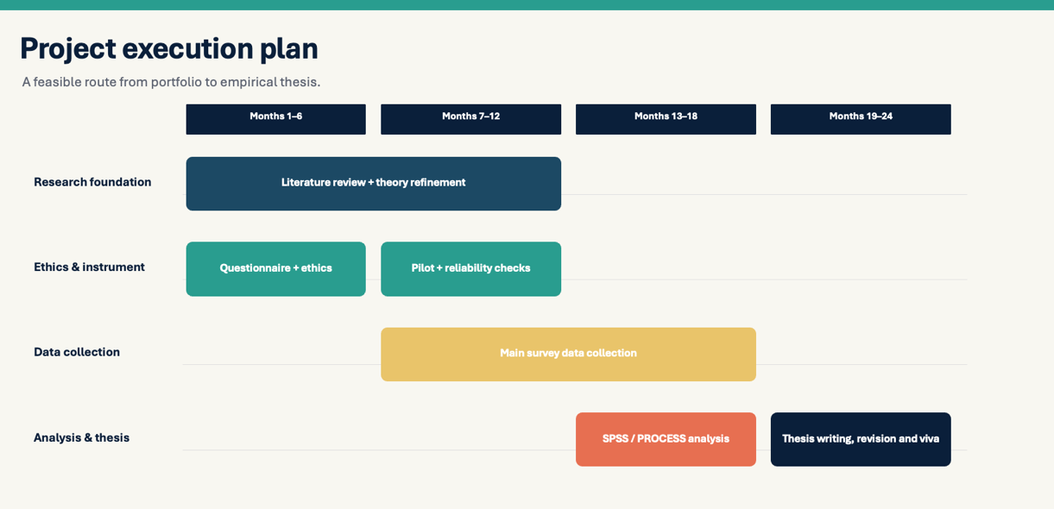

Figure 4. Proposed doctoral research execution plan
Source: Author's own development (2026).
Contingency planning: the data collection period will be extended if the response rate is low; if measurement problems are discovered during pilot testing, items will be revised and re-tested before proceeding to full data collection.
This portfolio shows a separate shift from a practice to a PhD proposal that may be defended. The CRP pilot and professional experience demonstrated the usefulness of digital payment dispute resolution, but they also exposed the shortcomings of a bank-centered viewpoint (Adhikari, 2026). The literature on service recovery shifted focus to customer assessments of organizational response; PMT introduced ongoing fraud-related threat as a potential boundary condition; Justice Theory introduced Perceived Fairness as the explanatory mechanism; and Trust Theory clarified Customer Trust as the proper outcome for a mixed-experience population.
Therefore, the final study looks at PDRQ to Perceived Fairness to Customer Trust, keeping the direct PDRQ to Customer Trust path while modulating the fairness–trust link with Fraud Concern. The idea is still subject to empirical confirmation, qualification, or rejection because the available data does not conclusively prove the fraud-concern interaction. The substantial shift in what I considered to be the research problem from practical conflict management to the interaction of customer perceptions, fairness, threat, and trust was explained by Kuhn's work without necessitating a declaration of paradigm revolution.

7.1 Refinement Following Task 2 Feedback
The Task 2 presentation's feedback made clear that the final doctoral study's theoretical sophistication needed to be strengthened. In response, the following phase will go back to the literature to critically assess what is already understood about the mechanisms connecting consumer trust with dispute-resolution quality and, more crucially, what is still not fully defined. Instead of adding complexity only for statistical reasons, this will direct the discovery of another theoretically supported mechanism or mediator. Therefore, before moving on to the doctorate research stage, the final framework will be improved through a more thorough theoretical synthesis and the identification of a distinct research gap and will make it sophisticated for the doctoral level.

7.2 Critical alignment and feasibility
The constructions' statistical functions are distinct from their theoretical functions: Fraud Concern is a theoretically motivated boundary question, not an addition for complexity; Perceived Fairness is the justice appraisal thru which that response acquires psychological meaning; and PDRQ is the customer's perception of organizational response capability, not just a convenient independent variable. This distinction is important because if the constructs lacked a cohesive explanatory logic, a statistically significant model would have minimal doctoral value. The same discipline holds true for customer trust: shifting away from "post-dispute trust" enhances population, measurement, and theory alignment without suggesting that all respondents are mending their damaged trust.
Additionally, the suggested contribution should keep going to be contingent on the evidence. Weak mediation could suggest that PDRQ effects trust thru means other than fairness; similarly, a well-powered test demonstrating that fairness stays strong across levels of fraud worry would itself refine the theoretical explanation rather than constitute a failed study. This means that the analysis is based on the study topic rather than a desired outcome.
The final design has been influenced by feasibility in two additional ways. The theoretical model, whose mediator, moderator, and outcome are customer-level constructs, leads to the customer-only design. Initially, a dual-perspective study involving both banking professionals and customers was considered but rejected because the two groups represent different units of analysis requiring separate sampling and measurement strategies. Although it is regarded as developmental evidence rather than doctoral evidence, the professional CRP pilot is still useful for elucidating the source of the issue. Second, the execution plan views the processes of literature consolidation, instrument refining, ethics, pilot testing, data collection, and analysis as interconnected. For example, items may need to be modified for pilot evidence, and analysis will start with data-quality and measurement evaluation prior to hypothesis testing. This sequencing keeps the study applied, banking-relevant motivation separate from its academic requirement to produce an explanation that can be examined beyond one organization and prevents the research from going straight to hypothesis tests without first establishing that the constructs have been measured credibly.

References
Abdelkader Ali, A., Gabriela Andrei, A., Ruiz-Moreno, F. and Zingone, L. (2025) 'Exploring justice perceptions in online banking recovery: gender moderation and behavioral outcomes', Journal of Business Economics and Management, 26(1), pp. 164–185. doi:10.3846/jbem.2025.22831.
Adhikari, S. (2026) Investigating Digital Payment Transaction Dispute Management Practices and Their Role in Consumer Trust in Banks and Financial Institutions in Nepal. Unpublished DBA pilot study, University of Wales Trinity Saint David.
Aljaradat, A. and Shukla, S.K. (2025) 'Trust and cybersecurity in digital payment adoption: socioeconomic insights from India', Journal of Business and Socio-economic Development, 5(4), pp. 372–386.
Das, M., Jebarajarkirthy, C., Maseeh, H.I., Lim, W.M. and Shah, J.S. (2026) 'Online service failure and recovery: an integrated meta-analytic perspective of attribution and justice theories', Journal of Business Research, 202, 115752. doi:10.1016/j.jbusres.2025.115752.
Devlin, J.F., Roy, S.K., Sekhon, H., Moin, S.M.A. and Sahiner, M. (2025) 'Trust and FinTech: a review and research agenda', Electronic Markets, 35, 62. doi:10.1007/s12525-025-00803-w.
Kuhn, T.S. (1962/2012) The Structure of Scientific Revolutions. Chicago: University of Chicago Press.
Lin, Y.-C. and Liu, Y. (2025) 'Beyond the courtroom: exploring consumers' trust and usage of ADR in financial dispute resolution', Finance Research Letters, 85, 107872. doi:10.1016/j.frl.2025.107872.
Mayer, R.C., Davis, J.H. and Schoorman, F.D. (1995) 'An integrative model of organizational trust', Academy of Management Review, 20(3), pp. 709–734.
Morgan, R.M. and Hunt, S.D. (1994) 'The commitment-trust theory of relationship marketing', Journal of Marketing, 58(3), pp. 20–38.
Naseer, H., Wijayanayake, J. and Jayasinghe, S.A. (2025) 'Antecedents of customer awareness in banking security: a Protection Motivation Theory-based systematic review', Kelaniya Journal of Management, 14(3), pp. 151–167. doi:10.4038/kjm.v14i3.7922.
Rao, A.S. et al. (2024) 'Service recovery system and service recovery in retail banks: a multilevel analysis', Cogent Business & Management, 11(1), 2349260. doi:10.1080/23311975.2024.2349260.
Raza, A., Tsiotsou, R., Sarfraz, M. and Ishaq, M.I. (2023) 'Trust recovery tactics in financial services: the moderating role of service failure severity', International Journal of Bank Marketing, 41(7), pp. 1611–1639. doi:10.1108/IJBM-10-2022-0447.
Rogers, R.W. (1975) 'A protection motivation theory of fear appeals and attitude change', The Journal of Psychology, 91(1), pp. 93–114.
Smith, A.K., Bolton, R.N. and Wagner, J. (1999) 'A model of customer satisfaction with service encounters involving failure and recovery', Journal of Marketing Research, 36(3), pp. 356–372.
Tax, S.S., Brown, S.W. and Chandrashekaran, M. (1998) 'Customer evaluations of service complaint experiences: implications for relationship marketing', Journal of Marketing, 62(2), pp. 60–76.
Van Vaerenbergh, Y. and Orsingher, C. (2016) 'Service recovery: an integrative framework and research agenda', Academy of Management Perspectives, 30(3), pp. 328–346.

Appendix 1: Summary of CRP Pilot Study
Pilot study title:
Investigating Digital Payment Transaction Dispute Management Practices and Their Role in Consumer Trust in Banks and Financial Institutions in Nepal
Purpose of the pilot:
The CRP pilot study examined digital-payment dispute-management practices from the perspective of banking professionals in Nepal. It provided preliminary insight into common dispute types, resolution processes, sources of delay and the perceived implications of dispute management for customer trust (Adhikari, 2026).
Participants:
The pilot involved 40 banking professionals in Nepal.
Summary of Key Findings
Area examined | Key finding
Common dispute type | Failed transactions where the amount was debited were the most frequently reported dispute type (77.5%).
Reporting channel | Branch reporting was the most commonly identified channel (45%), followed by mobile applications (35%).
Longest resolution stage | Coordination with other banks/payment service providers was identified most frequently as the longest stage (50%).
Resolution timeliness | 22.5% reported that prescribed timelines were always achieved and 42.5% reported that they were often achieved, while others reported less consistent performance.
Perceived effectiveness | 62.5% considered existing dispute-management practices effective, while 25% considered them moderately effective.
Sources of delay | Manual verification (27.5%), system limitations (25%), external PSP coordination (25%) and delayed internal responses (22.5%) were identified as key causes.
Trust implications | 45% indicated that delays strongly reduce customer trust, while 67.5% indicated that efficient dispute resolution strongly increases trust.

Contribution to the Development of the Doctoral Research

The pilot gave an important initial point for the development of the proposed doctoral research. It highlighted that dispute management involves not only operational procedure such as timeliness, coordination and settlement, but also potential implications for customer trust. However, because the empirical evidence represented the professional perspective, it could not explain how customers themselves psychologically evaluate dispute resolution. This limitation contributed to the subsequent shift towards a customer-focused perspective, with greater attention to perceived dispute-resolution quality, perceived fairness, fraud concern and customer trust.
Source: Adhikari, S. (2026)

