GIUSEPPE COSTANZA
ACCA5025
10-05-2023

USER GUIDE OF UWTSD LONDON’S WEB APPLICATION

Introduction

This report documents the design and deployment of a web application that leverages Microsoft Azure to manage student admission, hostel services, and a contact us page. The application is designed to provide a comprehensive platform for streamlining the student admission process, simplifying hostel services management, and facilitating communication between the institution and its stakeholders.

The purpose of this web application is to provide an efficient and scalable solution for managing student admission, hostel services, and a contact us page, while also leveraging the benefits of Microsoft Azure. By using Azure, the application can take advantage of the platform's scalability, reliability, and security features.

This report will describe the design, architecture, development, deployment, testing, and maintenance of the web application, with a focus on the role of Microsoft Azure in the project. The report will also provide insights into the challenges faced during the project and the solutions implemented to overcome them, including the use of Azure services such as Azure App Service, Azure SQL Database, and Azure Functions.

Design

Admin Login, Student Admission, Hostel Services, and Contact Us are the three main sections of the application. Each section is designed to be intuitive and simple to use, and the design language is consistent throughout the application.

- Admin Login

The admin login page is a crucial component of the student admission and hostel management system that allows authorized users to access and manage the application's backend. This page typically includes a login form that prompts the user to enter their username and password. Once the user provides their login credentials, the system verifies the information and grants access to the backend dashboard if the credentials are correct. The admin login page may also include additional security features, such as multi-factor authentication or CAPTCHA, to prevent unauthorized access to the system. From the backend dashboard, the authorized user can perform various administrative tasks, such as managing student records, managing hostel facilities, generating reports, and so on. The admin login page plays a crucial role in ensuring the security and integrity of the system and should be designed with robust security features to prevent unauthorized access or data breaches.

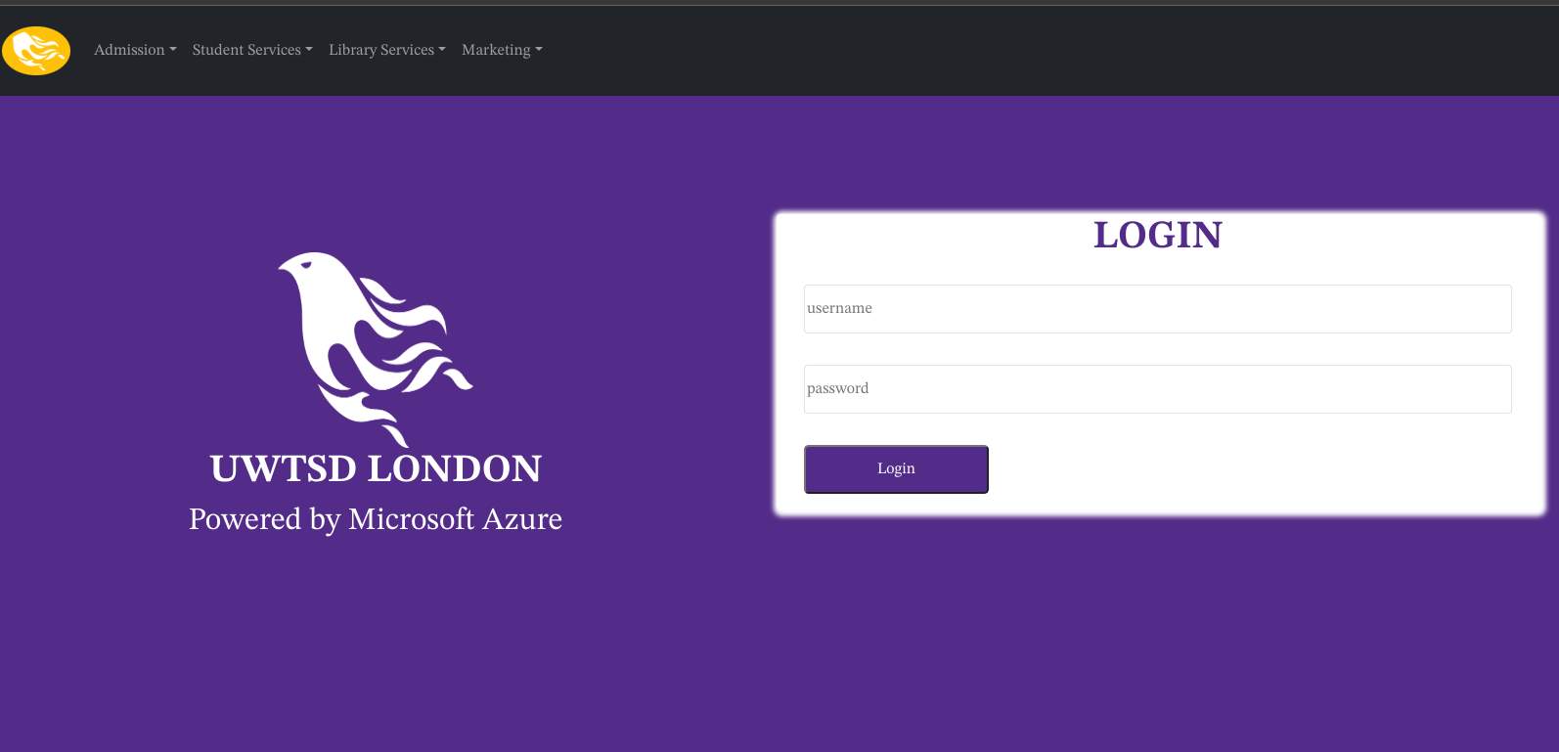

- Student Enrollment

The application's student admission section is intended to simplify the application process for prospective students. The user interface is intended to be straightforward and simple, with clear instructions and guidance provided throughout the process. The web application is intended to serve as a complete platform for managing student admission, hostel services, and a contact us page. The design process began with a requirement analysis for each feature, followed by the creation of wireframes and mockups to depict the user interface and user experience. The user must complete several forms with personal and academic information, upload supporting documents such as transcripts and identification documents, and then submit the application. The system also includes a dashboard where the applicant can track the status of their application and receive notifications from the institution about any updates or requests.

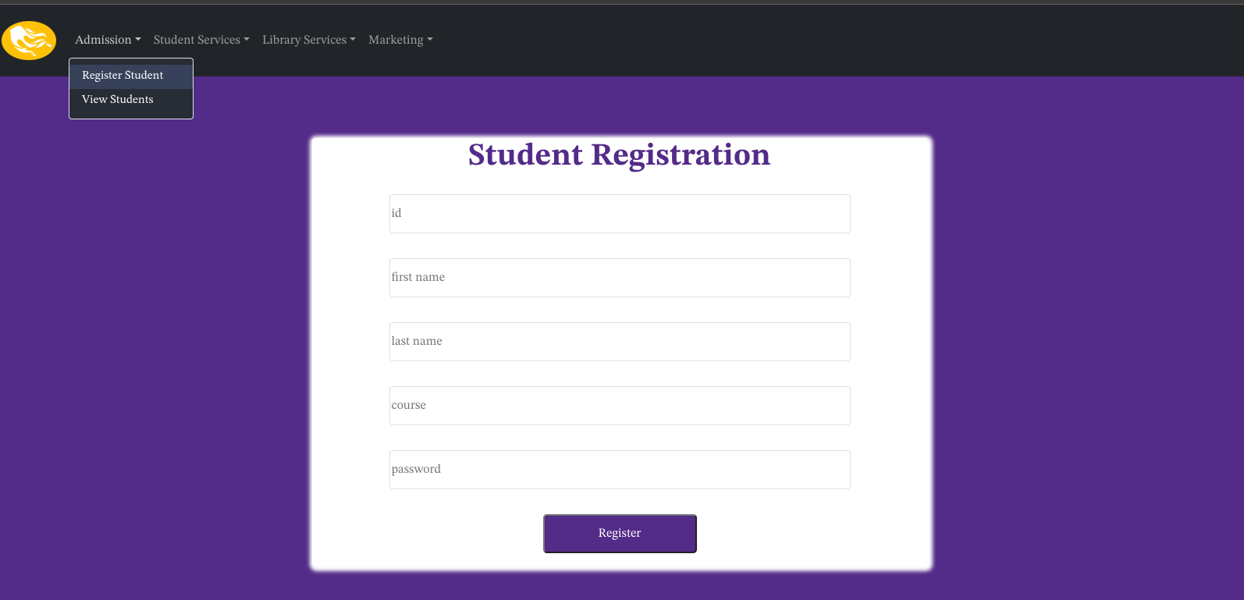

- Services for Hostels

The application's hostel services section is intended to simplify the management of hostel accommodations and related services.

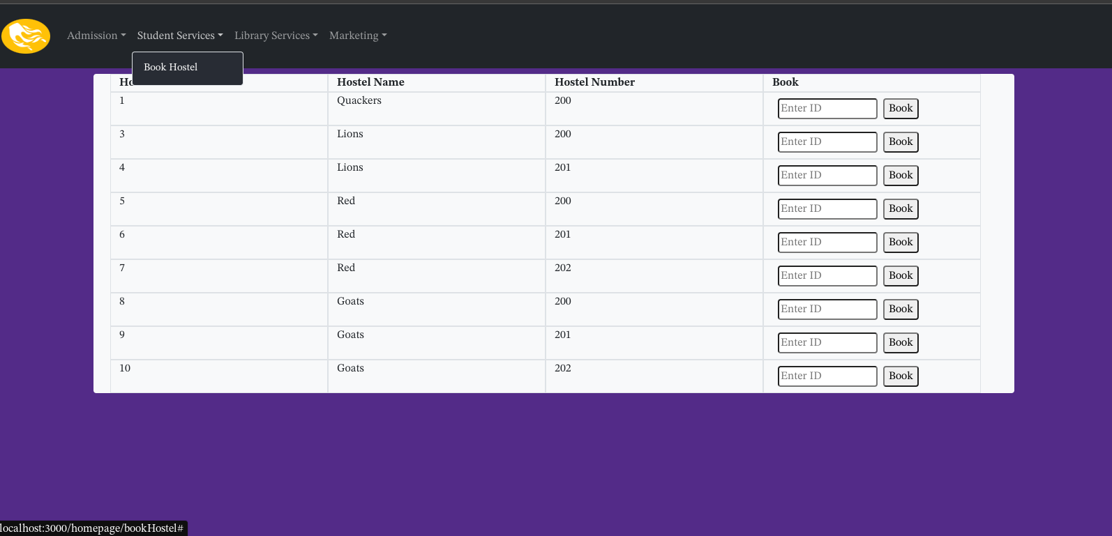

- Library services

The application also offers a seamless library service system that enables librarians to assign books to students in an efficient manner. Students can borrow books and return borrowed books with this system.
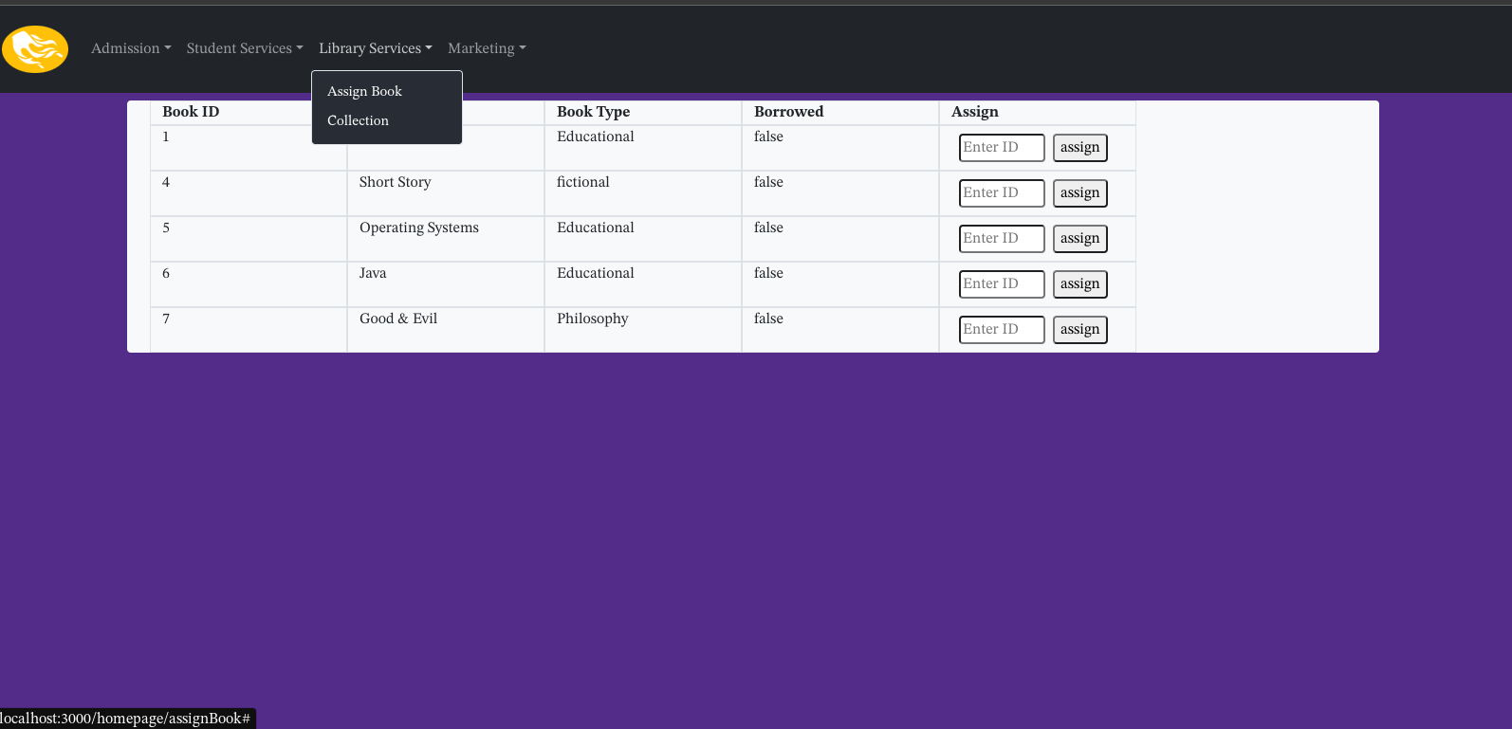

- Contact Us

The contact us page is designed to facilitate communication between the institution and its stakeholders. The user interface is designed to be simple and intuitive, with a form that allows users to send messages directly to the institution. The system also provides a dashboard for the institution to manage incoming messages, reply to inquiries, and monitor communication trends.

Overall, the design of the web application is focused on providing a simple, intuitive, and efficient platform for managing student admission, hostel services, library services, and communication. The design is consistent throughout the application, with a focus on clear communication and ease-of-use.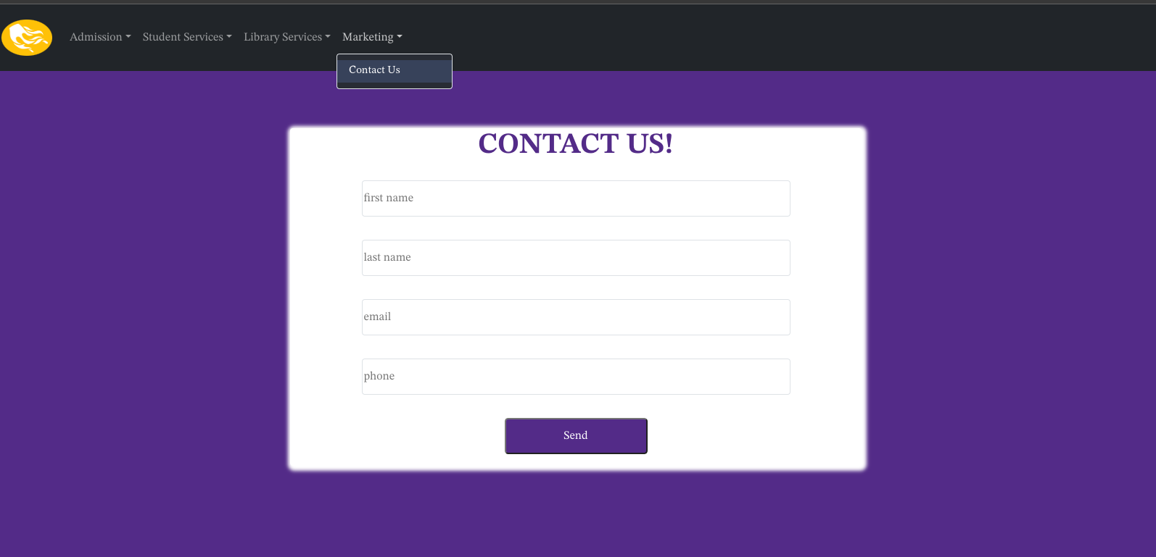

- Development Architecture

The development architecture of the web application was designed to leverage Microsoft Azure services to provide a scalable, reliable, and secure platform for managing student admission, hostel services, and communication.

The architecture consists of four main components:

- Front-end: The front-end of the web application was developed using Bootstrap and React.js. The user interface was designed to be responsive and intuitive, with a consistent design language throughout the application. The front-end communicates with the back-end using RESTful API calls.

- Back-end: The back-end of the application was developed using Node.js and Express.js. The back-end includes various modules for managing user authentication, student admission, hostel services, and communication. The back-end also includes various middleware modules for logging, error handling, and security.

- Database: The database for the application was developed using Microsoft Azure SQL Database. The database stores various data related to student admission, hostel services, and communication.

- Hosting: The web application is hosted on Microsoft Azure App Service. The App Service provides a scalable and reliable hosting platform for the application, with automatic scaling and load balancing options. The App Service also provides various security features, such as SSL certificates and firewall rules.

Deployment Process

The deployment process for the web application was designed to leverage Microsoft Azure DevOps to provide a streamlined and automated deployment process. The deployment process included the following steps:

- Code management: The source code for the application was stored in a Git repository hosted on Microsoft Azure DevOps. The code was managed using standard Git workflows, such as pull requests and branching.
1. I created the web app using the azure portal web app services this will allow me to get an azure domain and hosting services

To create the web app services I selected app services
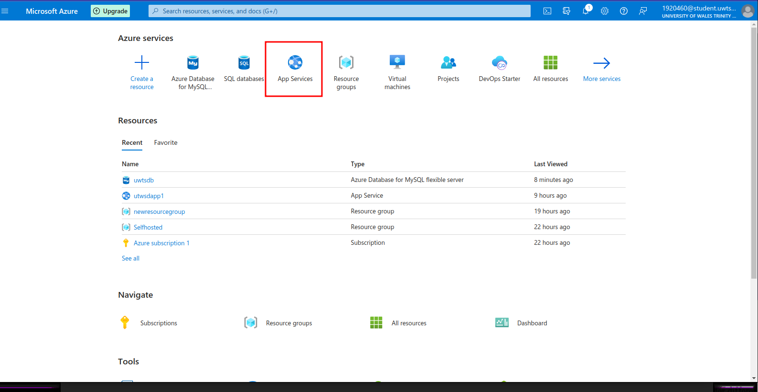

Then selected create
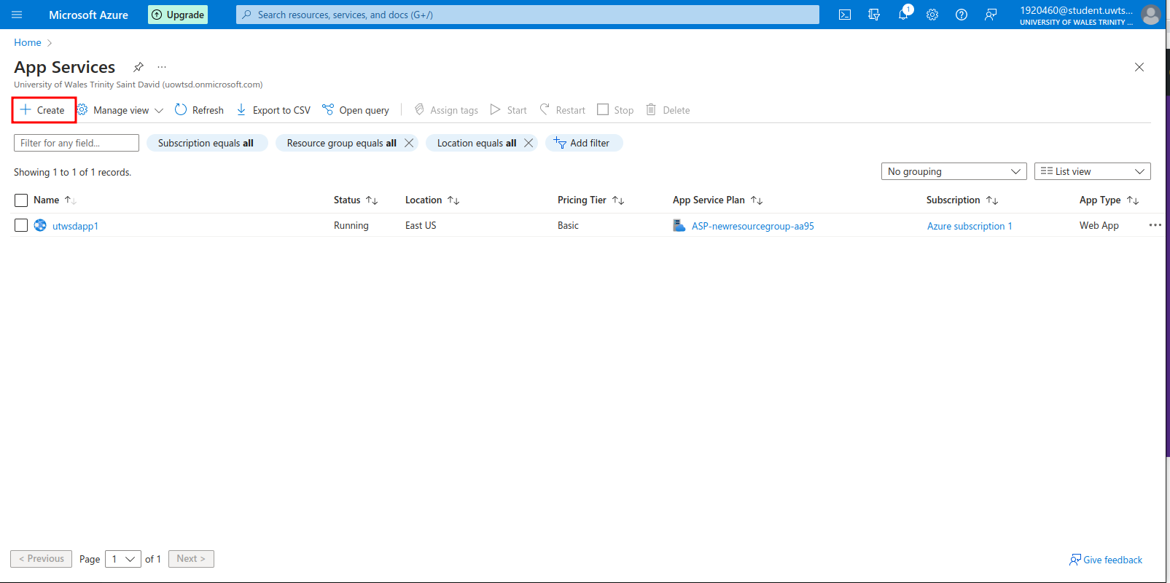

Filed the basic information
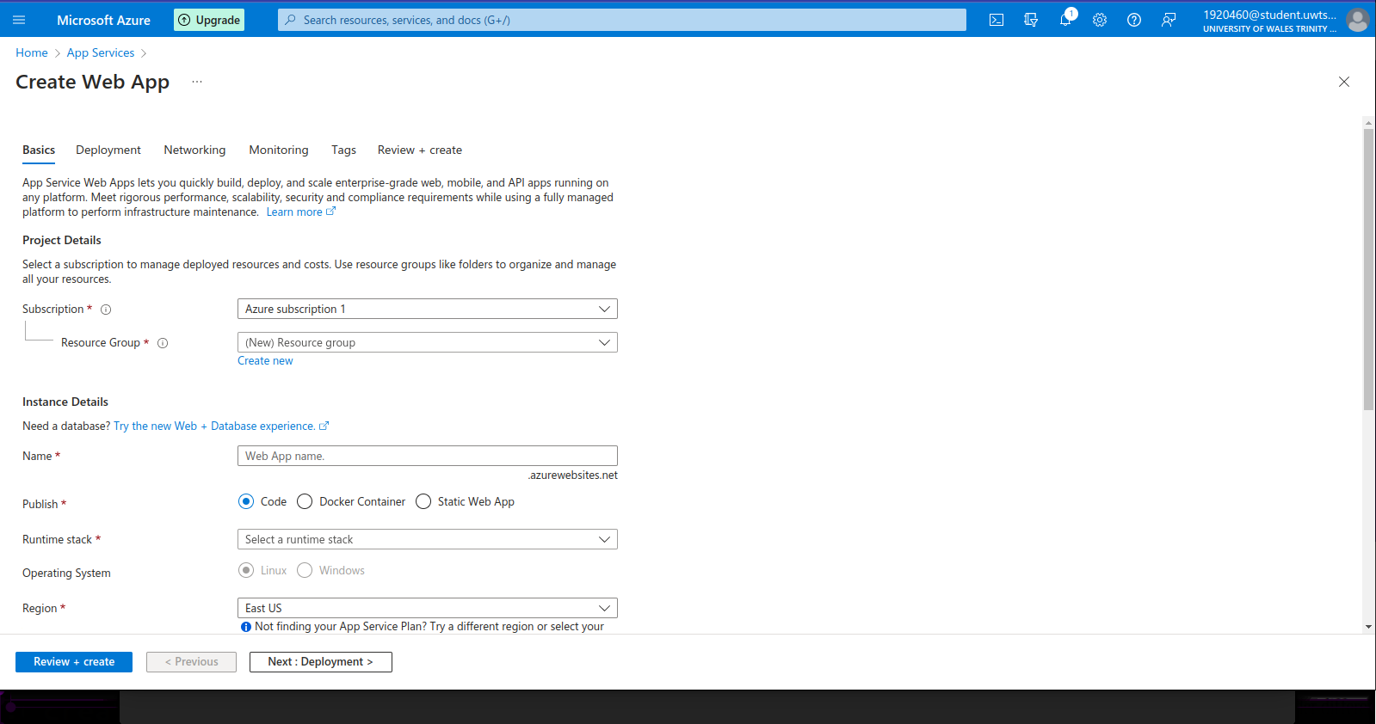
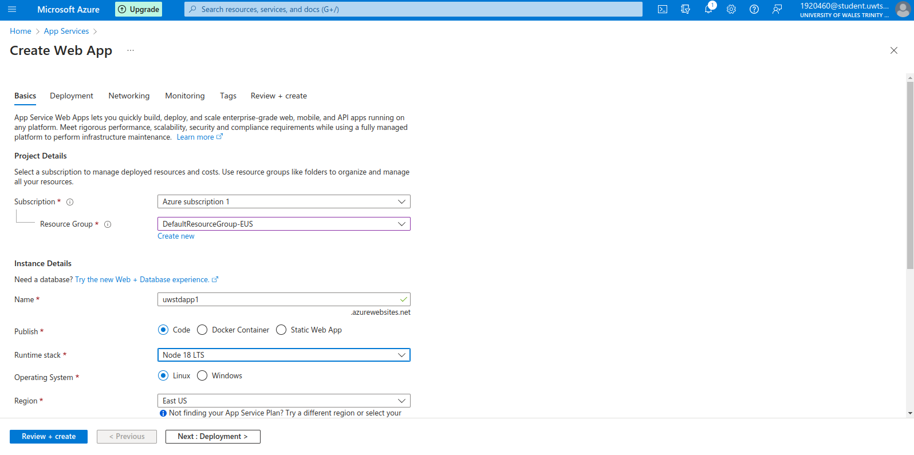

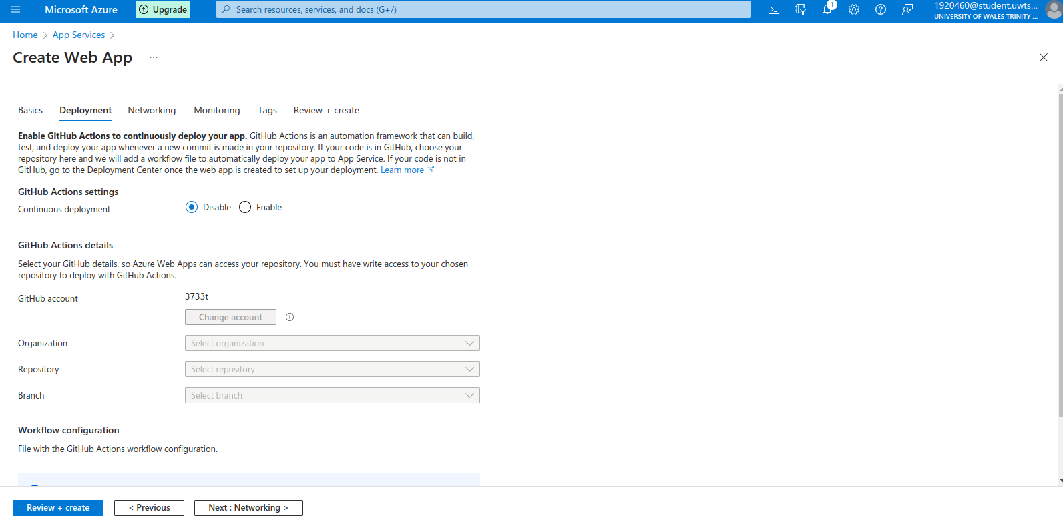
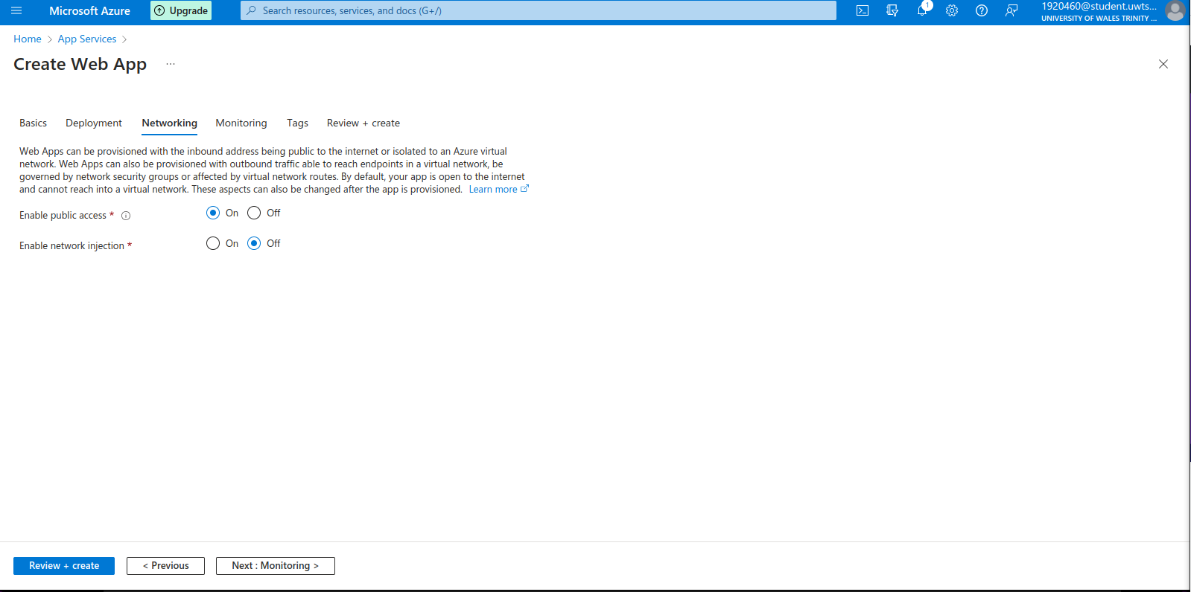

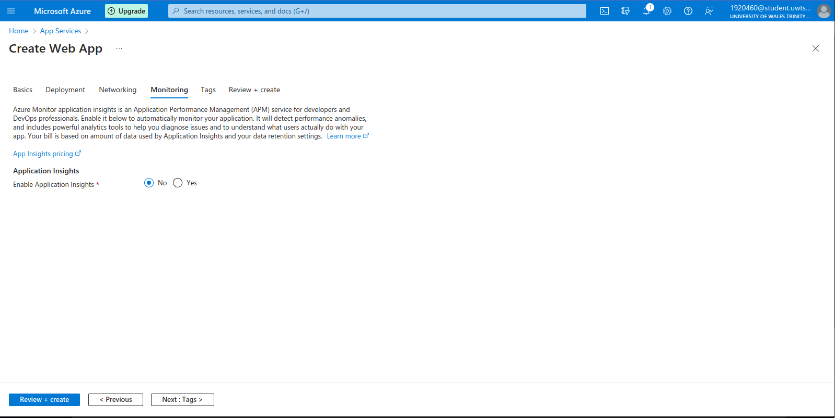
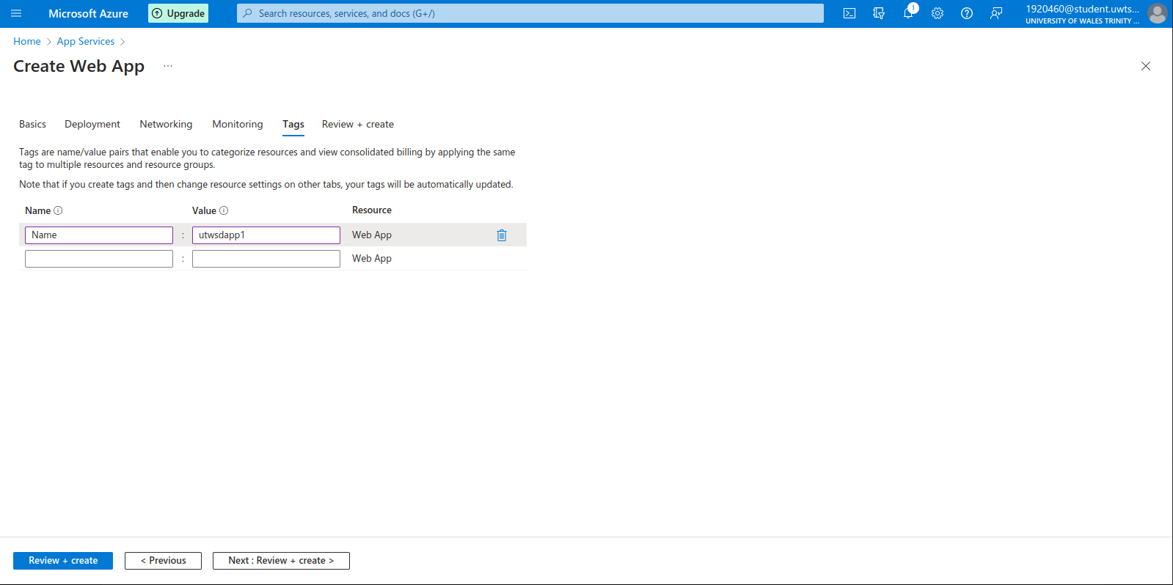

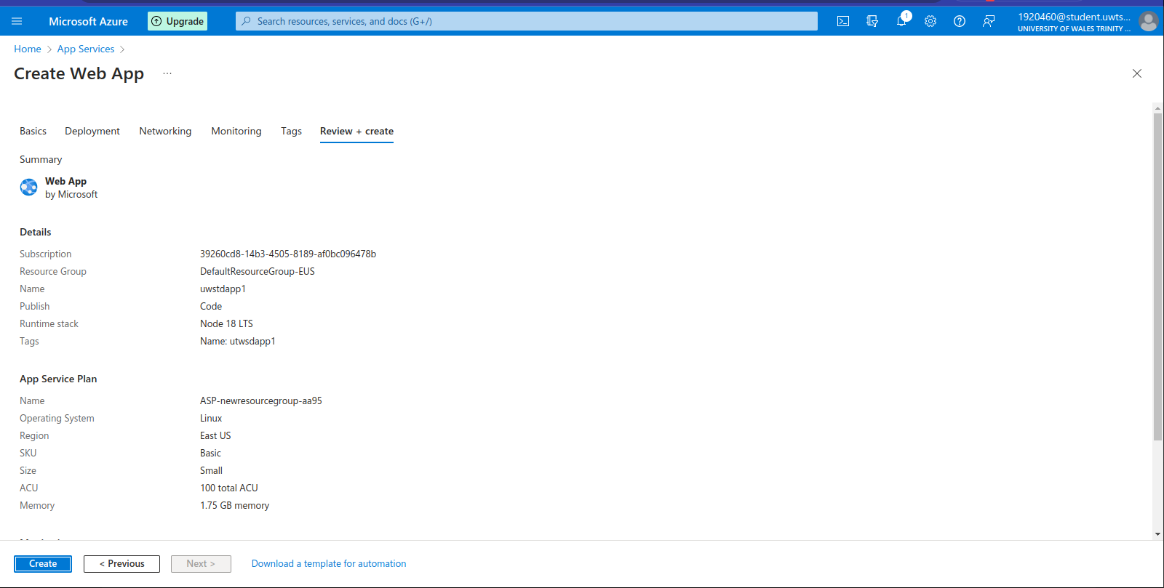

After creating the web app service now I created the mysql server
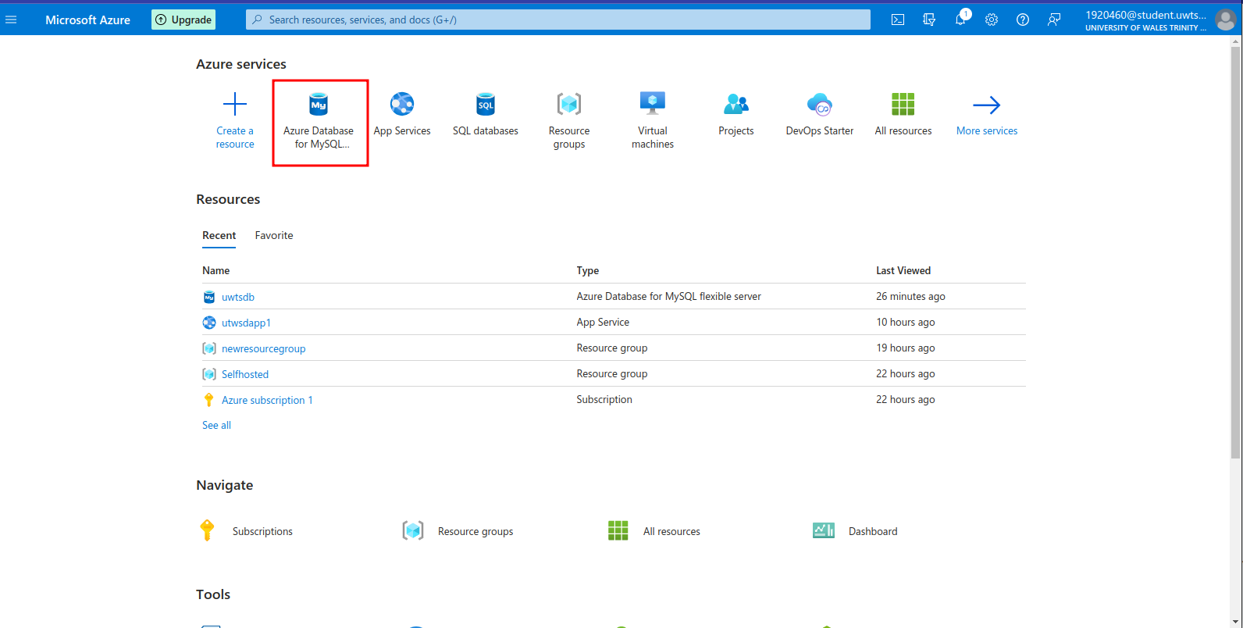

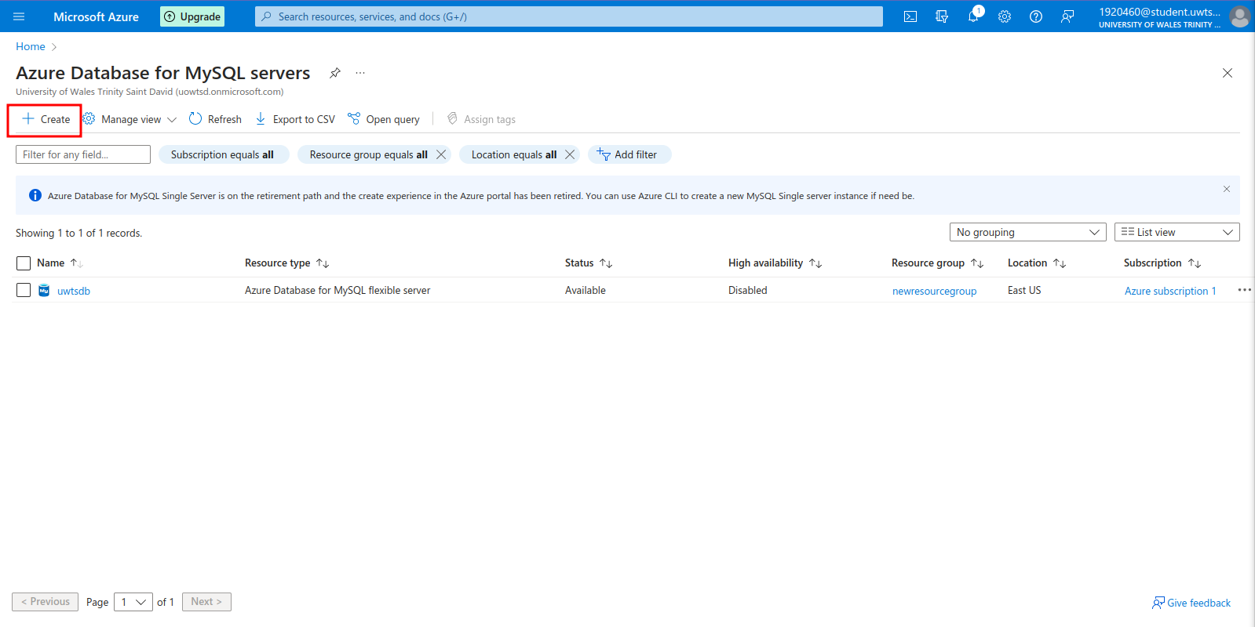
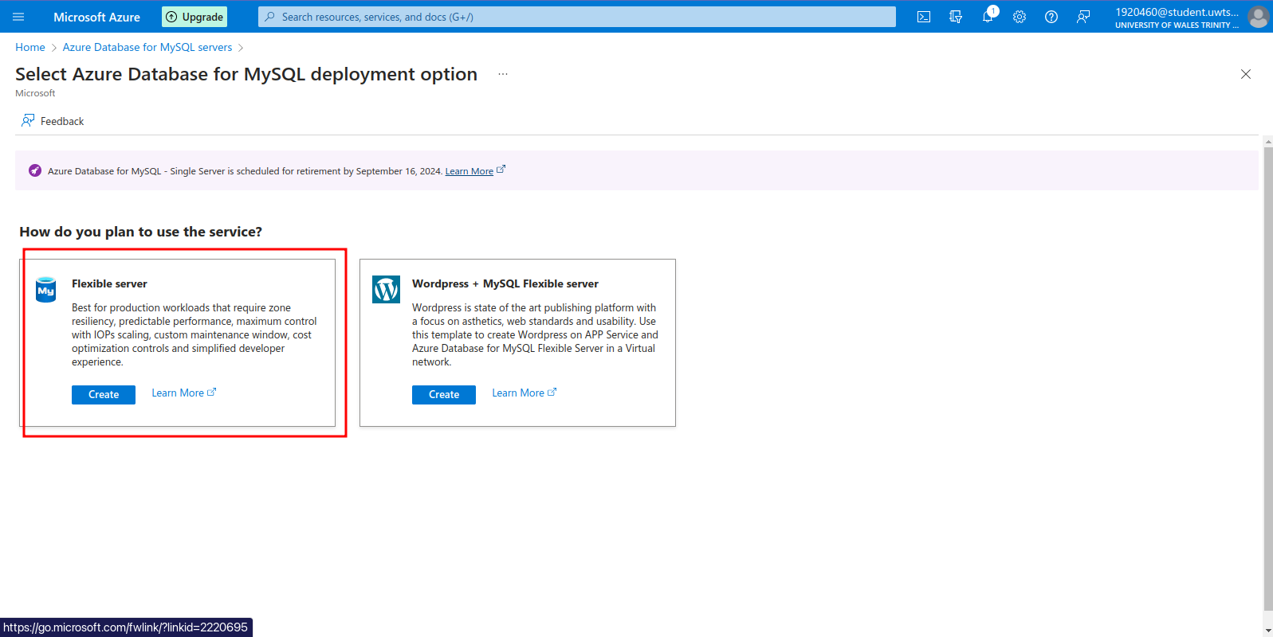

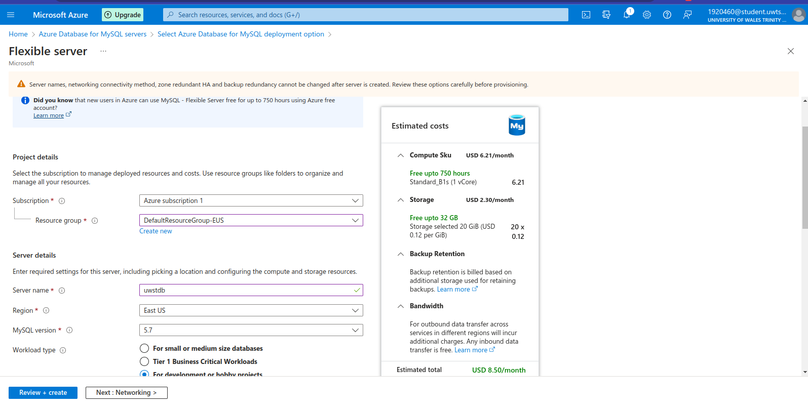

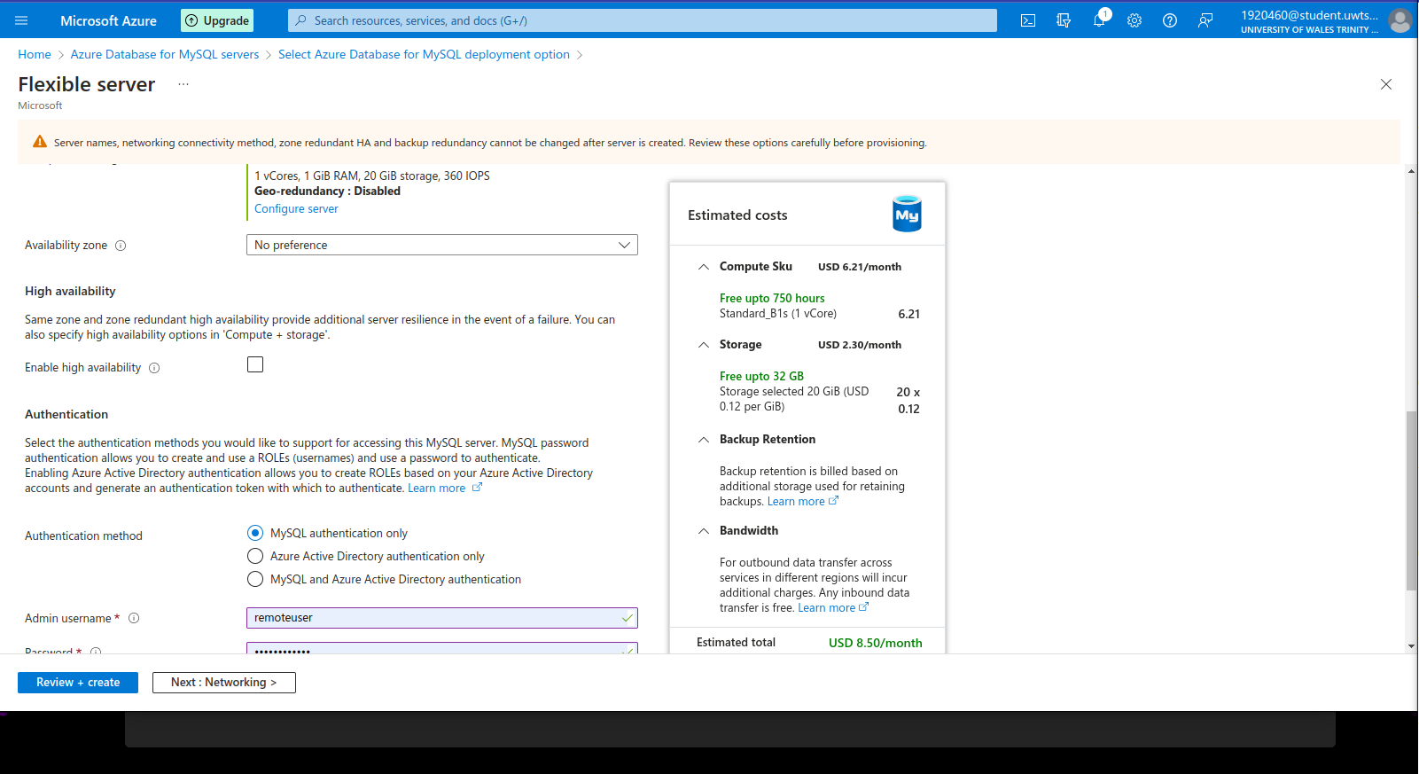

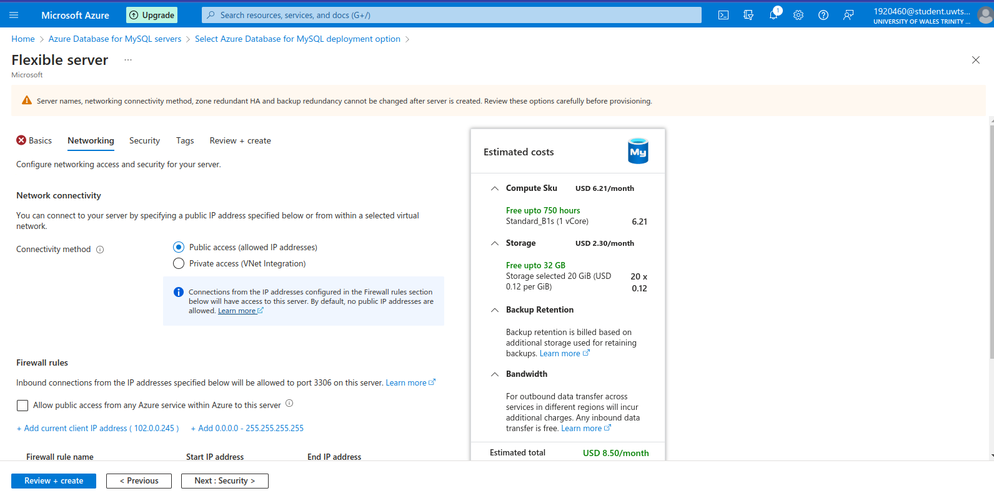
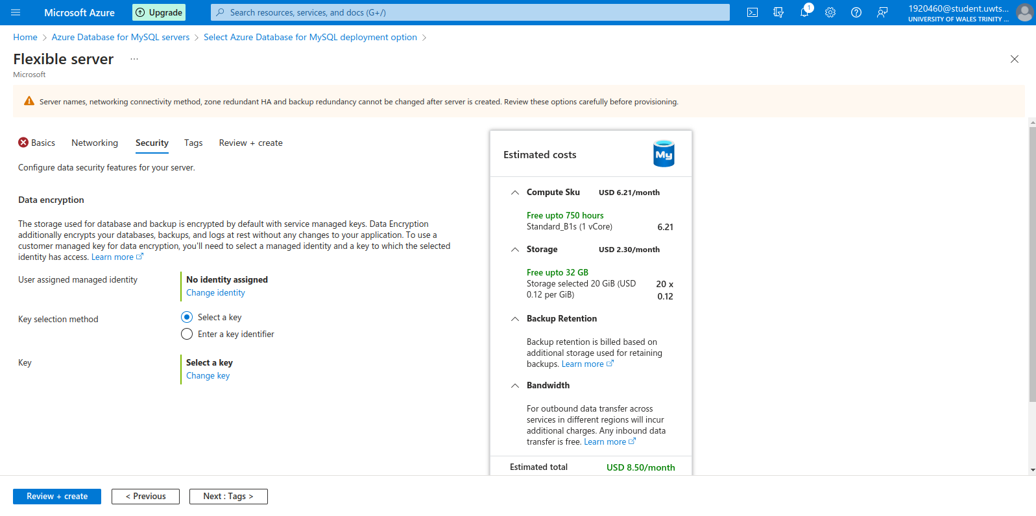

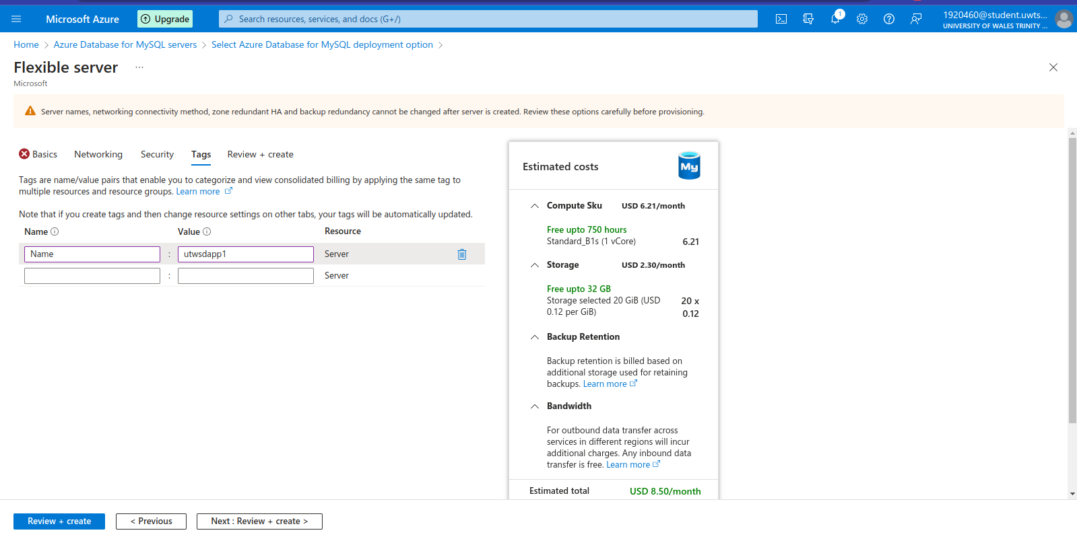

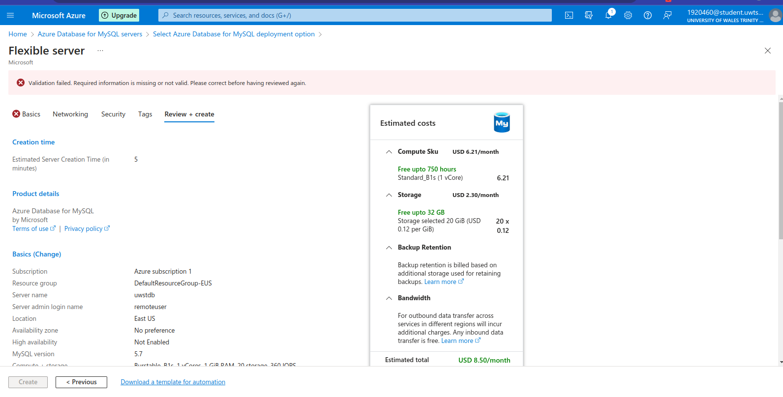
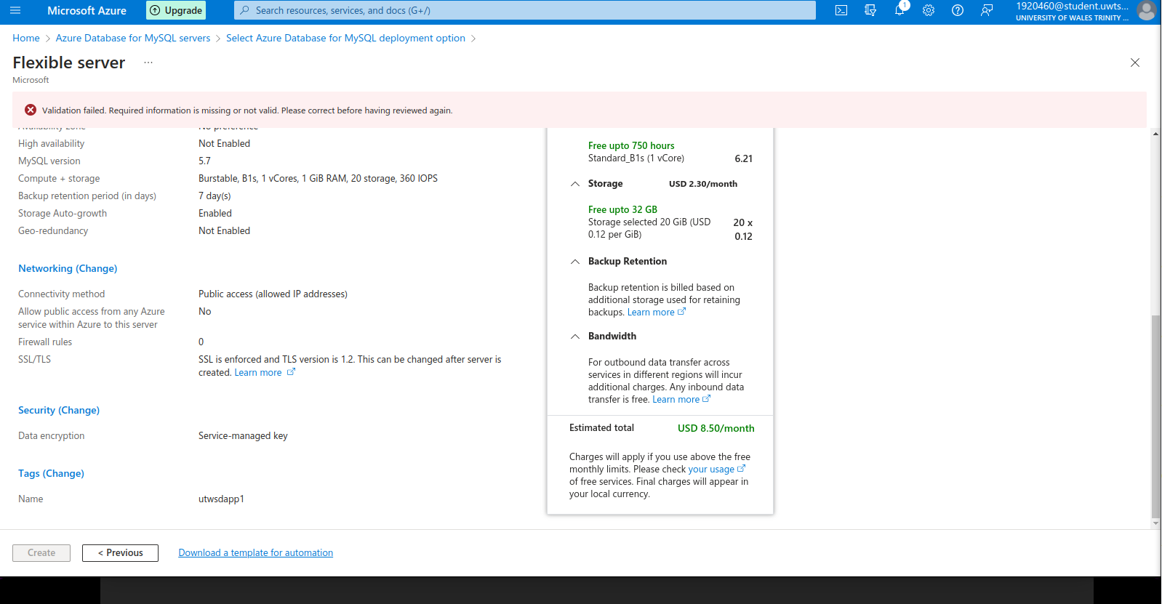

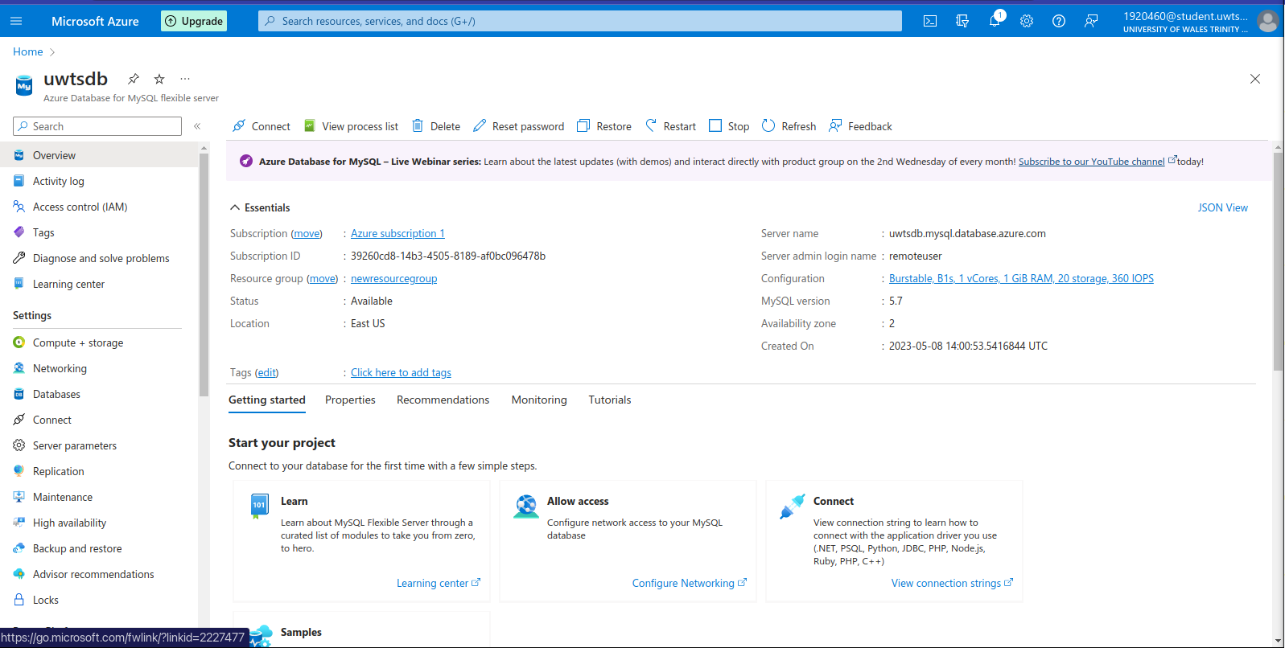

Connected the MySQL database to the application 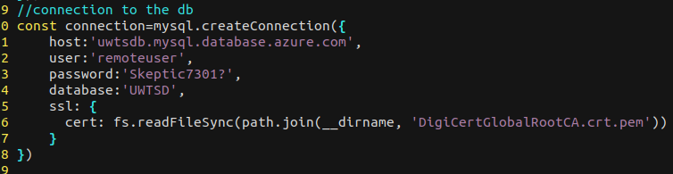

- Build and test: The code was built and tested using Azure Pipelines. Azure Pipelines provided an automated build and test process that was integrated with the Git repository. The build process included various stages, such as linting, unit testing, and integration testing.

- Deployment: The application was deployed to Microsoft Azure App Service using Azure Pipelines. The deployment process included various stages, such as packaging the application, deploying it to the App Service, and configuring the environment variables.

For deployment I used github and git when I push to github it uses github actions to build and deploy to azure web app services
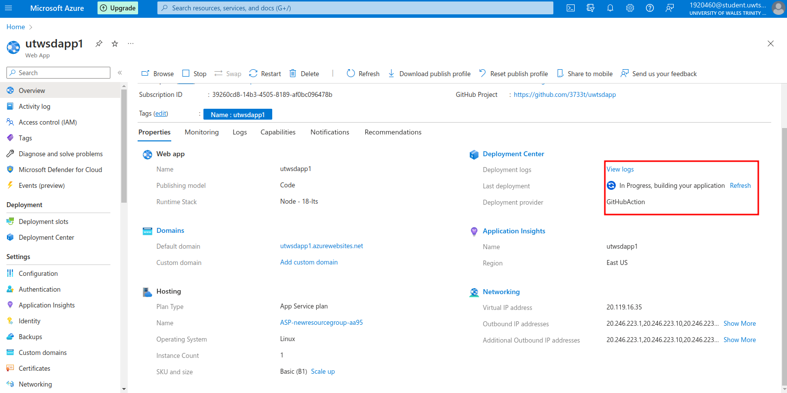

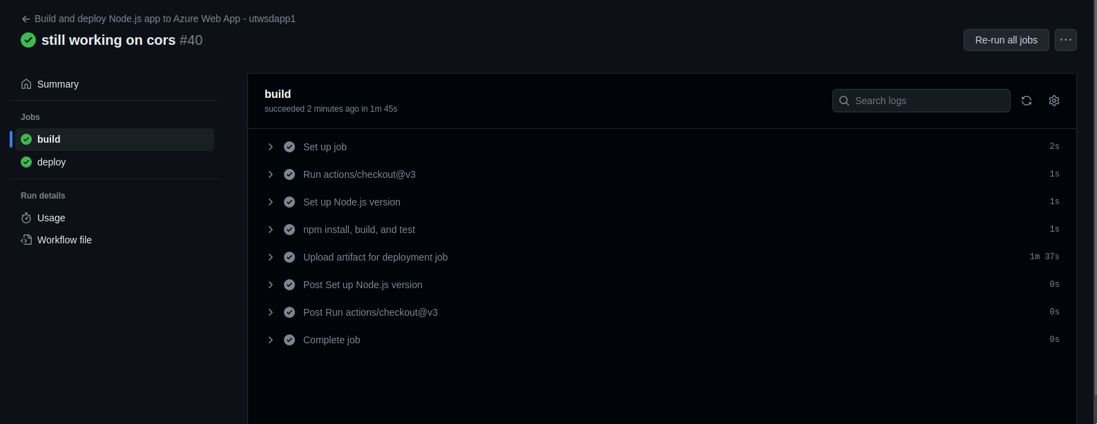

- Monitoring: The application was monitored using Azure Application Insights. Application Insights provided various metrics, such as response times, error rates, and usage trends. The monitoring process helped to identify issues and optimize the performance of the application.
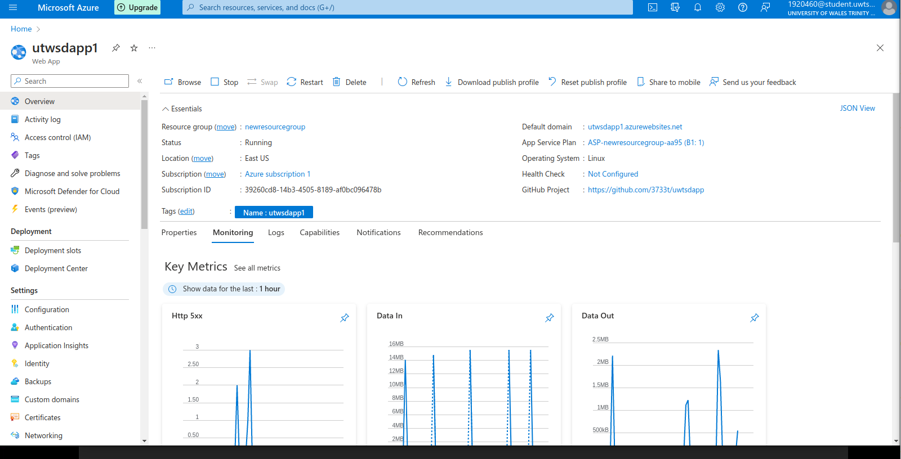

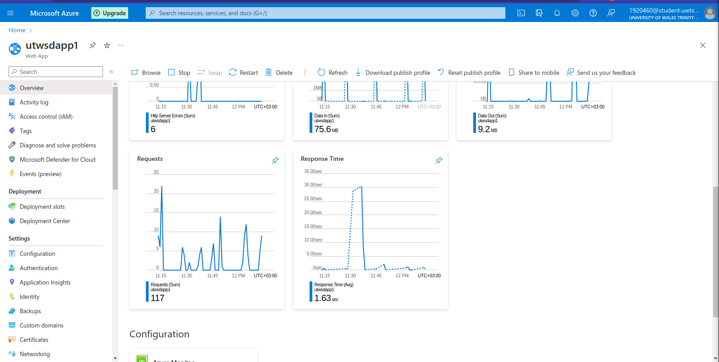

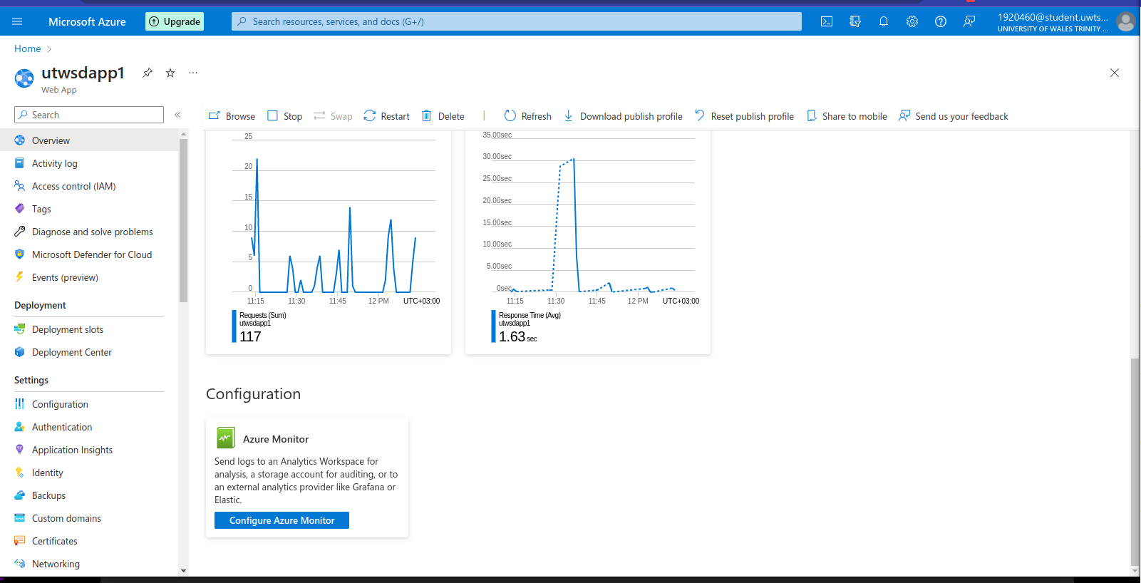

My website link: https://utwsdapp1.azurewebsites.net/

Challenges Faced During Deployment

During the deployment process, we faced several challenges related to the configuration of the Azure services and the integration of the various components. Some of the main challenges included:

- Authentication: Configuring the Azure Active Directory for user authentication was challenging, as it required integrating multiple components, such as the front-end, back-end, and App Service.

- Database migration: Migrating the data from the development database to the production database was challenging, as it required careful planning and execution to ensure that the data was migrated accurately and efficiently.

- Performance optimization: Optimizing the performance of the application was challenging, as it required identifying and addressing various performance bottlenecks, such as slow database queries and inefficient code.

- Environment configuration: Configuring the environment variables for the various components of the application was challenging, as it required ensuring that the variables were set correctly and securely.

Testing

The goal of testing is to ensure that the application is dependable, functional, and secure for the intended users. Running the application under various conditions and scenarios to simulate real-world usage and identify any issues that may affect the application's quality is what testing entails. Depending on the development team's preference, testing can be done manually or through automated tools and frameworks. Here are some of the tests we ran during the development phase.

- Unit tests: Unit tests are used to test individual units or modules of code, such as functions or methods. For example, we can write unit tests to test the functions that validate user input or handle database queries. Unit tests can be written using popular testing frameworks such as Mocha or Jest.

- Integration tests: Integration tests are used to test the integration of different modules or components of the application. For example, we can write integration tests to test the interaction between the front-end and the back-end, or between the back-end and the database. Integration tests can be written using frameworks such as Supertest or Chai HTTP.

- End-to-end tests: End-to-end tests are used to test the entire application flow, from the user interface to the database. For example, we can write end-to-end tests to test the entire admission process or the hostel booking process. End-to-end tests can be written using frameworks such as Cypress or Selenium.

- Security tests: Security tests are used to test the security of the application, such as testing for vulnerabilities or weaknesses in the authentication and authorization systems. For example, we can write security tests to test for SQL injection or cross-site scripting vulnerabilities. Security tests can be written using frameworks such as OWASP ZAP or Burp Suite.

- Performance tests: Performance tests are used to test the performance of the application under different loads and conditions. For example, we can write performance tests to test the response times or throughput of the application under heavy load. Performance tests can be written using frameworks such as Apache JMeter or LoadRunner.

Maintenance

By following these steps, the application can be maintained effectively and efficiently, ensuring its ongoing reliability, functionality, and security.

- Regular backups: Regular backups of the application data and code should be taken to ensure that the application can be easily restored in case of any data loss or system failure. Automated backups can be scheduled to run at regular intervals.

- Monitoring and logging: The application should be monitored and logged regularly to identify any issues or errors. Logging can be used to track application events, such as user actions and errors, and monitoring can be used to track the performance and availability of the application.

- Security updates: Security updates should be applied to the application and its dependencies regularly to ensure that the application is protected against any security vulnerabilities. These updates can be applied manually or automatically, depending on the preference of the development team.

- Code maintenance: The application code should be maintained regularly to ensure that it is up-to-date and conforms to industry standards and best practices. Code maintenance can involve code reviews, refactoring, and updating dependencies.

- Testing: Testing should be performed regularly to ensure that the application is functioning correctly and to identify any issues or bugs. Testing can involve the same types of tests mentioned earlier, such as unit tests, integration tests, end-to-end tests, security tests, and performance tests.

- User feedback: User feedback should be collected and used to improve the application. User feedback can be collected through surveys, feedback forms, or user testing sessions, and can be used to identify areas of improvement and prioritize feature requests.

Conclusions

The report outlined the design and deployment of a web application that manages student admission, hostel services, and a contact us page. The application was developed using the Node.js and Express frameworks, with a Mysql database hosted on Microsoft Azure. The deployment process involved using Azure App Service to deploy the application to the cloud.

The report also discussed the types of tests that can be used to ensure the quality and reliability of the application, such as unit tests, integration tests, end-to-end tests, security tests, and performance tests.

In terms of maintenance, the report recommended regular backups, monitoring and logging, security updates, code maintenance, testing, and user feedback to ensure that the application remains reliable, functional, and secure over time.

Overall, the key findings of the report indicate that the web application can be designed, developed, deployed, and maintained effectively using modern web development technologies and practices. By following the recommended steps for maintenance and testing, the application can remain robust and reliable for its intended users.

References

- Node.js - Retrieved from https://nodejs.org/en/

- Express - Retrieved from https://expressjs.com/

- Microsoft Azure - Retrieved from https://azure.microsoft.com/

- Azure App Service - Retrieved from https://azure.microsoft.com/en-us/services/app-service/

- MySQL - Retrieved from https://www.mysql.com/

- MySQL WorkBench - Retrieved from https://www.mysql.com/products/workbench/

