30/11/2021
Jamie Richards (0852036)
ACCA4019 – Analysing & solving problems
Scrabble

Table of Contents
1 – Introduction Page 2
2 - Scrabble Page 2
2.1 – Rules Page 2
2.2 – Requirements to play Page 4
3 – Implementation Page 5
3.1 – Variables and Constants Page 5
3.1.1 – Flowchart Page 5
3.1.2 – Pseudocode Page 7
3.1.3 – Sub processes Page 7
4 – Evaluation Page 8
5 – References Page 9

1 – Introduction

This report will look into and explore the popular board game Scrabble, the beginning of the report will cover a description of what Scrabble is and its rules, followed by the requirements to play. The latter sections of this report will consist of the implementation process, this will be done in a flowchart format, and finally pseudocode will be used to show examples of the sub processes needed within the structure of the game.

2 - Scrabble

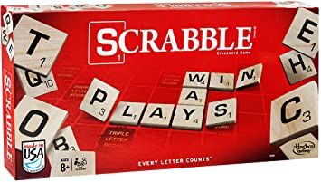
As stated on the Hasbro gaming website www.hsbro.com Scrabble is described as the ultimate crossword game where every letter counts, players take turns and are required to create words with random letters they have drawn from a bag. Different letters hold different values and when placed on the playing board, further values are added depending on the placement. [1]
The above image taken from the online shopping website www.Amazon.com, shows the box of the game of Scrabble. [2]

2.1 – Rules

Using the website www.ultraboardgames.com below is the most common setup and rules for a game of Scrabble.
Setting up – to begin the game, first it must be decided who will take their turn first. To do this all the letter pieces are placed face down and each player picks one, the player who gets the letter closest to the letter A is the player who will go first. Players who pick a faceless piece automatically goes first as this piece counts as any letter, so in this instance it would act as A itself, players who pick the same letter must pick another until there is a definitive winner of who goes first.
Next players pick seven letter tiles and place them on their racks, one player must be chosen to keep score and finally everyone must agree on which dictionary they will use in case of an words which are challenged.

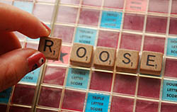
Aim of the game – the aim of the game is to get the highest score by creating words with letter tiles and placing them on the game board, each letter tile has a value. Furthermore there are slots on the game board where the letter tiles will be placed, some of these slots will provide a player with double the letter score or even triple score, which further add to the players overall word value.
Starting the game – the player going first needs to create and combine two or more letter tiles to create a word and place them on the game board.
The image to the left has been taken from www.ultraboardgames.com and illiterates a player placing their first word on the game board to begin their turn. [3]
Scores - The players word is then calculated and a score is written down, letter tiles are drawn equalling the number of tiles used to create the players letter, for instance in the image above roose is the word created meaning five letter tiles were used, therefore five letter tiles would be drawn by the player bringing their total letter tiles back up to seven, the players turn then ends and the player to the left goes next.
The new player now repeats the process but has the option to place their word onto or through the current word in play, for example again using the image above, a player can create a word using the letter O in the current placed word Roose. Doing this also grants that player the value of the letter tile already placed, furthermore letter tiles can also be placed at the end of the word to create a bigger word, resulting in the player receiving the full word value plus to added letter and also including any bonus values from the game board.
If a player uses all seven of their letter tiles to create a word then they receive a further fifty points.
Ending the game - the game will end when there are no more letters for players to draw and all possible words have been created and placed on the game board. Players who still have letter pieces left at the end of the game have the values of the letters deducted from their total score.
The player with the highest score wins, in case of a tie the player who had the highest score before deducting any points is the winner. [4]

2.3 – Requirements to play

In order to play a game of Scrabble certain requirements are needed, below is a table using the MOSCOW method. This method or technique allows the user to prioritise the requirements of a task by breaking it down into four different categories, these are shown below. The source of information in this section and the image was taken from a website article by an unknown Arthur www.productplan.com.
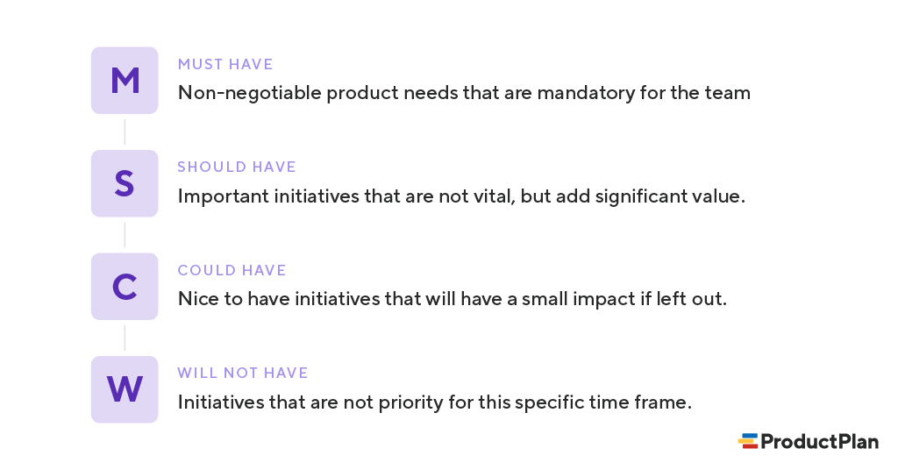 [5]
This method will be used to exhibit the requirements of Scrabble in the form of a table, shown below:
Must Have | Should Have | Could Have | Will Not Have
2 Players | Bag to hold letter tiles | 3 or more player
Letter tiles | Rack to player letter tiles | Timer
Game board | Pen and paper | Dictionary

For this example of the requirements, it’s clear to see that a minimum of two players are needed for the game as well as the game essentials of letter tiles and a game board. The game can be played with these however can be improved in quality with a bag to hold the letter times, a rack for the players to place their letter on and a pen and paper to keep the score. The game can also improve in quality by increasing the number of player, using a timer to limit the time each player has to take their turn and furthermore the use of a dictionary in case of any challenges.

3 – Implementation

In this section which is split into different subsections, a flowchart will be presented showing the process of the game of Scrabble, followed with a pseudocode algorithm highlighting any sub processes involved, but first the variables and constants will be identified and described.

3.1 – Variables and Constants

Variables – the main variables firstly identified in the game of Scrabble would clearly be the letter tiles, consisting of one hundred tiles each labelled with a different letters from the twenty six letter alphabet . This variable will be identified in the upcoming flowchart as randomletter.
A further variable could be looked at in respect to the words created by players, consisting of endless outcomes dependant on what letter tiles the players draw, this will be identified in the upcoming sections as playersword.
Constants – A constant, being something that won’t change during the game would be the game board itself, as a physical object designed in such a way it won’t change and even though the letter tiles placed on the board would be a variable the board itself would remain a constant.
Another constant would involve the players actions during their turn, due to the game rules a minimum two tiles must be used in order to create a word therefore as this requirement cannot change, this would be viewed as a constant also.

3.1.1 – Flowchart
Before displaying a flowchart, below is a IPO chart showing the input, processes and outputs, these are displayed as they would in the upcoming flowchart and Pseudocode algorithm.

INPUT | PROCESS | OUTPUT
randomletter | lettertilevalue | wordscore
playersword | gameboardbonus | totalwordscore

Below is a flowchart showing the process of the game of Scrabble
Start

Players turn

Does the player have 7 letter tiles?
Yes
No
PROCESS
Player to draw randomletter
INPUT lettertilevalue = playersword
SET
playersword + gameboardbonus = totalwordscore
INPUT gameboardbonus

Yes

Calculate highest score
Highest score wins
Are there any letter tiles left?
No
DISPLAY
totalwordscore

End

3.1.2 – Pseudocode

Following on from the flowchart above, below is the Pseudocode process of the game.

1 DISPLAY playersturn
2 INPUT lettertilevalue
3 SET lettertilevalue = playersword
4 INPUT gameboardbonus
5 SET playersword + gameboardbonus = totalwordscore
6 DISPLAY totalwordscore

3.2.3 – Sub processes
Considering the flowchart previously, there is room for sub processes, a sub process is a further algorithm that is tasked with separate actions alongside the mainstream task. A sub process within a flowchart would be presented with the following symbol:
Game board bonus

Within this sub process a further flowchart would be present, an example below.
Start

SET
Gameboardbons + playerword

End

4 – Evaluation

To summarise this report, its clear Scrabble is a complex game involving many variables especially when considering the twenty six letter alphabet and the endless words that can be created by players, resulting in the implementation for the game to becoming massive.

References

[1] | "Hasbro Gaming," [Online]. Available: https://scrabble.hasbro.com/en-us/product/scrabble-game:FA04DD51-5056-9047-F5CD-53F87A967AC6. [Accessed 30 11 2021].
[2] | [Art].
[3] | [Art].
[4] | Unknown. [Online]. Available: https://www.ultraboardgames.com/scrabble/game-rules.php. [Accessed 30 11 2021].
[5] | unknown. [Online]. Available: https://www.productplan.com/glossary/moscow-prioritization/. [Accessed 30 11 2021].

