
sainsbury’s strategic marketing plan
BMBM6016: Assignment 2

May 10, 2024
UNIVERSITY OF WALES TRINITY SAINT DAVID , SWANSEA
CHONITHA AMITHINENI (2107958)

Table of Contents
Introduction 3
Main Findings 4
Situation Analysis 5
Objectives 6
SMART objectives 7
Strategy 8
Tactics 10
Actions 13
Control 16
Recommendations 19
conclusion 19
References 20

Executive summary
This strategic marketing plan presents Sainsbury's strategy for achieving its objectives, improving competitiveness, and fostering growth in the UK supermarket industry. By conducting a thorough examination of both internal and external factors, Sainsbury's is focused on achieving a 5% increase in market share over the next year.
The plan starts by conducting a thorough analysis of the current situation, evaluating Sainsbury's internal strengths and weaknesses, as well as external opportunities and threats. This analysis leads to the establishment of a SMART marketing objective aimed at boosting market share. The strategy section provides an overview of Sainsbury's overall approach, which includes expanding their market presence, developing new products, and implementing focused marketing campaigns.
The strategy provides detailed tactics and actions to effectively execute various aspects of the business, including product innovation, pricing strategies, distribution channels, promotional activities, staff training, process optimization, and store ambiance enhancement. Control mechanisms are put in place to effectively monitor, evaluate, and optimize marketing efforts.
In summary, this strategic marketing plan outlines a comprehensive strategy for Sainsbury's to solidify its position as a market leader, provide value to customers, and achieve sustainable growth in the highly competitive retail industry. With a focus on strategic execution and ongoing monitoring, Sainsbury's is poised to achieve its goals and maintain its position as a leader in the market for years to come.

Introduction
In today's rapidly evolving retail landscape, Sainsbury's understands the importance of staying ahead of the curve and adapting to the ever-changing needs of consumers. With the rise of technology, shifting consumer behaviours, and global economic uncertainties, Sainsbury's is committed to maintaining its position as a market leader by embracing strategic foresight and remaining agile.
This marketing plan aims to strategically guide Sainsbury's in increasing its market share and improving its competitive position in the UK supermarket industry. This plan aims to drive Sainsbury's towards sustained growth and profitability in the coming year by utilizing key resources and capabilities identified through a comprehensive audit of the external and internal environments.
In order to accomplish this, the plan will make use of the SOSTAC framework and the SMART criteria for goal setting. The SOSTAC framework will provide a clear and coherent structure for developing and implementing the marketing plan, ensuring it aligns with organizational goals (Mary, 2023). In order to ensure that Sainsbury's marketing objectives are well-defined and achievable within the specified timeframe, it is important to utilize the SMART criteria. This criteria emphasizes the importance of setting objectives that are Specific, Measurable, Achievable, Relevant, and Time-bound (SPREP, 2022).

Main Findings
After conducting a thorough analysis of both the external and internal factors, it has been identified a strategic marketing objective to improve the supermarket chain's competitive position. One concerning discovery in (Sainsbury's, 2023) financial reports is that a mere 1.69% of its revenue is attributed to profit. In light of the current economic climate, supermarkets with low profitability are at a high risk of facing bankruptcy (Sari et al, 2022). Even in the recent times according to (Sainsbury’s, 2024) although their sales went up by more than 1000 million pounds, their profit seems to decline. Hence the goal is to achieve a 5% increase in market share over the next 12 months by implementing focused marketing strategies and adopting a strategic positioning approach. Attaining this goal will not just enhance profitability, but also strengthen the supermarket chain's position in the market and foster customer loyalty.

Situation Analysis
The situation analysis offers a thorough grasp of any supermarkets present market position, industry landscape, and competitive dynamics (Mamuaya, and Aditya, 2018).
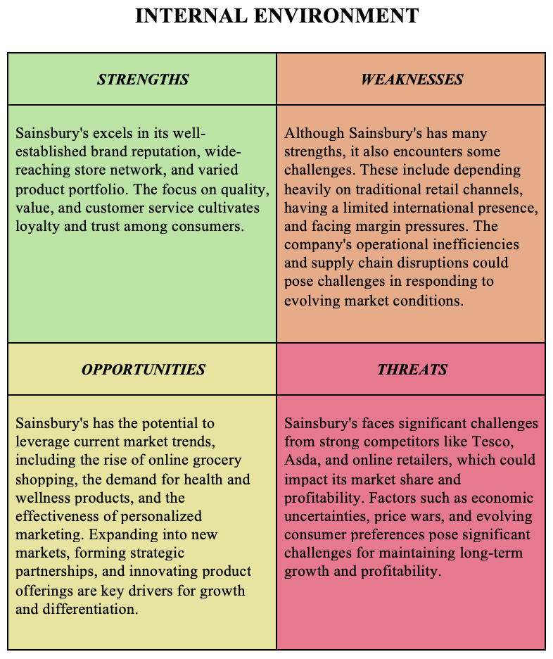
The TOWS analysis shows that the supermarket chain has a large distribution network and a well-known brand, but it also has to deal with tough competition, changing customer tastes, and problems caused by technology. Nevertheless, these challenges also offer chances for creativity and standing out from the competition.

Objectives
The goal is to achieve a 5% increase in market share over the next 12 months through strategic marketing efforts. This objective will be achieved by implementing focused marketing campaigns, expanding the product range, and improving the customer engagement efforts. By increasing market share, the supermarket chain can strengthen its competitive position, boost revenue growth, and establish itself as a leader in the retail industry (Christopher, and Peck, 2012). Successful implementation of this objective would provide financial stability and reduce the chances of uncertainty in the face of future cost-of-living situations in the UK (ENGLISH, and TOBI, 2023).
This objective is crafted to align with the organization's overall mission, vision, and values, while effectively tackling the significant challenges and opportunities identified in the situation analysis. Sainsbury’s aims to serve more and more customers, according to (Sainsbury’s, 2024) their main proposed mission is to make food “enjoyable, accessible and affordable to everyone everyday”. The objective is formulated with the SMART criteria in mind to ensure it is clear, measurable, and attainable (Jung, 2007).

SMART objectives
SMART objectives are goals that are specific, measurable, achievable, relevant, and time-bound (Chaffey, and Bosomworth, 2013). They offer a clear sense of direction and purpose for the organization's endeavours.
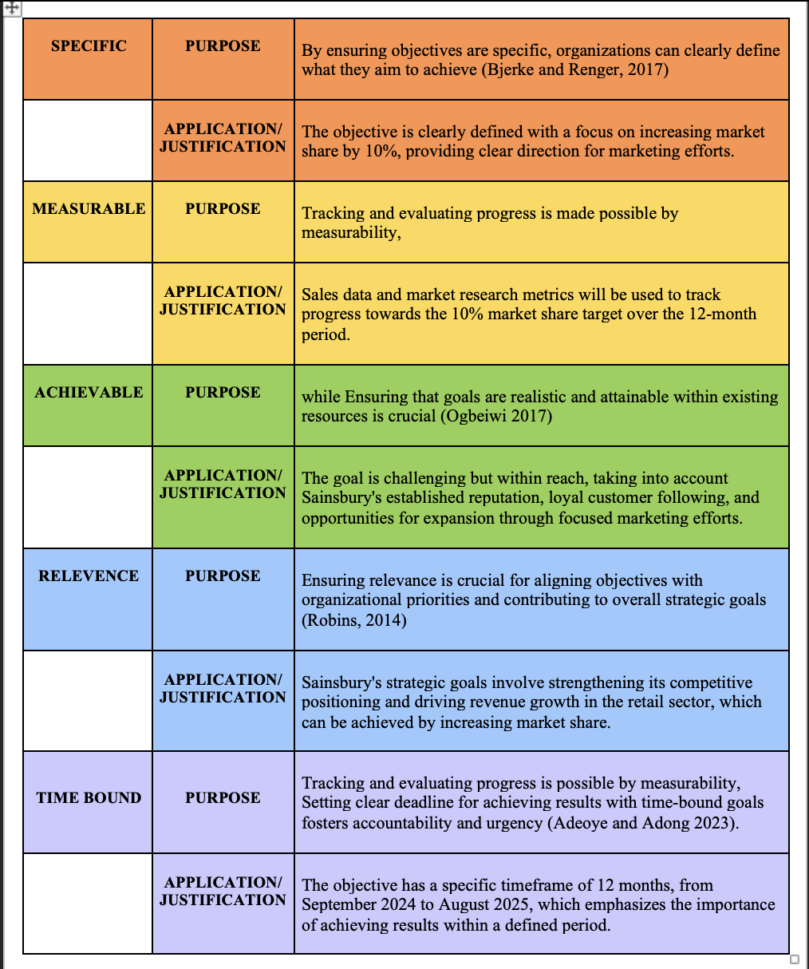

Strategy
The strategy section details the overall approach that Sainsbury's will take to accomplish its marketing goals. It involves a strategic approach and comprehensive marketing strategy focused on utilizing strengths, addressing weaknesses, taking advantage of opportunities, and managing threats identified in the situation analysis. The strategy is informed by well-known frameworks such as Ansoff's Growth Matrix, Porter's Generic Strategies, and principles of segmentation, targeting, and positioning.

Overall Strategic Direction:
Sainsbury's strategic focus revolves around expanding their market presence and enhancing their product offerings. Sainsbury's is focused on increasing its market presence and diversifying its product offerings to achieve growth, improve customer satisfaction, and strengthen its competitive position in the retail industry. This strategic direction is in line with Sainsbury's mission of delivering top-notch products, outstanding service, and value to its customers, all while prioritizing shareholder value (Sainsbury’s, 2024).

Broad Marketing Strategy:
- Market Penetration: Sainsbury's aims to enhance its market presence by attracting new customers and fostering stronger loyalty among its existing customer base. Our strategy involves implementing focused marketing campaigns, enticing promotional offers, and proactive customer engagement initiatives.
- Product Development: Sainsbury's is committed to staying ahead of the curve by investing in product innovation and diversification, ensuring that we continuously meet the ever-changing needs and preferences of our valued customers. This may involve implementing new product lines, expanding existing product categories, and collaborating with suppliers to provide exclusive and unique offerings. Additionally, it would involve exploring the growing demand for Asian food products due to increasing diversity.

Ansoff's Growth Matrix:
- Market Penetration: Sainsbury's plans to utilize its current products and distribution channels to boost sales in its existing markets. This could potentially involve increasing the number of stores, refining pricing strategies, and improving promotional efforts in order to attract a larger customer base.
- Product Development: Sainsbury's is committed to staying ahead of the curve by continuously enhancing their product offerings to align with evolving consumer needs and preferences. Our focus is on developing healthier and more sustainable product options, expanding organic and plant-based offerings, and introducing innovative packaging solutions.

Porter's Generic Strategies:
Sainsbury's Differentiation Strategy: Sainsbury's aims to stand out from competitors by providing exclusive products, exceptional service, and unforgettable shopping experiences. This differentiation will be effectively communicated through strategic branding, targeted advertising, and exceptional customer service initiatives, resulting in the establishment of a unique and highly sought-after brand identity.

Segmentation, Targeting, and Positioning (STP) Strategy:
Sainsbury's will analyze and focus on particular customer segments, taking into account their demographic, psychographic, and behavioral traits. Through a comprehensive understanding of customer needs and preferences, Sainsbury's will strategically customize its marketing messages, product offerings, and promotional activities to effectively engage and connect with customers.
In general, Sainsbury's aims to achieve growth, maintain competitiveness, and solidify its position as a market leader in the retail sector through its strategic direction and marketing strategy. By implementing strategies such as market penetration, product development, differentiation, and targeted marketing, Sainsbury's is focused on achieving its marketing objectives and providing value to its customers and stakeholders (Sainsbury’s, 2024).

Tactics

The tactics section outlines the precise actions and initiatives that Sainsbury's will implement to execute its marketing strategy and accomplish its objectives.
These strategies involve the thorough execution plans for every aspect of the marketing mix, which are widely recognized as the 7Ps: product, price, place, promotion, people, process, and physical evidence (Innanmaa, 2020). Every tactic is meticulously crafted to align with the overall strategy and tackle the important areas of focus identified in the strategy section.
Product
- Introducing New Product Lines: Sainsbury's will conduct market research to identify emerging consumer trends and preferences. After gaining valuable insights, Sainsbury's will be introducing new product lines or expanding existing ones to better cater to the changing needs of their customers. According to (Hong, and Gruda, 2020) It is worth considering how supermarkets could tap into the growing diversity in the UK by introducing a range of Asian foods and grocery products. Additionally, they could also explore the possibility of offering sustainably sourced products to appeal to environmentally conscious consumers (Clonan, et al 2010). According to (Statista, 2024) 39% market share of UK shoppers is held with brands that are sustainable and environment considerate.

Price
- Implement Competitive Pricing Strategies: Sainsbury's will carefully evaluate the pricing strategies of its competitors and make necessary adjustments to its own pricing strategy. One approach could be to provide competitive prices in comparison to other competitive supermarkets. (Sainsbury’s, 2024) current product pricing strategy is to show themselves as an high-end supermarket. According to (Simon and Echter 2022) Major player supermarkets adopted Aldi price match strategy and have been successful. For products that couldn’t do down in price , Sainsburys can increase the quality so that customers would believe to have the either lowest price nor the best quality for their item.

Place
- Enhance Distribution Channels: Sainsbury's aims to strengthen its distribution network by increasing its online and offline presence. This could include the expansion of store locations in key areas (Pozzi, 2013). Sainsburys can research where the majority population of an area are situated and what kind of population they are. Thereby according place small stores for everyday quick groceries and larger warehouse stores in outskirts for customers who shop monthly and would like to save more.
Promotion
- Implement Targeted Marketing Campaigns: Sainsbury's will create and implement focused marketing campaigns across various channels to enhance brand visibility and engage customers. This involves utilizing various marketing channels, such as traditional media, digital platforms, social media, and collaborations with influencers, to effectively target a wide range of consumers (Fan, et al 2023). Since Sainsbury’s strategy is to provide good price for a few products and best quality for the other, it can emphasise trust in its adverts and campaigns. Messages in collaborations with influencers should convince consumers to believe in Sainsburys and they would receive the best products in price or quality.
People
- Developing Staff Skills: Investing in training programs that will empower frontline staff to provide exceptional customer service is required. The training program will emphasize product knowledge, effective communication, and problem-solving skills to improve the overall shopping experience for customers (Giunipero, and Pearcy, 2000).
Process
- Optimizing Internal Processes: Sainsbury's should aims to optimize internal processes and operational workflows to enhance efficiency and productivity. This could include streamlining inventory management systems, improving order fulfilment processes, and integrating technology solutions to automate repetitive tasks. By automating tasks that don’t require human interference in the backend and in store, Sainsbury’s can showcase their technological advancement in grocery shopping and divert the workforce replaced into other tasks.
Physical Evidence
- Improving Store Ambiance: Enhancing the physical environment of stores is crucial for creating a welcoming and memorable shopping experience for customers (Bäckström, and Johansson, 2006). This may require revamping store layouts, enhancing signage and displays, and investing in interior design elements to create an atmosphere of elegance and refinement. Companies are increasingly utilizing data analysis to strategically position shelves and products (Sanders, 2014). After strategically placing Sainsbury’s stores, the smaller stores in commercial areas closer to offices can have ‘ready to eat’ , ‘grab and go’ products in the front and the larger warehouse stores, where consumers with more free time visit and have home appliances and clothing in the front and groceries and food at the back.
In summary, these strategies aim to implement Sainsbury's marketing plan and produce measurable outcomes in order to achieve its goals. Sainsbury's is committed to improving its competitive positioning and providing value to its customers. This is achieved through a focus on product innovation, competitive pricing, omnichannel distribution, targeted promotion, staff training, process optimization, and store ambiance enhancement.

Actions
This section provides a clear outline of the steps and responsibilities involved in implementing the tactics described in the marketing plan. These actions outline a clear plan for implementing the marketing strategy and reaching the desired goals within the given timeframe. Every task is assigned to specific individuals or teams who are responsible for carrying it out, ensuring that there is accountability and coordination throughout the implementation process.
1. Product:
- Conduct thorough market research to identify and stay ahead of emerging consumer trends and preferences.
- Work closely with product development teams to brainstorm and develop new product lines.
- Conduct product testing with focus groups to collect valuable feedback for further improvement.
- Create packaging designs and branding strategies for new product launches.

2. Price:
- Evaluate pricing strategies used by competitors and compare them to industry norms.
- Analysing costs and market demand to determine the most effective pricing for key product categories.
- Implementing promotional pricing and discounts for selected products to attract price-sensitive customers.
- Continuously analyze price elasticity and make necessary adjustments to pricing strategies in order to optimize profitability.

3. Place:
- Identify potential locations for new store openings or expansions by analyzing market demand and demographic trends.
- Successfully negotiate lease agreements and secure permits for new store locations.
- Work closely with construction teams to ensure the successful construction and furnishing of new store locations in alignment with brand standards.
- Provide training to store staff on operational procedures and customer service protocols for new store openings.

4. Promotion:
- Create innovative concepts and compelling messaging for marketing campaigns across various channels.
- Implement advertising campaigns on traditional media platforms such as television, radio, and print.
- Execute digital marketing strategies such as email marketing, social media advertising, and search engine optimization.
- Continuously track campaign performance metrics and make strategic adjustments using real-time data and analytics.

5. People:
- Crafting training programs that are customized to meet the unique requirements of frontline staff, managers, and support teams.
- Facilitate training sessions on product knowledge, customer service skills, and operational procedures.
- Offer consistent guidance and assistance to employees to strengthen their knowledge and promote a culture of constant enhancement.
- Implementing a system to acknowledge and reward outstanding performance can greatly motivate employees and encourage them to stay with the company.

6. Process:
- Perform a thorough examination of internal processes and pinpoint opportunities for streamlining and automating.
- Implementing technology solutions, such as inventory management systems and point-of-sale software, to optimize operations.
- Implement well-defined workflows and standard operating procedures to promote consistency and enhance efficiency.
- Consistently evaluate and enhance processes by incorporating input from staff and customers to foster ongoing improvement.

7.Physical Evidence:
- Evaluate the existing store environment and pinpoint areas for enhancement.
- Create store refurbishment plans and assign resources for renovation projects.
- Keep a close eye on customer feedback and satisfaction scores to measure the effectiveness of store ambiance improvements.
A Gantt Chart will be used to schedule responsibilities within a time frame, ensuring timely execution of marketing initiatives. It is a visual tool that illustrates the start and finish dates of various elements of a project, making project management more efficient (Wilson, 2003). Staff will undergo training to ensure they are aligned with the marketing strategy and capable of delivering exceptional customer service. Clear accountability, communication, and monitoring mechanisms will be established to ensure successful implementation and timely delivery of results.

Control
The control section details the mechanisms and processes that will be put in place to monitor and evaluate the effectiveness of the marketing plan and ensure it aligns with Sainsbury's strategic objectives. Through the implementation of precise Key Performance Indicators (KPIs) and measurement criteria, Sainsbury's can effectively monitor progress, pinpoint areas for enhancement, and make well-informed decisions to maximize marketing endeavours and achieve triumph.
1. Criteria for Measurement:
• Market Share: Assess changes in market share compared to competitors over time to evaluate the impact of marketing initiatives on Sainsbury's competitive positioning.
• Sales Performance: Monitor sales metrics such as revenue, unit sales, and average transaction value to assess the success of pricing strategies, promotional activities, and product offerings.
• Customer Satisfaction: Continuously assess customer feedback, satisfaction scores, and Net Promoter Score (NPS) to gauge the effectiveness of the shopping experience and pinpoint areas for enhancement.
• Brand Awareness: Evaluate brand recognition and recall using surveys, social media engagement metrics, and website traffic analysis to gauge the effectiveness of marketing campaigns in increasing brand visibility and awareness.
2. Monitoring Mechanisms:
• Schedule for Reporting: Implement a structured reporting schedule to regularly review performance metrics. This will help track progress and identify trends through weekly, monthly, and quarterly updates (Jones, et al 2016).
• Data Analytics: Utilize data analytics tools and software to collect, analyze, and visualize data from various sources, including sales transactions, customer interactions, and marketing campaigns.
• Implementing customer feedback channels such as surveys, reviews, and social media monitoring can help gather valuable insights from customers and identify areas for improvement.
• Ongoing monitoring of competitors' activities, pricing strategies, and market positioning to benchmark performance and identify opportunities for differentiation.
- Assessment Procedure:
• Performance Reviews: Regularly evaluate the effectiveness of marketing initiatives against predefined objectives and KPIs through performance reviews and assessments.
• Analyzing Root Causes: Uncover the underlying reasons behind performance discrepancies and deviations from expected outcomes by thoroughly examining data and trends.
• SWOT Analysis: Regularly perform SWOT analyses to evaluate strengths, weaknesses, opportunities, and threats in response to evolving market conditions and internal capabilities.
• Establishing feedback loops between marketing teams, sales teams, and other relevant stakeholders to enhance communication, collaboration, and drive continuous improvement.
4. Fine-tuning and Streamlining:
• Adopt an iterative approach to marketing planning and execution, allowing for flexibility and agility in response to changing market conditions and emerging trends.
• Optimization Strategies: Implementing optimization strategies to refine marketing tactics, reallocate resources, and maximize ROI based on insights gathered from performance data and feedback.
• Drive Continuous Improvement: Cultivate a culture of ongoing improvement within the marketing organization, promoting a spirit of experimentation, learning, and adaptation to foster innovation and achieve excellence.
Through the implementation of strong control mechanisms, Sainsbury's can efficiently track, assess, and enhance its marketing initiatives to accomplish its strategic goals and foster long-term growth and profitability in the highly competitive retail industry. Effective communication, collaboration, and accountability are crucial for the success of control processes and driving continuous improvement throughout the organization.

Recommendations
It is advisable to allocate adequate resources and budget towards implementing the marketing plan efficiently. It is imperative to continuously monitor and adapt strategies based on market feedback and performance metrics in order to achieve success. Ensuring staff motivation and fostering a sense of belonging are essential for achieving success. Through fostering a driven team dedicated to reaching the objectives, we can boost efficiency and make monitoring more feasible.
conclusion
Ultimately, the strategic marketing plan for Sainsbury's offers a well-defined path to accomplish goals, improve competitiveness, and foster expansion. By conducting a comprehensive evaluation of its current standing and market conditions, Sainsbury's is determined to boost its market share by 5% in the upcoming year. The company will prioritize strategies such as market penetration, product development, and targeted marketing to achieve this goal. The plan provides a detailed roadmap for implementing and overseeing marketing initiatives, ensuring their successful execution and monitoring. Through strategic analysis and a focus on improvement, Sainsbury's is well-positioned to strengthen its position in the market and provide value to its customers and stakeholders

References
Adeoye, M.A. and Adong, C., (2023). The Power of Precision: Why Your Research Focus Should Be SMART. Journal of Education Action Research, 7(4).

Bäckström, K. and Johansson, U., (2006). Creating and consuming experiences in retail store environments: Comparing retailer and consumer perspectives. Journal of retailing and consumer services, 13(6), pp.417-430.

Bjerke, M.B. and Renger, R., (2017). Being smart about writing SMART objectives. Evaluation and program planning, 61, pp.125-127.

Chaffey, D. and Bosomworth, D., (2013). Digital marketing strategy planning template. Smart Insights, pp.1-14.

Christopher, M. and Peck, H., (2012). Marketing logistics. Routledge.

Clonan, A., Holdsworth, M., Swift, J. and Wilson, P., (2010). UK consumers priorities for sustainable food purchases.

ENGLISH, A. and TOBI, R., (2023). Food prices and profits during the cost-of-living crisis.

Fan, F., Chan, K., Wang, Y., Li, Y. and Prieler, M., (2023). How influencers’ social media posts have an influence on audience engagement among young consumers. Young Consumers, 24(4), pp.427-444.

Giunipero, L.C. and Pearcy, D.H., (2000). World‐class purchasing skills: an empirical investigation. Journal of Supply Chain Management, 36(3), pp.4-13.

Hong, J. and Gruda, N.S., (2020). The potential of introduction of Asian vegetables in Europe. Horticulturae, 6(3), p.38.

Innanmaa, K., (2020). A strategic marketing plan.

Jones, A., Magnusson, R., Swinburn, B., Webster, J., Wood, A., Sacks, G. and Neal, B., (2016). Designing a healthy food partnership: lessons from the Australian food and health dialogue. BMC public health, 16, pp.1-10.

Jung, L.A., (2007). Writing SMART objectives and strategies that fit the ROUTINE. Teaching Exceptional Children, 39(4), pp.54-58.

Mamuaya, N.C.I. and Aditya, P., (2018). The effect of the situational factor, store atmosphere, and sales promotion on hedonic shopping motivation and its implication on supermarket consumer impulsive buying in Manado city.

Mary, M., (2023). Developing a Marketing Communications Plan to Attract Target Customers.

Ogbeiwi, O., (2017). Why written objectives need to be really SMART. British Journal of Healthcare Management, 23(7), pp.324-336.

Pozzi, A., (2013). The effect of Internet distribution on brick‐and‐mortar sales. The RAND Journal of Economics, 44(3), pp.569-583.

Robins, E., (2014). An instructional approach to writing SMART goals.

sainsburys (2023) About.sainsburys.co.uk. Available at: https://www.about.sainsburys.co.uk/~/media/Files/S/Sainsburys/documents/reports-and-presentations/2023/annual-report-2023/annual-report-and-financial-statements-2023.pdf (Accessed: 26 April 2024).

sainsburys (2024) About.sainsburys.co.uk. Available at: https://www.about.sainsburys.co.uk/news/latest-news/2024/04-25-2024-preliminary-results-march-2024 (Accessed: 7 may 2024).

sainsburys (2024) About.sainsburys.co.uk. Available at: https://www.about.sainsburys.co.uk/our-strategy (Accessed: 7 may 2024).

Sanders, N.R., (2014). Big data driven supply chain management: A framework for implementing analytics and turning information into intelligence. Pearson Education.

Sari, K.R., Martini, R., Almira, N., Hartati, S. and Husin, F., (2022). Prediction of Bankruptcy Risk Using Financial Distress Analysis. Golden Ratio of Finance Management, 2(2), pp.77-86.

Secretariat of the Pacific Regional Environment Programme (SPREP) (2022) FACTSHEET: A Guide to Developing “SMART” Objectives. Secretariat of the Pacific Regional Environment Programme SPREP.

Simon, H. and Echter, A., 2022. Lead in Competition. In Beating Inflation: An Agile, Concrete and Effective Corporate Guide (pp. 55-60). Cham: Springer International Publishing.
Statista (2024) Statista.com. Available at: https://www.statista.com/statistics/1056522/sustainable-shopping-behavior-of-uk-shoppers/. (Accessed: 7 may 2024).

Wilson, J.M., (2003). Gantt charts: A centenary appreciation. European Journal of Operational Research, 149(2), pp.430-437.

