

AI-Powered Mental Health Support and Early Triage System for NHS Patients

Ileana Cristina Marin (2314523)
BMHP5014 Creativity and Value Creation

Task 1 – Concept Map

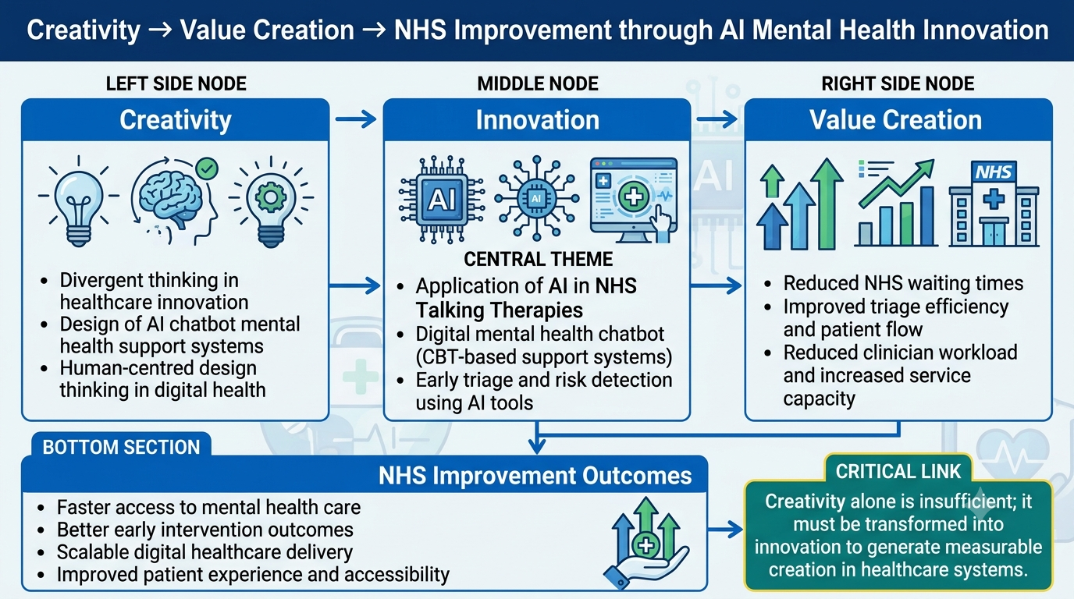
Figure 1: Concept Map
Source: (Williams, 2025; Stewart, 2021; Hull et al., 2025)

Task 2 - Self-Reflection of Group Activity
Divergent thinking involves producing multiple ideas, while convergent thinking involves logically evaluating and making decisions to choose the most suitable idea. In healthcare innovation, both strategies play crucial roles, especially in complex health care environments, such as the NHS.
Divergent thinking was exhibited in the paperclip class activity with many alternative uses being generated, such as paperclip medical tools, connectors, and repair functions. This was an invitation to be creative and explore problems in any way possible. Convergent thinking was used when the most realistic and functional solution was chosen, based on the feasibility, safety and appropriateness to healthcare contexts.
Divergent thinking is, most importantly, an innovation tool that promotes openness, originality and flexibility. This is in line with the application of AI in healthcare design processes, where new ideas, like mental health chatbots, emerge to address gaps in services. These ideas are made realistic, safe and viable in the NHS environment, e.g. clinical governance and risk management, by convergent thinking (Stewart, 2021).
In the context of innovation in healthcare, it's important to strike a balance between the two methods. So, for instance, things such as NHS digital mental health tools, such as Wysa, provide an illustration of how creative ideation (divergent thinking) needs to be developed and refined through clinical validation and system integration (convergent thinking). Thus, combining both perspectives will be crucial for effective healthcare innovation, as it will help to see how ideas can become viable, scalable solutions (NHS, 2025).
Key source support:
In healthcare, the adoption of AI mental health systems must strike a balance between creativity and clinical safety, while also being implemented in a structured manner.

Task 3 - Case Study of a UK innovation
UK Innovation Case Study: Wysa AI Mental Health Chatbot in NHS Talking Therapies
1. Background
The current situation in the NHS is that there is an extreme demand for mental health services, with more than a million people waiting for treatment. This has led to Talking Therapies being extremely stretched with long delays and a lack of access to early intervention. To tackle this, AI powered mental health solutions like Wysa have been rolled out in NHS Talking Therapies pathways. Research illustrates that Wysa has been introduced in 31 NHS Talking Therapy services to help patients with triage and self-referral (NICE, 2025).
2. Innovation Description
Wysa is an AI-powered mental health chatbot that uses evidence-based Cognitive Behavioural Therapy (CBT) techniques to provide real-time emotional support. It serves as a digital front-door system in NHS Talking Therapies which allows for early triage, screening of symptoms and guided self-referral. Patients also receive automated therapeutic conversations, mood tracking and structured self-help exercises during the period between sessions with clinical treatment. In addition, it provides clinicians with pre-assessment information and a risk stratification. NICE identifies such AI “digital front door” technologies as aids to improve the efficiency of the assessment process and to optimise access to care in the NHS, but not as substitutes for clinical professionals (NHS, 2025; National institute for Health and care Excellence, 2025).
3. Value Creation
Wysa creates a high level of value for the NHS system, patients, and clinicians. It enhances access, through the opportunity for quicker self-referral and minimising administrative hurdles to access. Research studies have demonstrated that AI triage systems can save around 21 minutes of clinician time for every patient, leading to a more efficient use of time and resources and freeing up staff to work on more complex cases (Wysa, 2024). It also improves patient engagement by providing immediate support without the stigma of a formal therapy session during the waiting time, which has the potential to lower the severity of symptoms prior to the onset of formal therapy. In addition, it can also help to increase the efficiency of the system, as it helps to avoid missed appointments and ensures that referrals are completed. These results show that these benefits are clearly realised in terms of improved service delivery, decreasing workload pressures and improving patient experience for mental health pathways (Wysa.com, 2024).
4. Critical Evaluation
While it has its merits, Wysa also comes with some drawbacks. AI systems do not have an empathetic understanding and are not always able to understand complex psychological distress. However, there are some potential drawbacks to consider, such as risk of incorrect answers, data privacy issues, and dependence on automated support systems. Furthermore, digital exclusion can also restrict access to vulnerable groups, which can cause inequities in accessing health care (National institute for Health and care Excellence, 2025).

Task 4 - Research Task
Mental Health Access Crisis: Research Analysis
1. Problem Identification
NHS mental health services are facing a crisis of access due to growing demand and staff shortages, and a high prevalence of anxiety and depression. There are currently over a million patients awaiting psychological therapy services and waiting longer for intervention resulting in poorer mental health outcomes. This has put pressure on NHS Talking Therapies and impacted timely access to NHS Talking Therapies (NHS England, 2025).
2. Source 1 – Academic Evidence
AI mental health interventions have demonstrated that AI chatbots can be effective in alleviating symptoms of anxiety and depression among patients awaiting mental health treatment. There is statistically significant decrease in scores on both the PHQ-9 and GAD-7 which remains over time in large studies. These tools are available for structured Cognitive Behavioural Therapy (CBT) techniques, and offer emotional support in real-time, which will help to minimize the clinical burden and enhance the outcome of early interventions during waiting periods (Chang et al., 2024).
3. Source 2 – NHS Policy/Healthcare Evidence
To enhance access and streamline referral processes, NHS Talking Therapies services have incorporated AI solutions like Wysa and Limbic. AI systems have been demonstrated to boost triage effectiveness, streamline administrative tasks, and enhance patient engagement. NICE has facilitated limited use of these tools pending further information about the safety and effectiveness of their use (NICE, 2025).
4. Critical Analysis
While access to access is enhanced, issues of digital exclusion, data privacy, and overreliance on AI systems persist, with a note that in more complex mental health scenarios, AI systems can be no substitute for clinical judgment.

Task 5 – Podcast
AI Mental Health Innovation Pitch
Opening (25 seconds)
There is currently a crisis in mental health care in the NHS and more than 1 million people are waiting for mental health treatment. This delay contributes to escalating anxiety and depression while identifying the need for innovative solutions now more than ever (NHS England, 2025).
Solution (60 seconds)
My proposed innovation is an AI mental health chatbot, embedded within NHS Talking Therapies. This system will include immediate emotional support, triage and referral to the appropriate service and employ techniques from the Cognitive Behavioural Therapy (CBT) model. It also provides self-help materials in waiting time periods, so that continual support is provided prior to clinical intervention (NICE, 2025).
Research on implementing AI in healthcare, like Wysa, demonstrates how these systems can facilitate self-referrals and lower the burden on healthcare providers by enhancing assessment efficiency and automating early screening procedures (Wysa.com, 2024).
Value Creation (30 seconds)
This innovation will generate value in terms of the reduction of waiting times, the relief of pressures on NHS staff and the enhancement of patient engagement. It's vital to ensure early intervention to prevent worsening of mental health issues and to enhance long-term results (NICE, 2025).
Closing (10 seconds)
In conclusion, AI-powered mental health tools are a promising and effective way to improve access to mental health help and support, which is particularly important in the current climate of capacity constraints within the NHS.

Task 6 - NHS Leadership Framework Analysis
NHS Leadership Framework Analysis
1. Summary of NHS Leadership Framework
The NHS Leadership Framework outlines the skills and qualities needed for good leadership in NHS services. It is organized into areas of key focus such as: Demonstrate personal qualities, Work with others, Manage services, Improve services, Set direction, Create vision, and Deliver strategy. Together, these domains enable leaders to handle complexity, promote service improvement and patient-centred care (NHS Leadership , 2021).
Personal qualities are related to integrity, self-awareness and emotional intelligence. Interpersonal skills focus on working together, communicating and collaborating with others in multidisciplinary environments. Managing services is also about making efficient use of resources, managing the workforce and holding people to account. Innovation, patient safety and continuous improvement are the areas of focus for improving services. Direction and vision are strategic thinking and long term planning, and delivering strategy is making sure organisational goals are realised in the results of the organisation. This is a resource to help NHS organisations to be led effectively and consistently (NHS England UK, 2025).
2. Application to Transformational Leadership
Transformational leadership is particularly relevant to the context of mental health innovations with AI, since it promotes change within the organisation, engages employees and fosters the use of new technology. Leaders can foster the adoption of AI chatbot systems in NHS Talking Therapies through transformational strategies, such as establishing a digital transformation vision and creating a collective understanding of the benefits (Wang, Liu and Ao, 2025).
But there can be some resistance to digital adoption as a result of a lack of training or fear of losing jobs. Thus, leaders should offer on-going professional development, communication, and emotional support for staff working with AI systems. This guarantees that they will be implemented and have the confidence of the staff and the quality of the services (NHS England UK, 2025).

Task 7 - Self-Reflection Journal Entry
This module has broadened my knowledge of the role of creativity as the basis of innovation and value generation in health and social care. I now have a better understanding that creativity needs to be put into practice as solutions to real NHS problems like demand for mental health services and limited resource.
I have developed an analytical and problem-solving perspective toward healthcare innovations through the analysis of them, as well as through theory (design thinking and leadership models). These skills have helped me to critically examine the possibilities of digital technologies, such as AI, to affect health services.
This course is very relevant to my work in the health care field because it focuses on developing the skills and knowledge that enable me to be creative, flexible and make decisions based on data. It has also enabled me to appreciate the future of digital solutions in the medical field, in regards to the efficiency, the betterment of the patients' health, and the increased accessibility.

Reference
Chang, C.L., Sinha, C., Roy, M. and Wong, J.C.-M. (2024). AI-Led Mental Health Support (Wysa) for Healthcare Workers During COVID-19: Service Evaluation (Preprint). JMIR formative research, [online] 8, pp.e51858–e51858. doi: https://doi.org/10.2196/51858.
Hull, T.D., Zhang, L., Arean, P.A. and Malgaroli, M. (2025). Mental Health Generative AI is Safe, Promotes Social Health, and Reduces Depression and Anxiety: Real World Evidence from a Naturalistic Cohort. [online] arXiv.org. Available at: https://arxiv.org/abs/2511.11689.
National institute for Health and care Excellence (2025). 1 Recommendations | Digital front door technologies to gather service user information for NHS Talking Therapies for anxiety and depression assessments: early value assessment | Guidance | NICE. [online] Nice.org.uk. Available at: https://www.nice.org.uk/guidance/htg756/chapter/1-Recommendations
NHS (2025). Wysa - AI-Powered Mental Health Support for Building Resilience - NHS Innovation Accelerator. [online] NHS Innovation Accelerator. Available at: https://nhsaccelerator.com/innovations/wysa/.
NHS England (2025). Overview | Digital front door technologies to gather service user information for NHS Talking Therapies for anxiety and depression assessments: early value assessment | Guidance | NICE. [online] Nice.org.uk. Available at: https://www.nice.org.uk/guidance/htg756.
NHS England UK (2025). NHS England» Management and leadership development. [online] England.nhs.uk. Available at: https://www.england.nhs.uk/long-read/management-and-leadership-development/.
NHS Leadership (2021). Healthcare Leadership Model – Leadership Academy. [online] www.leadershipacademy.nhs.uk. Available at: https://www.leadershipacademy.nhs.uk/healthcare-leadership-model/.
NICE (2025). 2 Information about the technologies | Digital front door technologies to gather service user information for NHS Talking Therapies for anxiety and depression assessments: early value assessment | Guidance | NICE. [online] Nice.org.uk. Available at: https://www.nice.org.uk/guidance/htg756/chapter/2-Information-about-the-technologies
Stewart, J. (2021). Can an app improve NHS mental health support? | Imperial News | Imperial College London. [online] Imperial News. Available at: https://www.imperial.ac.uk/news/227353/can-improve-nhs-mental-health-support/.
Wang, H.-Y., Liu, R.-H. and Ao, L. (2025). Transformational leadership and employee AI usage: the role of perceived organizational support and competitive workplace climate. Frontiers in Psychology, [online] 16. doi: https://doi.org/10.3389/fpsyg.2025.1581337.
Williams, T. (2025). NHS tackles mental health crisis with AI. [online] Digital Health Technology News UK. Available at: https://healthtechdigital.com/nhs-tackles-mental-health-crisis-with-ai/
Wysa (2024). NHS tackles mental health crisis with AI. [online] Wysa. Available at: https://blogs.wysa.io/blog/company-news/nhs-tackles-mental-health-crisis-with-ai.
Wysa.com (2024). Wysa AI Support for NHS Talking Therapies | Enhance Care and Support Better Outcome For Service Users. [online] Wysa.com. Available at: https://www.wysa.com/nhs-talking-therapies.

