Lewis Williams
P151968 UWTSD
Management of sustainable construction

1.0 Introduction
A twenty-storey building with a three levelled underground car park is being constructed at Paxton Street, car park. The task of producing a site waste management plan has been requested from the client in order to reduce waste production and saving materials effectively. This will aid in saving money for an economic benefit and helping the environment by creating less waste, reducing travel of waste transport, which creates an environmental benefit.

1.1 Aims + objectives
To identify a construction method to employ and with what materials to achieve this build. Alongside this a waste management plan will need forming, establishing roles and responsibilities of the plan which will also contain estimated waste statistics with reflective improvements to aid in the reduction of waste on site. With this all considered an estimated budget for the task will need to be generated and a BREEAM waste rating with potential credits earned.

2.0 Construction method
For this project a steel skeleton frame with an external cladding façade will be constructed to provide strength for the multi-storey building, similar to the New Bailey in Salford as shown in Appendix A. This will provide strength over long spans of the building which will be needed with large sized multi-storey building.
As the site is near the waterfront the ground is most likely going to be soft which is why a floating concrete foundation will used which will prevent sinking or unevenness over time, it also has the added benefit of being quick and cheap (Team, 2020).
The main materials being used are steel, concrete, double glazed glass and the cladding panels. These materials will have to be disposed of properly throughout the job if any are wasted.

3.0 Waste management
Approximately 32% of waste in landfills comes from the construction industry through construction processes and demolition of buildings, with in this 13% of materials delivered to site aren’t used for various reasons and sent to landfills (Construction waste, 2020). In today’s environmental situation with debates on climate change being influenced by humans or not and if global warming is actually happening or not, we should be making an effort to reduce these statistics in order to help the sustainability of our constructions material’s sources.

Follow some guidance from (Wrap, 2020), a tactical way in managing potential waste is to have deliveries of martials arrive in time with constructions phase. This helps with not over ordering too much product and prevents the materials being on site longer than they should, the less time the items are on site the less time they are stored preventing them being being ruined by labourers damaging them or weather ruining them.

3.1 Waste management officer
In order to reduce waste on large jobs like this a waste management officer will be in place whom have certain responsibilities that make them a vital role in reducing waste coming from the site and how that waste gets handled.
Several of the responsibilities of the waste management officer involve the following from (Waste management officer job profile | Prospects.ac.uk, 2020) to manage separate waste areas on site, one for recyclable materials and another for materials which aren’t. They’ll supervise transportation of waste to ensure it is done at an efficient standard without creating any unnecessary pollution. They also make sure the site is running in compliance with current legislation in the transport, handling and disposal of waste.

The waste management officer will be liaising with sub-contractors on site to ensure they are taking their own waste back to their yards and disposing of the material properly, this will be their offcuts of materials. For example, a flooring contractor can take their wasted off cuts of vinyl back to their yard via the fitters and get their own waste management team to deal with the load.

3.2 Site waste management Plan
In guidance with the local authorities of Swansea City Council
Brief: 20 storey building, including a three-storey underground car park at Paxton Street car park, SA1 3SA.

Types of waste identified throughout the building phases:

Excavation: | Soil 1705 | 8’640m3 or approx. 11’232tonnes
Basement: | Concrete 170101
 | Steel 1704
Foundation: | Concrete 170101
 | Steel 1704
Superstructure: | Concrete floor sections 170101
 | Steel Frame 1704
Cladding: | Insulation 170604
 | Pallets
 | Plastic Packages
 | Brick 170102
Reduction of waste
- Aiming to use at least 10% of soil dug for landscaping purposes on site, to alter the remaining carparks elevation to ensure its all level. Remaining soil excavated from the underground levels will be sent to other approved sites the contractor has got on for various purposes to reduce waste, hopefully this will reuse a further 50% of soil.
- Concrete will be used in the most efficient way possible; a scheme will be done to break down waste concrete to use for future concrete dry aggregate in aiding the waste management.
- Steel waste that isn’t needed can also be sent to other sites if its needed however, steel is easily recyclable which reduces waste.
- Insulation will be used from recycled products, but any waste would have to be sent to landfills as reusing insulation when damaged or dirty can hinder performance.
- All pallets will be agreed to be removed by the supplier with their packaging. This should be included in agreement with suppliers.
Reuse/recycle of waste
- Concrete will be reused as much as possible for future concrete aggregates as mentioned above and to protect the sea walls if needed, any remaining waste can’t be recycled.
- Steel waste will all be recycled, which Is why a steel frame build has been chosen. A recycle centre in Llansamlet has been chosen to recycle the steel.
- All pallets as mentioned above will be reused by the supplier.
- Soil will be reused by the contractor on other sites.

Identification of dealers and final destination of waste material
Type of waste | Total volume | Total mass | Dealer | Final destination
Soil | 8’640m3 | 11’232 tonnes | Contractor | 20% landscaping onsite  60% Sent to other approved sites  20% landfill
Concrete | 288m3 | 691  tonnes | Contractor | 100% Reuse
steel | 100m3 | 1’570 tonnes | Contractor | recycle
pallets | 0 | 0 | Supplier | --
packages | 0 | 0 | Supplier | --
Budget for disposing waste
Type of waste | volume | Number of skips (8 yard) | Cost per skip | Total cost
concrete | 288m3 | 0 | £0.00 | £0.00 | Reused on site
steel | 100m3 | 0 | £0.00 | £0.00 | Recycled at centre
packages | 0 | 0 | £0.00 | £0.00 | Supplier taken waste
Mixed (insulation) | 200m3 | 32 | £150 | £4’800.00 | Landfill
soil | 1’728m3 | 278 | £50 | £13’900.00 | Landfill
TOTAL |  |  |  | £18’700.00

Implementation
- Have an on-site waste management officer to keep the project on this track and budget.
- Provide separate waste points on site to aid in materials being separated ready for the disposal/transfer process.
- Have a designated day of the week for collection of waste materials to keep activity flowing.
- Appendix B lists calculations for waste materials.
Monitoring
- Waste management officer will oversee the entire process of waste exporting form site to ensure a smooth process.
Review
- Waste management officer will have weekly meetings with site management to see if the waste is being kept at a low level and following their expected targets and budget.
- At the end of the meeting a plan can be made if any part of the waste management hasn’t gone to target.
3.3 BREEAM rating
The BREEAM rating of buildings has a 7.5% weighting for waste (Scoring and Rating BREEAM assessed buildings, 2020). There is a total of 4 credits up for grab, 3 for construction resource efficiency and 1 for diversion of resources from landfills (Waste, 2020).
The planned SWMP will provide the project with the following waste generated per 100m2 of gross internal floor area, this excludes demolition and excavation waste:

900m2 per floor x 20 floors = 18’000m2
18’000m2/100m2 = 180m2
588m3 (Concrete, Steel and mixed waste) / 180 = 3.26m3

As shown in Appendix D this rating would give us 3 credits alone for the construction resource efficiency section.

The projects total waste is 9’228m3 of material and only 1928m3 will be disposed of to landfill sites. 7’300m3 has been avoided from going to landfills this is a 79% diversion of materials ending up in landfills. As shown in Appendix D this will also provide our buildings rating a further credit, giving us a total of 4 credits which is the maximum that can be achieved.

There is room for improvement as exemplary levels can be achieved, to improve to these standards the project will need to be overachieving its targets, which isn’t unheard and mainly be down to how well the waste management officer will run the projects waste management.

3.4 Site Layout
In Appendix C a site layout plan has been roughly drawn up mainly to show waste management areas on site for separation of materials, site traffic for how access is going to happen for waste transport.

The purpose of this layout plan is to have the most efficient system in place for collection of waste and transport to recycle centres. This is important for the cost savings for the project and for a beneficial environmental impact.

3.5 Waste and recycling site
In order to keep waste and pollution to a minimum landfill and recycling sites have been selected for the sites waste which are near. The location and distance from site have been listed.

Swansea Council Bailing Plant
(SA1 3SA to Swansea Council Baling Plant (commercial site), 2020)
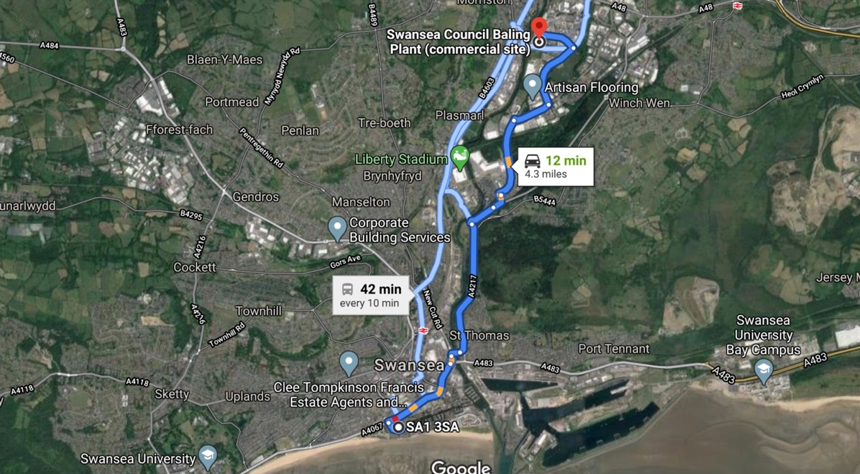

Swansea baling plant is the closest plant which can accept some of or material waste, especially the recyclable items like waste metals. The distance is only 4.3 miles away with an approximate 12minutes travel time which is ideal in keeping pollution low and quick refill times in transferring the materials.

3.6 Review for future projects
Once this project has been completed a proper review can be undertaken from management of the company in order to evaluate how well the project stayed on target with its SWMP. If not then what went wrong can be discussed in order for improvement in these areas for other projects. This end review stage is important for seeing how much money has been saved on projects with the added benefit in seeing how much waste the project has managed to avoid from sending to landfills which ruins lands and environments.

The whole process of trying to make the building industry more sustainable is vital more than ever with it being a major player in the waste industry. By providing this sector with such beneficial statistics of waste reduction, will help improve the country and improve building costs as materials being reused and recycled will bring costs down.

Appendices

Appendix A
A photo of the New Bailey, Salford, showing a multi-storey construction of a steel framed structure and a cladded panel being fitting for the façade (steelconstruction, 2020).
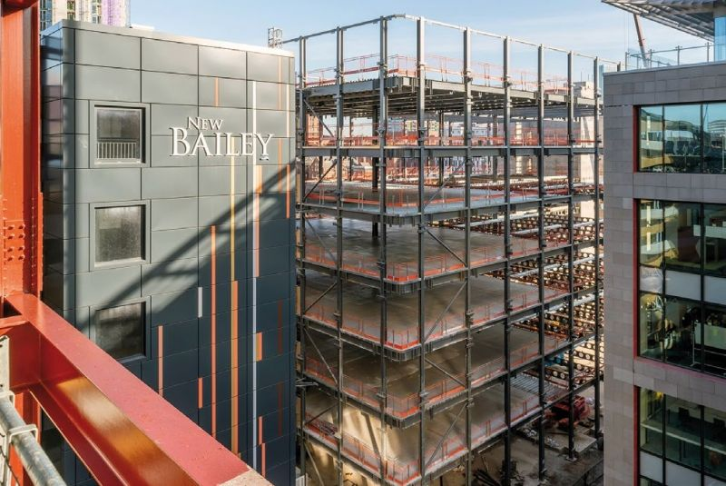

Appendix B

Material Calculations

Soil
The soil amount of 8’640m3 generated from the excavation process has been calculated using the following method:
30m x 30m = 900m2 per floor
900m2 x 3.2m (Typical floor height) = 2’880m3 per floor
2’880m3 x 3 storeys = 8’640m3

Concrete
The concrete waste has been calculated in the following process:
900m2 x 0.30m = 270m3 for foundation
900m2 x 0.10m = 90m3 per floor
90m3 x 29 floors = 2610m3
2610m3 + 270m3 = 2’880m3

2’880m3 is the total needed for the job completion, an estimated 10% of the material will be wasted through the concrete drying out before labours get to use it, excess material etc.

10% of 2’880m3 = 288m3 of waste
Appendix C

Site Layout Plan

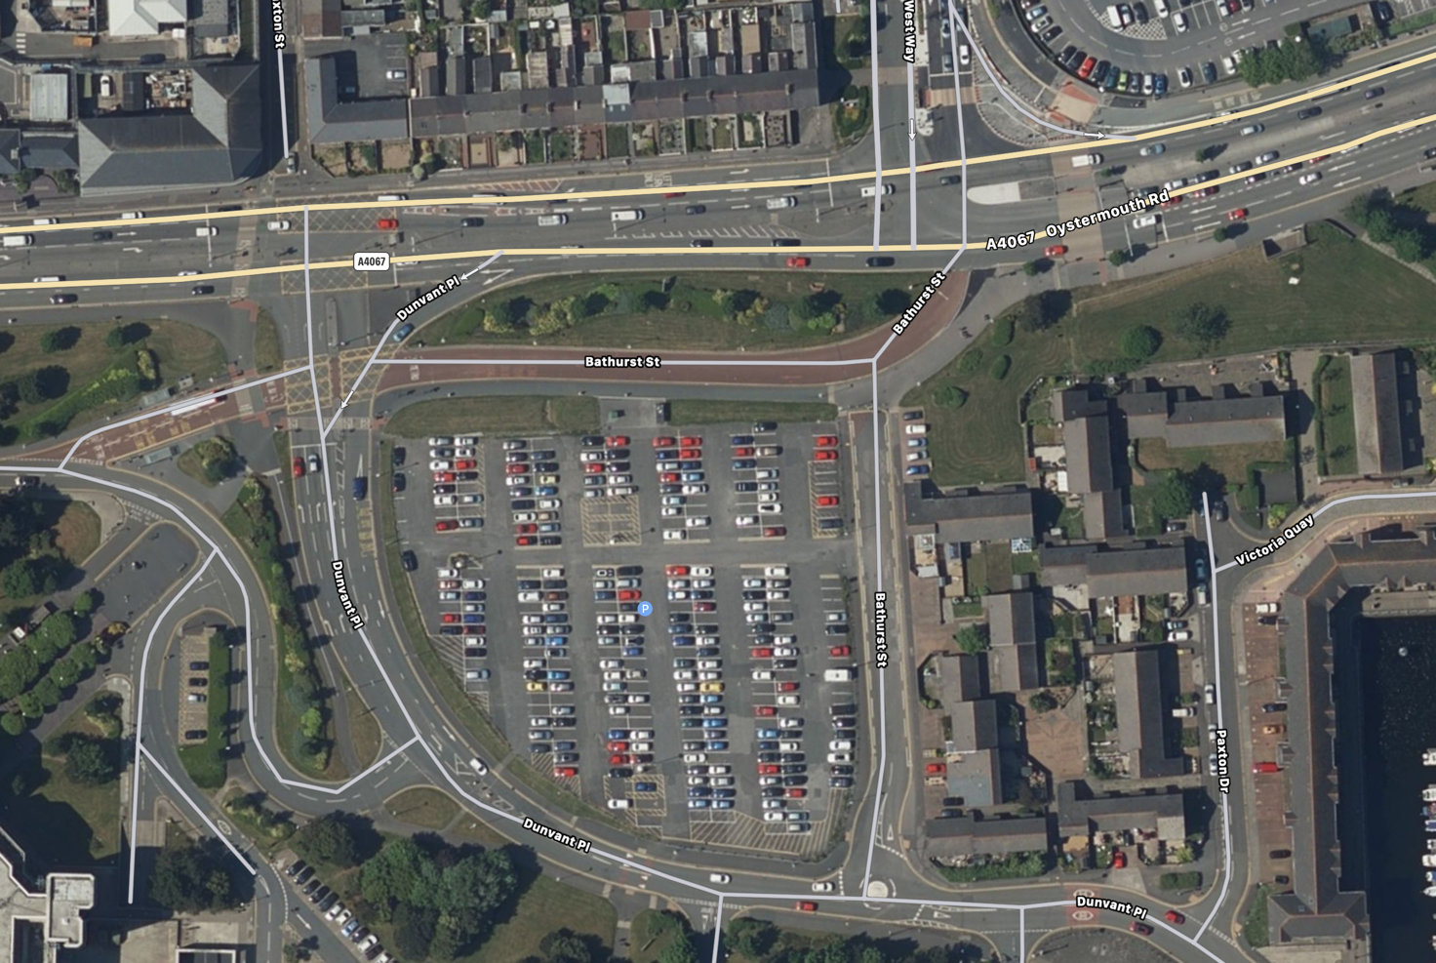
Blue marked area shows the site perimeter where the site wall and fencing will be erected to prevent access to the public.

The green marked area is where the proposed building will be built which is in the centre of the site.

The orange zone is the location of the site offices where management will be along with the site register and induction rooms.

Waste collection points are in red and yellow, two separate areas have been assigned for recyclable materials and another for non-recyclable or hazardous materials.

The pink marking is the site entrance which has been positioned as such so collection of waste can be collected easy as the vehicle can drive straight into the waste collection point and leave through the exit gate which is marked in white.

Appendix D

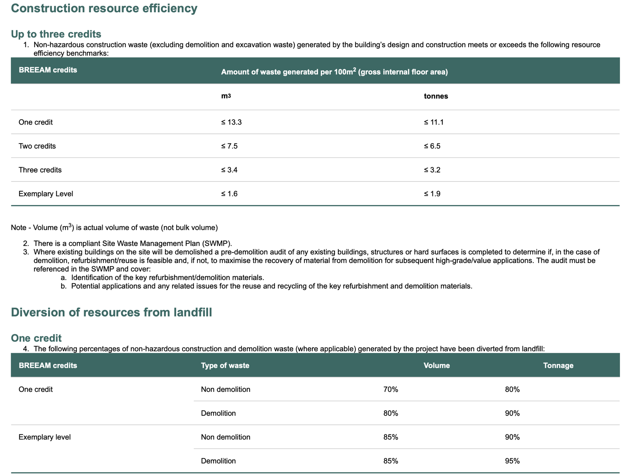
(Waste, 2020)

References

Breeam.com. 2020. Scoring And Rating BREEAM Assessed Buildings. [online] Available at: <https://www.breeam.com/BREEAM2011SchemeDocument/Content/03_ScoringRating/environmental_section_weightings.htm> [Accessed 20 March 2020].

Breeam.com. 2020. Waste. [online] Available at: <https://www.breeam.com/BREEAM2011SchemeDocument/content/10_waste/wst01.htm> [Accessed 20 March 2020].

Designingbuildings.co.uk. 2020. Construction Waste. [online] Available at: <https://www.designingbuildings.co.uk/wiki/Construction_waste> [Accessed 20 March 2020].

Prospects.ac.uk. 2020. Waste Management Officer Job Profile | Prospects.Ac.Uk. [online] Available at: <https://www.prospects.ac.uk/job-profiles/waste-management-officer> [Accessed 20 March 2020].

SA1 3SA to Swansea Council Baling Plant (commercial site). 2020. SA1 3SA To Swansea Council Baling Plant (Commercial Site). [online] Available at: <https://www.google.co.uk/maps/dir/SA1+3SA,+Bathurst+St,+Swansea/6,+Swansea+Council+Baling+Plant+(commercial+site),+Swansea+Enterprise+Park,+Ferryboat+Cl,+Llansamlet,+Swansea+SA6+8QN/@51.6508363,-3.9343133,9913m/data=!3m1!1e3!4m13!4m12!1m5!1m1!1s0x486e8aca57ebe9c3:0x103e81e96f69baec!2m2!1d-3.9456525!2d51.6144673!1m5!1m1!1s0x486e5f819fb84467:0x600332695d5f846!2m2!1d-3.9203383!2d51.6575191> [Accessed 20 March 2020].

Steelconstruction, 2020. [image] Available at: <https://www.steelconstruction.info/File:New_Bailey-5a.jpg> [Accessed 19 March 2020].

Team, W., 2020. Types Of Foundations For Steel Buildings. [online] Whirlwindsteel.com. Available at: <https://www.whirlwindsteel.com/blog/bid/368376/types-of-foundations-for-steel-buildings> [Accessed 20 March 2020].

Wrap.org.uk. 2020. [online] Available at: <http://www.wrap.org.uk/sites/files/wrap/Reducing%20your%20construction%20waste%20-%20a%20pocket%20guide%20for%20SME%20contractors.pdf> [Accessed 20 March 2020].

