Employability and Personal Development Assignment
Profession Focus: Cleaning / Facilities Supervisor

Module Number: LCLM4005_Lon
Module Lecturer: Mr. Rejwan Bin Sulaiman
Student Name: Jaspal Singh Binji
Student Number: 2509090

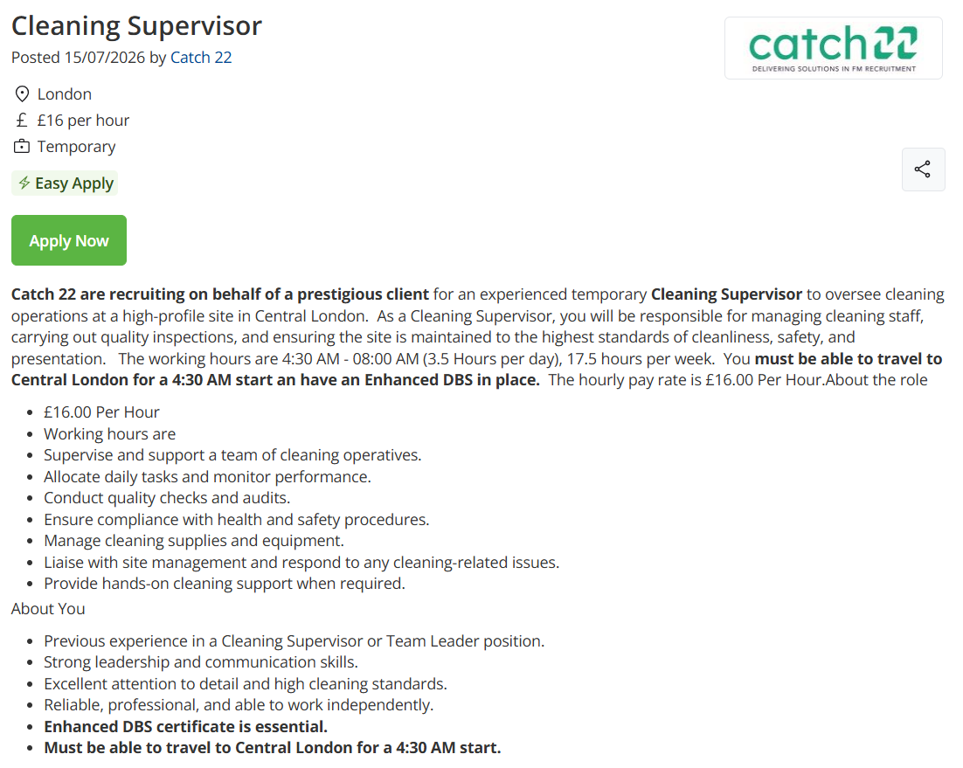

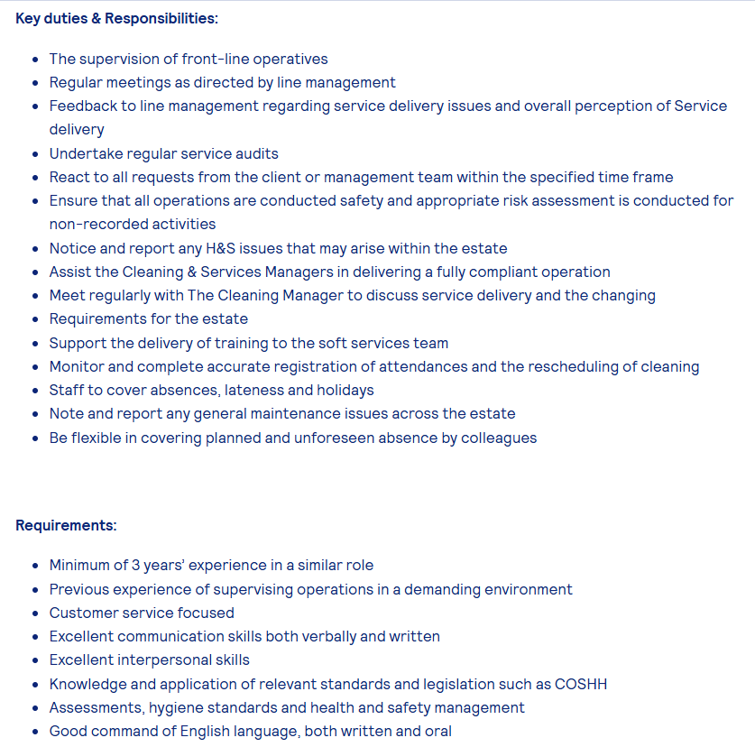

Task 1: Comparative Analysis of Two Job Adverts
The two adverts selected for comparison are both for supervisory roles within the cleaning and facilities/soft-services sector. Advert 1 is a temporary Cleaning Supervisor position advertised by recruitment agency Catch 22 for a high-profile Central London site, offering £16.00 per hour for a 4:30am–8:00am shift. Advert 2 is an in-house facilities supervisor role, unnamed in the excerpt provided, which sets out detailed duties for supervising front-line cleaning and soft-services operatives across an estate. Comparing the two provides a useful picture of the skills and knowledge that employers consistently expect from this profession.

Key skills and knowledge required
Advert 1 asks for previous experience in a Cleaning Supervisor or Team Leader role, strong leadership and communication skills, excellent attention to detail and high cleaning standards, and the ability to work independently and reliably. It also specifies an Enhanced DBS certificate as essential, reflecting the trust placed in supervisors who often work unsupervised and hold responsibility for site security and standards.
Advert 2 asks for a minimum of three years' experience in a similar role, previous experience supervising operations in a demanding environment, a customer-service focus, and excellent communication skills, both verbal and written. It further requires interpersonal skills and – more explicitly than Advert 1 – knowledge and application of relevant standards and legislation such as COSHH, alongside hygiene standards and health and safety management.

Common skills and knowledge areas
Across both adverts, four skill and knowledge areas appear consistently:
- Supervisory/leadership experience – both adverts require prior experience directly managing or supervising a team of cleaning or front-line operatives.
- Communication skills – both explicitly list strong communication (Advert 1) or excellent verbal and written communication (Advert 2) as essential.
- Health and safety knowledge – both reference compliance with health and safety procedures, with Advert 2 naming COSHH specifically.
- Quality assurance and attention to detail – both mention conducting audits, inspections, or maintaining high standards.

Why communication skills matter in this profession
Of these shared areas, communication skills are arguably the most fundamental to day-to-day success as a Cleaning or Facilities Supervisor. A supervisor sits between senior management/clients and the operational team, and must translate instructions, standards, and feedback in both directions clearly and accurately. Advert 2 specifically requires supervisors to feed back to line management on service delivery issues and to react to client requests within a set time frame; Advert 1 requires liaison with site management and hands-on coordination of a team. Without clear verbal and written communication, task allocation can be misunderstood, health and safety issues may go unreported, and client relationships can be damaged – all of which carry real operational and reputational risk in a facilities contract. Strong communication also underpins effective leadership: staff are more likely to follow instructions and maintain standards when a supervisor explains the reasoning clearly, gives constructive feedback, and remains approachable. For these reasons, communication is not simply a desirable soft skill in this profession but a core operational requirement.

Task 2: Reflective Self-Assessment (SWOT Analysis)
Reflective self-assessment is a structured way of evaluating one's own readiness for employment by identifying internal strengths and weaknesses alongside external opportunities and threats. Using a SWOT framework against the skills identified in Task 1 – supervisory experience, communication, health and safety knowledge, and attention to detail – allows me to see clearly where I already meet employer expectations for a Cleaning/Facilities Supervisor role, and where I need to develop further before I am fully job-ready.
STRENGTHS  - Supervisory and leadership skills  I have developed good leadership and organisational skills through my studies and previous responsibilities. I am able to organise tasks, work with others and take responsibility for completing activities to a good standard.  - Academic achievement and relevant knowledge  My university studies have helped me develop knowledge of business, management and employability. They have also improved my ability to analyse information, solve problems and apply theoretical knowledge to practical situations.  - Teamwork and responsibility  I work effectively as part of a team and understand the importance of cooperation, reliability and supporting others. I am also willing to take responsibility and contribute towards achieving team objectives.  - Communication and attention to detail  One of my strengths is my ability to communicate with other people and listen to instructions. I also understand the importance of accuracy and attention to detail, particularly when following procedures relating to cleaning standards, health and safety and customer requirements. | WEAKNESSES  - Limited formal supervisory experience  One of my main weaknesses is that I have limited formal experience of supervising a large team. I therefore need to gain more practical experience of allocating work, monitoring performance and managing a team.  - Limited formal COSHH and health-and-safety qualifications  I need to strengthen my formal knowledge of COSHH, health and safety legislation and other requirements relevant to cleaning and facilities management. This is important because both job adverts identify health and safety knowledge as an important requirement.  - Confidence when giving feedback and instructions  I need to develop greater confidence when giving instructions, providing constructive feedback and dealing with difficult conversations. Developing this skill will help me become a more effective supervisor.  - Professional written communication  I need to improve the conciseness and professionalism of my written communication, particularly when preparing reports, recording incidents and communicating information to management or clients.
OPPORTUNITIES  - Growing demand for supervisory roles in facilities management and soft services across London  - Access to short, low-cost courses (e.g. IOSH Managing Safely, COSHH awareness) to close knowledge gaps  - University careers service: CV clinics, mock interviews, and employer networking events  - Placement or part-time work available in the sector to build directly relevant experience | THREATS  - Competitive market — many candidates already hold 3+ years' supervisory experience  - Cost/time required to obtain an Enhanced DBS certificate before applying  - Physical demands and early/unsociable shift patterns (e.g. 4:30am starts) may limit availability  - Employers increasingly expect evidenced legislative knowledge (COSHH, H&S) at application stage

Strengths
My strengths align with the key requirements of Advert 1 and Advert 2, particularly leadership, teamwork, communication and organisation. In my part-time job, I coordinated a small team during busy shifts by allocating tasks, supporting colleagues and ensuring responsibilities were understood. This strengthened my leadership, decision-making and ability to work under pressure.

Weaknesses
One of my main areas for development is formal management experience. Although I have supervised small teams, I have not yet managed a larger workforce or dealt with more complex staff responsibilities.
I also do not currently hold an Enhanced DBS certificate or recognised Health and Safety/COSHH qualification, which may be required for the roles in Advert 1 and Advert 2.
Additionally, I have received feedback about being more confident and concise when giving instructions under pressure. I have improved by communicating priorities clearly and checking understanding. I aim to continue developing these areas through further experience, training and increased responsibility

Opportunities
Several external factors work in my favour. The facilities management and soft services sector has an ongoing need for supervisors, particularly in London, which Advert 1 and Advert 2 both illustrate. Low-cost, short courses (such as IOSH Managing Safely or COSHH awareness) are widely available and could close my legislative knowledge gap quickly. My university's careers service also offers CV reviews, mock interviews, and employer events that I have not yet fully used, and part-time or placement roles in the sector would let me build genuine supervisory experience while still studying.

Threats
The main external risks are competition and practical barriers. Both adverts specify prior supervisory experience (Advert 2 asks for a minimum of three years), meaning I am likely to be competing against candidates who are already more experienced. Obtaining an Enhanced DBS certificate takes time and a small fee, which could delay applications if I leave it too late. The unsociable hours in Advert 1 (a 4:30am start) may also limit which roles are realistically compatible with my other commitments, and employers appear to increasingly expect evidenced legislative knowledge at application stage rather than being willing to train it from scratch.

Overall readiness for employability
Taken together, this SWOT analysis shows that I already have some genuine building blocks for this profession – particularly around [replace: name your strongest matching strength] – but that formal health and safety knowledge, a DBS certificate, and more evidenced supervisory experience are the clearest gaps between where I am now and what Advert 1 and Advert 2 are asking for. This is a realistic and honest starting point, and directly informs the goals and personal development plan set out in Task 3.

Task 3: Employment Goals and Personal Development Plan
Based on the weaknesses identified in Task 2, I have set the following employment goals, distinguishing between what I can realistically achieve in the short term and what will take longer to build.
Absolutely — here is your content organised into a clear career development goals chart that you can use in a professional development plan or application.
Timeframe | Goal | Actions / Development Activities | Expected Outcome / Evidence
0–6 months | Improve Health & Safety knowledge | Complete a COSHH Short-Term Awareness course and/or IOSH Managing Safely course. | Certificates demonstrating improved Health & Safety knowledge and awareness.
0–6 months | Obtain Enhanced DBS clearance | Apply for and obtain an Enhanced DBS certificate. | Valid Enhanced DBS certificate, ensuring no delays at application stage.
6–18 months | Gain formal supervisory and management experience | Take responsibility for a larger team and seek opportunities to supervise staff. | Evidence of increased supervisory responsibility and experience managing a team.
6–18 months | Strengthen leadership and communication | Apply leadership and communication skills in more challenging workplace situations. | Improved confidence when leading others, giving instructions and communicating professionally.
6–18 months | Develop professional knowledge and qualifications | Complete additional professional training and qualifications relevant to Advert 1 and Advert 2. | Relevant certificates/qualifications and increased knowledge applicable to target roles.
6–18 months | Improve delegation and workload management | Practise delegating tasks, prioritising workloads and managing team responsibilities effectively. | Positive feedback and evidence of successfully coordinating workloads and tasks.
6–18 months | Develop problem-solving skills | Take opportunities to resolve workplace problems and support colleagues in challenging situations. | Examples of problems successfully resolved and improved decision-making skills.
6–18 months | Progress towards greater responsibility | Seek opportunities for career progression into supervisory, team-leader or management roles. | Applications, interviews, promotion or increased workplace responsibility.
6–18 months | Continue professional self-development | Use feedback, supervision and self-reflection to identify areas for improvement. | Evidence of acting on feedback and continued improvement in professional performance.
6–24 months | Gain evidenced supervisory/team-leader experience | Obtain supervisory or team-leader experience, including informal, temporary or part-time opportunities. | References, performance records or examples demonstrating leadership experience.
6–24 months | Improve professional verbal communication | Develop confidence in giving clear instructions, providing feedback and communicating with colleagues and team members. | More confident and effective verbal communication, supported by feedback from managers/colleagues.
6–24 months | Improve professional written communication | Practise writing clear, professional emails, reports, instructions and workplace documentation. | Improved quality and clarity of written communication and positive feedback.

Weakness / Goal | Action Steps | Resources Needed | Timeline | Success Measure
Short-term: Gain formal H&S/COSHH knowledge | Complete an IOSH Managing Safely or COSHH awareness course; apply learning during any current work | Online course (£30–£150), 1–2 days study time, university library resources | Next 3 months | Certificate obtained; able to explain COSHH principles confidently at interview
Short-term: Obtain Enhanced DBS certificate | Apply through an umbrella body or prospective employer; gather required ID documents in advance | £40–£50 application fee, proof of ID/address | Next 6–8 weeks | Certificate received and ready to submit with applications
Medium-term: Build supervisory experience | Seek a team-leader/shift-lead responsibility in current job, part-time role, or student society; ask for regular feedback | Support from current manager/mentor; university careers advisor | 6–12 months | Formal or informal supervisory duties evidenced on CV; positive manager feedback
Long-term: Develop confident, professional communication | Volunteer for presentations/group leadership at university; request feedback after each; consider a short business-writing course | University workshops, peer feedback, online writing course | 12–24 months | Improved feedback scores; ability to write clear reports and lead team briefings unaided

Progress against this plan will be measured through concrete, checkable outcomes – certificates obtained, feedback received from managers or mentors after taking on new responsibility, and, ultimately, my ability to meet the essential criteria listed in adverts such as Advert 1 and Advert 2 when I next apply.

