TABLE OF CONTENTS

Entry 1: Positionality and individuality 3
Appendix 1: List of useful academic sources. 5
Appendix 2: List of useful websites, links to code of practices/advices… 7
Appendix 3: Any useful quotations, frameworks, tables. 7
Appendix 4: Personal self-development activities. 12
Entry 2: Reading and evaluating literature and information sources 14
Appendix 1: List of useful academic sources. 17
Appendix 2: List of useful websites, links to code of practices/advices… 20
Appendix 3: Any useful quotations, frameworks, tables. 20
Appendix 4: Personal self-development activities. 25
Entry 3: The contribution of research to knowledge and organizational development 26
Appendix 1: List of useful academic sources. 28
Appendix 2: List of useful websites, links to code of practices/advices… 30
Appendix 3: Any useful quotations, frameworks, tables. 30
Appendix 4: Personal self-development activities. 34
Entry 4: Defining the research question 36
Appendix 1: List of useful academic sources. 38
Appendix 2: List of useful websites, links to code of practices/advices… 40
Appendix 3: Any useful quotations, frameworks, tables 40
Appendix 4: Personal self-development activities. 45
Entry 5: Philosophical frameworks for research 47
Appendix 1: List of useful academic sources. 50
Appendix 2: List of useful websites, links to code of practices/advices… 52
Appendix 3: Any useful quotations, frameworks, tables 53
Appendix 4: Personal self-development activities. 56
Entry 6: Types of Research and Research Design 58
Appendix 1: List of useful academic sources. 60
Appendix 2: List of useful websites, links to code of practices/advices… 62
Appendix 3: Any useful quotations, frameworks, tables 62
Appendix 4: Personal self-development activities. 68
Entry 7: Research ethics and integrity 70
Appendix 1: List of useful academic sources. 72
Appendix 2: List of useful websites, links to code of practices/advices… 74
Appendix 3: Any useful quotations, frameworks, tables 74
Appendix 4: Personal self-development activities. 78

Entry 1: Positionality and individuality
Every researcher who is about to start their research journey might have the feelings as such they are at the sea but could not be able to find the right direction for their research project (Blaxter et al. 2010) considering not only research in the social science but also in the various subjects. Nevertheless, it leads to the urge in understanding philosophy underlying the research process (Easterby-Smith et al. 2018) in which the knowledge and awareness of positionality and individuality should not be underestimated.
Positionality
Kezar and Lester (2010) indicated a claim of positionality theory that “Individuals have a position that impacts how they socially construct the world.”. It could be comprehended that none of the research projects are neutral or apolitical (Vanner 2015). In more details, the position of any individual in the field of research is recognized by multiple and specialized identities (Bourke 2014) which could be clarified as historical, political, economic, religious, social and intellectual contexts of a person that might have considerable impacts on both of their interpersonal relations and qualitative research process (Ozano & Khatri 2017).
Hoskin (2015) stated that her own identities, childhood experiences, education and employment led her to the appropriate approach to her research and also to the partially reveal of the unequal power relations in life history of feminist research. Under another circumstance, Boggiano et al. (2015) made a conclusion that in order to accomplish the early discussions about government involvement for their qualitative health field work in Viet Nam, they should have been considered their positionality more carefully to formulate the fundamental connections to the host organizations in the planning stage of their project to have better access lately to the country.
Therefore, it is believed that positionality plays a crucial role in influencing the knowledge and primary findings explored in any pieces of research (McGary 2016) because it paves the direct way to the shaped idea of ‘how we research, what we research and why we research’ (Goodley & Smailes 2011) or in other words, of ‘ontology, epistemology, methodology and the methods & techniques that underpin the research’ (Easterby-Smith et al. 2018).
Individuality
Individuality could be explained as the researcher is independent in the field of research, establish their own path to success based on ‘the self-reliant strength of natural genius’ (Carmichael 1919). In more details, Taylor (2010) claimed that individuality is important because it could lead to the inspiration for the new lines of research or new interventions in the field. Carmichael (1919) also indicated that the researcher is likely to let his nature to work out his own impression upon him rather than relying on the fixed habits or the existing/ preconceptions of contemporary science.
Although there might be the potential practical problems (Taylor 2010; Betz & Fitzgerald 1993), Carmichael (1919) indicated that for the individual to think from the centre of his own, he would be able to have the most consistent attention to the issues which lie closest to hand, therefore could gain the greatest achievement.
Reflections on reflexivity
Reflexivity was indicated as the vital and integral aspect of qualitative research (Cassell et al. 2018). Cassell et al. (2018) referred that reflexivity is always a self-monitoring of, and a self- responding to, our thoughts, feelings and actions. Therefore, through the various ranges of practical or verbal collective actions, the researcher could deconstruct their positionality to achieve the more trustworthy and transparent research (Ozano & Khatri 2017).
Göğüş (2019) mentioned one of the old Greek aphorisms as: ‘You need to know yourself, in order to understand what others are doing.’ to emphasize the importance of reflexivity in the research journey as he refers to his challenges to apply self-reflexivity practices, but in the end, it was worthy because it enabled him to scrutinise the origin of the ethnographic claims.

Appendix 1: List of useful academic sources.

Blaxter, L., Hughes, C., & Tight, M. (2010) ‘How to research’ (4th Edition, Open up study skills) Maidenhead, England ; New York. Open University Press, 1-54.

Betz, E., N., Fitzgerald, F., L. (1993) Individuality and diversity: Theory and Research in counselling psychology. Annual Reviews Inc.

Boggiano et al. (2015) ‘Building the connection in health field work in Viet Nam: 2 case study’.
Bourke, B. (2014) ‘Positionality: Reflecting on the Research Process.’ The Qualitative Report. NSUWorks. 19(33), 1-9.
Cassell, C., Cunliffe, A., Grandy, G. (2018) ‘Reflexivity and researcher positionality.’ The Sage Handbook of Qualitative Business and Management Research Methods. London. Sage, 377-389.
Carmichael, D., R. (1919) ‘Individuality in research.’ The Scientific Monthly. American Association for the Advancement of Science. Vol. 9, No. 6, 514-525.
Easterby-Smith, M., Thorpe, R., Paul, J., Lena J. (2018). Management & business research (6th Edition). London. Sage.

Göğüş, I., S. (2019) ‘Puzzling’ Moments in the Field: Dilemmas of Positionality and Self-Reflexivity. Peace Research Institute Frankfurt.

Goodley, D., Smailes, S. (2011) ‘Chapter 3: Positionalities.” Qualitative method in psychology.

Hoskins, K. (2015). ‘Researching Female Professors: The Difficulties of Representation, Positionality and Power in Feminist Research.’ Gender and Education, 27(4), 393-411.

Kezar, A., & Lester, J. (2010). ‘Breaking the Barriers of Essentialism in Leadership Research: Positionality as a Promising Approach.’ Feminist Formations, 22(1), 163-185.

Mcgarry, O. (2016) ‘Repositioning the Research Encounter: Exploring Power Dynamics and Positionality in Youth Research.’ International Journal of Social Research Methodology, 19(3), 339-354.

Ozano, K., Khatri, R. (2018) ‘Reflexivity, Positionality and Power in Cross-Cultural Participatory Action Research with Research Assistants in Rural Cambodia.’ Educational Action Research, 26(2), 190-204.

Taylor, D. (2010) ‘Together and Apart: Collegiality and Individuality in Research Centres.’ Journal of the Mechanical Behavior of Biomedical Materials, 3(2), 135.

Vanner, C. (2015) ‘Positionality at the Center: Constructing an Epistemological and Methodological Approach for a Western Feminist Doctoral Candidate Conducting Research in the Postcolonial.’ International Journal of Qualitative Methods, 14(4).

Appendix 2: List of useful websites, links to code of practices/advices…
- Your guide to the research process – The tree as a metaphor for a research project.
http://study.sagepub.com/sites/default/files/easterby-smith_pullout-e.pdf
Source: Jawad, C. (2020) ppt ‘Positionality and Identity’ UWTSD
- How you feel about individualism is influenced by your social class?
https://hbr.org/amp/2017/05/research-how-you-feel-about-individualism-is-influenced-by-your-social-class
- Writing strategies: What is your positionality?
https://weingartenlrc.wordpress.com/2017/01/09/research-writing-whats-your-positionality/
- Dear humanities Profs: We are the problem:
https://www.chronicle.com/article/Dear-Humanities-Profs-We-Are/243100
- “Picasso: Blue and Rose”:
https://www.artforum.com/print/reviews/201901/picasso-blue-and-rose-78012
- Beating the odds: Perception with reality:
https://www.psychologytoday.com/ca/blog/survive-anything/201903/beating-the-odds
- Forget or to remember
https://philosophynow.org/issues/137/To_Forget_or_To_Remember

Appendix 3: Any useful quotations, frameworks, tables.
- Insider and outsider perspectives.
‘A commonsense problematic positions comparative researchers as either inside or outside cultures, or their situation is considered so as to acknowledge cultural fluidity and fragmentation.’

Source: Kelly, P. (2014) ‘Intercultural comparative research: rethinking insider and outsider perspectives.’ Oxford review of education. Volume 40, issue 2, 246-265

- Two things that the allegory (Plato’s Cave) of the Cave tell us:
- that the world of our direct experience is a shadow or imitation of the real world equally important:
- that the world of our direct experience provides us with some knowledge of reality

“Socrates explains how the philosopher is like a prisoner who is freed from the cave and comes to understand that the shadows on the wall are not reality at all, for he can perceive the true form of reality rather than the manufactured reality that is the shadows seen by the prisoners. The prisoners manage to break their bonds one day and discover that their reality was not what they thought it was. They discovered the sun, which Plato uses as an analogy for the fire that man cannot see behind. Like the fire that cast light on the walls of the cave, the human condition is forever bound to the impressions that are received through the senses.”

Source: Jawad, C. (2020) ‘Positionality and Identity’ (ppt) UWTSD

- Illustration of Plato’s Cave
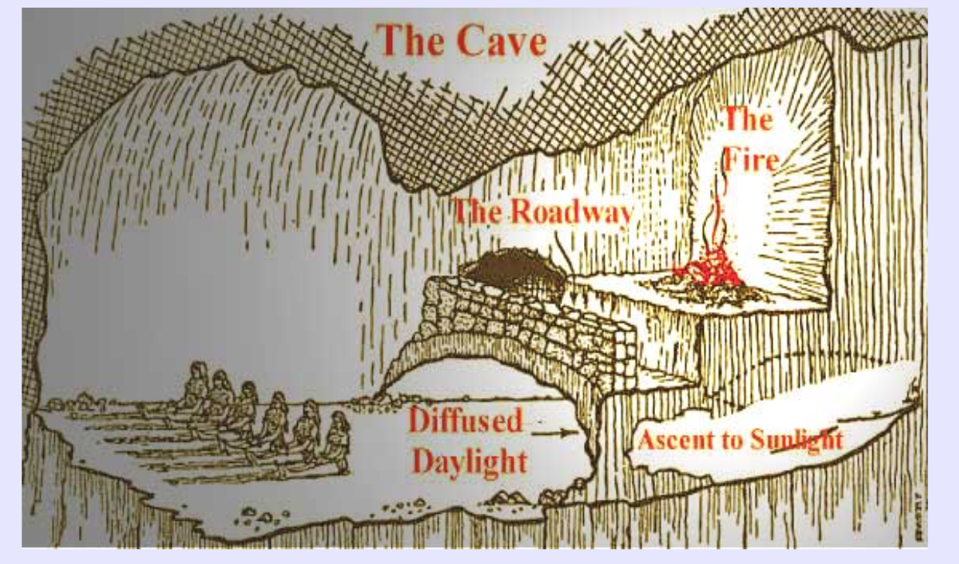
(Lahanas n/a)

Source: Lahanas, M. (n/a) ‘Plato’s Cave and Inverse Problems.’ Hellenicaworld [online] Available at: <http://www.hellenicaworld.com/Greece/Science/en/PlatosCave.html>

- Developing your research philosophy – the reflexive way.
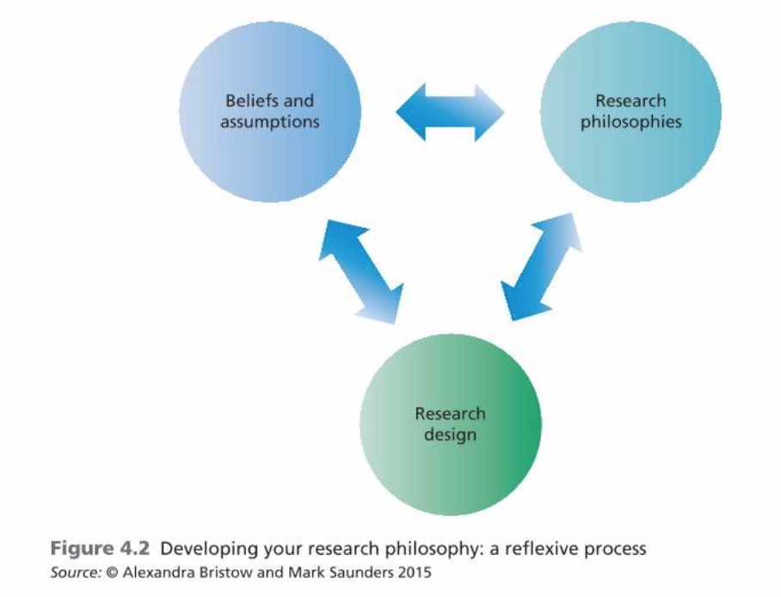
(Saunders et al. 2016)

Source: Saunders, M., Lewis, P., Thornhill, A. (2016) Research method for business student (7th Edition). England. Pearson.

- Comparison between the positionality of management and practitioner researchers.
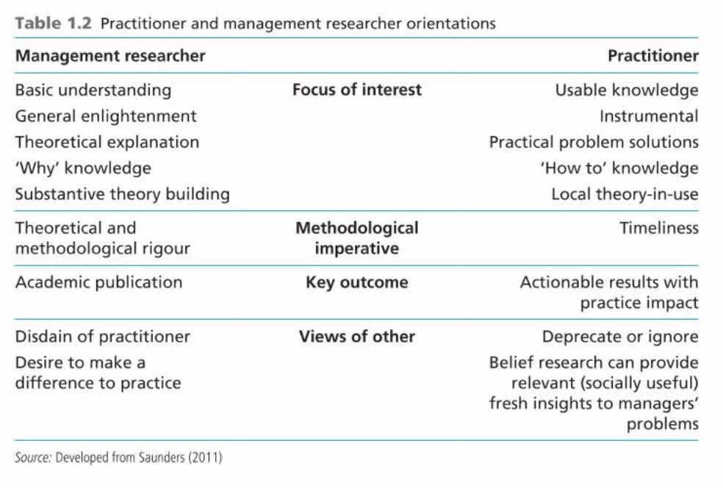
(Saunders et al. 2016)

Source: Saunders, M., Lewis, P., Thornhill, A. (2016) Research method for business student (7th Edition). England. Pearson.

- A model of ARGYRIS’ and SCHON’s “double loop learning”

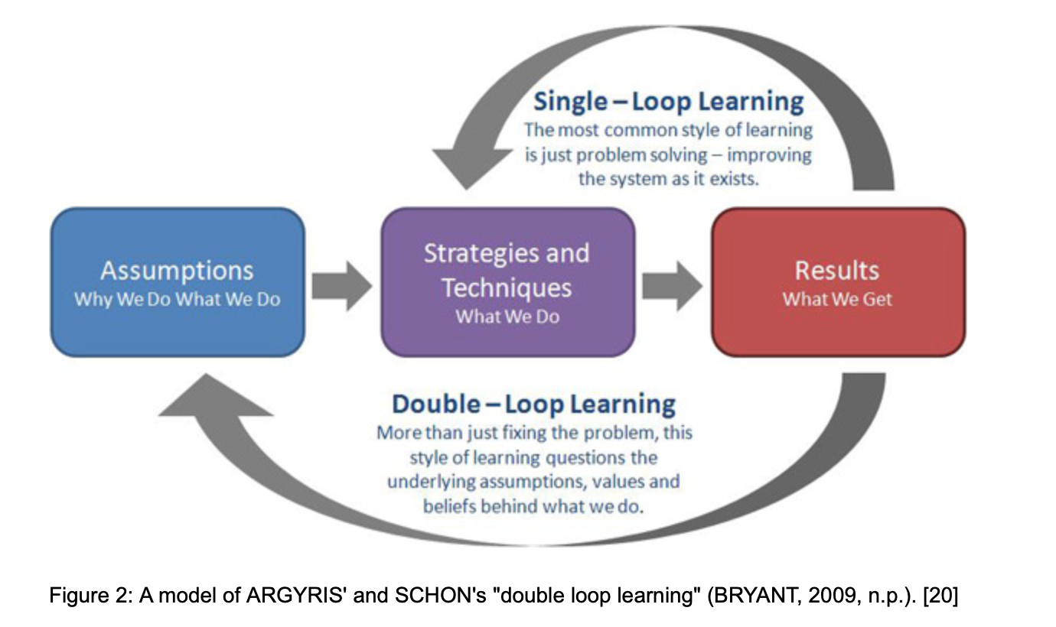
(Pitard 2017)

Source: Pitard, J. (2017) ‘A Journey to the Centre of Self: Positioning the Researcher in Autoethnography’ Forum Qualitative Social Research [online] Available at: < http://www.qualitative-research.net/index.php/fqs/article/view/2764/4131>

- An example of a completed social identity map.
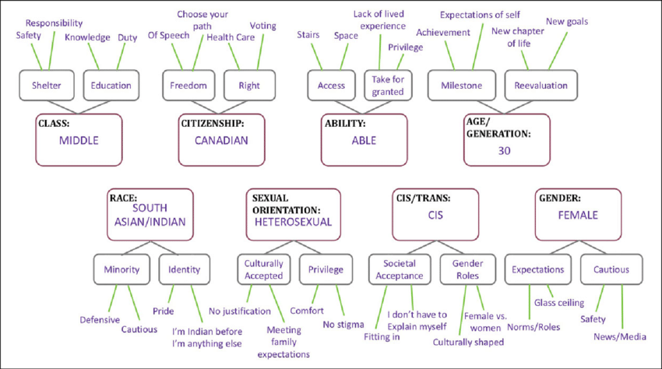
(Jacobson & Mustafa 2019)

Sourced: Jacobson, D., Mustafa, N. ‘Social Identity Mapping: A Reflexivity Tool for Practicing Explicit Positionality in Critical Qualitative Research’ Research gate [pdf] Available at: <https://www.researchgate.net/publication/334654230_Social_Identity_Mapping_A_Reflexivity_Tool_for_Practicing_Explicit_Positionality_in_Critical_Qualitative_Research>

Appendix 4: Personal self-development activities.
In the class of positionality and individuality, our lecturer brought 2 boxes with different sizes: one was bigger than the other. She then asked us to lift them up, observe, touch or shake it to guess what could be held inside. After that, we should write down what we thought that might be in the boxes. We did as required and was all waiting for her to reveal the mystery because we were really curious about the reasons lying behind the strange instructions.

As time passed by, we kind of forget about the box, then just right before we were about to finish the slides, she asked us to discuss our answer. Nevertheless, we all came up with the different or quite similar answer, some guessed there should be some books inside the big box, some thought pens or pencils were in the small box, the other have the different ideas of helmet, cake or even rock… Our lecturer did not confirm either reject our answers. She then asked us what we think about the boxes. We described the general appearance of the boxes, what they looked like to us, how we felt when we lifted them up.

To sum up, our lecturer told us that none of us was wrong because our classroom was like a field of research, the boxes were supposed to be the issues/ research topic or questions that we (the researchers) needed to examine and found out the way to analyse in order to achieve the greatest findings. Therefore, it could be considered as the amazing (yet simple but efficient) example of positionality of the researcher because even only where we located at the time we observed the box would lead to the different points of view about the shape of the boxes (some might find one have the darker shade than the other). Furthermore, when we guessed what might be inside the boxes, we all had different ways to approach the boxes and guessed based on our own perspectives or our own experiences so that we seemed to have the totally different findings. She led us to the end of the tunnel that we finally comprehended the concept of ‘positionality’ in research and how it would have impacts on our future research project in the next coming years.

Regarding my own self-development activities, I made a decision to have the revision process after each of the class – it could be called a diary but I prefer to make it as the mission and revision notebook in which after each class, I highlighted the key findings, concepts and theories that I had learned. It would look like a brain storming framework with the main concepts and the small branches to represent the related ideas, thoughts and further exploration.

After that, I would compare it with the to-do-list (mission lists) that I listed down the day before each class (after I did some research about what I was about to study the next day and prepare myself with some reading). As a result, a comparison would clearly indicate the progress of my own path by showing how my knowledge and skills had changed after each lecture.

I always tried to ask me these kinds of questions:
- Did I learn something new?
- How did it make my mind different than yesterday?
- How would it affect my way of thinking regarding the research project?
- Was it (the skill or mindset) developed in the positive or negative way?
- What needs to be improved and why?
- How am I going to do for the improvement plan?

As a researcher, I believe that I need not only the reflection on my own self but also the reflexivity, look back, revise and deconstruct what needs to be improved or simply my plan/ my way of thinking or my way to approach problems and tackle with them in order to master my research skills and have the opened mindset as well to gain the greatest achievement that I desire for my research project.

Entry 2: Reading and evaluating literature and information sources
Knowledge and the means of knowing.
Pritchard (2014) simply referred that if we want to achieve our goals in life, we should have the relevant knowledge related to these goals. In more details, depends on our purpose of knowing things, there might be a distinguish which includes practical knowledge and factual knowledge - ‘knowing how and knowing that’ (Hyman 2015). Hyman (2015), therefore mentioned that we also needed to know how knowledge can be acquired. Nevertheless, there are different means of ‘knowing something’ depends on specialized contexts (Booker et al. 2012).
Reading critically and effectively.
In any research journey, critical reading and thinking play a crucial role to support the researcher to accomplish the research (Cunliff 2004) because every single problem of the plan would need to be properly identified, structured and analysed for the decision-making and problem-solving process (Wolcott et al. 2002). Griffin (2020) stated that the researcher should have ‘critical eye’ to read critically and effectively. This would require the considerable skills and knowledge to fulfil and develop the successful reading process (Wallmann & Hoover 2012). Samson (2016) indicated that the primary skills involved in critical thinking are logic and argument analysis. Take the evaluation of the resources on the internet as an example, there are significant elements that should be considered carefully as: Accuracy, Authority, Objectivity, Currency and Coverage (Rager 2003).
Evaluating the literature and information sources.
A good and systematic literature review could present the existing debates and the key issues of the research project based on the research evidence (Tanskanen et al. 2017; Baker 2016). Therefore, the ‘Evidence based management (EBMgt) process’ is believed to be useful to evaluate the valuable sources for the quality literature review (HakemZadeh & Baba 2016) as Martelli (2018) claimed that EBMgt has been defined as: “systematic application of the best available evidence to the evaluation of managerial strategies for improving [organizational] performance”. It helps the researcher to narrow down the targeted and precise area of research (Morrell & Learmonth 2015) to avoid the waste of time and the wrong track of the research process (Trank 2014). To evaluate the sources and information thoroughly is believed to be useful for any types of research (Morrell & Learmonth 2015), both theoretically and practically (HakemZadeh 2016).
There are 5 primary steps of ‘Evidence based management process’ (Giavarina 2012) as following:
- Formulate an answerable question: Ask
- Search for the best available evidence: Acquire
- Critical appraise the quality of the found evidence: Appraise
- Integrate the evidence with managerial expertise & organisational concerns and Apply: Apply
- Monitor & evaluate the results: Assess.
If the researcher could identify the problem and define the right research questions (Giavarina 2012), it would be the former step to lead the research to the further success and facilitate the research process/ practical issues through the best available scientific evidences (Wright et al. 2013).
Secondly, in order to the ensure of the proper search for the best available evidence needed for the research project, the researcher needs to find the quality sources of evidence (Giavarina 2012). In more details, the researcher should critically think and make a decision on what types of evidence that are required for this research and why (Tanskanen et al. 2017). After that, the most appropriate research strategy could be clarified and applied to enhance the evidence-based search procedure (Booth 2016).
After the first 2 stages, it is believed that the research topic and the sources are now clearly informed. The researcher then needs to evaluate the sources and information carefully (Morrell & Learmonth 2015). Beside the elements mentioned previously (Le 2020), in order to have the in-depth insights of the value of the source, the researcher also needs to understand the structure of the article (Griffin 2020). Furthermore, it is required to always ask yourself the questions to consider the knowledge and issues presented in the sources (Profetto-McGrath & Smith 2003) such as: Does this make sense? How did they measure that? Is that a reliable way to measure (Griffin 2020).
The last steps are to think about the application of these resources in the contextualised cases (Booth et al. 2019) to have further consideration so that the researcher could finally decide whether the resources could contribute to the aim of answering the questions for the research project or not (Mahaffy 2006) and how potential they are to the success of the work.

Appendix 1: List of useful academic sources.

Baker, J. (2016). The Purpose, Process, and Methods of Writing a Literature Review. AORN Journal, 103(3), 265-269.

Booth, A. (2016) ‘Searching for qualitative research for inclusion in systematic reviews: A structured methodological review.’ Systematic Reviews, 5(1), 74

Booth, A., Moore, G., Flemming, K., Garside, R., Rollins, N., Tunçalp, &., & Noyes, J. (2019) ‘Taking account of context in systematic reviews and guidelines considering a complexity perspective.’ BMJ Global Health. 4, E000840.

Booker, L., Bontis, N., & Serenko, A. (2012). Evidence-Based Management and Academic Research Relevance. Knowledge and Process Management, 19(3), 121-130.
Cunliffe, L., A. (2004) ‘On becoming critically reflexive practitioner.’ Journal of Management Education. Organizational Behavior Teaching Society. Sage publication. 28, 407.
Griffin, D. (2020) ‘Evidence based management process.’ [ppt] University of Wales Trinity Saint David.
Giavarina, D. (2012). ‘Tools for critical appraisal of evidence in studies of diagnostic accuracy.’ Autoimmunity Reviews,12(2), 89-96.

HakemZadeh, F., & Baba, V., V. (2016). ‘Toward a theory of collaboration for evidence-based management.’ Management Decision, 54(10), 2587-2616.

HakemZadeh, F., & Baba, V., V. (2016) ‘Measuring the actionability of evidence for evidence-based management.’ Management Decision. Emerald publishing. 54(5), 1183-1204.

Hyman, J. (2015) ‘Knowledge as an ability.’ Action, Knowledge, and Will (1st Edition). Oxford. Oxford University Press. Chapter 7

Janati, A., Hasanpoor, E., Hajebrahimi, A., Sadeghi-Bazargani, H. & Khezri, A. (2018) An Evidence-Based Framework for Evidence-Based Management in Healthcare Organizations: A Delphi Study. Ethiopian Journal of Health Sciences, 28(3), 305-314.

Mahaffy, M. (2006) ENCOURAGING CRITICAL THINKING IN STUDENT LIBRARY RESEARCH: AN APPLICATION OF NATIONAL STANDARDS. College Teaching, 54(4), 324-327.

Martelli, F., P. (2018) ‘Three perspectives on evidence-based management: Rank, fit, variety.’ Management Decision. Emerald publishing. 56(10), 2085-2100

Morrell, K., & Learmonth, M. (2015) Against Evidence-Based Management, for Management Learning. Academy of Management Learning & Education, 14(4), 520-533

Pritchard, D. (2014) ‘Part 1: What is knowledge.’ What is this thing called knowledge (3rd Edition). New York. Routledge. Part 1, 1-60.

Profetto-McGrath, J., & Smith, K. (2003). What's in a question?: No matter how we phrase our questions, whether in daily practice or in a research capacity, critical thinking is key. The Canadian Nurse, 99(10), 29.

Rager, K. (2003). Assessing the Quality of Internet Resources: Challenges and Useful Tools. Adult Learning, 14(4), 17-19.

Samson, P. (2016). Critical Thinking in Social Work Education: A Research Synthesis. Journal of Social Work Education. Routledge. 52(2), 147-156

Tanskanen, K., Ahola, T., Aminoff, A., Bragge, J., Kaipia, R., & Kauppi, K. (2017). ‘Towards evidence-based management of external resources: Developing design propositions and future research avenues through research synthesis.’ Research Policy. Science Direct. 46(6), 1087-1105.

Trank, C. (2014). "Reading" Evidence-Based Management: The Possibilities of Interpretation. Academy of Management Learning & Education, 13(3), 381-395.

Wallmann, W. H., & Hoover, L., D. (2012). Research and Critical Thinking : An Important Link for Exercise Science Students Transitioning to Physical Therapy. International Journal of Exercise Science, 5(2), 93-96.

Wright, L., A., Nichols, E., Mckechnie, M., & Mccarthy, S. (2013) ‘Combining Crisis Management and Evidence-Based Management: The Queensland Floods as a Teachable Moment.’ Journal of Management Education, 37(1), 135-160.

Wolcott, S., Baril, C., Cunningham, B., Fordham, D., & St. Pierre, K. (2002). ‘Critical thought on critical thinking research.’ Journal of Accounting Education, 20(2), 85-103.

Appendix 2: List of useful websites, links to code of practices/advices…
- Different types of information seeking:
http://www.jonasfransson.com/7-search-strategies/
- This reading skill may not sound exciting, but is it the ‘missing piece’?:
https://www.ednc.org/this-reading-skill-may-not-sound-exciting-but-is-it-the-missing-piece/
- Don’t stop teaching comprehension, just embed it in content:
https://www.forbes.com/sites/nataliewexler/2020/04/06/dont-stop-teaching-comprehension-just-embed-it-in-content/#451b424c5195
- How AI and data science are helping to understand and tackle Covid-19:
https://www.forbes.com/sites/victoriacollins/2020/04/08/how-ai-and-data-science-are-helping-to-understand-and-tackle-covid-19/#4d4c19187c84
- How speech patterns lead to hiring bias:
https://hbr.org/2020/03/research-how-speech-patterns-lead-to-hiring-bias
- How to write a literature review:
https://www.scribbr.co.uk/thesis-dissertation/literature-review/

Appendix 3: Any useful quotations, frameworks, tables.
- The definition of research skill.
‘In a nutshell, research skills help us find answers to questions.
Research skills are the ability to search for, find, collect, analyse, interpret and evaluate information that is relevant to the subject being studied.
Research shapes the future, it teaches us new things and helps us adapt and evolve. Without research, we wouldn’t have cars, smartphones or the internet (or this website for that matter!)’

Source: The big choice (n/a) ‘Research skills.’ [online] Available at: <https://www.thebigchoice.com/graduate-jobs/careers-advice/research-skills

- Example of means of knowing the practical fact.>
Take the fact that Tunis is west of Pisa. An open-ended list of the means of knowing this might be: being told by someone who knows; consulting a map; measuring the longitude of each city with a sextant; and so on. How could anyone imagine that this list explains what it is to know that Tunis is west of Pisa, whether or not it is supplemented by an indication of which of these means, if any, is more basic than the others? Surely it is one thing to explain how knowledge can or cannot be acquired, and hence how knowledge-claims can be tested, and quite another to explain what knowledge is, just as it is one thing to explain how a right or a duty can be acquired, and hence how it is possible to decide whether someone has a certain right or duty, and quite another to explain what a right or a duty is.

Source: Hyman, J. (2015) ‘Knowledge as an ability.’ Action, Knowledge, and Will (1st Edition). Oxford. Oxford University Press. Chapter 7

- Existing debates about the definition of EBMgt (Evidence based management)
‘On the one hand, arguments for EBMgt have largely built upon and refined early definitions in a realist orientation (Martelli, 2012). For those adherent, EBMgt has been defined as the “systematic application of the best available evidence to the evaluation of managerial strategies for improving [organizational] performance” (Kovner and Rundall, 2006). Over time, this definition has been refined into one or another version of “making decisions through the conscientious, explicit and judicious use of the best available evidence from multiple sources by asking, acquiring, appraising, aggregating, applying, and assessing to increase the likelihood of a favourable outcome” (Barends et al., 2014).’

Source: Martelli, F., P. (2018) ‘Three perspectives on evidence-based management: Rank, fit, variety.’ Management Decision. Emerald publishing. 56(10), 2085-2100

- Specific purposes of literature reviews are to:
- Provide a theoretical framework for the specific topic under study;
- Define relevant or key terms and important variables used for a study or manuscript development;
- Provide a synthesized overview of current evidence for practice to gain new perspectives and support assumptions and opinions presented in a manuscript using research studies, quality improvement projects, models, case studies, and so forth;
- Identify the main methodology and research techniques previously used; and
- Demonstrate the gap (distinguishing what has been done from what needs to be done) in the literature, pointing to the significance of the problem and need for the study or building a case for the quality improvement project to be conducted

Source: Baker, J. (2016). The Purpose, Process, and Methods of Writing a Literature Review. AORN Journal, 103(3), 265-269.

- Foundation for critical thinking – elements of thoughts
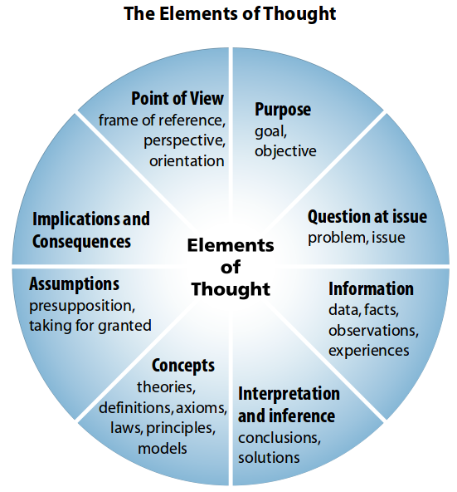
(Mormon Transhumanist Association, 2016)

Source: Mormon Transhumanist Association (2016) ‘I am a critical thinker!’ [online] Available at: <http://www.transfigurist.org/2016/06/im-critical-thinker.html>

- PICOC – define focused question
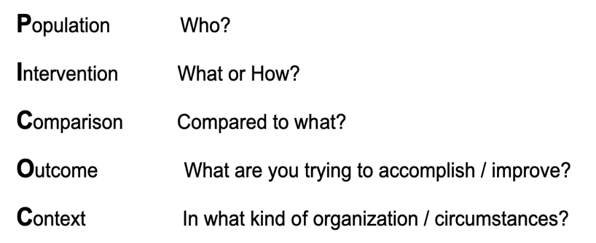
(CEBMa n/a)

Source: CEBMa (n/a) ‘What is a PICOC?’ [online] Available at:https:<//www.cebma.org/faq/what-is-a-picoc/>

- Types of search strategy
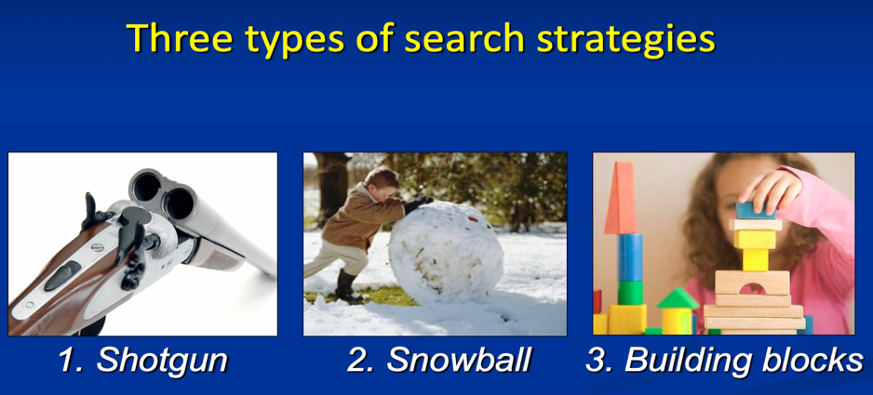
(Griffin 2020)

Source: Griffin, D. (2020) ‘Searching for scientific evidence.’ (ppt) UWTSD

- Literature review process.
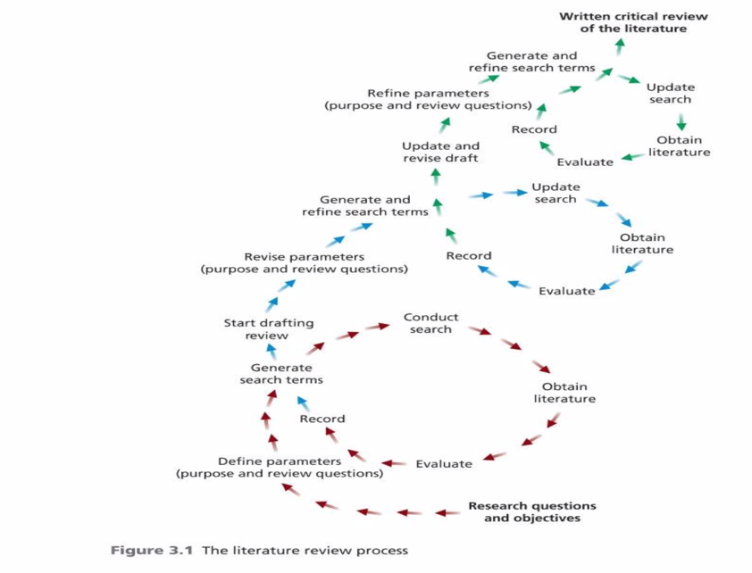
(Saunders et al. 2016)

Source: Saunders, M., Lewis, P., Thornhill, A. (2016) Research method for business student (7th Edition). England. Pearson.

- Literature review structure
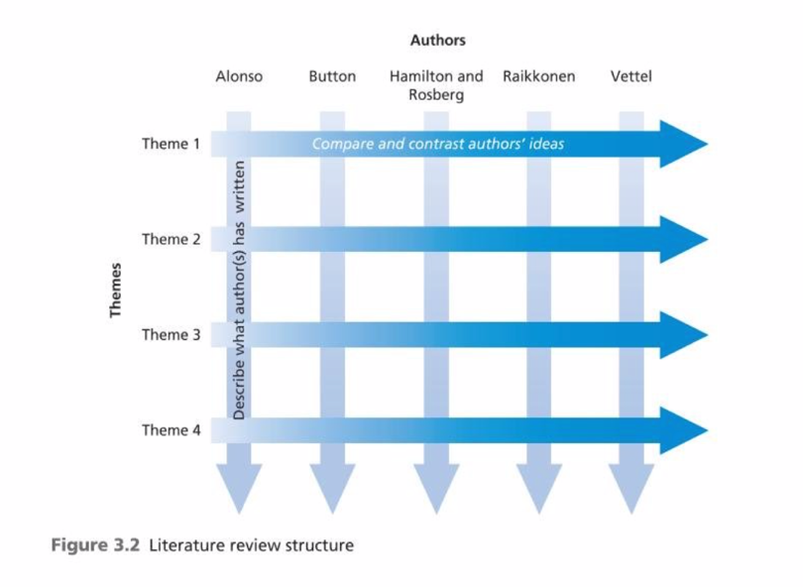
(Saunders et al. 2016)

Source: Saunders, M., Lewis, P., Thornhill, A. (2016) Research method for business student (7th Edition). England. Pearson.

Appendix 4: Personal self-development activities.
After the lectures regarding critical thinking/reading and evaluating various sources and information, I took note and looked back to revise how I had been working on my previous pieces of research.

One of the most fundamental things that I could recognize was that my way of thinking should change, I now should think at a DBA – candidate level – to enhance my current work and to leverage my future research projects into the greatest level that I could achieve.

Previously, I did not realize the importance of always being curious and asking as many and as good questions that I could. As a result, when it came to evaluating the existing research papers or debates in the field, I did not do it quite right and properly. I might still consider the accuracy, currency, coverage, authority or objectivity of the sources, however, I skipped asking such the crucial questions as: ‘Does this make sense?’ ‘Is that reliable way that the author utilizes to measure something in his research?’ or ‘How it would contribute to the exploration of the key findings in my research?’. Therefore, I used to be not really good critical thinker and researcher. It led to the facts that the quality of my research would not be as good as I expected and I did think that the mark itself could reveal all based on my previous transcript.

My plan is to keep up with my reflexivity notebook, revise and adjust day by day to see how I have grown up from the scratch of this DBA journey and how it helps me to overcome my weaknesses and narrowness through the improvement in my work.
I make a practical plan for each of the work that I need to focus on: the mission, the deadline, and the proper approach to achieve the goal so I could control the workload and time framework for my assessments. In addition, I feel a lot more confident working on the 2 assessment at this current time knowing that I could be able to evaluate and choose the valuable and reliable sources to form my pieces of research stemming from the better reading & thinking skills.

Entry 3: The contribution of research to knowledge and organizational development

The contribution of research to academic & practical knowledge
The contribution of research plays a crucial role to both academic and practical knowledge (European Commission et al. 2017) . Nyhan (2002) pointed out that the ‘the nature of knowledge and its development’ is aimed to portrait the different dimension of knowledge society such as knowledge production, research, education, learning and innovation activities.

Different types of studies which explore the in-depth insights by negotiating diverse boundaries in knowledge (Gaztambide-Fernández 2011) could be considered as a primary element of knowledge-production within the complex network and existing power structure such as university or organization (Gunter 2002). Nevertheless, the knowledge transferred from research could link to the innovation, research and development investment in any industry or economic sector (Committee of the Regions 2009). As a result, it would actively enable society or individuals in society to achieve political, economic and social goals (Nyhan 2020).

The contribution of business and management research to organizational development
Saunders et al. (2016) clarified the definition of research as the systematic process to discover the key findings in the relevance field of knowledge. In more details, business and management research is argued that not only contribute to the advanced knowledge and understanding but also to address business issues and practical managerial problems (Saunders et al. 2016). Ungar et al. (2015) referred PAR (participatory action research) as an ideal approach to research and evaluation because it supports the researcher to establish the connection with the participants with knowledge and invite them to reflect on what they know about the research topic.

Raymaker (2016) mentioned community based participatory research (CBPR) as a core instrument through the focus on community to lead research into action and equitability of partnership. In another research regarding the importance of managerial research to career guidance, Hug and Plant (2016) cited that: “Systematic reviews of randomized controlled trials (RCT) have become the preferred source of research in medicine “for judging whether a treatment does more good than harm” (Sackett et al. 1996, p. 71)”.”

Boisot (1999) indicated that the exploration into the knowledge-based competition might have the significant impacts on the organization’s strategic plan in term of product-markets or industry players. To sum up, Marin Ferrer et al. (2017) claimed the importance of the relevant scientific research to the decision-makers and practitioners in the attempt to recognise knowledge gaps and formulate the suitable approaches to the sustainable, smart and inclusive growth.

Possible gaps and limitation
Thompson (2003) pointed out that one of the relevance gaps in research is the lack of attention to the education or training for the researchers regarding the insufficient resources or design of surveys. Another issue was presented as because of the misuse of the term ‘theory’ in management field, it leads to the rejection of the potential pieces of research which might prevent the contribution to the science of organization (Shaphira 2011).
Learmonth (2008) argued about the drawback of ‘evidence based management’ in organizational studies that the process could merely be considered as the technical and scientific task. To an extent, the questions as such: “What counts as evidence; what organizational practices evidence might ethically and politically inform; what interests different evidence supports and denies.” might just draw the radical disputes (Learmonth 2008).
Furthermore, limitation regarding the researcher’s own bias when coping with unfamiliar and complex contexts is believed that could have considerable impacts on the analysis of the research project (Poos et al. 2017).

Appendix 1: List of useful academic sources.
Boisot, M.H. (1999) ‘Knowledge Assets: Securing Competitive Advantage in the Information Economy.’ Oxford University Press.

Committee of the Regions ; Metis Gmbh. (2009) ‘Knowledge and innovation.’ Brussels]: CoR.

European Commission ; Directorate-General for Education Culture ; Q-Plan International ; University of Manchester ; University of Twente ; Ingenio ; University of Rome (2017) ‘Measuring the contribution of higher education to innovation capacity in the EU study.’ Luxembourg: Publications Office.

Gaztambide-Fernández, R., Cairns, K., Kawashima, Y., Menna, L. & VaderDussen, E. (2011) ‘Portraiture as Pedagogy: Learning Research through the Exploration of Content and Methodology.’ International Journal of Education & the Arts. 2011, Vol.12 (4), 1-30

Gunter, M., H. (2002) ‘Purposes and Positions in the Field of Education Management: Putting Bourdieu to Work.’ Educational Management & Administration, 30(1), 7-26.

Haug, H., E., & Plant, H. (2016) ‘Research-based knowledge: Researchers’ contribution to evidence-based practice and policy making in career guidance.’ International Journal for Educational and Vocational Guidance, 16(1), 137-152.

Learmonth, M. (2008) ‘Speaking Out: Evidence-Based Management: A Backlash Against Pluralism in Organizational Studies?’ Organization 15, no. 2 (2008): 283-91.

Marin Ferrer, M., Poljanšek, K., De Groeve, T., & Clark, I. (2017) ‘Science for disaster risk management 2017 knowing better and losing less.’ (EUR (Luxembourg. Online), 28034). Luxembourg: Publications Office.

Nyhan, B. (2002) Taking steps towards the knowledge society : Reflections on the process of knowledge development. Luxembourg: Publications Office.

Poos, J., Van Den Bosch, K., & Janssen, C. (2017) ‘Battling bias: Effects of training and training context.’ Computers & Education,111, 101-113.

Raymaker, D. (2016) ‘Intersections of Critical Systems Thinking and Community Based Participatory Research: A Learning Organization Example with the Autistic Community.’ Systemic Practice and Action Research, 29(5), 405-423

Shapira, Z. (2011) ‘"I've Got a Theory Paper—Do You?": Conceptual, Empirical, and Theoretical Contributions to Knowledge in the Organizational Sciences.’ Organization Science, 22(5), 1312-1321.

Saunders, M., Lewis, P., Thornhill, A. (2016) Research method for business student (7th Edition). England. Pearson.

Thompson, H., G., A. (2003) ‘Questioning practices in health care research: The contribution of social surveys to the creation of knowledge.’ International Journal for Quality in Health Care, 15(3), 187-188.

Ungar, M., Mcgrath, P., Black, D., Sketris, I., Whitman, S., & Liebenberg, L. (2015) ‘Contribution of participatory action research to knowledge mobilization in mental health services for children and families.’ Qualitative Social Work, 14(5), 599-615.

Appendix 2: List of useful websites, links to code of practices/advices…
- Demonstrating research impact.
https://www.vitae.ac.uk/doing-research/leadership-development-for-principal-investigators-pis/intellectual-leadership/demonstrating-research-impact

- Expanding the contribution of the social sciences to social-ecological resilience research.
https://www.ecologyandsociety.org/vol23/iss1/art41/

- 4 ways you can contribute to the body of knowledge:
https://nairaproject.com/blog/ways-to-contribute-to-the-body-of-knowledge.html

- How research is creating new knowledge and insight:
https://nairaproject.com/blog/ways-to-contribute-to-the-body-of-knowledge.html

- Types of contributions in the research paper:
https://www.linkedin.com/pulse/types-contributions-research-paper-ali-asgari/

- A ‘contributions’ approach to impact:
https://blogs.lse.ac.uk/impactofsocialsciences/2015/09/01/a-contributions-approach-to-impact/

Appendix 3: Any useful quotations, frameworks, tables.
- ‘I grew up thinking that a research scientist was a natural thing to be.’ – Stephen Hawking

- Locke’s definition and kinds of knowledge
“The culmination of the Essay is Book IV, where Locke weaves together strands of the previous three Books into a comprehensive theory of knowledge. The heart of the theory is contained in chapters i–iv, xi, xii, and xiv–xvi. Chapter i, “Of Knowledge in General,” begins with this definition of knowledge (which Locke calls “knowledge in general,” because he goes on to partition knowledge into four kinds): “Knowledge [is] nothing but the perception of the connexion and agreement, or disagreement and repugnancy of any of our ideas. In this alone it consists” (IV.i.1:525:5–7; cf. IV.iii.1:538:25–26). Later, Locke says that “our knowledge [consists] in the perception of the Agreement, or Disagreement of any two Ideas” (IV.iii.15:538:10–11; cf. IV.ii.4:532:35, IV.ii.7:534:6). This is a little odd, since the later definition restricts the agreement/disagreement to two ideas, whereas the initial one does not. So does Locke mean “at least two ideas?” No, for he also says that “the Mind . . . perceives each Idea to agree with it self [my italics] (IV.i,4:526:6–7).” Locke makes no attempt to clear up this ambiguity, perhaps because (a) many of the instances of knowledge he will discuss, notably those attributing a property to a substance, invoke two ideas (a complex idea of the substance and a simple or a complex idea of a property), and (b) he does not think that instances involving more than two ideas raise any additional issues of principle.”
Souce: Dicker, G. (2019). Locke on Knowledge and Reality: A Commentary on An Essay Concerning Human Understanding. Oxford University Press.

- Research to outcome and to impact pathway.
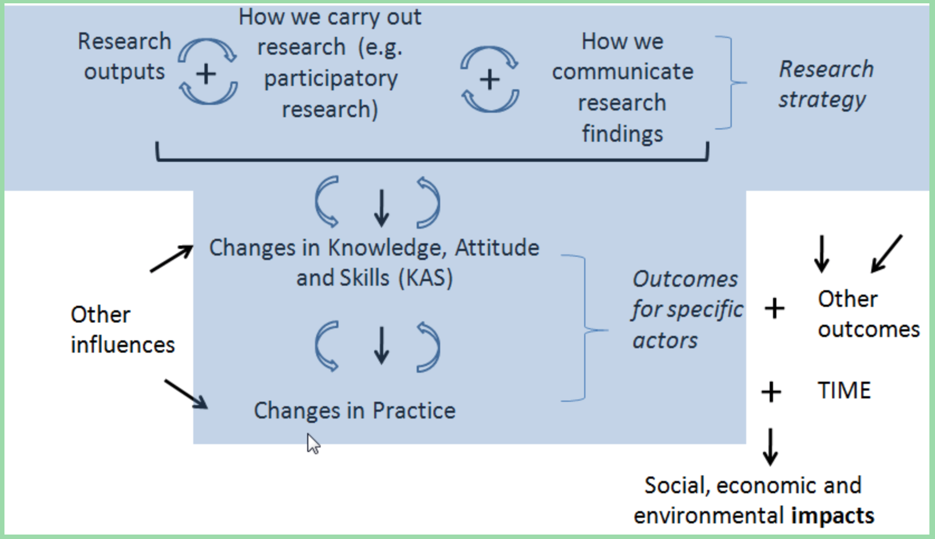
(CGIAR n/a)
Source: CGIAR (n/a) ‘Research to outcome and to impact pathway.’ [online] Available at: < https://sites.google.com/a/cpwf.info/m-e-guide/background/theory-of-change/research-to-outcome-to-impact-pathway>

- Enhancing knowledge base to support disaster risk management framework.
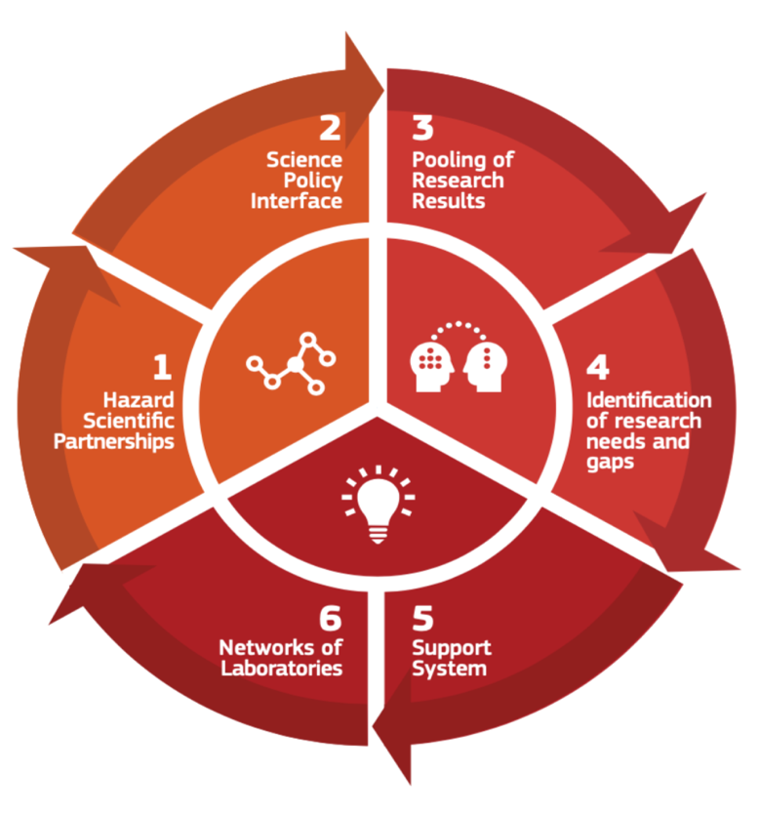
(Marin Ferrer et al. 2017)

Source: Marin Ferrer, M., Poljanšek, K., De Groeve, T., & Clark, I. (2017). Science for disaster risk management 2017 knowing better and losing less. (EUR (Luxembourg. Online), 28034). Luxembourg: Publications Office.

- Relevance gap in relation to managerial knowledge.
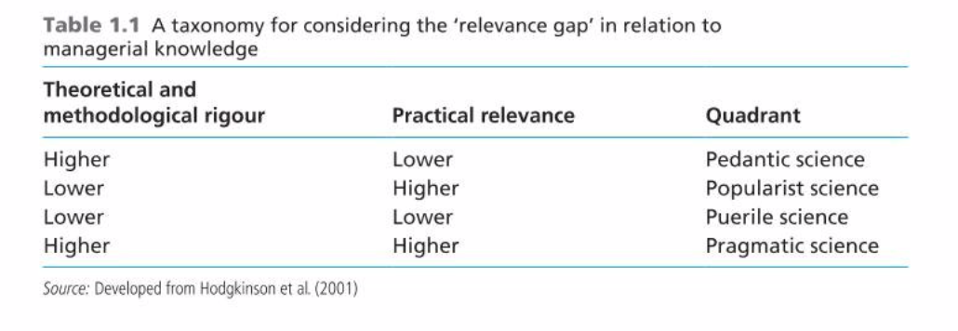
(Saunders et al. 2016)

Source: Saunders, M., Lewis, P., Thornhill, A. (2016) Research method for business student (7th Edition). England. Pearson.

- The difference between basic and applied research.
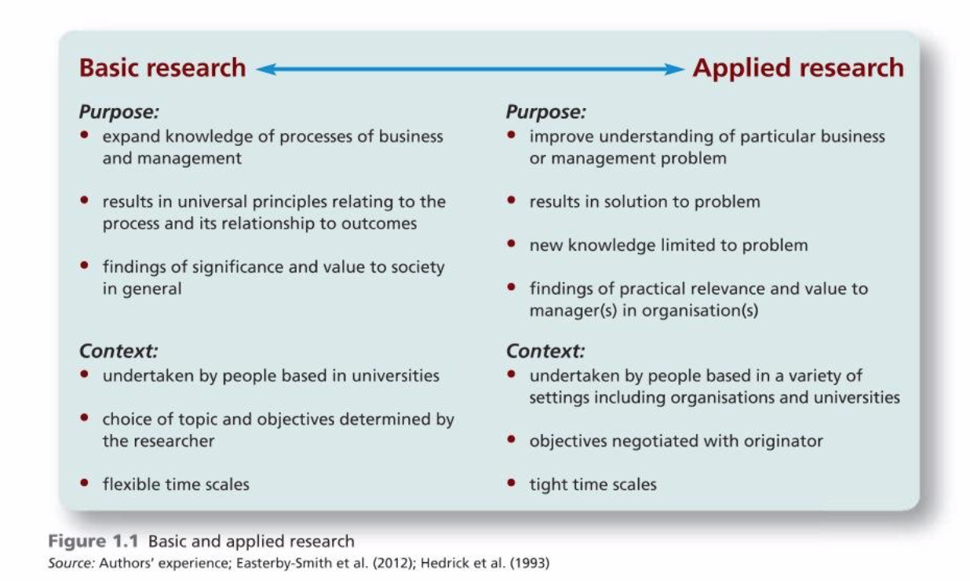
(Saunders et al. 2016)

Source: Saunders, M., Lewis, P., Thornhill, A. (2016) Research method for business student (7th Edition). England. Pearson.

Appendix 4: Personal self-development activities.
When it comes to evaluate the contribution of research to knowledge and organizational development, I recognize the importance of indicating this crucial aspect in any piece of research and made a decision to include it in the research proposal preparing for my 1st assessment as the practice for what I have learned so far.

Regarding my intended research project is about the relation between leadership style, I feel the need to consider the contribution of the research in both academical and practical context.
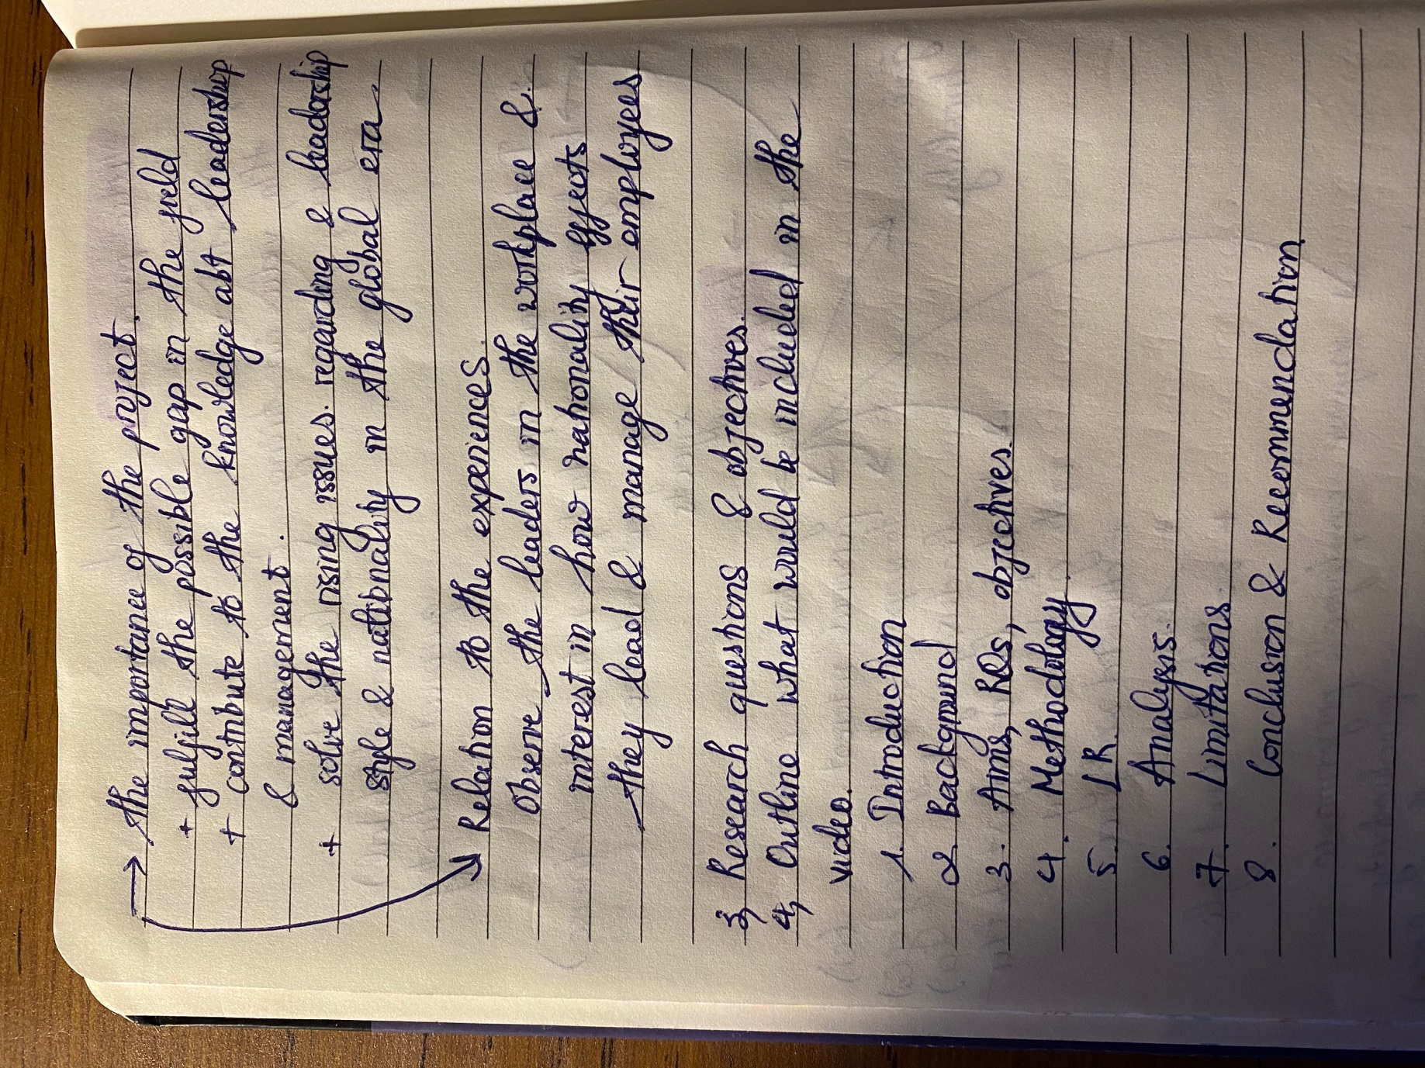

Entry 4: Defining the research question
The importance of defining research question.

Bryman (2007) stated that research question is one of most crucial steps of any research project. Research question accounts for the issues that the researcher aims to solve in the research project (Hart 2003). In addition, research question is believed to influence every single step of the research procedure (Stone 2002) from choice of research paradigm, literature review to research method (Saunder et al. 2016).

Walker & Davidson (2016) indicated that the first step of the research project is to form the right research question. Anastasiadis et al. (2015) claimed that research question will shape the way that the researcher would write the report. The researcher could distinguish the different types of research question as: descriptive, correlational or experimental (O’brien & Desisto 2013). Hällgren (2012) claimed that research question could identify gaps and extend literacy knowledge rather than challenge the theoretical assumptions.

Research question has the close connection with research aim and research objectives (Doody & Bailey 201). Research aim could be considered as the brief statement of the purpose of the research (Saunders et al. 2016) so that good research question will contribute to the clarification for the research aim (Doody & Bailey 2016). After that, the research objectives could be revealed to answer for the issues that are drawn from the research questions (Hunt et al. 2018).

How to formulate the good research question
Nevertheless, defining the good research question would have the significant impact on the quality of the research project (Lim 2014). There are some of the required elements to evaluate whether the research question is on point or not such as: manageable & feasible (O’brien & Desisto 2013), substantial & original, clear (Van Iddekinge et al. 2012) and interesting (Anastasiadis et al. 2015) & essentials (Caroline 2020)

Palaskar (2017) suggested to apply PICO framework as: ‘P: Patient, problem, or population; I: Intervention; C: Comparison and O: Outcome’ to form the well-built research question. Mantzoukas (2008) indicated that to formulate the right reseach question, the researcher should address the ‘What, When, Where, Who, Why and How’ of the research in the research question.
Possible limitation
There are 4 types of elements which is believed that could limit the research questions identified by Tarozzi (2013) as following:
- Paradigmatical constraints.
- Sponsor-related constraints.
- Ethical-political constraints. The researcher’s values that imply judgments on the reality to be investigated, which exceed the empirical inquiry.
- Organizational constraints. Time and human or financial resources that shape the scope and the extent of the research project.
Furthermore, Nutefall & Ryder (2010) pointed out that some of the researchers might fall into the trap of wrong timing for research question, starting too early that leads to the result of false focus. In addition, the researcher needs to consider carefully about the impacts of their own bias on the choice of interest topic (Denscombe 2012) which might threaten the formulation of good research question. Solutions for these problems vary, however, it could be suggested that a thorough field research and precise plan might help the researcher to identify not only the good research question but also how to mitigate the possible risks to the outcome of the research (Wyatt & Guly 2002).

Appendix 1: List of useful academic sources.
Anastasiadis, E., Rajan, P., & Winchester, C. (2015) ‘Framing a research question: The first and most vital step in planning research.’ Journal of Clinical Urology, 8(6), 409-411.

Bryman, A. (2007) ‘The Research Question in Social Research: What is its Role?’ International Journal of Social Research Methodology, 10(1), 5-21.

Denscombe, M. (2012) ‘Research proposals a practical guide (Open UP study skills).’ Berkshire, Eng. ; New York: McGraw Hill Open University Press.

Doody, O., & Bailey, M. (2016) ‘Setting a research question, aim and objective.’ Nurse Researcher (2014 ), 23(4), 19-23.

Hart, A. (2003) ‘What is the research question?: A case study in the early stages of design of a randomised controlled trial for a complementary therapy.’ Complementary Therapies in Medicine, 11(1), 42-45.

Hällgren, M. (2012) ‘The construction of research questions in project management.’ International Journal of Project Management, 30(7), 804-816.

Hunt, H., Pollock, A., Campbell, P., Estcourt, L., & Brunton, G. (2018) ‘An introduction to overviews of reviews: Planning a relevant research question and objective for an overview.’ Systematic Reviews, 7(1), 39.

Lim, J. (2014) ‘Formulating research questions in experimental doctoral dissertations on Applied Linguistics.’ English for Specific Purposes, 35(C), 66-88.

Mantzoukas, S. (2008) ‘Facilitating research students in formulating qualitative research questions.’ Nurse Education Today, 28(3), 371-377.

Nutefall, J., & Ryder, P. (2010) ‘The Timing of the Research Question: First-Year Writing Faculty and Instruction Librarians' Differing Perspectives.’ Portal: Libraries and the Academy, 10(4), 437-449.

O’brien, J., M., & Desisto, C.,M. (2013) ‘Every Study Begins With a Query: How to Present a Clear Research Question.’ NASN School Nurse,28(2), 83-85.

Palaskar, J., 2017 ‘Framing the research question using PICO strategy.’ Journal of Dental & Allied Sciences, 6(2), pp. 55.

Stone, P. (2002) ‘Deciding upon and refining a research question.’ Palliative Medicine,16(3), 265-267.

Tarozzi, M. (2013) ‘How Does My Research Question Come About? The Impact of Funding Agencies in Formulating Research Questions.’ The Qualitative Report, 18(51), 1-11

Van Iddekinge, C., Roth, P., Raymark, P., & Odle-Dusseau, H. (2012) ‘The critical role of the research question, inclusion criteria, and transparency in meta-analyses of integrity test research: A reply to Harris et al. (2012) and Ones, Viswesvaran, and Schmidt (2012).’ Journal of Applied Psychology, 97(3), 543-549.

Walker, S., & Davidson, A. (2016) ‘The big research question: Who decides?’ Paediatric Anaesthesia, 26(9), 862-863.

Wyatt, J., & Guly, H. (2002) ‘Identifying the research question and planning the project.’ Emergency Medicine Journal : EMJ, 19(4), 318-31821

Appendix 2: List of useful websites, links to code of practices/advices…
- Developing strong research question:
https://www.scribbr.com/research-process/research-questions/
- Too big, too small, just right: Design thinking and the Goldilocks protocol:
https://medium.com/@sbberk11/too-big-too-small-just-right-design-thinking-and-the-goldilocks-protocol-6ee273567437
- Core skill for new researcher: How to develop the good research question:
https://methods.sagepub.com/video/core-skills-for-new-researchers-how-to-develop-a-good-research-question
- How to write a research question:
https://writingcenter.gmu.edu/guides/how-to-write-a-research-question
- Examples of good and bad research questions:
https://examples.yourdictionary.com/examples-of-good-and-bad-research-questions.html
- The art of asking question:
https://hbr.org/2011/08/the-art-of-asking-questions.html

Appendix 3: Any useful quotations, frameworks, tables
- Definition of research question.
Research questions, sometimes termed operational or investigable questions, are a subset of questions that can be subjected to investigation. What kinds of questions might be sub- jected to investigation? Dillon (1984) reviewed different classification schemes for research questions and suggested one based on the order of the information that an answer to that question would yield. According to Dillon, a question is classified as a first-order question if it relates to a single phenomenon or variable, a second-order question if it compares two variables, and a third-order question if it asks about the causal relationships between two or more variables (also see below).

Source: Hasson, E., & Yarden, A. (2012) ‘Separating the Research Question from the Laboratory Techniques: Advancing High-School Biology Teachers' Ability to Ask Research Questions. ‘Journal of Research in Science Teaching,49(10), 1296-1320.

- Characteristic of a good research question – FINER.

“F” – Feasible
One should consider whether the research question is feasible in terms of adequate numbers of patients, participants or samples, sufficient time and research funding to successfully complete the study. In addition, you need to consider the methodology you will employ, as this will impact on how you ask the research question.

“I” – Interesting
It is important that the research question is interesting to the researcher and to the wider scientific and clinical community. Interesting research questions may also help with recruiting patients and engaging patient support groups.

“N” – Novel
Through the thorough literature review, the current body of evidence will be defined. The research question should seek to confirm, refute or extend previous findings, and potentially reveal new findings.

“E” – Ethical
It is imperative that the research question can be answered in an ethical manner. Adhering to research governance principles is necessary for study designs to be granted approval by ethics committees as well as institutional boards (e.g. National Health Service Research and Development (NHS R&D)).

“R” – Relevant
The research question should be relevant to current scientific and clinical knowledge on the subject, strive to influence clinical practice or health care policy, and lead to future research.

Source: Anastasiadis, E., Rajan, P., & Winchester, C. (2015) ‘Framing a research question: The first and most vital step in planning research’ Journal of Clinical Urology, 8(6), 409-411.

- Type of quantitative research question.
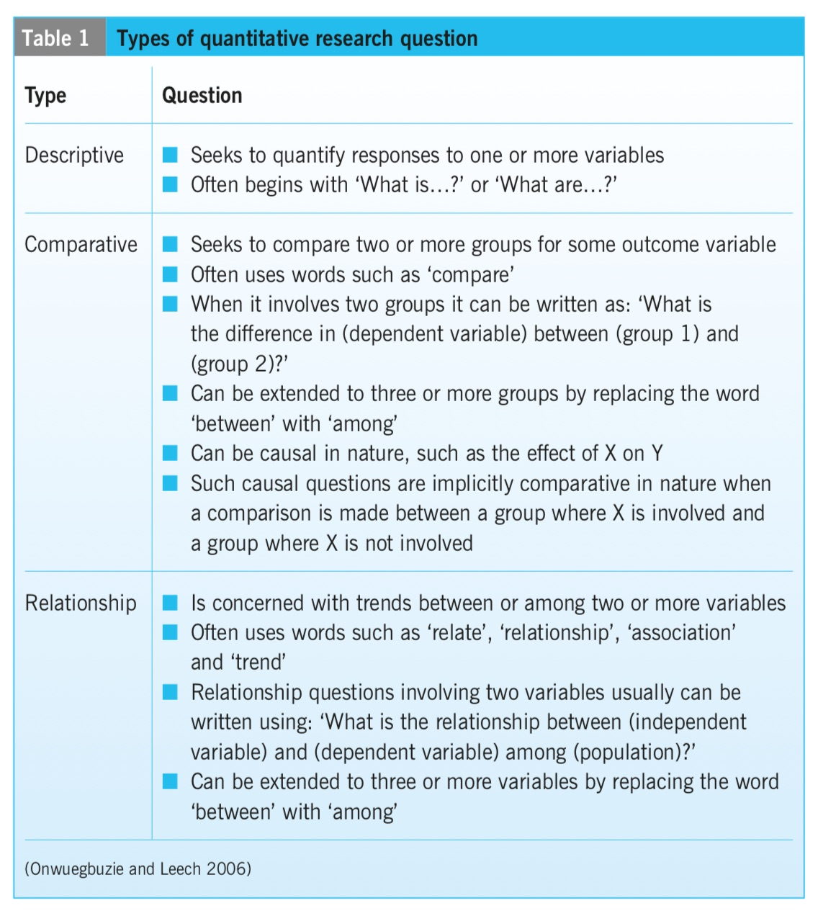
(Doody & Bailey 2016)

Source: Doody, O., & Bailey, M. (2016) ‘Setting a research question, aim and objective.’ Nurse Researcher (2014 ), 23(4), 19-23.

- Framework for formulating the interesting marketing research question.
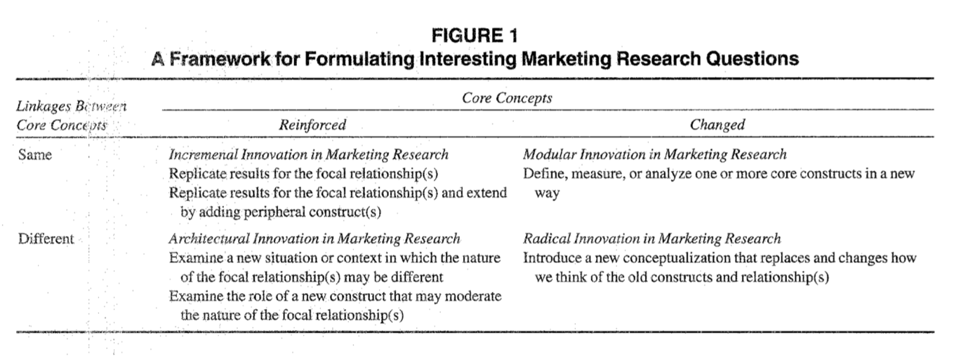
(Voss 2003)

Source: Voss, G. (2003) ‘Formulating interesting research questions.’ Journal of the Academy of Marketing Science, 31(3), 356-359.

- “The "right choice" of subject pool depends on the research question. If the researcher is interested in understanding behavioral variation between particular groups of people, then the right choice is running experiments with these people.”

Source: Gächter, S. (2010). ‘(Dis)advantages of student subjects: What is your research question?’ Behavioral and Brain Sciences,33(2-3), 92-3.

Substruction

“In this article, substruction is treated as a method of bringing into bas relief the theoretical foundations of a study and connecting the structural elements to visible representations of theory, measure- ment, and analysis. Using substruction as a heuristic device in proposal development helps neophytes and seasoned investigators to describe more explicitly the theoretical and methodological framework of studies.”

Source: Wolf, Z., & Heinzer, M. (1999) ‘Substruction: Illustrating the Connections from Research Question to Analysis.’ Journal of Professional Nursing, 15(1), 33-37.

- Research onion.
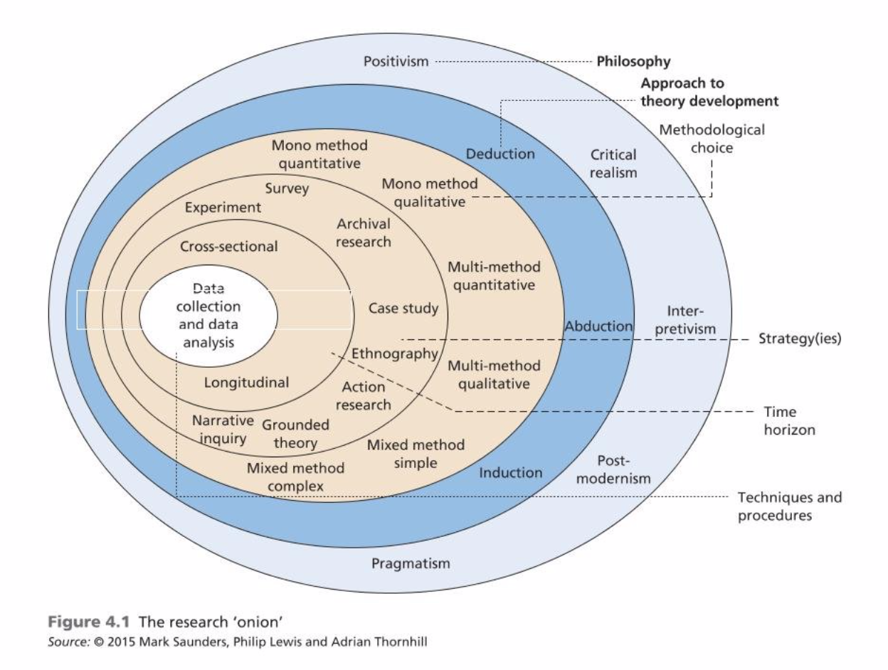
(Saunders et al. 2016)

Source: Saunders, M., Lewis, P., Thornhill, A. (2016) Research method for business student (7th Edition). England. Pearson.

Appendix 4: Personal self-development activities.
Comprehending the importance of forming the right research question to get any research paper thoroughly accomplished, I practice my skills by taking each of the entry assessment as one small project that I need to achieve.

The plan is I would identify the core issues that I am required to address in each entry and how I am going to represent them. By that preparing step, I could define the research questions for each entry. As a result, all the problems are outlined and planned to be analysed critically with the suitable and relevant set of examples and frameworks. Furthermore, it also helps me to mitigate the possibilities of the possible lack of any required information in each entry.
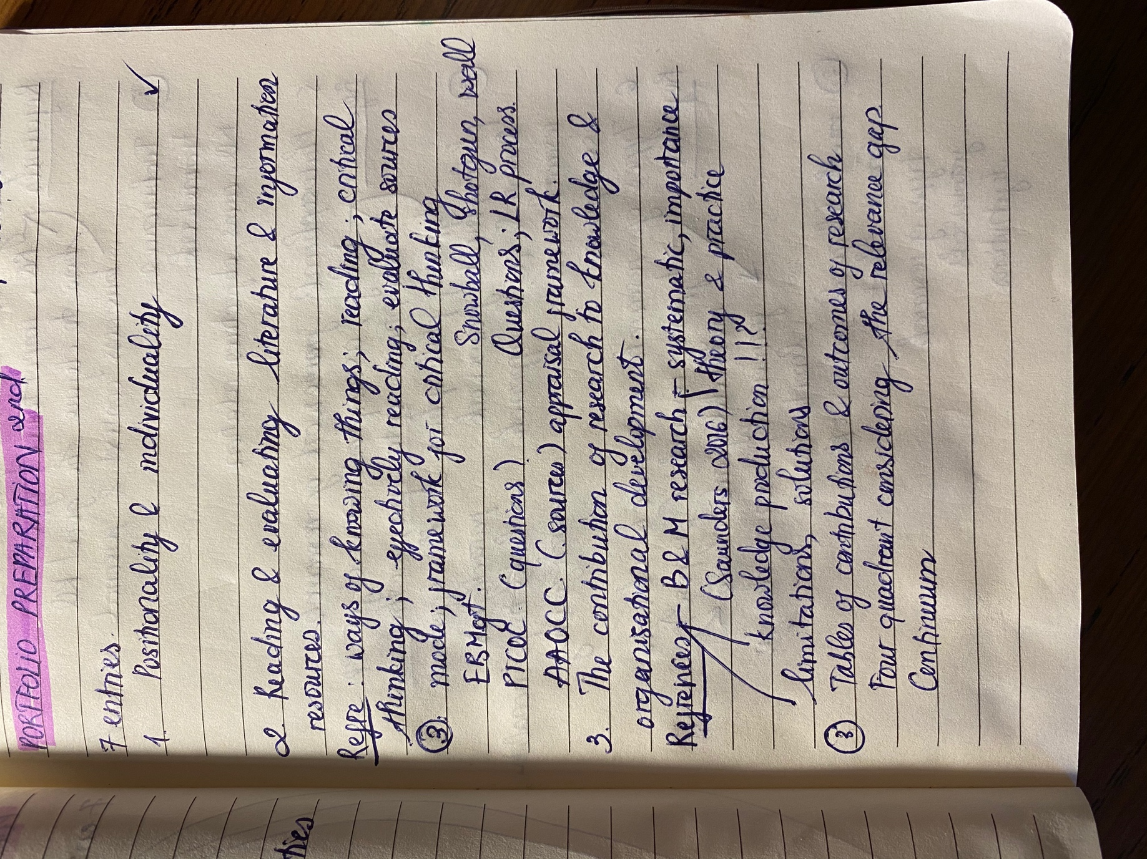

:

Entry 5: Philosophical frameworks for research

Research philosophy

It could be considered as research philosophy stands for a system of beliefs and assumptions regarding the development of knowledge (Saunders et al. 2006). Floridi (2011) found out the vital insight as philosophy itself consists of conceptual studies whose essential nature is neither empirical nor logico-mathematical. Pallesen (2017) pointed out that understanding the nature of ‘becoming and movement’ is the primary when it comes to the process of philosophy.

A statement of the French philosopher – Henri Bergson provided a further explanation that understanding the difference between quantitative and qualitative multiplicity is important to comprehend the order of reality that characterizes movement (Pallesen 2017). Pajares (1992) stated that when the specified beliefs are precisely operationalized with the appropriate choice of methodology and have the well-constructed design, the study will become viable and rewarding.

Matiz and Chaerki (2018) shined a light on the importance of research philosophy as it has considerable impacts on the way the research will be conceptualized, interpreted & analysed and also how the researcher might establish new rules or practices at the same time. Nevertheless, it results in the potential to facilitate ‘the generation of new knowledge, the formation of pluralist alliances, education and self-development, the building of democratic capacity and the power to drive political action’ (Harney et al. 2016).

Ontology – Epistemology – Axiology
Saunders et al. (2016) clarified 3 types of assumptions to classify research philosophies as: ontology, epistemology and axiology. While ontology stands for the nature of reality, epistemology raises a concern regarding how knowledge would be communicated and known, and axiology might represent the role of values and ethics in research process (Saunders et al. 2016). To an extent, Turk (2006) mentioned that in ontologies, we deal with things, properties, kinds and laws; and ontology is referred to what kinds of thing that the research method will build models of (Mingers 2003). Epistemology could be defined as an answer to the question: ‘How do we know what we know?’ by the frameworks of ideas that guide our way of thinking (Zakus et al. 2007). For further clarification, axiology addresses the questions in term of the notion of theory of value which could be classified into 8 different types such as: material and physical value; economic value; moral value; social value; political value; aesthetic value; religious value; and intellectual value (Biedenbach & Jacobsson 2016).
Different types of research paradigm

Pansiri (2009) stated the simple yet clear explanation of research paradigm as it represents different view of the social world based on different meta-theoretical assumptions in relation to the nature of science and society. It is argued that there are five types of research paradigm as such: post-positivist, positivist, interpretivist, advocacy/ participatory, constructivist and pragmatist (Azzopardi & Nash 2014). Ontologically, positivism refer to the assumption of a single objective reality, while interpretivism assumes that people create their own subjective meanings from their experiences (Petty et al. 2012).

Constructivist, on the other hand, is believed to have the combination of all the aspects of positivist and interpretivist (Levers 2013). However, interestingly, pragmatism paradigm could be considered as an alternative methodological option to the rest four paradigms (Azzopardi & Nash 2014). In the pragmatism, the ideal practical solutions to the problems are at the core rather than anything else (Azzopardi & Nash 2014).

Furthermore, research paradigms could also be classified into quantitative purist (pretty as same as positivist) and qualitative purist (as equal as interpretivist and constructivist) (Burke & Onwuegbuzie 2004). Additionally, there is also a rising debates about the effectiveness of a so-called mix method approach (Haverkamp et al. 2005). Denscombe (2008) revealed that pragmatism is generally considered as a philosophical partner of mix method approach, however, mixed-method approach does not actually operate on the basis, of agreed visions of pragmatism.

Appendix 1: List of useful academic sources.
Azzopardi, E. & Nash, R. (2014) ‘AN EXAMINATION OF PHILOSOPHICAL PARADIGMS AND A RATIONALE FOR ADOPTING A MIXED METHODS APPROACH.’ Tourism Analysis 19, no. 2: 151-60.

Burke, R.J & Onwuegbuzie, J., A. (2004) ‘Mixed Methods Research: A Research Paradigm Whose Time Has Come.’ Educational Researcher 33, no. 7: 14-26.

Biedenbach, T., & Jacobsson, M. (2016) ‘The Open Secret of Values: The Roles of Values and Axiology in Project Research.’ Project Management Journal 47, no. 3: 139-55.

Denscombe, M. (2008) ‘Communities of Practice: A Research Paradigm for the Mixed Methods Approach.’ Journal of Mixed Methods Research 2, no. 3 (2008): 270-83.

Floridi, L. (2011) The Philosophy of Information. Oxford University Press.

Harney, L., Mccurry, J., Scott, J., & Wills, J. (2016) "Developing ‘process Pragmatism’ to Underpin Engaged Research in Human Geography." Progress in Human Geography 40, no. 3 (2016): 316-33.

Haverkamp, B., Morrow, S. and Ponterotto, J. (2005) ‘A Time and Place for Qualitative and Mixed Methods in Counseling Psychology Research.’ Journal of Counseling Psychology 52, no. 2 (2005): 123-25.

Levers, D., M. (2013) ‘Philosophical Paradigms, Grounded Theory, and Perspectives on Emergence.’ SAGE Open 3, no. 4: SAGE Open, 16 December 2013, Vol.3(4).

Matitz, S., R., Q. & Chaerki, F., K. (2018) ‘Process Philosophy’s Potential Contributions to Innovation Process Research within Organization Studies.’ RAI 15, no. 4 (2018): 386-93.

Mingers, J. (2003) ‘A Classification of the Philosophical Assumptions of Management Science Methods.’ The Journal of the Operational Research Society 54, no. 6: 559-70.

Pajares, F., M. (1992) ‘Teachers' Beliefs and Educational Research: Cleaning up a Messy Construct.’ Review of Educational Research62, no. 3: 307-32.

Pansiri, J. (2009) ‘Evolution of a Doctoral Thesis Research Topic and Methodology: A Personal Experience.’ Tourism Management30, no. 1: 83-89.

Pallesen, E. (2017) ‘Documenting the Invisible – on the ‘how’ of Process Research: (Re)considering Method from Process Philosophy.’ Methodological Innovations 10, no. 3 (2017): Methodological Innovations, December 2017, Vol.10(3).

Petty, J., N., Thomson, P., O. & Stew, G. (2012) ‘Ready for a Paradigm Shift? Part 1: Introducing the Philosophy of Qualitative Research.’ Manual Therapy 17, no. 4: 267-74.

Rapport, F. & Braithwaite, J. (2018) ‘Are We on the Cusp of a Fourth Research Paradigm? Predicting the Future for a New Approach to Methods-use in Medical and Health Services Research.’ BMC Medical Research Methodology 18, no. 1 (2018): 131.

Saunders, M., Lewis, P., & Thornhill, A. (2016) ‘Research method for business student’ (7th Edition). England. Pearson.

Turk, Ž. (2006). ‘Construction Informatics: Definition and Ontology.’ Advanced Engineering Informatics 20, no. 2: 187-99.

Zakus, H., D., Malloy, C., D., & Edwards., A. (2007) ‘Critical and Ethical Thinking in Sport Management: Philosophical Rationales and Examples of Methods.’ Sport Management Review 10, no. 2 (2007): 133-58.

Appendix 2: List of useful websites, links to code of practices/advices…
- How to select a research paradigm?
http://researcharticles.com/index.php/how-to-select-a-research-paradigm/

- How to choose the research methodology best suited for your study:
https://www.editage.com/insights/how-to-choose-the-research-methodology-best-suited-for-your-study

- Choosing quantitative or qualitative research methodologies:
https://www.macmillanihe.com/studentstudyskills/page/choosing-appropriate-research-methodologies/

- The role of philosophy and philosophers in the Corona virus pandemic:
https://dailynous.com/2020/03/27/role-philosophy-philosophers-coronavirus-pandemic/

- How evolution build genes from scratch:
https://www.nature.com/articles/d41586-019-03061-x

- What makes science ‘trustworthy’?
http://bostonreview.net/science-nature-philosophy-religion/philip-kitcher-what-makes-science-trustworthy

- Science will not come on a white horse with a solution:
https://www.thenation.com/article/society/sheila-jasanoff-interview-coronavirus/

- A threat to the quality of academic research in France:
http://dailynous.com/2020/01/09/threat-quality-academic-research-france-guest-post-philippe-huneman/

- What is Scottish government’s guiding philosophy?
https://www.bbc.co.uk/news/uk-scotland-scotland-politics-51547587
Appendix 3: Any useful quotations, frameworks, tables
- Aristotle’s ontology
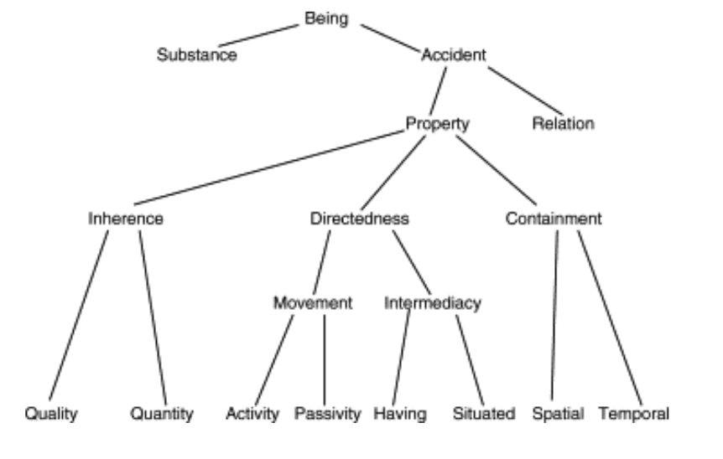
(Turk 2006)

Source: Turk, Ž. (2006) ‘Construction Informatics: Definition and Ontology.’ Advanced Engineering Informatics 20, no. 2 (2006): 187-99.

- The paradigms of research
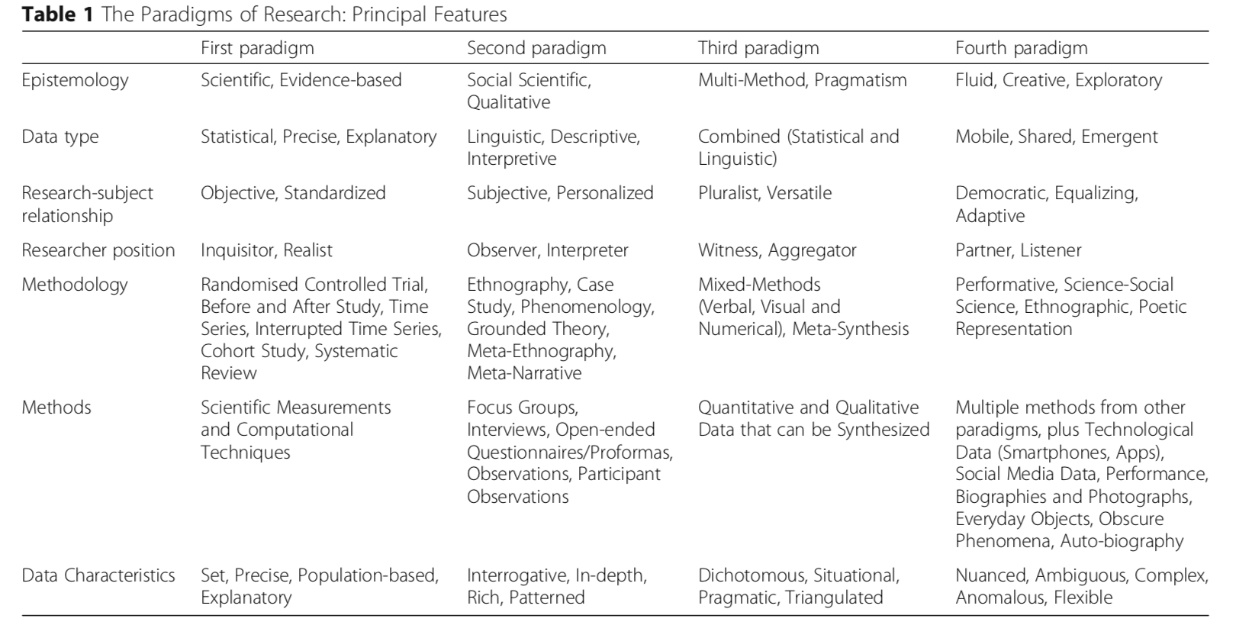
(Rapport & Braithwaite 2018)

Source: Rapport, F. & Braithwaite, J. (2018) ‘Are We on the Cusp of a Fourth Research Paradigm? Predicting the Future for a New Approach to Methods-use in Medical and Health Services Research.’ BMC Medical Research Methodology 18, no. 1 (2018): 131.

- Critical realist stratified ontology
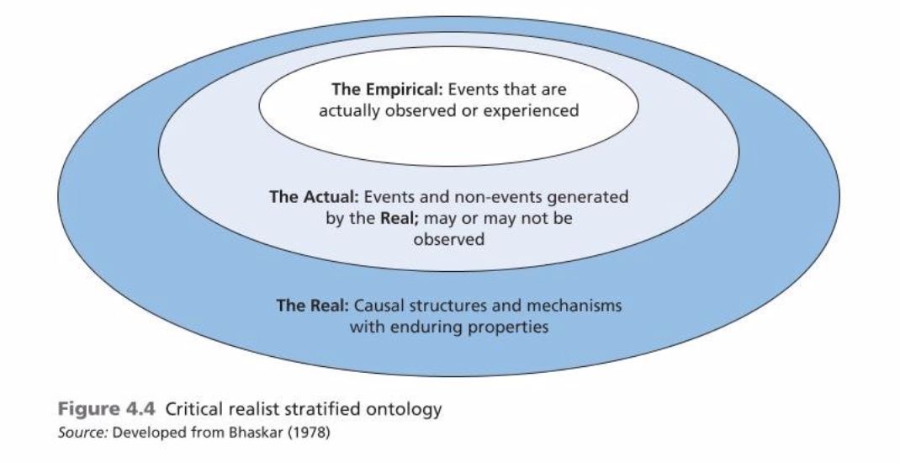
(Saunders et al. 2016)

Source: Saunders, M., Lewis, P., Thornhill, A. (2016) Research method for business student (7th Edition). England. Pearson.
- Developing your research philosophy.
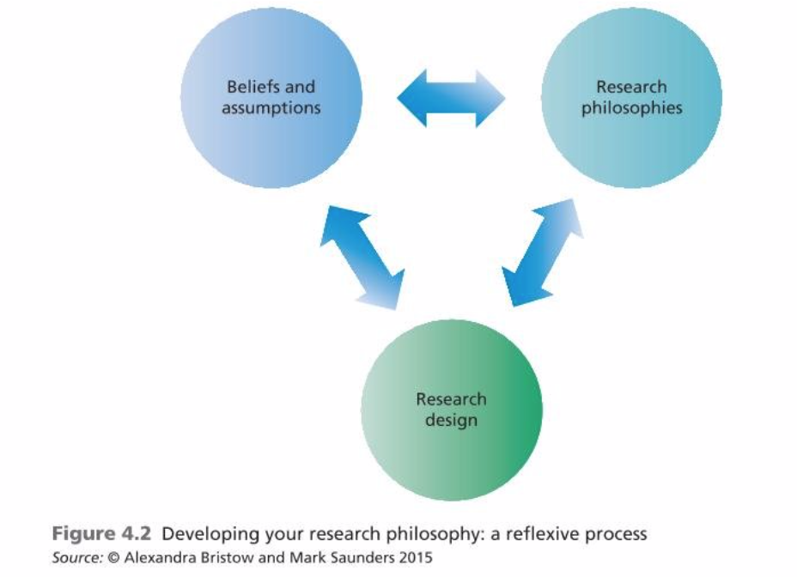
(Saunders et al. 2016)

Source: Saunders, M., Lewis, P., Thornhill, A. (2016) Research method for business student (7th Edition). England. Pearson.

- Renaissance Philosophy
“Observational science and naturalistic art began to flourish, particularly in Italy with (p.32) famous painters such as Leonardo da Vinci and Michelangelo, writers such as Dante, and thinkers such as Pico della Mirandola, a neo-Platonist nobleman who published the Oration on the Dignity of Man in 1486, setting the stage for a new form of humanism. The human being was now put on center stage—and this was a self-confident, dignified, and perceptive human being, prepared for the individualism that was to affect Western thought and societies for centuries to come.

Leonardo is a wonderful example of “the Renaissance man,” witnessed in his many-sided intellectual endeavors. Leonardo examined the world through his paintings (the Mona Lisa is arguably the most famous painting in the world) and detailed sketches (e.g., of the human body), and he invented machines and technologies that still amaze us today. Renaissance painters invented perspective in the modern sense, and this in itself is an indication of the shift from Greek and medieval cosmologies. In the earlier religious cultures, it was God who was conceived as the center of the universe, and this was reflected in the ancient works of art. Regardless of where the depicted objects are located, they are typically of the same size because God sees everything at the same time from “a view from nowhere” to use the phrase made famous by Thomas Nagel (1986). It is not yet the particular human viewpoint that is important. This changes, however, with the Renaissance, where the person viewing the painting becomes the center. Thus, objects become depicted relative to the observing individual and not in relation to an all-encompassing deity. This whole development can be viewed as a move away from the theocentric cosmology (with God as center) that was characteristic of metaphysically oriented philosophies and toward an anthropocentric cosmology (with man as center) that was to become significant, and which also indicates a shift to epistemology as the prime philosophical discipline, as I have argued. Beginning in the early 20th century, the anthropocentric cosmology is then again surpassed by a development of what some call a polycentric cosmology (Qvortrup, 2003) in which there is no one center but, rather, multiple centers or nodal points from which one may approach the world. This is also known as perspectivism and postmodernism, emphasizing “local knowledges” (in the plural) as discussed later in the book, and it was reflected in the art forms from the 20th century such (p.33) as expressionism—for example, in the celebrated paintings by Picasso that depict a human being from several angles at the same time. There is no longer a privileged perspective on the world but, rather, multiple perspectives and thus many truths. But this takes me ahead of the story, so let us return to the Renaissance humanists and ask how they influenced what we now know as qualitative research.”

Source: Brinkmann, S. (2017) ‘Philosophies of Qualitative Research.’ Oxford University Press, 2017.

Appendix 4: Personal self-development activities.
Our homework for the lecture about philosophical framework of the research was each of the student should find 3 scholar article to examine and clearly identified the research paradigm of each of the articles.

My analysis is as below:

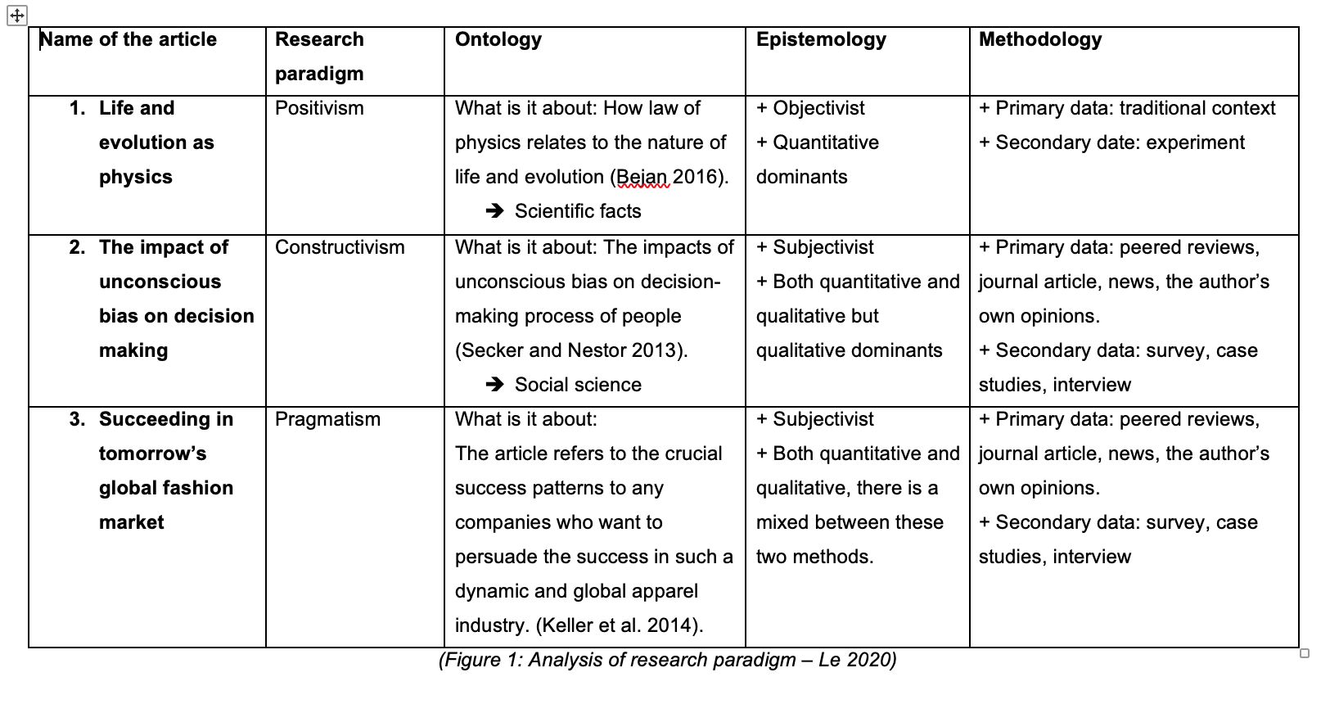
From the analysis of the articles from different authors with different perspectives and knowledge indicated, I could understand how research paradigm could be formulated and opted to fulfil my research journey and process.

After that, before conducting any research work and considering an appropriate research paradigm, I always think about the 4 terms as: ontology, epistemology, axiology and methodology which I find very helpful because it might sound vague at first, but it does give me the in-depth and the most original insight into philosophy of research. As a result, it would help me to have the concrete and firm base to have further step in my research career exploring the new types of knowledge.

Entry 6: Types of Research and Research Design

Types of research - Methodological choice
Carnevalli & Miguel (2008) considered that there are two primary types of studies as: conceptual and empirical research. In order to accomplish any types of research through the effective research design, the researcher should be prudent to consider the methodological choice of either quantitative, qualitative or mixed-method approach (Saunders et al. 2006). Kapoor (2016) in a study about medical research suggested that research could also be classified in to 2 categorizes as: primary and secondary research. In more detail, secondary or quantitative research covers 3 core areas as: basic research, clinical research and epidemiological research (Kapoor 2016). On the other hand, qualitative or primary type of research covers: narrative review, systematic review or meta-analysis (Kapoor 2016).

Haig (2018) mentioned the philosophy of research method to understanding statistics with the term as: ‘the exploratory data analysis’ stating the process that evaluated data could result into crucial patterns of interest. This process could be accomplished by applying either 3 of the scientific methods as deductive, inductive or abductive method (Haig 2018).

Toye (et al. 2016) revealed that qualitative research could draw out the questions to help the researcher contextualize or reflect on the research design quantitative findings. Bryman (1984) provided a claim that qualitative research is more fluid and flexible than quantitative research as by the ‘participant observation’ technique, the researcher could get closer to his subjects to see the world from their perspectives. As a result, it would produce the ‘rich’ data with a great deal of depth (Bryman 1984).

It was argued that mixed-method approach could outweigh the other 2 approaches in conducting research for a number of considerable features (Klingner & Boardman 2011). Östlund et al. (2011) pointed out that this approach could draw upon the strengths and perspectives of both of the other methods to not only emphasize on the physical, nature world but also on the reality and human experience. To what extent, it was clarified that mixed-method research could support the researcher to tackle with the issues in term of theory building and measurement in quantitative research and the problems of case selection and transferability in qualitative research (Kelle 2006).

Research design.
Saunders et al. (2006) provided the simple clarification as the research design is aimed to answer the research question. Tobi & Kampen (2018) suggested the ideal research design framework should begin with the conceptual design to address the ‘why’ and ‘what’ of the research project, following with the technical design to answer the question of ‘how’, ‘where’ and ‘when’. To an extent, the technical plan will address the instrument selection, the sampling plan stated the recruiting of research units and the analysis plan clarifying how the collected data would be analysed and synthesized (Tobi & Kampen 2018). It is also recommended that the thorough search strategy plan should also be implemented so that the researcher could reach the potential source of data for the research project (Kable et al. 2012).

Appendix 1: List of useful academic sources.
Bryman, A. (1984) ‘The Debate about Quantitative and Qualitative Research: A Question of Method or Epistemology?" The British Journal of Sociology 35, no. 1 (1984): 75-92.

Carnevalli, A., J., & Miguel., C., P. (2008) ‘Review, Analysis and Classification of the Literature on QFD—Types of Research, Difficulties and Benefits." International Journal of Production Economics 114, no. 2 (2008): 737-54.

Haig, B., D., (2018) The Philosophy of Quantitative Methods: Understanding Statistics. Oxford University Press, 2018.

Kable, K., A., Pich, J., Maslin-Prothero, E., S. (2012) ‘A Structured Approach to Documenting a Search Strategy for Publication: A 12 Step Guideline for Authors." Nurse Education Today 32, no. 8: 878-86.

Kapoor, M. (2016) ‘Types of Studies and Research Design." Indian Journal of Anaesthesia 60, no. 9 (2016): 626-30.

Kelle, U. (2006) ‘Combining Qualitative and Quantitative Methods in Research Practice: Purposes and Advantages.’ Qualitative Research in Psychology 3, no. 4: 293-311.

Klingner, K., J., & Boardman, G., A. (2011) ‘Addressing the “Research Gap” in Special Education Through Mixed Methods.’ Learning Disability Quarterly 34, no. 3 (2011): 208-18.

Östlund, U., Kidd, L., Wengström, Y., Rowa-Dewar, N. (2011) Combining Qualitative and Quantitative Research within Mixed Method Research Designs: A Methodological Review.’ International Journal of Nursing Studies 48, no. 3: 369-83.

Saunders, M., Lewis, P., Thornhill, A. (2016) Research method for business student (7th Edition). England. Pearson.
Tobi, H., Kampen., J. (2018) ‘Research Design: The Methodology for Interdisciplinary Research Framework.’ Quality & Quantity 52, no. 3 (2018): 1209-225.

Toye, F., Williamson, E., Williams, A., M., Fairbank, J. & Lamb, E., S. (2016) ‘What Value Can Qualitative Research Add to Quantitative Research Design? An Example From an Adolescent Idiopathic Scoliosis Trial Feasibility Study.’ Qualitative Health Research 26, no. 13 (2016): 1838-850.

Appendix 2: List of useful websites, links to code of practices/advices…
- The main types of research compared:
https://www.scribbr.com/methodology/types-of-research/

- Three types of survey research:
http://fluidsurveys.com/university/3-types-survey-research-use-can-benefit-organization/

- Research design and methodology:
https://www.intechopen.com/online-first/research-design-and-methodology

- Four basic research methods for business start-ups:
https://www.intechopen.com/online-first/research-design-and-methodology

- Research design 101: A guide to planning an experiment research design:
https://uxstudioteam.com/ux-blog/research-design/

- What makes a good qualitative research question:
https://www.bl.uk/business-and-ip-centre/articles/what-makes-a-good-qualitative-research-question

- 9 tips to conducting accurate qualitative research:
https://www.invespcro.com/blog/9-tips-to-conducting-accurate-qualitative-research/

- What is good quality research:
https://www.saferinternet.org.uk/research/what-good-quality-research

Appendix 3: Any useful quotations, frameworks, tables
- 2 types of research.
“A table used in Martín et al. (1999) was adapted to record the articles. The articles were organized into two groups: “conceptual research” and “empirical research.” Articles whose goal was to develop theoretical–concepts work, reviews of the literature, simulations or theoretical modelling were considered to be conceptual. Empirical research included articles that had the goal of undertaking surveys, case studies, research-action or experimental research. The affiliation of the researchers, the average number of authors per article and the existence of financial support were also verified to discover sources of support for QFD research.”

Source: Carnevalli, A., J., & Miguel., C., P. (2008) ‘Review, Analysis and Classification of the Literature on QFD—Types of Research, Difficulties and Benefits.’ International Journal of Production Economics 114, no. 2 (2008): 737-54.

- Combined etic-emic approach.
“Key determinants of diversity among cultures, including those of journalism and mass media systems, cannot be detected through standard questionnaire techniques that are mostly based upon conceptions generated and tested in the West. This is because it is extremely difficult to conclusively formulate the kind of exploratory questions that are necessary to reveal the diversities that are in question. We have tried to reformulate and adapt one of the intricate key problems in the field of ethnography having a bearing on the trans-national comparison of media systems.
During recent years, an increased methodological innovation is to be observed within multi-ethnic countries and within trans-national research projects accentuating underlying cultural diversities, particularly in the field of social psychology. For example, ‘combined etic-emic’ approaches, have recently been discussed as way of improving empirical research (Ho and Cheung, 2007). There, the two opposing conceptions within cognitive anthropology, that is, the formerly distinct categories of ‘etic’ (the outside observing perspective) and ‘emic’ (the inside endogenous perspective), are effectively reconciled for the development of analytic instruments in non-Western cultures.”
Source: Hayashi, K. & Kopper., G., G. (2014) ‘Multi-layer Research Design for Analyses of Journalism and Media Systems in the Global Age: Test Case Japan.’ Media, Culture & Society 36, no. 8 (2014): 1134-150.

- A culturally specified multi-layer research design that can be applied to cultures of various and most diverse origins.
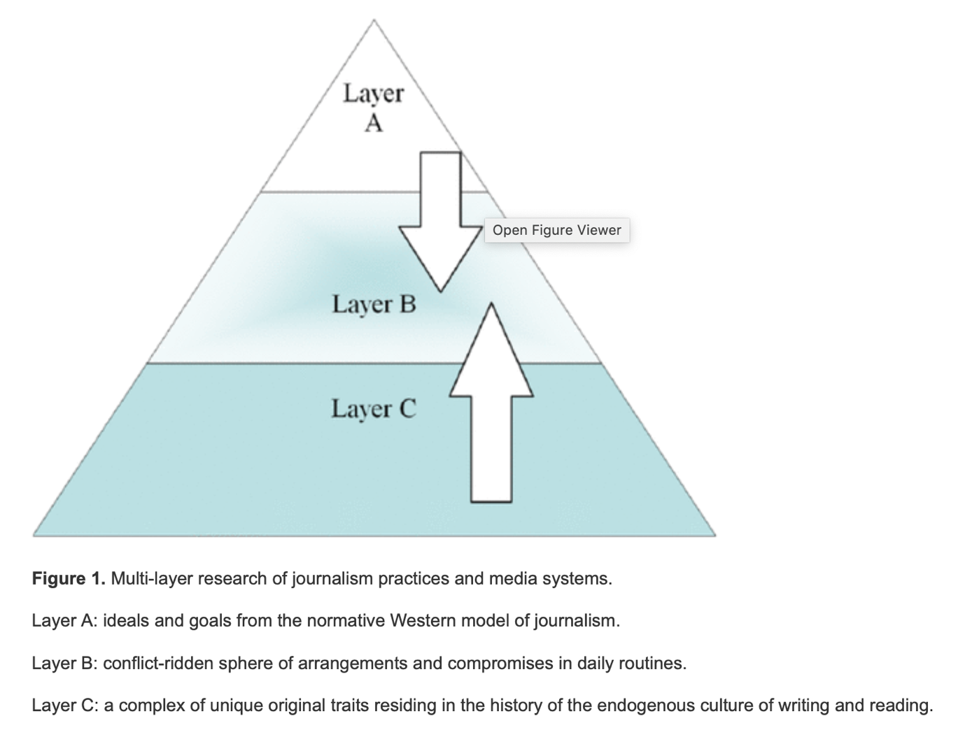
(Hayashi & Kopper 2014)

Source: Hayashi, K. & Kopper., G., G. (2014) ‘Multi-layer Research Design for Analyses of Journalism and Media Systems in the Global Age: Test Case Japan.’ Media, Culture & Society 36, no. 8 (2014): 1134-150.

- Exploratory data analysis with abductive method.
“As stated earlier, in the abductive theory of method (Haig, 2005, 2014), scientific inquiry proceeds as follows: Guided by evolving research problems, sets of data are analysed to detect robust empirical regularities, or phenomena. Once detected, these phenomena are explained by abductively inferring the existence of underlying causes that are thought to give rise to the phenomena. Here, abductive inference involves reasoning from claims about phenomena, (p.24) understood as presumed effects, to their theoretical explanation in terms of underlying causes. Upon positive judgments of the initial plausibility of these explanatory theories, attempts are made to elaborate on the nature of the causal mechanisms in question. This is done by constructing plausible models of those mechanisms by analogy to relevant ideas in domains that are well understood. When the theories are well developed, they are assessed against their rivals with respect to their explanatory goodness. This assessment involves employing criteria specifically to do with explanatory worth.
It should be apparent, even from this brief sketch, that the abductive theory is considerably broader than both the hypothetico-deductive and inductive alternatives (and all three accounts go beyond Tukey’s near-exclusive concern with data analysis). The breadth of the abductive theory enables it to operate as a framework theory within which an extensive array of data analytic and theory construction methods and strategies can be usefully located.”
Source: Haig, B., D. (2018) The Philosophy of Quantitative Methods: Understanding Statistics. Oxford University Press, 2018.

- The methodology of interdisciplinary research framework.
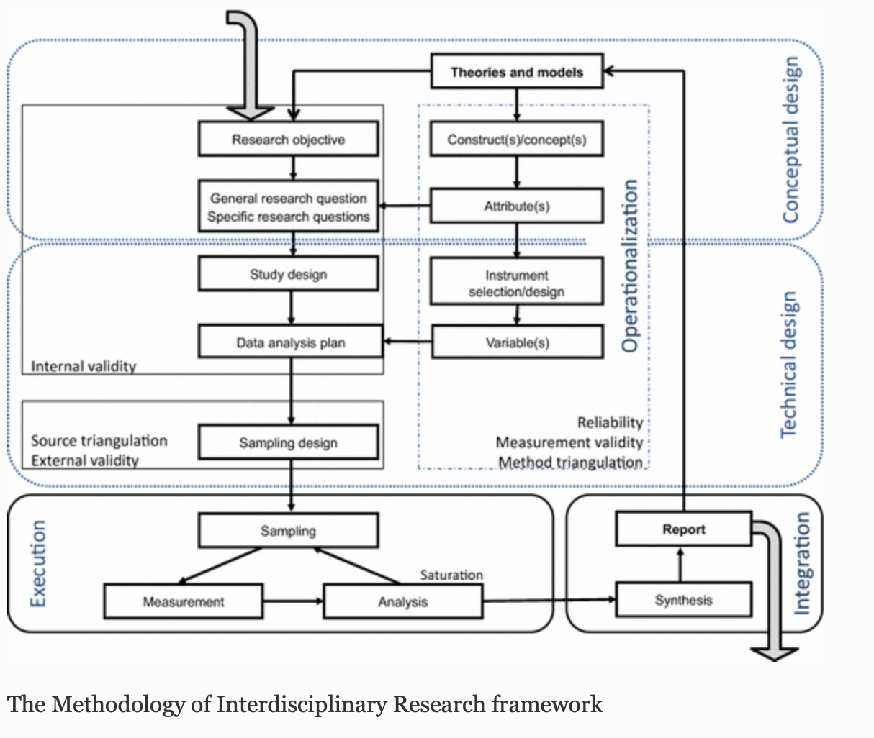
(Tobi & Kampen 2018)

Source: Tobi, H., Kampen., J. (2018) ‘Research Design: The Methodology for Interdisciplinary Research Framework.’ Quality & Quantity 52, no. 3: 1209-225.

- The nature of consent.

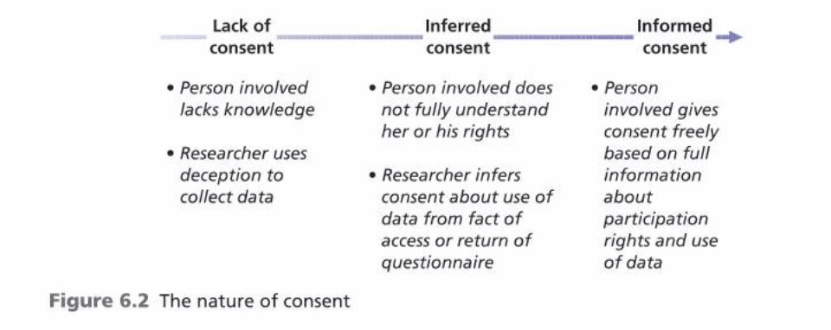
(Saunders et al. 2016)

Source: Saunders, M., Lewis, P., Thornhill, A. (2016) Research method for business student (7th Edition). England. Pearson.

- A classical experiment strategy.
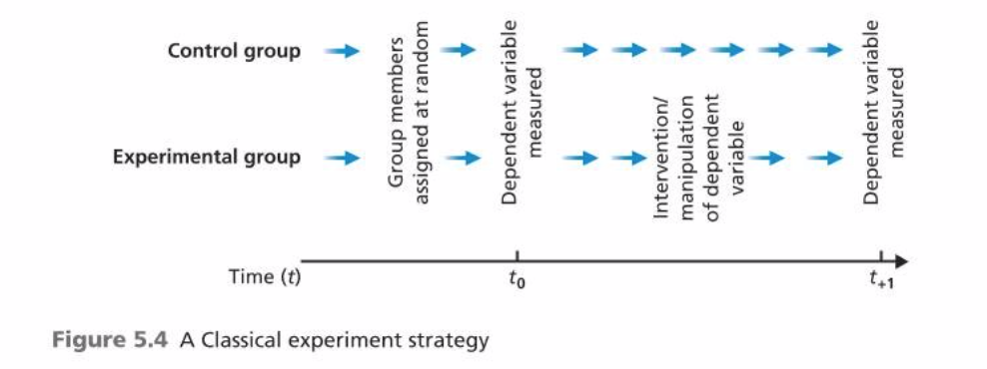
(Saunders et al. 2016)

Source: Saunders, M., Lewis, P., Thornhill, A. (2016) Research method for business student (7th Edition). England. Pearson.

- The three cycles of the Action research spiral.
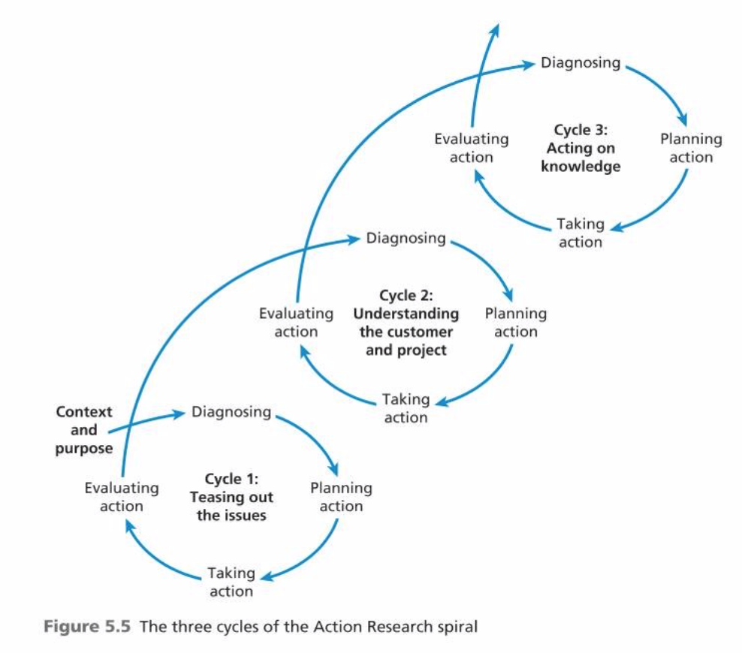
(Saunders et al. 2016)

Source: Saunders, M., Lewis, P., Thornhill, A. (2016) Research method for business student (7th Edition). England. Pearson.

Appendix 4: Personal self-development activities
Being fully equipped with the knowledge regarding the purposes of conducting research and different types of approaches to conduct a research, I revised the previous way that I used to utilize to apply for my work, whether it is a class activity or homework from the lecturers.

By observing my progress in my ‘mission notebook’ as I mentioned previously, I realized that I was not too critically considering all the core elements before jumping on doing research in the way that I supposed to be fine. As a result, it did prevent me to achieve the findings that I expected due to the unstructured and ambiguous research plan. I then helped myself by start working on the research plan for any work that needed to be done. Firstly, I would work on the key points that I need to do research on, then I thought about the effective search strategy and further issues that I might have to tackle with on the way conducting the research.
Just after I had the precise and pretty neat research plan, I would start the research process and the result is it does help me a lot to be more effective, is smarter way to approach the findings and I could save a lot of time.

Entry 7: Research ethics and integrity

Ethic and integrity in research
It is argued that there has been a prevalence growth of concern regarding the standards and demand of ethic in research (Tucker 2013). Price et al. (2001) listed down the most ordinary forms of misconduct in research as: plagiarism, duplication, fragmentation, multiple authorship, conflict of interest, fraud, collegiality/sharing, data collection, and participant protection. Therefore, they might lead to the considerable types of harm such as: psychological harm, financial harm or social harm (Jaguar 2020). Considering the research process itself, it is believed that ethical issue could also have the considerable impacts on the researcher in term of positionality and identity (Brandt & Josefsson 2017).
Ethical issues in conducting research

Participants involved in the research on sensitive topics as sexual or child abuse might find distress reminiscing their horrible experiences (Decker et al. 2011). Argyropoulos et al. (2011) posed the issue related to financial aspect as conflict of interest where financial gain over the publication of research might affect the academic freedom. It is also revealed that when it comes to the research about illicit cultural property the researchers might experience the restriction of information when the dealers protect their clients’ identity (Argyropoulos et al. 2011).

Another research indicated that there might still be the lack of journals to contribute to full justice to the growing discipline of biomedical ethics in term of laboratory animals (McCarthy 1999). In addition, the issue of overlapping publication, fraud in research and publication and plagiarism & its checking could be considered as the ethical issues stemming from the researcher itself (Yip et al. 2016). There could also be a problem as, for example, in the research of deaf education, the researchers should be entirely aware of their position to not assume the idea that that one deaf person might represent the entire community (Cawthon & Garberoglio 2017)

Solutions to mitigate misconduct in research
There have been protection principles, laws, regulations, and guidelines gradually introduced and applied in the recent decades (Raul & Rubenfeld 2017). Laneader et al. (2007) suggested that the researcher should ensure the highest ethical standard in the very first initial stages of study design in term of its population, choice of control or data collection procedures because it would likely link to the nature of ethic in research that will arise. In another research, it is believed that to prevent the publish of the work that does not meet criteria for responsible research, there should be the intervention of research review committees or ethic committees (Sathyanarayana & Chittaranjan 2015).

In more details, it is suggested that the medical research should be applied the ethical principles stated in the Declaration of Helsinki (Skierka & Michels 2018). The guidelines from Belmond report developed by The National Commission for Protection of Human Subjects of Biomedical and Behavioural Research is also recommended for the research in humanity subject in term of informed consent, assessment of risks and benefits, and subject selection (Moran 2006). Matteson & Lincoln (2009) recommended that practicing care as an ethic to form either professional, functional or emotional bond between the interviewer and interviewee would result in the atmosphere of trust and professional aspect in the interviews in the qualitative research studies.

In conclusion, according to Markham (2006), to be an ethical researcher, one should work from the centre – the heart which should be: being knowledgeable and prepared; present and aware; adaptive and context sensitive; and honest or mindful.

Appendix 1: List of useful academic sources.
Argyropoulos, V., Polikreti, K., Simon, S. & Charalambous, D. (2011) ‘Ethical Issues in Research and Publication of Illicit Cultural Property.’ Journal of Cultural Heritage 12, no. 2: 214-19.

Brandt, F., & Josefsson., J. (2017) ‘Sexuality and Power on South African Game Farms; Reflections on Positionality and Emotions in Ethnographic Research.’ Emotion, Space and Society 23, no. C:26-32.

Cawthon, S., Garberoglio, L., C. (2017) Research in Deaf Education: Contexts, Challenges, and Considerations. Oxford University Press, 2017.

Decker, E., S., Naugle, E., A., Carter-Visscher, R., Bell, K., & Seifert., A. (2011) ‘Ethical Issues in Research on Sensitive Topics: Participants' Experiences of Distress and Benefit. Journal of Empirical Research on Human Research Ethics 6, no. 3: 55-64.

Laneader, A., A., P., Ferrell, R., B., P., Kolker, A., Miner, T., Padilla, G., Swaney, J., Krouse, S., B., & Casarett., D. (2007) ‘Ethical Issues in Research to Improve the Management of Malignant Bowel Obstruction: Challenges and Recommendations.’ Journal of Pain and Symptom Management 34, no. 1: S20-27.

McCarthy, R., C. (1990) ‘Toward a Coherent Ethic of Research Involving Laboratory Animals.’ ILAR Journal 40, no. 1 (1999): 1-2.

Markham, A., N. (2006) ‘Ethic as Method, Method as Ethic: A Case for Reflexivity in Qualitative ICT Research.’ Journal of Information Ethics 15, no. 2 (2006): 37-54.

Matteson, M., S., & Lincoln, S., V. (2009) ‘Using Multiple Interviewers in Qualitative Research Studies: The Influence of Ethic of Care Behaviors in Research Interview Settings.’ Qualitative Inquiry 15, no. 4: 659-74.

Moran, B., M. (2006) ‘Ethical Issues in Research with Human Subjects.’ Journal of the American Dietetic Association 106, no. 9: 1346-348.

Price, H., J., Dake, A., J. & Islam, R. (2001) ‘Selected Ethical Issues in Research and Publication: Perceptions of Health Education Faculty.’ Health Education & Behavior 28, no. 1: 51-64.

Raul, A. & Rubenfeld., S. (2017) ‘Ethical Issues in Research.’ Best Practice & Research Clinical Obstetrics & Gynaecology 43: 107-14.

Sathyanarayana, R., T., and Chittaranjan, A. (2015) ‘Ethical Issues in Research: Study Design and Publication-worthiness as a Case in Point.’ Indian Journal of Psychiatry 57, no. 1: 1-3.

Skierka, A. & Michels.B, K. (2018) ‘Ethical Principles and Placebo-controlled Trials – Interpretation and Implementation of the Declaration of Helsinki’s Placebo Paragraph in Medical Research.’ BMC Medical Ethics 19, no. 1 (2018): 24.

Tucker., B. (2013) ‘Realizing a Research Ethic of Solidarity: The Role of the Unconscious and an Ontology Drawn from Zen Buddhist Teachings on Nonduality.’ International Journal of Multiple Research Approaches 7, no. 3 (2013): 374-83.

Yip, C., Han, N. & Sng, B. (2016) ‘Legal and Ethical Issues in Research.’ Indian Journal of Anaesthesia 60, no. 9: 684-88.

Appendix 2: List of useful websites, links to code of practices/advices…
- Ethical issues in research:
https://www.skillsyouneed.com/learn/research-ethics.html

- Ethical issues in research – a ‘how to…’ guide:
https://www.kirklees.gov.uk/involve/document/EthicalIssues.pdf

- Five principles for research ethic:
https://www.apa.org/monitor/jan03/principles

- Ethical standards and procedures for research with human-beings:
https://www.who.int/ethics/research/en/

- Why ethic matter more than rules in the IOT age?:
https://www.research-live.com/article/news/why-ethics-matter-more-than-rules-in-the-iot-age/id/5066542

- Declaration of Helsinki:
https://www.who.int/bulletin/archives/79(4)373.pdf

- Belmond report:
https://www.hhs.gov/ohrp/regulations-and-policy/belmont-report/index.html

- The European code of conduct for research integrity:
https://ec.europa.eu/research/participants/data/ref/h2020/other/hi/h2020-ethics_code-of-conduct_en.pdf

Appendix 3: Any useful quotations, frameworks, tables
- Justice
“This principle deals with the concept of fairness. Researchers designing trials should consider what is fair in terms of recruitment of participants and choice of location to conduct a trial. This encompasses issues related to who benefits from research and who bears the risks of research. It provides the framework for thinking about these decisions in ways that are fair and equitable.
People who are included in research should not be included merely because they are a population that is easy to access, available, or perhaps vulnerable and less able to decline participating.
An experimental strategy that is likely to be used by many types of people should be tested in the very populations of people who are likely to use it, to ensure that it is safe, effective, and acceptable for all of the potential users. For example, experimental treatments that are intended for use in the general population must be studied not only on men, but on enough women to ensure that they are also safe and effective for women.
The principle of justice also indicates that questions being asked in trials should be of relevance to the communities participating in the study.”

Source: AVAC (2020) ‘Principles of research ethics.’ [online] Available at: <https://www.avac.org/principles-research-ethics>

- Ethical issues at different stages of research.
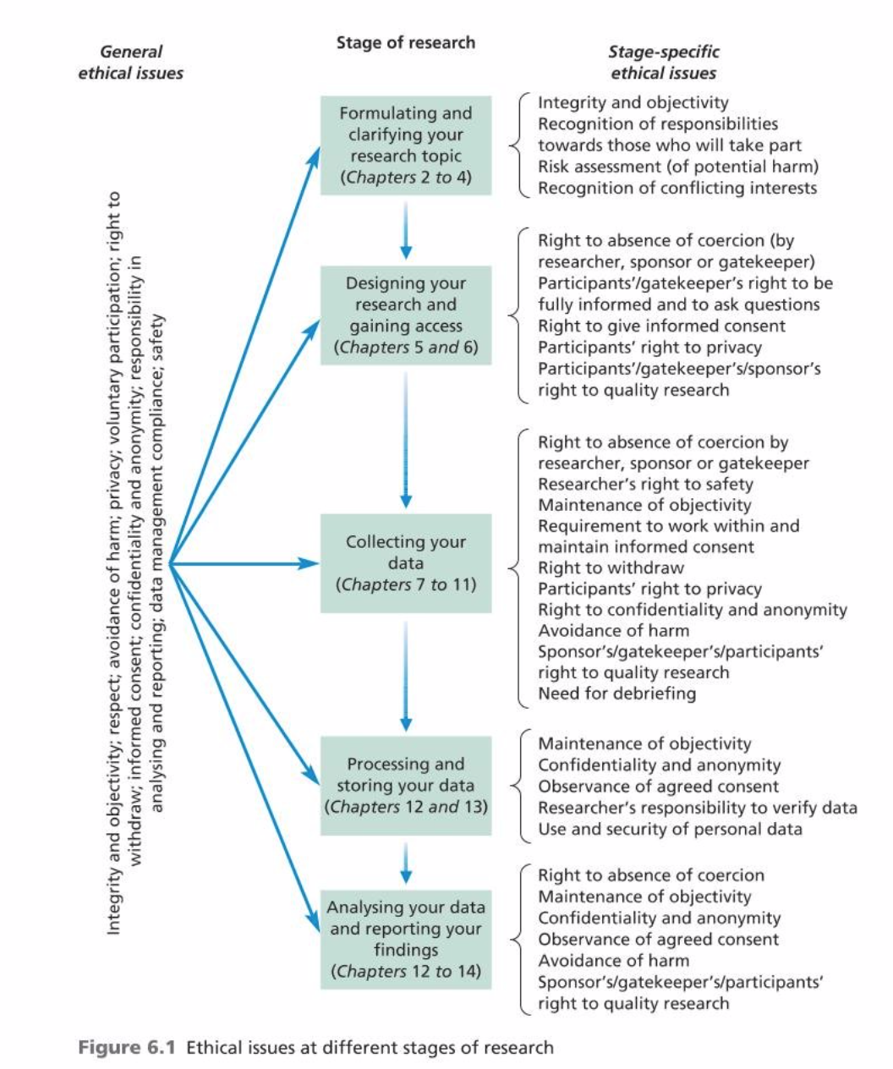
(Saunders et al. 2016)

Source: Saunders, M., Lewis, P., Thornhill, A. (2016) Research method for business student (7th Edition). England. Pearson.

- The nature of consent
(Saunders et al. 2016)

Source: Saunders, M., Lewis, P., Thornhill, A. (2016) Research method for business student (7th Edition). England. Pearson.

- Ethical AI
“Crucially, most guidelines also insist that thought be given to the ethical implications of the technology from the very first stage of conceptualising a new tool, and all the way through its implementation and commercialisation.
This principle of 'ethics by design' goes hand in hand with that of responsibility and can be translated, roughly, as: 'coders be warned'. In other words, it's now on developers and their teams to make sure that their program doesn't harm users. And the only way to make sure it doesn't is to make the AI ethical from day one.
The trouble with the concept of ethics by design, is that tech wasn't necessarily designed for ethics. "This is clearly well-meaning, but likely not realistic," says Ben Zhao, professor of computer science at the University of Chicago. "While some factors like bias can be considered at lower levels of design, much of AI is ethically agnostic."
Big tech companies are waking up to the problem and investing time and money in AI ethics. Google's CEO Sundar Pichai has spoken about the company's commitment to ethical AI and the search giant has published an open-source tool to test AI for fairness. The company's Privacy Sandbox is an open web technology that allows advertisers to show targeted ads without having access to users' personal details.
Google even had a go at creating an ethics committee, called the Advanced Technology External Advisory Council (ATEAC), founded last year to debate the ethical implications of AI. For all of the company's goodwill, however, ATEAC was shut down just a few weeks after it launched.

Pichai is not the only one advocating for greater ethics: most tech giants, in fact, have joined the party. Apple, Microsoft, Facebook, Amazon -- to name but a few -- have all vouched in one way or the other to stick with human rights when deploying AI systems.

Big tech might be slightly too late, according to some experts. "The current trend of Silicon Valley corporations deciding to empower ethics owners can be traced to a series of crises that have embroiled the industry in recent years," note researchers Data & Society in a paper on "corporate logics".”

Source: Leprince-Ringuet, D. (2020) ‘Developers - it’s time to brush up on your philosophy: Ethical AI is the big new thing in tech.’ ZD Net [online] Available at: https://www.zdnet.com/article/developers-its-time-to-brush-up-on-your-philosophy-ethical-ai-is-the-big-new-thing-in-tech/

Appendix 4: Personal self-development activities
After the lecture about research ethic and integrity, when planning for the research project, I always reminded myself to consider about the possible aspects which might relate to ethical issues in research.

For example, for my research topic of the first assignment as creating a video, in term of the secondary data research, I was thinking carefully about my population for the research sample and how to protect them from the possible harm that might be caused in my research. As it was aimed to be a research about leadership and management, my survey or interview might include the employees or the employers. It might lead to the further conflicts and issues in the workplace if I did not have the proper plan to make sure that my research would handle well on the question regarding sensitive topics.

Furthermore, as to practice and to help myself to get used to the ethical mindset as a researcher, when I evaluate the articles or the research project of the other authors, I always try to also think about how they tackle with ethical issues in their research. I believe that examining this kind of aspect would not only help me to enhance my own research skills, but also could be considered as a great instrument to know whether the research is worthy and valuable or not.

