Module Name: Employability and Career Development
Module Code: LCLM4005
Student Name:Sefora mihai
Student ID: 2421152
Table of Contents
Introduction 2
Task A 3
Job Adverts and Key Skills 3
Common skills and knowledge areas 5
Use one of these key skills in a future role of employment 5
Task B 6
Self-Assessment 6
Evidence of Readiness 7
Task C 8
Employment Goals 8
A Personal Development Plan 8
Conclusion 10
References 11

Introduction
The following portfolio will compare the skills mentioned in the two identified job advertisements and will recognise the common skills among them. A self-assessment will be conducted through SWOT analysis to identify the strengths, weaknesses, opportunities and threats associated with career and academics. Furthermore, evidence related to employability and personal development will also be provided, and on the basis of this assessment, a personal development plan will be developed.

Task A

Job Adverts and Key Skills
Both job advertisements have been found for the role of marketing manager, as I have an interest in this field to develop my career.
Advertisement 1
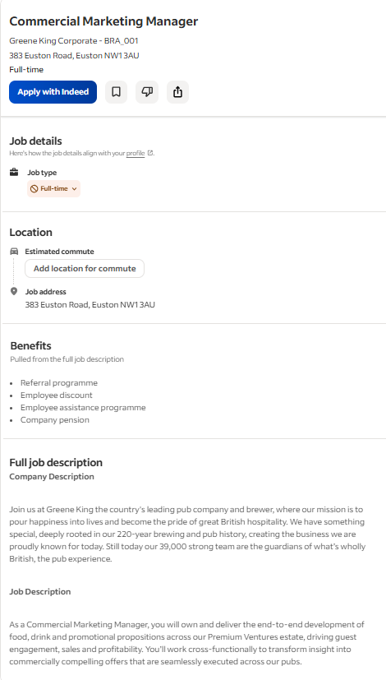
Figure: Job advertisement
Source: (Indeed, 2026)
The first advertisement is found for the role of a commercial marketing manager at Greene King Corporate, and the responsibility in this role is to deliver the end-to-end development of food and drink, as well as promotional activities across the premium venture estate. The key skills mentioned in the job description are leadership skills to lead the development of customer-led food, drink and promotional propositions that drive commercial growth. Proper management skills and communication skills to translate guest, business and market insights into clear and actionable proposition strategies are also mentioned in the job description. Planning and delivering promotional activities, use of data, EPOS systems ad insights and development of a collaborative team culture are also the key skills for this role (Indeed, 2026).
Advertisement 2
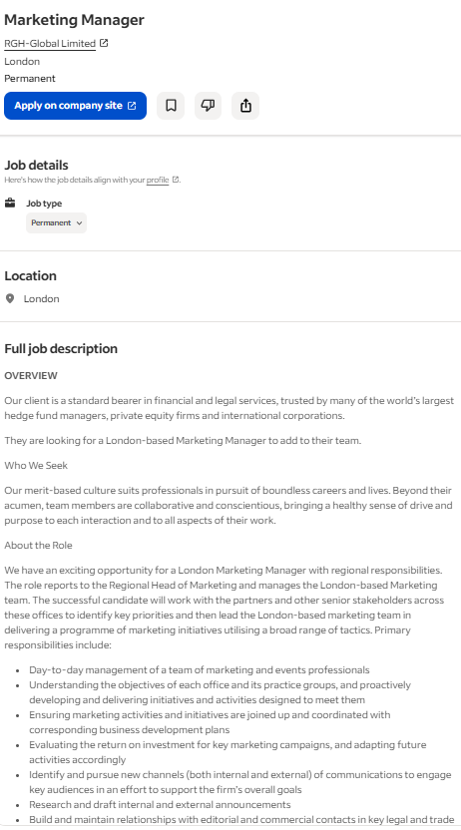
Figure: Job advertisement
Source: (Indeed, 2026)
The second job advertisement is for the role of marketing manager at RGH‑Global Limited, London. The key skills mentioned in the job description are the day-to-day management of a team of marketing and event professionals and the maintenance of proper coordination and correspondence between business development plans. Several other skills are the evaluation of the return on investment for the marketing campaigns and adaptation of future activities. It is crucial to have effective communication skills to keep the key audiences engaged and to support the overall marketing goals. The job description mentions skills such as research, drafting internal and external announcements, and developing commercial relationships (Indeed, 2026).

Common skills and knowledge areas
Considering both the job advertisements, it can be said that both of them demand the skills of communication and leadership to execute the responsibilities in the role of a marketing manager. Another common skill mentioned in the advertisements is the skill to develop commercial relationships, collaboration, and a positive workplace culture for the team members.

Use one of these key skills in a future role of employment
Communication skills are one of these skills that I can use in my future career, as I have developed this skill through my experience and studies. I have the ability to convey my thoughts and perspective to others without any type of error. I know that the job market in the UK has become quite competitive, and communication skills are crucial for the role of marketing manager. This is the reason why I will try to implement my communication skills to get my desired role of a marketing manager.

Task B

Self-Assessment
SWOT Analysis
Strengths: My communication skills are one of my key strengths, as it enables me to convey my thoughts and perspective to others (Brower, 2023). In addition to this, I have efficient time management skills to manage my time properly, as per the priority and requirements of tasks (Hart, 2024). I have effective problem-solving skills as well, as I try to find the root causes of the problems that come my way and overcome them. This type of aspect helps me to reduce the chances of the same problems arising again and again (Eboli, 2024). I want to mention my research skills as another strength, as it helps me to gather knowledge regarding different areas and implement them properly.
Weaknesses: Apart from the strengths, I have several weaknesses as well, as I have a lack of adaptability skills. This is the reason why I face difficulties adapting to changes and respond accordingly, and due to this, I often face complexities in my studies. Though there is a high demand for digital literacy, I have a gap in digital literacy, which can raise difficulties for my career path. Furthermore, my collaboration and teamworking skills are also inefficient, and there is an area for development. In order to achieve the desired role for marketing manager, I need to work on these areas and address the gaps.
Opportunities: I have an opportunity to enrol in a short-term digital literacy development course so that I become more eligible for my desired role. I can work in a marketing executive role so that I can develop experience and knowledge regarding this field and implement them in my future career growth (Palazzo, 2024). Through the development of all the areas of gaps, I can get the opportunity to get the desired role of marketing manager.
Threats: The increasing competition in the job market will be a key threat for me, and due to gaps in several skills, I may not be eligible for the role of marketing manager (Partridge, 2026). In addition to this, digital literacy is a key requirement for every job role. However, a gap in this area can reduce the chances of my career growth to a great extent (Puyt et al., 2023). Furthermore, increasing inflation in the UK and political changes can also affect my career aspirations in a negative way.

Evidence of Readiness
Academic achievements: My academic tasks and activities have provided me with the opportunity to participate in group activities and understand the importance of a collaborative culture. Through the tasks, my communication skills, time management and research skills have been developed to a great extent. My academic tasks and assignments have contributed to developing my research skills to a great extent. This is the reason why I always try to conduct detailed research about business areas with the purpose of gathering efficient and valuable knowledge.
Work Experience: I have worked in the field of customer service, and this work experience has helped me to understand the different preferences, needs and expectations of customers. I have a strong belief that understanding customers’ expectations will help me in the desired role of marketing manager as well. I want to gain experience in the field of marketing so that I can become eligible for the role of marketing manager.
Extracurricular activities: Apart from this, as part of the extracurricular activities, I have participated in seminars and workshops. These activities have helped me to gather required and valuable information regarding the business area, and these will be beneficial in my future career path at the same time.
Feedback from mentors and peers: In order to identify the areas of gap, I have always gathered feedback from my mentors and peers. My peers have helped me to understand that I need to work on my team working skill so that I can understand the views and perspectives of others. In addition to this, as per the advice from my tutors, there is a requirement for development in the digital literacy area.

Task C

Employment Goals
Short-term employment goals
To develop digital literacy relevant to the role of digital marketing through an online course within the time frame of 1 year
To attend marketing-related conferences to connect with professionals and improve networking over the next 2 years
To improve the adaptability skills by getting feedback from tutors within the time frame of 1 year
Long-term employment goals
To achieve the role of marketing manager and achieve specialised expertise in this position within 5 years
To become able to mentor junior staff and help to develop the team strategies within 3 years

A Personal Development Plan
Skills | Resources | Way of measurement | Timeline
Adaptability skills | E-learning courses and workshops will help develop the skill of adaptability (Jr, 2025). | Being able to adapt and respond to the changes will be the metric for measurement | A timeline of 1 year will be enough
Collaboration and teamworking | Teambuilding and application-related workshops and digital tools will contribute to the development of collaboration and teamworking skills (Adkins, 2026). | When I am able to collaborate with my team members in an appropriate way, then I will understand that I have developed my collaboration and teamwork skills. | I will need a timeframe of 1 year to develop the collaboration and teamwork skills.
Digital literacy | I will use digital literacy books, journals, and articles and will enrol on a short-term online course (Marr, 2022). | Being able to acquire digital technology and tools, related knowledge and using them will be a way of measuring growth. | A time frame of 1 year will be enough for the development of digital literacy to the desired extent.

Conclusion
There are strengths in the areas of communication, research and time management; however, there is a need to develop adaptability and digital literacy. This development can help to become more eligible for the desired role of marketing manager. Through the application of the personal development plan, it can be easier to work on the areas of weakness.

References
Adkins, R. C., (2026). Building Success Through Teamwork And Collaboration. [Online] Available at: https://www.forbes.com/sites/forbesbooksauthors/2026/07/14/building-success-through-teamwork-and-collaboration/ [Accessed 16 July 2026].
Brower, T., (2023). Powerful Strategies To Improve Your Communication Skills. [Online] Available at: https://www.forbes.com/sites/tracybrower/2023/08/27/powerful-strategies-to-improve-your-communication-skills/ [Accessed 16 July 2026].
Eboli, A., (2024). Problem-Solving: Exploring Three Diverse Approaches. [Online] Available at: https://www.forbes.com/councils/forbesbusinesscouncil/2024/01/16/problem-solving-exploring-three-diverse-approaches/ [Accessed 16 July 2026].
Hart, H., (2024). Productivity And The Hard Truth About Time Management. [Online] Available at: https://www.forbes.com/sites/hannahart/2024/01/25/productivity-and-the-hard-truth-about-time-management/ [Accessed 16 July 2026].
Indeed, (2026). Marketing manager. [Online] Available at: https://uk.indeed.com/q-marketing-manager-jobs.html?vjk=9171373736ae225e&gclsrc=aw.ds&aceid=&gad_source=1&gad_campaignid=22920057519&gbraid=0AAAAADe30jN7a1_MUhoiY9lk-njd7V2jI&gclid=Cj0KCQjw6_HSBhCpARIsANvVltas42EJjCmAzxIHILiZyvyEWkOY2M_1JotLnnCOahdfUDukjV [Accessed 16 July 2026].
Jr, J. G., (2025). Adaptability: The One Skill You Need To Maximize Job Security Right Now. [Online] Available at: https://www.forbes.com/councils/forbesbusinesscouncil/2025/06/11/adaptability-the-one-skill-you-need-to-maximise-job-security-right-now/ [Accessed 16 July 2026].
Marr, B., (2022). The 4 Digital Skills Everyone Will Need For The Future Of Work. [Online] Available at: https://www.forbes.com/sites/bernardmarr/2022/07/22/the-4-digital-skills-everyone-will-need-for-the-future-of-work/ [Accessed 16 July 2026].
Palazzo, M., (2024). The SWOT analysis: An evolving decision-making model. In Rethinking decision-making strategies and tools: Emerging research and opportunities (pp. 53-70). Emerald Publishing Limited.
Partridge, J., (2026). UK job vacancies ‘fall to lowest level since pandemic’. [Online] Available at: https://www.theguardian.com/business/2026/feb/23/uk-job-vacancies-fall-to-lowest-level-since-pandemic [Accessed 16 July 2026].
Puyt, R.W., Lie, F.B. and Wilderom, C.P., (2023). The origins of SWOT analysis. Long range planning, 56(3), p.102304.

