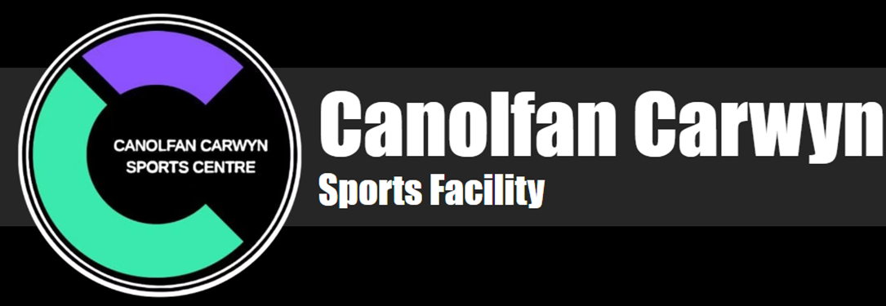
Figure 1: (Canolfan Carwyn Sports Facility, 2026)

Figure 2: (“The Benefits of Internships”, 2019)
Assignment 3: Critical Appraisal Report
Module: Internship and Volunteerism (BMSP5022)
Name: Iestyn Thomas 2404285
Lecturer: Jessica Shore
Due Date: 2nd May 2026

Introduction
This report provides a critical appraisal of my internship experience at the Canolfan Carwyn Sports Facility. The purpose of this critical appraisal report is to evaluate the success of the overall placement experience, review to what extent the objectives and methods of measuring success established prior to the internship were achieved, assess the impact of the internship on my personal and professional development, and to create recommendations for future improvements.
Placement Overview
The internship took place at the Canolfan Carwyn Sports Centre in Drefach, which is a local community-focused sports facility that includes the NXTLVL Fitness gym and a multi-purpose sports hall which is used for a variety of sporting activities and community events (“Canolfan Carwyn Sports Facility”, 2026). The placement involved working remotely as an accounts assistant, supporting the organisation’s financial operations. My responsibilities for this role included to complete a transaction list, prepare a profit and loss statement, provide recommendations for financial improvements based of the P&L sheet findings and discover potential grants for some of the centre’s current and desired future projects.
Personal and Professional Skills Developed Throughout the Internship Experience
By conducting a post-placement skills audit, which can be seen in the appendix, I have identified several areas in which my personal and professional skills have improved during the internship. One area of improvement was my proactivity and problem-solving skills. Because the internship was conducted remotely, I had to independently find solutions to issues I did not initially understand. For example, when I was unsure about where to categorise certain transactions for the transaction list, I demonstrated proactivity and problem-solving skills by first researching online and then contacting my supervisor through WhatsApp and email for support and clarification. This proactive approach ensured that the tasks were completed accurately. Therefore, following the internship, I now feel that my problem-solving skills and level of proactivity have improved significantly (Bayubay, 2024). This is highly beneficial as these skills are considered key for employers, which therefore can improve my employability (Johnson, 2025).
Another skill I identified as improved through the skills audit was my written communication. As the internship was conducted remotely, to communicate with my supervisor at Canolfan Carwyn I had to through written forms via emails and WhatsApp messages. This strengthened my professional written communication skills, as I needed to ensure that all messages and submitted work were clear, grammatically accurate, factually correct, and appropriately tailored to the audience (“A Complete Guide”, 2025). Examples of when I used this skill included when I was asking for clarification on where to categorise transactions, as well as when communicating about tasks such as the grant research assignment. Written communication is considered a key employee asset, therefore developing this ability has further enhanced my employability (Johnson 2025).
Gaining workplace experience is another attribute I developed during the internship. By completing a 10-week placement, I gained valuable hands-on workplace experience in a finance-related role, which is a potential path that I am interested in pursuing. This experience allowed me to develop key finance skills, while also improving my understanding of general workplace expectations and professional environments. This workplace experience gained through the internship can also help to strengthen my CV and enhance my overall employability. This can be explained through the human capital theory, which suggests that an individual’s employability is influenced by the skills, knowledge, and experience they accumulate through education and practical work. For example, prior to the internship, I was unsuccessful in securing some accountancy and marketing internship roles, mainly due to a lack of workplace experience. However, having now gained the practical experience, I am more likely to be employed for similar roles in the future, highlighting workplace experience as a key personal and professional attribute that I gained form the internship (Bayubay, 2024; “Pros and Cons of Internships”, 2025; Ross, 2026).
Internship Challenges
Through conducting a personal post-placement skills audit, I also identified several skills that had either regressed or not improved as expected. One example of this is my time-management skills. For the implementation plan before the internship, I recognised time-management as a potential risk, as poor time-management could negatively affect my university work if I failed to balance both commitments effectively. This challenge did occur during the placement, as procrastinating and not achieving my personal goal of completing internship assignments within a two-week timeframe, led to placement work taking over the time available for my university assignments. This led to increased stress and a reduction in the quality of my university work (“Pros and Cons of Internships”, 2025).
Another challenge I experienced during the internship process was a loss of confidence in my abilities and motivation. Prior to securing my placement at Canolfan Carwyn, I applied for several internships in accounting and finance roles. Despite these efforts, I received limited responses, with only one organisation formally rejecting my application. I also progressed through initial discussions for a marketing role at Natural UK. However, I was unsuccessful due to a lack of relevant skills and experience. These repeated setbacks led to a short-term decrease in my confidence and motivation. These feelings can be explained by Bandura’s concept of self-efficacy, which suggests that repeated negative outcomes can reduce an individual’s belief in their ability to succeed, which in turn can lower motivation (Lopez-Garrido, 2025).
Measuring Placement Success
As stated in the implementation plan prior to the beginning of the internship, three methods were identified to measure the success of the placement.
- Evaluating the Achievement of Initial Personal Objectives Set
The first method I identified for measuring the success of the internship was to evaluate the achievement of the initial personal objectives set. By completing a skills audit to identify weaknesses to improve on and using the SMART goal framework, three personal objectives were set prior to the internship (Venier, 2024).
The first SMART objective set, aimed at improving my networking skills, was to create a LinkedIn profile and connect with at least ten individuals, either from the Canolfan Carwyn workforce or the finance industry by the end of the internship. This goal was successfully achieved demonstrating clear progress in my networking abilities during the internship. Evidence of this improvement is not only reflected in the completion of the objective but also in my post-internship skills audit, where I noted an increase in my networking abilities and confidence. Achieving this goal has enabled me to connect with professionals in a desired industry of mine, enhance my personal brand and increase future employment opportunities. However, while I have established a profile and these connections, I have not yet fully engaged with them (Herbert, 2024; Mahtani, 2025).
Another goal I set was to be able to provide five examples of verbal interactions with colleagues for reasons such as asking for help, clarifying tasks, seeking knowledge, or discussing progress by the end of the internship. This was intended to support the development of my self-confidence and oral communication skills. As the placement was conducted virtually, this goal proved to be challenging to achieve, and in the end, I was unable to reach the target of five verbal interactions. However, I did interact regularly with my supervisor remotely through email and WhatsApp, for support and clarification regarding tasks, which did require self-confidence and written communication skills. Therefore, although the SMART goal was not achieved and this internship did not contribute to my aim of improving my oral communication skills, it was successful in helping to improve my self-confidence and written communication abilities, as is also demonstrated through my post-internship skills audit (Drew, 2023).
The final SMART objective I set, was to improve my time-management skills during the internship by completing at least one placement task every two weeks. Although I successfully completed all required tasks, I did not achieve all of them within the two-week timeframe. For example, my first task which was to complete the transaction list and profit and loss statement, and then provide recommendations for improvement took longer than two weeks to finish. Although this objective was a personal goal and not a goal set by my supervisor from Canolfan Carwyn, this outcome aligns with my initial skills audit self-assessment which was that I have a tendency to procrastinate and leave tasks till near formal deadlines. This pattern is something that needs solving as time management is seen as a vital skill for employers (“16 Skills”, 2025).
- Feedback from Placement Supervisor
The second method I identified for measuring the success of the internship was gathering feedback from my placement supervisor. This provides an external perspective on my performance, enabling me to better understand which skills I developed during the internship, and which require further development to improve for my next professional role (“Here's how you can evaluate”, n.d.).
Feedback from Placement Supervisor Jessica Shore:
"We are absolutely delighted with Iestyn's contribution whilst he was on placement with us here at BTAC Canolfan Carwyn. He was able to complete our profit and loss accounts for the entire year, ready to be submitted to our accountant. He did this with very limited direction, using sold initiative he created the accounts, reached out using whatsapp to ask specific questions and turned around our accounts in a more the adequate time frame. He was also able to create some recommendations for potential grant applications, he had researched himself with a very brief overview of our needs. On the whole, Iestyn was able to work independently, communicate effectively with any uncertainties he may have had and stay focused on the task to return the accounts within the deadline. He has made a very solid contribution to our business and we are very grateful."
Overall, the feedback received from my supervisor suggests that my time at Canolfan Carwyn was successful as the positive review highlights that I was able to contribute effectively to the organisation through task completion while also subsequently develop important personal and professional skills including my problem-solving, written communication, research and finance-related skills as well as my independent working ability.
- Achievement of all Internship Tasks
The final method I identified for measuring the success of the internship was the completion of all internship tasks. This was successfully achieved, as all placement tasks and requirements assigned were completed. These included completing a transaction list, preparing a profit and loss account, analysing the profit and loss sheet and providing recommendations for improvement, as well as discovering and recommending grants for the sports facility.
Recommendations for Personal Development
To improve for future placement and employment roles, as well as for personal development, I have set a few recommendations based on the findings from the internship experience. The first area I aim to improve is my time-management, to ensure that I consistently meet both personal, academic and workplace deadlines. To achieve this, I have used the SMART goals principals to set a suitable aim to try and achieve for the long-term future. The SMART goal I have set myself is to improve my time management by completing all assigned internship, work or university tasks at least 5 days before their deadline (Bonassi, 2025). Additionally, to support this in the short term and reduce procrastinating, I will use a weekly task schedule to break larger tasks into smaller, more manageable steps and to ensure that I meet daily and weekly targets, reducing the likelihood of work pilling up over time (Zambas, 2023). Following these aims will help reduce stress, enhance the quality of my work, and prevent other deadlines from being negatively affected (“Pros and Cons of Internships”, 2025). Furthermore, achieving this goal for future internships, short-term working arrangements and university deadlines is especially key, as it will better prepare me for full-time professional environments where time-management and meeting deadlines is essential (“16 Skills”, 2025).
Another recommendation I have identified for personal and professional development is to further strengthen my networking and personal brand on LinkedIn. Although I did achieve the initial goal set for the placement of connecting with at least ten individuals either from the Canolfan Carwyn workforce or the finance industry, I have not yet fully engaged with many of these connections. Therefore, I have set a SMART goal to become more active on LinkedIn of posting at least one piece of personal work-related content each month and engaging with at least three connections every week, through liking, commenting, or messaging them. Doing this will strengthen my networking skills, improve my personal brand, and help to enhance future employment opportunities (Herbert, 2024; Mahtani, 2025; “How to Set SMART Goals”, 2024).
Conclusion
This concludes the critical appraisal report of my internship experience at Canolfan Carwyn. Although some objectives were not fully achieved, the majority of success indicators were met. For example, the networking goal, completion of all assigned tasks, and positive feedback received from my supervisor, highlighting the internships success. Additionally, key personal and professional skills such as problem-solving, proactivity, written communication and workplace experience were gained and developed throughout the internship. Overall, these outcomes suggest that the internship was a successful experience for both personal and professional development.

Reference List
Canolfan Carwyn Sports Facility. (2026). Available at: https://www.canolfancarwyn.co.uk/
The Benefits of Internships. (2019). Harbour America. Available at: https://hapeo.com/hr-services/resources/the-benefits-of-internships
Bayubay, L. (2024). Why Are Internships Important? (16 Reasons). Up Journey. Available at: https://upjourney.com/why-are-internships-important
Johnson, K. (2025). A List of 12 Key Competencies Employers Look For in 2026. Wiki Job. Available at: https://www.wikijob.co.uk/interview-advice/competencies/key-competencies
A Complete Guide to Effective Written Communication. (2025), Indeed. Available at: https://www.indeed.com/career-advice/career-development/written-communication
Pros and Cons of Internships for Students. (2025). Is This Degree Useless. Available at: https://www.isthisdegreeuseless.com/blogs/pros-and-cons-of-internships-for-students
Ross, S. (2026). Human Capital Theory: Key to Workforce Productivity and Business Success. Investopedia. Available at: https://www.investopedia.com/ask/answers/032715/what-human-capital-and-how-it-used.asp
Lopez-Garrido, G. (2025). Bandura’s Self-Efficacy Theory Of Motivation In Psychology. Simply Psychology. Available at: https://www.simplypsychology.org/self-efficacy.html
Venier, G. (2024). Skills Audits: A Complete Guide in 2026 - Definition, Benefits & Tips. Simple work apps. Available at: https://www.simpleworkapps.com/blog/skills-audit/
Herbert, M. (2024). Why LinkedIn is Important: 7 Reasons to Polish Your Profile Today. Top Resume. Available at: https://topresume.com/career-advice/why-linkedin-is-important
Mahtani, R. (2025). 16 Smart Tips To Improve Your LinkedIn Profile in 2025. Resume Worder. Available at: https://resumeworded.com/improve-your-linkedin-profile-key-advice
Drew, C. (2023). 50 SMART Internship Goals Examples. Helpful Professor. Available at: https://helpfulprofessor.com/internship-goals-examples/
16 Skills You Need To be Successful at Work. (2025). Indeed. Available at: https://www.indeed.com/career-advice/career-development/skills-to-be-successful-in-the-workplace
Here's how you can evaluate the effectiveness of your internship programs. (n.d.). Linkedln. Available at: https://www.linkedin.com/advice/0/heres-how-you-can-evaluate-effectiveness-your-5trkf
Bonassi, K. (2025). How to Improve Time Management Skills at Work: A Practical Guide. Hubstaff Blog. Available at: https://hubstaff.com/blog/improve-time-management-skills-work/
Zambas, J. (2023). How to Improve Your Time Management Skills (15 Proven Tips). Career Addict. Available at: https://www.careeraddict.com/time-management-skills
How to Set SMART Goals for Career Development. (2024). Janets. Available at: https://www.janets.org.uk/how-to-set-smart-goals/

Appendix
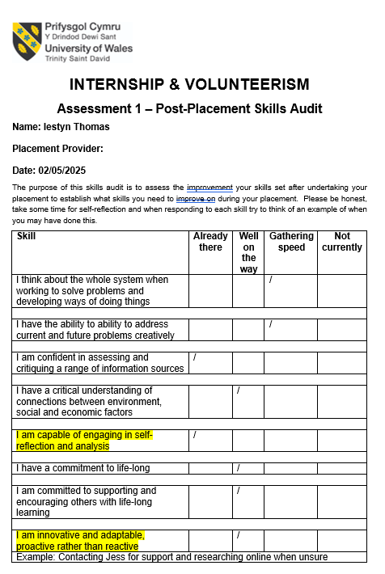
Appendix 1



