Digital Skills and Research Methods Assignment 1 Task 2
BMSW4003 – Lecturer: Suneth Fernando
Daniele Hamza Fathallah
(2011264)

Table of Contents
INTRODUCTION 2
BACKGROUND 2
Services 2
Technology 2
Benefits 5
Challenges 5
Opportunities 5
Risks 6
Legislations 6
AIMS AND OBJECTIVES 6
METHOD 6
RESULTS 7
Responses for questions Q1 and Q2 7
Responses for questions Q3 and Q4. 7
Responses for questions Q5 and Q7. 8
Responses for questions Q& and Q8. 8
Responses for question Q9. 8
Responses for question Q10. 9
DISCUSSION 9
7.0 CONCLUSION 10
References 11
Appendix 12

INTRODUCTION
In this report will be discussed the impact “Virtual Learning Environment” (VLE) or “e-learning” has on students learning experiences. The term e-learning was introduced in the late 90s and there are many definitions of it as it comes in several forms. However, its comprehensive definition is:
“all forms of electronic supported learning and teaching, which are procedural in character and aim to effect the construction of knowledge with reference to individual experience, practice and knowledge of the learner. Information and communication systems, whether networked or not, serve as specific media …to implement the learning process” (Craig, et al., 2012).
VLE was supposed to be the best solution to overcome the drawback of classrooms capacity at academic institutions and avoid the implied costs of building new school facilities, even so it is now used by many higher education institutions all-over the world in response to the recent global pandemic, as classrooms are now potential causes of mass contamination. Though, anyone with a computer or smartphone and access to the internet can benefit of the services offered by many on the Web.

BACKGROUND

Services
As said before, virtual learning exists in many forms. For example, there is “computer-based”, which involves the student to learn through a software stored on a local computer or server, or “Internet-based” that is similarly learning through a device, but the information is streamed using the Web (Nejad & Nejad, 2012). Someone could hire a “remote teacher online” and this teacher would interact with his student through online video chats and or instant messaging. There is also “blended learning” which is an amalgamation the original classroom learning, computer-based learning, internet-based learning, and remote teacher online.
A similar combination to blended learning would be “facilitated virtual learning”, where the classroom learning is replaced with a “human” facilitator who supports the student during his learning process, and that could be physically present with the student or communicating with him through electronic communication. “Online learning” is any kind of study that is done over the internet. Last is “full-time online learning” which is a blend of internet-based learning and remote teacher online (Kanimozhi, 2018).

Technology
Technology is the main pillar that led to the realisation of Virtual Learning Environments; indeed, it is thanks to recent technology advancement that the world population is able to use superfast internet connection and buy laptops with high resolution cameras already installed within them. Since these are pretty common things that almost everyone has or can get, this is why and how it is possible nowadays to communicate with someone at the other end of the world in a matter of seconds. (Kanimozhi, 2018)
Therefore, a computer and an internet connection (preferably fast) are the main requirements to access any VLE, although some institutions may require their students to install a software or an application, accordingly, it is important to check for compatibility with the computer that is intended to be used. These software are usually “Learning Management Systems” (LMS). These assist with teaching activities and are categorized by the features they support, such as course management, class management, communication tools, student tools, content management and school-management (Benta, et al., 2015).
In this report will be explored in detail the course management system (CMS) called “Moodle” as a result of it being recognised by many authors as a very productive CMS (Benta, et al., 2015). It was also chosen because it is being used by my University, and this allowed the conduction of primary research, that will be presented later in this report.

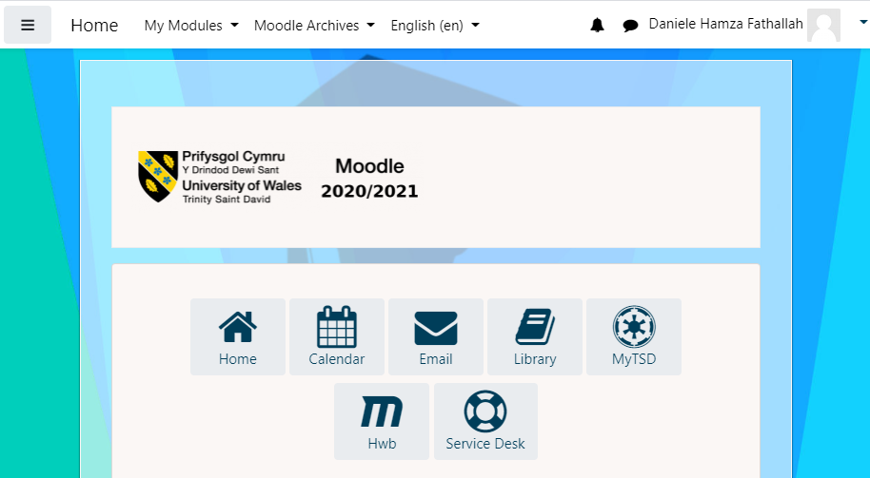
The image above is a screenshot of the homepage of my student account on Moodle. At the top can be seen a tool bar that gives access to the homepage, the modules of the student, and in case the scholar has been at the institution for more than one year, they can access the contents and modules form the previous years through the archives. The language can also be changed between 4 different languages.
In the middle of the page there are some useful links. “Calendar” brings the user to a calendar where are displayed any upcoming lessons or deadlines. “Email” redirects you to your student email account where you can communicate with your colleagues and teacher, as well as get feedback from them. “Library” gives to the student access to the institution library online. “MyTSD” shows the student’s personal information such as attendance and letters received. Through “Hwb” the student can access the institutions website where can be found general information about the university. “Service Desk” allows the student to contact the school’s helpdesk and support-centre where an operator will assist the student with any technical issues they might have.
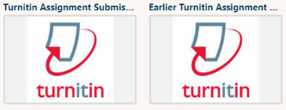
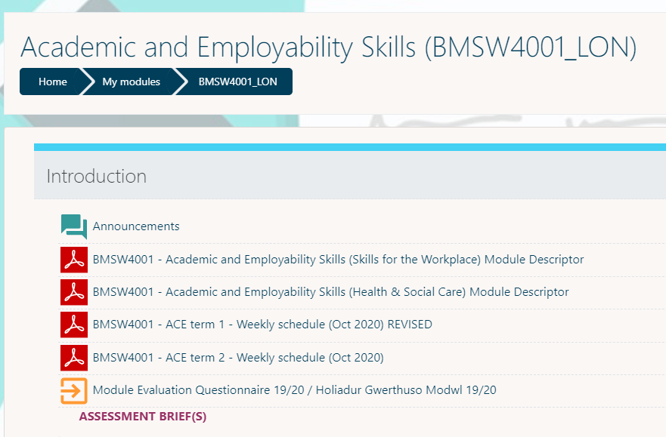
For each module, the student is provided with assessment briefs that explain the guidelines for the assessments, and a link to “Turnitin” the most widely used plagiarism detection software (Craig, et al., 2012) where the students upload their assignments for review and grading.
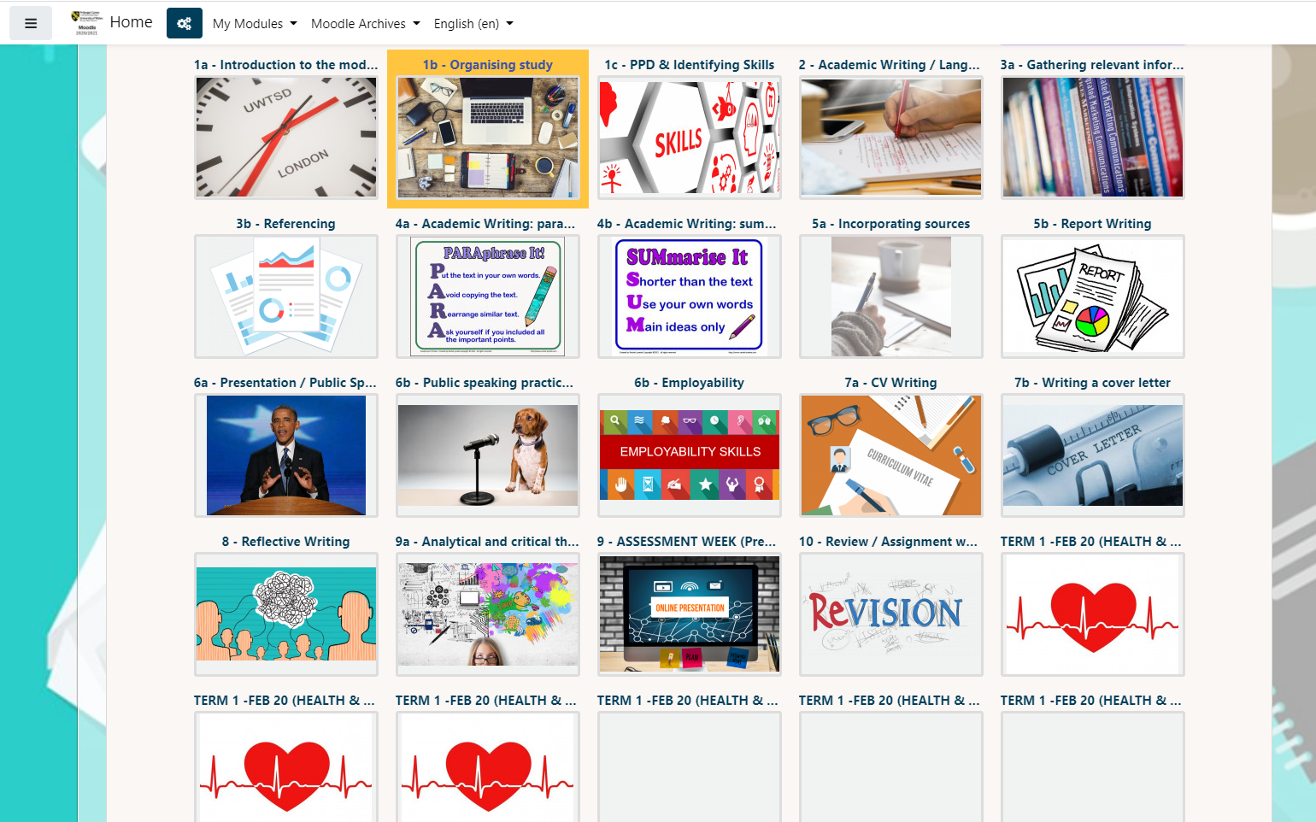
For each module can also be found a number of lessons that are prepared by the teachers before the beginning of the academic year, with the support from Service Desk, and for each lesson is provided a PowerPoint Presentation, Word documents, articles from journals and/or videos to implement different types of information available to the learner.
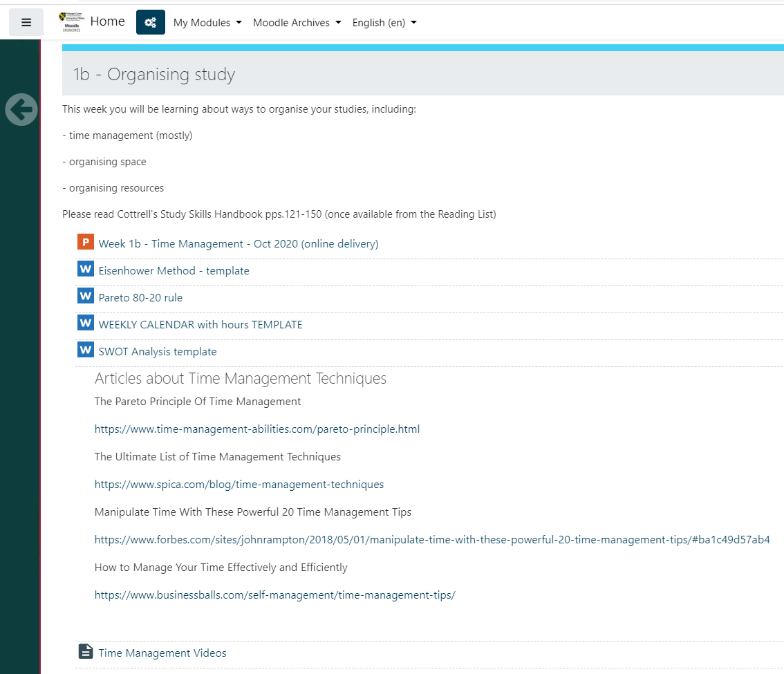

Benefits
There are many benefits that come from the use of VLE at universities. For the institutions training courses costs decrease exponentially and it is easier to manage e-learning programs for large numbers groups of students rather than traditional classes (Nejad & Nejad, 2012). The students can adjust to their learning program and speed, and also eliminate unnecessary and costly travel to attend classrooms (Nejad & Nejad, 2012). It is also recorded that the use of VLE improves the quality of teaching and learning by attacking the lost interest from the students towards their homework tasks and course participation.
In fact, a study carried out during spring 2012 to compare traditional teaching and e-learning has shown that 82% of the student using VLE were able to submit their work, where a 56% of students taught via traditional learning did not submit their work in time. In addition, VLE learners also had a higher percentage of students attending the lessons by a good 15% (Benta, et al., 2015).

Challenges
The main challenge in VLEs is the student’s ability to manage their time in order to meet set deadlines, and the level of skills of each individual with computers, however this can be overcome very easily by teaching those subjects first, like my university has done with me.

Opportunities
The opportunities to improve the VLE services can be found out by gathering reviews from the students, teachers and administrators and use them to adjust any software malfunction, teaching instruction or issue that may be brought up. However, it is up to the institution to collect those feedbacks and analyse them to create opportunities, like for example, the academic office of my university regularly sends an email when approaching the end of each term. This email invites the students to complete an evaluation questionnaire where is asked their opinion on the different aspects of the modules. The university academic office team also confirms in the same email that the answers are going to help the teaching teams to make more informed decisions on how to improve moving forwards.

Risks
The risks of using VLE come mainly from the users and the developers. As a matter of fact, they all must be aware of hackers and/or other users with malicious intents like modification or destruction of assignments, or passwords theft. In spite of this the developers must create software with robust security features that are able to defend against these hacking attacks or viruses/malwares. The users, on the other hand, must be able to recognise fraudulent activities in order to avoid them when online and be aware of the various types of strikes that hacker might use, and this is valid for all users; students, teachers, and administrators. (Sharma, et al., 2012)

Legislations
The last part of this report’s section concerns the legislations associated with e-learning. The Defence Awarding Organisation (DAO) is a powerful establishment approved from the Office of Qualifications and Examinations Regulations (Ofqual) that develops and provides nationally recognised qualifications to the defence communities (Government Digital Service, n.d.). The DAO aim is to enable students to study via e-learning without being disadvantaged by the implementation of VLEs, and so they have adopted seven principles to support this aim and other policies and legislations associated with e-learning (Government Digital Service, n.d.), more information can be found here.

AIMS AND OBJECTIVES
The aim of this report is to find the positive and negative aspects of the impact virtual learning services had on academic institutions in the UK, identify possible opportunities to improve it, and gain knowledge about the VLEs. To achieve these aims was conducted research on the topic to collect data, various sources were explored, then the information collected was analysed.

METHOD
For this report was performed initially performed secondary research to collect quantitative and qualitative data in order to come to an understanding of what services does VLEs offer, the technologies required to use them, and all the benefits, opportunities, risks, and legislations that come from using VLEs. To be more precise, in this report various reliable journals articles, conference papers and websites were mentioned. In addition, the university’s Moodle was accessed to collect the screenshots and information relevant to the study of the topic.
Next, was conducted a primary research approach to collect quantitative and qualitative data related to my university’s VLE. For that reason, the online software tool, Google Forms, was used to create an online questionnaire that includes 10 questions related to the VLE used by my university and then it was shared with colleagues and friends who were using the same VLE via email and WhatsApp link, to gather their feedback. MS Excel was used to charts. The survey consisted in 8 multiple choice questions and 2 open-end questions.

RESULTS
Responses for questions Q1 and Q2
Question | Yes | No | Not sure
Q1 | 19 | 0 | 0
Q2 | 11 | 5 | 3

Since the responses of questions 1 and 2 have been taken and analysed, it is noted that the majority of the students are currently studying via VLE and finds it easy to use.

Responses for questions Q3 and Q4.
Questions | Strongly disagree | Disagree | Agree | Strongly agree
Q3 | 3 | 7 | 7 | 2
Q4 | 0 | 1 | 17 | 1

There seems to be a disagreement on whether or not the students would like to complete their studies with VLEs, however, the majority of the respondents would continue to use VLE to communicate with friends and lecturers.

Responses for questions Q5 and Q7.
Questions | 1(Poor) | 2 | 3 | 4 | 5(High)
Q5 | 0 | 1 | 1 | 8 | 9
Q6 | 0 | 0 | 2 | 8 | 9

Almost all the students rated the performance and the services of the VLE they are using as high or very high.

Responses for questions Q& and Q8.
Questions | Very dissatisfied | Dissatisfied | Neutral | Satisfied | Very satisfied
Q7 | 0 | 0 | 5 | 10 | 4
Q8 | 0 | 0 | 6 | 9 | 4

From these responses we can establish that not one student was dissatisfied from the support received from the university staff, or from the resolution of technical issues by the IT Support team.

Responses for question Q9.
Questions | Positive | Negative
Q9 | 17 | 2

This chart confirms that the majority of the students have had a positive experience with VLE.

Responses for question Q10.
Questions | Improvements needed | Improvements not needed
Q10 | 9 | 10

There were still quite a good number of improvements deemed to be necessary by the respondents.

DISCUSSION
From the completed survey we are able to identify that the respondents are currently studying via VLE and that it is easy for them to use it. In spite of this, there is a large part of the respondents would not continue to use VLEs for their studies, though, they would use it to communicate with their colleagues and lecturers. They also rated the performance and the service offered via the VLE as high or very high. The support provided by the IT Support Team and university staff has also been acknowledged and praised by the respondents. There were still many feedbacks regarding improvements that could be done to the VLE and there were some very similar like the need for Moodle to be more interactive, or the need of books in paper-copy rather than e-books.
I do not find myself agreeing with my colleagues only for this last part, even so, since it was not only one person who brought up those improvement opportunities, those might actually be needed by some students. With this said, I found my self very comfortable using the VLE provided by my university and did not find any difficulties whatsoever.

7.0 CONCLUSION
Throughout this report was conducted primary and secondary research to find and explore various aspects of the VLE used by the universities. The result of the research was collected, saved, and examined with the operation of appropriate software tools and it was then used to provide suggestions and opportunities for the improvement of VLE.

References
Benta, D., Bologa, G., Dzitac, S. & Dzitac, I., 2015. University Level Learning and Teaching via E-Learning Platforms. Procedia Computer Science, Volume 55, pp. 1366-1373.
Craig, A., Coldwell-Neilson, J., Goold, A. & Beekhuyzen, J., 2012. A Review of E-Learning Technologies: Opportunites for Teaching and Learning. Porto, INSTICC.
Government Digital Service, n.d. DAO online learning policy. [Online]
Available at: https://www.gov.uk/government/publications/dao-policies/dao-learning-policy#e-learning
[Accessed 14 December 2020].
Government Digital Service, n.d. Defence Awarding Organisation. [Online]
Available at: https://www.gov.uk/government/groups/defence-awarding-organisation#:~:text=The%20Defence%20Awarding%20Organisation's%20mission,exploit%20accreditation%20opportunities%20across%20the
[Accessed 14 December 2020].
Kanimozhi, 2018. Virtual Learning Enviroment. International Journal, 23-24 February, pp. 11-14.
Nejad, M. B. & Nejad, E. B., 2012. Impact of E-Learning and Realizing Information Society. Research Journal of Applied Sciences, Engeneering and Technology, 1 December, 4(23).
Sharma, D., Karforma, S. & Barik, N., 2012. Risks and Remedies in E-Learning System. International Journal of Network Security & Its Applications, January, 4(1), pp. 51-59.

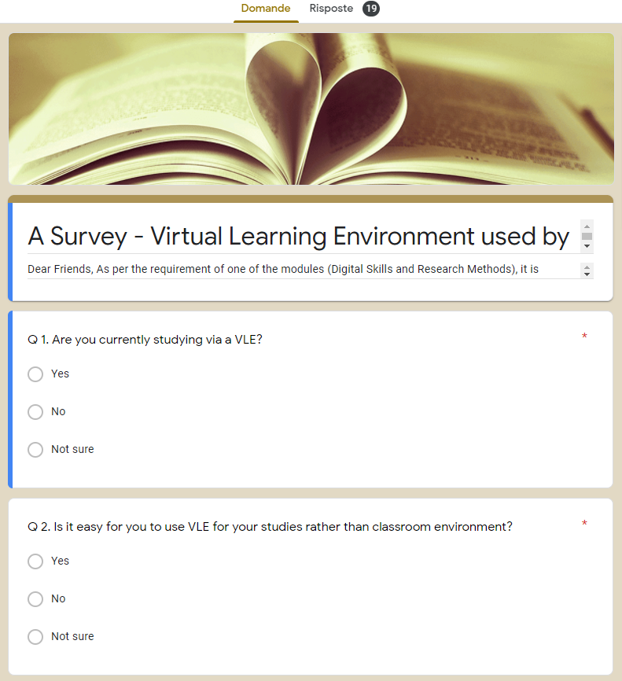
Appendix:


