Marketing Essentials
Individual Presentation & Supporting Marketing Plan

Contents
Introduction 3
Situation Analysis: 5C’s 4
Company Analysis of Travelodge: SWOT 4
Customer Analysis of Travelodge 4
Competitor Analysis of Travelodge: Perceptual Position and Bowmans Clock 5
Collaborator Analysis of Travelodge 5
Climate Analysis of Travelodge: PESTEL 6
Objectives of Travelodge 7
SMART Objectives 7
Strategies for Travelodge 7
Travelodge’s Value Proposition 7
Linking Value Proposition to Target Market 7
Tactics of Travelodge: Marketing Mix 8
Products 8
Place 8
Price 8
Promotion 9
Action for the Plan of Travelodge 9
Controlling the Plan and Activities 9
Conclusion 10
References 11
Appendices 13

Introduction
A marketing plan is a document that outlines the activities that will be followed to achieve a company's marketing goals and objectives, such as research and development, cost analysis, distribution, advertising, and customer service (Kotler, 2020). Travelodge hotel has been selected to demonstrate an understanding of the module. The marketing plan's purpose is to raise awareness and demand for Travelodge's services within the target audience (Travelodge, 2022). To ensure that Travelodge's marketing activities are focused and effective, this report creates a marketing plan for the company by doing a situation analysis utilising frameworks such as SWOT, Bowman's strategy clock, PESTEL, SMART, 4Ps, Gantt Chart, and others.

Situation Analysis: 5C’s

Company Analysis of Travelodge: SWOT
Internal | Strengths | Weakness
Internal | - Extensive network of hotels in the UK  - Low-cost accommodation  - Excellent customer service  - Wide range of amenities | - Limited presence in other markets  - Low level of brand visibility (Viinikka, 2019)
External | Opportunities | Threats
External | - Expansion into other markets  - Increase brand visibility  - Improve customer service (Viinikka, 2019) | - Increasing competition from other budget hotels  - Price fluctuations in the market  - Changes in customer preferences

Customer Analysis of Travelodge
Travelodge's target demographic consists of leisure and business travellers on a restricted budget who value convenience and comfort. Convenience, price, and closeness are more important to these customers (Wu, 2021). Young professionals, families, and the elderly are good clients for the hotel since they prioritise ease and dependability over opulence. Travelodge's demographic surveys show that their average guest is between the ages of 25 and 45 and earns a middle-class wage. They are frequent travellers who book rooms online, often at the last minute, and look forward to a peaceful stay in a clean, quiet room with free Wi-Fi, parking, and breakfast (Misopoulos, 2019).

Competitor Analysis of Travelodge: Perceptual Position and Bowmans Clock
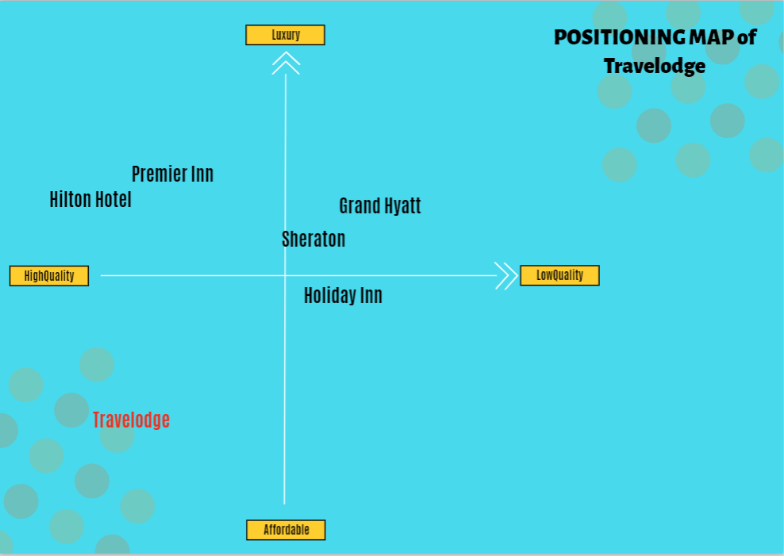
On this map, Travelodge is positioned towards the medium quality of the market, offering affordable accommodation with basic amenities (Wu, 2021). This can further be analysed using Bowman’s Clock Strategy (Bowie, 2017)-
Competitors | Affordability | Quality
Travelodge | Affordable | Medium-High
Premier Inn | Luxury | High-Medium
Holiday Inn | Affordable | Low-Medium
Hilton Hotel | Medium-Luxury | High
Grand Hyatt | Luxury | Low

Collaborator Analysis of Travelodge
Travelodge frequently forms business-to-business (B2B) partnerships, franchises, and other connections. These consumers come from industries such as the airline industry, tourism, vehicle rental, hotel industry, and business sector (Baker, 2022). Travelodge has worked with other big hotel brands such as Accor and Marriott to provide its customers with even more options. Travelodge also has franchise agreements with several individual hotel owners, providing them with the tools and support they need to manage their businesses successfully.

Climate Analysis of Travelodge: PESTEL
Factors | Impacts on Travelodge
Political | Changes in regulations and taxes can affect Travelodge's operations and profitability
Economic | Economic downturns can reduce demand for travel and impact Travelodge's revenue (George, 2021)
Social | Trends towards eco-friendliness and sustainable travel can impact Travelodge's reputation and customer preferences
Technological | Advances in technology can impact the way customers book and experience hotels, requiring Travelodge to adopt (Smith, 2019)
Environmental | Natural disasters and climate change can impact Travelodge's physical assets and operations
Legal | Compliance with laws and regulations related to safety, labour, and data privacy can impact Travelodge's operations and reputation.

Objectives of Travelodge

SMART Objectives
For the next 12 months, the goal of this digital marketing initiative is to increase direct bookings by 15% among the target market of cost-conscious British holidaymakers aged 25-45. This goal is SMART, which means it is both attainable and time bound. A 15% increase in direct bookings is a measurable and relevant goal that is fundamental to the marketing plan (Wu, 2021). Travelodge has identified the market it wants to target and give itself a year to do so. A digital marketing plan will be established to promote direct reservations on Travelodge's website by reaching out to and engaging the target demographic with compelling content and applicable incentives (Madanayake, 2019).

Strategies for Travelodge

Travelodge’s Value Proposition
Travelodge's unique selling point is that it offers low-cost, high-quality hotels in convenient locations. Travelodge is an excellent choice for a hotel that provides economical accommodations without sacrificing quality (Ruetz, 2021). To promote this value offer, Travelodge's marketing campaigns highlight the brand's proximity to public transportation and popular tourist attractions. The organisation delivers on its value promise by consistently meeting customers' expectations for excellent service and investing in cutting-edge solutions to improve their interactions with the company (Jobber, 2019). Travelodge's franchising model allows it to rapidly expand its hotel network while maintaining the same high standard across all of its sites.

Linking Value Proposition to Target Market
With a unique set of amenities, Travelodge caters to a wide range of customer types, from economical vacationers to corporate travellers. This has an impact on its positioning and targeting since it allows it to match the diverse value needs of its clients (Jobber, 2019). Travellers on a tight budget can take advantage of bargains and promotions, while business travellers can take advantage of specially tailored packages that include everything they need, from a central location to the most up-to-date business amenities. Because of the granularity with which its value proposition may be applied, Travelodge is able to effectively engage with and support its preferred clientele.

Tactics of Travelodge: Marketing Mix

Products
Travelodge hotels cater to business travellers, families, and tourists by locating them near transportation hubs and tourist attractions. Travelodge hotel rooms are spacious, modern, and well-equipped with amenities such as free Wi-Fi, a flat-screen TV, and an en suite bathroom. Some of their locations include on-site eateries, conference rooms, and fitness centres, to name a few amenities (Chandiok, 2017). Overall, Travelodge's offers are focused on providing customers with a location to stay that satisfies their demands in terms of affordability, comfort, and accessibility.

Place
Clients of Travelodge can find the location and book rooms in a variety of ways. The Travelodge website is the primary direct booking channel since it includes a simple booking engine where customers can browse hotel rooms, check availability, and book stays (Bowie, 2017). Consumers can also book rooms through third-party websites such as Hotels.com, Expedia, and Booking.com. Travelodge uses social media channels such as Facebook, Twitter, and Instagram to engage with customers, publicise deals, and answer questions. Finally, Travelodge offers a toll-free number for guests to call in and reserve a room. Travelodge has a multi-channel distribution strategy in general, making it easy for customers to identify and book rooms through their preferred channels.

Price
Travelodge's pricing strategy is centred on offering customers competitively priced rooms that fulfil their demands. Prices are affected by a variety of factors, including location, demand, and seasonality. The company studies the market to see how its competitors are faring and adjusts its prices accordingly (George, 2021). At Travelodge, visitors may choose between a room-only stay and a stay that includes breakfast, and the rates vary depending on the decision. Travelodge's pricing is plainly displayed on the website, and customers may save even more by making a reservation in advance or joining the company's loyalty programme (Kotler, 2019). Maintaining a competitive price point is critical for Travelodge in order to satisfy customers and promote the brand.

Promotion
Travelodge will use a mix of old and new media, such as television and radio advertisements, billboards, internet display ads, and social media marketing. The organisation will build these channels to enhance bookings in addition to advertising the website, social media, and email marketing campaigns with offers and discounts (Chandiok, 2017). Travelodge plans to boost conversions by communicating with customers on social media and making the online booking as simple as possible. The company's marketing strategy will focus on building brand recognition, generating reservations, and retaining existing customers.

Action for the Plan of Travelodge
This Gantt chart provides the marketing activities along with the timing to complete and precede each other’s to go through the marketing channels effectively to meet the goals (Stephenson, 2020).

Controlling the Plan and Activities
Surveys, internet analytics, and sales data can all be used to measure Travelodge's success. Client feedback can be gathered through surveys, online reviews, and chats with support employees. Web analytics allows Travelodge to track traffic, interactions, and sales (Ferrell, 2021). Finally, sales analytics can be used to track things like bookings, revenue per booking, and total sales. Travelodge may evaluate the effectiveness of its advertising by monitoring these factors and altering its approaches accordingly.

Conclusion
Travelodge's target demographic consists of cost-conscious leisure and business travellers who value convenience, affordability, and quality. Travelodge intends to deploy a concentrated digital marketing approach over the next 12 months to increase direct reservations by 15% among cost-conscious British travellers aged 25-45. Travelodge hotel pricing, amenities, and availability vary depending on location, demand, and season. Travelodge will use both traditional and online channels to spread the word about its brand and drive interest in its promotions and discounts.

References
Baker, S. and Cantillon, Z., 2022. Zines as community archive. Archival Science, 22(4), pp.539-561.
Bowie, D. Buttle,F. Brookes, M & Mariussen, A (2017), Hospitality Marketing. 3rd ed, Routledge,
London
Chandiok, S. and Sharma, P., 2017. Hospitality Marketing: Strategic Issues. In Strategic Marketing Management and Tactics in the Service Industry (pp. 213-242). IGI Global.
Ferrell, O.C., Hartline, M. and Hochstein, B.W., 2021. Marketing strategy. Cengage Learning.
George, R., 2021. The Tourism and Hospitality Marketing Environment. In Marketing Tourism and Hospitality: Concepts and Cases (pp. 183-219). Cham: Springer International Publishing.
George, R., 2021. Tourism and Hospitality Products, Branding, and Pricing. In Marketing Tourism and Hospitality: Concepts and Cases (pp. 249-283). Cham: Springer International Publishing.
Jobber, D. and Ellis-Chadwick, F., 2019. EBOOK: Principles and Practice of Marketing, 9e. McGraw Hill.
Kotler, P., Armstrong, G., Harris, L. and He, H., 2020. Principles of marketing. 8th European ed,
London: Pearson Education Limited.
Kotler, P., Bowen, J.T., Makens, J.C. and Baloglu, S., 2019. Marketing for hospitality and tourism.
Madanayake, U.H., 2019. Application of lean construction principles and practices to enhance the construction performance and flow.
Misopoulos, F., Mitic, M., Kapoulas, A. and Karapiperis, C., 2019. Uncovering customer service experiences with Twitter: the case of airline industry. Management Decision, 52(4), pp.705-723.
Ruetz, D. and Marvel, M., 2021. Budget Hotels: Low Cost Concepts in the US, Europe and Asia: What Lies Ahead for the Industry?. Trends and issues in global tourism 2011, pp.99-124.
Smith, P.R. and Zook, Z., 2019. Marketing communications: Integrating online and offline, customer engagement and digital technologies. Kogan Page Publishers.
Stephenson, R., 2020. How to write a digital marketing plan using PR Smith’s SOSTAC planning model. Verfügbar unter: https://digitaldimensions4u. com/how-to-write-a-digital-marketingplan-sostac-model/(Zugriff am 31.07. 2021).
Travelodge (2022). Travelodge | Great value hotels throughout the UK & Ireland. [online] Travelodge. Available at: https://www.travelodge.co.uk/.
Viinikka, E.L., 2019. The Future Development of The New County Hotel.
Wu, S.Y., 2021. A Study on Promotion Strategies and Purchase Intention during the epidemic situation-In the Travelodge Industry.

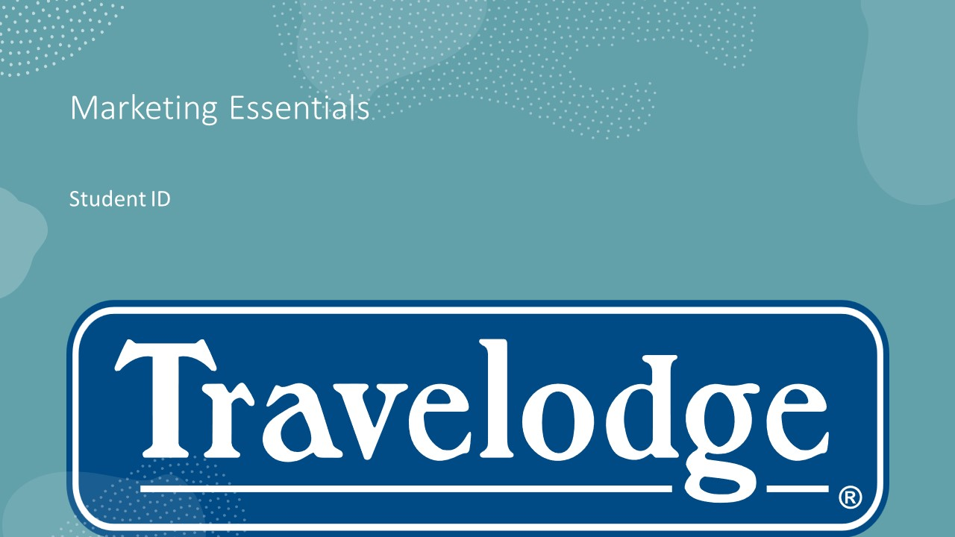
Appendices


