NAME:Isha muskaan

STUDENT ID:2128279

MODULE:Human resource management assessment1

MODULE CODE: LCMB7000

LECTURER: Gladius David kulothungan

COURSE:Master’s in business administration

SUBMISSION DATE:14-09-2022

LCMB7000 HRM_A1
Impact of Brexit and Covid-19 on the labor market of the country
Table of Contents
Introduction 2
Section A 2
A brief explanation of the labor market 2
The current state of employment in the UK 2
Factors that affect the labor market in the UK 3
The current state of the Labour market in the UK 4
What issues are the companies in the UK facing due to the depletion in the labor market? 5
What mitigations can the companies take to improve their labor market in the coming years? 6
Section B 7
Background of the company (Tesco) 7
Definition of Human resource strategies 7
The changes occurred post covid in the HMR scenario after covid in the UK 7
What is the effect of covid on the company (Tesco) 8
What is the effect of Brexit on the company (Tesco) 8
What are the various strategies that are implemented by the company (Tesco) to manage its human resources, in post covid and post Brexit scenario 10
Conclusion 10
References 11

Introduction
The labor market and proper labor management are one of the most important factors in the development of a country's economy. This report puts light on the effect of the covid-19 and Brexit on the labor market of the UK economy, what are the major impacts of the two factors, and what steps can be taken on behalf of an organization to mitigate these factors and uplift the labor market of the UK economy. For research, UK-based company Tesco has been taken as an example, to state the major impacts of covid and Brexit on the company’s economy.

Section A

A brief explanation of the labor market
The manpower which is essential for the owners to implement the objectives regarding their business in the market is known as the labor market. It mainly refers to the employee circle that plays an important part in initiating the business management of an organization or company successfully. It deals with the handling of the supply chain, mitigating customer-related queries, and so on. The labor market mainly depends upon two factors: the supply of an organization and the manpower that the company provides that is required to run the supply chain efficiently. The employees over the manpower are hired by the organization based on technical or educational qualifications, in return for monetary wages. The laborers work under the employers in return for wages and help them to run a successful production chain.

The current state of employment in the UK
In recent years the employment level in the UK has dropped down subsequently due to covid (74.7%), though at the beginning of the recent year it has shown a bit of development (75.6%), as stated in figure 1. In the first half of the year 2020, just before covid hit the country, the employment level was climbing up but fell drastically due to the effects of covid in the latter half of the year.
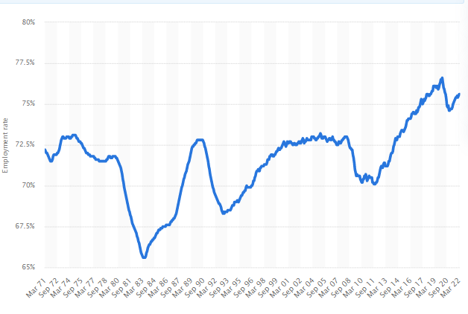
Figure 1: Graph showing employment growth in the UK
(Source: Statista, 2022)
As per the views of Wielgoszewska et al. (2021), the employment levels reached higher levels before the covid-19 hit the country and that resulted in the breakage of the supply chain of several industries, as they had to enforce a break due to the lockdown scenario. Before the pandemic, it was recorded that more than 31.68 million people in the country were amongst, which declined by a major margin of 500,000 once the covid situation arose. The situation affected the economy of the UK's labor market.

Factors that affect the labor market in the UK
As per the views of Worth and Faulkner-Ellis, (2021), a lot of situations affect the labor market in the UK, one of the main reasons is the effects of Brexit and Covid on the economy of the nation, but these are some issues which come in the daily informative platforms, whereas there are certain other factors which have an impact on the labor market of the country,
Regeneration programs regarding the country's economy are one such issue. Money is invested by the organizations to impose employees on certain projects. But due to the covid the companies ahs to close down their working, thus, creating fewer chances of job opportunities within the country leading to unemployment. training and education-related initiatives, as the schools and education centers were closed down due to the lockdown scenario within the country, it stopped the normal flow of new employees with various technical skills, which caused a disbalance in the labor market of the country. According to Wang et al. (2021), the factor is of course the unemployment factor in the country, during the pandemic, there was a high demand for products in the market as the production line was closed which resulted in many people couldn't afford the products as they were not getting any proper wages. As stated by Fullard, 2021, the working population of the country has declined rapidly after the break of the pandemic as the industries and organizations have to stop their business chain, which also affected the labor market of the country.

The current state of the Labour market in the UK
The current status of the labor market in the UK suggests that from December last year till the end of February this year the employment rate of the country is almost the same, while the latter part of the year has seen a slight rise in the employment rate. The employment rate of the country was on the higher side just before the global outbreak of the covid-19. However, there was a drastic change in the employment rate due to the effects of covid. 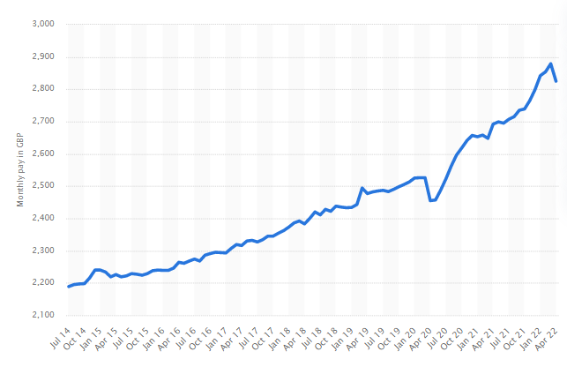
Figure 2: Graph showing the rise in the mean monthly pay of the employees in the UK
(Source: Statista, 2022)
According to the present scenario, the employment rate of the country increased by 3.8% after the pandemic scenario passed and currently the country's economic conditions are towards improvement. After the pandemics, the industries have again opened up their productions and are in high demand of employees, as in the early part of this year the job vacancy rose to a record-breaking 1,288,000 seats, along with a growth in the pay wages (5.4%) as shown in figure 2.

What issues are the companies in the UK facing due to the depletion in the labor market?
The two major issues that are faced by the companies in the country is due to the offset of Brexit and the outbreak of pandemic as shown in figure 3,
Effect of Brexit on the labor market of the UK, the country is facing severe problems in its economy after the Brexit situation rose the country, as the company stopped trading with other parts of Europe. This caused a major downfall in the supply chain of the country, causing a rise in unemployment. According to Davenport and Levell, (2022), the Brexit scenario has reduced the economy of the country within its local markets and the monopoly percentage has fallen by 1.5%. As the companies based in the UK no longer are eligible to trade in other parts of Europe.
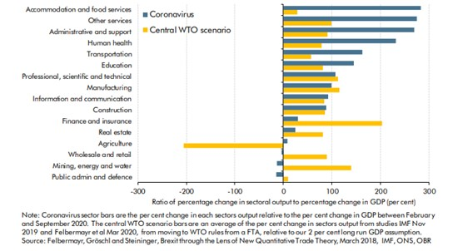
Figure 3: Comparison of the impact of Brexit and covid-19 on the UK economy
(Source: TUC.co.uk, 2020)
Effect of covid-19 on the labor market of the country, just after the Brexit situation the country faced the measured impact of covid-19. As stated by Khamis et al. (2021), the UK government has to enforce a lockdown scenario within the country for public health safety, as a result of which the unemployment rate declined further, impacting the labor market of the country.

What mitigations can the companies take to improve their labor market in the coming years?
The labor market of the country is constantly changing due to the changing global scenarios with each passing day. As stated by Clemens (2021), the Brexit scenario followed by the outbreak of the covid-19 within the country has led to large depletion in the human resource rate. Thus, the companies also have to be aware of these situations and have to implement further strategies by keeping these factors in mind. According to Simionescu et al. (2021), the first and foremost thing before strategizing the plans with the help of an experienced advisor is the key, to keep updated about the global marketing scenario and the effects it may have or the situations it may cause. As per the views of Piroșcă et al. (2021), it is also important to be updated about the present situation of the industrial sector in which the company belongs, as acquiring proper data will help in the implementation of the strategies more effectively. A company should be well aware of the market demands and customer preferences and should involve its employees to function accordingly, to gain suitable results for the company.

Section B

Background of the company (Tesco)
Tesco is the UK's largest retailer of general merchandise and the company carries out its business with the yelp of online and multi-format offline stores. The company sells a variety of differentiated products and operates stores in various formats. Tesco has a wide variety of food and general products including baby products, general appliances, beauty products, clothing, and bakery to offer and even provides services such as retail baking, consultancy, and insurance services.

Definition of Human resource strategies
A human resource strategy is a strategy devised by organizations to address issues with the help of people-centered solutions. As stated by Bartik et al. (2020), an effective human resource strategy is essential for organizations to develop the appropriate policy and is also essential for talent management, compensation, recruitment, and maintaining the corporate culture. To develop an effective human resource development plan, it is essential to have an accurate estimate of the organization’s strengths, opportunities, threats, and weaknesses. With the help of this information, it is easier for employers to determine realistic goals and decide upon necessary improvements.

The changes occurred post covid in the HMR scenario after covid in the UK
The coronavirus pandemic has disrupted businesses and organizations and changed the way organizations work as businesses now have to adjust to the new social; distancing practices. To cope with the spread of the virus, companies have switched to a work-from-home model and email and video conferencing have replaced face-to-face interactions (Collings et al. 2021). Companies are now encouraging their workers to work remotely and there is little chance for organizations to go back to a full on-site arrangement since it would mean losing almost fifty percent of the workforce. For this new hybrid environment to work, it is essential to have culture connectedness, employee flexibility, and effective human leadership. There is a shortage of skills in the market and employers are finding it hard to find talent who will fill the skill gap in the industry (Azizi et al. 2021). There is also the difficulty of optimizing costs in the current economic environment since the pandemic timers have given rise to an inflated economy. The hybrid model also does not ensure that employees will adjust to it and this has made the diversity, equity, and inclusion (DEI) outcomes worse (Gigauri, 2020). To make sure that all employees are supported in the hybrid model, it is essential to ensure that any bias in performance is mitigated and underrepresented talent is supported. The hybrid model has also increased the turnover rate since there is more choice in employees when the location is no longer a factor. The role of managers is also changing and managers are now taking more initiatives to establish and develop meaningful relationships with the team members. The manager-employee relationship is now considered critical to maintaining the culture of the organization (Zhong, 2021).

What is the effect of covid on the company (Tesco)
Tesco is regarded as the UK's largest supermarket chain and during the pandemic times, the organization’s profits went down by a fifth over the past due to the high costs of hiring employees as well as pandemic expenses. Due to covid related costs, the company’s profits went down almost by 900 million which included the cost for hiring new employees. During the pandemic time, Tesco had to hire almost 50,000 new employees and out of these 50,000 employees, only a small number of workers went on to work with the company permanently( business-standard.com, 2022). To ensure that its stores were safe and sanitary, the company had to undertake extra costs, and the company's decision to hand back 585 million pounds of tax relief to the British government significantly lowered the profit margin of the company
Like other retailers, Tesco had benefited from the increase in demand to hoard groceries at the start of the pandemic when at-home meals and stay-at-home orders altered the eating habits of the customers (Cummins et al. 2022). At the end of 2020, Tesco's sales had increased by 7% with the sales from its online portal jumping to 77 percent (business-standard.com, 2022). This was due to the company's decision to double the delivery capacity to meet the increasing demand from house-bound consumers. Tesco's incredible strength and agility during the pandemic times contributed to its success although the company's share price fell to 1.5 percent.

What is the effect of Brexit on the company (Tesco)
Brexit is regarded as a revolutionary decision in recent times for both the UK and EU. The Brexit crisis has affected the delivery of goods to Northern Ireland including fresh fruits and ready meals. The obstacle in the delivery of goods to North Ireland, among other post-Brexit complications has impacted supermarkets including Tesco. The cost and delay in the food supply network have negatively impacted Tesco and have led to repercussions. Due to Brexit, Tesco can operate more freely with other countries which are in the EU trading bloc, and hence the cost of importation and supplies is reduced (thegardian.com, 2022).
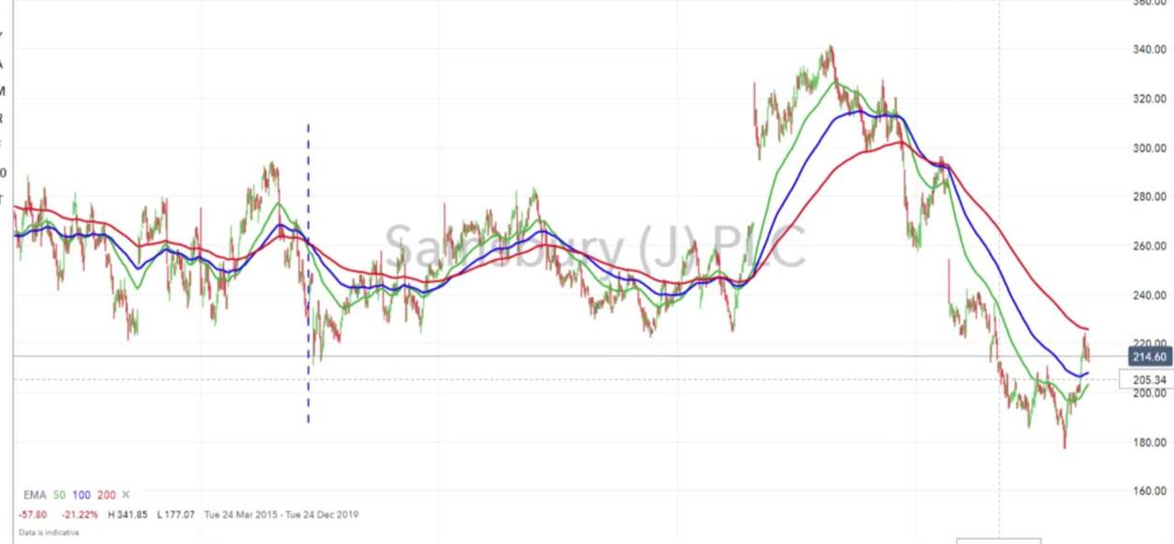
Figure 4: Impact of Brexit on Tesco
(Source- ig, 2022)
The above graph shows the impact Brexit has had on Tesco. Although food retailers are trying to keep their process down, in the post-Brexit climate the increasing shipping and commodity costs as well as the red tape which was relaxed due to Brexit means that low prices of food will not be sustainable (Breinlich et al. 2022). The cost of food processes is likely to increase due to Brexit and food retailers like Tesco will eventually find it hard to cope with the rise in prices. However, John Allan who is the chairman of Tesco does not regard the rise in food prices as a challenge and maintains that changes in food prices will be quite moderate under Brexit (theguardian.com, 2022). He notes that it will be hard for the consumers to deal with the rise in prices and hence Tesco will ensure that the prices remain moderate and affordable. Due to the increased costs of importing, even the price of raw food products like eggs, vegetables, fresh meat, and dairy will also face a rise in prices and hence Tesco faces the possibility of an increase in prices of raw food products (Symes and Phillipson, 2019).

What are the various strategies that are implemented by the company (Tesco) to manage its human resources, in post covid and post Brexit scenario
Tesco has an effective finance department in place which helped the company to deal with both the covid crisis and the post- Brexit climate. During the pandemic timers, the organization’s business doubled its capacity for online shopping and was one of the first UK retailers to fulfill one million grocery orders (Monte, 2021). To deal with the increase in demand, Tesco employed almost 50,000 new workers to work at distribution centers and delivery drivers and even members of the finance team were ready to work on store floors (icaew.com, 2022). Like other organizations, employees at Tesco had to get used to a work-from-home model and the company ensured that this transition went smoothly so that employees could work seamlessly during the difficult times. While Tesco experienced an increase in sales due to online shopping, the pandemic also meant additional costs and the company had to maintain a disciplined approach toward cost and cash (Boons et al. 2021).
To deal with Brexit, Tesco had to introduce several measures to maintain strong supplier relations and an effective distribution capacity to ensure the ready availability of goods and services to its customers. Tesco has claimed that it has one billion in gross cost savings and hence it will be able to tackle the problem of cost inflation (firesafecouncil.org, 2022). Tesco has relied on innovation to cope with the post-Brexit climate and hence they are paying more attention to the needs and demands of the customers. The organization has invested in technology such as upgraded delivery systems and shopping machines to improve the customer experience.

Conclusion
To conclude, in this report the labor market and the current state of employment in the UK have been evaluated. The effect of Brexit on the labor market of the UK has also been discussed along with the strategies UK companies have taken to deal with the changing labor laws. In this context, the report also includes background information on Tesco and the effect of covid and Brexit on the company. Further, the report also analyses the strategies the company has taken to deal with both the Covid-10 and Brexit crises.

References
Azizi, M.R., Atlasi, R., Ziapour, A., Abbas, J. and Naemi, R., 2021. Innovative human resource management strategies during the COVID-19 pandemic: A systematic narrative review approach. Heliyon, 7(6), p.e07233.
Bartik, A.W., Bertrand, M., Lin, F., Rothstein, J. and Unrath, M., (2020). Measuring the labor market at the onset of the COVID-19 crisis (No. w27613). National Bureau of Economic Research.
Boons, F., Doherty, B., Köhler, J., Papachristos, G. and Wells, P., 2021. Disrupting transitions: Qualitatively modeling the impact of Covid-19 on UK food and mobility provision. Environmental innovation and societal transitions, 40, pp.1-19.
business-standard.com, 2022, uk-supermarket-giant-tesco-sees-profit-dented-by-covid-related-costs [Available at: https://www.business-standard.com/article/international/uk-supermarket-giant-tesco-sees-profit-dented-by-covid-related-costs-121041400640_1.html#:~:text=Profits%20were%20weighed%20down%20by,have%20joined%20the%20retailer%20permanently.] [Accessed on: 7.07.2022]
Clemens, J., (2021). How do firms respond to minimum wage increases? understanding the relevance of non-employment margins. Journal of Economic Perspectives, 35(1), pp.51-72.
Collings, D.G., Nyberg, A.J., Wright, P.M. and McMackin, J., 2021. Leading through paradox in a COVID‐19 world: Human resources comes of age. Human Resource Management Journal, 31(4), pp.819-833.
Cummins, S., Berger, N., Cornelsen, L., Eling, J., Er, V., Greener, R., Kalbus, A., Karapici, A., Law, C., Ndlovu, D. and Yau, A., 2020. COVID-19: impact on the urban food retail system and dietary inequalities in the UK. Cities & Health, pp.1-4.
Davenport, A. and Levell, P., (2022). Brexit and labor market inequalities: potential spatial and occupational impacts. Oxford Review of Economic Policy, 38(1), pp.50-67.
firesafecouncil.org, 2022, how-can-brexit-affect-tesco/#12 [Available at: https://www.firesafecouncil.org/how-can-brexit-affect-tesco/#12] [Accessed on: 7.07.2022]
Fredman, S., 2022. Inching Forward: Preliminary Victory for Equal Value at Tesco and Asda. Industrial Law Journal, 51(1), pp.166-173.
Fullard, J., (2021). Bad economy, good teachers? The countercyclicality of enrolment Into Initial Teacher Training Programmes in the UK (No. 2021-06). ISER Working Paper Series.
Gigauri, I., 2020. Influence of Covid-19 crisis on human resource management and companies’ response: the expert study. International Journal of Management Science and Business Administration, 6(6), pp.15-24.
icaew.com, 2022, adapting-to-covid19-the-Tesco-story [Available at: https://www.icaew.com/insights/interviews-and-profiles/2020/july-2020/adapting-to-covid19-the-tesco-story] [Accessed on: 7.07.2022]
ig.com, 2022 [Available at: https://www.ig.com/en/news-and-trade-ideas/are-tesco--sainsburys-and-morrisons-ready-for-brexit--190923] [Accessed on: 7.07.2022]
Khamis, M., Prinz, D., Newhouse, D., Palacios-Lopez, A., Pape, U. and Weber, M., (2021). The early labor market impacts of covid-19 in developing countries.
Monte, A., 2021. A study of value chain reconfiguration processes under Covid-19 pressures: the case of Tesco PLC in the United Kingdom.
Piroșcă, G.I., Șerban-Oprescu, G.L., Badea, L., Stanef-Puică, M.R. and Valdebenito, C.R., (2021). Digitalization and labor market—A perspective within the framework of pandemic crisis. Journal of Theoretical and Applied Electronic Commerce Research, 16(7), pp.2843-2857.
Simionescu, M., Bilan, Y., Zawadzki, P., Wojciechowski, A. and Rabe, M., (2021). GHG Emissions Mitigation in the European Union Based on Labor Market Changes. Energies, 14(2), p.465.
Staista, (2022)[Accessed from: https://www.statista.com/statistics/281992/employment-rate-in-the-united-kingdom/#:~:text=In%20the%20three%20months%20to,the%20same%20period%20in%202021.][Accessed on: 7-07-2022]
Statista, (2022)[Accessed from: https://www.statista.com/statistics/1224830/mean-monthly-pay-of-employees-uk/] [Accessed on: 7-07-2022]
Symes, D. and Phillipson, J., 2019. 'A sea of troubles'(2): Brexit and the UK seafood supply chain. Marine Policy, 102, pp.5-9.
theguardian.com, 2022, Tesco-prices-UK-EU-fail-agree-Brexit-no-deal-shortages-tariffs [Available at: https://www.theguardian.com/business/2020/dec/09/tesco-prices-uk-eu-fail-agree-brexit-no-deal-shortages-tariffs] [Accessed on: 7.07.2022]
theguardian.com, 2022, Tesco-prices-Uk-EU-fail-agree-Brexit-no-deal-shortages-tariffs [Available at: https://www.theguardian.com/business/2020/dec/09/tesco-prices-uk-eu-fail-agree-brexit-no-deal-shortages-tariffs] [Accessed on: 7.07.2022]
Tuc.org.uk, (2020)[Accessed from: https://www.tuc.org.uk/research-analysis/reports/impact-covid-19-and-brexit-uk-economy][ccesed on: 7-07-2022]
Wang, S., Coutts, A., Burchell, B., Kamerāde, D. and Balderson, U., (2021). Can active labor market programs emulate the mental health benefits of regular paid employment? Longitudinal evidence from the United Kingdom. Work, Employment and Society, 35(3), pp.545-565.
Wielgoszewska, B., Maddock, J., Green, M.J., Di Gessa, G., Parsons, S., Griffith, G.J., Croft, J., Stevenson, A.J., Booth, C., Silverwood, R.J. and Bann, D., (2021). The UK Coronavirus Job Retention Scheme and changes in diet, physical activity, and sleep during the COVID-19 pandemic: Evidence from eight longitudinal studies. MedRxiv.
Worth, J. and Faulkner-Ellis, H., (2021). Teacher Labour Market in England: Annual Report 2021. National Foundation for Educational Research.
Zhong, Y., Li, Y., Ding, J., and Liao, Y., 2021. Risk management: Exploring emerging Human Resource issues during the COVID-19 pandemic. Journal of Risk and Financial Management, 14(5), p.228.

