
Assignment 1: E-Portfolio
Syed Ali Aijaz Haider Shah
ID: 2544683
Course: Learning in the Digital Era
Module code: ACCA4025

Learning in the Digital Era
ACCA4025
July 24, 2026

Table of Contents

E-Portfolio 2
Task 1 – Written summary. 3
Task 2 – Mind Map & Academic poster. 5
Task 3 – Automatic Referencing tool 7
Task 4 – e-Portfolio creation and review. 8

E-Portfolio
This section provides access to the online e-portfolio created for this assignment, along with a screenshot of the homepage for reference.
1. Link to e-portfolio homepage: https://sites.google.com/view/syedshahacca4025e-portfolio/home
2. Screenshot of the e-portfolio homepage:

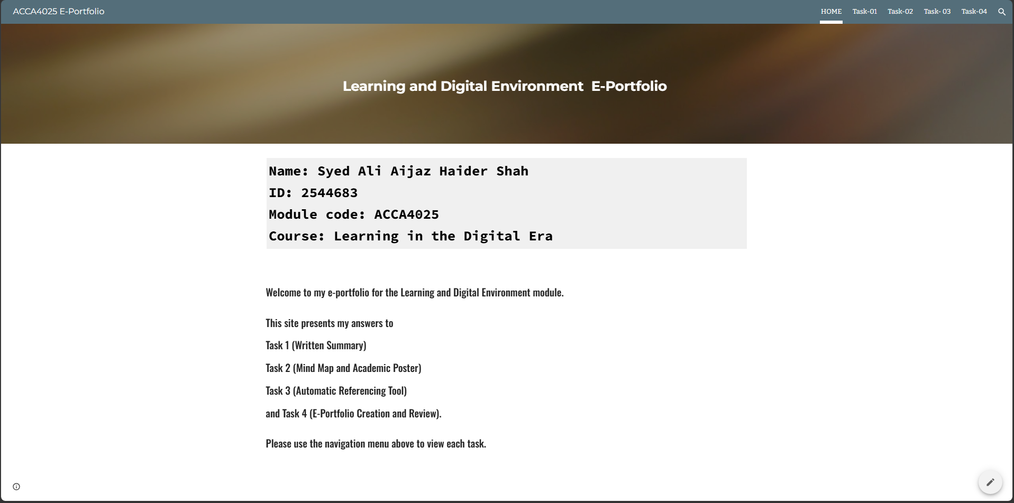

Fig: Screenshot of the Homepage.

Task 1 – Written summary.

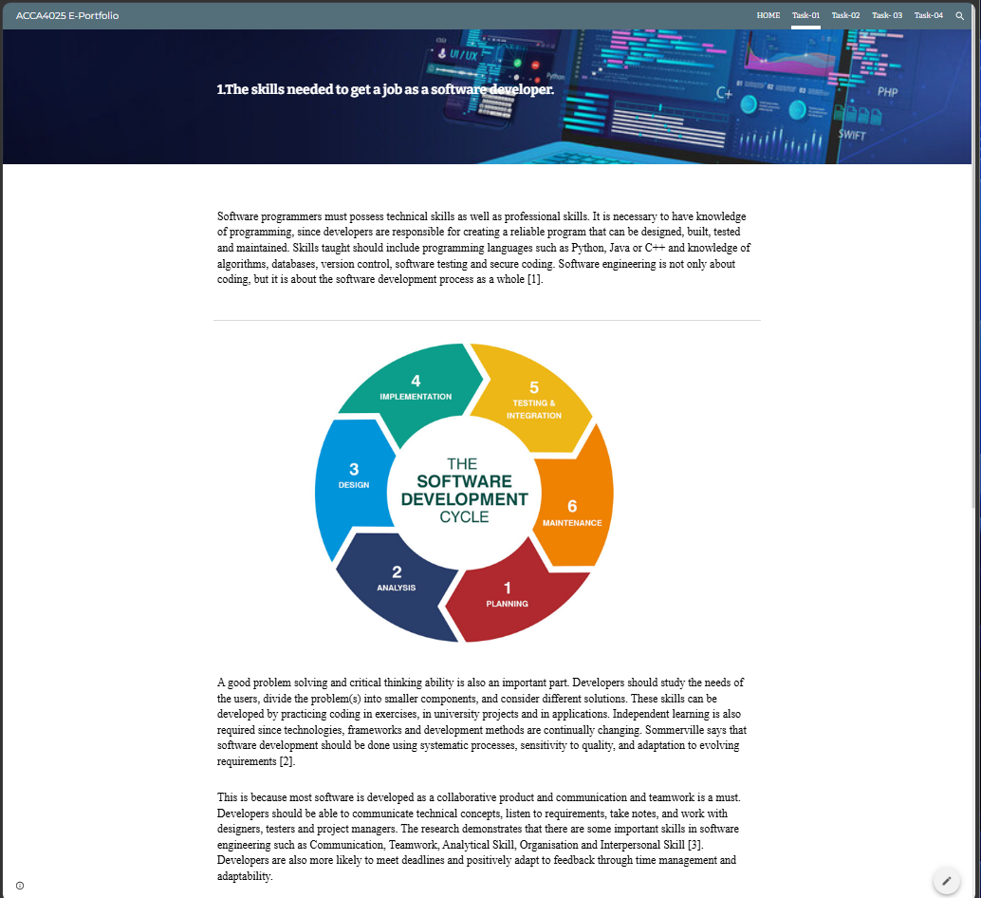

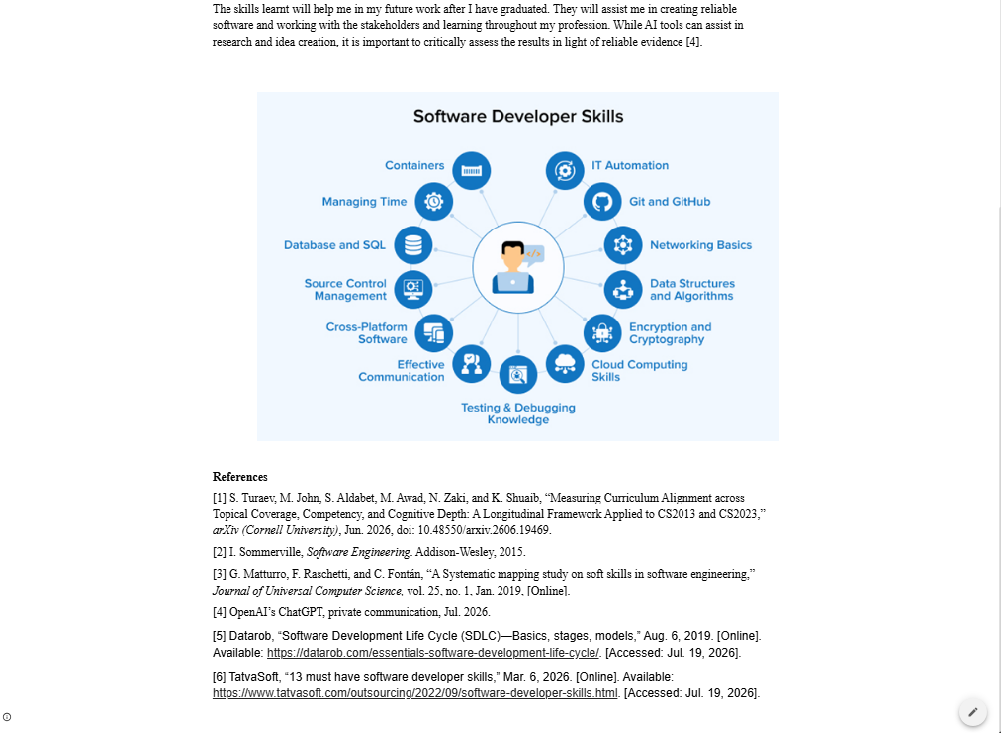

Task 2 – Mind Map & Academic poster.
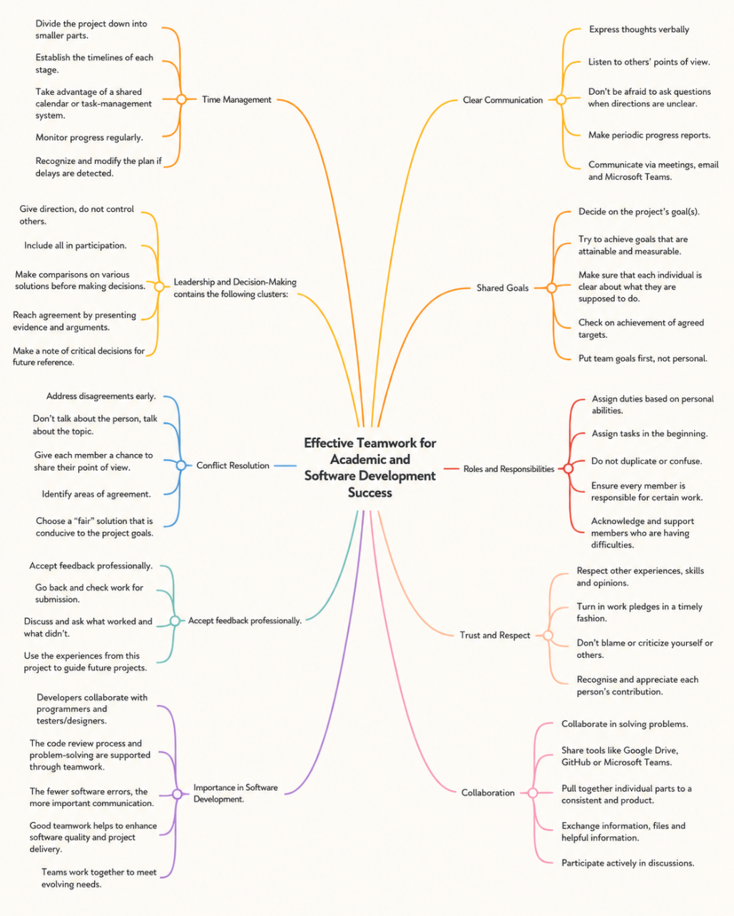

2b. A screenshot of the Poster

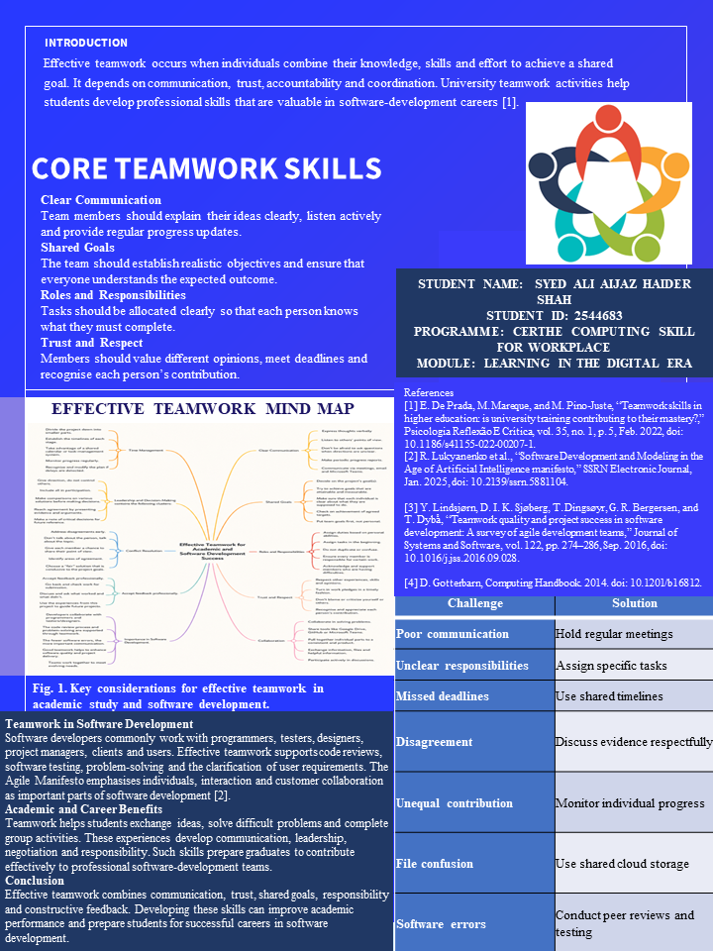

Task 3 – Automatic Referencing tool



Task 4 – e-Portfolio creation and review.

Find below screenshot of each page of E-portfolio.



