Student name: Rosena Lucy

Student ID: 2210256

Programme: MSc Public Health and Social Care in Practice

Module: Community Care and Management of Longer-term Conditions

Module code: LCHS7003

Lecturer: Dr Aishat Bakre

Assignment Title: Component 1

Information Booklet of Long- term Condition Management

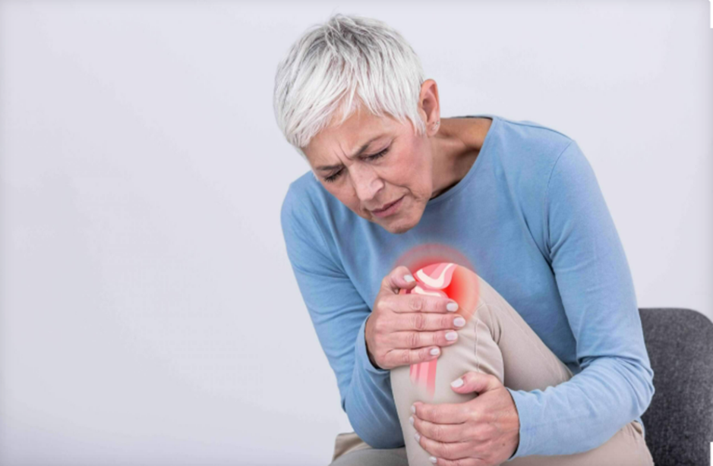
Osteoarthritis
(Bing, 2025)

Contents
Introduction 4
An Information Booklet for Adults Over 45 Living Well with Osteoarthritis: 4
Understanding Osteoarthritis 5
Global Burden and Prevalence 5
Risk Factors and Aetiology 6
Physical Implications 6
Psychological Implications 7
Social Implications 7
Wider Implications for Families and Carers 7
Non-Pharmacological Treatments 8
Pharmacological Treatments 9
Surgical Interventions 10
Multidisciplinary and Community-Based Approaches 10
Evaluation of Effectiveness 10
UK Model: The House of Care 11
International Model: WHO Innovative Care for Chronic Conditions (ICCC) Framework 13
Comparison of Models 14
Policy and Political Influences on Osteoarthritis Care in the UK 14
National Policy 14
Local Policy and Implementation 14
Critical Examination 14
Person-Centred Care and Self-Management in Osteoarthritis 14
Self-Management Approaches 15
End-of-Life Care Considerations 16
Critical Evaluation 17
Recommendations and Conclusion 17
Conclusion 19

Introduction
An Information Booklet for Adults Over 45 Living Well with Osteoarthritis:

There are over 100 types of arthritis, including osteoarthritis (OA), rheumatoid arthritis, psoriatic arthritis, gout, lupus, and juvenile idiopathic arthritis. Each affects joints differently, causing pain and stiffness (Arthritis Foundation, 2025). This booklet focuses on OA. OA is a major chronic condition impacting people over 45 in the UK and globally (Versus Arthritis, 2020). Formerly seen as “wear and tear,” it is now understood as a complex joint disease involving cartilage, bone, ligaments, and muscles (NICE, 2022). Its progression often results in persistent pain, stiffness, and reduced mobility, making tasks like walking, climbing stairs, and gardening challenging (NHS, 2023). This booklet aims to empower individuals aged 45+ with a clearer understanding of OA and its management. It explores OA’s nature, prevalence, and causes, alongside its impact on physical health, emotional wellbeing, and family life (Mayo Clinic, 2025). It reviews NHS treatments, evaluates their effectiveness, and highlights self-management strategies, person-centred care, and informal carers. It also examines UK and global models for long-term condition management and health policies (NHS, 2025), offering evidence-based reassurance that people with OA can lead active, fulfilling lives (Versus Arthritis, 2021).

Understanding Osteoarthritis
Osteoarthritis is a chronic musculoskeletal disorder involving the gradual breakdown of joint cartilage and underlying bone, most often affecting the knees, hips, hands, and spine (World Health Organisation, 2023). Unlike rheumatoid arthritis, it develops through mechanical and biological processes that impair joint integrity, leading to pain, stiffness, reduced mobility, and occasional swelling (Hunter, 2019; NICE, 2022).

Global Burden and Prevalence
Osteoarthritis is the most common form of arthritis globally and a leading cause of disability in older adults. WHO (2023) reports that musculoskeletal conditions, including OA, affect over 528 million people, with women and older adults most at risk. OA ranks among the top ten causes of disability (Vos et al., 2020), imposing significant health, social, and economic burdens. In the UK, around 8.75 million people have sought OA treatment, mainly for knees, hips, and hands (Versus Arthritis, 2019). It strains services through direct costs (GP visits, medications, physiotherapy, surgery) and indirect costs (lost productivity, informal care, reduced independence) (NHS Digital, 2021; National Joint Registry, 2022).

Risk Factors and Aetiology
Osteoarthritis (OA) is influenced by both modifiable and non-modifiable risk factors. Age is the strongest predictor, with risk increasing after 45 due to reduced cartilage resilience (Litwic et al., 2013). Women are disproportionately affected post-menopause, suggesting hormonal involvement (Srikanth et al., 2005). Genetic predisposition also contributes, particularly in cases of hand and hip OA (Zengini, Finan and Wilkinson, 2016). Obesity exacerbates OA by overloading joints and promoting systemic inflammation (Vincent et al., 2012). Additional risks include joint injuries that impair cartilage or alignment (NICE, 2022), and occupations involving heavy lifting, kneeling, or prolonged standing (Palmer, 2012). Although often labelled degenerative, OA is now recognised as a complex condition involving mechanical, metabolic, inflammatory, and genetic factors (Hunter, 2019). This evolving understanding has shifted clinical priorities toward prevention and early intervention, beyond symptom management.

Physical Implications
Osteoarthritis significantly affects physical health and daily functioning. Core symptoms such as pain, stiffness, and limited joint mobility can reduce independence and restrict movement (Versus Arthritis, 2020). These challenges typically progress over time, making once-routine tasks like getting out from a chair, climbing stairs, or walking short distances increasingly difficult (NICE, 2022). The impact of OA extends beyond the affected joint; reduced mobility may contribute to muscle atrophy, weight gain, cardiovascular decline, and a broader deterioration in physical wellbeing (Hunter, 2019).

Psychological Implications
Falls risk is a significant concern in osteoarthritis particularly among older adults. OA-related joint instability and altered gait patterns increases the likelihood of falls, which can lead to fractures, extended hospital stays, and further reductions in independence (Stubbs et al., 2015).
Uncertainty about the future can contribute to psychological distress in individuals with osteoarthritis (Stubbs et al., 2016). As a progressive condition with no current cure, OA often prompts concerns about increasing disability or the potential need for surgical intervention factors that may lead to feelings of hopelessness and emotional strain (Bair et al., 2013).

Social Implications
Osteoarthritis can significantly affect social engagement and interpersonal relationships. Mobility limitations may hinder individuals from maintaining friendships, participating in community life, or remaining in employment (Versus Arthritis, 2020). These restrictions often lead to social isolation, which can negatively impact psychological wellbeing (Griffith et al., 2018). Among working-age adults, OA is a major contributor to work-related disability, frequently resulting in reduced income and early retirement (Rice et al., 2018). OA also reshapes family roles, especially among older adults. Former caregivers may require support themselves, prompting shifts in family dynamics. Relatives often assume informal caregiving roles, introducing emotional, physical, and financial strain (NHS England, 2019).

Wider Implications for Families and Carers
Families supporting individuals with osteoarthritis often face a dual burden providing care while managing personal and professional responsibilities. Spouses and adult children frequently assist with shopping, domestic tasks, and personal care, which can lead to emotional strain, physical exhaustion, and resentment when support is insufficient (Greenwood et al., 2019). Carers are at risk of poorer physical and mental health due to sustained caregiving demands and may need tailored support services, respite care, and financial assistance (Carers UK, 2021). OA extends beyond joint pathology, impacting physical, psychological, and social domains. Recognising this multidimensional burden is vital to ensure care strategies address not only clinical symptoms but also the broader, holistic needs of individuals and their families (NHS, 2023).
Evidence-Based Treatments Available in the UK (NHS)

Non-Pharmacological Treatments
According to NICE guidelines (2022), non-pharmacological interventions should be prioritised as the first-line treatment for osteoarthritis. These strategies are designed to enhance joint function, alleviate pain, and support overall quality of life.
Exercise: Consistent, personalised physical activity still the most effective non-pharmacological intervention for osteoarthritis (Fransen et al., 2015). Strengthening exercises enhance muscular support around affected joints, while aerobic activities contribute to weight control and cardiovascular health. Low-impact options such as swimming, cycling, and walking are especially recommended for keeping joint function.
Weight management: For individuals who are overweight or obese, even modest reductions in body weight can substantially decrease joint loading and alleviate pain in the knees and hips (Messier et al., 2013). The NHS offers weight management support through services such as dietitian referrals and structured weight-loss programmes.
Physiotherapy and occupational therapy: Physiotherapists deliver tailored exercise programmes and guidance on activity pacing to support joint function and symptom management. Occupational therapists may advise on joint protection techniques and recommend assistive devices such as braces, splints, or adapted tools to facilitate everyday tasks and maintain independence (NHS, 2022).
Education and self-management: Patient education initiatives such as those facilitated by Versus Arthritis equip individuals with the knowledge to better understand osteoarthritis (NICE, 2022), establish achievable goals, and adopt effective pain management techniques. Within the NHS, self-management is recognised as a cornerstone of long-term condition care, promoting autonomy and sustained wellbeing (NHS, 2023).

Pharmacological Treatments
While lifestyle measures are insufficient, pharmacological interventions may be introduced:
Analgesics: Paracetamol has historically been used to manage osteoarthritis pain; however, recent NICE guidelines recommend against its routine use due to limited clinical efficacy (NICE, 2022).
Non-steroidal anti-inflammatory drugs (NSAIDs): Topical and oral NSAIDs such as ibuprofen and naproxen are regularly prescribed for symptom relief. While effective in reducing pain and inflammation, they carry risks of gastrointestinal, renal, and cardiovascular adverse effects, particularly in older populations (Zeng et al., 2018).
Opioids: For cases of severe pain, opioids may be considered, though their use is restricted due to potential for dependency and a range of adverse effects. Careful monitoring is essential (Chou et al., 2015).
Corticosteroid injections: These may offer short-term relief for moderate-to-severe joint pain, although their therapeutic effect typically lasts only a few weeks to months (Bannuru et al., 2019).

Surgical Interventions
For patients with advanced OA who do not respond to conservative management, surgery may be considered: (NHS, 2023).
Joint replacement (arthroplasty): Hip and knee arthroplasties are among the most effective surgical interventions in contemporary medicine, providing sustained pain relief and improved mobility for individuals with advanced osteoarthritis. In the UK, over 100,000 knee replacements and 80,000 hip replacements are performed annually (National Joint Registry, 2022). While clinical outcomes are generally favourable, extended NHS waiting times remain a persistent challenge.
Arthroscopy: Previously a common procedure for knee OA, arthroscopy is now seldom recommended (NHS, 2023). Current evidence indicates minimal long-term benefit when compared to conservative management approaches (Khan et al., 2014).

Multidisciplinary and Community-Based Approaches
Effective management of osteoarthritis is best achieved through a multidisciplinary team approach, involving general practitioners, physiotherapists, rheumatologists, orthopaedic surgeons, dietitians, and pain specialists (NHS England, 2019). Community based programmes such as exercise-on-referral schemes play a vital role in enhancing accessibility and promoting sustained engagement with treatment NICE, 2022).

Evaluation of Effectiveness
Robust evidence pinpoints exercise and weight reduction as the most effective and low-risk interventions for managing osteoarthritis (NICE, 2022). While pharmacological treatments can offer symptom relief, they require careful evaluation due to potential adverse effects. Joint replacement surgery stays a phenomenally successful possibility for advanced cases, though it is resource-intensive and access varies across UK regions (Versus Arthritis, 2019). Ultimately, OA care should be personalised, integrating lifestyle modifications, medical therapies, and where right surgical interventions to optimise patient outcomes.

UK Model: The House of Care
The NHS Long Term Plan and NICE Guidelines
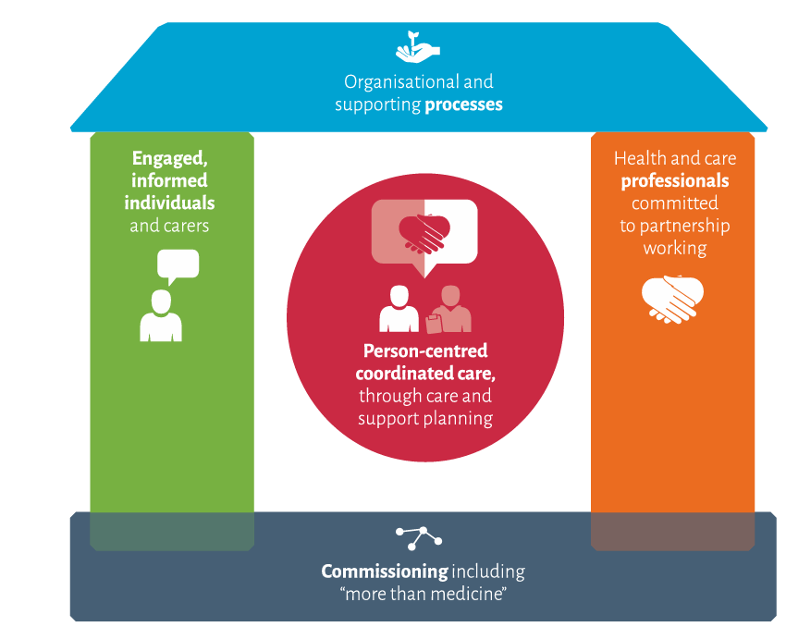 (NHS England, 2016)
The House of Care framework (Year of Care Partnerships, 2019) embeds personalised care planning for long-term conditions like osteoarthritis (OA). Using a house metaphor, it identifies four pillars engaged individuals, committed professionals, supportive systems, and responsive commissioning centred on collaborative conversations that prioritise what matters most to the person (NHS England, 2016; Health and Social Care Alliance Scotland, 2020). In the UK, OA care is guided by strategic frameworks such as the NHS Long Term Plan (NHS England, 2019) and NICE guidelines (NICE, 2022), both emphasising prevention, early intervention, and person-centred care. The NHS Long Term Plan promotes Integrated Care Systems (ICS) to coordinate services across primary care, hospitals, social care, and community settings, ensuring holistic support. NICE (2022) recommends self-management, physical activity, and weight reduction as first-line interventions, reflecting a shift from pharmacological reliance. It also highlights the need for personalised care, recognising OA’s varied presentation. This approach aligns with Engel’s biopsychosocial model (1977), which integrates biological, psychological, and social dimensions of chronic illness. A key strength of the UK’s OA model is its emphasis on patient empowerment, though regional disparities in service provision persist (Versus Arthritis, 2019).
International Model: WHO Innovative Care for Chronic Conditions (ICCC) Framework
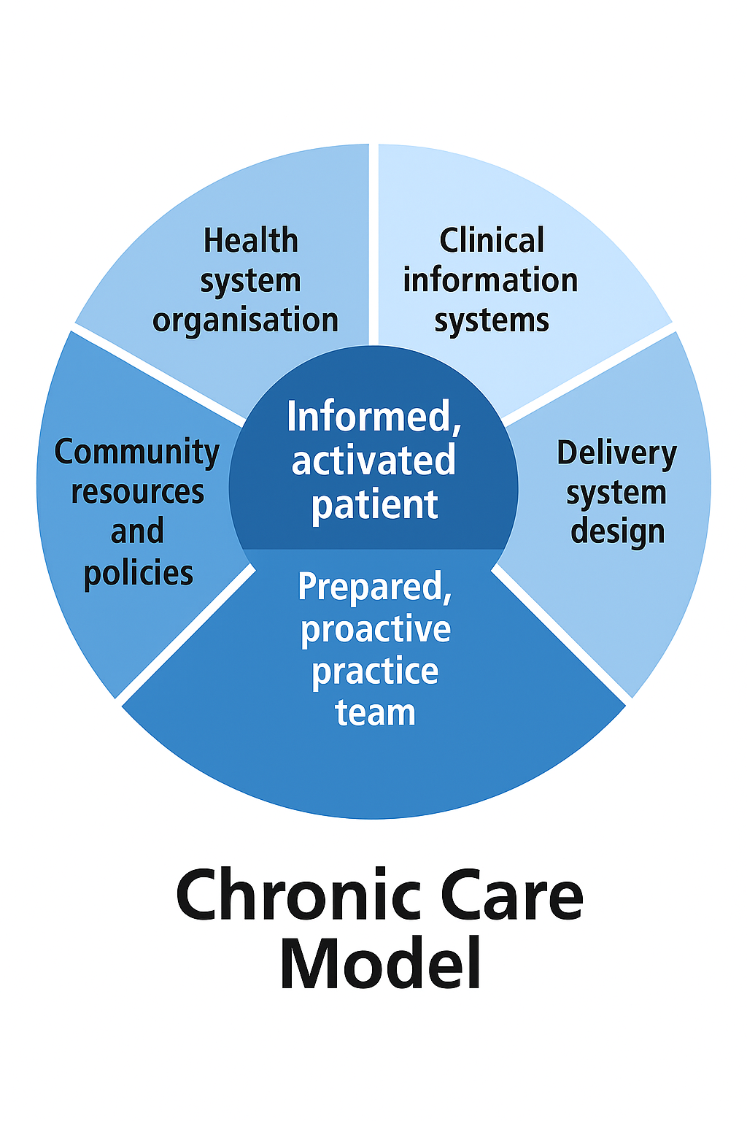 (Wagner, 1998)

Wagner et al. (1998) present the Chronic Care Model as a foundation for osteoarthritis management, comprising six components: self-management support, decision support, delivery system design, clinical information systems, health system organisation, and community resources. It centres on informed patients and proactive care teams.
Globally, the World Health Organization’s Innovative Care for Chronic Conditions (ICCC) framework offers a comprehensive approach to managing long-term conditions like OA (WHO, 2002).
The Chronic Care Model promotes proactive, community-focused health systems that support patient self-management. It emphasises collaborative partnerships among patients, families, professionals, and policymakers, recognising that chronic conditions cannot be effectively managed within brief clinical encounters (Wagner et al., 1998).
The ICCC framework also highlights the impact of social determinants such as poverty, education, and housing on health outcomes. In OA care, this means recognising how access to safe spaces for exercise, affordable nutritious food, and strong social networks directly influences an individual’s ability to manage their condition (World Health Organization, 2002).
Comparison of Models
While the UK’s NHS model prioritises evidence-based guidelines and integrated service delivery, the World Health Organization’s ICCC framework offers a broader lens by addressing global and social determinants of health. Both models support self-management and person-centred care, but the ICCC framework further emphasises policy reform and societal change for chronic condition management (World Health Organization, 2002). The UK integrates elements of both: community-based exercise schemes reflect ICCC’s local resource focus, while NICE guidelines ensure clinical consistency. However, implementation barriers such as limited funding, workforce shortages, and insufficient patient education can hinder progress and leave strategic goals unmet (Charles et al., 2018). Policy and Political Influences on Osteoarthritis Care in the UK

National Policy
Osteoarthritis management in the UK is guided by national policies emphasising prevention, early intervention, and consistent care. The NHS Long Term Plan (2019) prioritises musculoskeletal health, encouraging early diagnosis and digital tools for self-management to reduce hospital admissions. NICE guidelines (2022) offer structured clinical pathways to standardise OA care. The Healthy Ageing agenda aims to extend healthy life expectancy by addressing age-related conditions like OA, focusing on physical activity, fall prevention, and community support (Public Health England, 2020). The Health and Care Act 2022 established Integrated Care Systems (ICS) to promote coordinated, cross-sector OA management (The King’s Fund, 2022).

Local Policy and Implementation
At the local level, osteoarthritis care is delivered through Integrated Care Systems (ICS) and previously Clinical Commissioning Groups (CCGs), which tailor national guidelines to regional needs. Access to physiotherapy, exercise programmes, and surgery varies, creating a “postcode lottery” in OA care (The King’s Fund, 2022). Local councils support public health through active travel and community exercise initiatives, but austerity-driven budget cuts over the past decade have constrained their scope and effectiveness (Marmot et al., 2020).

Critical Examination
Despite robust national strategies, significant challenges persist in osteoarthritis (OA) care delivery. Waiting times for joint replacement surgery have risen sharply, worsened by the COVID-19 pandemic, leaving many in prolonged pain and decline (NHS England, 2022). Access to physiotherapy and pain management remains uneven, while preventative initiatives like community-based exercise programmes face chronic underfunding (Versus Arthritis, 2023). Health inequalities are stark: individuals in deprived areas often develop OA earlier and face barriers to timely diagnosis and treatment (Versus Arthritis, 2019). These disparities reflect broader political and social determinants, showing that clinical guidelines alone cannot close the care gap (The Health Foundation, 2022). While frameworks like the NHS Long Term Plan offer strategic direction, their success depends on local implementation, sustained investment, and attention to societal factors (NHS England, 2019).

Person-Centred Care and Self-Management in Osteoarthritis
Person-centred care (PCC) places the individual at the core of healthcare decision-making, ensuring that their values, preferences, and lived experiences inform the care they receive (Health Foundation, 2016). In the context of osteoarthritis, this means recognising that symptoms such as pain and stiffness vary widely between individuals, needing tailored treatment approaches. PCC also acknowledges the prevalence of multimorbidity among older adults, particularly those over 50, reinforcing the need for OA management to be integrated within broader care pathways rather than treated in isolation (NHS England, 2019).
Key features of PCC in OA include:
Shared decision-making between patients and healthcare professionals.
Individualised care plans, including lifestyle goals.
Involving family or carers where necessary.
Ongoing communication and support.
The NHS advocates PCC as part of the Long-Term Plan, recognising that empowering patients improves health outcomes and reduces unnecessary hospital visits (NHS England, 2019).

Self-Management Approaches
Self-management is a cornerstone of contemporary osteoarthritis care. Evidence shows that individuals who engage in symptom management through structured education, targeted exercise, and behavioural modification report improved physical function and reduced pain levels (Hurley et al., 2018).
Exercise and Physical Activity
Regular physical activity is vital in managing osteoarthritis (OA), strengthening periarticular muscles, improving joint flexibility, and reducing stiffness. NICE guidelines (2022) recommend exercise as a first-line intervention due to its effectiveness and low risk. Programmes like ESCAPE-pain combine education, behavioural strategies, and tailored exercise, improving pain, function, and quality of life for individuals with OA (Hurley et al., 2018; Versus Arthritis, 2023). Excess body weight increases mechanical stress on joints, worsening symptoms. Weight reduction is a core component of OA management, especially for those living with obesity. Support should be multidisciplinary, involving dietetic services, general practice, and community-based programmes (NICE, 2022).
Pain Management and Coping Strategies
Individuals living with osteoarthritis are encouraged to adopt a combination of physical activity, pacing strategies, and relaxation techniques to manage symptom flare-ups. Educational workshops and peer-led group sessions such as those eased by Versus Arthritis offer valuable psychosocial support, helping to reduce isolation and anxiety while promoting self-efficacy in condition management (Versus Arthritis, 2019).
Digital and Remote Support
The growth of telehealth and mobile health applications has expanded access to exercise guidance, symptom tracking, and educational resources for individuals managing osteoarthritis from home (NICE, 2025). However, for older adults, the effectiveness of these digital tools depends on their usability and the provision of right training and support to prevent digital exclusion (Greenhalgh et al., 2020).

End-of-Life Care Considerations
Although osteoarthritis is not a terminal condition, advanced cases particularly when compounded by other chronic illnesses can lead to significant disability and diminished quality of life in later years (NICE, 2022). In such contexts, palliative approaches may be proper to support pain relief, preserve dignity, and promote independence (WHO, 2020). Advance care planning, carer support, and access to social care services become increasingly vital, especially for individuals who are not candidates for surgical or intensive medical interventions.

Critical Evaluation
While person-centred care (PCC) and self-management are widely endorsed in osteoarthritis policy and practice, implementation challenges persist. Regional disparities in service provision mean that some individuals lack access to physiotherapy or structured support programmes (Versus Arthritis, 2019).
Added barriers including low health literacy, mobility limitations, and financial constraints further hinder engagement with recommended interventions. Although digital tools offer promising avenues for remote support, older adults may struggle to adopt these technologies without right training and aid (Greenhalgh et al., 2020). To be effective, PCC and self-management must be underpinned by fair funding, robust community infrastructure, and sustained family and carer support.

Recommendations and Conclusion
Expand Access to Community-Based Programmes
National rollout of evidence-based initiatives such as ESCAPE-pain should be prioritised, ensuring fair access regardless of location. Funding must be protected to avoid postcode lotteries in physiotherapy and exercise provision.
Address Health Inequalities
Targeted support should be offered to those in deprived areas, who are more likely to develop OA earlier and experience worse outcomes (Versus Arthritis, 2019). Initiatives could include free community exercise classes, transport support, and culturally tailored education materials.

Enhance Integration of Services
Integrated Care Systems (ICS) should ensure seamless collaboration between GPs, physiotherapists, dieticians, and social care providers, reducing fragmented care pathways (NHS England, 2022)
Invest in Digital Inclusion
Digital health tools should be developed with older adults in mind, ensuring accessibility. Local services should offer training for patients and carers to confidently use telehealth platforms (Age UK, 2023).
Promote Research and Innovation
More investment in regenerative therapies, joint preservation techniques and non-surgical interventions is needed to expand treatment options and reduce reliance on joint replacement surgery (Versus Arthritis, 2023).
Strengthen Carer Support
Families providing care need structured support, such as respite services, financial allowances, and educational programmes. Recognising carers within care planning will improve outcomes for both patients and families (NHS England, 2022).
End-of-Life Planning for Complex Cases
While OA is not fatal, for patients with multiple long-term conditions, healthcare teams should provide guidance on palliative options, pain relief, and dignity-preserving care (NICE, 2023).

Conclusion
Osteoarthritis (OA) is a multifactorial condition influenced by modifiable and non-modifiable risk factors. Age is the strongest predictor, with risk increasing after 45 due to reduced cartilage resilience (Litwic et al., 2013). Women are more commonly affected post-menopause, suggesting hormonal changes may contribute to onset (Srikanth et al., 2005). Genetic predisposition also plays a role, particularly in those with a family history of hand or hip OA (Zengini, Finan and Wilkinson, 2016). Obesity places excess strain on load-bearing joints and promotes systemic inflammation, accelerating joint damage (Vincent et al., 2012). Other risks include previous joint injuries (NICE, 2022) and occupations involving heavy lifting or prolonged standing (Palmer, 2012). OA is no longer seen as simple “wear and tear” but as a complex interplay of mechanical, metabolic, inflammatory, and genetic factors (Hunter, 2019), shifting clinical focus toward prevention and early intervention.

REFERENCES.
Bair, M. J., Wu, J., Damush, T. M., Sutherland, J. M., and Kroenke, K. (2008) ‘Association of depression and anxiety alone and in combination with chronic musculoskeletal pain in primary care patients.’ Psychosomatic medicine, pp. 70(8), 890–897.Available at: https://doi.org/10.1097/PSY.0b013e318185c510.
Bannuru, R. R., Osani, M. C., Vaysbrot, E. E., Arden, N. K., Bennell, K., Bierma-Zeinstra, S. M. A., Kraus, V. B., Lohmander, L. S., Abbott, J. H., Bhandari, M., Blanco, F. J., Espinosa, R., Haugen, I. K., Lin, J., Mandl, L. A., Moilanen, E., Nakamura, N., Snyder-Mackler, L., Trojian, T., Underwood, M., … McAlindon, T. E. (2019) ‘OARSI guidelines for the non-surgical management of knee, hip, and polyarticular osteoarthritis.’ Osteoarthritis and cartilage, pp. 27(11), 1578–1589. Available at: https://doi.org/10.1016/j.joca.2019.06.011.
Bartels, C.M., Ramly, E., Johnson, H.M., Lauver, D.R., Panyard, D.J., Li, Z., Sampene, E., Lewicki, K. and McBride, P.E., (2018) ‘Connecting rheumatology patients to primary care for high blood pressure: specialty clinic protocol improves follow‐up and population blood pressures.’ Arthritis care & research, 71(4), pp.461-470. Available at: https://doi.org/10.1002/acr.23612.
Carers UK (2021) ‘State of Caring 2021’ Available at: https://www.carers-ni-state-of-caringfinal.pdf. (Accessed: 11 September 2025).
Charles, A., Ham, C., Baird, B., Alderwick, H. and Bennett, L. (2018) ‘Reimagining community services: Making the most of our assets.’ The King’s Fund. Available at: https://www.kingsfund.org.uk/publications/community-services-assets. (Accessed: 11 September 2025).
Charles, A., Wenzel, L., Kershaw, M., Ham, C. and Walsh, N., (2018) ‘A year of integrated care systems.’ Reviewing the journey so far. London: The King’s Fund, 2009, pp.2018. Available at: https://www.A Year Of Integrated Care Systems | The King's Fund. (Accessed: 14 September 2025).
Chou, R., Turner, J. A., Devine, E. B., Hansen, R. N., Sullivan, S. D., Blazina, I., Dana, T., Bougatsos, C and Deyo, R. A. (2015) ‘The effectiveness and risks of long-term opioid therapy for chronic pain: a systematic review for a National Institutes of Health Pathways to Prevention Workshop.’ Annals of internal medicine, pp.162(4), 276–286. https://doi.org/10.7326/M14-2559
Engel, G.L., (1977). The need for a new medical model: a challenge for biomedicine. Science, 196(4286), pp.129-136. Available at: https://www.the Need for a New Medical Model: A Challenge for Biomedicine | Science. Accessed: (14 September 2025).
England, N.H.S. and Improvement, N.H.S., (2022) ‘Delivery plan for tackling the COVID-19 backlog of elective care.’ Available at: https://www.The NHS Long Term Plan and COVID-19 | The Health Foundation. (Accessed: 11 September 2025).
Fransen, M., McConnell, S., Harmer, A. R., Van der Esch, M., Simic, M., & Bennell, K. L. (2015) ‘Exercise for osteoarthritis of the knee: a Cochrane systematic review.’ British journal of sports medicine, 49(24), 1554–1557. Available at: https://doi.org/10.1136/bjsports-2015-095424.
Greenhalgh, T., Wherton, J., Shaw, S., & Morrison, C. (2020) ‘Video consultations for covid-19.’ BMJ (Clinical research ed.), 368, m998. Available at: https://www.Video consultations for covid-19 - PubMed. (Accessed: 11 September 2025).
Greenwood, N., Mackenzie, A., Cloud, G.C. and Wilson, N., (2009) ‘Informal primary carers of stroke survivors living at home–challenges, satisfactions and coping: a systematic review of qualitative studies.’ Disability and rehabilitation, 31(5), pp.337-351. Available at: https:// Informal primary carers of stroke survivors living at home–challenges, satisfactions and coping: A systematic review of qualitative studies: Disability and Rehabilitation: Vol 31, No 5. (Accessed: 12 September 2025).
Hawker, G.A., Stewart, L., French, M.R., Cibere, J., Jordan, J.M., March, L., Suarez-Almazor, M. and Gooberman-Hill, R., ( 2008) ‘Understanding the pain experience in hip and knee osteoarthritis–an OARSI/OMERACT initiative.’ Osteoarthritis and cartilage, 16(4), pp.415-422.Available at: https://www.understanding the pain experience in hip and knee osteoarthritis – an OARSI/OMERACT initiative - ScienceDirect. (Accessed: 12 September 2025).
Health Foundation (2016) ‘Person-centred care made simple.’ Available at: https://www.health.org.uk/publications/person-centred-care-made-simple (Accessed: 11 September 2025).
Hunter, D.J. and Bierma-Zeinstra, S. (2019) ‘Osteoarthritis’, Lancet, London, England. Available at: https://doi.org/10.1016/S0140-6736(19)30417-9.
Jin, J.O., Kawai, T., Cha, S. and Yu, Q., (2013) ‘Interleukin‐7 enhances the The1 response to promote the development of Sjögren's syndrome–like autoimmune exocrinopathy in mice.’ Arthritis & Rheumatism, 65(8), pp.2132-2142. Available at: https://www.interleukin‐7 Enhances the Th1 Response to Promote the Development of Sjögren's Syndrome–like Autoimmune Exocrinopathy in Mice - Jin - 2013 - Arthritis & Rheumatism - Wiley Online Library (Accessed: 12 September 2025).
Kars Fertelli, T., (2020) ‘Effects of education about rheumatoid arthritis and sexuality on the sexual problems of women with rheumatoid arthritis.’ Clinical Nursing Research, 29(3), pp.189-199. Available. at: https://www.Effects of Education About Rheumatoid Arthritis and Sexuality on the Sexual Problems of Women With Rheumatoid Arthritis - Tülay Kars Fertelli, 2020. (Accessed: 11 September 2025).
Keith T. Palmer (2012) ‘The older worker with osteoarthritis of the knee,’ British Medical Bulletin, Available at: https://www. older worker with osteoarthritis of the knee | British Medical Bulletin | Oxford Academic. (Accessed: 10 September 2025).
Khan, M., Evaniew, N., Bedi, A., Ayeni, O.R. and Bhandari, M., (2014) ‘Arthroscopic surgery for degenerative tears of the meniscus: a systematic review and meta-analysis.’ Cmaj, 186(14), pp.1057-1064. Available at: https://doi.org/10.1503/cmaj.140433.
Litwic, A., Edwards, M. H., Dennison, E. M., & Cooper, C. (2013). ‘Epidemiology and burden of osteoarthritis’. British medical bulletin. Available at: https://doi.org/10.1093/bmb/lds038.
Lopes, David G., Daniela Costa, Eduardo B. Cruz, Nuno Mendonça, Ana Rita Henriques, Jaime Branco, Helena Canhão, and Ana M. Rodrigues. (2022) "Association of physical activity with physical function and quality of life in people with hip and knee osteoarthritis: longitudinal analysis of a population-based cohort." Arthritis Research & Therapy 25, no. 1 (2023): 14. Available at: https://www.Association of physical activity with physical function and quality of life in people with hip and knee osteoarthritis: longitudinal analysis of a population-based cohort | Arthritis Research & Therapy. (Accessed: 11 September 2025).
Marmot, M., Allen, J., Boyce, T., Goldblatt, P. and Morrison, J. (2020) ‘Health Equity in England: The Marmot Review 10 Years On.’ London: Institute of Health Equity. Available at: https://www.health.org.uk/publications/reports/the-marmot-review-10-years-on (Accessed: 11 September 2025).
McTaggart‐Cowan, H.M., Brazier, J.E. and Tsuchiya, A., (2010) ‘Clustering Rasch results: a novel method for developing rheumatoid arthritis states for use in valuation studies.’ Value in Health, 13(6), pp.787-795. Available at: https://www.Clustering Rasch Results: A Novel Method for Developing Rheumatoid Arthritis States for Use in Valuation Studies - McTaggart‐Cowan - 2010 - Value in Health - Wiley Online Library (Accessed: 11 September 2025).
Murray, M.L., Pinches, H., Mafham, M., Hartley, S., Carpenter, J., Landray, M.J., Love, S.B., Parmar, M. and Sydes, M., (2022) ‘Use of NHS Digital datasets as trial data in the UK: a position paper’. Available at: https://doi.10.5281/zenodo.6047154.
National Institute for Health and Care Excellence (NICE) (2022) ‘Osteoarthritis: care and management.’ Available at: https://www.nice.org.uk/guidance/cg177. (Accessed: 11 September 2025).
National Joint Registry (2022) Annual Report 2022. Available at: https://reports.njrcentre.org.uk/. (Accessed: 11 September 2025).
NHS (2025) ‘Osteoarthritis Treatment and support’. Available at: https://www.nhs.uk/conditions/osteoarthritis/treatment/ (Accessed: 11 September 2025).
NHS Digital (2021) ‘Health Survey for England 2021.’ Available at: https://www.Health Survey for England, 2021 part 1 - NHS England Digital. (Accessed: 11 September 2025).
NHS England (2019) ‘The NHS Long Term Plan.’ Available at: https://www.longtermplan.nhs.uk/. (Accessed: 11 September 2025).
NHS England (2019) The NHS Long Term Plan. Available at: https://www.NHS England » NHS Long Term Plan to tackle major killer conditions and save up to half a million lives. (Accessed: 11 September 2025).
Peak Health Physiotherapy (2022) ‘Osteoarthritis ‘How Can You Help Your Pain’. Available at: Osteoarthritis - How Can You Help Your Pain | Peak Health Physiotherapy (Accessed: 11 September 2025).
Public Health England (2020) ‘Healthy ageing: consensus statement.’ Available at: https://www.gov.uk/government/publications/healthy-ageing-consensus-statement (Accessed: 11 September 2025).
Qiao, L., Li, M., Deng, F., Wen, X., Deng, H., Xue, Z., Wan, P., Xiang, R., Xie, Y., He, H. and Fan, X., (2024) ‘Epidemiological trends of osteoarthritis at the global, regional, and national levels from 1990 to 2021 and projections to 2050.’ medRxiv, pp.2024-06. Available at: Epidemiological trends of osteoarthritis at the global, regional, and national levels from 1990 to 2021 and projections to 2050 | medRxiv. (Accessed: 12 September 2025).
Riddle, D. L., & Stratford, P. W. (2013) ‘Unilateral vs bilateral symptomatic knee osteoarthritis: associations between pain intensity and function.’ Rheumatology (Oxford, England), 52(12), pp. 2229–2237. https://doi.org/10.1093/rheumatology/ket291.
Robinson, S.M., Ryan, S., Adams, N., Hassell, A. and Walker, D., (2018) ‘An exploration of the experiences of rheumatology nurses counselling patients on methotrexate therapy.’ Musculoskeletal Care, 16(4), pp. 463-470. Available at: An exploration of the experiences of rheumatology nurses counselling patients on methotrexate therapy - Robinson - 2018 - Musculoskeletal Care - Wiley Online Library. (Accessed: 11 September 2025).
Sabah, S.A., Knight, R., Nicolson, P.J., Taylor, A., Kendrick, B., Alvand, A., Petrou, S., Beard, D.J., Price, A.J. and Palmer, A.J., (2023) ‘Epidemiology of revision hip replacement surgery in the UK over the past 15 years an analysis from the National Joint Registry’. BMJ. Available at: Epidemiology of revision hip replacement surgery in the UK over the past 15 years an analysis from the National Joint Registry | BMJ Open. (Accessed: 11 September 2025).
Srikanth, V.K., Fryer, J.L., Zhai, G., Winzenberg, T.M., Hosmer, D. and Jones, G., (2005) ‘A meta-analysis of sex differences prevalence, incidence and severity of osteoarthritis.’ Osteoarthritis and cartilage, Available at: A meta-analysis of sex differences prevalence, incidence and severity of osteoarthritis - ScienceDirect. (Accessed: 10 September 2025).
Stubbs, B., Binnekade, T., Eggermont, L., Sepehry, A. A., Patchay, S., and Schofield, P. (2014) ‘Pain and the risk for falls in community-dwelling older adults: systematic review and meta-analysis.’ Archives of physical medicine and rehabilitation, 95(1), pp.175–187.e9. Available at: https://doi.org/10.1016/j.apmr.2013.08.241.
The King’s Fund (2022) ‘What are Integrated Care Systems?’ Available at: https://www.kingsfund.org.uk/publications/integrated-care-systems-explained.(Accessed: 11 September 2025).
Versus Arthritis (2019) ‘The state of musculoskeletal health 2019.’ Versus Arthritis, 91(5), pp.31-32. Available at: The State of Musculoskeletal Health. (Accessed: 11 September 2025).
Versus Arthritis (2019) ‘The State of Musculoskeletal Health 2019.’ Available at: Global Burden of Musculoskeletal Disorders in Adults Aged 50 and Over, 1990–2021: Risk Factors and Sociodemographic Inequalities - PMC. (Accessed: 11 September 2025).
Versus Arthritis (2019) ‘The state of musculoskeletal health.’ Versus Arthritis, 91(5), pp.31-32. Available at: Versus Arthritis Musculoskeletal Disorders Research Advisory Group Priority Setting Exercise Protocol | medRxiv. (Accessed: 11 September 2025).
Vincent, H.K., Heywood, K., Connelly, J. and Hurley, R.W., (2012) ‘Obesity and weight loss in the treatment and prevention of osteoarthritis.’ PM&R, 4(5), pp. S59-S67. Available at: Obesity and Weight Loss in the Treatment and Prevention of Osteoarthritis - ScienceDirect. (Accessed: 12 September 2025).
Vos, T., Lim, S.S., Abbafati, C., Abbas, K.M., Abbasi, M., Abbasifard, M., Abbasi-Kangevari, M., Abbastabar, H., Abd-Allah, F., Abdelalim, A. and Abdollahi, M., (2020) ‘Global burden of 369 diseases and injuries in 204 countries and territories,’ 1990–2019: a systematic analysis for the Global Burden of Disease Study 2019. The lancet, 396(10258), pp.1204-1222. Available at: Global burden of 369 diseases and injuries in 204 countries and territories, 1990–2019: a systematic analysis for the Global Burden of Disease Study 2019 The Lancet. (Accessed: 12 September 2025).
World Health Organization (2002) Innovative Care for Chronic Conditions: Building Blocks for Action. Geneva: WHO. Available at: https://apps.who.int/iris/handle/10665/42500. (Accessed: 11 September 2025).
World Health Organization (2020) ‘Palliative care.’ Available at: https://www.who.int/news-room/fact-sheets/detail/palliative-care. (Accessed: 11 September 2025)
World Health Organization (2023) ‘Musculoskeletal conditions.’ Available at Musculoskeletal health. (Accessed: 11 September 2025).
Zeng, C., Wei, J., Persson, M. S. M., Sarmanova, A., Doherty, M., Xie, D., Wang, Y., Li, X., Li, J., Long, H., Lei, G., & Zhang, W. (2018) ‘Relative efficacy and safety of topical non-steroidal anti-inflammatory drugs for osteoarthritis: a systematic review and network meta-analysis of randomised controlled trials and observational studies.’ British journal of sports medicine, 52(10), 642–650. https://doi.org/10.1136/bjsports-2017-098043.
Zengini, E., Finan, C., & Wilkinson, J. M. (2016) ‘The Genetic Epidemiological Landscape of Hip and Knee Osteoarthritis: Where Are We Now and Where Are We Going.’ The Journal of rheumatology, 43(2), 260–266.Available at: https://doi.org/10.3899/jrheum.150710

