Trinity Saint David University of Wales
Introduction to Web and Database Concepts (ACCA4023)

Author: | Tutor:
Chris Hampton | Beverley Holland
2116517@student.uwstd.ac.uk | Beverley.Holland@uwtsd.ac.uk

03/05/2022

Contents
Table of Figures 3
Introduction 4
Abstract 4
Requirements 4
Database Implementation 4
Table 1 – Books 4
Design: 4
Table 2 – Customers 4
Design: 4
Table 3 – Supplier 4
Design: 5
Table 4 – Customer Orders 5
Design: 5
Table 5 – Stock 5
Design: 5
Table 6 – Supplier Orders 5
Design: 5
Relationships 6
Database Functionality 7
Main Menu 7
Stock Search 7
Customers 8
Add New Book 9
Orders Form 9
Stock Report 9
Third Normal Form 10
Context Diagram 11
Data Flow Diagram – Level 0 12
Entity Relationship Diagram 13
Conclusion 13
References 14

Table of Figures
Figure 1 - Diagram of the Relationships 6
Figure 2 - Database Initial Form 7
Figure 3 - Stock Search Form 7
Figure 4 - Customers Form 8
Figure 5 - Add New Book Form 9
Figure 6 - Orders Form 1 9
Figure 7 - Stock Report 10
Figure 8 - Stock Report Query 10
Figure 9 - Context Diagram 11
Figure 10 - DFD - Level 0 12
Figure 11 - Entity Relationship Diagram 13

Introduction

Abstract
The basis of this report is reviewing the current processes with Dylan’s Book Shop and implement a database design that meets the requirements laid out by the end user. By improving the way in which the then processes are operated within the book shop setting will be advantageous to the end user and to management to enable more efficient way of working.

Requirements
The requirement of project is to implement a database design to enable Dylan’s Book Store to track their sales and orders to work in a more efficient way. To implement this a Microsoft Access Database will be designed and produced to allow the end users to ass, delete and update data that they hold within the shop setting. By creating appropriate tables and linkages the end users should be able to monitor orders through the book ordering, selling, and buying process.

Database Implementation
The initial database design is to create appropriate table and ensure that can link to further appropriate tables.

Table 1 – Books
This table will hold the details the books that the bookstore offers. The Book ID column is the Primary Key

Design:

Columns:
Column Name | Description
Book ID | This is an auto-generated number
Book Name | This is the Name of the book
Book Author | This is the Author of the book
Book Rare | This is the classification of the book

Table 2 – Customers
This table holds the details of the customers. The Customer ID column is the Primary Key.

Design:

Columns:
Column Name | Description
Customer ID | This is an auto-generated number
Customer Name | This is the customer’s name
Customer Address | This is the customer’s address
Customer Telephone Number | This is the customer’s telephone number
Customer Contactable | This is to indicate when the customer wants to be contacted by phone, email, or both

Table 3 – Supplier
This table holds the details of the Suppliers that can supply the books to the store. The Supplier ID column is the Primary Key.

Design:

Columns:
Column Name | Description
Supplier ID | This is an auto-generated number
Supplier Name | This is the supplier’s name
Supplier Category | This is to indicate whether the supplier stocks rare editions of books

Table 4 – Customer Orders
This table holds the details of the Suppliers that can supply the books to the store. The Order ID column is the Primary Key.

Design:

Columns:
Column Name | Description
Order ID | This is an auto-generated number
Date Ordered | This is the date that the customer placed the order
Customer ID | This links to the customer table that placed the order
Status | This is the status of the order
Book ID | This links to the books table for the book that was ordered
Date Fulfilled | This is the date that the order was fulfilled

Table 5 – Stock
This table holds the details of stock of books within the store. The Stock ID column is the Primary Key.

Design:

Columns:
Column Name | Description
Stock ID | This is an auto-generated number
Book ID | This links to the books table for the book that was ordered

Table 6 – Supplier Orders
This table holds the details of order of books to the Suppliers. The Supplier ID column is the Primary Key.

Design:

Columns:
Column Name | Description
Supplier ID | This is an auto-generated number
Date Ordered | This is the date that the customer placed and order
Supplier ID | This links to the supplier table that the order was placed
Order Date | This is the date that the shop placed the order
Status | This is the status of the order to the supplier
Book ID | This links to the books table for the book that was ordered
Date Actioned | This is the date that the order was processed

Relationships
Each table has a Primary Key and a Foreign Key that can link each entity together.
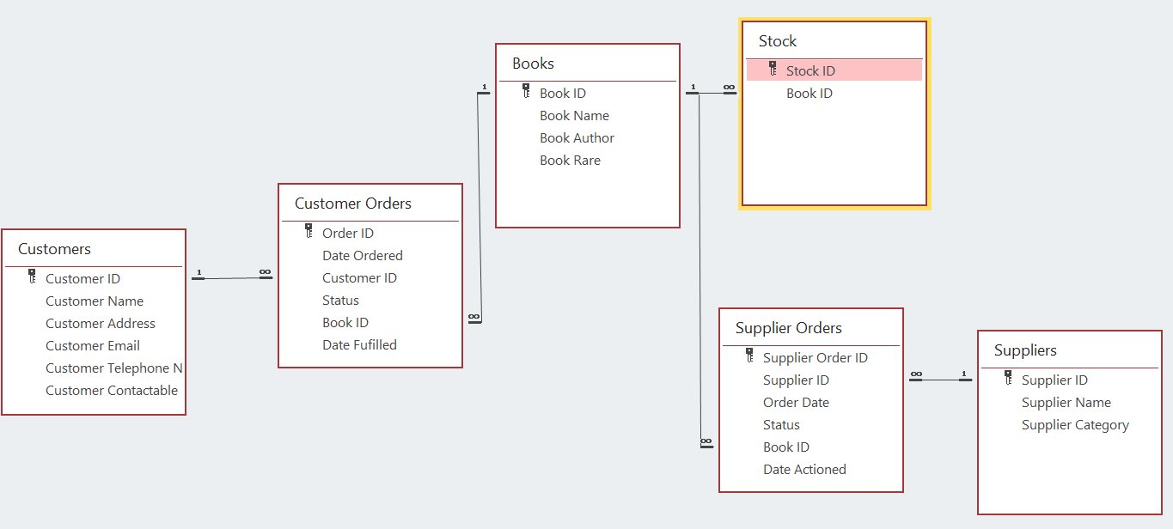
Figure 1 - Diagram of the Relationships
Table | Primary Key | Foreign Key
Customers | Customer ID
Customer Orders | Order ID | Customer ID, Book ID
Books | Book ID
Stock | Stock ID | Book ID
Supplier Orders | Supplier Order ID | Supplier ID, Book ID
Suppliers | Supplier ID

Each table has a one-to-many relationship that enables multiple values to be linked to a single entity in the parent table.
These relationships can be verified within the database project and allows suitable reports to be created for the end user.

Database Functionality

Main Menu
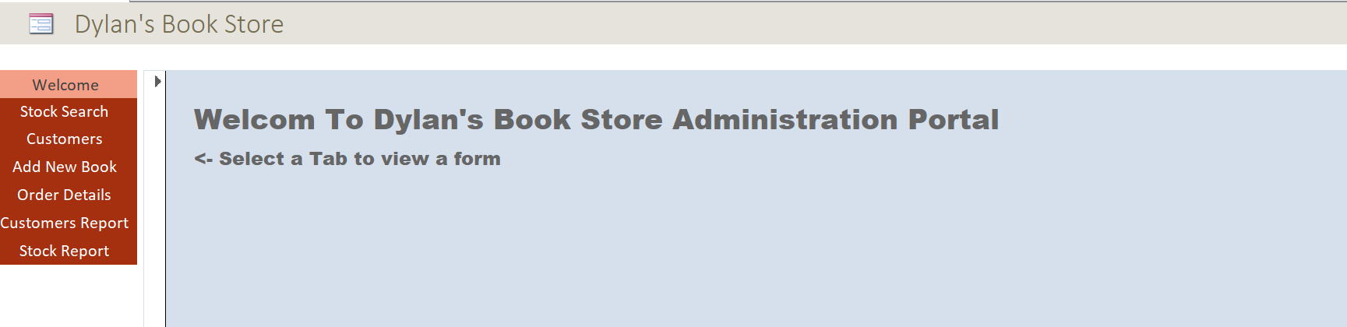
Figure 2 - Database Initial Form
The database opens with the main menu form. The user can then select a further report or form from the menu tabs on the left.

Stock Search
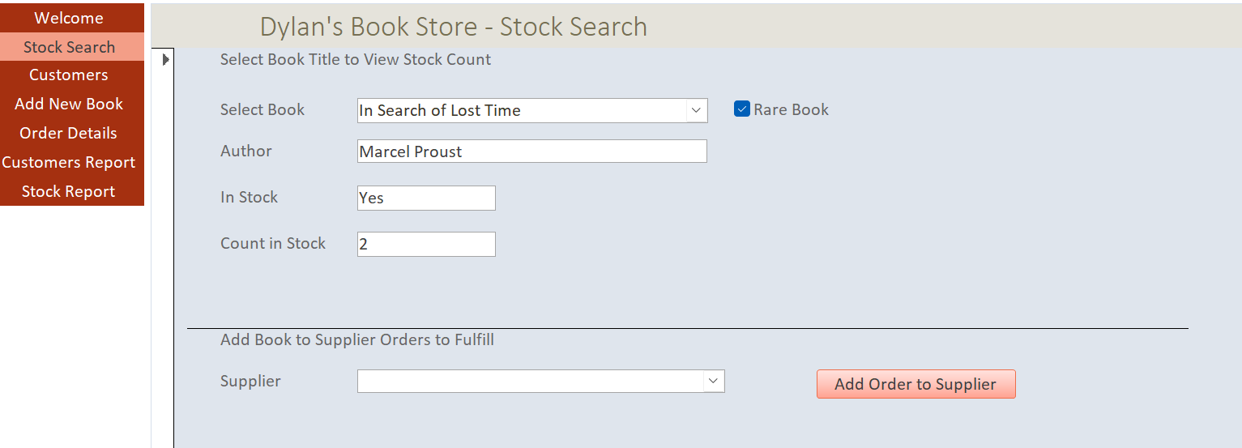
Figure 3 - Stock Search Form
The stock search form allows the user to select a book from the dropdown and view stock levels of the title.
The Author field uses the following formula:
=DLookUp("[Book Author]","[Books]","[Book Name] = '" & [SelectBookCombo].[Text] & "'")
This formula takes the value from the Select Book dropdown, named [SelectBookCombo] and returns the author for that book in the ‘Books’ table.
Additionally, on this form the user can decide whether to add the title to the supplier orders if they need to order the book. By using the ‘Rare Book’ indicator the user can decide which supplier to use.

Customers
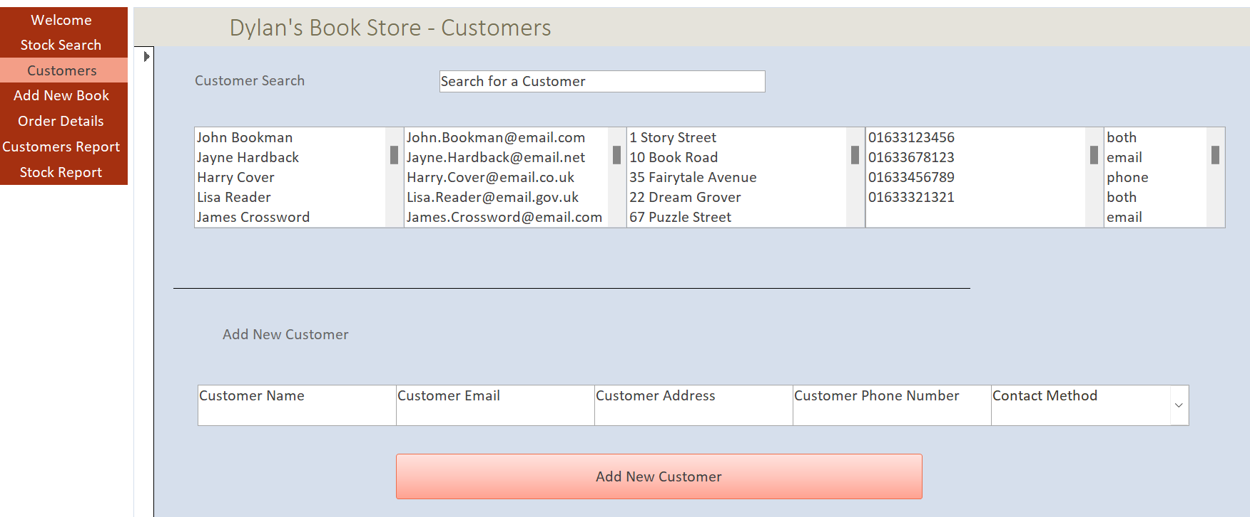
Figure 4 - Customers Form
The customers form allows the user to search for a customer in the database. Once the user types into the search box, relevant filters are applied to the table below it to get the relevant information.
If the user wants to add a new customer, then they can input data into the boxes and click ‘Add New Customer’.
This Macro below is initiated by the click button.
Private Sub AddNewCustomer_Click()
sNewName = Me.AddNameText
sNewEmail = Me.AddCustomerEmail
sNewAddress = Me.AddCustomerAddress
sNewPhone = Me.AddCustomerPhone
sNewContactable = Me.AddContactable

sSQL = "insert into [Customers] ([Customer Name],[Customer Address],[Customer Email],[Customer Telephone Number], [Customer Contactable]) values('" & sNewName & "','" & sNewAddress & "','" & sNewEmail & "','" & sNewPhone & "','" & sNewContactable & "')"

DoCmd.RunSQL sSQL
Me.AddNameText = "Customer Name"
Me.AddCustomerEmail = "Customer Email"
Me.AddCustomerAddress = "Customer Address"
Me.AddCustomerPhone = "Customer Phone"
Me.AddContactable = "Contactable"

End Sub

The macro uses the inputs from the boxes and uses them in an input statement to insert a new row into the Customer table. Once the command has been executed default values are then reset into the text boxes.

Add New Book
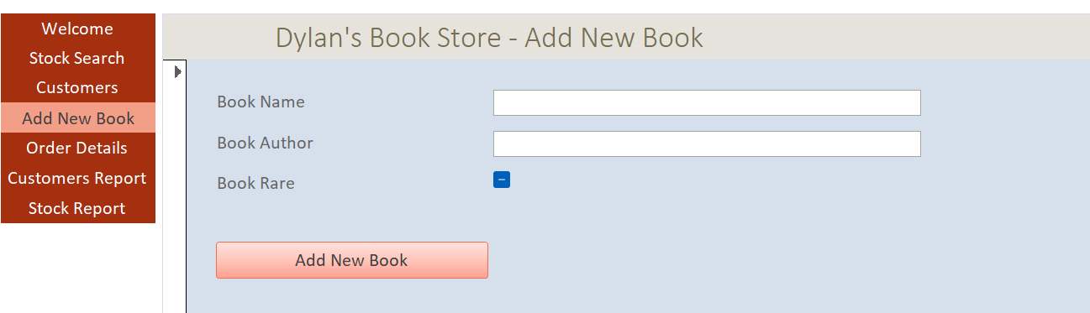
Figure 5 - Add New Book Form
The ‘Add New Book’ form allows a user to add a new book into the books table. The function of the button is like the ‘Add New Customer’.

Orders Form
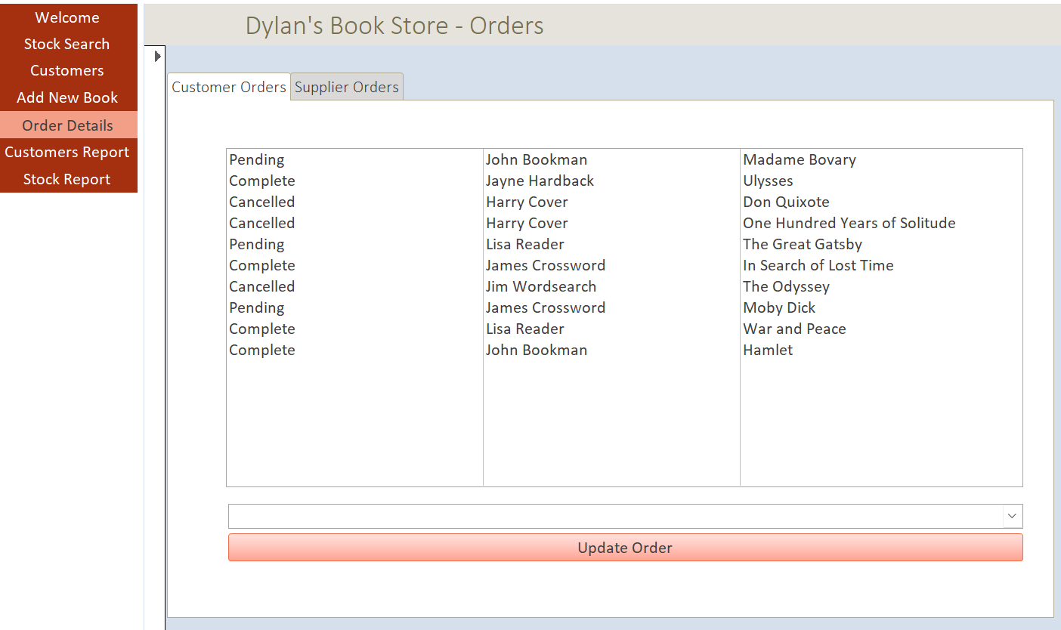
Figure 6 - Orders Form 1
The Orders form allows the user to view Customer Orders and the Supplier Orders and separate tabs. The process on each tab is similar with the relevant data sources changed.
The user can click on a row and update the status depending on the selection within the dropdown. The use can then click the update button to update that record. The list table will update with the user’s selection.

Stock Report
The stock report allows a user to view the amount of stock that is currently in inventory. This report runs a custom query to join the ‘Books’ table to the ‘Stock’ table.
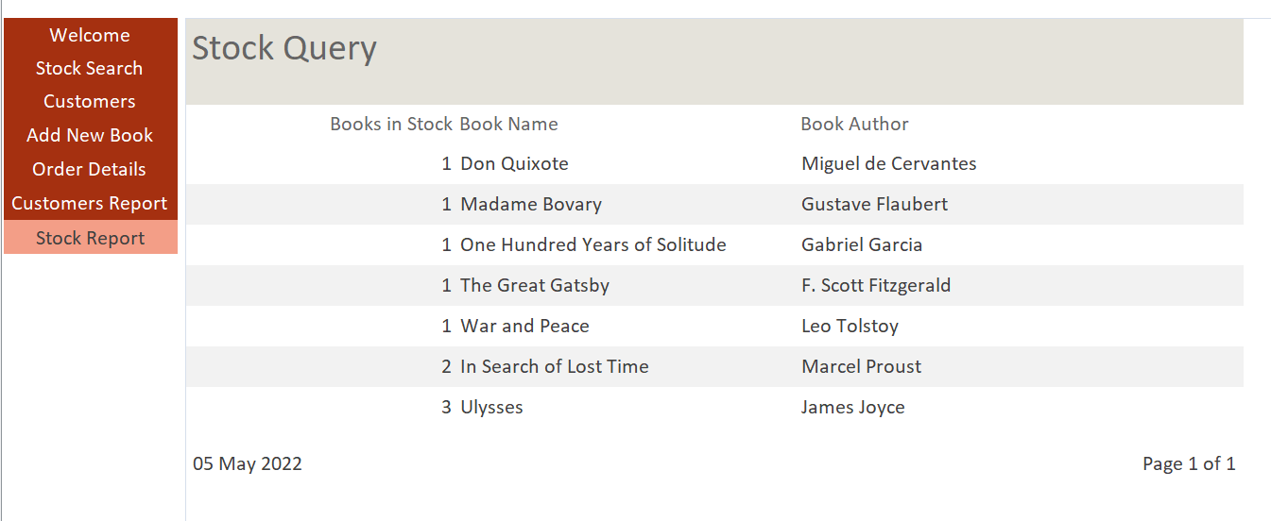
Figure 7 - Stock Report
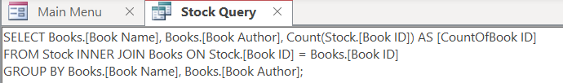
Figure 8 - Stock Report Query

Third Normal Form
Third Normal Form, 3NF, [1] is described as an approach to database design that uses principles to normalise the data, thus ensuring that duplication, anomalies, and integrity is maintained throughout the database design.
For a database to meet the requirements of Third Normal Form a set of requirements need to be satisfied.
Firstly, a table needs to be in First Normal Form, this is when there is not data duplication within the tables, i.e., each row must be unique. Each table that has been designed with a primary key as an auto generated incremental integer to ensure that each row does not contain duplicates.
Secondly, a Second Normal Form table must every attribute that is not the primary key must depend on the primary key. Every table can be filtered using the primary key only. For example, in this project the Suppliers table only holds the information regarding the suppliers and not incorporating the supplier orders as this will generate dependencies on non-key attributes within the table.
Lasty, for a database schema to be in Third Normal Form, initially the two conditions detailed above need to be met and no transitive partial dependencies occur. For example, within the customers table further development could be made to break down the address into town, city, country, and postcode etc. Instead of having a City and Country column within the master customer table a separate table could be made to hold the City and Country data. Each city can then be linked to a country within the secondary table, thus creating Third Normal Form schema design.

Context Diagram
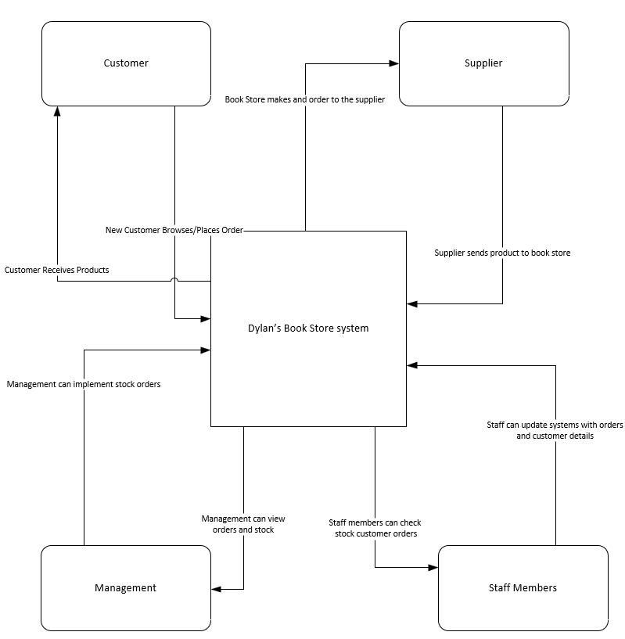
Figure 9 - Context Diagram
A Context diagram is a high-level Data Flow Diagram that demonstrates the basic functions of a process [2]. Using a Context diagram can give an initial projection of what the process will be with the design and build of the database. However, a downside of a Context Diagram does not include time scales for each process. The figure shown above gives an indication of what the processes will be within Dylan’s Book Store.

Data Flow Diagram – Level 0
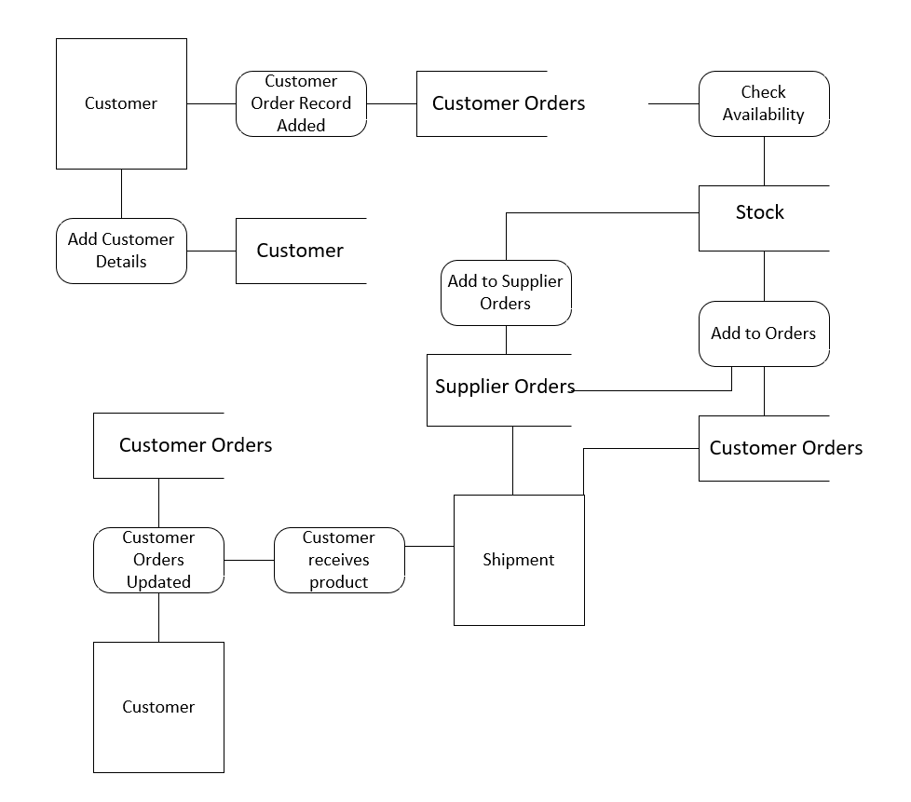
Figure 10 - DFD - Level 0
A Level 0 Data Flow diagram shows a deeper level of detail than a context diagram. The figure above shows the sub processes within the context diagram. Although, sub processes beneath would need to be incorporated into a Level 1 DFD.

Entity Relationship Diagram
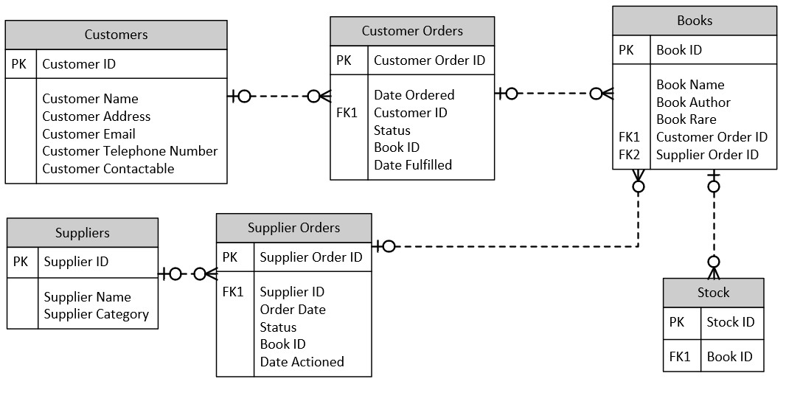
Figure 11 - Entity Relationship Diagram
An Entity Relationship Diagram, or ERD, is described as a diagram used to design and build a database [3]. The figure above shows the design and relationships between the tables held within the project. This design was used, with appropriate data types for each field, when creating the database.

Conclusion
In conclusion, by using correct techniques and database design a sufficient process was produced. By designing the database using Microsoft Visio with Context Diagrams and Entity Relationship Diagram appropriate results have been achieved. To improve on this solution several changes can be made to ensure the integrity of the project is kept intact. By having more functionality such as being able to send newsletters can also be implemented to improve autonomy within the business.

References

[1] | Wikipedia, “Third_normal_form,” [Online]. Available: https://en.wikipedia.org/wiki/Third_normal_form. [Accessed 05 2022].
[2] | “What is a Context Diagram?,” [Online]. Available: https://www.edrawmax.com/context-diagram/. [Accessed 05 2022].
[3] | “What is Entity Relationship Diagram (ERD)?,” [Online]. Available: https://www.visual-paradigm.com/guide/data-modeling/what-is-entity-relationship-diagram/;WWWSESSIONID=4DE27C1859FDF9322F8F0BE62EEE3333.www1. [Accessed 05 2022].

