Quality Assurance and Quality Control for Project Effectiveness in Construction and Management

By Dylan J Pugh 2011595

Contents
1. Introduction 2
2. Quality 2
2.1. What is Quality within Construction 2
3. Management Concepts 3
3.1. Quality Control 3
3.2. Quality Assurance 3
3.3. Total Quality Management 4
3.4. Peter Druckers Management by Objectives 5
4. Conclusion 6
5. Bibliography 6
6. Appendices 8
6.1. Appendix 1 – BS EN ISO 9001:2015 Quality Management Systems Requirements (ISO, 2015) 8
6.2 Appendix 2 – Alun Griffiths Contractors Ltd BS EN ISO 9001:2015 Certification 9
6.3 Appendix 3 – Alun Griffiths Contractors Ltd C.A.T and Genny Function Check Sheet. 10
6.4 Appendix 4 – Alun Griffiths Contractors Ltd Quality Policy 11

Introduction
In the following report, I’ll be discussing the different management concepts and principles of Quality Assurance and Quality Control which are a part of Quality Management. Furthermore, I’ll be discussing Total Quality Management a new and different form of Quality Management. Lastly, I’ll conclude which strategy is the most effective and efficient way to help run a Project and why its better than the other method.

Quality

What is Quality within Construction

Quality is a topic which has always had many different descriptions and terminology. As can be described as “fitness for use,” “customer satisfaction,” “doing things right the first time,” or “zero defects.” (ISOUpdate.com, 2019). However the Oxford Dictionary defies quality as “the standard of something when it is compared to other things like it; how good or bad something is” (Dictionary, 2022). Within Construction, quality is a factor that heavily affects a project and how its run, how its perceived and how quality will be defined. The person most affected by this in the end user as Quality Management is designed to ensure the product or service provided fits the purpose of it for the user.
In construction, companies must have a Quality Management system in place to carry out any project and any procedures as well. Their Quality Management system must comply with BSI ISO 9001:2015 (See Appendix 1 for Cover of Standard) as this is the current standard for Quality Management Systems. So a company would have to get audited by the BS to gain certification to prove their system complies with the standard. See appendix 2 for example of the certificate from the audit.
Quality also affects the standard of work, professionalism and training companies can provide and give to a client.

Management Concepts

Quality Control
Quality Control (QC) can be defined as the “process through which a business seeks to ensure that product quality is maintained or improved” (Hayes, 2022) or as that “products and services comply with requirements” (CIOB, 2021). This is the next stage of Quality Management that focus’s on that the product is compared to the current standard and analysed to see the differences with the product to the standard. In construction, Quality Control mainly described as “periodic inspection” (Constructor, 2012). As its about monitoring how the task and facilities hit the desired targets within the project. This can be CBR Test making sure the road is meeting the standard requirements for travelling on or PAT Testing sockets or lights that they are safe to use and no faults on the system before passing it off. Control is to prove everything in the Quality Assurance systems has meet and fulfilled the required requirements.
The way Quality Control is carried out is through series of testing, inspections and monitoring for defects or abnormalities. Clients can issue their own standards to the project which the project will have to follow and use as their guidelines as well as the British standard. The specifications they issue will then be used for the Quality Control as this is what you’ll compare everything to and get your results from.
This is usually done during the project as its going along, however it can be done post project as doing As-builts, Health and safety file as used to check that everything built, installed and done during the project has complied with the specifications and standards set. They are usually carried out by the contractor but the client can carry out their own inspections and checks during or after the project as to compare their results as the Contractor could always alter and change the results to suit them whereas an outside body won’t as there paid to make sure that standard is met and controlled. Please see Appendix 3 for example of Check sheet to check the functions on a Cable Avoidance Tool (C.A.T) and Genny.

Quality Assurance
Quality Assurance (QA) is one of the stages apart of Quality Management it’s focused on the aims, standards and purpose of the product or service provided has to meet during the manufacturing stages or during the design stage even the tender/procurement stage as to help prevent defects and possible mistakes from occurring with the product making it faulty or delaying a project. As in ISO 9001 the current standard used for Quality Assurance its says "part of quality management focused on providing confidence that quality requirements will be fulfilled” (ISO, 2015). Its to provide the client or customer confidence and reinsurance in the product or service that it will work and no defects on it.
Why Do we use Quality Assurance? We use it as it helps companies assess, monitor and test their products to a certain criteria and standard such as ISO-9001:2015, European Union Standards and Construction Products Regulation 2011 (CPR) or to the companies guidelines/standards. All these standards and objectives volve around that the product provide is making sure it’s targets in terms of safety with using it or won’t cause any harm to others. Furthermore, that its fit for purpose and of a good quality with its practicability.
Please see Appendix 4 for Alun Griffiths Contractors Ltd Quality Policy.

Total Quality Management
Total Quality Management (TQM) is the newest and most recent method for Quality Management out there in the industry. It’s based on the purpose of improving an organisations or companies standards and “abilities to deliver quality to its customers on a continuously improving basis” (Designing Buildings, 2020).
This process is involved during the whole phase of the project from Design and Tender, Procurement, Construction and Post Construction. As its purpose is to monitor the whole life span of the project to prevent and maintain the standards on the project. It does involve and include the suppliers and customers as it’ll integrated them to the process of the system.
TQM is suggesting that everyone within a business are ”expected to improve operations, from development to production to fulfilment” (Placements, 2022). Its about improving the quality of everyone involved within the project and meeting the requirements. This can be more involvement and checks done by the client that before anything is passed off them, the site manager and engineer would sign off areas or structures saying they’ve met the requirements and fit for purpose.
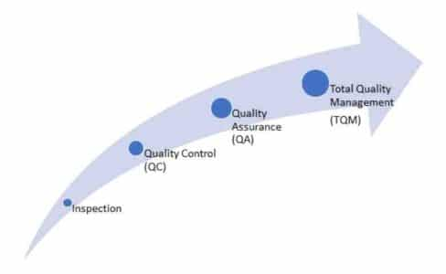
Figure 1 – Evolution of TQM (Constructor, 2012)
TQM is a combination of 4 Phases shown in Figure 1 – Evolution of TQM. As it starts with Inspection as to make sure that we inspect, test and measure the Activities done and if its met it’s requirements and if not its rejected. Then Quality Control aims to assess and check the product or service against a specification or the standard that set for it. Testing is its main objective within QC. Quality Assurance is the next stage as it is for the improvement and monitoring to develop a product or service to ensure it meets an agreed upon standard. With the focus of prevention of faults and errors occurring. Lastly, is Total Quality Management which is focused mainly on engaging the whole organization and those involved with the project together to integrate “quality discipline” within the organization through data, communication and involvement.

Peter Druckers Management by Objectives
With the industry there have been different management theories which have been introduced as they relate to the principles and running of a project. From the likes of Douglas McGregor’s X and Y theory to Peter Druckers Management by Objectives Theory. These theories do have an impact on the Quality Management of a project as it shows how the best systems out there can be effect by different factors outside of their control.
In Peter Druckers theory on Management by Objectives is focused on the “ Performance Management” and “between the objectives of employees and the company goals” (Mulder, 2022). This theory looks at the different objectives that the employer and employee have as these impact the quality of work to sought out a balance between their objectives. As he believed that setting out challenges but attainable objectives that it would promote motivation to the employees to help develop and improve the standard of work, quality, efficiency and time. Please see below Figure 2 – The MBO Process Cycle, Developed by Peter Drucker
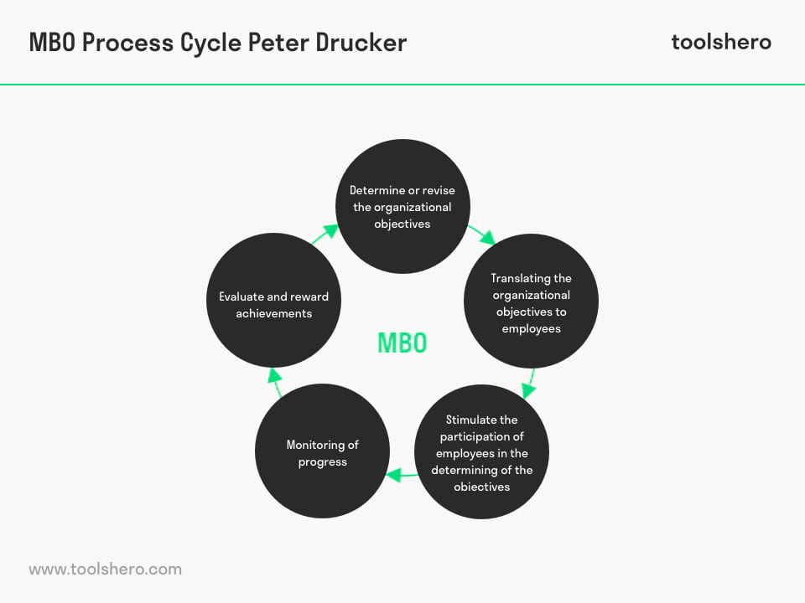
Figure 2 – The MBO Process Cycle, Developed by Peter Drucker (Mulder, 2022)

Conclusion
In conclusion, all the above systems do work with in their own rights and have valid points about them. As Quality Control and Quality Assurance go hand and hand together as QC looks at making sure the aims and targets are met and are compared to the standard to see if the results met it, while the QA is to help insure that no defects or errors happen to the product during it’s life cycle. Both these aim for Monitoring and Preventing faults on the product while improving them as well to prevent further issues.
Although, in my conclusion I do believe Total Quality management is the best option and way forward for Quality Management (QM). As it involves all 4 stages of QM with Inspections, QC, QA and TQM. It combines all the attributes of the 4 different stages. It looks at monitoring the whole project from start to finish highlighting any abnormalities along the way before they become a major issue or delay the project. With this it emphasizes the importance of including testing and inspections early on the lifecycle As well as insuring what has been installed, made and provided is up to the current standards and meets these requirements.
However, all these methods can alter and have issues which at times are out of a person control. This relates to the Management theories as having these systems in place and structure set for people to use and develop can be challenging as in the X and Y theory you have Y workers who are determined, enthusiastic and wanting to work, while you have X workers which are the opposite which don’t want to be there and only there for money. Y workers will do it to the best of their ability and follow the standard and take pride in their work and want it to be the best. Whereas, X workers will only do the bare minimum to do as little as possible and to a standard they think is alright. With Druckers theory he goes on about objective with the Employer and Employee’s this only works when the objectives a line and both parties want the say same but employer might have different goals and standards to that of the employee.
Quality is all down to how you manage and lead those around you and these systems do work but will have their problems along the work which shows nothings perfect and that within these systems you with have to account for these issues and look at ways of dealing with them as it can be setting targets which if they meet they get a bonus, improving the quality of the workforce you have with training and experience. Then its just down to Cost and Time.

Bibliography

CIOB. (2021, October 3). Quality control for construction works. Retrieved from Designings Buildings, The Construction WIKI: https://www.designingbuildings.co.uk/wiki/Quality_control_for_construction_works
Constructor, T. (2012, March 3). Quality in Construction Industry - Objectives, Factors Affecting Quality. Retrieved from The Constructor, Building Ideas: https://theconstructor.org/construction/quality-construction-objectives-factors-affecting/707/
Dictionary, O. (2022). Quality. In O. U. Press, Oxford Dictionary. https://www.oxfordlearnersdictionaries.com/definition/english/quality_1#:~:text=Definition%20of%20quality%20noun%20from%20the%20Oxford%20Advanced,care%20for%20nursing%20home%20residents%20is%20a%20priority.
Hayes, A. (2022, August 16). Quality Control: What It Is, How It Works, and QC Careers. Retrieved from Investopedia: https://www.investopedia.com/terms/q/quality-control.asp
ISO, I. O. (2015). ISO 9001 - Quality Management Systems. International Orgnization of Standardization.
ISOUpdate.com. (2019, September 23). What is Quality. Retrieved from ISO UPDATE: https://isoupdate.com/resources/what-is-quality/

Appendices

Appendix 1 – BS EN ISO 9001:2015 Quality Management Systems Requirements (ISO, 2015)
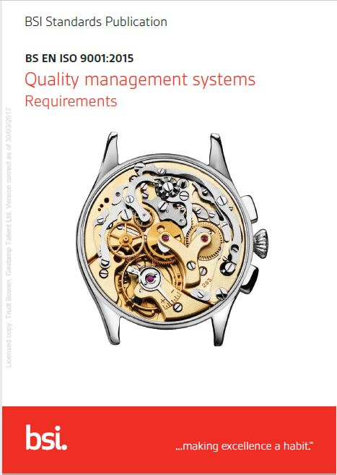

Appendix 2 – Alun Griffiths Contractors Ltd BS EN ISO 9001:2015 Certification
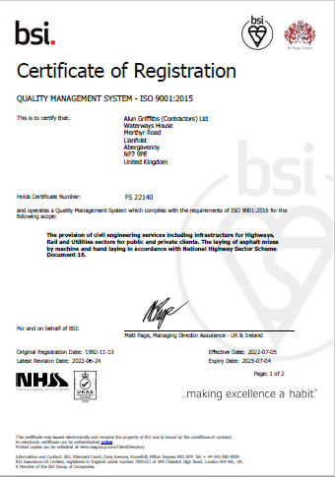

Appendix 3 – Alun Griffiths Contractors Ltd C.A.T and Genny Function Check Sheet.
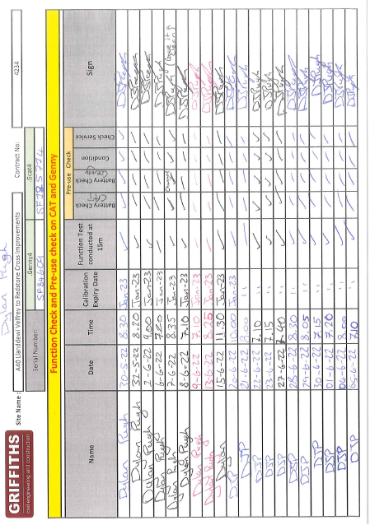

Appendix 4 – Alun Griffiths Contractors Ltd Quality Policy


