Site investigation case study: ACBA4001

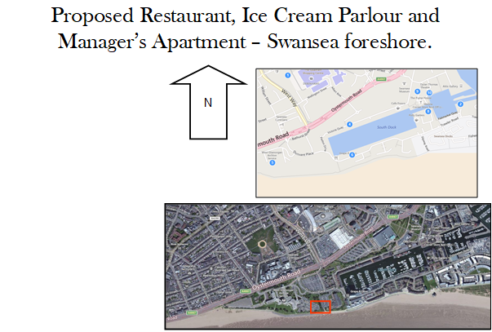
  - By Ben Kneeshaw – 1902457

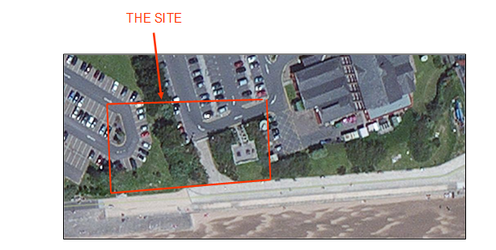

Table of contents
- Introduction ………………………………………………………………… Page 3
- General Overview………………………………………………………….. Page 3
- Historic Background ………………………………………………………. Page 4
- Ground Conditions………………………………………………………… Page 6
- Additional Considerations………………………………………………… Page 7
- Recommendations for Site Investigation………………………………... Page 8
- Recommendations for Foundation………………………………………..Page 9
- List of Figures………………………………………………………………. Page 10
- List of References…………………………………………………………..Page 10

Introduction:

During this report I shall outline my recommendations for a full site investigation of the proposed location. This will be based on archival information with regards to the site, and applicable codes of practice/regulations. I shall then describe a suitable foundation detail based on my preliminary observations.

General Overview:

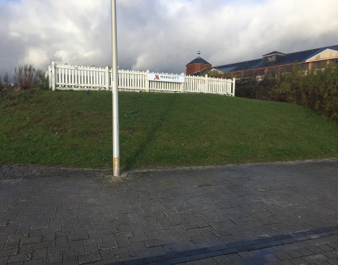
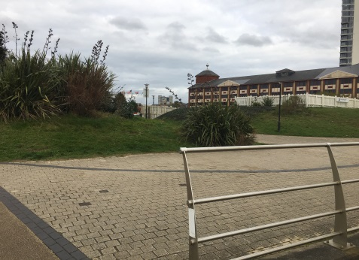
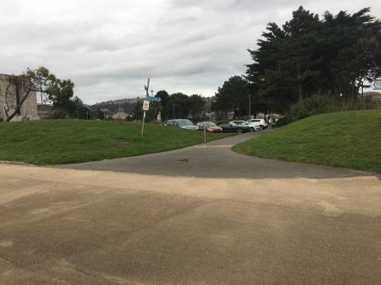
I began my site investigation with a walk over of the site. It consists of three mounds separated by a footpath and driveway, shrubbery is present on two of the mounds, on the most eastern mound sits a picnic area for the Marriott hotel, shown in figures 1 through 3. There are four manhole covers on the site indicating the presence of underground utilities/services, shown in figures 4 and 5. On the southern site boundary is a footpath with streetlights lining the side closest to the site. The site is easily accessible from either of the adjacent car parks seen as they both belong to organisations funding the project. In terms of weather, the site is exposed to strong winds due to being on the seafront, as such the possibility of erosion from the coastal winds and rain should be taken into account. As it sits next to the manmade tidal barrier it is above the high-tide mark. I have included an up-to-date aerial image of the site in figure 6.
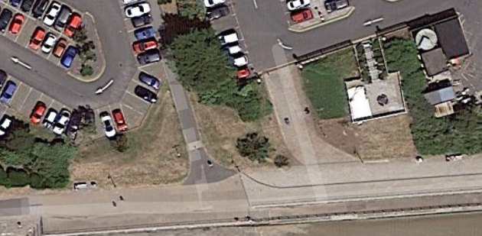
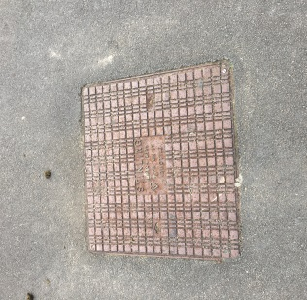
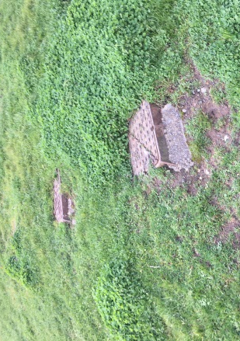
Figure 3
Figure 1
Figure 2
Figure 6
Figure 5
Figure 4

Historic Background:

The next step was to conduct a detailed historic background check using archival records and online information. The earliest records of the site come from the 1878 ordinance survey, shown in figure 7. This shows the south dock branch of the old railway cutting through the area. Where the civic centre is now sits a hospital for contagious diseases, north of the Marriott hotels current location sits an old Sawmill and timber yard. The direct location of the site is covered by sand dunes at this point.
Figure 7:
Ordinance Survey 1878

The next instance of the site in records comes from the 1899 ordinance survey, shown in figure 8. This shows the Sawmill in the same place but the timber yard has moved southwest to roughly the area of the site. At this point the area currently occupied by the civic centre has been developed further to include an engine shed and further train tracks to service the Swansea railway. This was ‘Paxton’s engine shed and marshalling yards’, acquired from British rail in in the seventies in order to build the civic centre.
Figure 8:
Ordinance survey 1899
The next instance of the site in records comes from the 1919 ordinance survey, shown in figure 9. This shows the Sawmill in the same place although the timber yard has been converted into a canister works. The engine shed and marshalling yards have been expanded to include more tracks and therefore space for trains.
The next instance of the site in records comes from the 1964 ordinance survey, shown in figure 10. At this point the Sawmill still occupies the same location but its timber yard is now directly south in the location of the current Marriott hotel. The canister works is also still in the same place but now has a paint factory adjacent. There is now a wagon repair works connected to the engine shed and marshalling yards, this is sandwiched between the manmade tidal barrier and the south dock branch of the old railway; this puts it in roughly the same area as the site.
Figure 10:
Ordinance Survey 1964
Figure 9:
Ordinance Survey 1919
The next instance of the site in records comes from the 1974 ordinance survey, shown in figure 11. This map shows the railway and ‘Paxton’s engine shed and marshalling yards’ have been demolished, along with the wagon repair works, this is to make way for the civic centre. The Sawmill has extended southwards slightly along the west side of the docks. The canister factory has been converted into warehouses whilst the paint factory remains.
The final instance of the site in records comes from the 1989 ordinance survey, shown in figure 12. This shows the site in its current state with the civic centre to the west and Marriott hotel to the east. The Sawmill and other industries have been demolished at this point.

Ground Conditions:
Figure 12:
Ordinance Survey 1989
Figure 11:
Ordinance Survey 1964

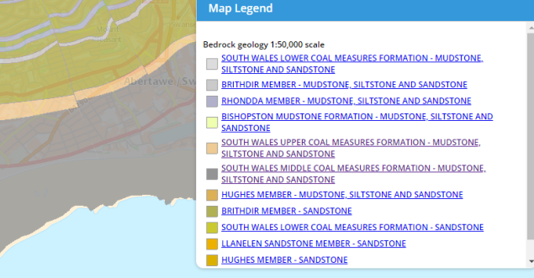
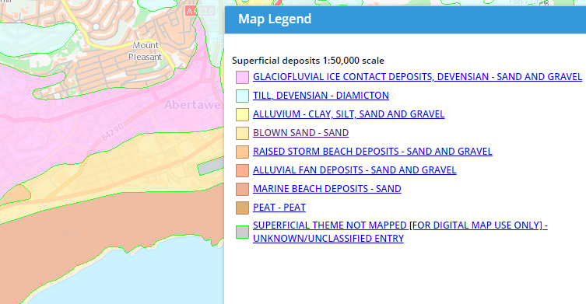
There is a wealth of information with regards to ground conditions on the British geological society’s website. The superficial deposits of the area are blown sand, shown in figure 13. The bedrock is the south wales middle coal measure; this is a productive layer of coal bearing mudstones and siltstones, with seat earths and minor sandstones, shown in figure 14. This has been topped off with artificial land, shown in figure 15.
Figure 13:
Blown Sand
Figure 14:
South Wales Middle Coal Measure

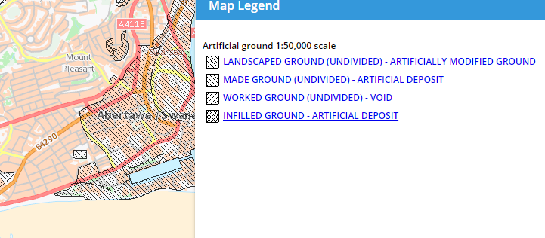
Figure 15:
Artificial Ground
Information is available in the county archives with regards to previous land use, although this is limited and only for a specific date. It states the lands main use has been industrial and rough land, the rough land being before the industry. The historic background check confirmed this as the area has been used for a number of industries, before which it was rough land e.g. dunes.
There is also a number of borehole scans available for the given area, these show the results of previous ground investigations. The first of these is directly on the proposed location. It was borehole number two in the county hall project and has a reference code: SS69SE345. This showed made ground down to four point nine five metres, folowed by gravel and sand down to seven point nine five metres. Followed by gravely boulder clay down to eleven metres, the next layer was very stiff grey gravelly boulder clay to a depth of eighteen point six metres. At this point the extraction method had to be changed from percussion to open hole rotary drilling due to gravel falling into the hole making coring impossible. The next layer is described as grey mudstone stretching to a depth of twenty-two metres, this is likely the coal measure as it is described to contain coal-bearing mudstones.
There is another borehole accesible in a nearby location. This was borehole four in the county hall project, it has a reference code: SS69SE348. This shows much the same as borehole two, with loose sand and gravel to a depth of eight point five metres. This is followed by boulder clay mixed with gravel and sand to a depth of twenty-two point five metres, with the strata being grey mudstone again. The drilling method was much the same with percussion coring used to nineteen metres, followed by open hole rotary drilling from nineteen to twenty-two metres, followed by rotary wash drilling from twenty-two to twenty-four metres. This shows the ground is relatively unstable until the substrata is reached.

Additional Consideration:

As Swansea was a prime target for the luftwaffe during world war two, it is also important to take into account the possibility of unexploded ordinance at the site. The Swansea docks are a high risk area with a bomb density of fifty bombs or more per one thousand acres, this is shown in figure 16.
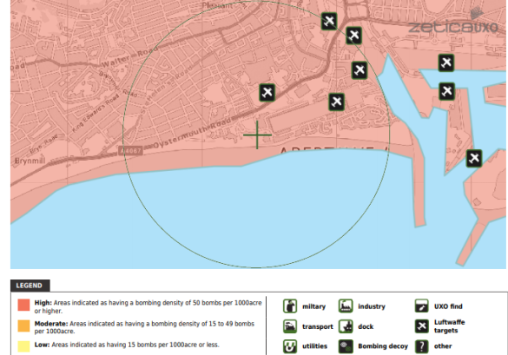
Figure 16:
Bomb Risk

Reccomendations For Site Investigation:

The first important consideration for the site investigation is to conduct a probe for unexploded ordinance. This is crucial as later intrusive methods of investigation could trigger said device if it exists. Therefore prior knowledge is required so as to mitigate any risks and allow alteration to plans if necessary.
Given the results from the ordinance probe are positive the next stage would be an intrusive investigation of the ground. My first recommendation with regards to this would be to dig a shallow trench coinciding in-line with the manhole covers present on site. This is to ensure the depth and location of the underlying utilities, thus ensuring the rest of the site investigation can be carried out without damaging or disrupting said services/utilities.
Based on the results from previous boreholes we should expect the ground to be comprised in the following way: anthropogenic ground, followed by sandy gravelly layers, followed by boulders and clay, followed by the south wales middle coal measure. Due to the shallow coal deposit and presence of useable clays there is a high risk that this area may have been mined previously. When compiled with the past presence of industrial activities on the site it becomes clear that there could be complications within the ground. Because of this I would recommend core samples to be taken on a one metre square grid, down to thirty metres if possible, this will help ensure all potential risks within the ground are picked up. This should be done using a combination of percussion drilling, ‘open-hole’ drilling and rotary wash drilling as per previous investigations. This should be done using an off-road rig as the terrain of the site is relatively uneven. Work should be carried out during daytime hours to avoid any disturbance to the nearby hotel. Assuming no complications arise, the samples should then be taken for laboratory test for the following: shear strength, hydraulic characteristics and deformation potential.
I have derived my recommendations from ‘BS 5930: 2015 code of practice for ground investigations’.

Recommendations for foundation:

Based on preliminary observations and assuming no contradictions from the ground investigation, I would recommend a bored pile foundation with supported hole. This is based on a number of reasons.
First is the likely composition of the ground. Due to a high percentage of gravel and sand in the various layers, it is likely any shallow foundations shall undergo substantial subsidence once the building is constructed. The presence of clay also means any drops in the water table could cause further subsidence. A piled foundation would avoid this by placing the load of the construction onto the bedrock, thus avoiding the gravelly and sandy layers. This is also why I have chosen a supported hole so as to avoid gravel and sand falling into the hole prior to concrete pouring. This is an issue that was encountered during core sampling for borehole two of the county hall project.
Another reason is the sites proximity to nearby buildings. As it is relatively close to existing structures it is important to minimise any disturbance or displacement in the ground, so as to protect said nearby structures. It is for this reason I have chosen bored piles. This will cause minimal displacement in the soil and substrata compared to driven piling methods, thus ensuring minimisation of any overlaps with existing pressure bulbs. As such it should be done using a rotary auger as opposed to any of the driven methods.
This will need to be an end-bearing pile as the soil is mainly loose gravel and sand. This makes it unsuitable for bearing large weights without substantial settlement. Using an end-bearing pile it is possible to bypass this and put the load directly onto the bedrock.
I have derived my recommendations from ‘BS 8004: 2015 code of practice for foundations’.

List of figures:
- Figure 1. Own photo. Taken: 30.11.19
- Figure 2. Own photo. Taken: 30.11.19
- Figure 3. Own photo. Taken: 12.12.19
- Figure 4. Own photo. Taken: 30.11.19
- Figure 5. Own photo. Taken: 30.11.19
- Figure 6. Google maps. Available at: https://www.google.com/maps/@51.613259,-3.9453051,62m/data=!3m1!1e3 Accessed: 12.12.19
- Figure 7. Ordinance Survey (1878) ‘Glamorgan’, 1:2500. Available at: https://digimap.edina.ac.uk/historic Accessed: 02.12.19
- Figure 8. Ordinance Survey (1899) ‘Glamorgan’, 1:2500. Available at: https://digimap.edina.ac.uk/historic Accessed: 02.12.19
- Figure 9. Ordinance Survey (1919) ‘Glamorgan’, 1:2500. Available at: https://digimap.edina.ac.uk/historic Accessed: 02.12.19
- Figure 10. Ordinance Survey (1964) ‘Glamorgan’, 1:1250. Available at: https://digimap.edina.ac.uk/historic Accessed: 02.12.19
- Figure 11. Ordinance Survey (1974) ‘Glamorgan’, 1:1250. Available at: https://digimap.edina.ac.uk/historic Accessed: 02.12.19
- Figure 12. Ordinance Survey (1989) ‘Glamorgan’, 1:1250. Available at: https://digimap.edina.ac.uk/historic Accessed: 02.12.19
- Figure 13. British Geological Society (2019), ‘Geoindex onshore’. Available at: http://mapapps2.bgs.ac.uk/geoindex/home.html Accessed: 12.12.19
- Figure 14. British Geological Society (2019), ‘Geoindex onshore’. Available at: http://mapapps2.bgs.ac.uk/geoindex/home.html Accessed: 12.12.19
- Figure 15. British Geological Society (2019) ‘Geoindex onshore’. Available at: http://mapapps2.bgs.ac.uk/geoindex/home.html Accessed: 12.12.19
- Figure 16. Zetica UXO (2019) ‘Risk map’. Available at: https://zeticauxo.com/downloads-and-resources/risk-maps/ Accessed: 12.12.19

List of references:
- BSI (2015) Codes of practice for ground investigations. Available at: https://geotechnicaldesign.info/download/bs5930-2015.pdf Accessed: 13.12.19
- BSI (2015) Code of practice for foundations. Available at: http://geotechnicaldesign.info/bs8004-2015.html#c6 Accessed: 13.12.19
- Strata Surveys Ltd (1975) Borehole 2: proposed county hall. Available at: http://scans.bgs.ac.uk/sobi_scans/boreholes/370246/images/10677923.html Accessed: 12.12.19
- Strata Surveys Ltd (1975) Borehole 4: proposed county hall. Available at: http://scans.bgs.ac.uk/sobi_scans/boreholes/370249/images/10677930.html Accessed: 12.12.19

