ACCA4023 – Introduction to Web Development
Website Design, Implementation and Evaluation Report

Student Name: Ahmad Kassabi
Student Number: 2419776
Teacher Name: Sadhana Jha
Module: ACCA4023 Introduction to Web Development
Website Title: Ahmad Mecca Photography
Submission Date: 2 April 2026

Table of Contents
1. Introduction 2
Abstract 2
2. Requirements 2
3. Implementation 3
Discussion of implementation 7
4. Validation 7
5. Evaluation 13
5.1 Website usability, accessibility, and search engine optimisation 13
Usability 13
Search engine optimisation (SEO) 14
5.2 Analysis of the completed website 15
Usefulness (utility, usability and content) 15
Search Engine Optimisation (SEO) on-page 15
WCAG 2.1 16
6. Comparison of Two Live Websites 17
7. Conclusion 17
References 17
Appendix A. index.html 18
Appendix B. about.html 21
Appendix C. gallery.html 23
Appendix D. contact.html 26
Appendix E. style.css 28
Appendix F. script.js 36

1. Introduction

Abstract
This report describes a multi-page website titled "Ahmad Mecca Photography." The site is based on a photography portfolio focused on Mecca and Madina and features a straightforward, visual organization that allows for atmosphere, scale, architecture, and respect aesthetics and narrative. This site is based on the principle of using design and layout to communicate the architectural message of Mecca and Madina that provides visitors with a way of accessing the Mecca architecture and its connections to them.
The final website has separate Home, About, Gallery, and Contact pages with easy-to-navigate navigation bar, full width hero image, readable text hierarchy, and card based content areas. This visual aesthetic is based around a minimal colour palette, a large photographic background, rounded buttons and responsive layout rules ensuring that the site is usable on both desktop and smaller devices.
This report describes the website purpose, target audience, design decisions, and technical detail. At the end of this report it evaluates usability, accessibility, search engine optimisation, and responsive behaviour using direct observations of work completed to last-page comments, supported by scholarly journal and book materials published between 2021-2025.
Also, the report reflects on strengths, shortcomings, future improvements, validation observations, and comparisons with two well-known live websites. Full listing of the website source files, so that the submitted implementation can be reviewed transparently, appears in appendices.

2. Requirements
The website was developed as a stand-alone, multi-page front-end site that can open locally through the main index.html file without building any dependency on a development environment. The subject is a photography portfolio for Mecca and Madina with scenes of the Kaaba, Masjid al-Haram, Al-Masjid an-Nabawi and Makkah Clock Tower. The aim of the site is to offer a collection of different photographs in a calm and clean manner that respects the history of the field they represent. In addition, it will involve an HTML-style website structure and also use HTML, CSS and very small amounts of JavaScript for mobile navigation behavior and footer date use.
General visitors to the site should be attracted with a curiosity in sacred architecture, Islamic landmarks and travel or pilgrimage scenes as well as by the visual presentation of portfolios. The website was planned in practical terms, requiring at least three related pages and a clear navigation that was readable, with sections for good content.
The Home page sets topics and gives an overall feeling of the site. The About Page explains the visual concept and design focus. The Gallery page uses more diverse image cards to take the theme a step further. The Contact page features a distinct contact form and enquiry information. The criteria of all pages were consistency, ease of navigation on page types, simple to navigate, ease of grouping of information, explicit headings, and display in other screen size formats.
Both the visual and content requirement were as crucial. The website required it to look sleek but not crowded, letting photos dominate the page, good contrast of text and background text and less clutter from background, and simplicity of the user interfaces and design, and less complexity for the interface. For that, it's a great way to use large hero sections, dark layers behind white header text, limited colour selection, limited “green and white” themes, subtle shadows, round and rounded buttons, and cards.
From a standards standpoint of view, the work needed also semantic HTML structure, a linked stylesheet and the relative page-to-page navigation, basic access support, and some form of validation and evaluation that is suitable for an academic web development submission.

3. Implementation
The final implementation follows a consistent page layout. For the design of page elements a single layout is used. Each page has a skip link for keyboard users, a sticky header that displays the site brand and a navigation menu, and a larger hero section, including a themed background image and a top-level introduction. Below the hero, the content is separated into subsections using a centred container and a two-column grid or card layout along with clear h2 and h3 headings. This provides the site a clear format so the visitor knows how to navigate easily.
CSS controls most of the design work, it takes the focus and proportionate application on spacing, colour, responsive breakpoints, cards, buttons, shadows and hero presentation. JavaScript is very lightly used for mobile menu switches and footer year updates keeping the performance of these pages clear and in good proportion with a relatively small target site.
Screen grabs of completed pages
Below are screenshots of completed website pages in the final form using data supplied for this submission rather than regenerated page captures.
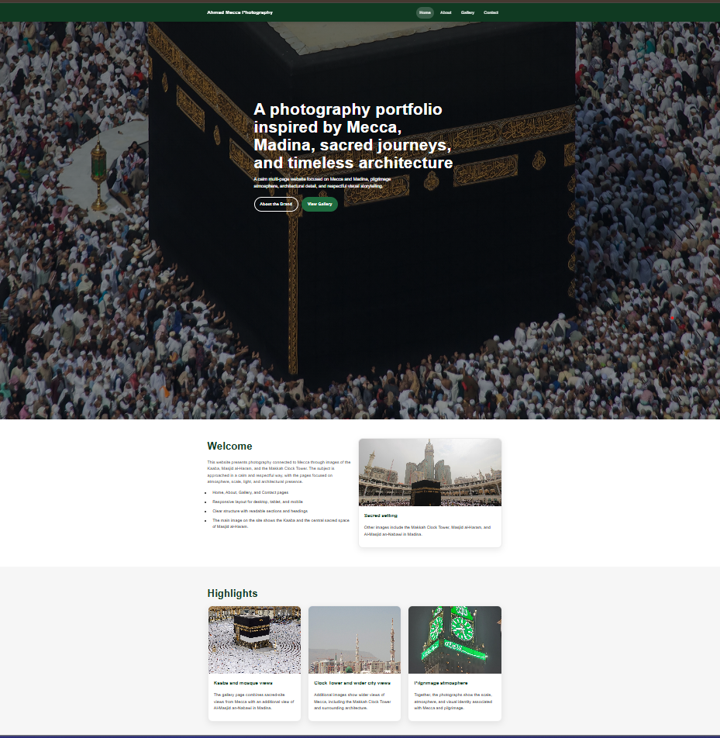
Figure 1. Home page for the final site.
The Home page focuses on the website's identity. The giant hero picture is visually bold and the headline and action buttons can quickly inform the visitor what the site is about. The welcome page and the highlight cards in the lower part of the page support the theme and inform to a level that the visitor can maintain, but not overload their attention.
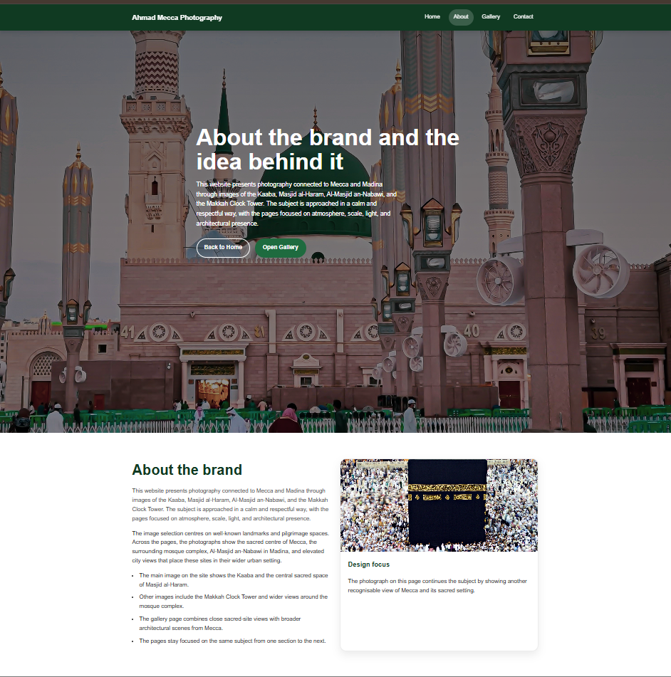
Figure 2. Final website About page.
The About page takes the brand idea farther than the site as a whole. It maintains that same visual framework as the Home page, but the text takes it further to explain the subject matter and how the design is focused. The page offsets lengthy explanatory text to support image card so it remains readable, as it will all of it still be readable with visual.
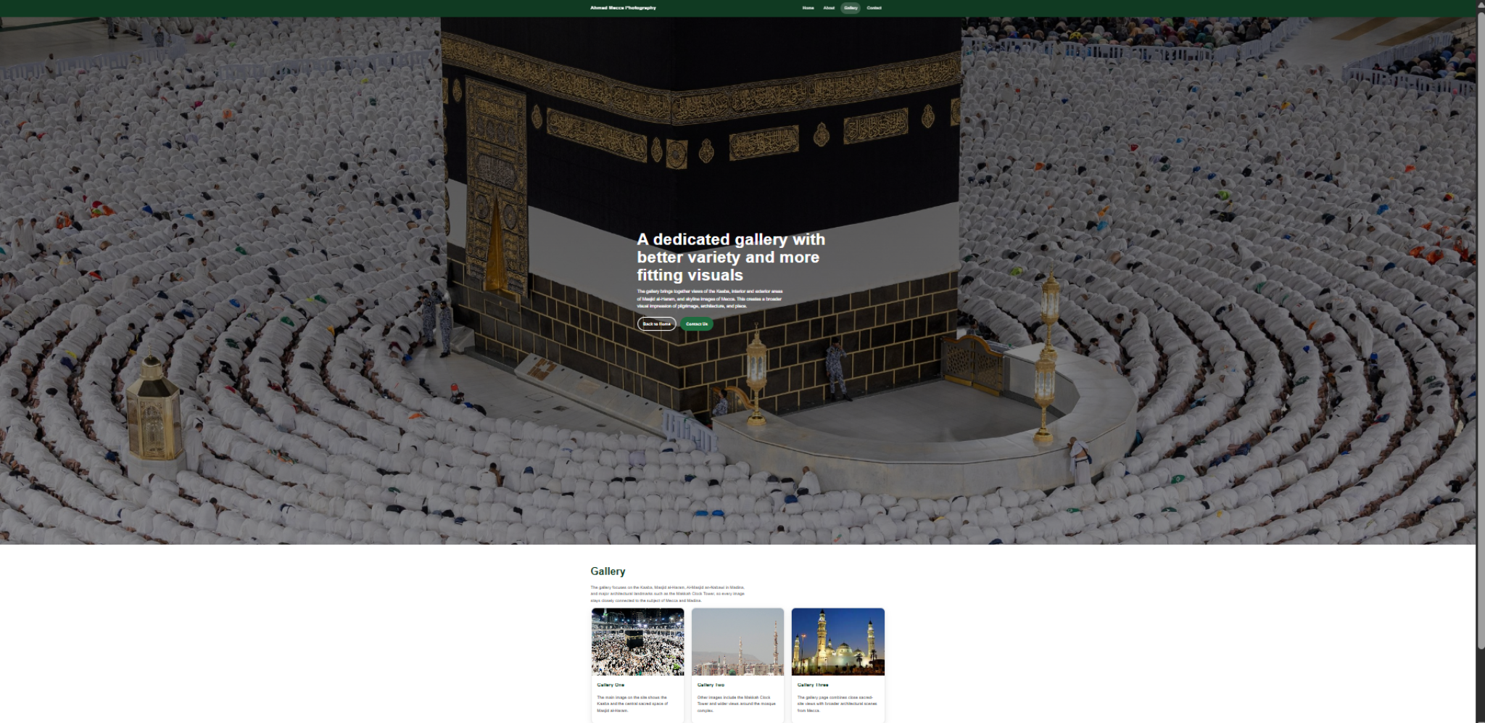
Figure 3. Gallery page of the site.
The Gallery page increases the project’s variety and reinforces the portfolio concept. The page retains similar navigation and hero types, but the card structure is the predominant one since this page was designed to present pictures of visual examples. This is important in the case of consistency, as it makes it clear to the visitor and they can know the site identity and feel that it is the same site identity although the emphasis changes in content.

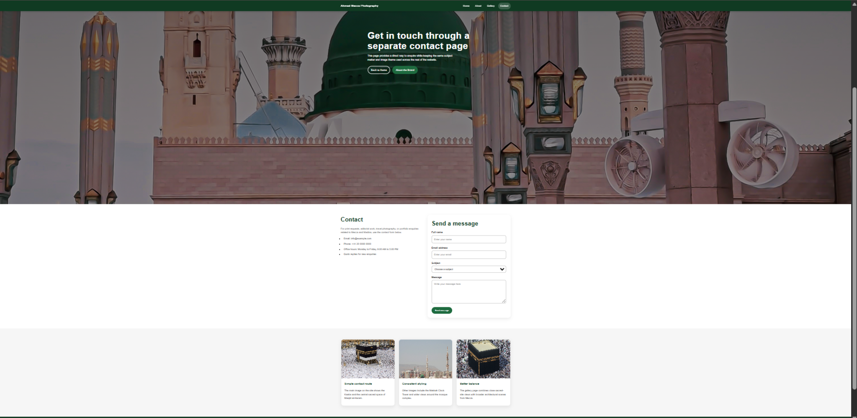
Figure 4. The final website Contact page.
A separate space for communication is provided on the Contact page. Maintaining the contact form in isolation will help clarify where you are going, and will not be distracting to the whole portfolio pages of an already busy site. Labels, a subject selector, and a message zone give the form structure a sense of focus, and surrounding contact information and image cards keep visual connections to the rest of the site.

Discussion of implementation
Few implementation decisions are shown in the screenshots and the code. First, we use a shared stylesheet on the site -- and so your typography, colors, grids, cards, buttons and section spacing are consistent from one page to the next. The second thing is that it is a responsive design: CSS grid layouts reduce from multiple columns to a single-column arrangement on smaller screens, and the mobile menu button becomes visible below the specified breakpoint. This is in accordance with responsive design, the design pattern should be tailored to screen width, and not based on a pre-set desktop layout. Responsive design has been found significantly to be beneficial to usability and effect in usability research specifically towards its use by smartphone users in all the different connection environments as well as mobile devices [6].
Third, the codebase goes a step further in trying to offer rudimentary accessibility. These pages include a skip link, language statement, viewport meta tag, annotated form controls, and navigational toggle displaying the state of the page through aria-expanded. This is good because accessibility is much simpler to design in, and much easier to retrofit than to find. Finally, the content strategy is intentionally kept in check. Utilizing short blocks of text and image-led composition, it avoids many competing widgets and thick paragraphs. For a portfolio site specifically, this works well since the visitor’s interest should stay on the photographs, a point supported by a pithy context description.

4. Validation
The work consists of checking the website against established web standards. It demonstrates the ability to interpret the data and analyze its semantics correctly in order to support content creation. The provided screenshots in the W3C validator have also been added directly to the report as the evidence base in the validation discussion for this final version. HTML pages were evaluated with the Nu HTML Checker and the stylesheet was validated using the W3C CSS Validation Service.
Item checked | Result | Comment
Home page HTML structure | Largely valid | Semantic page structure, headings, images and navigation are present.
Main CSS file | Mostly accurate | Layout, colours, cards, forms and responsive rules use standard syntax.
Most likely issue identified | Needs improvement | Some pages have a <script> element pointing towards an image/file path URL rather than JavaScript. You should remove or replace this with a correct script reference.
Metadata quality | Partly complete | Home and About pages have better meta description, but Gallery and Contact are less so: their description text is too short.

In the validation evidence provided, it was found that three checks in HTML that were completed had no errors or warnings, and one in HTML check that had one warning that one heading was missing in one of the four sections. CSS validation result for style.css reported no error found.
As a result of these results, it can be stated that most of the website is standards-compliant, only a small semantic issue lies on one page section. Overall, these results suggest that the site is relatively close to standard front-end practice in this regard. The clean CSS validation result is the best result that reflects the consistency and technical validity of the main layout rules. The one HTML warning is of limited relevance in this case because the single warning is less on page element broken element and more on section headings structure, but it still has a significant component in terms of semantic quality and accessibility as well because well-heading sections are relatively easy for assistive technologies to recognize [1], [9].
Figures 5-9 provide the validation screenshots that were employed as evidence in this report. The script.js validator screenshot also provided independently isn't considered an important figure, because we only mention HTML and CSS verification in the introduction.
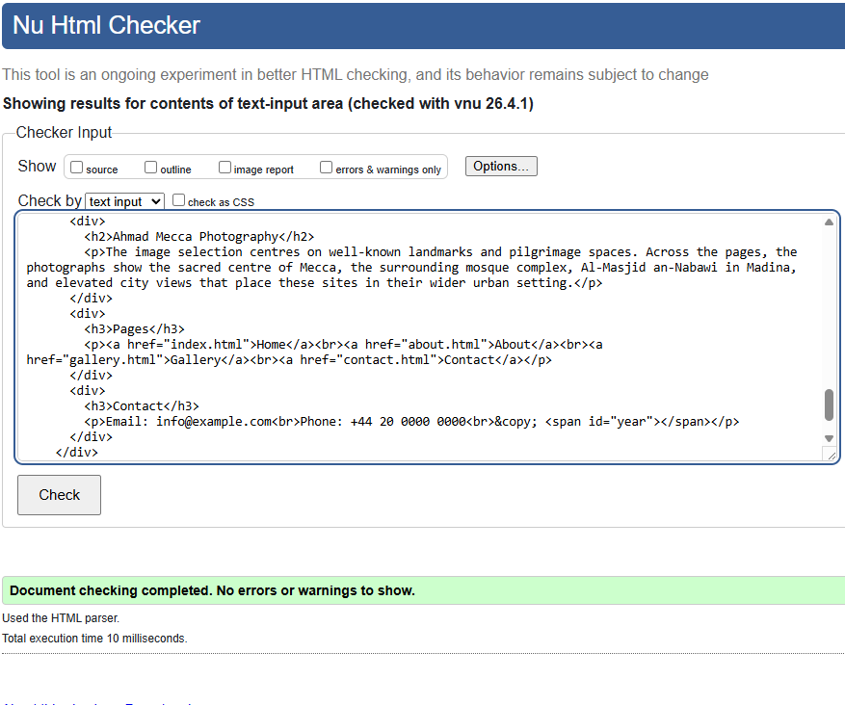
Figure 5. Provided screenshot HTML validation result with no errors or warnings.
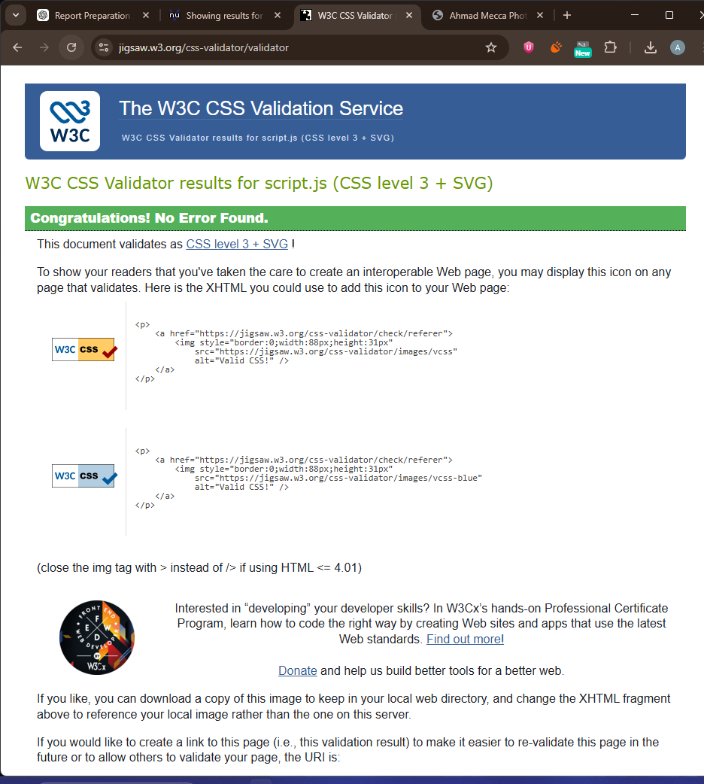
Figure 6. Screenshot of HTML validation result provided indicates no errors or warnings.
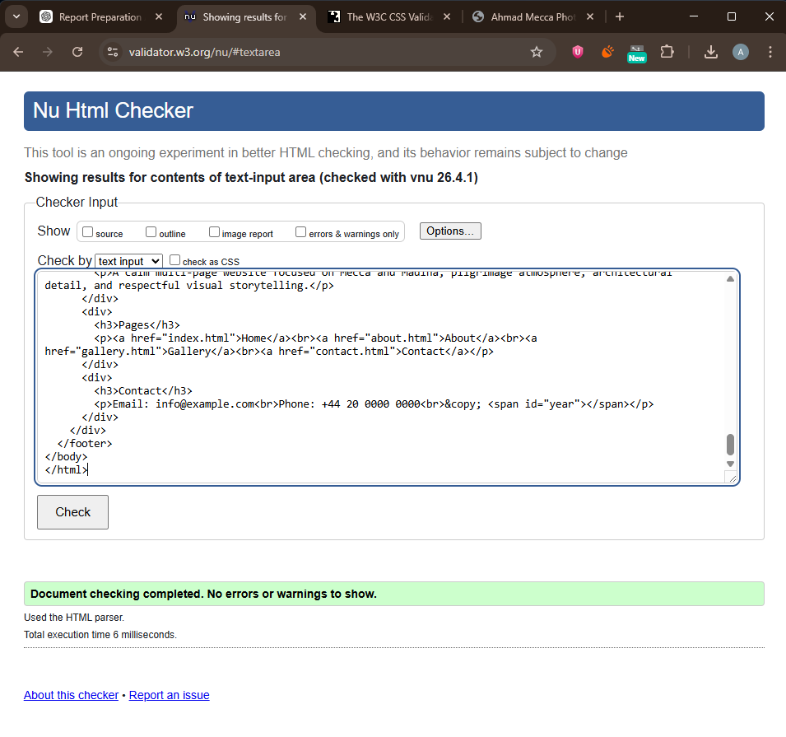
Figure 7. Insert HTML validation result screenshot with no errors or warnings.
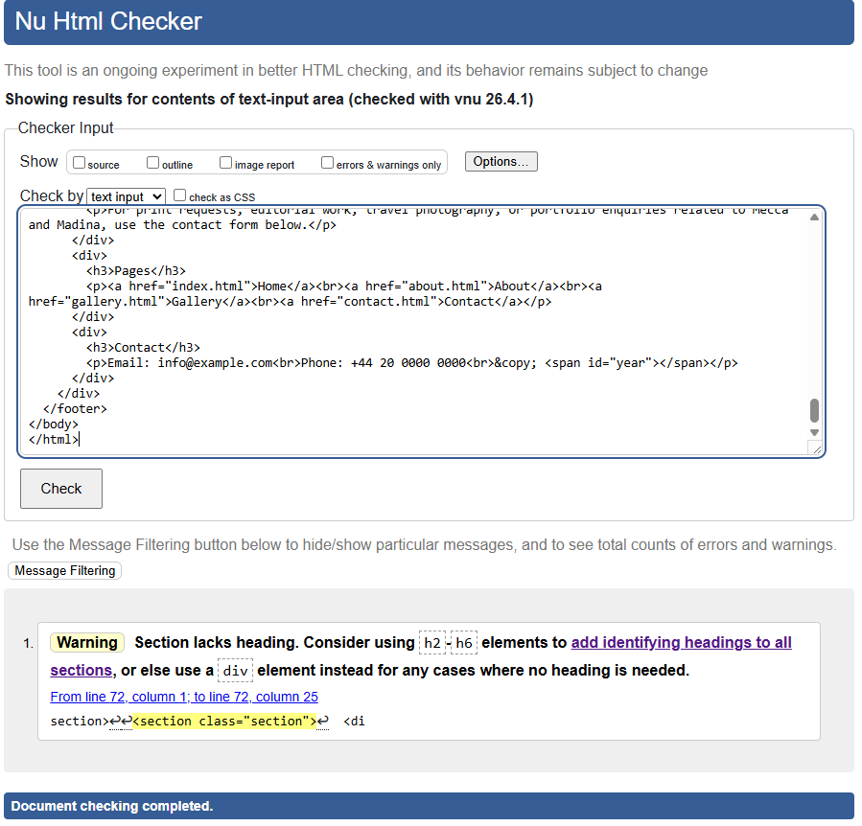
Figure 8. Provided HTML validation result screenshot, one section-heading warning.
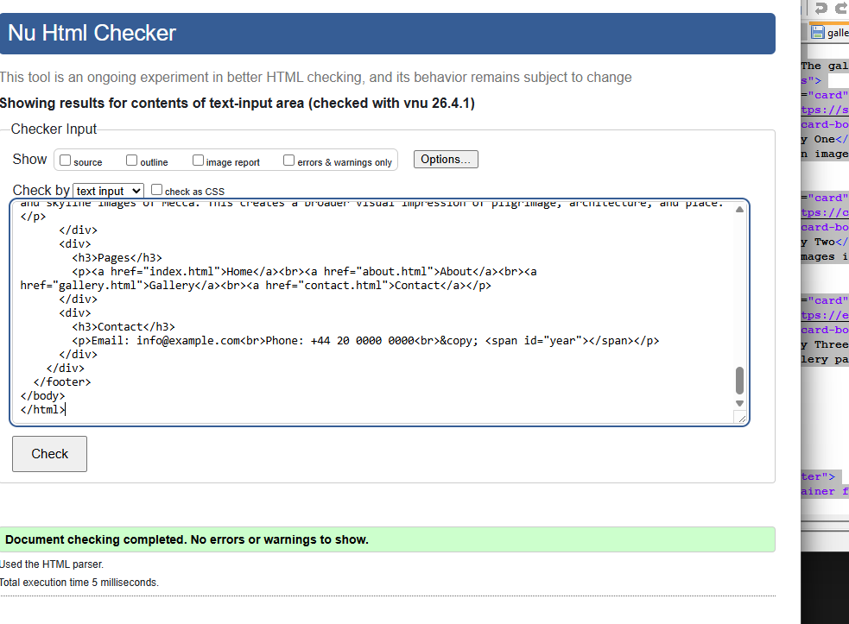
Figure 9. Supplied CSS validation result screenshot showing no error found for style.css.

5. Evaluation

5.1 Website usability, accessibility, and search engine optimisation
Website quality often cannot be judged by appearance alone. And a site can look good, and still be hard to use, difficult to access, and weakly discoverable in search results. For that consideration the three related dimensions - usability, accessibility and search engine optimisation - are considered. We define these terms first and then link them to research, before we evaluate the complete website.

Usability
Usability has to do with how effectively, efficiently and satisfactorily users perform actions with an interface. In practice, this means clarity of navigation, readability of content, predictability of your web pages’ structure, visual hierarchy, and the speed with which users can navigate over to next pages. Website usability conceptualisation 2023 concluded that website usability is multidimensional and that its assessment will need to take place from the end users’ perspective not just from aesthetics [7]. Another 2023 report on the online journal interfaces of scholarly publishers indicated that mixed user testing and after-task questionnaires are relevant in determining friction in task completion and satisfaction [5]. These findings are consistent with the notion good usability is not accidental; it relies on structure, content quality and user-centred evaluation.
Usability is also associated with responsive behaviour. According to research done by Parlakkiliç, responsiveness is positively associated with perceived usability and effectiveness among university students, where ease of use was revealed to be one of several features of university students. For a website like this project, that is very important, because people visit the pages a lot of the time on mobile devices. Clean scaling across a variety of scale allows you to avoid frustration in navigation and content blocks.
Accessibility is designing and creating websites, with the intention of allowing people with disabilities to find visual material, navigate and interact with contents. Recent academic and practitioner textbooks published between 2022 and 2025 uniformly described WCAG 2.1 by following the four principles of POUR: perceivable, operable, understandable, and robust [1][8][9]. Recent work and synthesises further demonstrate that disabled users experience heterogeneous barriers in online environments and depend on different accessibility features and services, and accessibility must be considered a fundamental part of inclusive design, not a highly technical checklist [1][3].
More recent studies have demonstrated that accessibility enhances experience, but in general, experience and accessibility aren’t always the same in all measures. Vollenwyder et al. showed that better conformance was not correlated to the improved usability score across all testers per se, however, users with visual impairments reported improved experiences on the more accessible version of the test site [2]. Droutsas et al. similarly show that barriers affect different disability groups in different ways, which means accessibility should be considered a matter of continual designing and testing, not just a one-off checklist [3].

Search engine optimisation (SEO)
SEO improves visibility on how well a website shows relevancy to search engines through titles, meta descriptions, headings, descriptive content, internal links, image text, performance, and optimised mobile-friendliness. New studies treat SEO as a strategic process rather than an expedient device that can be used in the short term and consider ranking potential as a function of specific keyword selection, relevance and retention and long-term structure of posts [4]. The academic literature also reports that metadata, page relevance, and keyword matching still are the key bases for discoverability [4]. The strongest features in terms of SEO in this project are descriptive page titles, headings, image alt attributes, and the topic is presented in a consistent manner. The worst parts here are the very short meta descriptions on pages and lack of specific long-tail keywords in the page copy (photography portfolio, sacred architecture, and Mecca landmarks etc) which should be implemented more systematically.

5.2 Analysis of the completed website

Usefulness (utility, usability and content)
The website works well for the purposes of that it provides the theme for a photography portfolio across a number of separate but linked pages. Visitors will be able to see the topic instantly, jump from page to page, and come across contact form without being confused. As the website is not attempting complicated functionality, that’s a strength here as the project brief does not require database behaviour or transactional features. Its specialized features allow for a simple experience and coherence.
Usability-wise the highest-performing things is consistency, layout, and hierarchy. Navigation is the same on the following pages, hero section always tells why the page is there, and the cards keeps it from becoming an excessive visual overburden. Strong colour contrast is also evident. For example, the white text on the dark green navigation bar of the website far surpasses the general expectations of a visual contrast, from the simplest comparison point of view. The responsive grid and menu logic enhance flexibility when viewed on smaller screens.
The main limitations are detail of content and depth of task. Visually, the site is crisp but not particularly full. Image descriptions could be more polished, the contact form could mention confirming feedback if nothing else, and in terms of real contact details in the real world, or call to action there should use more real world contact information and action. In the future, those improvements should thus include more rich captions and realism contact workflow, and maybe a specific page for highlighted collections or stories behind individual photos.

Search Engine Optimisation (SEO) on-page
Many SEO techniques are already set up in this website. All the pages have a unique title element, making it easy for the search engines to identify the pages. The Home and About pages also employ meta descriptions which summarise the content summary of their subject information. The pages use a heading hierarchy that starts with a single heading format starting from a single h1 and then using headings including h2 and h3 which is a better semantic structure. There are several image alt attributes in place, and internal links connect all important pages. You have a viewport tag too for mobile display, as well as that the responsive design itself can provide indirect SEO related benefits due to how mobile usability is demanded by the current SEO expectation.
But, the current one is rudimentary for SEO. Gallery and Contact descriptions are too generic, some alt text labels are functional instead of fully descriptive and there is no structured data, XML sitemap or canonical strategy. The site might be improved by a stronger metadata section, more content that uses searches for text naturally, compressing and locally managing images better, and all media and scripts being loaded in the best technical sense.

WCAG 2.1
Perceivable Accessibility: The website is fair on the perceivable principle because text appears, page structure is well-defined, and images contain alt attributes. Dark overlay behind the hero text is used to ensure reading the page over pictures. The main weakness was some image alternative text is generic rather than descriptive, especially with gallery cards, so the non-visual meaning needs to be improved.
Operable: The website offers skip links, button-like links (seen via navigation) and a toggle to use aria-expanded which sends the state. Keyboard and assistive technology users are advised to be excited. The pages, however, avoid complex hidden interactions. However, full keyboard testing with focus-order testing, live automated checking with tools like WAVE or axe would be helpful to ensure if every interactive item works in all possible scenarios.
Understandable: The page layouts themselves are predictable — it’s easy to navigate, the content is constantly changing, and sections stick together. The language used throughout the pages is straightforward but the labels on the contact form can easily be grasped, and there are clear instructions as to how to view what is included. Supporting this explanation is the fact that in practice users do not feel obliged to re-learn the topic from page to page. Improvements could consist of clearer on error marking on the form or by having a more detailed explanatory text in the painting of its interpretation of images on site.
Robust: The HTML structure is quite traditional and is suitable for modern browsers, but slight reduced robustness is evident when the script tags at certain pages point to non-script resources. Since robustness in WCAG terms is contingent on the correct interpretation by a range of user agents and assistive technologies, technical tidiness is essential. While the site offers a strong foundation towards accessible content, we feel the site lacks adequate descriptive alt text and technical implementation/testing against WCAG 2.1 AA.

6. Comparison of Two Live Websites
Two useful live comparison points are GOV.UK and BBC.com. They are not a personal portfolio site in the extreme sense of the word, however they are incredibly obvious web properties and thus a good comparison point for usability, accessibility, SEO and mobile sensitivity. GOV.UK is particularly strong in clarity, consistency and accessibility. On its homepage it has a more concise layout, higher contrast, clear headings, predictable navigation, and no fancy words. This leads to a far more efficient experience for users, though it is, in a way, purposely less lively than image-driven websites.
BBC.com offers a different benchmark. It deals a lot in news, multimedia and large quantities of content, so its interface is more visually crowded than GOV.UK for having to straddle headlines, images, video, and multiple content categories. As a result, it has some things going for it: strong editorial distribution, nice section size separation and responsive viewing on both video and web-screens.
The submitted website is significantly smaller and simpler from these sites. It is strong on thematic and visual focus. But it's also weaker: It's an incomplete piece because it doesn't have the depth of content, the technical polish, or the maturity of proven accessibility in it. Generally speaking, GOV.UK provides a better benchmark for accessibility/usability whereas BBC.com is the solid benchmark for visuals rich in content.

7. Conclusion
The website provides a cohesive multi-page photography website based on Mecca and Madina imagery. The final site follows consistent navigation, responsive layout behaviour and a logical use of HTML, CSS and JavaScript. The screenshots and validation evidence you provided make it clear that the website is visually organised and technically very close to standard-compliant practice. The assessment also reveals significant strengths in usability, thematic focus, and simple accessibility, while pinpointing tangible enhancements such as improvements in metadata, semantic precision, richer content, and more solid form feedback. Ultimately, this submission fulfills the essential objectives for the brief and establishes a credible basis for further refinement.

References
[1] V. Bercaru and N. Popescu, “A Systematic Review of Accessibility Techniques for Online Platforms: Current Trends and Challenges”, Applied Sciences, vol. 14, no. 22, p. 10337, 2024, doi: 10.3390/app142210337.
[2] B. Vollenwyder, S. Petralito, G. H. Iten, F. Bruhlmann, K. Opwis and E. D. Mekler, “How compliance with web accessibility standards shapes the experiences of users with and without disabilities,” International Journal of Human-Computer Studies, vol. 170, p. 102956, 2023, doi: 10.1016/j.ijhcs.2022.102956.
[3] N. Droutsas, F. Spyridonis, D. Daylamani-Zad and G. Ghinea, "Web accessibility barriers and their cross-disability impact in eSystems: A scoping review," Computer Standards & Interfaces, vol. 92, p. 103923, 2025, doi: 10.1016/j.csi.2024.103923.
[4] A. Erdmann, R. Arilla, and J. M. Ponzoa, "Search engine optimization: The long-term strategy of keyword choice," Journal of Business Research, vol. 144, pp. 650–662, 2022, doi: 10.1016/j.jbusres.2022.01.065.
[5] S. Peker and G. G. M. Dalveren, "Usability assessment of scholarly publishers' online journal interfaces," Journal of Data, Information and Management, vol. 5, pp. 363-374, 2023, doi: 10.1007/s42488-023-00110-z.
[6] A. Parlakkilic, “Evaluating the effects of responsive design on the usability of academic websites in the pandemic", Education and Information Technologies, vol. 27, pp. 1307–1322, 2022; doi:10.1007/s10639-021-10650-9.
[7] A. K. M. N. Islam, M. R. Islam and M. N. Uddin, "Conceptualization and Survey Instrument Development for Website Usability," Informatics, vol. 10, no. 3, p. 75, 2023, doi: 10.3390/informatics10030075.
[8] S. Horton and D. Sloan, What Every Engineer Should Know About Digital Accessibility. Boca Raton, FL, USA: CRC Press, 2024.
[9] N. Palani, The Web Accessibility Project Development and Testing Best Practices. Boca Raton, FL, USA: Auerbach Publications, 2022.

Appendix A. index.html
<!DOCTYPE html>
<html lang="en">
<head>
<meta charset="UTF-8">
<meta name="viewport" content="width=device-width, initial-scale=1.0">
<title>Ahmad Mecca Photography | Home</title>
<meta name="description" content="A calm multi-page website focused on Mecca and Madina, pilgrimage atmosphere, architectural detail, and respectful visual storytelling.">
<meta name="author" content="Ahmad Kassabi">
<link rel="stylesheet" href="style.css">
<script defer src="https://commons.wikimedia.org/wiki/Special:FilePath/Kaaba_Mecca.jpg"></script>
<style>:root { --hero-image: url('https://commons.wikimedia.org/wiki/Special:FilePath/Kaaba_Masjid_Haraam_Makkah.jpg'); }</style>
</head>
<body>
<a class="skip-link" href="#main-content">Skip to main content</a>
<header class="site-header">
<div class="container navbar">
<a class="brand" href="index.html">Ahmad Mecca Photography</a>
<button class="menu-toggle" type="button" aria-expanded="false" aria-controls="primary-nav">Menu</button>
<ul class="nav-links" id="primary-nav">
<li><a class="active" href="index.html">Home</a></li>
<li><a href="about.html">About</a></li>
<li><a href="gallery.html">Gallery</a></li>
<li><a href="contact.html">Contact</a></li>
</ul>
</div>
</header>
<main id="main-content">
<section class="hero" aria-label="Page introduction">
<div class="container hero-content">
<h1>A photography portfolio inspired by Mecca, Madina, sacred journeys, and timeless architecture</h1>
<p>A calm multi-page website focused on Mecca and Madina, pilgrimage atmosphere, architectural detail, and respectful visual storytelling.</p>
<div class="button-row"><a class="btn btn-secondary" href="about.html">About the Brand</a><a class="btn btn-primary" href="gallery.html">View Gallery</a></div>
</div>
</section>
<section class="section section-alt">
<div class="container grid-2">
<div>
<h2>Welcome</h2>
<p class="lead">This website presents photography connected to Mecca through images of the Kaaba, Masjid al-Haram, and the Makkah Clock Tower. The subject is approached in a calm and respectful way, with the pages focused on atmosphere, scale, light, and architectural presence.</p>
<ul class="feature-list">
<li>Home, About, Gallery, and Contact pages</li>
<li>Responsive layout for desktop, tablet, and mobile</li>
<li>Clear structure with readable sections and headings</li>
<li>The main image on the site shows the Kaaba and the central sacred space of Masjid al-Haram.</li>
</ul>
</div>
<div class="card">
<img src="https://upload.wikimedia.org/wikipedia/commons/thumb/b/bd/Kaaba%2C_Makkah5.jpg/960px-Kaaba%2C_Makkah5.jpg?_=20160906170930" alt="Ahmad Mecca Photography featured image">
<div class="card-body">
<h3>Sacred setting</h3>
<p>Other images include the Makkah Clock Tower, Masjid al-Haram, and Al-Masjid an-Nabawi in Madina.</p>
</div>
</div>
</div>
</section>
<section class="section">
<div class="container">
<h2>Highlights</h2>
<div class="cards">
<article class="card">
<img src="https://commons.wikimedia.org/wiki/Special:FilePath/Masjid_al-Haram_2025.jpg" alt="Highlight image one">
<div class="card-body">
<h3>Kaaba and mosque views</h3>
<p>The gallery page combines sacred-site views from Mecca with an additional view of Al-Masjid an-Nabawi in Madina.</p>
</div>
</article>
<article class="card">
<img src="https://commons.wikimedia.org/wiki/Special:FilePath/Al-Masjid_an_Nabawi.jpg" alt="Highlight image two">
<div class="card-body">
<h3>Clock Tower and wider city views</h3>
<p>Additional images show wider views of Mecca, including the Makkah Clock Tower and surrounding architecture.</p>
</div>
</article>
<article class="card">
<img src="https://commons.wikimedia.org/wiki/Special:Redirect/file/Clock%20Tower%20in%20Mecca.jpg" alt="Highlight image three">
<div class="card-body">
<h3>Pilgrimage atmosphere</h3>
<p>Together, the photographs show the scale, atmosphere, and visual identity associated with Mecca and pilgrimage.</p>
</div>
</article>
</div>
</div>
</section>
</main>
<footer class="footer">
<div class="container footer-grid">
<div>
<h2>Ahmad Mecca Photography</h2>
<p>A calm multi-page website focused on Mecca and Madina, pilgrimage atmosphere, architectural detail, and respectful visual storytelling.</p>
</div>
<div>
<h3>Pages</h3>
<p><a href="index.html">Home</a><br><a href="about.html">About</a><br><a href="gallery.html">Gallery</a><br><a href="contact.html">Contact</a></p>
</div>
<div>
<h3>Contact</h3>
<p>Email: info@example.com<br>Phone: +44 20 0000 0000<br>&copy; <span id="year"></span></p>
</div>
</div>
</footer>
</body>
</html>

Appendix B. about.html
<!DOCTYPE html>
<html lang="en">
<head>
<meta charset="UTF-8">
<meta name="viewport" content="width=device-width, initial-scale=1.0">
<title>Ahmad Mecca Photography | About</title>
<meta name="description" content="This website is built around a simple idea: the photography should feel calm, respectful, and memorable. I wanted the design to stay clean so the images remain the main focus while the pages still feel polished and easy to move through.">
<meta name="author" content="Ahmad Kassabi">
<link rel="stylesheet" href="style.css">
<script defer src="https://commons.wikimedia.org/wiki/Special:FilePath/Al-Masjid_an_Nabawi.jpg"></script>
<style>:root { --hero-image: url('https://commons.wikimedia.org/wiki/Special:FilePath/Al_Masjid_An-Nabawi.jpg'); }</style>
</head>
<body>
<a class="skip-link" href="#main-content">Skip to main content</a>

<header class="site-header">
<div class="container navbar">
<a class="brand" href="index.html">Ahmad Mecca Photography</a>
<button class="menu-toggle" type="button" aria-expanded="false" aria-controls="primary-nav">Menu</button>
<ul class="nav-links" id="primary-nav">
<li><a href="index.html">Home</a></li>
<li><a class="active" href="about.html">About</a></li>
<li><a href="gallery.html">Gallery</a></li>
<li><a href="contact.html">Contact</a></li>
</ul>
</div>
</header>

<main id="main-content">
<section class="hero" aria-label="Page introduction">
<div class="container hero-content">
<h1>About the brand and the idea behind it</h1>
<p>This website presents photography connected to Mecca and Madina through images of the Kaaba, Masjid al-Haram, Al-Masjid an-Nabawi, and the Makkah Clock Tower. The subject is approached in a calm and respectful way, with the pages focused on atmosphere, scale, light, and architectural presence.</p>
<div class="button-row"><a class="btn btn-secondary" href="index.html">Back to Home</a><a class="btn btn-primary" href="gallery.html">Open Gallery</a></div>
</div>
</section>

<section class="section section-alt">
<div class="container grid-2">
<div>
<h2>About the brand</h2>
<p class="lead">This website presents photography connected to Mecca and Madina through images of the Kaaba, Masjid al-Haram, Al-Masjid an-Nabawi, and the Makkah Clock Tower. The subject is approached in a calm and respectful way, with the pages focused on atmosphere, scale, light, and architectural presence.</p>
<p>The image selection centres on well-known landmarks and pilgrimage spaces. Across the pages, the photographs show the sacred centre of Mecca, the surrounding mosque complex, Al-Masjid an-Nabawi in Madina, and elevated city views that place these sites in their wider urban setting.</p>
<ul class="feature-list">
<li>The main image on the site shows the Kaaba and the central sacred space of Masjid al-Haram.</li>
<li>Other images include the Makkah Clock Tower and wider views around the mosque complex.</li>
<li>The gallery page combines close sacred-site views with broader architectural scenes from Mecca.</li>
<li>The pages stay focused on the same subject from one section to the next.</li>
</ul>
</div>
<div class="card">
<img src="https://commons.wikimedia.org/wiki/Special:Redirect/file/Kaaba%20%281%29%20Makkah%20%28Mecca%29.jpg" alt="About page image">
<div class="card-body">
<h3>Design focus</h3>
<p>The photograph on this page continues the subject by showing another recognisable view of Mecca and its sacred setting.</p>
</div>
</div>
</div>
</section>

</main>
<footer class="footer">
<div class="container footer-grid">
<div>
<h2>Ahmad Mecca Photography</h2>
<p>The image selection centres on well-known landmarks and pilgrimage spaces. Across the pages, the photographs show the sacred centre of Mecca, the surrounding mosque complex, Al-Masjid an-Nabawi in Madina, and elevated city views that place these sites in their wider urban setting.</p>
</div>
<div>
<h3>Pages</h3>
<p><a href="index.html">Home</a><br><a href="about.html">About</a><br><a href="gallery.html">Gallery</a><br><a href="contact.html">Contact</a></p>
</div>
<div>
<h3>Contact</h3>
<p>Email: info@example.com<br>Phone: +44 20 0000 0000<br>&copy; <span id="year"></span></p>
</div>
</div>
</footer>
</body>
</html>

Appendix C. gallery.html
<!DOCTYPE html>
<html lang="en">
<head>
<meta charset="UTF-8">
<meta name="viewport" content="width=device-width, initial-scale=1.0">
<title>Ahmad Mecca Photography | Gallery</title>
<meta name="description" content="Gallery page">
<meta name="author" content="Ahmad Kassabi">
<link rel="stylesheet" href="style.css">
<script defer src="script.js"></script>
<style>:root { --hero-image: url('https://commons.wikimedia.org/wiki/Special:FilePath/Masjid_al-Haram_2025.jpg'); }</style>
</head>
<body>
<a class="skip-link" href="#main-content">Skip to main content</a>

<header class="site-header">
<div class="container navbar">
<a class="brand" href="index.html">Ahmad Mecca Photography</a>
<button class="menu-toggle" type="button" aria-expanded="false" aria-controls="primary-nav">Menu</button>
<ul class="nav-links" id="primary-nav">
<li><a href="index.html">Home</a></li>
<li><a href="about.html">About</a></li>
<li><a class="active" href="gallery.html">Gallery</a></li>
<li><a href="contact.html">Contact</a></li>
</ul>
</div>
</header>

<main id="main-content">
<section class="hero" aria-label="Page introduction">
<div class="container hero-content">
<h1>A dedicated gallery with better variety and more fitting visuals</h1>
<p>The gallery brings together views of the Kaaba, interior and exterior areas of Masjid al-Haram, and skyline images of Mecca. This creates a broader visual impression of pilgrimage, architecture, and place.</p>
<div class="button-row"><a class="btn btn-secondary" href="index.html">Back to Home</a><a class="btn btn-primary" href="contact.html">Contact Us</a></div>
</div>
</section>

<section class="section section-alt">
<div class="container">
<h2>Gallery</h2>
<p class="lead">The gallery focuses on the Kaaba, Masjid al-Haram, Al-Masjid an-Nabawi in Madina, and major architectural landmarks such as the Makkah Clock Tower, so every image stays closely connected to the subject of Mecca and Madina.</p>
<div class="cards">
<article class="card">
<img src="https://static01.nyt.com/images/2016/07/21/magazine/pilgimage-vr/pilgimage-vr-superJumbo.jpg" alt="Gallery image one">
<div class="card-body">
<h3>Gallery One</h3>
<p>The main image on the site shows the Kaaba and the central sacred space of Masjid al-Haram.</p>
</div>
</article>
<article class="card">
<img src="https://commons.wikimedia.org/wiki/Special:FilePath/Al-Masjid_an_Nabawi.jpg" alt="Gallery image two">
<div class="card-body">
<h3>Gallery Two</h3>
<p>Other images include the Makkah Clock Tower and wider views around the mosque complex.</p>
</div>
</article>
<article class="card">
<img src="https://encrypted-tbn0.gstatic.com/images?q=tbn:ANd9GcRKk_2BTSfkS1cfJKdW8yajF1mHU3IEOyywxg&s" alt="Gallery image three">
<div class="card-body">
<h3>Gallery Three</h3>
<p>The gallery page combines close sacred-site views with broader architectural scenes from Mecca.</p>
</div>
</article>
</div>
</div>
</section>

</main>
<footer class="footer">
<div class="container footer-grid">
<div>
<h2>Ahmad Mecca Photography</h2>
<p>The gallery brings together views of the Kaaba, interior and exterior areas of Masjid al-Haram, and skyline images of Mecca. This creates a broader visual impression of pilgrimage, architecture, and place.</p>
</div>
<div>
<h3>Pages</h3>
<p><a href="index.html">Home</a><br><a href="about.html">About</a><br><a href="gallery.html">Gallery</a><br><a href="contact.html">Contact</a></p>
</div>
<div>
<h3>Contact</h3>
<p>Email: info@example.com<br>Phone: +44 20 0000 0000<br>&copy; <span id="year"></span></p>
</div>
</div>
</footer>
</body>
</html>

Appendix D. contact.html
<!DOCTYPE html>
<html lang="en">
<head>
<meta charset="UTF-8">
<meta name="viewport" content="width=device-width, initial-scale=1.0">
<title>Ahmad Mecca Photography | Contact</title>
<meta name="description" content="Contact page">
<meta name="author" content="Ahmad Kassabi">
<link rel="stylesheet" href="style.css">
<script defer src="script.js"></script>
<style>:root { --hero-image: url('https://commons.wikimedia.org/wiki/Special:FilePath/Al_Masjid_An-Nabawi.jpg'); }</style>
</head>
<body>
<a class="skip-link" href="#main-content">Skip to main content</a>

<header class="site-header">
<div class="container navbar">
<a class="brand" href="index.html">Ahmad Mecca Photography</a>
<button class="menu-toggle" type="button" aria-expanded="false" aria-controls="primary-nav">Menu</button>
<ul class="nav-links" id="primary-nav">
<li><a href="index.html">Home</a></li>
<li><a href="about.html">About</a></li>
<li><a href="gallery.html">Gallery</a></li>
<li><a class="active" href="contact.html">Contact</a></li>
</ul>
</div>
</header>

<main id="main-content">
<section class="hero" aria-label="Page introduction">
<div class="container hero-content">
<h1>Get in touch through a separate contact page</h1>
<p>This page provides a direct way to enquire while keeping the same subject matter and image theme used across the rest of the website.</p>
<div class="button-row"><a class="btn btn-secondary" href="index.html">Back to Home</a><a class="btn btn-primary" href="about.html">About the Brand</a></div>
</div>
</section>

<section class="section section-alt">
<div class="container grid-2">
<div>
<h2>Contact</h2>
<p class="lead">For print requests, editorial work, travel photography, or portfolio enquiries related to Mecca and Madina, use the contact form below.</p>
<ul class="feature-list">
<li>Email: info@example.com</li>
<li>Phone: +44 20 0000 0000</li>
<li>Office hours: Monday to Friday, 9:00 AM to 5:00 PM</li>
<li>Quick replies for new enquiries</li>
</ul>
</div>
<div class="form-wrap">
<h2>Send a message</h2>
<form action="#" method="post">
<label for="contact-name">Full name</label>
<input id="contact-name" name="contact-name" type="text" placeholder="Enter your name" required>
<label for="contact-email">Email address</label>
<input id="contact-email" name="contact-email" type="email" placeholder="Enter your email" required>
<label for="contact-subject">Subject</label>
<select id="contact-subject" name="contact-subject" required>
<option value="">Choose a subject</option>
<option>General enquiry</option>
<option>Booking request</option>
<option>Pricing information</option>
</select>
<label for="contact-message">Message</label>
<textarea id="contact-message" name="contact-message" rows="5" placeholder="Write your message here"></textarea>
<button class="btn btn-primary" type="submit">Send message</button>
</form>
</div>
</div>
</section>

<section class="section">
<div class="container cards">
<article class="card">
<img src="https://commons.wikimedia.org/wiki/Special:FilePath/Masjid_al-Haram_2025.jpg" alt="Contact section image one">
<div class="card-body">
<h3>Simple contact route</h3>
<p>The main image on the site shows the Kaaba and the central sacred space of Masjid al-Haram.</p>
</div>
</article>
<article class="card">
<img src="https://commons.wikimedia.org/wiki/Special:FilePath/Al-Masjid_an_Nabawi.jpg" alt="Contact section image two">
<div class="card-body">
<h3>Consistent styling</h3>
<p>Other images include the Makkah Clock Tower and wider views around the mosque complex.</p>
</div>
</article>
<article class="card">
<img src="https://commons.wikimedia.org/wiki/Special:FilePath/Kaaba_Masjid_Haraam_Makkah.jpg" alt="Contact section image three">
<div class="card-body">
<h3>Better balance</h3>
<p>The gallery page combines close sacred-site views with broader architectural scenes from Mecca.</p>
</div>
</article>
</div>
</section>

</main>
<footer class="footer">
<div class="container footer-grid">
<div>
<h2>Ahmad Mecca Photography</h2>
<p>For print requests, editorial work, travel photography, or portfolio enquiries related to Mecca and Madina, use the contact form below.</p>
</div>
<div>
<h3>Pages</h3>
<p><a href="index.html">Home</a><br><a href="about.html">About</a><br><a href="gallery.html">Gallery</a><br><a href="contact.html">Contact</a></p>
</div>
<div>
<h3>Contact</h3>
<p>Email: info@example.com<br>Phone: +44 20 0000 0000<br>&copy; <span id="year"></span></p>
</div>
</div>
</footer>
</body>
</html>

Appendix E. style.css
* {
box-sizing: border-box;
}

html {
scroll-behavior: smooth;
}

body {
margin: 0;
font-family: Arial, Helvetica, sans-serif;
line-height: 1.6;
color: #222;
background: #f6f6f6;
}

img {
max-width: 100%;
display: block;
}

.skip-link {
position: absolute;
left: -9999px;
top: 0;
background: #000;
color: #fff;
padding: 12px 16px;
z-index: 10000;
}

.skip-link:focus {
left: 12px;
top: 12px;
}

.container {
width: min(1140px, 92%);
margin: 0 auto;
}

.site-header {
position: sticky;
top: 0;
z-index: 1000;
background: #103a22;
color: #fff;
box-shadow: 0 4px 14px rgba(0,0,0,0.14);
}

.navbar {
display: flex;
justify-content: space-between;
align-items: center;
gap: 20px;
padding: 14px 0;
}

.brand {
color: #fff;
text-decoration: none;
font-weight: 700;
font-size: 1.2rem;
}

.menu-toggle {
display: none;
background: transparent;
color: #fff;
border: 2px solid rgba(255,255,255,0.35);
border-radius: 10px;
padding: 8px 12px;
cursor: pointer;
}

.nav-links {
list-style: none;
display: flex;
gap: 10px;
padding: 0;
margin: 0;
}

.nav-links a {
color: #fff;
text-decoration: none;
padding: 10px 14px;
border-radius: 999px;
display: inline-block;
}

.nav-links a:hover,
.nav-links a:focus,
.nav-links a.active {
background: rgba(255,255,255,0.18);
outline: none;
}

.hero {
min-height: 72vh;
display: grid;
align-items: center;
background:
linear-gradient(rgba(0,0,0,0.58), rgba(0,0,0,0.42)),
var(--hero-image) center/cover no-repeat;
color: #fff;
}

.hero-content {
max-width: 780px;
padding: 88px 0;
}

.hero h1 {
font-size: clamp(2rem, 5vw, 4rem);
line-height: 1.08;
margin: 0 0 16px;
}

.hero p {
font-size: 1.08rem;
max-width: 60ch;
margin: 0 0 26px;
}

.button-row {
display: flex;
flex-wrap: wrap;
gap: 14px;
}

.btn {
display: inline-block;
padding: 12px 20px;
border-radius: 999px;
text-decoration: none;
font-weight: 700;
border: 2px solid transparent;
}

.btn-primary {
background: #1e6b3f;
color: #fff;
}

.btn-primary:hover,
.btn-primary:focus {
background: #2d8c57;
outline: none;
}

.btn-secondary {
color: #fff;
border-color: #fff;
}

.btn-secondary:hover,
.btn-secondary:focus {
background: rgba(255,255,255,0.12);
outline: none;
}

.section {
padding: 72px 0;
}

.section-alt {
background: #fff;
}

.section h2 {
font-size: clamp(1.7rem, 4vw, 2.5rem);
margin: 0 0 14px;
color: #103a22;
}

.lead {
max-width: 70ch;
color: #444;
}

.grid-2,
.cards,
.footer-grid {
display: grid;
gap: 24px;
}

.grid-2 {
grid-template-columns: repeat(2, 1fr);
}

.cards {
grid-template-columns: repeat(3, 1fr);
}

.card {
background: #fff;
border-radius: 18px;
overflow: hidden;
border: 1px solid #ececec;
box-shadow: 0 10px 24px rgba(0,0,0,0.08);
}

.card img {
width: 100%;
height: 260px;
object-fit: cover;
}

.card-body {
padding: 22px;
}

.card h3 {
margin-top: 0;
color: #103a22;
}

.feature-list {
padding-left: 20px;
}

.feature-list li {
margin-bottom: 10px;
}

.form-wrap {
background: #fff;
padding: 28px;
border-radius: 18px;
box-shadow: 0 10px 24px rgba(0,0,0,0.08);
}

label {
display: block;
font-weight: 700;
margin-bottom: 6px;
}

input,
select,
textarea {
width: 100%;
padding: 12px 14px;
border: 1px solid #cfcfcf;
border-radius: 12px;
margin-bottom: 16px;
font: inherit;
}

input:focus,
select:focus,
textarea:focus {
outline: 3px solid rgba(0,0,0,0.08);
border-color: #1e6b3f;
}

.footer {
background: #103a22;
color: #fff;
padding: 32px 0;
border-top: 4px solid rgba(255,255,255,0.08);
}

.footer-grid {
grid-template-columns: 2fr 1fr 1fr;
}

.footer a {
color: #fff;
}

@media (max-width: 900px) {
.grid-2,
.cards,
.footer-grid {
grid-template-columns: 1fr 1fr;
}
}

@media (max-width: 700px) {
.menu-toggle {
display: inline-block;
}

.nav-links {
display: none;
width: 100%;
flex-direction: column;
background: #103a22;
padding: 12px 0 4px;
}

.nav-links.show {
display: flex;
}

.navbar {
flex-wrap: wrap;
}

.grid-2,
.cards,
.footer-grid {
grid-template-columns: 1fr;
}

.hero-content {
padding: 72px 0;
}
}

Appendix F. script.js
document.addEventListener('DOMContentLoaded', function () {
var toggle = document.querySelector('.menu-toggle');
var nav = document.querySelector('.nav-links');
if (toggle && nav) {
toggle.addEventListener('click', function () {
nav.classList.toggle('show');
var expanded = toggle.getAttribute('aria-expanded') === 'true';
toggle.setAttribute('aria-expanded', String(!expanded));
});
}
var year = document.getElementById('year');
if (year) {
year.textContent = new Date().getFullYear();
}
});

