EFFECTIVE TEAM WORKING AND COMMUNICATION SKILLS ASSESSMENT 1

Student name: Zhyulven Bekirova
Student ID: 2119746

Lecturer name: Lloyd Beharry



1. INTRODUCTION
According to the Oxford English Dictionary communication is described as “The transmission or exchange of information, knowledge or ideas by means of speech, writing, mechanical or economical media” (EOD,2019).
The human voice was the first form of communication in ancient times. With time the methods are changing. People use cave paintings, smoke signals, and pigeons. Most civilisations had a postal system after the invention of writing. The discovery of printing was the next major step, followed by telegraphs, telephones, radio, computers and most recently smartphones.
Even with technology communication is not always effective. The reason is the communication barriers. Examples for barriers are noise, poor listening, poor feedback, body language, mental health etc. To ensure our communication is effective we can avoid the barriers by learning Communication skills, methods, and strategies.

2. MODELS OF COMMUNICATION

Models of communication are conceptual frameworks used to describe how people communicate. The first significant communication model was developed by mathematician Claude Shannon in 1948 and later published by Bell Laboratories with an introduction by scientist Warren Weaver. Later, the mathematical theory became known as the “mother of all models” or Shannon and Weaver model of communication. Compared to other linear models, this is more mathematical. The model has six elements: Information source, Transmitter, Channel, Receiver, Destination, and Noise. Shannon discovers that the element “NOISE” has an impact on communication.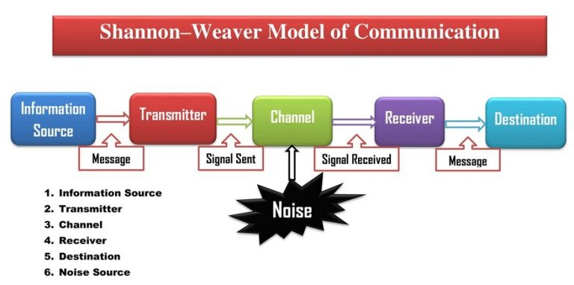
Noise can be physical, psychological, cultural, electrical, syntactical, semantic, and so more. For example, my experience with GP surgery. I frequently have trouble hearing the receptionist when I contact my GP’s office to make an appointment because my daughter is nearby screaming and chatting to me at the same time. Due to the background NOISE (my daughter’s voice), communication is becoming ineffective and terrible. In this case, the receptionist is the source of information (SENDER) that generates the message. The smartphone is the CHANNEL that converts the message into the soundwave signal to transmit from the SENDER (receptionist) to the RECEIVER (me). My daughter’s voice is the NOISE (physical) that bars the communication process.
Shannon made a crucial distinction between the technical challenge of message delivery and the challenge of message interpretation. Engineers may concentrate on the messaging system thanks to this step. In his 1948 article, Shannon focused on two key issues, figuring out the best way to encrypt a message using a particular alphabet in a noiseless environment and figuring out what additional measures are required in the presence of noise. The linear and one-way model of Shannon and Weaver is far not perfect, as human communication is not mathematical in nature. This is the reason why many researchers criticise it. An example of this is the case study with Pedro and Maria. Their dialogue via the phone was interrupted by a physical NOISE in his workplace, and instead of “chicken” Pedro understood “kitchen”. The weakness of the model is to be one-way with no FEEDBACK. If there was FEEDBACK, Pedro can ask his wife to repeat, and the communication will be effective and clear.
In 1950, Norbert Weiner added the “FEEDBACK”, but the original model is linear.
Compare with Shannon’s model in 1954 Wilber Schramm introduced a communication model with FEEDBACK. 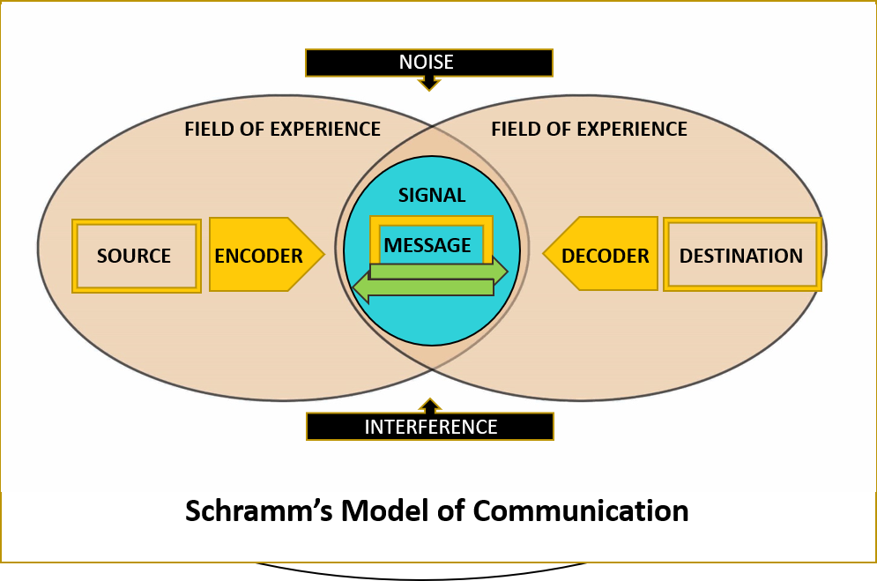
He suggested a two-way process where SENDER and RECEIVER take turns to send and receive a message. It is a circular model and includes ENCODER or SENDER, DECODER or RECEIVER, INTERPRETER, and MESSAGE. He believes that if communication is broken down, the RECIPIENT cannot understand the information. Until the SENDER receives confirmation from the RECEIVER that their message has been correctly understood, the communication cycle is not complete.
According to Schramm a person’s knowledge, experience, and cultural background are all significant factors in communication. People from various cultures, religions, and backgrounds frequently give the message varied interpretations.
As we mentioned earlier, Pedro and Maria's case study is an excellent example of poor communication. If Schram’s model was used in this case and Pedro responded to Maria to confirm that he received the information, they may avoid the misunderstanding.
Another communication model is introduced by David Berlo 1960. His model is linear like Shannon’s. Berlo’s model is known as the SMCR with four components: Source, Message, Channel, and Receiver, and no Feedback. Each of the components is affected by many factors.

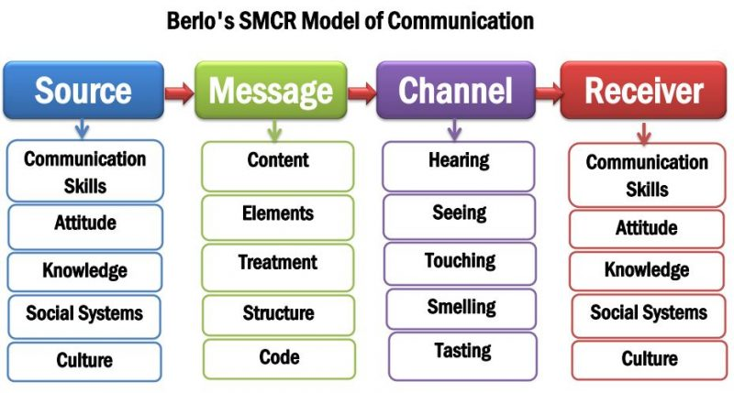
According to Berlo’s theory, the SOURCE and the RECEIVER must be on the same level for communication to be effective. As “EXTERNAL”, like in Shannon’s model, the NOISE might be “INTERNAL” caused by the difference between SENDER and RECEIVER.
The differences like communication skills, attitudes, knowledge, social system, and culture. If the SENDER is not clear with the MESSAGE and chooses the wrong voice of tone and gestures the RECEIVER will not understand well the MESSAGE. All these factors have impact on effective communication.
For example, in a workplace, if a manager talks fast and in a high level of English it is possible for the new staff and people from foreign countries to not understand their daily tasks. This kind of poor communication can raise serious problems in the workplace. If the manager pays attention to the staff’s background, the problems can be avoided.
It is the same situation in the case study “The Professor and the Village People”. The reason the village people do not understand him is the level of language he uses. If he sent simple and clear messages at the same level of their education, he would not lose his house.
In Berlo’s model, the main elements that are part of any communication process are considered together, with the factors which affect them.

3. COMMUNICATION SKILLS

Effective communication involves not only model knowledge but also certain skills. These skills allow people to understand and be understood by others. The main communication skills are verbal, non-verbal and effective listening.
- VERBAL – oral and written
- NON- VERBAL – body language, facial expressions, gestures
- LISTENING – active and empathetic
Verbal communication is a form of oral and written communication in which the message is transmitted through words (language). The sender uses words to express feelings, ideas, thoughts, and opinions. For effective verbal communication, the correct language skills and the ability to understand other people’s messages are essential. The critical element of effective communication is to choose the right tone of voice, body language and class of words. Since the message is sent and received by the sender and the receiver in the case of verbal communication, the feedback is immediate. To ensure the communication is received exactly as intended, the sender should always double-check with the receiver. Such communication is more prone to mistakes since words may not always be enough to convey a person’s thoughts and feelings. Verbal communication includes two kinds of communication rules – regulative and constitutive rules.

- Regulative rules are focused on how, when, where, and with whom the communicator to talks about specific things.
- Constitutive rules define what communication means by specifying how to count specific kinds of communication (Wood & Schweitzer,2010).
Having strong verbal communication skills can boost confidence and help in the development of long-lasting personal and professional relationships.
Non-verbal communication is communication where it is not necessary to use words to communicate. It is the way how we introduce ourselves and our ideas by using body language, facial expressions, and gestures. Non-verbal communication repeats what verbally is being said, but if it is not used carefully, it can also conflict what is being said.
The main forms of verbal communication include space, environment, body movement, vocal expression, gestures, and postures, facial and eye expressions, and touch.
Territorial and personal space violations can be destructive in business and professional settings. How physically close we go to people and how close we let them come to us depends on our connections with them, our position of power and status, and our cultural origins (Burgoon & Jones, 1976).
Additionally, the environment (e.g., lighting, colour, furniture, temperature) influences how people communicate. If the person is familiar with the environment, he feels comfortable to speak, but if the place is unfamiliar the person does not know what to expect and how to behave.
Saying “YES” and shaking head, using direct eye contact, controlling emotions and voice of tone, sitting or standing straight and relaxed are the keys to good communication. Business and personal relationships may suffer from a loss of connection and trust if body language is not properly used.
“We listen at about an efficiency rate of 25 per cent maximum, and we remember only about 50 per cent of what is delivered during a ten- minute speech/ lecture/ communication.” (Crocket, 2011).
To not only hear but listen actively to information it is necessary to pay attention, concentrate and be interested. Active and effective listening can be destructed by the thing surrounding us. For example, external noise – ruffling papers or a cell phone ringing or other people. As result, we can lose interest and not pay attention. Beyond noise, other factors that can affect the focus on the information can be using of jargons, overload messages, receiver apprehension and bias. By using the technics and methods listening can be improved. A framework for skill-based listening is provided by HUREEM model which categorises listening into six interconnected parts: hearing, understanding, remembering, interpreting, and responding (Brownell,1994,1996). Making an emotional connection with the speaker is the process of emphatic listening. It is the ability to put yourself in their situation and empathise with them.

4. THE ADVANTAGES AND DISADVANTAGES OF COMMUNICATION TECHNOLOGY

