Assignment Title: Effective Team Working & Communication
Module Code: BMSK4002

Student Name: Razvan Raducanu
Student Id: 1811975
Lecturer Name: Dr. Rexton Nting

Contents
Introduction 3
Working collaboratively by shared ownership, responsibility and issues of confidentiality 4
Negotiating and development of ideas 4
Theories of group dynamism 5
Belbin’s team structures theory 5
Group strategies of effective delegation, group agreements, shared objectives, and meaningful schedules 7
Interpersonal communication skills of body language, personal attributes, active listening 8
Factors and structures of written communication 8
Strategies to improve clarity of expression, punctuation, grammar, and syntax 9
Formats and structures of presentation 9
Communication by visual and electronic resources 9
Conclusion 10
References 11

Introduction
Individual performances have lower output than group performances which proved and in business context in the modern time, they are focusing on the developing the group performances such as applying higher collaboration and communication among the team players. Different theories and models play vital role in understanding the role and needs of the team. The following report has pointed various issues regarding team work and collaboration among the team members for higher and better organisational objectives achievements.

Working collaboratively by shared ownership, responsibility and issues of confidentiality
In the modern business world money or capital is not the key to success rather a business organization or a health organization requires to have a strong team. Limitation of money or finance can be overcome through financial innovation and shared ownership is an example of this innovation. It refers the process of having property through purchasing it partially. Generally, business organisations can purchase 25% to 75% and the remaining portion use through availing rent. Thus, organisations are not required to pay all the money for purchasing the complete property.
In working collaboratively, employees work under team where team members share their work ownership and responsibilities. For example, at Hotel Marriott service providers share their responsibilities according to their expertise. It has different team to ensure the food and hygiene of the accommodations. On the other hand, for attracting guests it has different marketing team. Thus, in a business organisation people share their ownership, responsibilities to attain its goals and objectives.
Confidentiality is also an important that is required to keep in priority basis. Losing confidential data may cause business to disrupt. For example, at Hotel Marriott it requires to keep its customer’s personal data to take their accommodation services and these customer data is obviously confidential. But if this data gets attacked or losing its confidentiality will cause to lose customer loyalty and trust. Thus, confidentiality is crucial part in collaborative work in a team.

Negotiating and development of ideas
Negotiation is basically gaining objectives from the other party through discussing and getting better share of the output. In a business context, it is highly important to have negotiation skills as they required to enter into transactions and deals (Tracy, 2013). For example, at Hotel Marriott it requires to have negotiation with its suppliers to ensure quality products and efficient rate. There are some ideas by which employees can develop their negotiation skills and those are as follows:
Recognizing the power through preparation: Routine preparation of a negotiator develops the power of identifying the weak points of the opposite party. The negotiator must ensure the practice through researching the issues relevant with negotiation topic. Through research and preparation, negotiator needs to identify the Best Alternative to a Negotiation Agreement (BATNA) along with identifying opposite party’s BATNA (Cottrell, 2011).
Being proactive: In the negotiation process, negotiator needs to be proactive in raising positive issues by which negotiator can weaken opposite party’s strong points. Negotiator needs to raise those issues proactively which will ensure strong positioning of the negotiators. For example, Hotel Marriott is large buyer in the industry which needs to be placed on the discussion board proactively.

Theories of group dynamism
Group dynamism represent the output of the team work through considering the member’s characteristics and influences through each member on the group behaviour. Group member’s behaviour gets affected from the attitude and actions of other members. Thus, group output is not simply summing up the capacity and characteristics of all the group members, rather the performances of the group get influenced (Adair, 2009). Factors that affects group dynamism are as follows:
Higher competition: In a group performance, members feel competition to prove and show their capacity by nature. Thus, team work stimulates group member’s individual performances. A healthy environment in a group work gets positive stimulation among the group members.
Sparking innovation: In addition of competition, group members can think creatively due to having diversified skills and knowledge in collaborative performances. Due to unstructured work process, group members can think out of the box from different ideas from different members. Thus, innovation and creativity sparks the work performance in group work and promotes group dynamism than individual work.

Belbin’s team structures theory
According to the Belbin’s theory, it has identified nine different roles in a teamwork which are required to ensure an effective output from team. It is not necessary to have nine different people with different approach of roles, because one member may have multiple capacity or can play different roles. The roles that has identified by Belbin’s theory are as follows:
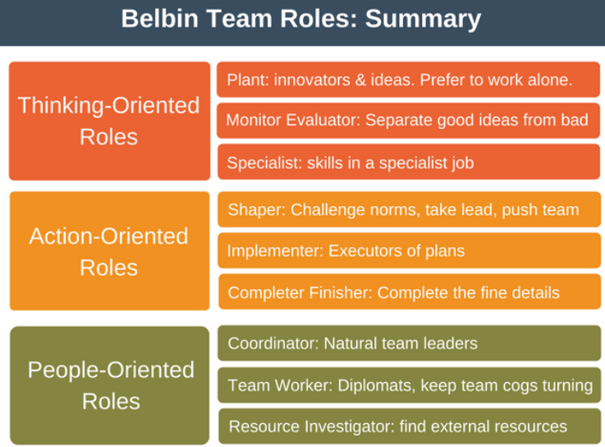
Figure 01: Belbin’s team roles (Belbin, 2012)
Action oriented
Shaper: In the team work, shaper plays the role to keep the work progress through maintaining focus point and taking aggressive initiatives.
Implementer: This group of people in a team performance basically realise the plan and make it real. In the implementation role, it has generally less flexibility and slow to response.
Complete finisher: In complete finisher stage of the group members, they are meticulous to find error and scrutinize the projects to complete and finish.
People oriented
Coordinator: Leaders in a teamwork plays this role, such as they keep the objectives in the focus point and ensure the achievement of the objectives through leading and coordinating all the performances of the team workers.
Team worker: The members in a team requires to be cooperative and to use versatility to ensure the targets of team work. Team workers plays the role of being cooperative in performing the objectives.
Resource investigator: This group of people in a team work, investigate the resources to ensure the maximum usage of the available resources through innovation and creativity with effective and efficient plan (Gennard, 2009).
Thought oriented
Plant: This is the innovation hub of a team work, where members think out of the box, and provides the environment for free thinking and generate ideas by solving difficult problems.
Monitor evaluator: This sort of role player in the team work provides logical eyes which ensure proper evaluation of the performed task to ensure control and quality.
Specialist: The performer of this role usually have in depth knowledge on a particular topic or area. Performer also have single-minded, self-starting and dedicated mentality for the performance and objectives of the team performances.

Group strategies of effective delegation, group agreements, shared objectives, and meaningful schedules
Effective delegation: Delegation refers the transferring process of a task toward another performer. But effective delegation requires to more criteria to be followed such as the capacity of the delegated person. For example, Hotel Marriott the chief marketing manager delegates various responsibilities toward his junior managers. But before delegating the responsibilities, chief must have understanding about the capacity of the junior manager whether he or she can accomplish the job.
Group agreement: This is a written piece of commitment where all the group members pointed in single and unified matter. For example, the marketing team at Hotel Marriott has group agreement to ensure 10% higher responses from the customers than the previous year.
Shared objectives: In the modern business context, sharing responsibilities and objectives are getting popular (Hoechsmann, 2012). Collaborative performances are bringing higher rate of success. For example, at Hotel Marriott the marketing team and services providing team shared their objectives in order to achieve common objectives.
Meaningful schedules: Providing services and products within the committed deadline is important ensure customer satisfaction and earn customer loyalty. To achieve objectives within the given deadline, the team performer requires to have a meaningful schedule of the performance which will consider all the contingency and feasible manner.

Interpersonal communication skills of body language, personal attributes, active listening
Interpersonal communication is the process of exchanging feelings, messages and opinion among the people or between the members. It is highly important to have strong interpersonal communication skill in the modern business world, as it requires to understand the needs of the customers to deliver products and services according to the requirements. There are several requirements in developing interpersonal communication skills and those are as follows:
Body language: Body language can deliver feelings beyond the speech and it is highly important to understand the mood of the customers (Jacks, 2011). For example, not smiling may indicate that the person is not happy. Or in some cases verbal communication may not possible such as language barrier etc. where body language plays vital role. In a business organisation such as at Hotel Marriott, here guests come from different region of the world with different language where it requires to deliver messages through body languages.
Personal attributes: Some personal attributes indicate messages to understand such as passionate, good looking etc. refers positive sign about an individual to treat him or her in a better way.
Active listening: In a working context, active listening is fundamental requirements because employees or service providers first need to understand the needs of the people through active listening. For example, at Hotel Marriott employees first listen their customers what they need and then propose available services according to the needs.

Factors and structures of written communication
Written communication is being used in formal and hierarchical process where upper level managers deliver their messages toward lower or field level managers. In addition, field level managers are also required to use written communication to reach a message to higher level managers.
In written communication, the content must be relevant to the subject and should avoid unnecessary explanation because the readers may not have sufficient time to read. The written content must be in concise format (Lansford, 2008). The written context requires to be specific and easy to understand. Established formal structure should be followed for example, in application, it has established format in the UK.

Strategies to improve clarity of expression, punctuation, grammar, and syntax
As written communication requires specified method or structure, employees may not have such understanding or knowledge. Organisations or the individual himself can arrange training programs where understanding can be developed on clarity of expression, punctuation, grammar and syntax. In addition, reading books on written communication can be helpful in learning the proper method of written documents. Along with that, tutorial or internet materials can also be helpful in understanding practical sense of written communication.

Formats and structures of presentation
In written communication such as in a report it has some fundamental formats and structures to be followed such as introductory speech, main body of discussion, and concluding speech etc. Formats of a written report are as follows:
Introduction: The writers are required to have basic understanding and context of the report on its introduction part. In addition, he or she can describe phase of the discussion briefly to have snapshot of the main body.
Main body: In the main body, writer must include his or her logical analysis, information, planning, findings and outcome etc. (Morgan, 2016)
Transitions: In the transition period, writers need to ensure link between the previous study and current analysis.
Conclusion: In the conclusion part, it is required to have a summary of the findings in order to provide logical recommendations.

Communication by visual and electronic resources
Due to technological development and innovation, visual communication in the business context is getting popular day by day. Visual communication has more power of attracting message receiver’s attention (Sikula and Koocher, 2001). And in addition, it is easier to have better understanding through visual communication. In the modern business context, several electronic resources are being used as visual communication methods such as Skype, Viber, Messenger, Facebook, Imo, Twitter etc. These online based communication services also have different features of communication such as group meeting can be facilitated by several services providers such as Messenger.

Conclusion
Business organisation should focus on the creativity and innovation in order to develop the team performance with higher collaboration and cohesiveness. Business organisations such as Hotel Marriott can arrange training program to develop team collaboration and communication among the team members. In addition, it should adopt various innovative team solution such as shared objectives and collaborative goals achievement with rewards.

References
Adair, J.E. (2009) Effective Teambuilding: How to make a winning team. London: Pan Books
Belbin, M.R. (2012) Team roles at work. 2nd edn. Oxford: Butterworth-Heinemann
Cottrell, S. (2011) Critical thinking skills: Developing effective analysis and argument (Palgrave study skills). 2nd edn. Basingstoke: Palgrave Macmillan.
Gennard, J. (2009). The financial crisis and employee relations. Employee Relations, 31(5), pp.451-454.
Hoechsmann, M. (2012) Media literacies: a critical introduction. Malden, MA., Wiley- Blackwell.
Jacks, A. (2011). Negotiation. Champions Gate: Legend Press.
Lansford, T. (2008). Conflict resolution. Detroit: Greenhaven Press.
Morgan, P. (2016). The Business Student’s Guide to Study and Employability. Sage Publications.
Sikula, A., Sikula, J. and Koocher, G. (2001). Employee relations ethics. Mahwah, N.J.: Lawrence Erlbaum Associates.
Tracy, B. (2013). Negotiation. New York: American Management Association.

