Case Study:
What is the effect of increased parental engagement on an individual in key stage 4?
Introduction
This case study takes place in a 11-18 comprehensive school in Wales, for the purpose of this study the school will be referred to as school X. The study is concerned with improving achievement in a disaffected pupil in key stage 4, who will be referred to as pupil A. Pupil A has been selected for this study, as he is currently underachieving and this combined with poor attendance makes him in real danger becoming a NEET( Not in employment, education or training) statistic, in the future.
About Pupil A
Pupil A is the youngest of four children, who have all attended school X. Pupil A lives with his disabled mother, who has difficulties walking, due to an accident when pupil A was three. Pupil A does not have any contact with his father. Pupil A’s older siblings all had difficulties in school, the older brothers started school X, but both had a placement in a PRU by year 9. Both older brothers have a criminal record and have spent time in prison. The third pupil, a girl, had attendance issues and much work was done with the EWO to encourage her to attend. The sister has since left home and moved in with the father of her child. Pupil A then, has been the only child at home for the past two years. The attendance record of pupil A has been a cause for concern since primary school and his mother told the primary school that she liked him at home to help out and keep her company.
There has been no positive engagement from pupil A’s mother since halfway through year 9 when she had an argument with the head of year and the educational welfare officer, despite the effort of the school. The mother said that she felt she was being targeted unfairly due to her older children’s poor behaviour at school. In Year 9 she had been invited in to discuss strategies to improve his attendance, his behaviour was not a concern when he was in school. Since year 9, pupil A’s mother has not attended any meetings at school and has refused to talk to the educational welfare officer on his visits. Pupil A qualifies for free school meals. Since starting key stage 4, pupil A’s attendance dipped from 65% to 48%
This leads to the hypothesis that if it is possible to reengage his mother it may result in better attendance and consequently some positive plans for him to follow at the end of key stage 4.
Methodology
As mentor to a group of pupils in key stage 4; pupil A is a member of my mentor group. This study will aim to confirm, or otherwise that if his parent can become more engaged, then pupil A may have a better chance of success. In order to assess what interventions are appropriate for pupil A, it is first necessary to examine existing evidence and collect current information about pupil A. Existing evidence which is available is the most recent monitoring report (Appendix A) and his attendance record( Appendix B). Appropriate methods of data collection will need to be selected for this case.
The accepted methods of data collection; interviews, observations and questionnaires were considered. It was felt that questionnaires would not be necessary in this case, the advantages of questionnaires are that they can be used to collect a lot of data and can be completed remotely. Neither condition applied to this case. It was therefore decided to collect current information by observation and interviewing.
Classroom observations would take place before any informal meetings pupil A to establish whether there are any relevant curriculum issues which could be addressed in the meetings. It was decided that it would be beneficial to observe lessons where pupil A was underachieving. These subjects were identified by looking at his latest monitoring report, (Appendix A). Before any observations took place, attention was paid to research which suggested that open observation should be avoided. Hopkins(2014) wrote ‘ A problem with the open observation approach is that it can be unfocused and can lead to premature judgements.’ Although Hopkins was referring to the observation of teachers in the classroom it is relevant to a pupil observation as there is a danger that already having selected lessons based on underachievement, premature judgements would be a pitfall that needs to be avoided. To achieve a focussed observation a set of questions were used to refer to, during the observation (Appendix C). Additional notes would be made if other issues were observed.
Instead of formally interviewing pupil A, pupil A will attend an informal meeting in the mentor room over coffee. The reason this method was selected was to provide a friendly less intimidating environment for pupil A, who had already experienced several interviews with pastoral staff and the EWO. Pupil A had not been forthcoming in these interviews and not much progress had been made. For this meeting to be successful, a set of questions will be prepared, to be used as a focus for the ‘informal chat’. The aim of collecting information about pupil A before meeting his mother, is to determine what strategies would be appropriate for pupil A for the school, the pupil and his parent to consider and hopefully agree on together.
Before questions are planned it is necessary to look at some research which could identify some key factors which become barriers for a disengaged pupil. Attendance is an important issue, the All Wales Attendance Framework (2011) stated, that,
“A child’s success at school is likely to be affected negatively by poor attendance. Those who do not attend regularly may not be able to keep up with their work and in a busy school day it can sometimes be difficult for schools to find the extra time needed to help a child catch up. In addition, research shows that children who are not in school are more vulnerable and can be easily drawn into crime and anti-social behaviour and are more likely to be unemployed after leaving school.”
This is clearly applicable to pupil A. Statistically; pupil A’s attendance is below 50% .Estyn’s report on attendance in Secondary schools in 2014 stated
‘Absence from school has a clear impact on educational performance. About two-fifths of pupils who are absent for between 10-20% of sessions gain the level 2 threshold including English or Welsh and mathematics, compared with about three-fifths for pupils who are absent for between 4-6% of sessions. (see chart 1, Appendix D ) Despite the impact that an absence rate of 10-20% has, the threshold for referral to Education Welfare Services is generally an absence rate of over 20%. 4 Pupils who are eligible for free school meals are more likely to be absent, to be persistent absentees, and to underperform. The overall absence rate of pupils eligible for free school meals is nearly twice the rate for pupils not eligible. Pupils eligible for free school meals have an unauthorised absence rate that is four times higher than for pupils not eligible. Just under a fifth of pupils eligible for free school meals are persistently absent. This is much higher than the 5% of pupils not eligible who are persistently absent’
Interestingly pupil A is eligible for free school meals and the statistics show that he is therefore more likely to be a persistent absentee and underperform.
Since pupil A’s attendance is a cause for concern (<50%) and the implications of this have been identified, it will be necessary to identify what other barriers to engagement are relevant to pupil A’s situation. Ofsted (2007) identified ‘three main barriers to successfully re-engaging students. The first related to parents or carers who were unwilling to work with the school and who sometimes colluded with the students to make the situation worse. The second barrier was seen as the influence of external factors, such as involvement in gangs, criminal activity or substance misuse, which proved more compelling than the influence of the school. The third barrier could involve other external factors as well as weaknesses in the schools’ own provision. Some schools felt that significant delays in the provision of specialist services, such as child and adolescent mental health services, had contributed to students’ continuing disengagement, as well as other factors such as being a young carer or being moved between care placements.’ In addition to these three barriers it would be worth discussing with pupil A, if he is finding the demands of the curriculum a barrier. The results of lesson observations would be discussed with the pupil. Using the research from Ofsted and Estyn provides a focus for preparing the questions to be discussed with pupil A. The Record of the interview (informal chat) with pupil A in appendix D.
It was decided that once the data was collected on Pupil A that his mother would be invited into school to discuss a plan. Crucially it would be important that she was aware of the needs of her son and the implications of him missing so much school. It was important that she viewed this as support and not criticism of her or her son. In order to attempt to engage the parent of pupil A, it was decided to make an initial contact by telephone in order to start a conversation about any concerns of both her and her son. The aim of the first telephone contact was to find out if she was both willing and able, considering her mobility problems, to attend school for an informal chat about her son and her concerns. The meeting is referred to as an informal chat, rather than an interview, which could in itself be a barrier for some parents. However, it is important that the time spent with the parent is productive and a set of questions were prepared (Appendix C ) to be referred to during the chat in order to gather the required information.
Harris and Goodhall, (2004) identified eight barriers which affected parental engagement in school. These were ; parental experience of education, parental lack of skills, practical issues, perceived teacher attitude, attitude of the child, parental interest, the school, the school not doing enough. These features, alongside any relevant data collected during lesson observations and interviews with pupil A, would be discussed during the first meeting in order to identify priorities for improving engagement.

Findings
Classroom observations
The monitoring data was used to decide on which lessons to observe. Initially it was decided to visit lessons where pupil A was underachieving. Catering, Science (Chemistry) and English were selected. Since the report has taken place pupil A’s attendance has also dipped so it was also decided to observe Maths where he appeared to be performing above expectations, which was a bit of an anomaly. The observations can be found in Appendix D.
From the observations, it can be seen that behaviour is not an issue. Pupil A did not contribute to any lessons. He had the minimum of equipment but relied on borrowing extra equipment from his teachers, when needed. In catering, he thought he needed ingredients and tried to avoid the lesson. It will be worth finding out if there is an issue with him purchasing the ingredients, to ensure his home circumstances are not a disadvantage. The school has a stock larder for such cases, the teacher had spoken to pupil A individually, but he just said he hadn’t bothered to go to the shop. Visiting such a small number of lessons, doesn’t collect enough data to form valid conclusions, but the aim of the observations was to identify how pupil A is coping in lessons generally and to identify if his absence is caused because he is struggling with his work. At this stage it is too early to form a conclusion, but from the lessons observed, it did not appear that he was finding the work difficult.
The knowledge gained from the observations formed a basis for some questions which were included in the first pupil interview.
Interview (Informal meetings) with pupil A
The aims of the first meetings were to introduce myself as a mentor and to identify how pupil A feels about school, home and hopefully identify some reasons for his current low attendance. In addition, the pupil’s relationship with his mother will be explored.
The record of the pupil A’s responses in the first meeting can be found in Appendix E
As a result of the interview with pupil A, it was decided to rearrange an interview with Careers Wales as soon as possible. Hopefully, this would give pupil A some focus for the future. Pupil A expressed a desire to catch up and the lesson observations identified this was a real need. It will be an area to explore with his parent, to find out if she is amenable to the suggestion of her son missing some lessons to catch up with the ones he needs to concentrate on. The interview also gave a fuller picture of Pupil A’s attitude to school and his mother’s attitude, from his viewpoint. It appears that Pupil A would like some help in some curriculum areas and there is a clear need to get his mother on board to help him improve his attendance. In the interview Pupil A mentioned his mother did not like the school and blamed the school for the older son’s behaviour. Interestingly one of the barriers to engagement identified in the FaCE the challenge guidance is ‘Suspicion and mistrust: parent/carers may believe they won’t be listened to and taken seriously by the school.’ This seems relevant to this case study. Research has shown that ‘Parents’ beliefs about various issues can act as barriers to effective parental engagement’ (Hornby & Lafaele 2011). Three issues were identified which could act as a barrier to a child’s education. The first issue was how parents view their role in their child’s education. So far in the initial interview the findings were clear that the mother of pupil A shows no interest in his school day. (According to the pupil). The second issue was the belief that a parent has in their ability to help their child. In this case Pupil A is in Key stage 4 and it may be the case that the parent does not feel able to help. Finally, the third issue identified was the parents’ perception of the child’s abilities. These issues were to be discussed in the parental interview.
First Contact with pupil A’s mother. (Phone conversation with parent of Pupil A)
The aim of this call was to introduce myself as pupil A’s mentor and hopefully arrange a time for his mother to come in to meet and chat further. The call was found to be more successful than history would predict. Pupil A’s mother said her son had told her he had a mentor and was willing to come in to school for a coffee and chat about her son, although she did mention that she had been before and not got anywhere with her other children. She also added ‘you will have your work cut out getting him to improve’ A time and date which suited her was arranged.
Meeting with Parent of pupil A
The record of the interview with the parent of pupil A is in Appendix F
In the interview it can be seen that the mother had a very low opinion of her son’s potential to achieve any qualifications. She seemed surprised that he could be aiming for a college place. She did foresee difficulties in getting him to come to school on some days. Hopefully if he can catch up by reducing his timetable and making sure he is prepared for catering lessons then he may feel more like attending school. Pupil A’s parent was definitely ready for help in getting her son to school, even if it was simply because he was annoying her spending so much time on his computer. The findings from the interview indicate that further meetings with pupil A, combined with continued ongoing communication with his mother will be essential for further progress.
Since pupil A’s mother attended school, pupil A has returned for several mentoring sessions. Pupil A did mention that he didn’t think his mother would be bothered to come in and she had surprised him by talking to him about college. It has been decided to reduce pupil A’s timetable in order to spend time catching up with his work. Pupil A’s mother has been in contact with the school via phone calls.

Conclusion
The aim of this study was to identify the effect of increased parental engagement on a key stage 4 pupil. (pupil A). At the start of the study pupil A’s parent had not attended any meetings and had not communicated with the school since half way through year 9. Parental engagement has been increased as she has attended a meeting and sounded positive about building up a point of contact with the school. There has been much research on the effect of parental engagement, and it is generally accepted that the younger the learner, the bigger the effect. So, is it too late for our key stage 4 pupil? If it is not too late, what initiatives should be implemented in this case? Desforges and Abouchaar (2003) list involvement initiatives as ‘good’ parenting in the home, including the provision of a secure and stable environment, intellectual stimulation, parent-child discussion, good models of constructive social and educational values and high aspirations relating to personal fulfilment and good citizenship; contact with schools to share information; participation in school events; participation in the work of the school; and participation in school governance’ (Desforges & Abouchaar, 2003, p.2). Relating these to the case study, pupil A’s mother indicated that her son spent all of his time on his computer playing games and pupil A said he did not discuss school with his mother, so there seems little intellectual stimulation between them. Pupil A’s mother had very low aspirations for her son when she attended the first interview. She is not likely to participate in school events or the work of the school. Despite all this negativity there is the possibility that she can maintain the recent contact with the school and now has higher aspirations for her son, now that she is aware, he is capable of achieving a place on a college course. At this stage then in order to reduce the variables which effect successful engagement it would be sensible to concentrate on working together with the aim of targeting three areas, Communication, attendance and achievement. Since the mother has attended the school and pupil A has attended several mentor sessions, his attendance has improved, his attendance since his mother came in to school has been 80%. This still means he has a day off every week on average, so there is some way to go here. Pupil A’s mother remains in communication with the school and phoned up one day to ask the EWO to come over and get him out of bed. On this occasion, she phoned back within a short time to say he was on his way. As for improvement in achievement, pupil A has been catching up with some subjects, although up to now he has been concentrating on his construction more readily than other subjects.
It will now be important to maintain both pupil A’s motivation and his mother’s involvement. To achieve this aim, it is intended to organise a college visit with pupil A and to invite his mother with pupil A for coffee to show her what progress he is making in his work.
It is fair to conclude at this stage that the increased involvement of pupil A’s mother has improved the prospects for this pupil. However, working as his mentor, it is important to be aware that there are other external barriers which may influence the future success of pupil A’s progress. For example, pupil A said in his interview that he spends his spare time with older pupils and Ofsted (2007) found that ‘external factors, such as involvement in gangs, criminal activity or substance misuse, which prove more compelling than the influence of the school.’ As his mentor, despite earlier success with the pupil and parent, it is recognised that this is an ongoing task, and there are likely to be more hurdles to overcome. It may be necessary in the future to engage outside agencies and extra support staff in the school to help this pupil achieve his potential.

References
Hopkins, D. (2014). A Teacher’s Guide to Classroom Research, (5th Ed) OU Press

Wales: Department for Education, Lifelong Learning and Skills ( 2011) All Wales Attendance Framework , Cardiff: Welsh Assembly Government

Web sites
Desforges, C. and Abouchaar, A.(2003) The Impact of parental support and family education on pupil achievement and adjustment. Available at www.dfes.gov.uk/research/data [Accessed 12th February 2019]
Harris, A and Goodall, J. (2007) Engaging parents in raising Achievement. Do parents know they matter? Available at https://dera.ioe.ac.uk/6639/1/DCSF-RW004.pdf [Accessed 11th February 2019]
Ofsted (2008) Good practice in re-engaging disaffected and reluctant students in secondary schools. Available at https://dera.ioe.ac.uk/9213/1/Good%20practice%20in%20re-engaging%20disaffected%20and%20reluctant%20students%20in%20secondary%20schools.pdf [Accessed 10th February 2019]
Wales: FaCE the challenge together: Family and community engagement toolkit for schools in Wales, Main guidance (2016). Available at learning.gov.wales/deprivation [Accessed 10th February 2019]

Journals
Hornby, G and Lafaele, R. (2011)Barriers to parental involvement in education: an explanatory model. Educational Review Vol. 63, No. 1, February 2011, 37–52

Bibliography
Atkin, J. and Bastiani, J. (1988) Listening to Parents, Croom Helm Ltd
Auerbach, S. (2012) School Leadership for authentic family and community partnership, Routledge
Hallgarten, J.(2000) Parents Exist, Ok, Biddles Ltd.
Hornby, G (2000) Improving Parental Involvement, Cassell Education
Yin, R. K. (2014) Case Study research, Design and methods, Sage

Web sites
Center for Mental Health in Schools (UCLA): Reducing School attendance Problems. Available at http://www.smhp.psych.ucla.edu/hottopic/hottopic(schoolattendance).htm [Accessed 12th February 2019]

Wales: Department for Education and Skills ( 2012) Improving Schools: Welsh Government. Available at http://gov.wales/education and skills [Accessed February 10th 2019]

Wales: Theme 3; Welcoming families to engage with the school, Resources 1-9 (2016). Available at learning.gov.wales/deprivation [Accessed 11th February 2019]

Wales: Department for Education and Skills ( 2012) Improving Schools: Welsh Government. Available at http://gov.wales/education and skills [Accessed 10th February 2019]

Appendices

Appendix A Latest Monitoring report
Appendix B Current Attendance Data
Appendix C Chart to show the effect of attendance on achievement
Appendix D Observation Sheets (Blank and completed)
Appendix E Record of interview with pupil A
Appendix F Record of interview with parent of pupil A

Appendix A Monitoring report
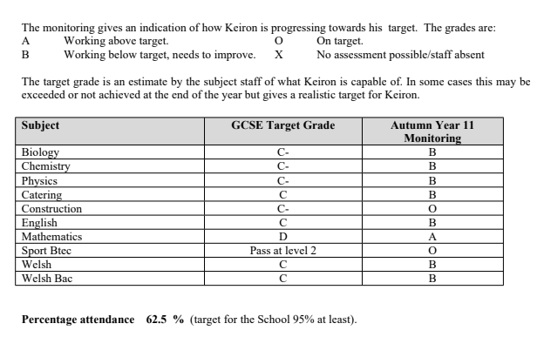
Since this monitoring ( 6 weeks ago) Pupil A’s attendance has gone down significantly and is now at 48%

Appendix B Current Attendance Data
The percentages of lesson attendance over the last 6 weeks are shown below
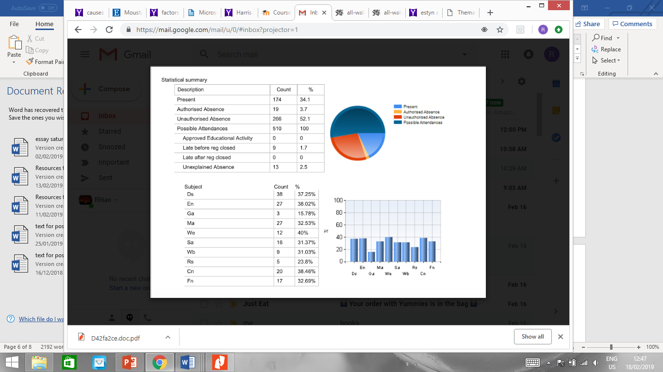

Key Ds Double Science (Shown as three separate subjects on the monitoring report)
En English
Ga Games
Ma Maths
We Welsh
Sa Btec Sport
Wb Welsh Bacc
Rs Construction
Cn Catering

Appendix C Chart to show the effect of attendance on achievement Estyn (2014)
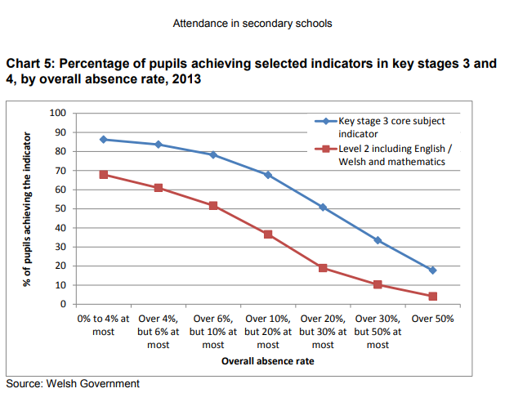
Pupil A’ s attendance of 48% currently means he is unlikely to achieve Level 2 threshold (including maths and English)

Appendix D Observation Sheets Blank and completed
Pro Forma to be filled in during observation

Subject Lesson no:

Pupil present on time
Equipment
Settled to task quickly
Needed help
Asked for help
Participated in any group activity
Stayed on task
Contributed to lesson
Toilet visit
Homework given /collected
Planner used

Other comments

Completed Observation Sheets (transcribed from hand written notes)

Subject English Lesson no:3

Pupil present on time : Arrived 5 mins after the start of the lesson, which was after morning break
Equipment : School bag, pen in pocket, did not use the bag
Settled to task quickly: Missed some instruction but relied on the group he was with to catch up
Needed help: seemed to manage but little effort
Asked for help: NO
Participated in any group activity: Just to find out what he was supposed to do, then just watched the others
Stayed on task: Not much achieved but wasn’t disruptive
Contributed to lesson: NO
Toilet visit: YES, about half way through the lesson and was out of the room for at least 10 mins
Homework given /collected : A task was given for homework, not written in his planner despite the teacher’s instruction
Planner used NO

Other comments: Did not seem to enjoy the lesson, the task set was fairly straight forward, and late arrival didn’t help. The teacher did not seem surprised he was late, perhaps a little surprised he was there. Although no comment was made to him.

Subject Maths Lesson no: 4

Pupil present on time Yes
Equipment Only a pen, the teacher provided a calculator when it was needed
Settled to task quickly Yes
Needed help NO
Asked for help NO
Participated in any group activity n/a
Stayed on task: Yes, and completed before some of the group but did not proceed with the next task set
Contributed to lesson NO
Toilet visit NO
Homework given /collected NO
Planner used NO

Other comments
This lesson was the start of a new topic reviewing percentages and associated exam questions. They were allowed to use a calculator for the first part of the lesson. Pupil A seemed to manage the work but dis not progress to the further questions set when he finished. He chose to sit at the back and spent a lot of time not doing anything until his teacher came around and praised him for completing the first task and suggested he continued with the further questions.

Subject Catering Lesson no:1

Pupil present on time: Pupil A was marked present but was not in the lesson, he had gone to the pupil support area who contacted the catering teacher. He had told the teacher in pupil support he had forgotten the ingredients for his catering. The catering teacher explained he was doing a demo lesson and asked the support teacher to bring him along. He arrived 10 mins into the demonstration.
Equipment: None required despite the pupil thinking he needed ingredients, he had a pen to copy down the recipe and ingredients for the next catering lesson.
Settled to task quickly yes
Needed help no
Asked for help no
Participated in any group activity n/a
Stayed on task: copied up the recipe and ingredients diligently
Contributed to lesson no
Toilet visit no
Homework given /collected had to bring the ingredients for the next lesson
Planner used no, used a notebook for the info

Other comments
Pupil A appeared to enjoy watching the demo by the teacher. He was quick to write up the recipe and copy down the ingredients after he found his notebook in his bag. Late arrival made the start a bit confusing as he was not sure what was being demonstrated!

Subject Science( Chemistry) Lesson no: 2

Pupil present on time Yes
Equipment work book in the classroom
Settled to task quickly yes
Needed help no
Asked for help no
Participated in any group activity watched a demo of an experiment quietly
Stayed on task completed most of the follow up task in his workbook
Contributed to lesson no
Toilet visit no
Homework given /collected no
Planner used no

Other comments Pupil A seemed to cope with this class. They started a new experiment and was not disadvantaged by his absence although there were lots of gaps in his workbook where he had missed lessons.

Appendix E
Record of interview with pupil A (transcribed from handwritten notes)

- What is the best thing about school and what is the worst?
‘Seeing my friends, I hate Games and Welsh’
- Which lessons do you like best?
‘I like construction when we’re are doing something, but the writing is really boring, I don’t see the point’
- Do you mix with pupils from your year group after school hours?
‘Yes, I hang around the village most nights and sometimes we play games on our PS4’s’…but my friends are not all in my school…some have left
- Does your mother get upset or annoyed with you if you don’t come in to school?
‘Sometimes she does…it depends what mood she is in…or if she wants me to go and do some shopping…but mostly she nags me about not getting up in time’ She also nags me if I have bought stuff for catering, then don’t get to school. She says it’s a waste of money.
- On the days you don’t come in to school, what do you do?
‘Play on my computer in my bedroom’…One day my mother didn’t know I was still in the house when she got up, I gave her a real fright she went mad (he laughed). She is used to it now though.
- On the days you do come in to school when do you decide you are coming in? On the morning or the night before?
‘Usually in the morning, sometimes I tell my friends in the night I will see them tomorrow, but it depends on whether I get up in time and what lessons I have’
- Does your Mother ask you about your school day?
‘Nah, she hates the school, thinks they are useless and thinks that’s why my brother was in trouble.’
- Is there anything you would like to change about the school day? Times or lessons?
‘Not really, I wish I could miss some lessons without getting caught’
- What lessons would you like help to catch up with?
‘Construction, I am miles behind with my prac’
- Have you got any plans for when you finish Year 11?
‘No I had an appointment with that careers bloke but I missed it’ I wouldn’t mind going to college to do construction. I have a friend who is there and says it’s a good laugh and he is planning on a job soon as he passes his course.
- If you improved your attendance do you think you would do better in your subjects
‘I dunno’

Appendix F
Record of interview with parent of pupil A (transcribed from handwritten notes)
1 How do you think your son is doing in school at the moment?
‘He cann’t be doing very well he hardly ever goes in’
2. Does talk to you about his school day?

‘I don’t see him much, he is always on his computer, or out with his friends’ Oh he did say he had you as a mentor to help him.
3. Does he ever ask you for help with school?
‘No, no point I haven’t a clue what he’s doing. It’s all different from when I was in school. Oh yes, he asks me when he needs money to buy stuff for his cooking lesson? But I never get to see what he cooks. So last time he asked, I told him he wasn’t having any more money for that as I don’t think he is spending it on stuff for school.’
4. Considering the amount of time has missed, he is just about managing in his subjects and he should be aiming to achieve C’s or D’s in most subjects. This means he could plan on a college place when he finishes school.

‘That would be good, he could do with getting a trade. I heard plumbers get lots of money’
5. He does need to come in more often though, do you think we can work together to help him catch up.?
Well I can’t help him with his work, but I can try and get him in to school in the morning. I was thinking if he missed the bus, I can drive him in or ask the school to come and get him, but he will just run off. So, I don’t know what else to do.
6. Hopefully if he has a plan for the future and catches up with some of his work he will want to come in to school. Would you mind him missing some P.E. and Welsh lessons, which he says he doesn’t like, to catch up with some work.?
‘I don’t care what you try as long as he isn’t in the house on that computer of his all day.’
7. I notice he has a planner in his bag that he doesn’t use, would it help if I wrote his ingredients for school when he needs them, for him to be prepared?
‘That would be ok then I will know what he needs the money for’
8. If you have any worries about him you can ring me at the school, for example if he will not come in.
Yes, that’s fine, you can have my mobile number if you want, too

