
Module code: LCMB7024
Module: Marketing Management
Assessment component 2: Marketing Strategies Portfolio

Apple Ring: Strategic Brand Extension, STDP Analysis, and Marketing Mix Strategy for Apple’s Smart Health Wearable

NAME: Dinyo RADEV
ID:2129750
Words: 2641

Table of Contents
Element 1 3
Element 2: STDP Analysis for Apple Ring 3
Element 3: Apple Ring Marketing Mix Strategy. 6
Element 4: Reflection 10
Conclusion 11
References 12

Element 1
Apple Ring: The Future of Invisible Health Technology
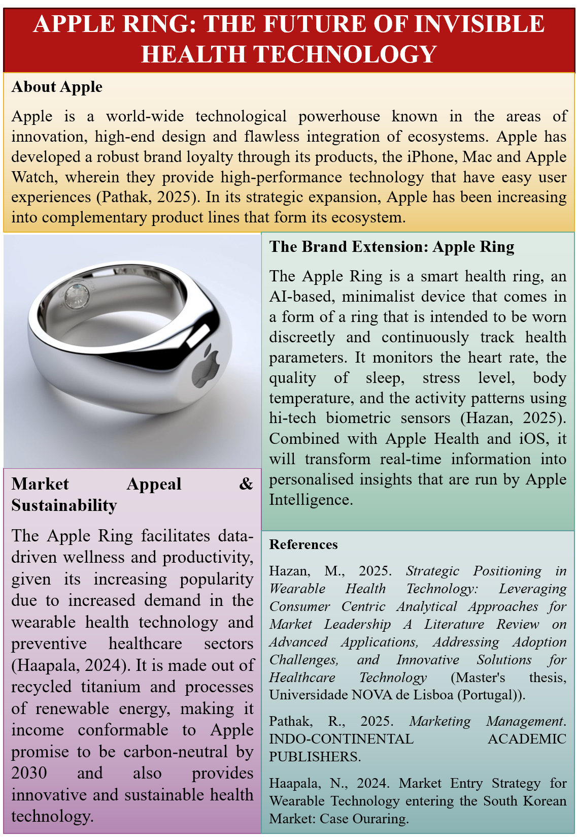
About Apple
Apple is a world-wide technological powerhouse known in the areas of innovation, high-end design and flawless integration of ecosystems. Apple has developed a robust brand loyalty through its products, the iPhone, Mac and Apple Watch, wherein they provide high-performance technology that have easy user experiences (Pathak, 2025). In its strategic expansion, Apple has been increasing into complementary product lines that form its ecosystem.
The Brand Extension: Apple Ring
The Apple Ring is a smart health ring, an AI-based, minimalist device that comes in a form of a ring that is intended to be worn discreetly and continuously track health parameters. It monitors the heart rate, the quality of sleep, stress level, body temperature, and the activity patterns using hi-tech biometric sensors (Hazan, 2025). Combined with Apple Health and iOS, it will transform real-time information into personalised insights that are run by Apple Intelligence.
Market Appeal & Sustainability
The Apple Ring facilitates data-driven wellness and productivity, given its increasing popularity due to increased demand in the wearable health technology and preventive healthcare sectors (Haapala, 2024). It is made out of recycled titanium and processes of renewable energy, making it income conformable to Apple promise to be carbon-neutral by 2030 and also provides innovative and sustainable health technology.

Element 2: STDP Analysis for Apple Ring
Introduction
The given section examines the Segmentation, Targeting, Differentiation, and Positioning (STDP) approach towards the proposed Apple Ring brand extension. It describes the manner in which Apple can use its excellent brand equity and ecosystem integration to venture into the smart ring market and create a competitive and premium positioning.
Segmentation
Market segmentation breaks a wide market into small segments that are similar in some areas, needs or behaviour (Sims and Course, 2022). In the case of the Apple Ring, the analysis of segmentation can be done based on geographic, demographic, psychographic, and behavioural variables.
Geographic Segmentation
The main geographic markets are the developed economies like North America, Western Europe, Australia and some parts of East Asia. The areas exhibit a high rate of smartphone usage, high disposable incomes and high wearable technology adoption. The cities in these markets are especially appealing because of large communities of professionals, adopters of technologies, and highly-digital consumers (Guendouz, 2025). Also, an emerging interest in preventative healthcare and digital health solutions is observed in such areas.
Demographic Segmentation
The Apple Ring will be aimed at people aged between 25 and 45 years old who have medium and high-income levels. This group is usually consisting of university-trained workers, entrepreneurs, and persons in the technology, finance, healthcare, and creative sectors. Such consumers are in a good position to buy high quality wearable and are used to spending money on high quality technology (So, 2025). There is a wide gender market for the product with the tracking of health and wellness being of interest to both men and women.
Psychographic Segmentation
Apple Ring is psychographically targeted at people who appreciate innovation, efficiency and self-optimisation. These consumers are health-focused, performance-driven and productivity-oriented consumers. A high number of people are proactive to their wellbeing by exploring the tools that will improve their sleepiness and their coping with stress as well as their monitoring daily activities (Yang, 2022). They are also brand conscious and identify Apple as a status, quality and reliable product.
Behavioural Segmentation
The behavioural segment is the most loyal users of Apple ecosystem who already have iPhones, Apple Watch, or MacBooks. These are consumers who have high brand loyalty and will readily accept complementary devices which have a smooth fit into the ecosystem. Early users of new technology and those who utilise the health and fitness applications more often are also a significant target group (Al-Sakaf, 2025). These people are very much innovators who appreciate convenience, precision and evidence-based information.
Targeting
With this type of segmentation, Apple would have a differentiated targeting approach with primary and secondary markets identified.
The key market audience includes technologically advanced professionals aged between 25 and 40 that are already integrated into the Apple universe. These are people who appreciate connectivity, high design, and enhanced functionality (Works, 2022). They will also view the Apple Ring as a seamless part of their digital life that will make them more productive and manage their health. The fact that they are not new to Apple products makes them less risky to purchase and more likely to adopt.
The second target audience is wellness-aware buyers and workout lovers that do not want to use smartwatches but seek a more discrete alternative. This segment can also consist of those who come to corporate wellness programmes, fitness training, mindfulness training, or biohacking communities. By catering to the two markets, Apple is put in a position where it will be able to reach as many markets as possible and at the same time preserve its high end status.
Differentiation
Differentiation is imperative in the competitive market of wearable technology. Although smart rings are already offered, Apple has an edge over competitors due to its integration of the ecosystem, brand loyalty, privacy, and design.
First, the ability to connect seamlessly with the Apple Health and iOS will be a major benefit compared to independent gadgets. The customers enjoy easy synchronisation and compatibility with various Apple products.
Second, Apple has built a reputation in the field of data privacy, which predisposes it in comparison to its rivals (Yandug, Ponce and Ong, 2023). With the growing concern over privacy of personal health information, privacy-focused marketing positioning will improve consumer confidence in Apple.
Third, the Apple Ring is a fashionable piece of furniture, as Apple is a firm adhering to the philosophy of minimalism in design. This two-fold functionality enhances emotional appeal and aids with high prices.
Lastly, AI-based personalised insights take the data gathered about health and translate it into valuable suggestions, enhancing the perceived value above simple tracking features.
Positioning
The Apple Ring would be positioned as a high-quality, smart, and subtle health companion that is created to optimise wellbeing in busy professionals in an effortlessly manner. The positioning focuses on three key qualities; invisibility, intelligence and integration.
The Apple Ring is not bulky, unlike other wearables, and is capable of constant, non-obtrusive monitoring without interfering with the day-to-day activities (Gong et al., 2022). Its AI functionalities offer insightful information available to act upon, but should not be considered a mere data collection, and its integration with ecosystems guarantees a digital experience that is flawlessly smooth.
A suitable positioning statement is:
Apple Ring is a premium, discreet wearable designed for modern professionals seeking intelligent, secure, and seamless health optimisation.
Such positioning supports the premium brand image of Apple and makes the special value proposition of the product evident.

Element 3: Apple Ring Marketing Mix Strategy.
Introduction
This section discusses the fact that the 4Ps, which include Product, Price, Place, and Promotion, can be used to promote the launch and growth of the Apple Ring. It describes how marketing mix fits in the premium brand name, emphasis on innovation, and sustainability engagements of Apple to bring success in the long term.
Product Strategy
The Apple Ring is a concrete product that is backed by the intangible brand value. The Apple Ring can be strategically analysed considering that Kotler proposes three levels of product theory (core, actual and augmented product).
At the core product level, Apple Ring provides optimisation of health, convenience, and improvement of performance. Consumers are not buying a ring, they are investing into better wellbeing, productivity, and data-driven lifestyle management.
At the actual product, Apple Ring would have advanced biometric sensors that would monitor heart rate, sleep cycles, stress levels, body temperature, blood oxygen levels, and daily activity. Recycled titanium would be used to make the device, which would preserve the Apple minimalist design and at the same time be durable and comfortable to carry around (Xin et al., 2023).
At the augmented product tier, the customers would enjoy the system integration, software upgrades, warranty, AppleCare services and in-store technical assistance provided by Genius Bar. This value addition adds perceived value and brand loyalty.
Brand development wise, the product strategy strengthens the leadership of innovativeness at Apple and extends to a new line of wearable (Bushell, 2022). Notably, the discrete ring format is what makes it stand out among other larger devices like smartwatches; it is a minimalistic technology that is attractive to consumers.
The product strategy has an element of sustainability. Recycled materials, energy-saving materials, and carbon-neutral production process are aligned with the 2030 carbon neutrality of Apple. This enhances brand positioning ethics and attracting consumers who are green conscious.
Price Strategy
Apple has a conventional premium pricing policy and this will be retained to the Apple Ring. The suggested cost between 399 and 499 would place the product in the high-end wearable segment.
The premium pricing ensures a number of strategic functions. To start with, it is indicative of the good brand equity that Apple has, and it strengthens the perception of quality, innovation, and exclusivity. The signalling theory postulates that, in technology markets, higher prices are usually used to convey higher quality. Second, the high-price policy contributes to profitability and enables Apple to follow the path of constant research and development.
An adjusted price skimming can be used as well during launch. Early adopters are not very price sensitive and are much absorbed in the innovation of the technology, and they would be ready to pay a greater initial price. In the long term, Apple will be able to make minor pricing changes or create product differentiation to access a wider market.
Place (Distribution) Strategy
Apple employs a selective distribution strategy, and this approach would support the premium positioning of the Apple Ring. The product would be distributed through:
- Apple’s official website
- Apple retail stores
- Selected authorised premium resellers
Selective distribution improves brand control, secures the high-end image and guarantees a uniform customer experience. The retail stores of Apple are not only a point of sale but also a marketing experience where consumers are able to touch, get a demonstration of the products and seek the help of trained employees. Distribution Online distribution is essential in terms of accessibility and international coverage (Harala et al., 2023). The direct-to-consumer business model of Apple enhances the profit margins and enables customisation of purchases such as customisation of devises and engraving. Also, the aspect of control over the number of authorised retailers stops excessive exposure and preserves the feeling of exclusivity. This is a long-term brand equity management distribution strategy and limits the risks of grey market sales.
Promotion Strategy
Advertisement of the Apple Ring would be based on integrated marketing communications (IMC) strategy in order to create consistency of the message conveyed across the media.
Product Launch Strategy
Apple is a company known to have high impact product launch events. The Apple Ring would probably be launched at an international Apple keynote meeting and play off of media publicity and live presentations. This builds anticipation, earned media coverage and innovation leadership.
Digital Marketing
Promotion would focus on digital channels. Instagram, YouTube, and Tik Tok campaigns would feature social media posts on the benefits of lifestyle, optimisation of health, and elegant design (Kaipainen and Aarikka‐Stenroos, 2022). It would be more credible to engage influencers who are in collaboration with fitness experts, health professionals, and technology reviewers.
Online advertising and targeting of ads would target the consumers who will be keen to find solutions to wearable health technology.
Emotional Branding
Apple has been able to employ emotional branding as opposed to feature-based communication. Advertisement would focus on empowerment, balance and personal wellbeing and not just on the technicalities. Advertising using storeys can represent how the professionals can optimise their everyday lives by using subtle health tips.
Sustainability Messaging and PR
Sustainability messages would be a major component of promotional messages as the consumer consciousness about environmental responsibility grows. Recycled materials, renewable energy generation, and commitment to carbon neutrality could be the focus of campaigns. This makes the product consistent with the wider societal values and improves the corporate image.
Strategic Alignment with Brand Extension Objectives
All the marketing mix elements support the overall brand extension strategy of Apple. Technological leadership is boosted by the product innovation. Premier pricing preserves brand status. Selective distribution prevents competition and guarantees quality customer experience. Combined promotion creates emotional involvement and consciousness.
Notably, the Apple Ring will be used alongside alternatives to the existing Apple products and not to substitute them. It improves the ecosystem with the offering of another form factor of health tracking (Sulandjari et al., 2022). This customer-focused approach builds customer lifetime value, multi-device ownership, and brand loyalty, and it is based on the ecosystem.

Element 4: Reflection
Introduction
The Apple Ring brand extension creation of Apple has been a good learning experience that has not just deepened my theoretical knowledge of brand development but also my practical marketing strategy skills (Yandug, Ponce and Ong, 2023). To work on this project, branding theory, strategic analysis and creative thinking were to be integrated to come up with a convincing and realistic proposal. In the process, I learned more about the brand extension strategy, the competitive positioning, and the increasing role of sustainability in the contemporary marketing.
Learning from the Brand Extension Development Process
Among the most important lessons was the fact that a brand extension needs to be adapted to the existing brand equity. I also got to know that a successful brand extension is not just a new product but a strategic expansion which relies on brand trust, reputation and quality. In the case of Apple, brand consistency was anchored on ecosystem integration and high positioning.
The use of STDP framework enhanced my skills in performing a systematic market analysis. The geographic, demographic, psychographic, and behavioural variables of market segmentation helped me realise the role of various consumer characteristics in the targeting decision (So, 2025). Another thing that I learned to appreciate more is differentiation and positioning, especially in the competitive markets of technology where brand perception and innovation are a major concern.
The development of the marketing mix also boosted my thinking. I realised that Product, Price, Place and Promotion cannot be performed individually but as a team. It was important to ensure that there is a consistency in the brand strategy by ensuring that premium pricing, selective distribution, sustainability, and promotional messaging are aligned.
Experience Preparing and Delivering the Poster Presentation
Making the poster helped me to be more effective in conveying complex messages in a very brief manner. The task of condensing an elaborate strategic analysis into a 3–5-minute presentation involved making choices on priority information and organisation of the message in a logical sequence. This enhanced my skill of applying the theory into real and convincing business language (Yang, 2022). During the presentation, my confidence and professional ability in communication were improved. I was made more conscious of good storytelling, tone and body language. Another way the brand extension proposal increased my persuasive skills that are crucial in both marketing and management positions is through presentations.
Skills Gained and Areas for Improvement
This project enhanced my analytical, research and creative abilities. I enhanced my skill to implement marketing frameworks in a strategic manner in balance between innovation and feasibility. The time management and organisation were also practised as a result of coordination of the research, writing and preparation of the presentation (Haapala, 2024). To enhance it, I would consider using primary research to improve the decision on segmentation and use more detailed financial projections to increase the credibility in the future.

Conclusion
This project helped me to improve my knowledge of brand development as a product growth strategy and improve my skills in applying the theory of marketing in practise. The experience has helped me develop strategic orientation, confidence, and professionalism in marketing management.

References
Al-Sakaf, H.F.T.A., 2025. International marketing strategy of the enterprise (based on the materials company «Apple Inc.».
Bushell, C., 2022. The impact of metaverse on branding and Marketing-A study of how individuals and celebrities use metaverse as a brand extension, and the implications for marketing. Available at SSRN 4144688.
Gong, H., Jiang, W., Yang, Y., Zhang, Y., Chen, X., Li, W., Yang, P., Wang, Z., Wang, Q. and Li, Y., 2022. Cyclic di-GMP regulates bacterial colonization and further biocontrol efficacy of Bacillus velezensis against apple ring rot disease via its potential receptor YdaK. Frontiers in Microbiology, 13, p.1034168.
Guendouz, T., 2025. Strategic Marketing stimulated by Disruptive Technologies for the Fifth Wave of the Industrial Revolution (STP Energized by AI, BDA, IoT, AR, & VR). Rihan Journal for Science Publishing, 2(64).
Haapala, N., 2024. Market Entry Strategy for Wearable Technology entering the South Korean Market: Case Ouraring.
Harala, L., Alkki, L., Aarikka-Stenroos, L., Al-Najjar, A. and Malmqvist, T., 2023. Industrial ecosystem renewal towards circularity to achieve the benefits of reuse-Learning from circular construction. Journal of cleaner production, 389, p.135885.
Hazan, M., 2025. Strategic Positioning in Wearable Health Technology: Leveraging Consumer Centric Analytical Approaches for Market Leadership A Literature Review on Advanced Applications, Addressing Adoption Challenges, and Innovative Solutions for Healthcare Technology (Master's thesis, Universidade NOVA de Lisboa (Portugal)).
Kaipainen, J. and Aarikka‐Stenroos, L., 2022. How to renew business strategy to achieve sustainability and circularity? A process model of strategic development in incumbent technology companies. Business Strategy and the Environment, 31(5), pp.1947-1963.
Pathak, R., 2025. Marketing Management. INDO-CONTINENTAL ACADEMIC PUBLISHERS.
Sims, A. and Course, B.M.C., Carter’s Smart Apparel-Strategic Marketing Plan.
So, Y.Y., 2025. Creating a Market Entry Strategy: a Case Study of Sanmaya OY’s Recharge & Rejuvenate Online Yoga Course.
Sulandjari, K., Putra, A., Sulaminingsih, S., Cakranegara, P.A., Yusroni, N. and Andiyan, A., 2022. Agricultural extension in the context of the Covid-19 pandemic: Issues and challenges in the field. Caspian Journal of Environmental Sciences, 20(1), pp.137-143.
Works, H.I., 2022. Research Paper on Global Marketing Mix.
Xin, L., Zhang, R., Wang, X., Liu, X., Wang, Y., Qi, P., Wang, L., Wu, S. and Chen, X., 2023. Extracellular and intracellular infection of Botryosphaeria dothidea and resistance mechanism in apple cells. Horticultural Plant Journal, 9(2), pp.209-223.
Yandug, J.S.G., Ponce, F.D. and Ong, A.K.S., 2023. Application of conjoint analysis and 5Ps marketing mix in identifying customer preference of alcohol consumption among youths in the Philippines. Foods, 12(7), p.1401.
Yang, X., 2022. Internet Hospitals in China-Exploration of Business Models and Marketing Strategies (Doctoral dissertation, Massachusetts Institute of Technology).

