BSMP6007: Economics of Sustainability
  - The Evaluation of Market Failure and Sustainability within ’The Plastic Industry’.
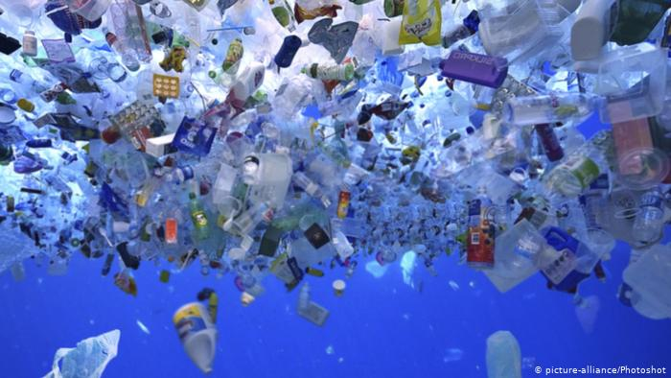
ASSESSMENT 2: A Report of Market Failure within the Plastic Industry
This report will analyse concepts such as; the green economy and sustainable economics. The assignment will then critically appraise how differing sectors approach sustainable development for example; ‘The Plastic Industry’ will be critically researched into, in regards to market failure and as an environmental problem.
Creating sustainability
According to the UN and Giraldo (2019) the definition of sustainable development refers to growth and maintaining needs for present generations without compromising future generations. For example, Saleem et al states without oil we would not have plastic and limitations have been placed on oil to conserve the resources for future generations ( Saleem et al,2018). This said, oil is not considered sustainable as it takes hundreds of years to naturally to form (K.F Mulder,1998).
According to Morelli when discussing sustainability one must look at what will be ideal and what would work. Sometimes these are two concepts that do not always come together, usually the ideal is not plausible and what will work is not good enough (J.Morelli, 2011). Sustainability in business, has a varied definition, the definition of sustainability appears to be an operative term within economics and can be applied when looking at the running of companies within the plastic industry. It is not the most prevalent model, however as Savitz (2013) seems to agree, most companies start and run successfully for profit, then they usually implement environmental/social solutions once there is enough capital to cover those costs. Some professionals such as Gibson and colleagues (2013), emphasise sustainability is unsuccessful when companies go into liquidation, as they try to remain or turn environmentally friendly. This reflects that being sustainable may be a costly process.
Furthermore, The World Summit of Social Development (WSSD, 2005) identified three core areas of sustainable development, also known as ‘the Three Pillars of Sustainability’, these pillars are; economic, environmental and social development, also informally known as profit, planet, and people. Dauvergne (2018) highlights one main issue is that most business are not created for people or consider the environment, they are made for profit and usually fill a gap in a market. Accentuating this point on sustainability, business success would depend on taking on these pillar values that can be seen in social enterprises, charities or public funded programmes. On the contrary, Ambrose (2019) states that those interested in profit have greater rule-bending tendencies, in the past major companies like Tesco, Amazon and Exxon mobile have been found guilty of hiding their environmental waste affects from authorities.
The Green Economy
From sustainable business and the three pillars the United Nations Environmental Programme (UNEP, 2020) went on to create a new way to generate businesses called the Green Economy. The Green Economy was established in 2020 by the UNEP to convince business to incorporate three main ideas when starting and growing a business. Jacobs (1993) explains a ‘Green Economy’ consists of clean, environmentally friendly budget that promotes health, wealth, and well-being. However UNEP appear to contradict their idea saying a Green Economy is dependent on sustainable development, because everyone needs to abide by the green economy policy, when it is not a legal requirement.
On the positive, the green economy seems to mean growing economies in ways that benefit, not sacrifice, social justice and equity as well as the environment, that takes into consideration the people’s needs and the global impact of business (UNEP, 2020). Moreover, this green economy theory seems to have good intentions, making great changes to the world’s health and combatting global issues. It is said that in a green economy the financial sacrifice is made by the CEOs (Chief Executive Operatives), which use this theory as guidelines to satisfy the directors through positive enviro-social outcomes , where customer needs are met and the company operate self-sufficiently (Louiseau et al, 2016).
Government bodies use this analysis diagram internationally and nationally to establish tax/subsidiaries, which is the basis for the Green Economy’s ideology (this is only attainable through international bodies forced involvement, see picture below). These companies use this method to analyse costs and benefits to establish the risks involved with the environment/sector and balance the cost against the benefit.
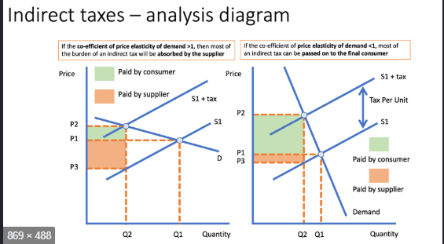

(Geyer et al, 2015)

Market failure
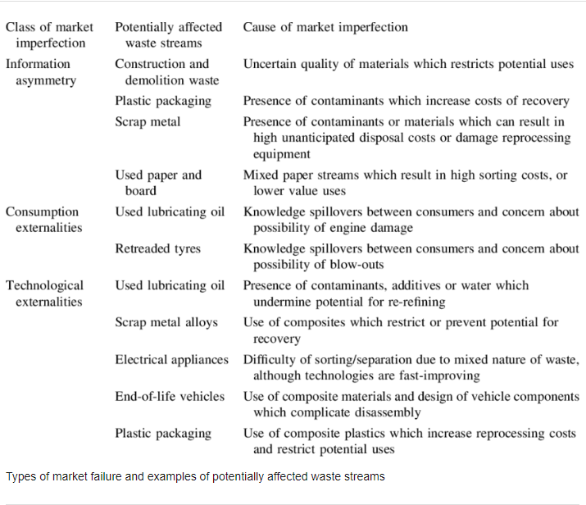
According to DiPerna and Lueken (2018) there are 4 trends to market failure, these are as follows:
Information Asymmetry (sellers in the market have access to important information), for example means one party has more or better information than the other when making decisions and transactions.
Concentrated Market Power (monopoly affects as the market lacks competition because one or few providers have a disproportionate amount of power within the market), for example when power is concentrated into too few hands.
Public Goods (the producer cannot limit its consumption to paying customers), for example public goods the private sector do not usually produce goods because it is difficult to supply them for a profit, which is why government decides what output of public goods is appropriate for society.
Externalities (costs and benefits are unbalanced for providers in the market), for example a lack of money means negative externality goes unchecked and ultimately makes it easier for them to produce that good or service but at a lower quality and price leading to market failure (Diperna & Lueken , 2018).
These types of market failures appear to accentuate where guidelines and legislation are needed not only to promote profit but evaluate the impact the service will have on society.
A case study on the plastic industry: - Here shows relevant case study of market failure in the plastic industry illustrated by Patrick Soderholm, which sums up points highlighted previously.

(P.Soderholm, 2020).

Evaluation of the Market Failure in ‘The Plastic Industry’
According to Chappelow (2020) market failure occurs in the plastic industry when; directors in companies act irrational taking into account self-interests that produce a less optimal or economically efficient outcome, typical markets have less demand of plastic products or favours are exchanged that create an implicit market of special treatment that can cause market failure. It looks as if market failure can be resolved using private market solutions, government-imposed solutions, or voluntary collective actions.
Society seems to yearn for laws or rules to prevent market failure, as Rundh (2005) would state products sold globally have many functions but need packaging for many reasons or are made of a variety of materials, however plastic seems a popular material to evaluate with the most prevalent use within the present market and the amount of waste that is disposed of nationally and internationally (Jambeck et al, 2015).
Stromberg states that the plastic industry is an industry that needs evaluation of market failure, as it accesses important information not visible for the public due to business use, it is a unique material that is powerful, its profit margin is questionable and it creates an interesting cost-benefit analysis (P.Stromberg, 2004).
Evidence stresses that different sectors are affected by the plastic industry and the dominant sectorial use of plastics is ‘Packaging ‘. The following graph shows the annual waste generation:-
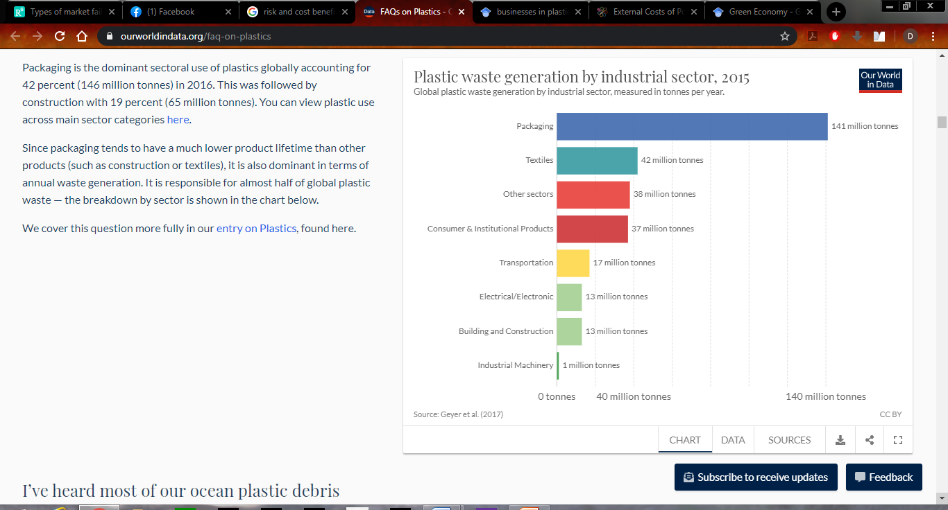

(Geyer et al, 2017).
Environmental problems must be considered when looking at the plastic industry as one of the biggest contributions to market failure in the plastic industry is waste into the sea, because before environmental legislation became more known, the dumping of plastic waste became the norm until environmentalists highlighted the impact of it on sea life and its effects on the fishing industries. This causes the country involved nationally or internationally to be affected by contamination of the marine life and affecting the economy in producing profit from the produce. Wabnitz and Nicholas quote it is a “Ocean emergency”(Wabnitz & Nicholas, 2010).

Plastic pollution issues in oceans are as stated below in the images;
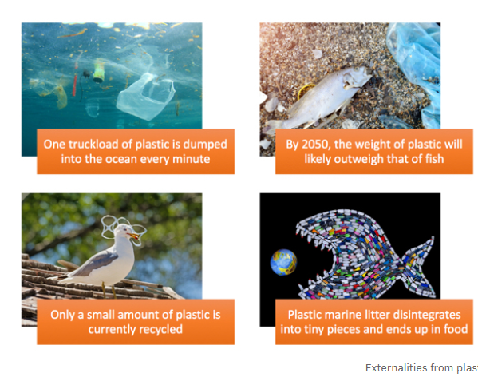(Blue Planet, 2020)
Government policies to address these problems of the plastic pollution stated by Riley et al, are as illustrated in 6 points:-
- Banning microbeads from consumer products.
- Consumers are unable to buy cotton buds and products like these.
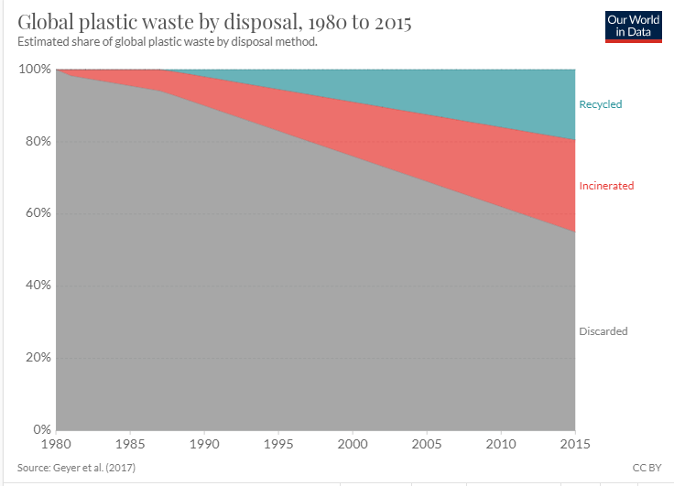
- Plastic Bag charge/tax to reduce single use bags.
- Encourage business to use recyclable polymers.
- Cafes/restaurants/public places provide free drinking water.
- Deposit schemes refundable on plastic bottles.
( Riley et al, 2018).
These polices when followed can be beneficial for the environment by decreasing the amount of pollution in the ocean and therefore creating more profit for the fishing industry and plastic industry, causing less issues to be resolved and less probability of market failure.
(Ritchie ,Oxford Martin School,2018)
This image shows the decline in the number of people recycling and discarding waste into the ocean and if we concentrate on recycling, this will prevent market failure.

Rice (2019) states there are an estimated 150 million metric tons already in our marine environment that the Ocean conservancy is concerned about and an estimated 12 million metric tons of plastics on top of that figure. These statistics have apparently risen since the 1950s which seems to show the lack of care through the generations for our oceans well-being as well as the environmental ozone not only by the plastic industry but the whole marketing sector, creating a serious threat to marine life and releasing chemicals that harm oxygen-producing microorganisms creating dead zones. (The Guardian, 2019). At present this would explain the flood of environmental campaigns from 2017 promoting ethics and questions the actions of individual companies promoting humanity and questions if people take charge too late.

Critically appraise how differing sectors approach sustainable development
The point of sustainable growth seems to point out that companies need to grow in every way and not limit themselves, without having an adverse effect on our planet or social environment. It`s become so apparent that Rolf Halden (2020), professor of environmental health engineering said “every human in the developed world has traces of plastic constituents in his or her blood’’. Halden appears to be accentuating the question at what point is it too late to intervene, as the consequence of this type of market failure seems to have significant consequences to public health, that appear to be irreversible.
A majority of the world’s plastic is found in the ocean and coming from the following top six countries for ocean garbage; “China, Indonesia, the Philippines, Vietnam, Sri Lanka and Thailand” (Rice, 2019). This statement climaxes that all expect china are considered developing countries (almost third world countries) where china have no excuse, but the others have far less education and resources, which is understandable how they are ignorant to modern ways as they have less education, knowledge and are less likely to understand the complications of their own actions. A respectable solution for these five countries (not china) of the top most damaging to the environment is simply to provide them with more education and increase the severity of government eco-laws. China seems to need evaluation of consequences as they have the education skills but still participate in the behaviour.
Conclusion
To conclude, the research appears to highlight the fundamental relationship of Government interventions being addressed on an international and national level, which could lead to a sustained economy such as a green economy (UNEP,2020). A cost benefit analysis hypothetically demonstrates that the main problem in preventing a sustainable economy is market failure and its externalities (Gayer et al, 2015)). Of the four Externalities, the most common form of market failure in the plastic industry according to (Stromberg, 2004) is affected by recyclable materials due to barriers such as imperfect data, asymmetric information, technology and consumption. Geyer et al (2017) suggests that failures can be overcome by technological innovation and econometric investigations into the role of policy measures in reducing plastic packaging and the other sectors generating waste pollution.
According to the UN and Giraldo (2019) the plastic market should consider ‘Bans’ on plastic bags enhancing the need for businesses to use reusable bag manufacturers that could lead to increased employment opportunities and improved working conditions. As plastic is used in many sectors (Gayer et al,2017); Packaging (36%), Building & Construction (16%), Textiles (15%), Consumer products (10%), transportation (7%), electrical (4%) and others (11%), it could be translated that the packaging, building and textiles sectors should be environmentally evaluated to reduce market failure. Also the development of packaging design guidelines and assessment protocols re-evaluation could be analysed in regards to a successful and efficiently operating business.
Moreover, the plastic industry in the UK has its strengths in differing sectors; firstly its manufacturing benefits of feedstock for sources of polymer and additives secondly, it is a significant oil producer, thirdly, it’s success in plastic packaging inventing ‘polythene’. Agreeing with Jambeck et al (2015), the UK plastics sector relies on machinery that is efficient, innovative and flexible, where companies use technology to quickly respond to new customer’s requirements and remain competitive in the global market. The niche market depends on high quality processing measurements and implementing rigorous recycling legislations, developing reprocessing technologies that highlight a world-leader in its industry.
In the future, the plastic industry must have a strategic vision for growth such as; Promoting the reputation of plastics, Improving the industry’s skills base, emphasising educational support for companies, accelerating the sustainability of the Plastic Industry with the circular economy, Underlining future markets for plastics products, Focus on overseas market development and encourage industry collaboration with multi-agencies to address the consequences of developing economies sustainably and decrease market failure.

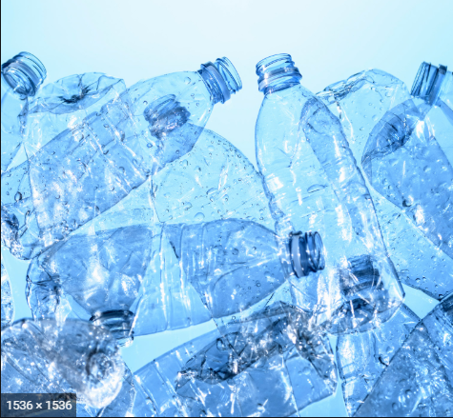

(Mckinsey,2020)

References
UNEP, 2020. Greenup. Greenup-unep.org. Available at: http://www.greenup-unep.org/green-economy/what-is-green-economy.htm?lng=en#.XrA1sp5KjIU
DiPerna, P. and Lueken, M., 2018. Defining Market Failure (With Examples). [online] EdChoice. Available at: <https://www.edchoice.org/engage/defining-market-failure-with-examples/> [Accessed 4 May 2020].
Ambrose, J., 2019. Major Global Firms Accused Of Concealing Their Environmental Impact. The Guardian. Available at: https://www.theguardian.com/environment/2019/jun/16/major-global-firms-accused-of-concealing-their-environmental-impact
Geyer, R., Jambeck, J. R., & Law, K. L. (2017). Production, use, and fate of all plastics ever made. Science Advances, 3(7), e1700782.
Giraldo, A., 2019. Sustainability And 5 Examples Of Economic Growth - IDEAS For Us. IDEAS For Us. Available at: https://ideasforus.org/sustainability-and-5-examples-of-how-it-helps-economic-growth/
Gordon, W.J., 1982. Fair use as market failure: A structural and economic analysis of the Betamax case and its predecessors. J. Copyright Soc'y USA, 30, p.253.
CHAPPELOW, J., 2020. Market Failure Definition. Investopedia. Available at: https://www.investopedia.com/terms/m/marketfailure.asp
Rice, D., 2019. Eu.usatoday.com. Available at: https://eu.usatoday.com/story/tech/science/2018/09/07/great-pacific-garbage-patch-where-did-all-trash-come/1133838002/
P. Soderholm. Resolving failures in recycling markets: The role of technological innovation - Scientific Figure on ResearchGate. Available from: https://www.researchgate.net/figure/Types-of-market-failure-and-examples-of-potentially-affected-waste-streams_tbl1_235937272 [accessed 17 May, 2020]
Marine Pollution Bulletin.Volume 137, December 2018, Pages 157-171. Marine Pollution Bulletin. Reducing marine pollution from single-use plastics (SUPs): A review. Author links open overlay panel. Riley E.J.Schnurr, VanessaAlboiu, Meenakshi Chaudhary, Roan A.Corbett, Meaghan E.QuanzKarthikeshwarSankarHarveer, S.SrainVenukasan Thavarajah DirkXanthos and Tony R.Walker.
Plastic pollution: An ocean emergency. C Wabnitz, WJ Nichols - Marine Turtle Newsletter, 2010
Powers, M.C., 1967. Fluid-release mechanisms in compacting marine mudrocks and their importance in oil exploration. AAPG bulletin, 51(7), pp.1240-1254.
Mulder, K.F., 1998. Sustainable consumption and production of plastics?. Technological Forecasting and Social Change, 58(1-2), pp.105-124.
Morelli, J., 2011. Environmental sustainability: A definition for environmental professionals. Journal of environmental sustainability, 1(1), p.2.
Gibson, B., Hassan, S. and Tansey, J., 2013. Sustainability assessment: criteria and processes. Routledge.
Dauvergne, P., 2018. Will Big Business Destroy Our Planet?. John Wiley & Sons.
Jacobs, M., 1993. The green economy: Environment, sustainable development and the politics of the future. UBC press.
Hannah Ritchie. September 02, 2018. Oxford Martin School website.
Jambeck, J.R., Geyer, R., Wilcox, C., Siegler, T.R., Perryman, M., Andrady, A., Narayan, R. and Law, K.L., 2015. Plastic waste inputs from land into the ocean. Science, 347(6223), pp.768-771.
Rothstein, H., 2003. Risk management under wraps: self-regulation and the case of food contact plastics. Journal of Risk Research, 6(1), pp.61-74.
Wright, D., 2001. Failure of plastics and rubber products: causes, effects and case studies involving degradation. iSmithers Rapra Publishing.
Newhouse, J.P., Williams, A.P., Bennett, B.W. and Schwartz, W.B., 1982. Does the geographical distribution of physicians reflect market failure?. The Bell Journal of Economics, pp.493-505.
Bromley, D.W., 2007. Environmental regulations and the problem of sustainability: Moving beyond “market failure”. Ecological Economics, 63(4), pp.676-683.
Nimisha, M. and Dharmaraj, A., 2016. Emotional Intelligence of Entrepreneurs’ Stress with Special Reference to Plastic Industry in Coimbatore District. Bonfring International Journal of Industrial Engineering and Management Science, 6(1), pp.72-77.
Sudesh, K. and Iwata, T., 2008. Sustainability of biobased and biodegradable plastics. CLEAN–Soil, Air, Water, 36(5‐6), pp.433-442.
Álvarez-Chávez, C.R., Edwards, S., Moure-Eraso, R. and Geiser, K., 2012. Sustainability of bio-based plastics: general comparative analysis and recommendations for improvement. Journal of Cleaner Production, 23(1), pp.47-56.
Hottle, T.A., Bilec, M.M. and Landis, A.E., 2013. Sustainability assessments of bio-based polymers. Polymer degradation and stability, 98(9), pp.1898-1907.
Zah, R., Hischier, R., Leão, A.L. and Braun, I., 2007. Curauá fibers in the automobile industry–a sustainability assessment. Journal of cleaner production, 15(11-12), pp.1032-1040.
Hottle, T.A., Bilec, M.M. and Landis, A.E., 2013. Sustainability assessments of bio-based polymers. Polymer degradation and stability, 98(9), pp.1898-1907.
El-Haggar, S.M. and el-Haggar, S., 2015. Sustainability and innovation: The next global industrial revolution. Oxford University Press.
Corbett, L.M. and Cutler, D.J., 2000. Environmental management systems in the New Zealand plastics industry. International Journal of Operations & Production Management.
Depoers, F., 2000. A cost benefit study of voluntary disclosure: Some empirical evidence from French listed companies. European Accounting Review, 9(2), pp.245-263.
Hopewell, J., Dvorak, R. and Kosior, E., 2009. Plastics recycling: challenges and opportunities. Philosophical Transactions of the Royal Society B: Biological Sciences, 364(1526), pp.2115-2126.
Cohen, M.A., Agrawal, N., Agrawal, V. and Raman, A., 1995. Analysis of distribution strategies in the industrial paper and plastics industry. Operations Research, 43(1), pp.6-18.
Kahle, L.R. and Gurel-Atay, E. eds., 2013. Communicating sustainability for the green economy. ME Sharpe.
Milani, B., 2000. Designing the green economy: The postindustrial alternative to corporate globalization. Rowman & Littlefield.
Brand, U., 2012. Green economy–the next oxymoron? No lessons learned from failures of implementing sustainable development. GAIA-Ecological Perspectives for Science and Society, 21(1), pp.28-32.
Barbier, E.B. and Markandya, A., 2013. A new blueprint for a green economy. Routledge.
Ostrom, E., 2009. A general framework for analyzing sustainability of social-ecological systems. Science, 325(5939), pp.419-422.
Tainter, J.A., 2006. Social complexity and sustainability. ecological complexity, 3(2), pp.91-103.
Eccles, R.G., Ioannou, I. and Serafeim, G., 2014. The impact of corporate sustainability on organizational processes and performance. Management Science, 60(11), pp.2835-2857.
Simnett, R., Vanstraelen, A. and Chua, W.F., 2009. Assurance on sustainability reports: An international comparison. The accounting review, 84(3), pp.937-967.
Datta-Chaudhuri, M., 1990. Market failure and government failure. Journal of Economic Perspectives, 4(3), pp.25-39.
Teece, D.J., 2008. The multinational enterprise: Market failure and market power considerations. World Scientific Book Chapters, pp.405-419.
Winston, C., 2007. Government failure versus market failure: Microeconomics policy research and government performance. Brookings Institution Press.

