CASE STUDY 2.1
The maintenance stores dilemma
A case study of Vortex, a maintenance stores operation

Gwynne Richards

AUTHOR BIOGRAPHY

GWYNNE RICHARDS is the Director of Apprise Consulting Ltd.

You are a logistics and warehousing consultant. You have just come out of a three-hour meeting with members of the management team of a maintenance stores operation in the UK. You also took a tour of the stores.

This is what the general manager told you as you were being shown around.

Introduction
Vortex, a manufacturer of hi-tech drilling equipment, has grown significantly over the past few years and it is now running out of storage space for its maintenance stores operation. The number of parts required to service and repair the company’s equipment has increased substantially as new equipment and clients have been introduced and therefore space is at a premium.

This is borne out by the amount of floor space taken up by the storage of items ranging from large engines and drill bits, including metal suitcases containing repair equipment.

The engines and drill bits are banded onto pallets and are not stackable.

Returned equipment from various sites across the world are also stored on the floor close to the inbound area.

A second warehouse (Unit B), across the road from the main facility, also contains refurbished items whilst a third warehouse (Unit C), approximately 800 metres away, stores items that are yet to be refurbished together with items that, although deemed obsolete, have yet to be written off and removed. Some of these items are being cannibalized by the engineers on a regular basis.

The business philosophy of the company is to ensure that all their equipment, whether operated in the UK or abroad, has sufficient parts both local to the equipment and at the main warehouse to ensure minimum downtime. The main warehouse is utilized to replenish the local country warehouses and also to provide emergency cover for those parts that are not held at the local warehouses. A great deal of the company’s success is based on a near 100 per cent up time for its equipment. However, the introduction of new equipment on a regular basis results in more hi-tech equipment being produced and therefore more sophisticated parts being required. These parts are produced both locally and in manufacturing sites in China, Brazil and Russia.

This can amount to 20 new lines each week as the machinery is very complicated and sophisticated.

In order to achieve competitive prices the procurement director needs to purchase large quantities from suppliers so as to obtain the best possible discounts.

The three directors are experienced in finance, engineering and procurement respectively.

In July 2004 TMS moved into a new warehouse and distribution centre. A 10-year lease was signed on the building. There is an additional plot of land adjacent to the warehouse on which an extension can be built. This will increase total space by at least 25 per cent and possibly up to 30 per cent. However, it will require an extension of the lease for at least a further 10 years. The other local stores sites are on short leases and the company can vacate easily by agreement and by giving three months’ notice.

The stores
The stores area in Unit A has a floor area of approximately 3,000 square metres and a mezzanine floor at the far end of the warehouse opposite the inbound door. This is approximately 1,000 square metres and is reached by a set of stairs on the eastern side of the building. The warehouse has an internal height of eight metres to the eves. There is no sprinkler system installed.

A second structure of 1,000 square metres was constructed, with the landlord’s permission, three years ago. This is accessed via a low tunnel (2.5 metres high) between the two structures. This also has a single door to the outside yard. The overall height of this structure is only 3.5 metres. This area is utilized for packing and despatch.

In total there is only one inbound door and one outbound door.

It was decided that the best configuration was to use Section 1 for inbound and to store all of the parts. Section 2 is used for packing, staging and despatch. Many of the replenishment orders for the local warehouses are held in this area until sufficient parts are ordered to fill a 20-inch container. Urgent orders are despatched either on a less-than-container load (LCL) basis or air freighted to the required destination.

Section 1 utilizes mobile shelving and standard shelving for the storage of the majority of the parts. These are situated both under the mezzanine and on the mezzanine itself.

A number of filing drawers are also utilized for the storage of very small parts such as nuts, bolts and washers.

Engineers and the localized stores are able to place orders for any quantities of goods. This often necessitates opening bags of screws to count out individual items.

The company operates a stock control system which is updated on a daily basis by manually keying in the quantities received and despatched.

Inbound
The inbound operation receives parts from a number of different suppliers. These are mainly delivered by parcel couriers; however, larger items and those parts manufactured in China, Russia and Brazil are received in 20-inch containers. On average the warehouse receives two containers per month. Some LCL traffic is also received.

Returns arrive on a regular basis although the warehouse is not always informed of their imminent arrival. These can remain in the inbound area for long periods awaiting decisions from quality control (QC) staff and the budget holders as to whether they should be transferred to the workshops for repair, sent to a third-party for repair, transferred to another working site or, if not able to be repaired, set aside for disposal.

All deliveries are checked against purchase orders. The inbound staff physically count each item and once checked the items are set aside either for put-away or are cross-docked and put in a cage awaiting despatch to the relevant country site.

A number of sites are in countries where the customs formalities take a significant amount of time and are very manual. Staff have to ensure that the paperwork is accurate and that all parts destined for a particular country have been labelled correctly and declared on the paperwork. This again takes a significant amount of time.

A large number of items have lot numbers, including screws and fasteners, which are all recorded. This has a knock-on effect on picking with individual lot ID numbers having to be picked. A receipt number from the system is entered onto the delivery note, dated and initialled.

Once the items have been picked the lot number integrity disappears as each individual item cannot be identified by lot number.

Storage
The location system in the warehouse is tied to individual products. There are over 15,222 stock lines on record but only 9,555 lines currently in stock of which only 60 per cent are ‘live’ – ie the part has appeared on at least one order in the past 12 months.

Every stock item has a fixed location.

Many of the fast moving parts are stored on the mezzanine floor in the filing drawers. This area has shelving and filing drawers which are used to store small parts. The shelving stores work-wear and PCBs in the main. There is available space both on the shelves and in the drawers; however, products are also left above the drawers because some of the allocated locations are not big enough to hold all the stock.

Unit B
This area is currently used to store pallets of lubricant, engineers’ backpacks which have been purchased in bulk and items waiting for repair. It has been agreed not to renew the lease on this building which expires in June this year. The office area is used to store refurbished items and items awaiting repair.

Unit A repair area
This is located on the eastern side of the warehouse between the inbound shelving area and the stairs to the mezzanine floor.

It has some shelving but also utilizes the floor space in the centre of the warehouse. Items remain in this area until the repairs are authorized or labelled for disposal.

Warehouse office
This office is used by the manager but is also used for the storage of items such as work-wear, batteries and tools. It is located under the mezzanine floor.

Replenishment
This is carried out on an as and when required basis. As the location quantity falls below a certain level the stock control system produces a replenishment order. This can happen at any time during the day.

Outbound
Each order is picked individually through the use of a paper pick list. Orders are picked manually from the shelving and, depending on the item size, parts are put into trolleys, baskets or carried by hand. Order lead time could be up to five working days. During emergencies engineers were seen to enter the warehouse and pick their own items.

Orders for engineers’ work-wear are received on a regular basis. These are shipped to the engineers’ home addresses prior to them leaving for site.

Once orders have been picked they are checked, packed, all relevant documentation is produced and the items are either put into the static cages to be consolidated or stacked in the despatch area awaiting the arrival of the freight forwarder’s vehicle to take them away to be loaded into a container.

The outbound staff spend a large percentage of their time producing export documentation and thoroughly checking the items prior to despatch. Hazardous products are sent off-site to be packed in crates.

Other information
There are no specific key performance indicators for the warehouse. For example, cycle count adjustments are how many lines are counted in total not how many errors are found; there are no measures around productivity.

The warehouse staff consists of 10 people. Overtime is being worked extensively and labour costs are way above budget. The mechanical handling equipment consists of two counter-balance forklift trucks and two pump-up trucks. Hours of work are from 6 am to 8 pm Monday to Friday with some overtime worked on a Saturday. This is a two-shift system.

One area of concern is the number of urgent requests received which has a detrimental effect on the warehouse operation. Staff are expected to respond immediately. Unfortunately this is not reciprocated when the warehouse require responses on what to do with items awaiting repair, disposal and the like.

Appendix A
Sketch of warehouse

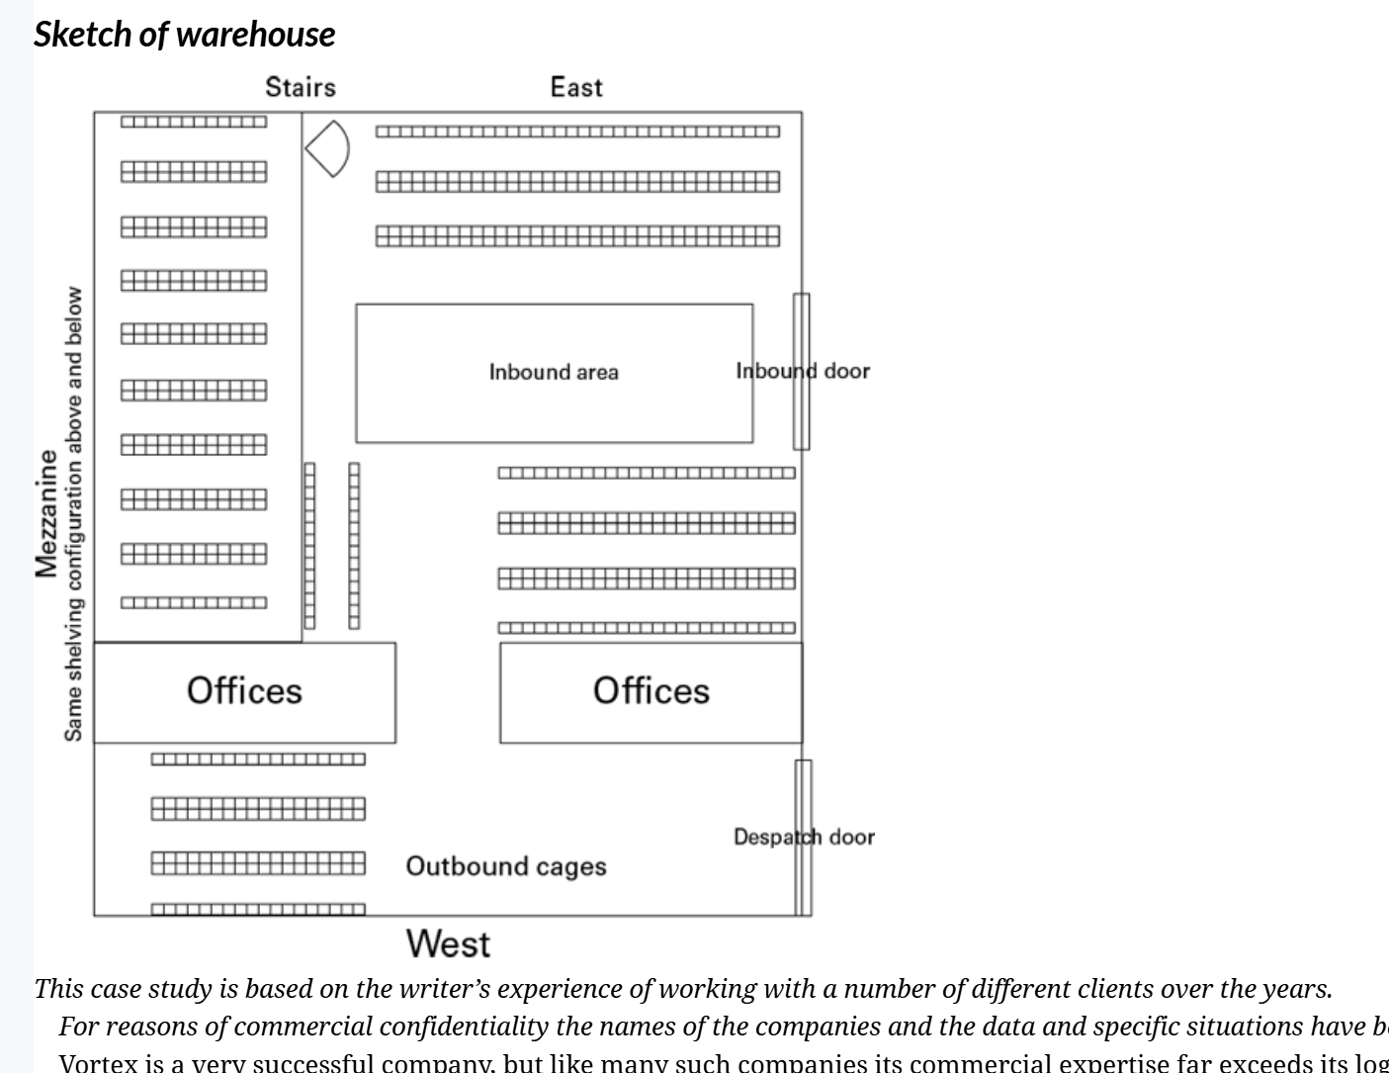

This case study is based on the writer’s experience of working with a number of different clients over the years.

For reasons of commercial confidentiality the names of the companies and the data and specific situations have been disguised.

Vortex is a very successful company, but like many such companies its commercial expertise far exceeds its logistics performance.

Despite the new larger warehouse there are still some serious problems:

There is a limited warehouse information management system.
Stock information is entered manually.
Some items do not have their own location and are located on top of the cabinets and mobile shelving.
By March 2013 these influences were having an adverse effect on the warehouse operations. Items had to be block stacked with all the attendant problems of damage and lack of safety. More importantly the warehouse was close to saturation as volumes received exceeded volumes despatched. Service to the engineers was also in decline and security was becoming an issue as higher-value products were being introduced.

It seems clear to you that the immediate priority is to increase the storage capacity and reduce block and floor stacking. But it is also important to consider what the warehouse policy should be in the light of the company’s planned growth.

Questions
You have been engaged by the managing director as an experienced logistics consultant to solve the lack of space problem and to put forward a plan to cope with a significant increase in the number of sku over the next three years.

Using the information supplied detail the issues you have found that are causing problems for the company and produce a preliminary report detailing what steps you suggest should be taken to solve them.

What advice would you give the MD about expanding the size of the warehouse and extending the lease?

What other options are available to the MD?

