

Postgraduate/Distance Learning
Assignment coversheet & feedback form

THIS SHEET MUST BE THE FIRST PAGE OF THE ASSIGNMENT YOU ARE SUBMITTING (DO NOT SEND AS A SEPARATE FILE)

For completion by the student:
Student Name: Hristina Ivanova Yadkova

Student University Email: 1808015@student.uwtsd.ac.uk
Module code: HPCA7016  Module title: Researching Contemporary Cosmologies | Student ID number:  1808015 |  |  | Educational support needs:  Yes/No x
Assignment title: Research Project in Contemporary Cosmology

Assignment due date: 14.05.2021
This assignment is for the 1st 2nd 3rd x 4th 5th 6th module of the degree
I confirm that this is my original work and that I have adhered to the University policy on plagiarism.
Signed Hristina Ivanova Yadkova
Email submission:if you are submitting this form via email, please tick this box □
(as a substitute for your signature) to confirm that you agree to the above declaration.
Assignment Mark
1st Marker’s Provisional mark
2nd Marker’s/Moderator’s provisional mark
External Examiner’s mark (if relevant)
Final Mark

NB. All marks are provisional until confirmed by the Final Examination Board.

For completion by Marker 1 :
Comments:

Marker’s signature: |  |  | Date:
For completion by Marker 2/Moderator:

Comments:

Marker’s Signature: |  | Date:
External Examiner’s comments (if relevant)

External Examiner’s Signature: |  | Date:

Research Project in Contemporary Cosmology

Word Count 5126 words

- Introduction
The aims of this research project are to examine what beliefs are held by astrologers and what they might say about forecasting/prediction practice for global catastrophic events and to investigate what practicing astrologers think astrological forecasting and prediction for global events are – a form of divination or science like weather forecasting for hurricanes, earthquakes, extreme temperatures. This project examines statements amongst a group of astrologers by exploring their beliefs and practice, especially forecasting and predicting of global catastrophic events like earthquakes, floods, air flight accidents, fires. Also, the aim of this study is to investigate what astrologers think about prediction astrology and how they view the contemporary use of astrology to predict and forecast global catastrophic events. Further, to examine views of fate and karma held by modern astrologers.

- Prediction Astrology in the Contemporary World

AstroWiki defines that pre-diction (literally fore-tell or pro-gnosis = fore-knowing) is one of the most fascinating aspects of astrology while also being responsible for astrology's bad reputation at various times throughout history.
Cambridge Dictionary states that ‘Prediction is ‘a statement about what you think will happen in the future’.
From time immemorial, people have been trying to look to the future and look at the sky to read the messages of the stars. Farebrother pointed out that nearly all past cultures developed systems for forecasting the future and observed the sky for omens, from ancient civilizations like Egypt, Mayans, subcultures in Asia, America, and Africa. She claimed that astrological forecasting was used, and astrologers performed an important function for powerful nobles for decision making in many cases looking about the future in the classical and medieval world. She pointed out that after the growth of scientific thinking the astrology discontinued to be a part of a scientific astronomy, and was related to practice as magic and superstition till the moment of Alan Leo established the Astrological Lodge. Predictions based on science, such as weather forecasting are referred by many in know days, and Farebrother suggested that it may be astrologers can explore and approach more forecasting using the planetary cycles, and this can be viewed to be astrologically prepared.
Vilhena pointed out that ‘Astrology is a divinatory system that postulates a correspondence between celestial movements and the character and life events of each individual’.
In his survey ‘How Astrologers view Astrology’, Campion provided a glimpse of some specific features of astrology as a form of divination, and 64.8% of participants in his survey choose this answer by eight other options. Also, 53,4% of the participants view astrology as a means of predicting the future.
According to Jerome, although, the narrative of orthodox science is that ‘since the claim that astrology can be used to predict the future events is not supported scientifically, it can be only a form of divination, but further to the above claim ‘scientists must agree with the astrologer that at least the Sun and the Moon, and possibly planets, have both a theoretical and an actual effect on the earthly process. Stars can have at least a theoretical effect on Earth's inhabitants for the very simple reason that they can be seen.’
Cornelius said that ‘the main body of astrology’s practice, and especially the interpretation of the horoscopes, is properly to be understood as a form of divination. It is divination, despite all appearances of objectivity and natural law. It is divination despite the fact that aspects of symbolism can be approached through scientific method, and despite the possibility that a few factors in horoscopy can arguably be validated by the appeal of science.'
The focus of the study was to explore these statements during the research process and gathering the data from the participants. The aim was to examine these claims and to relate some of them with findings and the results.

- Methodological approach
I used a mixed method, and regarding the objectives of the project to conduct qualitative research, I used a questionnaire and semi-structured interviews in order to explore the research statements stated above.
According to Bryman, qualitative research is appropriate and responds to the aim of the study to provide a pure description and examine of analysis of the subject’s beliefs. The aim of the study is to focus a substantial attention to details. Qualitative research is appropriate and responds to the study's aim to provide a pure description and examine the subject's beliefs and focus substantial attention on details. The study can produce analyses and explanations by contributing details and context of subjects’ interpretations in conducted interviews. Bryman suggested that qualitative research responds and could emphasize the terms and participants' experiences to understand the data collected by the current project in their social and historical context.
Research strategy included conducting of four semi-structured interviews of practicing astrologers and 24 questionnaires. Following the authors of Qualitative Research. An Introduction to Methods and Designs the semi-structured interviews allowed to follow more open with a free-flowing conversational format. There are different positions among astrologers regarding astrological predictions and predictions of global catastrophic events. The choice of in-depth interviews is aimed at participants with contrasting claims, who have relevant experience, and observations. This allowed the data with different perspectives to be collected.
The data by questionnaire was collected online by Google Docs, prepared Form, by sending link by email, in social media groups and forums.
The semi-structured interviews were organized by applications like Messenger, Skype, Viber via online meetings and was audio recorded. Following Bryman, the interview process started with a set of basic pre-defined questions, but further allow the interviewees to follow their line of thought and add further data.
According to the authors of Qualitative Research. An Introduction to Methods and Designs the use of a method of qualitative research to the study from the perspective of insiders allowed revealing framework in a social context. The use of a qualitative research method achieves flexible and comprehensive design and eventual change during the investigation.
Bryman said that qualitative research method allowed gaining deep and rich data for the study by close relationship with the subjects, and as insider to the theme of the study.
The approach aimed with the interviews can be further marked as phenomenological, as Bryman defined to ‘describe and analyse the culture and behavior of humans and their groups from the point of view of those being studied’.
Following Bell, for the purpose of this research, I used computer data software provided by Google for the results by questionnaire. Bell said that the questionnaire includes the mixed type of questions with well-structured questions and options for word from a list or scale responses and questions for open sentence responses.
- Ethical consideration
The participants were informed that participation in this study is entirely voluntary and to feel free to disregard any question and complete other sections if they feel more comfortable responding. Also, they were offered an option to choose to use the 'Other' tick box as an alternative to disregard a question completely or add their response to limit or expand on any open-ended follow-on questions. They were informed to feel free to withdraw from the research at any time and to request immediate deletion of their responses.
The participants were aware that all information they provided is stored anonymously, and in the research, they will be assigned a pseudonym or code so that they cannot be identified, and all data will be held securely and confidentially until the end of my MA studies and then deleted; the information that I collected about them during the research will be kept strictly confidential. Finally, they were informed that they could not be identified or identifiable in any reports or publications, and any data collected about them in the online questionnaire will be stored online in a form protected by passwords and other relevant security processes and technologies.

- Questionnaire Survey Data
The questionnaire was conducted from 23rd April till 6th May 2021. The link to the questionnaire was sent by email and shared on social media in astrological groups with professional astrologers and non-professional astrologers.
The Questionnaire included twenty questions. On the question what their relation to astrology is 43,5% (10) were professional astrologers, 34,8% (8) had strong interest and basis knowledge in astrology, 17,4% (4) answered that they study astrology but not consider starting practice in astrology, and 4,3% (1) answered that study astrology and consider starting practice. 87,5% (21) answered that they practice Western astrology, 8,3% (2) practiced Vedic astrology. 42,3% (8) from the responders were members of Astrological organisation as ISAR, OPA, NCGR, CIA, and 57,9% (11) were not members had no membership at any astrological organisation. Only 19 participants answered to the question of membership. On the question how often the participants post and publish their own forecasts and predictions for global catastrophic events as earthquakes, floods, fires, fly air accidents, 58,3% (14) choose and answer ‘Never’, 20,8% (5) marked an option ‘Rare’, 8,3% (2) marked ‘Very Rare’, 4,2% (1) marked ‘Regularly Weekly’, 4,2% (1) marked ‘Regularly Monthly’, and 4,2% (1) marked ‘Other’ as answered with own words that post such predictions but with very softened tone, and only as tendencies, not exact predictions. 33,3% (8) read and followed predictions for catastrophic events posted by professional astrologers rare, 25% (6) read and followed such publications regularly weekly, 25% (6) regularly monthly, 4,2% (1) very rare, 8,3% (2) never read and followed such publications, and 4,2% (1) choose as option ‘Other’ and answered with own words that read and followed such predictions but did not specify how often.
41,7% (10) choose to answer with ‘Agree’ to the statement ‘Astrology can predict catastrophic global events’, 29,2% (7) answered with ‘Strongly Agree’, 25% (6) answered with ‘May be’, 4,2% (1) marked ‘Other’ and responded with own words ‘Yes, I know that astrology can predict global accidents.
On the question ‘Would you agree with the statement ‘’Forecasts and predictions for catastrophic global events are useful in daily life’’, 25% (6) marked ‘Strongly Agree’, 25% (6) were agree, 25% (6) marked ‘May be’, 20,8% (5) marked ‘Agree’, and 4,2% (1) choose an option ‘Other’ and answered with own words ‘Yes, I think such predictions are useful, for example like weather forecasting.
To explore what the astrologers think astrology is and how they could define it I included a question ‘What do you believe astrology is’ in the questionnaire. 33,3% (8) defined astrology as science, 25% (6) defined as form of divination, for 16,7% (4) astrology is a form of psychological method, 16,7% (4) answered with an answer ‘Other’ but did not provided own words, 4,2% (1) marked ‘A means of predicting the future’, and 4,2% (1) chose to answer with own words and gave ‘A divination’ as response.
To examine what the astrologers think for usefulness of astrological forecasts and predictions for global accidents there was a question included in the questionnaire ‘Would you agree with the statement ‘’Astrological forecast and predictions for global catastrophic accidents, earthquakes, floods, fires, etc. can help people’s lives be preserved’. 33,3% (8) answered ‘May be’, 29,2% (7) marked ‘Agree’, 16,7% (4) choose ‘Strongly Agree’, 16,7% (4) marked ‘Disagree’, and 4,2% (1) responded with ‘Other’ and answered ‘Yes’.
Regarding the question what the participants think about post for forecasts for global catastrophic events and should not be posted such forecasts for various reasons, 50% (12) responded ‘May be’, 25% (6) answered ‘Disagree’, 12,5% (6) marked ‘Strongly Agree’, 8,3% (2) choose ‘Agree’, and 4,2% (1) marked ‘Other’ and answered ‘No’.
On the question ‘What other types of divination you use for forecasting, divination, or predictive tools’, 37,5% (9) used Tarot, 33,3% (8) used Numerology, 29,2% (7) did not use other types of divination.
On the question ‘What you practice as spiritual ritual and / or prayers to protect against bad forces or unfortunate events, etc.’, 41,7% (10) answered that practice prayers, 33,3% (8) marked that practice spiritual rituals, 16,7% (4) responded that practice meditation, 8,3% (2) responded that do not use any practice.
On the question what the participants think the ability of astrology to predict the future global catastrophic events is, 73,9% (17) think that this is a prognostication based on mathematical calculations, 21,7% (5) think that this is a form of divination, and 4,3% (1) marked ‘Other’ as answer but did not provide own description.
On the question what the participants think the ability of astrology to predict the future global catastrophic events is based on, 65,2% (15) answered ‘Planets cycles’, 21,7% (5) marked an answer ‘Methodological astronomy calculations’, 8,7% (2) choose an answer ‘Observing of omens’, and 4,3% (1) marked ‘Other’ but did not provided own description.
On the question ‘Do you think that astrological forecasting and prediction for global catastrophic events is similar to weather prognostication for floods, fires, hurricanes, earthquakes’, 52,2% (12) marked ‘Agree’, 34,8% (8) answered ‘May be’, 8,7% (2) answered ‘Disagree’, and 4,3% (1) responded ‘Strongly Agree’.
75% (18) form the responders believe in karma, 50% (12) believe in reincarnation, 45,8% (11) believe in free will, 33,3% (8) believe in fate, 29,2% (7) believe in destiny, and 4,2% (1) answered ‘Other’ wit own words ‘Yes, I believe’ but did not specify with further descriptions.
On the statement ‘I believe that karma (the low of cause and effect) also influences global catastrophic events on Earth. For example, human civilization’s actions against nature and phenomena as global warming, overpopulation, etc. destroy the balance on our planet’, 47,8% (11) answered ‘Agree’, 21,7% (5) answered ‘Strongly Agree’, 21,7% (5) marked ‘May be’, 8,7% (2) answered ‘Disagree’.
The last three question in the questionnaire was opened every responder to be able to give answer with own word. On the question 18 ‘How you relate the concept of fate to astrology?’ 14 responders answered to that question, and some of the answers was ‘Fate may have different ways, some kind of choices, and at the same time, it is written in the stars.’, ‘Fate, as I understand it, implies a lack of choice, and astrology is all about choice.’, ‘It’s a free will.’, ‘The fate is sealed in astrological birth chart but not all events are determined by the fate.’, ‘Fate, a Competent examination of the specific natal chart, as well as his parents, can satisfactorily describe much of the events in a person's life. As I understand it, it implies a lack of choice, and astrology is all about choice.’, ‘Fate is related to personal planets' positions.’, ‘It does not relate at all, ‘Fate is the evolvement of character over time. As above, so below.’, ‘Given the continuum of possibilities with an archetype, as we work to integrate the chart, the context of that work is produced in content that mirrors the psyche.’, ‘Fate /the natal chart/ and free will /our actions based on possibilities offered by prognostic methods/.’, ‘I believe that the world and life are possible to study and predict.’.
On the question 19 ‘How you relate the concept of free will to astrology?’ were answered 15 responders, and some of the answers was ‘You have free will to clean the karma.’, Astrological correlations are manifold - we always have a choice whether we're aware of the consequences of our actions or not - so astrology can only point to potentials.’, ‘Astrology can help the individual to force a free will and consciously to develop the will. Free will is how will you prefer to play your cards in certain planet positions. A good astrologer can help a client choose a suitable path.’, ‘Awareness determines the free will. Consciousness gives choices.’, ‘Faith is a higher level of knowledge of the world and life than astrology.’,
On the question 20 ‘Do you consider that planets and stars influence all earthly catastrophic events?’ 19 responders answered, and some of the answers was ‘Yes’, ‘What is there (sky) it is the same on earth., ‘Yes, I consider that’, ‘Agree’, Yes, most of them are related to cosmic events. As above so below.’, ‘No’, ‘Planets and stars may point to potential events, but unfortunately, people do their best to help any destructive process: they influence our actions on Earth.’.

5. Interview data
For the aim of this research project, I conducted four interviews with practicing astrologers. The interviews were conducted from 24th April till 14th May 2021. The interviews were managed by skype and were audio recorded, every interview took 45-60 minutes.
- AU is a professional astrologer with more than 35 years of practice, studied western astrology with astrologer Vitaliy Vagsberg, taught western astrology for 30 years, has MA in Mundane Astrology about patterns, models, and algorithms in astrology, member of OPA. Educational background is in history and ancient history for 35 years.
Astrology is a cosmic program but also has versions to its manifestation in our life, there are levels of its realization, as a scenario of a film, but we also have free will to change some things. Astrology is a form of navigation, even possible to compare with a global computer program.

- GW is a professional astrologer, a tutor with more than 35 years of practice in western astrology, studied western astrology with Nikolay Doynov, member and tutor of western astrology at the School of Astrology at the White Brotherhood lodge, established by master Beinsa Duno (Petar Danov).
- KM is a professional astrologer, with 3.5 years practice, five years active study of Vedic astrology.
- KAT is a professional astrologer, with six years study, practice for two years in western astrology.
Regarding the predictions and forecasting of global catastrophic events such as earthquakes, airplane crashes, fires, floods, etc. three of interviewed astrologers explained that avoid posting publications for predictions for such events with different motives. The main reasons they gave for their motives for not making and publishing such predictions are not to spread fear among their followers and society. KM interviewee pointed out that apart from the fear that publishing forecasts of global catastrophic events could cause, the other reason is that even if these forecasts are made public, this will not have much effect. Public institutions do not take such astrological predictions seriously and do not take appropriate measures for prevention and protection. In addition, KM added that there are enough meteorological institutes and scientific bodies that successfully predict earthquakes, hurricanes, fires., etc. According to KM, it is pointless to use astrology for such predictions and duplicate public scientific institutes performing this function. On the other hand, she believes that if such predictions are studied and researched in separate professional groups of astrologers, it gives an excellent basis to research which astrological techniques work successfully.
On the other hand, the interviewed AU claimed that it is helpful to publish forecasts for upcoming catastrophes and accidents to do prevention together with the institutions and especially with the media. 'We can do prevention.', she pointed out. From ancient times, the ancient priests who also practiced astrology and other forms of divination performed various rituals when they saw such events. Nowadays, can be performed group meditations, powerful prayers, spiritual rituals in a similar way. Nowadays, it is even easier to use social media, which can be very helpful. 'Who is aware is armed.', she pointed out.

6. What Contemporary Astrologers think Astrology is
Phillipson pointed out that according to Curry, astrology is ‘the practice of relating the heavenly bodies to lives and events on earth, and the tradition that has thus been generated.’ Phillipson claimed that astrology is working through physical, causal forces that emanate from planets.
The debate over whether astrology is a science or divination is not new, and the astrological community does not have a unanimous opinion on the definition of astrology. Astrologers like Vilhena, Campion, Cornelius, Green, Curry, Phillipson explored and analyzed the theme widely.
The debate had deep historical roots from the time of earliest centuries, was vastly examinate by scholars like Ptolemy, Aristotle, and in the late medieval centuries. According to Cornelius, the dilemma of the astrologers cannot be supported by the Aristotelian – Ptolemaic definition of classical astrology. Cornelius referred as an anti-astrology signature in our contemporary world when astrology was marked as pseudo-science by 168 leading scientists in 1975. Cornelius said that astrologers respond to defend astrology using the language of science and under characteristics of modern scientific rationalism, but at the cost of the philosophical basis of astrology.
AU interviewee suggested that:
….Astrology is a science. If we assume that astrology is divination, how could someone learn astrology if he is not gifted, for example? In the same way that we study physics or medicine, we can learn astrology. How good the astrologer will depend on the personal qualities of the astrologer, diligence, practice, and statistics. If an astrologer believes that astrology is not a science, for me, he is a clairvoyant, not an astrologer. Such an astrologer probably does not have enough practice and does not have enough statistical basis. Astrology is a 100% science that reveals a complete cosmogram with its patterns, logic, algorithms. And here we enter a field that is welcome for astrology - quantum physics. It explains well why, for example, it makes no sense to consider astrology only as a 100% predictive science due to the fundamental laws and various other possibilities, which are also embedded in the cosmogram. Astrology works excellent according to the laws of quantum physics. Modern science itself questions even established theories and tests various hypotheses.
Vilhena claimed as valuable to reveal how the physics of Aristotle laid the fundamental principles in astrology and how it has been occupied by modern science. He suggested that many astrologers followed the transformation in the field of science regarding the quantum particles in the atom. Vilhena criticized the astrologers that not realized that and cited Arroyo, who said that the four elements ‘are in fact the basis of the zodiac, and consequently of all of astrology’.
GW interviewee pointed out that:
….. Astrology itself is more significant than all attempts to define it and put it in a drawer with a label because it is all this - it is also a science, it is an art, it is also the most ancient, it is also able to predict the future; there is also historicity in it, but it also deals with the future, i.e., covers in space and time all vectors in all directions of all spheres.
Vilhena said that there are arguments to support the scientific character of the astrological system that could overcome beyond modern science.
KM interviewee suggested that:
….. Astrology is the science of cycles. What we call science today, centuries ago, was magic for humans, such as electricity. What we do not understand and for which we still have no explanation will be explained in the following centuries and epochs. What is defined today as esoteric arts will be part of scientific knowledge in the future. But the way astrology is practiced depends on the qualities and experience of the astrologer. So, there are elements of art in astrology because there is an element of creativity, but astrology is closer to science.

Cornelius pointed out that ‘Since, astrology repeatedly fails to achieve scientific and rational justification, in reality it takes its chances as another variant of personal and religious belief.’ He further distinguish two categories as ‘scientific astrology’ or ‘revolutionary-science’ astrology’. Cornelius claimed that although scientific astrology tries to find a scientific definition of astrology, this scientifically confirmable cosmic relation will be harder acceptable for science because of many dramatic consequences. The acceptable scientific approach, according to Cornelius, laid on a comprehended and significant direction based on metaphysics, following the approach and distinguished by Kepler and development of harmonics and concept of the planetary orbits.
On the other hand, Vilhena said that astrology in its zodiacal form was a divinatory art, and based on the relationship between celestial and individual planes it is questioned how the efficacy of astrology can be explained. Vilhena pointed out that ‘Astrology can be defined as the divinatory art which postulates the existence of a relationship between celestial movements and everything that happens on earth, possessing a system of classifications which permits definite meaning to be articulated to each of these movements, as well as a group of techniques which establish the procedures suitable to interpret them.’ On the other hand, he also claimed that there many arguments to the supposed scientific character of the astrological system that gives the capacity to go across modern science.

- The views of fate and karma held by contemporary astrologers.
According to Brennan, the concept of fate in astrology was related to the concept of an astrology of causes, formed by Aristotle, and developed by causal or naturalistic conceptualization of astrology by Ptolemy. Brennan claimed that astrologers held different positions about the events that are predetermined or fated to appear.
KM interviewee pointed out that:
……. Astrology is life changing. Vedic astrology is recommended to be studied and practiced as a corrective method as a spiritual discipline in many cases. This is to soften or avoid certain generic and karmic predestinations. Karma exists; we have minimal free will.
GW interviewee suggested that:
……..Astrology is a tool for activating the free will to work out karma and improve destiny. There is nothing else with such tremendous power as astrology to expand consciousness. The way a person goes through life lessons depends on the degree of his awareness.
According to Brennan, ‘The basic premise of astrology in general, and natal astrology in particular, implies that there are some things that are fated or predeterminated in a person’s life from the moment of birth, but the extent to which things are predeterminated and unalterable became a point of debate in the astrological tradition. Different astrologers held different views, which created a spectrum of positions.’
KAT interviewee said that:
…… I think free will remains unmanifested or appears to a minimal degree when a person does not work with his astrological chart. The people follow certain determined patterns and events that they cannot avoid because they cannot understand the reasons for these events. However, when one begins working consciously with the astrological chart and starts to realize the influence of the planets, the horoscope begins working on a higher level. Only then the free will can manifest.
Brady claimed that the classical idea of a cosmos related to personal fate was abandoned because it represented non-causal physics. The concept was substituted with a non-divine universal cause, determinism, which cannot consist of the idea of free will. This replacement also affected the meaning of life based on the physical laws as it was broadly accepted as universal law and relevant to all organic and inorganic world.
Brady said also that ‘In astrology, the instrument of determinism or fate is generally the horoscope which may act as an antecedent cause where its geometry ultimately imposes the timing of the events of life.’
Brady pointed out also, that as a universal law, determinism refers to that the organic and the inorganic worlds are equally affected by the laws of physics, absent of moral content, based only on mathematics and the laws of thermodynamics. Determinism has no relation to the experience of human life., quality of life, matters of fortune, misfortune, good or evil.

8. Findings
Campion pointed out that forecasting the future was the original purpose of astrology in the ancient world, but in our contemporary world, this function of astrology lost some of this essential characteristic because of the development of psychological astrology. The data from this research reveal that the use of astrology in the modern world to predict and forecast global catastrophic events is not very popular among astrologers. More than 70% of survey participants do not publish or promote their predictions and predictions about such events or do so too infrequently. About 30% of the participants follow publications about catastrophes and incidents based on astrological predictions. Still, only 25% regularly follow such publications monthly, and only 25% periodically follow such publications on a regular weekly basis. Although about 70% of participants confirm their belief in the predictive abilities of astrology for various reasons, they do not approve or support the use of astrology to predict and predict global catastrophic events such as earthquakes, plane crashes, fires, etc. These results reveal a tendency for the use of astrology in the modern world as psychological astrology rather than predictive.
On the other hand, Campion said that astrological consultation is incomplete without forecasting the future. The first step is to examine the patterns of the chart astrologer to be able to give practical and relevant advice. According to Campion, major events may be predicted.
The one aspect of mundane astrology, according to Campion, is related to the physical environment in all its forms, including the weather and accidents such as earthquakes and volcanic eruptions.
Regarding the definition of astrology, this is variable among practicing astrologers and depending on their belief, practice, and personal attitude toward astrology. Based on the gained research data in this study, the following results cannot refer to strictly only one definition of astrology. The participants in this research preferred to defined astrology as science but the represented result 33,3% (8) is closer to these responders that defined astrology as divination or form of divination - 25% (6), followed by these astrologers that think astrology is a form of psychological method - 16,7% (4), which is very close to the result of these that choose to answer with an option ‘Other’ - 16,7% (4), but did not provided own definition. Only 1 (4,2%) defined astrology as ‘A means of predicting the future', and 4,2% (1) chose to answer with own words and gave ‘A divination’ as a response.

9. Conclusion
The aims of this research project was to examine what beliefs are held by astrologers and what they might say about forecasting/prediction practice for global catastrophic events and to investigate what practicing astrologers think astrological forecasting and prediction for global events are – a form of divination or science like weather forecasting for hurricanes, earthquakes, extreme temperatures. This project examine statements amongst a group of astrologers by exploring their beliefs and practice, especially forecasting and predicting of global catastrophic events like earthquakes, floods, air flight accidents, fires. Also, the aim of this study was to consider how astrologers view prediction astrology and the contemporary use of astrology to predict and forecast global catastrophic events. The focus of the study was to explore these statements during the research process and by gathering the data from the participants. The aim was to examine the claims represented in the Section 2. Prediction Astrology in the Contemporary World and to relate some of them with findings and the results gained in current study.

10. Bibliography

Bell, J., Doing Your Research Project. A guide for ﬁrst-time researchers in education, health, and social sceince, (New York: Open University Press, 2005).
Brady, B., Theories of Fate among Present-day Astrologers, (Bath: Bath Spa University College, 2005)
Brennan, C., Hellenistic Astrology. The Study of Fate and Fortune, (Denver: Amor Fati Publications, 2017)
Bryman, A., Quantity and Quality in Social Research, (Routledge, Taylor & Francis Group, 2004)
Campion, N., Prophecy, Cosmology and the New Age Movement. The Extent and Nature of Contemporary Belief in Astrology.(Bath : Study of Religions Department, Bath Spa University College, 2004)
Campion, Nickolas, The Practical Astrologer, (Harry N. Abrams, Inc., Publishers, New York, 1987)
Cornelius, G., The Moment of Astrology. Origins in Divination, (Bournemouth: Wessex Astrologer Ltd, 2003)
Cornelius, G., Astrology as Divination, https://www.uraniatrust.org/astrology/astrology-as-divination, accessed on 5 th May, 2021
Farebrother, S. M., Astrology Forecasting. The expert guide to astrological prediction, (London: Ryder, Ebury Publishing, Penguin Random House UK, (2019)
Jerome, L. E., Astrology and Modern Science: A Critical Analysis, (Leonardo , Spring, Vol. 6, No. 2, The MIT Press, 1973) , pp. 127-128.
Lapan, D. Stephen, Quartaroli, Marylinn, T., Riemer, Frances Julia - Editors, Qualitative Reserach. An Introduction to Methods and Designs, (San Francisco: Jossey - Bass, A Willey Imprint, 2012)
Phillipson, Garry, Astrology and Truth: A Context in Contemporary Epistemology, (University of Wales Trinity Saint David, 2019)
Vilhena, L. R., The World of Astrology. An Ethnography of Astrology in Contemporary Brazil, (Ceredigion, Wales: Sofia Centre Press, 2014).

11. Appendix 1 Questionnaire Sample
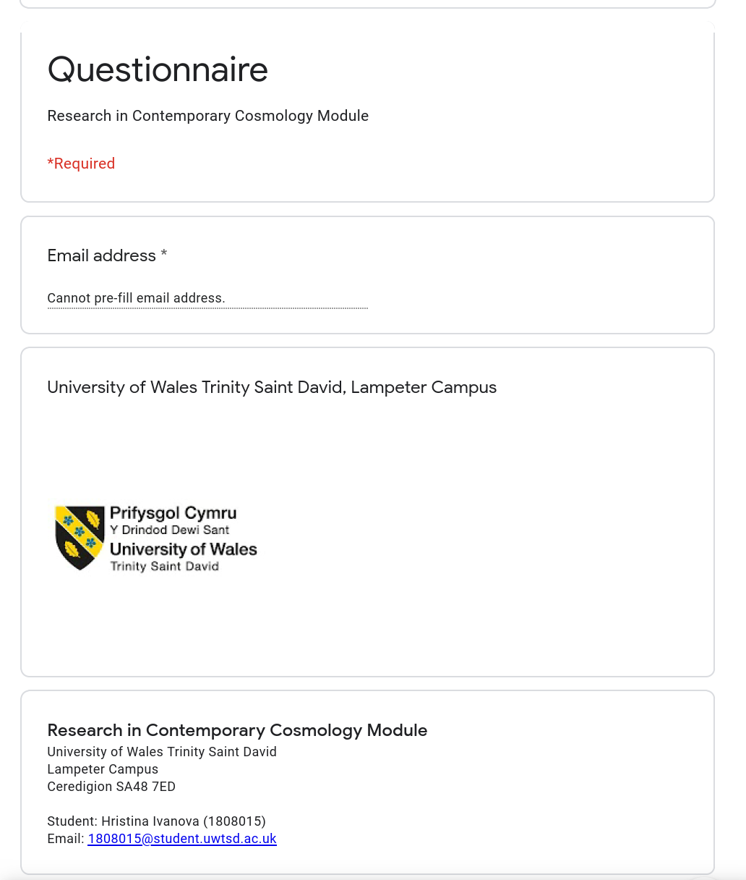
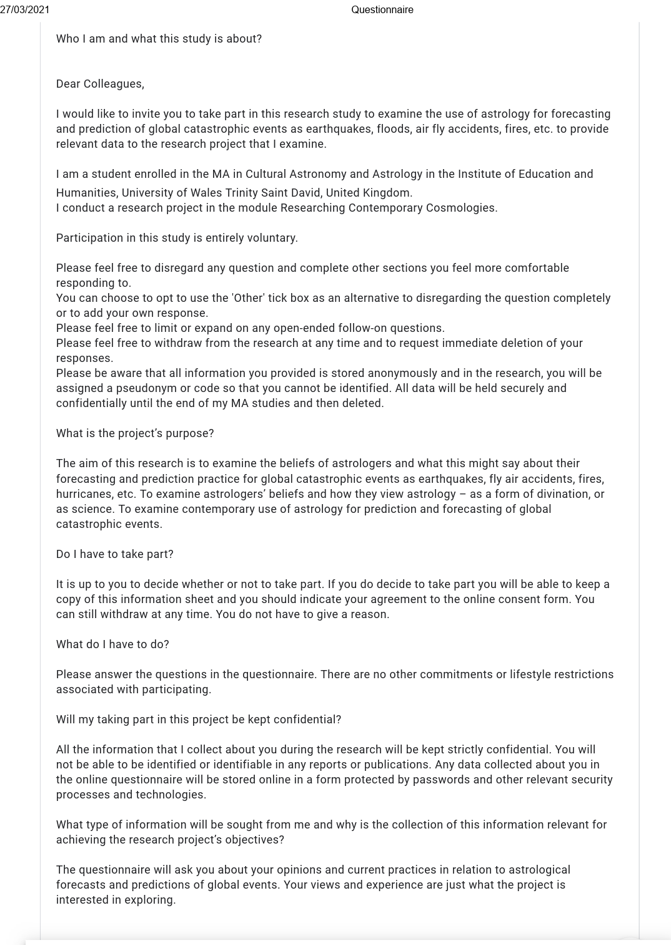
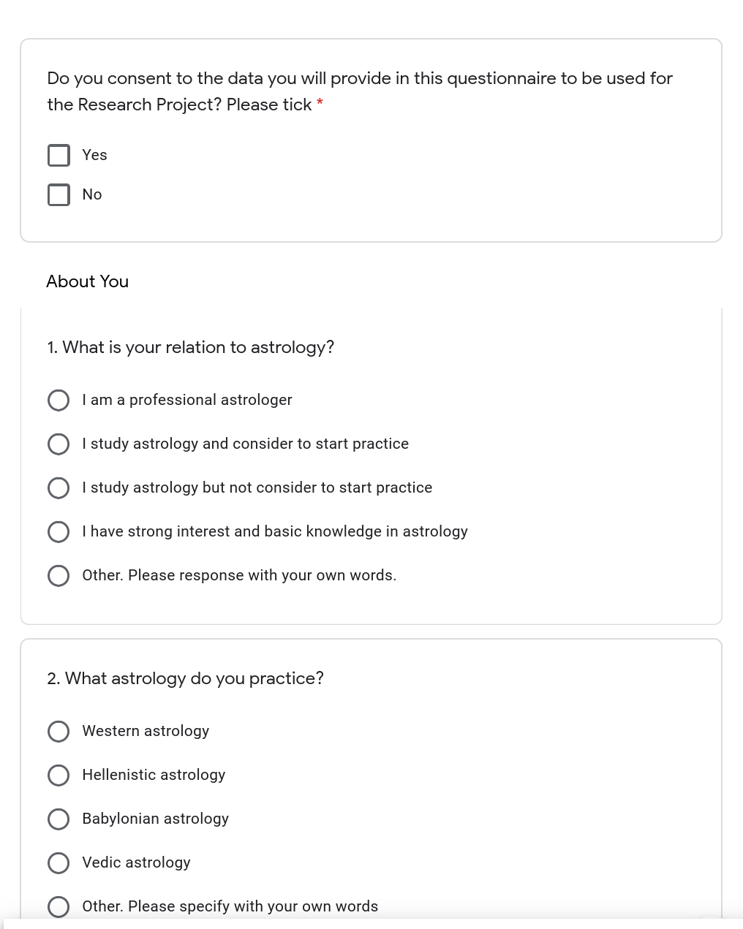
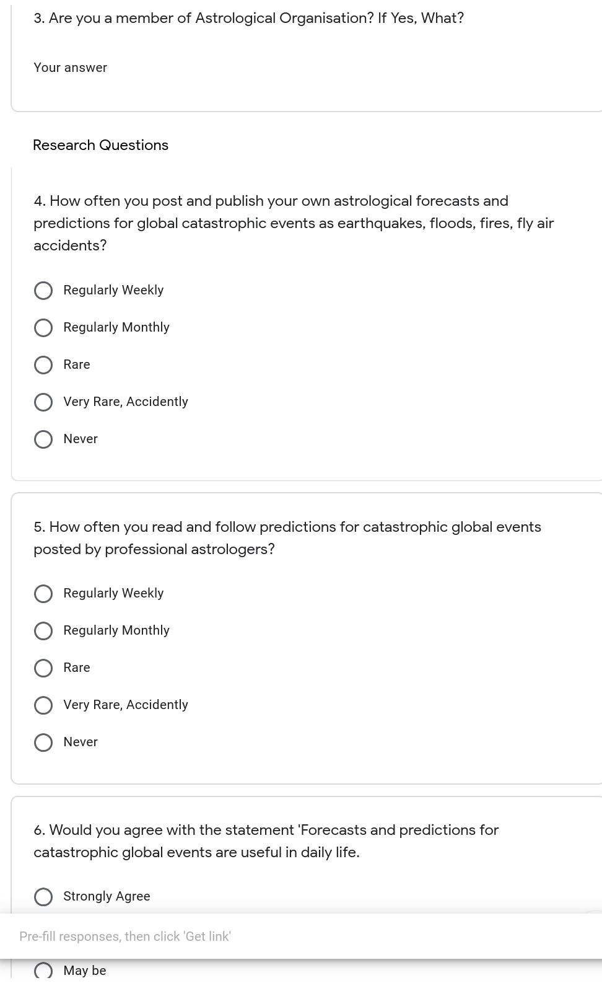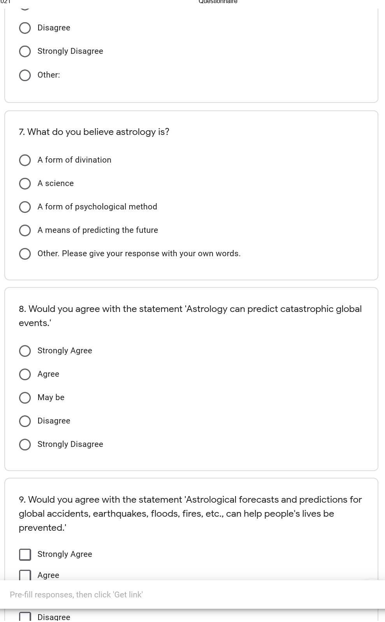
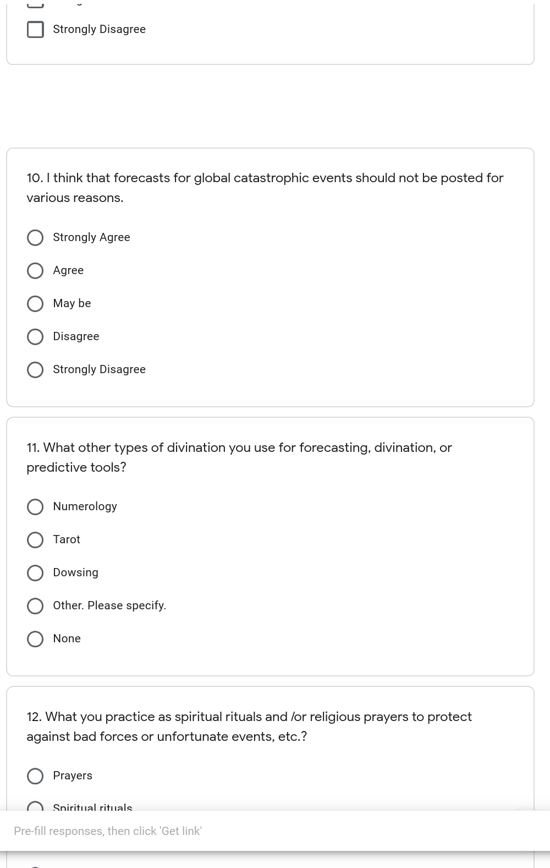
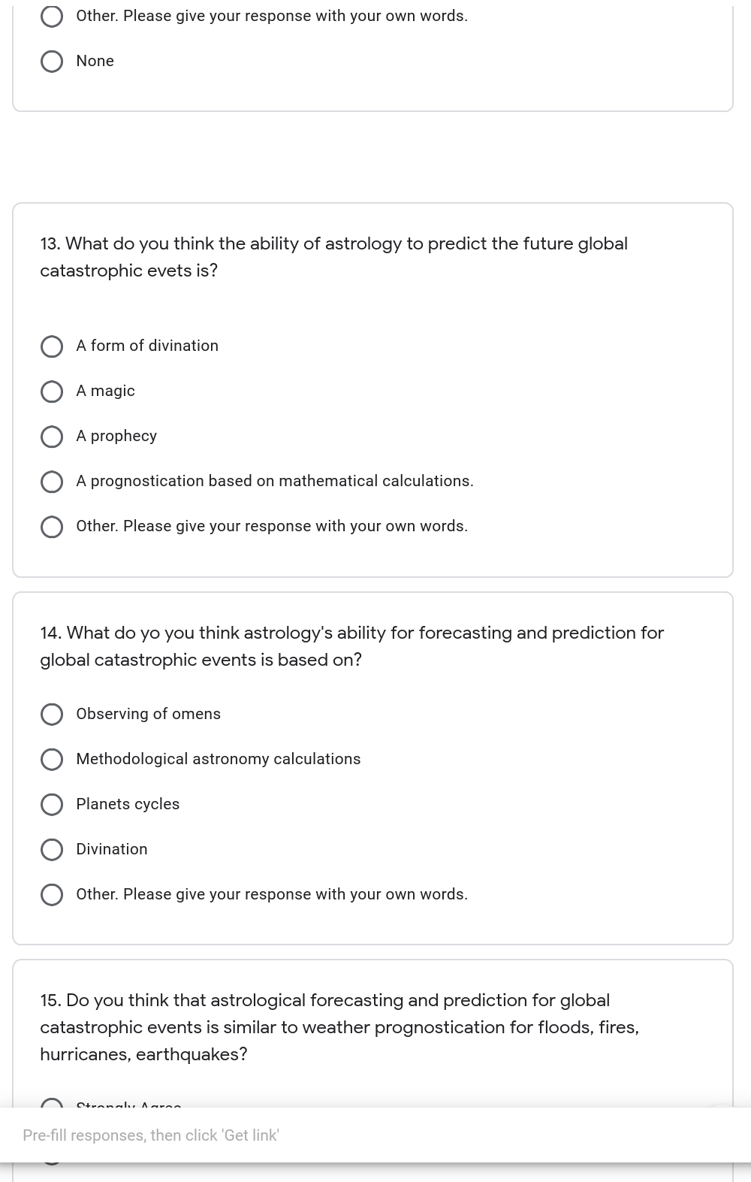
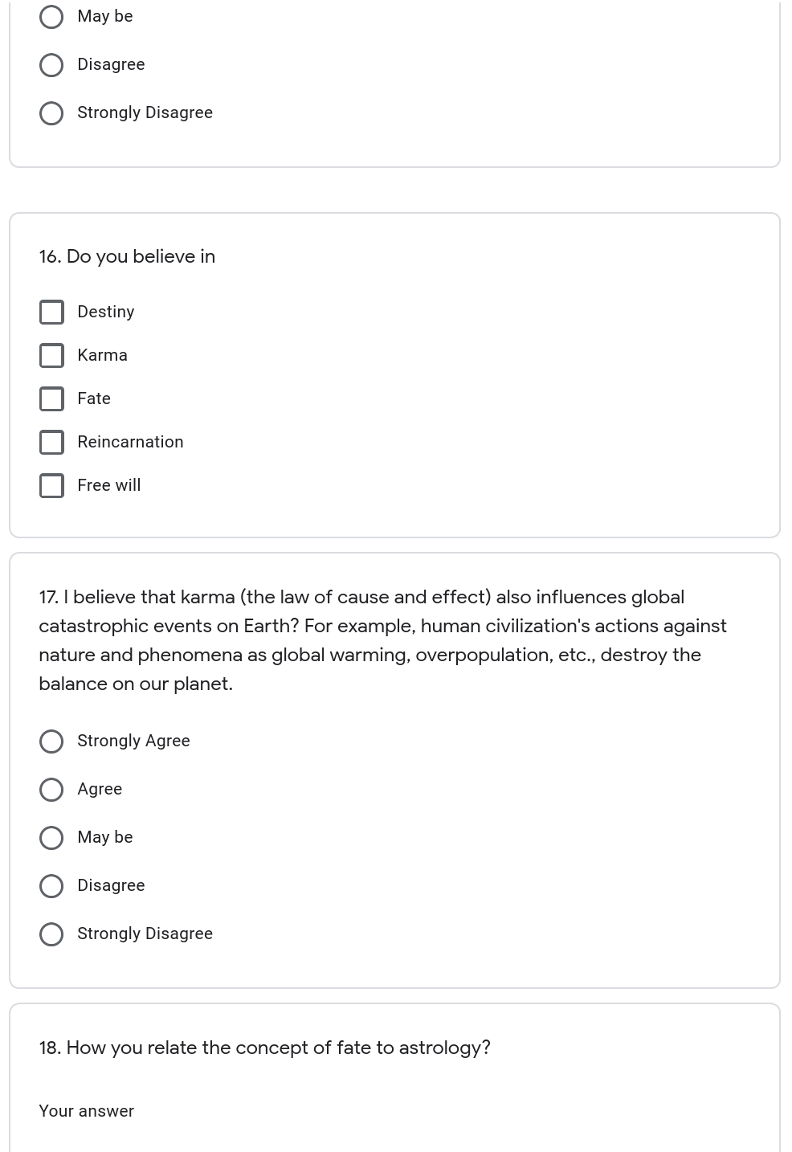
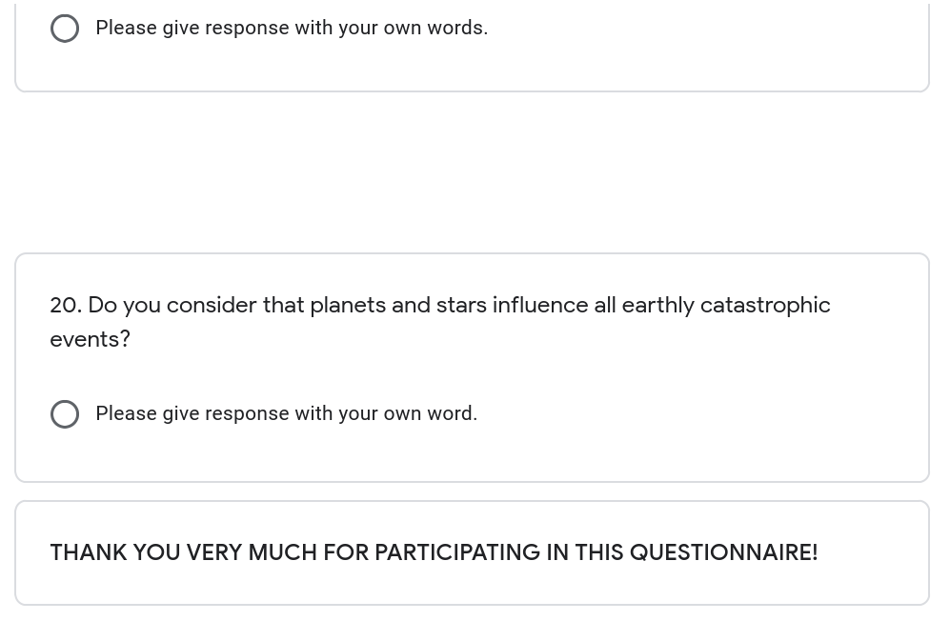

12. Appendix 2 Questionnaire Responses
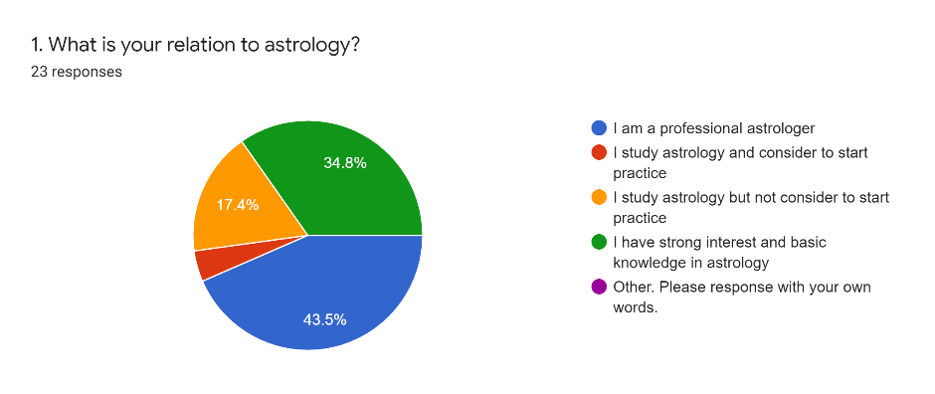
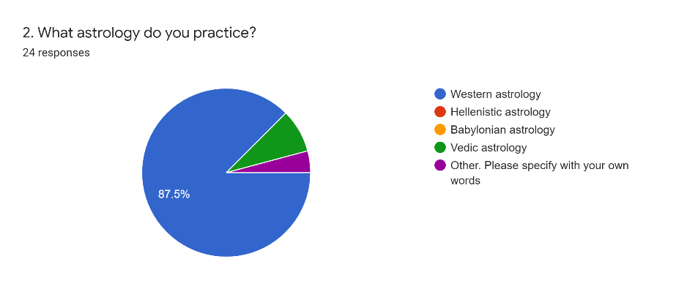
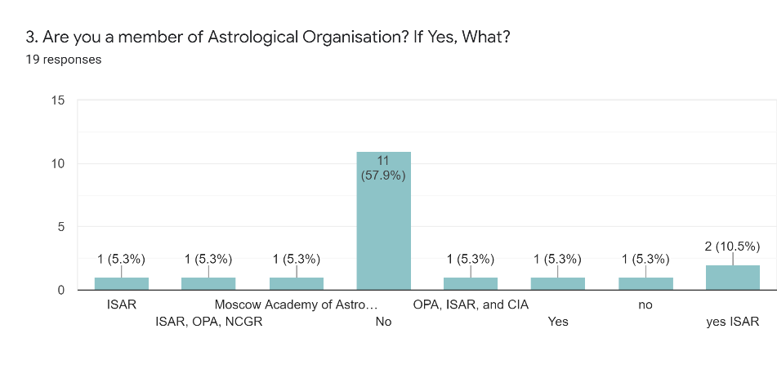
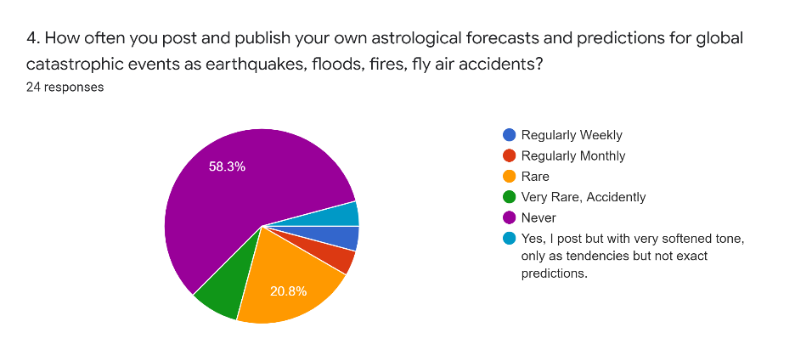
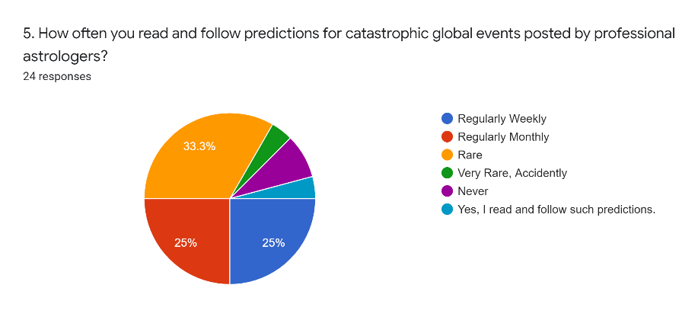
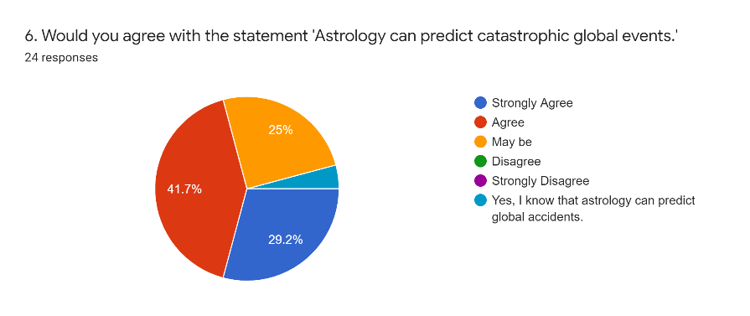
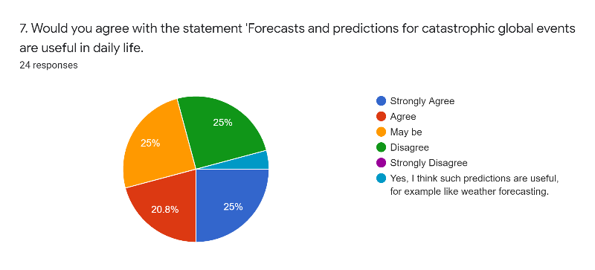
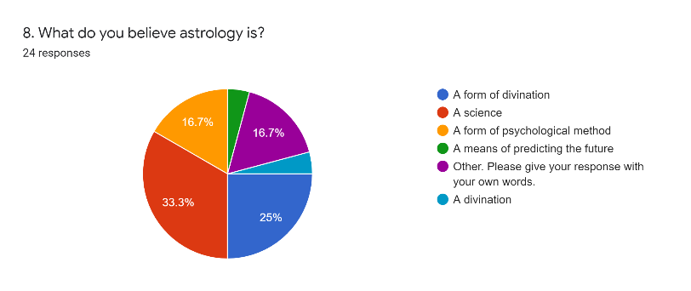
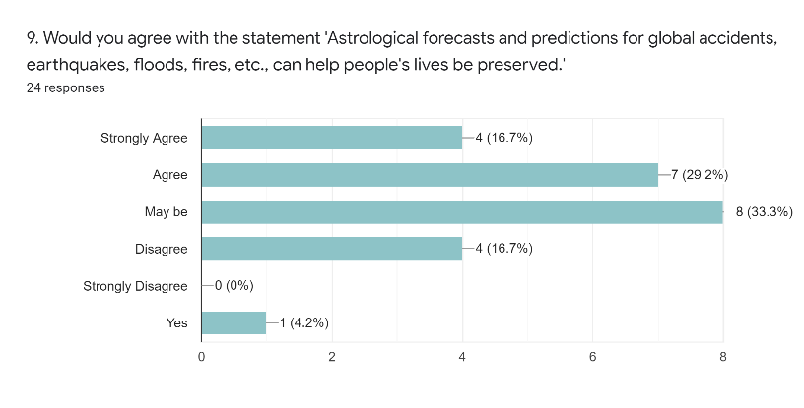
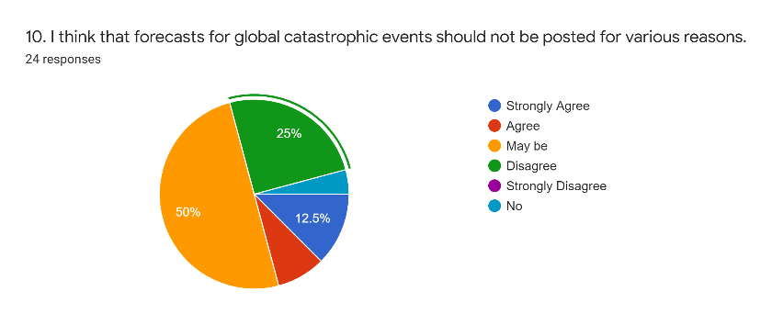
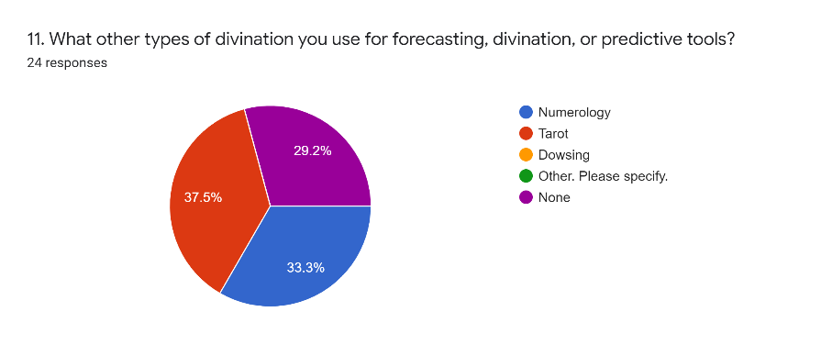
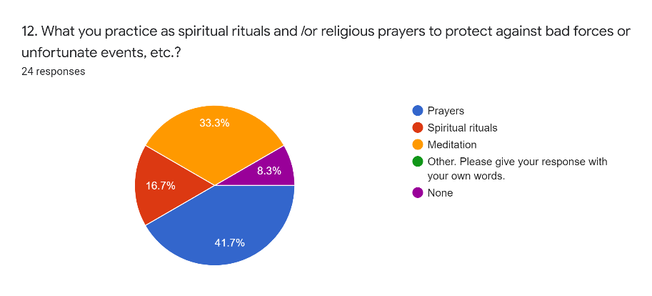
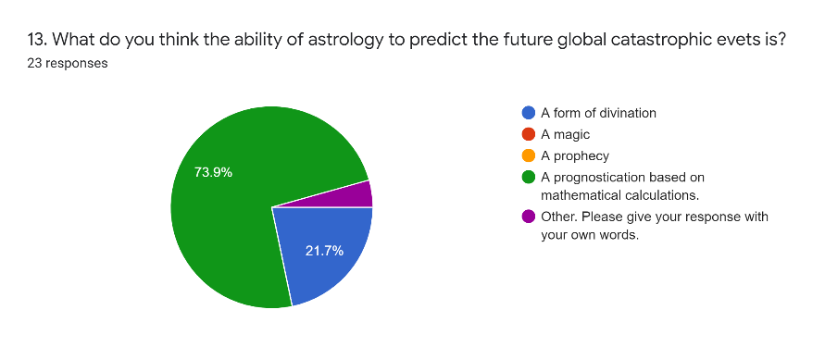
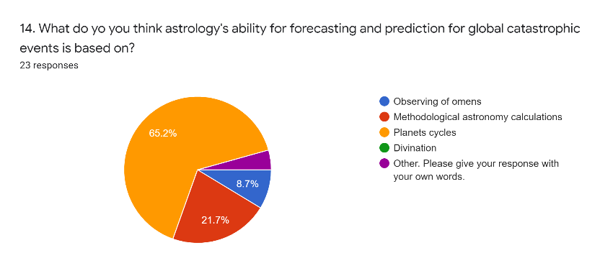
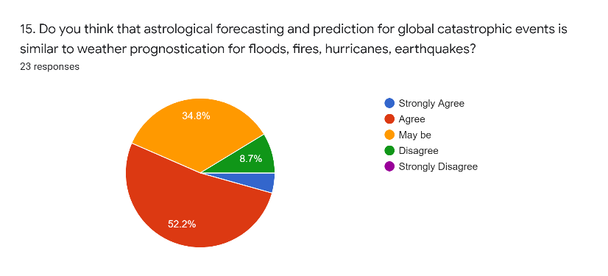
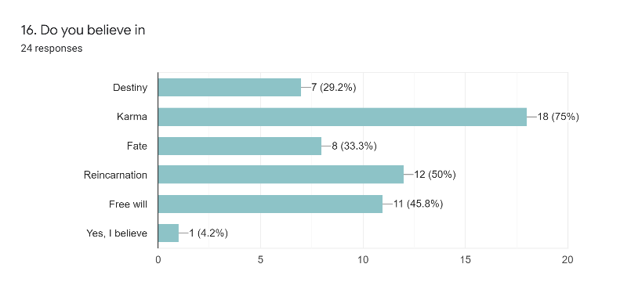

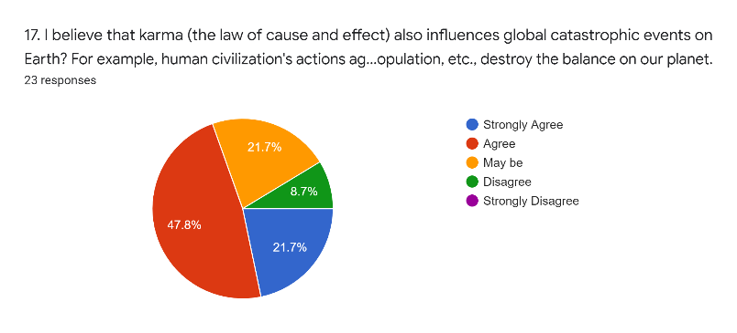

- Appendix 3 Interview Release Form

https://www.astro.com/astrowiki/en/prediction, accessed on 10th May 2021
https://dictionary.cambridge.org/dictionary/english/prediction, accessed on 05th May 2021
Farebrother, S. M., Astrology Forecasting. The expert guide to astrological prediction, (London: Ryder, Ebury Publishing, Penguin Random House UK, 2019), p. 14
Farebrother, S. M., Astrology Forecasting. The expert guide to astrological prediction, (London: Ryder, Ebury Publishing, Penguin Random House UK, 2019), p. 14
Farebrother, S. M., Astrology Forecasting. The expert guide to astrological prediction, (London: Ryder, Ebury Publishing, Penguin Random House UK, 2019), pp. 16-17
Vilhena, Luis Rodolfo, The World of Astrology. An Ethnography of Astrology in Contemporary Brazil, (Sofia Centre Press, 2014), p. 35
Campion, Nickolas, Prophecy, Cosmology and the New Age Movement. The Extent and Nature of Contemporary Belief in Astrology. (Study of Religions Department, Bath Spa University College, 2004), p.
Jerome, Lawrence E., Astrology and Modern Science: A Critical Analysis, (Leonardo, Spring, Vol. 6, No. 2, The MIT Press, 1973), pp. 127-128
Cornelius, Geofrrey, The Moment of Astrology. Origins in Divination, (Wessex Astrologer Ltd, 2003), p. xxii
Bryman, Alan, Quantity and Quality in Social Research, (Routledge, 2004), p.63
Bryman, Alan, Quantity and Quality in Social Research, (Routledge, 2004), p.63
Bryman, Alan, Quantity and Quality in Social Research, (Routledge, 2004), p.65
Lapan, Stephen D., Lynn, Mary, Quartaroli, Marylyn T., Riemer, Frances Julia, Qualitative Research. An Introduction to Methods and Designs, (Jossey-Bass. A Willey Imprint, 2012), p. 69
Bryman, Alan, Quantity and Quality in Social Research, (Routledge, 2004), p.46
Lapan, Stephen D., Lynn, Mary, Quartaroli, Marylyn T., Riemer, Frances Julia, Editors, Qualitative Research. An Introduction to Methods and Designs, (Jossey-Bass. A Willey Imprint, 2012), p. 3
Bryman, Alan, Quantity and Quality in Social Research, (Routledge, 2004), p. 94
Bryman, Alan, Quantity and Quality in Social Research, (Routledge, 2004), p.46
Bell, Judith, Doing Your Research Project. A guide for first-time researchers in education, health, and social studies, (Open University Press, 2005), p.118-119
Bell, Judith, Doing Your Research Project. A guide for first-time researchers in education, health, and social studies, (Open University Press, 2005), p.138
Phillipson, Garry, Astrology and Truth: A Context in Contemporary Epistemology, (University of Wales Trinity Saint David, 2019)
Cornelius, Geofrrey, The Moment of Astrology. Origins in Divination, (Wessex Astrologer Ltd, 2003), p.17
Cornelius, Geofrrey, The Moment of Astrology. Origins in Divination, (Wessex Astrologer Ltd, 2003), p.23
Cornelius, Geofrrey, The Moment of Astrology. Origins in Divination, (Wessex Astrologer Ltd, 2003), p.25
Vilhena, Luis Rodolfo, The World of Astrology. An Ethnography of Astrology in Contemporary Brazil, (Sofia Centre Press, 2014), p. 63
Vilhena, Luis Rodolfo, The World of Astrology. An Ethnography of Astrology in Contemporary Brazil, (Sofia Centre Press, 2014), p. 47
Cornelius, Geofrrey, The Moment of Astrology. Origins in Divination, (Wessex Astrologer Ltd, 2003), p. 44
Cornelius, Geofrrey, The Moment of Astrology. Origins in Divination, (Wessex Astrologer Ltd, 2003), p. 44
Cornelius, Geofrrey, The Moment of Astrology. Origins in Divination, (Wessex Astrologer Ltd, 2003), p. 47
Cornelius, Geofrrey, The Moment of Astrology. Origins in Divination, (Wessex Astrologer Ltd, 2003), p. 48
Vilhena, Luis Rodolfo, The World of Astrology. An Ethnography of Astrology in Contemporary Brazil, (Sofia Centre Press, 2014), p. 93
Vilhena, Luis Rodolfo, The World of Astrology. An Ethnography of Astrology in Contemporary Brazil, (Sofia Centre Press, 2014), p. 39
Vilhena, Luis Rodolfo, The World of Astrology. An Ethnography of Astrology in Contemporary Brazil, (Sofia Centre Press, 2014), p. 47
Brennan, C., Hellenistic Astrology. The Study of Fate and Fortune, (Denver: Amor Fati Publications, 2017), pp. 147-148
Brennan, C., Hellenistic Astrology. The Study of Fate and Fortune, (Denver: Amor Fati Publications, 2017), p. 152
Brennan, C., Hellenistic Astrology. The Study of Fate and Fortune, (Denver: Amor Fati Publications, 2017), p. 158
Brady, B., Theories of Fate among Present-day Astrologers, (Bath: Bath Spa University College, 2005), p.90
Brady, B., Theories of Fate among Present-day Astrologers, (Bath: Bath Spa University College, 2005), p.112
Brady, B., Theories of Fate among Present-day Astrologers, (Bath: Bath Spa University College, 2005), p.112
Campion, Nickolas, The Practical Astrologer, (Harry N. Abrams, Inc., Publishers, New York, 1987), p. 94
Campion, Nickolas, The Practical Astrologer, (Harry N. Abrams, Inc., Publishers, New York, 1987), p. 94
Campion, Nickolas, The Practical Astrologer, (Harry N. Abrams, Inc., Publishers, New York, 1987), p. 142

