


School of Applied Computing / Ysgol Cyfrifiadura Gymhwysol

INDEPENDENT PROJECT HANDBOOK
(COMPUTING CLUSTER – DDA STUDENTS)

for

BSc (Hons) Computing (Computer Networks and Cybersecurity)
BSc (Hons) Computing (Data and Information Systems)
BSc (Hons) Computing (Software Engineering)

2021/2022
(Sem 2/Sem 3)

School of Applied Computing,  University of Wales Trinity St David,  SA1 Swansea Waterfront  SWANSEA,  UK  SA1 8PH  +44 (0)1792 481000  http://www.uwtsd.ac.uk | Ysgol Cyfrifiadura Cymhwysol,  Prifysgol Cymru Y Drindod Dewi Sant  SA1 Swansea Waterfront  ABERTAWE,  Y DU  SA1 8PH  +44 (0)1792 481000  http://www.uwtsd.ac.uk

Vice Chancellor: | Professor Medwin Hughes
Head of WISA: | Prof Ian Walsh
Independent Project Coordinator for Computing Cluster: | Gaynor Thomas | gaynor.thomas@uwtsd.ac.uk

TABLE OF CONTENTS

1. INTRODUCTION 4
2. THE PROJECT MODULE (from Programme Validation Document) 5
Independent Project 6
3. PROJECT DEADLINES 9
4. THE STUDENT-SUPERVISOR RELATIONSHIP 10
4.1 Your Supervisor 10
4.2 Responsibilities of supervisors 10
4.3 Responsibilities of students 11
4.4 Logbook/Blog 11
4.5 Attendance 11
5. ASSESSMENT 12
6. PROJECT PROPOSAL (5%) 13
7. INTERIM VIVA (10%) 15
8. FINAL REPORT (55%) 16
8.1 SUGGESTED STRUCTURE FOR REPORT 16
8.2 GENERAL POINTS ABOUT REPORT 28
8.2.1 Spelling and Grammar 28
8.2.2 Word Limit 28
8.2.3 Style Requirements 28
8.2.4 Assessment 29
8.2.5 Plagiarism 30
8.2.6 Handing in your Project Report 31
9. FINAL VIVA (20%) 32
9.1 Demonstration (Experimental- and Development-based Projects) 32
10. EXHIBITION (10%) 33
10.1 Guidance for Exhibition 33
10.2 Degree Show 34
10.3 Handing in your Exhibition materials 37
APPENDIX 1: DECLARATION FORM AND FORM OF CONSENT 38
APPENDIX 2: ELECTRONIC DATABASES AND JOURNALS 39
APPENDIX 3: REFERENCING CONVENTIONS 40
APPENDIX 4: NUMERIC REFERENCING SYSTEM 43

1. INTRODUCTION

The Level 6 Project is a major piece of work undertaken by the student on an individual basis. The project is a 40 credit module on all programmes. The student’s performance in the Project has a substantial influence on the class of degree awarded.

The stated aim of the project is:

"To develop the ability of students to engage critically and innovatively with theory and/or practice relevant to their studied subject areas in order to produce a discipline specific in-depth project."

You have already selected a project through the Research Methods module in Year 2/Level 5 and produced a project proposal. Project supervisors will be confirmed at the start of Year 3/Level 6.

Throughout the year you will meet your Project Supervisor in a 20 minute timetabled slot every week. In addition, there will be occasionally be extra briefing sessions organised by the Project Co-ordinator. It is expected that students will undertake considerable period of independent work. The Project is looked upon as a final large scale integrating study.

Attendance of weekly supervision and briefing session is and student attendance as well as progress will be monitored carefully.

The completed Project within Computing will normally include a deliverable (software system, evaluation report, framework document, implementation plan etc). This is a requirement for our British Computer Society (BCS) degree accreditation.

Useful tips:

• The project can be a deceptive experience. As the submission deadline is so far away when you start, there is a danger of wasting time in the early stages of the process.

• Start writing as soon as possible. There are dangers in putting off this task.

• Always allow as much time as possible for the final stages. Final amendments, organising, testing, debugging, word processing and doing a thorough job on the proof reading all take longer than you imagine. Something will always go wrong to thwart your schedule!

2. THE PROJECT MODULE (from Programme Validation Document)

Module Code | ACCA6020
Title | Independent Project
Date | 25/06/2020
Level | 6
Credits | 40
Pre-Requisites | None

AIM(S)
- To develop the ability of students to engage critically and innovatively with theory and/or practice relevant to their studied subject areas in order to produce a discipline specific in-depth project.

LEARNING OUTCOMES

Upon the successful completion of this module, the student should be able to:
- Demonstrate intellectual skills in the identification of an appropriate topic, problem or challenge for investigation pertinent to their field of study and formulate a suitable plan for further research utilising relevant investigative methods in order to produce a response.
- Evidence in-depth knowledge and critical understanding of principles necessary to underpin their education within their chosen field of study and problem solving techniques applicable to this.
- Evidence independence of thought and critical evaluation in the production of an independent piece of work, demonstrating transferable skills through exercising initiative and personal responsibility in planning own learning and self-management.
- Organise their knowledge and learning through use of a range of media, and present their work appropriately in a manner that can be understood by specialist and non-specialist audiences.

INDICATIVE CONTENT
- Research paradigms, methods, and techniques of research and enquiry.
- Conducting and writing literature reviews.
- Ethical concerns and the research process.
- Resource, project, and skills management processes and techniques.
- Presenting and illustrating data and information.
- Communication of general, specialist, technical ideas and results.
- Problem solving, creative, entrepreneurial thinking and approaches.
- Collaboration, adaptability and reflection.

Study Time Allocation

The study time for the module is divided as follows:

Activity type | Hours | Percentage
Scheduled learning | 36 | 9%
Independent learning | 364 | 91%
Placement learning
TOTAL | 400 | 100%

ASSESSMENT

Assessment Component 1
(Tick one)
☐ | Written exam | ☒ | Coursework | ☐ | Practical

Mode of assessment | Volume | Weighting
Portfolio | Minimum of 3 elements (equivalent to 10,000 words) | 100%

Assessment Summary
Activity type | Percentage
Written exam
Coursework | 100%
Practical
TOTAL | 100%

INDICATIVE READING LIST
This will be guided by the student’s individual project.

Module Code | ACCA6020
Module Title | Independent Project
Classification | Reading List entry | Electronic*
Essential | Cottrell S, (2015) Skills for Success Personal Development and Employability, 3rd edition, Palgrave. London. | ☒
Essential | ASET, 2013 Good Practice Guide for Workbased Learning and Placement Learning in Higher Education | ☒
Essential | Gray, D.E. (2018) Doing Real World Research, London: SAGE. | ☐
Further | Gallagher K, (2016) Essential Study and Employment Skills For Business and Management Students, Oxford | ☐
Further | Gottschall, Jonathan (2013), The Storytelling Animal: How Stories Make Us Human, Houghton Mifflin | ☐
Further | Storr, Will (2020), The Science of Storytelling, William Collins | ☐
Further | Cohen, L. Manion, L. and Morrison, K. (2017) Research Methods in Education, 8th edition London: Routledge. | ☒
Further | Flick, U. (2014) An Introduction to Qualitative Research, London: SAGE. | ☐
Further | Aubrey, K. & Riley, A. (2017) Understanding and Using Challenging Education Theories, London: SAGE. | ☒
Further | Brinkmann, S. and Kvale, S. (2018) Doing Interviews (Qualitative Research Kit). Sage | ☐
Further | Gibbs, G. (2018) Analysing Qualitative Data (Qualitative Research Kit). Sage | ☒
Further | Creswell, J. W. (2012). Qualitative inquiry and research design: Choosing among five approaches. Sage | ☐
Further | Obschonka, M., Hakkarainen, K., Lonka, K. et al. Entrepreneurship as a twenty-first century skill: entrepreneurial alertness and intention in the transition to adulthood. Small Bus Econ 48, 487–501 (2017). https://doi.org/10.1007/s11187-016-9798-6 | ☒
Further | https://ec.europa.eu/jrc/en/entrecomp | ☒

3. PROJECT DEADLINES

The deadlines for the project for DDA students 2021/22 are:

Interim Viva | 26th/27th/28th April – timeslots to be arranged
Final Report | Friday 22nd July by 3pm
Final Viva | 6th/7th/9th September – timeslots to be arranged
Exhibition: Poster | Friday 29th July by 3pm (poster)
Exhibition: Degree Show materials | Friday 29th July by 3pm (images and questionnaire)

Note:
Return from Easter holiday: Monday 25th April 2022

Exact details of viva timetables will be circulated by email closer to the time.

Please note that neither your supervisor nor the project co-ordinator are able to grant extensions to the above dates. Any student requiring an extension must apply via myTSD to the University’s Extenuating Circumstances (EC) Committee.

Any element of the above (including the vivas) which are not submitted/attended on time will be deemed to be a failure by non-submission.

Please put these dates in your calendar now, and contact Gaynor immediately if there are any problems nearer the time.

4. THE STUDENT-SUPERVISOR RELATIONSHIP

4.1 Your Supervisor

- Your supervisor is there to guide you, not to do or write your Project for you. The Project is your responsibility.
- Your supervisor will be available to see you, every week, at a mutually agreed time.
- Your supervisor is there to guide you but can only do so if contact is regular and frequent.
- Feed your supervisor material on a regular basis. It is unfair to expect detailed comments on a major part of your work at a moment's notice.
- Your supervisor will keep a record of your attendance and will report on your progress regularly to the Project Coordinator
- If you have (reasonable!) project resourcing requests, please ask your supervisor and Gaynor

4.2 Responsibilities of supervisors

- Help the student refine the original Project proposal. The emphasis must be on what is achievable.
- Advise the student of relevant data/literature sources and discuss approaches to the literature review.
- Discuss research design and choice of appropriate methods ensuring that the student has thought through the process adequately, and advice is given on how to refine the design/methodology process.
- Discuss the Plan of Action.
- Meet with student at agreed times, on average 20 minutes per week, and keep a note of contact and advice.
- Monitor and discuss student attendance and progress and advise the Project Co-ordinator of any students causing concern.
- Discuss research findings.
- Read and comment on draft chapters to help students identify any weaknesses in analysis and presentation.
- Read and comment on one complete draft of the Project if submitted in sufficient time.
- Mark Project.
- Ensure resources (eg suitable equipment) are available for the project.
- Provide limited technical support as required.
- Recommend any necessary changes to the original proposal to the Project Co-ordinator.
- Agree to all changes to the project proposal in conjunction with student and Project Co-ordinator.

4.3 Responsibilities of students

- To attend meetings with supervisor on a weekly basis and occasional meetings with project co-ordinator.
- To adhere to the Project Plan timetable and inform supervisor of any problems.
- To supply a complete final draft in sufficient time (agreed between supervisor and student) for reading and comment. Although he/she will be advised of presentational problems, the student is responsible for accurate citation, the standard of English, overall presentation and proof reading.
- To submit the Project assessment components by the specified date and time.
- To give a presentation and answer questions about the project during the vivas.
- Report any problems concerning project supervision to the Project Co-ordinator.

As a general point, the Project process and the production of the Project are primarily the student's responsibility. The supervisor is there to help and guide but not to do the work or write it for you.

4.4 Logbook/Blog

The student is advised to keep a logbook or blog that records each continuous period spent on the project in chronological order, giving the date, starting and ending times, and a brief description of what was done in that time. Meetings with supervisors and others should be recorded.

A logbook can be very helpful when you are writing up your project – it is easy to forget important details of work carried out when writing up later.

4.5 Attendance

Just like any other module, student attendance at project meetings will be monitored closely. Failure to attend project supervision meetings will be recorded and disciplinary measures taken. Also, you are very likely to fail if you do not have regularly advice from your supervisor!

5. ASSESSMENT

As shown in the Project Module in Section 2, there are a number of assessment points. There are four required components:

Interim Viva (15%)
Final Report (55%)
Final Viva (20%)
Exhibition (10%)

More detail about each part of the assessment is provided in the following chapters.

Deadlines are shown in Section 4.

6. INTERIM VIVA (10%)

The Interim Viva will take place after Easter in the form of a presentation. The marking sheet is as follows:

Interim Viva
Project type: | Survey | Review | Experiment | Development
1. Literature Review (level of progress, suitable synthesis of background material completed) | /40 | /40 | /40 | /40
2. Discussion of Findings | /20 | /20 | /10 | /10
3. Code examples /prototypes /demo | - | - | /10 | /10
4. Project Plan | /10 | /10 | /10 | /10
5. Response to Questioning | /20 | /20 | /20 | /20
6. Quality of Presentation | /10 | /10 | /10 | /10
TOTAL | /100 | /100 | /100 | /100

Students are required to attend a 30 minute total oral examination of their project before at least two examiners. These are normally the student’s project supervisor and a second marker. Occasionally, other members of staff, e.g. the Project Co-ordinator, might be present.

During the viva, the student should give a presentation on his/her project for 10-15 minutes using a Powerpoint presentation to assist. The student should summarise their project, presenting the aims and objectives and the main findings of the literature review, so far. The student should also present a plan ie Gantt chart for the rest of the project.

Remember that the second marker has no knowledge of your project, so your presentation should be pitched to accommodate the second marker.

For Experimental- and Development-based projects, students should also present prototypes of code developed so far, and if practicable, demonstrate work produced so far. This can be done after the main Powerpoint demonstration.

7. FINAL REPORT (55%)

Marking sheet
 | Survey | Review | Experiment | Development
Research-informed Literature
Introduction | 5 | 5 | 5 | 5
Literature Review | 20 | 35 | 20 | 15
Knowledge and Understanding of Subject
Methodology | 5 | 5 | 5 | 5
Survey Design | 15 | - | - | -
Requirements/Design | - | - | - | 5
Analysis
Results & Discussions | 25 | 25 | 25 | 25
Conclusions and Recommendations | 10 | 10 | 10 | 10
Practical Application and Deployment
Development | - | - | - | 15
Experimental Design | - | - | 15 | -
Skills for Professional Practice
Reflection | 10 | 10 | 10 | 10
Quality of Report | 10 | 10 | 10 | 10
TOTAL | 100 | 100 | 100 | 100

7.1 SUGGESTED STRUCTURE FOR REPORT

Each project is unique and consequently the sections covered may vary somewhat from project to project. Also some sections may be larger than others and be split into two chapters, especially if the project deals with the convergence of more than one technology.

The following is meant to be a guide to help you, not a straight-jacket. Each major section should be present in some way, although not necessarily in a chapter of its own. The chapter layout must be appropriate to each particular project.

Your supervisor should be consulted about the best layout for your particular project documentation.

1. TITLE PAGE

- Title of work
- Full name of student
- Name of Supervisor
- Name of Second Marker
- Project submitted as part of the requirements for the award of (change course as appropriate).
- Date of submission

IMPORTANT NOTE: By instruction of the External Examiner, your cover MUST be presented as shown below. No colours! No fancy designs! No underlining etc! No images other than the University logo! (The project coordinator will make the file containing the University logo available on Moodle for you to use)

It must look very similar to the below. A sample title page is available on Moodle for you to adapt.



A Study of the use of Wireless
Underwater Sensor Networks in Swansea Bay

by
Joe Bloggs

Supervisor: Dr Kapilan Radhakrishnan
Second Marker: Dr Carlene Campbell

Project submitted as part of the requirements for the award of BSc (Hons) Computing (Computer Networks and Cybersecurity)

July 2022

2. DECLARATION FORM AND FORM OF CONSENT (see Appendix 1)

This states that the candidate is the author of the Project and the work contained therein has been done by the candidate. This can be found in Appendix 1, and also on Moodle.

3. ABSTRACT (1 page or around 300 words)

The abstract is short summary of the entire project. It should summarise the important points and should include:

a) The overall aims and objectives.
b) A summary of the methods used.
c) A summary of the major findings and/or deliverables.
d) A statement of conclusions and recommendations.

Keep it concise. The idea of the Abstract is that someone could read it and decide from it whether it would be worth their while to read the whole report. Although it’s the first thing that appears in the report, it is the last thing to be written.

4. CONTENTS PAGE
Show the main chapter and the sub-chapters. Also provide a List of Tables/Figures.

CHAPTER 1 - INTRODUCTION

This chapter should start off by setting the context for the work:

- What is the project about? What are the initial aims and objectives for the project?
- Aim - what is the overall research question you're trying to answer?
- Objectives - what are the actions you're going to take to try to satisfy the aim?
- A brief description of what is coming up in the following chapters (this should be the final paragraph of the introduction).

Usually, you start with a very broad statement of the problem and refine that down to more specific items. Unless yours is a problem area with which all readers of your report will be familiar (very unlikely), you will want to describe the problem in some detail and give sufficient background information so that everyone can understand it.

You should then describe the objectives, aims or goals of your particular piece of work. Your overall aim was presumably to solve a particular problem or to answer a particular question. This could be broken down into a number of specific objectives that together work towards achieving the aim.

The introduction should end with a section that leads the reader in to the rest of the report. The important thing is to give your reader a clear picture of what your report is setting out to do.

CHAPTER 2 - RESEARCH & REVIEW OF LITERATURE

Year 3/Level 6 projects should include a comprehensive element of review and scholarly research. Your work is done in the context of an academic discipline, Computing. Show how your project fits into the framework of that discipline by reviewing books and papers describing the problem you are trying to solve and potential solutions to the problem.

- What other research has been done in your field?
- Who did this research?
- What were their results?
- How do these results relate to other researchers' work in the field?
- Split the literature review into sections, each looking at a different part of the research problem
- Write an introductory paragraph at the start of the chapter that briefly describes the sections
- Write a concluding paragraph at the end of the chapter that briefly sums up the most important points.

The Literature Review gives your reader sufficient background knowledge for them to be able to appreciate later why the approach you took was valid or best. Since they may not be familiar with either the problem or the possible solutions or both, you need to provide them with a basic grounding in the important and relevant material. This does not, however, mean that you should include a detailed tutorial.

You also need to demonstrate that you considered all the possible solutions to the problem and that you took all available material into account. This part of the review usually summarises quite succinctly approaches that have been taken by other people in similar situations. Some will have been successful and some not, and this should be indicated. It is perfectly all right to express justified disagreement with something you’ve read - “criticism” is often an excellent feature of a review.

The most important attribute that your review should possess is relevance.

It is strongly recommended that a first draft of this section is developed in the first term. You will also need to present your initial literature review at the Interim Viva. Ask your supervisor for advice.

CHAPTER 3 - RESEARCH AND/OR DEVELOPMENT METHODOLOGY

Research Methodology

Here you explain in detail the what, why and how of the procedures you used in order to generate the solution to the idea.

The rule is to describe your method in sufficient detail to allow the reader to replicate your study. What research methodology/methodologies did you use - experimental (hypothesis testing), investigative, action, survey, case-study etc? Do not include a review of all possible methods that could be used – the reader is interested in what method you chose and why.

For each of the layers of the research onion, decide which method you intend to use and explain:
  - Why you have chosen that method
  - What are the advantages of that method to your project
  - If there are any disadvantages to the method then how will you work around them?

Also indicated what evaluation criteria are to be used? What methods of testing and statistical analysis are to be used?

For Survey-based Projects
- What are the objectives of your survey? (SMART)
- Who is your target group?
- For each question you plan to ask:
  - What is the question?
  - Why are you asking it?
  - Are there any specific links to things in your literature review for this question?
- Is your survey valid? Why?
- Is your survey reliable? Why?
- Is your survey generalisable? How far?
- How did you prototype the survey?
- What changes did you make as a result of prototyping the survey?
- For any questions that have been changed, explain
  - What is the question?
  - Why are you asking it?
  - Are there any specific links to things in your literature review for this question?
- How do you intend to analyse your results?
- What, if any, statistical methods do you plan to use?
- If you are doing a questionnaire and an interview then these questions must be answered for both survey instruments.

For Experimental-based Projects
- What is your experimental hypothesis?
- What hardware are you using?
- What software are you using?
- What were your inputs?
- Is your experiment valid? Why?
- Is your experiment reliable? Why?
- Is your experiment generalisable? How far?
- How did you conduct the experiment?

Development Methodology (for Development-based Projects)

- For your chosen software development methodology explain:
  - Why you have chosen that method
  - What are the advantages of that method to your project
  - If there are any disadvantages to the method then how you will work around them.
- What software are you going to use, and why is it appropriate for the project?
- Do you need any particular hardware, and if so why?
- Materials and Tools. eg why are you using a particular package or language to design and develop your software?

CHAPTER 4 - DESIGN & IMPLEMENTATION
- For Development- and Experimental-based Projects only
For Chapter 4 for Survey and Review-based Projects, please see Page 25

This is a major section which describes your deliverable. It may be a software artifact, a new framework, a systems design, etc. This may span more than one chapter and will have title(s) which reflect its content.

Design

If you’ve built something to solve a problem, you had to make some design decisions along the way. Why did you choose to do something one way rather than another? Why did you choose to include one thing but leave out something else? Which factors did you think were most important and which did you choose to ignore?

Don’t just list your decisions; place them in a context. It should be possible for the reader to understand how your design decisions contributed to meeting your objectives. Also important is that you show the method by which you accomplished your design - “process” is as important as “product” to an engineer.

- What processes did you use?
- How did they contribute to ensuring that what you did was complete/consistent/correct?

It should be possible for the reader to understand how your design decisions contributed to meeting your objectives. Also important is that you show the method by which you accomplished your design - “process” is as important as “product” to an engineer. What processes did you use? How did they contribute to ensuring that what you did was complete/consistent/correct? Don’t just write about what you did, or how you did it. Why you did it is most important.

The starting point for your design is, of course, your requirements. In some projects the requirements are specified in advance. The customer provides a document that (in more or less detail) specifies the behaviour of the item to be constructed. More commonly, the customer has a more vague “need” for something, and it is part of the project itself to refine that into a more detailed set of requirements. A project that doesn’t have a written set of requirements is not a very good one, though it would not be normal to describe the requirements in much detail in the body of the report. It is better to include the requirements specification document as an appendix to your report. If a detailed discussion of how you elicited, analysed and specified the requirements is necessary, (for “necessary”, read interesting and relevant), it could be a separate chapter before this one.

A project that doesn’t have a written set of requirements is not a very good one, though it would not be normal to describe the requirements in much detail in the body of the report. It is better to include the requirements specification document as an appendix to your report. If a detailed discussion of how you elicited, analysed and specified the requirements is necessary, (for “necessary”, read interesting and relevant), it could be a separate chapter before this one.

The “design” stage is often held to be the key stage of your project. It is certainly the part of project reports that is most closely looked at by external examiners! It is the one where you can show off your ability to apply your engineering and commercial knowledge and skills to best advantage. This is precisely what you will be doing in your working life if your chosen career is in any way related to your degree.

In terms of computing projects, this section will include details of algorthms, data structures, file systems, user interfaces etc.

Implementation

After you designed your solution to your problem, you implemented it. This section normally describes how you did that. What tools and techniques did you use? What difficulties did you encounter, and how did you overcome them?

Some students believe that this section is equivalent to writing the internal documentation of a program. It isn’t. This chapter of your report should only address issues that are interesting. Mundane details about how the program is structured should be left out. On the other hand, if you developed a new algorithm or applied an old technique in a new way, then that is of interest and should be included.

Do not include all or significant amounts of code in your report, only include code fragments to illustrate a technique that was used. Focus on why you have implemented the system, application, program, etc, in the way you have to achieve the results you have obtained.

If, in your project, you designed something but did not build it, there may still be scope for an equivalent to this chapter, in that you could discuss issues that would probably arise during future implementation and provide advice on how potential problems could best be prevented or solved.

Involving potential users of the system in the evaluation is always a good idea. If this can be done in a simulation of the real environment, then so much the better. Feedback from users which is structured is more useful than their verbal comments.

You do not want to give lots of boring, mundane detail here. So, for example, you would not normally describe in excruciating detail exactly what tests you conducted and their results, but you would describe in general terms what you did (your strategy) and what results you obtained.

Development-based Projects
- What are the project requirements? How did you discover them?
- Explain any system models that you have created (e.g. Use Case, BPMD or E-R diagrams) to describe the system (use case documents accompanying a use case diagram can go in the appendices)
- Describe any interfaces you have created (e.g. using prototypes and storyboards)
- Describe problems or successes you had in coding the software
- Include code snippets where appropriate, but do not include pages of code
- Describe the testing of the software:
  - Unit testing (do the individual bits of code work?)
  - System testing (does the system as a whole work?)
  - Usability testing (does the interface work?)
  - Acceptance testing (does the user believe that it does what it's supposed to do?)
- If you are using an iterative methodology then document what you did in each iteration/timebox

Experiment-based projects
- For each experiment performed
- What were the results?
- If appropriate, show the results diagrammatically
- If appropriate, show the results of any statistical analysis
- Were they what you expected?
- If they are not what you expected, is there any reason for this?
- How does this link back to your literature review?
- Are there any interesting correlations in your data? If so, are they expected?
- Overall, are the answers what you would expect? If not then why not?
- If you have done multiple experiments, do they support each other or differ from each other? Do the experiments show what the literature review suggested would happen?

CHAPTER 4 – ANALYSIS
- For Survey- and Review-based Projects only
For Chapter 4 for Development- and Experimental-based Projects, please see Page 21

Survey-based Projects

- For each question in the survey:
- What were the results?
- If appropriate, show the results diagrammatically
- If appropriate, show the results of any statistical analysis
- Were they what you expected?
- If they are not what you expected, is there any reason for this?
- How does this link back to your literature review?

- Are there any interesting correlations in your data? If so, are they expected?
- If you have done interviews as well as questionnaires, do the interviews agree with or differ from the results of the questionnaires? Do the interviews agree with or differ from the literature review?

Use graphs and tables wherever possible to support your words. Further data may be included in the appendices.

Review-based projects
It may be appropriate to combine the Literature Review and Analysis sections, and place it after the Research and Development section. Ask your supervisor for guidance on this.

CHAPTER 5 – EVALUATION

Evaluation usually comes in one of two forms: either you compare what you did with your objectives, or you can compare what you did with what someone else did.

- What conclusions can be drawn from your data?
- Did your data back up the research in your literature review or disagree with it?
- Did you meet your objectives? If not, why not?
- Did you meet your aim? If not, why not?
- Overall, are the answers what you would expect? If not then why not?
- If you were to do it again, what would you do differently?

CHAPTER 6 - CONCLUSIONS AND RECOMMENDATIONS

- This section should summarise everything you've done
- Does your project suggest any further avenues for research?

This chapter is where you tie up all the loose ends in the previous chapters. It is most important that it relates to what you have described previously, and that it does so in a relevant and concise fashion.

In your summing-up, you need to show how what you did contributed to meeting the objectives you set in the introduction. In doing so, it is appropriate to repeat (in summary form) key points from your review, design, implementation and evaluation as necessary.

Any further work that can, or should, be undertaken to expand upon your work is to be highlighted, fully explained and justified. The benefits gained from your work should be identified (these are not to include personal benefits). Also, any recommendations should be included here.

It is perfectly OK to have some loose ends left at the end of a project. Sometimes there will be aspects you simply did not have time to address. Other times there will be things that you were unable to do because of force of circumstances. Above all, there will have been pointers raised during the course of the project that you did not anticipate and were not within your scope to tackle. All these things can be discussed in this chapter and, where further work can be identified, a distinct sub-section, “Suggestions for further work”, should be included.

CHAPTER 7 – REFLECTION
The key question here is:

- What did you learn while doing the project? How did it change you as a person?

You will need to reflect upon the work that you’ve done and there is a specific mark allocated to this in the marking scheme. Reflection is the process of looking back at something which has happened in order to show what you have learned from it. The purpose of reflective writing is to help you learn from a particular practical experience. It will help you to make connections between the documented theory and what you did in practice. Through reflection, you should be able to make sense of what you did and help yourself to do a superior job next time. Put simply - could you have done it better and, if so, how?

CHAPTER 8 – REFERENCES
A list of references (work directly quoted or paraphrased in your text) and its source. For more information on this, see Appendices 4 and 5.

CHAPTER 9 – BIBLIOGRAPHY
A list of background reading undertaken, but not necessarily directly quoted in the text.

APPENDICES
Appendices to a report contain information that, while not important or interesting enough to be included in the body of the report, is nevertheless relevant. Common examples include program source code, program documentation, intermediate documents. Your report stands alone without these, but the reader may occasionally wish to refer to them.

The key word here is “occasionally”. If it is crucial to read something in order to understand some point being made in the report, then that “something” should be replicated in the body of the report.

- All data used in the development of the project.
- Annotated code for any programs developed.
- Examples of questionnaires
- A summary of questionnaire results.
- Test data used to evaluate the product.
- Tables too detailed for the main text
- Technical notes
- Copies of documents not generally available but referred to in the report

(Note: If you have a lot of program source code which is too big to upload to Moodle, provide it on a CD or DVD, or ask Gaynor to set up a OneDrive folder)

7.2 GENERAL POINTS ABOUT REPORT

7.2.1 Spelling and Grammar

You should take care to present your work in an attractive, legible format.

Spelling and grammar should always be checked as part of the proof reading process. A poor standard of spelling will create a poor impression to the reader and will invariably be marked down as will poor sentence construction and punctuation. Be careful when using the spell checker on the word processing package that it is set to UK English and not US English.

7.2.2 Word Limit

The Project documentation has a maximum word limit of around 10,000 words. Other relevant material, eg code listings, may be included in appendices and are not subject to the word limit.

The word limit is set for the following reasons:

- The discipline to write at this length is considerable. It is a substantial piece of academic work yet it requires good editorial skills to avoid excessive length.
- It encourages incisiveness and a good grasp of technical/theoretical
issues to bring them into sharp focus.
- It necessitates a tight definition of the topic.
- It necessitates a meaningful analysis of the relevant literature not a mere
listing of sources with brief comments.
- It necessitates communication of complex ideas in clear and precise fashion.

Condensing a lot of information/ ideas into a well-structured answer within the word limit is a real skill. It shows you have the ability to sift information, construct an argument, and express yourself succinctly. If you have difficulty "pruning" material to fit a word limit, remember that economy of words and clarity of expression are important. Sometimes, it may be useful to create footnotes/endnotes or appendices so that you can refer to information without losing the thrust of your argument.

7.2.3 Style Requirements

You should make sure that the final submitted version of your work conform with the following specifications. If in any doubt, consult your supervisor or the Project Co-ordinator.

- White, A4 size in portrait format to be used. Seek guidance for any larger illustrative material.
- Black word-processed type to be used. The font chosen for the main body of the finished work should be easy to read. eg Times New Roman, Arial, Calibri.
- Text should be double-spaced (or 1.5 spaced)
- Pages should be numbered consecutively throughout the main text (including appendices) Numbering should be bottom centre of each page, approximately 10 mm away from the edge.
- Each chapter should begin on a separate page.
- Illustrative material should be arranged near the appropriate text.
- Tables or figures should be given a number, a title and a source if not derived from original research work. As with other illustrative material, they should be placed as close as possible to any text reference and referred to by their number in the text.

7.2.4 Assessment

The breakdown of marking criteria is shown in the Project Module in Section 2 of this handbook. In arriving at an assessment mark, a number of factors will be taken into account by the markers, some of which are listed below:

- The original aims and objectives of the Project were clear, satisfactory at honours degree level, and had been fully met.
- The relationship between the current and previous research in the topic area was defined, with similarities and differences considered.
- The methodology employed was appropriate and applied in a suitable manner. Where knowledge was gathered from external sources valid and reliable methods were used. Critical use was made of published work and source materials.
- Due credit was given to previous workers for ideas and techniques used by other authors. There is a clear appreciation of the relationship of the special theme to the wider field of knowledge. Where a conceptual framework was used/developed, use was made of it in a systematic way.
- The document was organised in a logical manner and the style is attractive.
- The ideas presented and software developed display original and creative thought.
- The work opens up possibilities for future projects and research.
- A working system that meets the requirements laid down in the project specification was developed.
- The system produced was evaluated through the application of appropriate test data.
- The challenging nature of the project.
- The degree to which the project is original, creative and interesting.
- The quality, reliability, timeliness and maintainability of the deliverable.

The more of the following your report has, the lower the mark it will attract:

- errors of fact;
- vague aims and objectives;
- vague requirements for artefacts;
- unexplained or ill-judged design decisions;
- little or no analysis, solely descriptive;
- trite conclusions;
- misinterpretations of literature;
- development of poor quality artefacts;
- work that was facile;
- little evidence of work done by the student;
- spelling mistakes, poor grammar, odd structure, crazy layout.

Some of the above are mutually dependent – a project with weak practical outcomes is likely to be weak on conclusions as well.

7.2.5 Plagiarism

Plagiarism is defined as the unacknowledged use of another's work as if it were one's own. To illustrate, if you when you are evaluating the state of the art of a subject area you come across a really good section in a textbook or research journal that made a salient point and you copied it without acknowledgement, that would be plagiarism. So using the words of another author, or even using figures from elsewhere, without saying where they came from is a serious academic offence. What you are doing really amounts to theft of another person's intellectual property and deception in trying to pass it off as your own work. This is regarded as very serious.

The following are clear examples of plagiarism:

- Using directly quoted material without placing it within quotation marks (or indenting and single spacing the quote);
- Paraphrasing the work of an author and attempting to pass it off as your own by not including a citation;
- Submitting the work of someone else as if it is your own.
- Incorporating a piece of program code within your solution without reference to the source.
- Inability to defend written work in a viva situation.

You can, of course use the ideas, program code and data of others - there is no problem if you acknowledge the source. That is why the referencing system is so important. See Appendices 4 and 5 for more detail on this.

Plagiarism is a serious matter and will not be tolerated. Disciplinary action will be taken against transgressors.

7.2.6 Handing in your Project Report

- All projects must be submitted to TurnItIn via the link on Moodle. Submission is electronic-only. No printed copies are required.

- Remind: Your report should include a page with the Declarations and the Form of Consent. These should be included just after the title page. A copy of the forms can be found in Appendices 1 and 2.

- If you have a DVD/memory stick with source code, installation instructions etc, please hand it to the project coordinator or your supervisor (make sure your name is on it), or upload it to the link on Moodle.

8. FINAL VIVA (20%)

Final Viva
Project type: | Survey | Review | Experiment | Development
1. Response to Questioning | /30 | /30 | /30 | /30
2. Discussion of Findings | /50 | /50 | /25 | /25
3. Demo | - | - | /25 | /25
4. Presentation Style | /10 | /10 | /10 | /10
5. Supporting Materials | /10 | /10 | /10 | /10
TOTAL | /100 | /100 | /100 | /100

Students are required to attend a 30-40 minute total oral examination of their project before at least two examiners. These are normally the student’s project supervisor and a second marker. Occasionally, other members of staff, e.g. the Project Co-ordinator, might be present.

During the viva voce the student should give a presentation on his/her project for 15-20 minutes using a Powerpoint presentation to assist. The student should summarise the project, presenting the aims and objectives, main findings of the literature review, main results/conclusions and any recommendations for future work. The student will then answer questions about the work for a further 15 minutes.

Remember that the second marker only has knowledge of your project from the information presented in the Interim Viva, so your presentation should be pitched to accommodate the second marker.

Warning: if the student is unable to answer questions about their project report, this may be an indication of Unfair Practice (see Section 8.2.5)

8.1 Demonstration (Experimental- and Development-based Projects)

For experimental- and development-based projects, there is a discrete mark for a demonstration of the work produced as part of your viva mark.

You should arrange a demonstration of your project deliverables. This should preferably be at the end of the viva, or arranged during the same week in the event that demonstration is impossible at the standard viva venue (for example due to requiring specialist hardware or software)

9. EXHIBITION (10%)

Exhibition
1. Poster: Clarity of Technical Description | /40
2. Poster: Quality of Visual Display | /40
3. Degree Show: Images for Degree Show (5-6) and Questionnaire | /20
TOTAL | /100

9.1 Guidance for Exhibition

The exhibition section provides a summary of your work in a concise and visually attractive manner. It involved the projection of a poster, and materials for online display of your project. These are used to show the external examiner (during his visit) an overview of your project. Very good poster boards/degree show exhibits will be used to show to inspiration/motivate future students for future projects.
The ideal poster:
- be visually attractive
- provide a brief overview of your work
- initiate discussion and questions
The poster should be produced and printed at A1 size, and should cover the key points of your work. It should include illustrations as well as text (this helps to make your board visually attractive). You should clearly show the progression of the work by clearly numbering sections, or by using arrows to show the ‘flow’ of the work.
The title of your project should appear prominently, with your name and degree programme below. The University logo should also appear (see “Title Page” for logo)

If we have a physical Degree Show in 2021 (COVID permitting) a colour A1 print should be made of the contents of your poster. This can be obtained from the art shop at the bottom of Mount Pleasant Hill for around £10. More details about this will be circulated by the project co-ordinator nearer the time

A backing made of black board (to stick your A1 print to) will be provided by the Project Co-ordinator (available in Room IQ208)

Advice: Do not use staples, drawing pins, or blutack to attach your print to the board! It looks very messy and you will lose marks for visual attractiveness! Decent quality glue is the order of the day.

9.2 Degree Show
We hold a Degree Show each year. It is usually an event where family/friends/potential employers can come and see your work. In 2020 and 2021 it was online-only due to COVID.

This event has two purposes:

      - For family, friends, students from lower years and most importantly, employers, to come and view the student work. The posters produced by the students formed an integral part of this event. Please keep in mind while creating your board that it might be seen by a future employer.
      - For staff to assess the boards – you will need to talk your staff through your board at the event, so attendance is compulsory!

To support the Degree Show, you will be required to submit separately 5-6 images (.jpgs) representing your project and to complete a questionnaire. More details will be circulated about this nearer the time.

Here are some of the previous graduating students at the Degree Show with their poster boards to give you some examples:

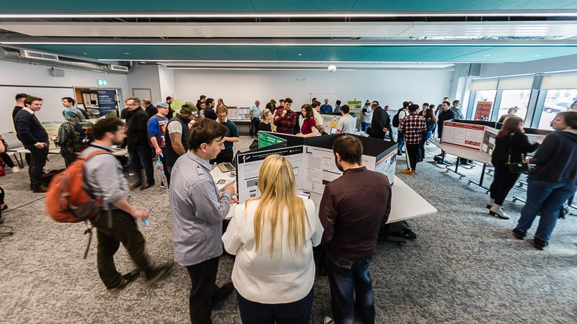

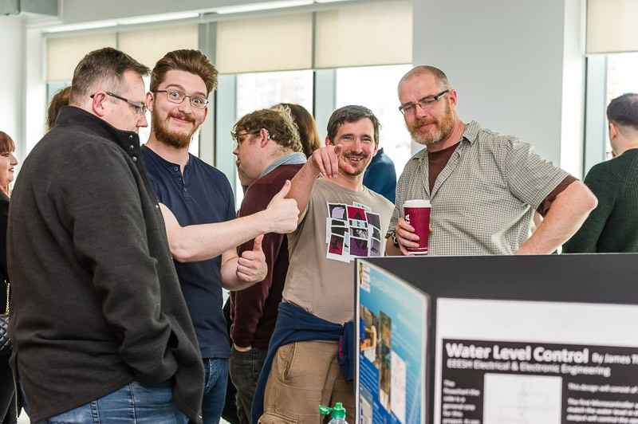

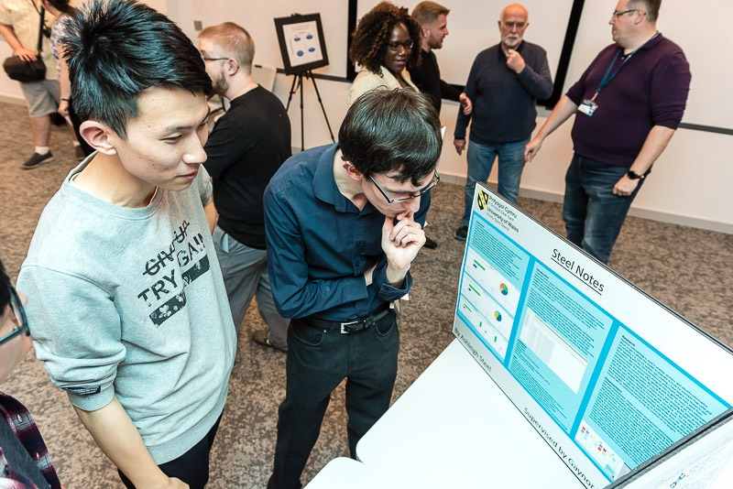

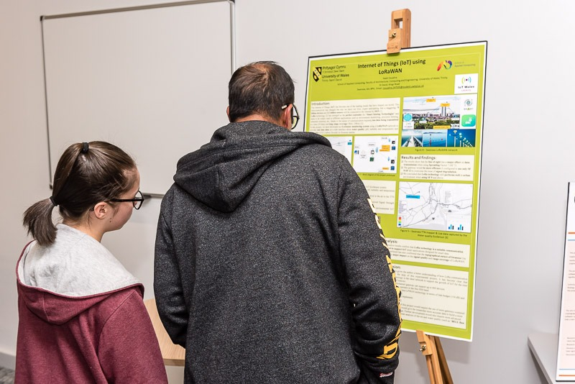

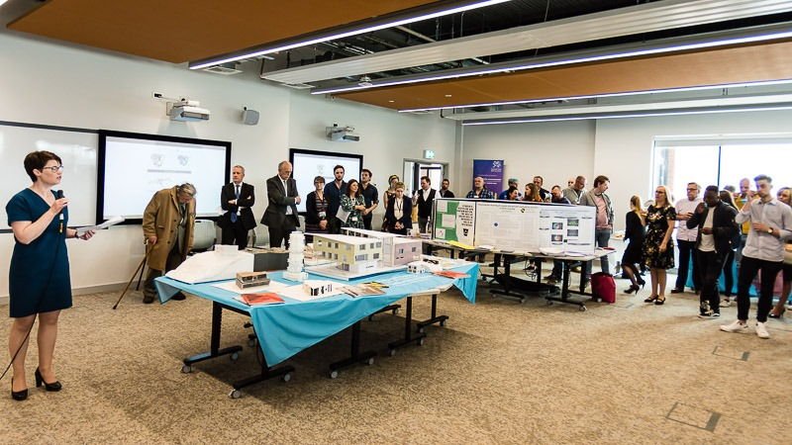

As you can see by some of the photos, it is a relaxed event.

The Summer 2020 and 2021 online Degree Shows can be viewed here:

https://stemsummershowsuwtsd.org/

https://stemsummershowsuwtsd2020.org/

9.3 Handing in your Exhibition materials

            - Hand in your poster board by the deadline to Room 207/8 in the IQ Building (Gaynor will email exact details of hand-in nearer the time)
            - Submit 5-6 images (.jpgs) representing your project to Moodle
            - Complete questionnaire (URL will be circulated nearer the time)

APPENDIX 1: DECLARATION FORM AND FORM OF CONSENT

DECLARATION

I, ............................................(FULL NAME HERE)………………………………… declare that I am the sole author of this Project; that all references cited have been consulted; that I have conducted all work of which this is a record, and that the finished work lies within the prescribed word limits.

This work has not previously been accepted as part of any other degree submission.

FORM OF CONSENT

I ............................................(FULL NAME HERE)………………………………… hereby consent that my Project, submitted in candidature for the B.Sc. (Hons) Computing (xxxxxxxxxxxx) degree, if successful, may be made available for inter-library loan or photocopying (subject to the law of copyright), and that the title and abstract may be made available to outside organisations.

(replace B.Sc. (Hons) Computing (xxxxxxxxxxxx) with the name of your degree)

APPENDIX 2: ELECTRONIC DATABASES AND JOURNALS

Library web pages available at https://uwtsd.ac.uk/library/
(Links from here to: General library information; Library catalogue; Subject Guides plus Electronic Journals and Databases)

The following databases are accessible via the web pages:

ACM (Association for Computing Machinery)
IEEE Xplore
ZETOC
ANTE
ASSIA
Science Direct
SWETSWISE
EMERALD MANAGEMENT REVIEWS
NEWSBANK
INDEX TO THESES

APPENDIX 3: REFERENCING CONVENTIONS

When you refer to a piece of work in an essay, report, program or academic paper, you must give adequate bibliographic information to allow the reader to trace the original document. (For note on Plagiarism See Section 8.2.5). So, if you wish to incorporate points made by another author or figures derived from a survey or report, acknowledge the sources used in the text of your project and give full details of the source in the reference list at the end of your work.

A reference is usually in two parts:

1. a marker at the end of the text being quoted or referred to, and
2. a complete citation in either a footnote or, more usually in computer science, collected with other citations in a “References” section at the end of your work.

Note sometimes you will find references at the foot of the page rather than at the end of the work but it is simpler to provide an alphabetical list at the end of the project.

The Numeric System

Citations use a sequential number scheme, with the citation number enclosed in square brackets corresponding to the appropriate reference provided at the end of the document.

Example :

In your work :

...... as Smith [14] has shown ......
...... blue has been shown [14] to be the best ......

In the Bibliography at the end :

[14] A. Smith, A Book Title, 2nd ed., Wiley, 2002
The numbering should be sequential as citations are used, the first reference used in the document should begin with one, the second is two, etc. If the same reference is used in the document then you may repeat the previously assigned reference number e.g.

In your work :

….. from Smith [1] we find that ……
….. Jones et al [2] also states …….
….. it has been shown [1] that ……
….. which matches similar findings [3] …..
…. other research [1][2][3] has proven …..
In the Bibliography at the end :

[1] A. Smith, A Book Title, 2nd ed., Wiley, 2002
[2] D. Jones, B. Thomas, Another Book Title, O’Reilly, 2004
[3] K. Smith, Yet Another Book Title, Chichester: Wiley, 2006

When using a reference you don’t explicitly need to specify the author(s) name, but specifying the author’s name can increase readability. Also, if many authors contributed to the book, paper, etc, then identify the first author and use “et al” to indicate that there were many contributors.

In your work :

….. it has been shown [2] that ……
….. Jones et al [2] also states …….

Quotations should be placed in quotes, italicized and tabbed from the edge, with a clear reference to the source. In addition, for clarity it is recommended that a single blank line be added before and after the quotation
For example:

“It becomes clear that, in most cases, the goal of finding out about people through interviewing is best achieved when the relationship of interviewer and interviewee is non-hierarchical and when the interviewer is prepared to invest his/her own personal identity in the relationship” Bloggs et al [6]

The author’s name (Bloggs et al) in the above is optional but is included for readability.

When should a citation be used?

- All direct quotes must be cited.

2. Even when you have translated an author’s words into your own (which you should make every effort to do), you must still give them credit by including a citation. When an entire paragraph of material is based on one author’s ideas, you only need place one citation at the end of the paragraph. Exceptions to this rule follow in (3) and (4).

3. All statistics that are cited require a citation immediately following the sentence in which they appear.

- All historical events and dates mentioned require a citation.

- References should be included for all websites used.

Reference Information and Structure

All references should be added to a “References” section included towards the end of the document.

The details which need to be included in references (author, title, etc) depend on the type of publication you are citing (articles, books, etc). For the commonest types of publication, the examples below show the information you should give, as well as the correct use of italics and punctuation.
There are a number of referencing systems but the Numeric system is the system that MUST BE USED FOR THE Project. For a full explanation and examples of the numeric systems see Appendix 4.

APPENDIX 4: NUMERIC REFERENCING SYSTEM

Numeric Referencing Guidelines

The details which need to be included in references (author, title, etc) depend on the type of publication you are citing (articles, books, etc). For the commonest types of publication, the examples below show the information you should give, as well as the correct use of italics and punctuation.

Book
Author(s) or editor(s) of book | Title of book: and sub-title if there is one (in italics) | Edition (if not the first) | Place of publication | Publisher | Year of publication
Author(s) and Title should be given as they appear on the title page inside the book. (The front cover may have less detail.) Information such as the year, place of publication and publisher is usually on the back of the title page.
Edition should be abbreviated: 2nd ed.
Place of publication is usually a town or city. For U.S. place names, give the two-letter state abbreviation as well.
Examples

[1] W.-K. Chen, Linear Networks and Systems. Belmont, CA: Wadsworth, 1993.
[2] S. Lin and D. J. Costello, Jr., Error Control Coding: Fundamentals and Applications. Englewood Cliffs, NJ: Prentice Hall, 1983.
[3] G. C. Clark, Jr. and J. B. Cain, Error-Correction Coding for Digital Communications. New York: Plenum Press, 1981.
[4] R. Steele and L. Hanzo, Eds., Mobile Radio Communications, 2nd ed. Chichester: Wiley, 1999.
[5] M. A. Soderstrand, W. K. Jenkins, G. A. Julien, and F. J. Taylor, Eds., Modern Applications of Residue Number System Arithmetic to Digital Signal Processing. New York: IEEE Press, 1986.

Chapter in a Book
Author(s) of chapter | "Title of chapter" (in quotes) | in Title of book (in italics) | Edition (if not the first) | Editor(s) of book | Place of publication | Publisher | Year of publication | Pages covered by chapter
Examples

[6] G. O. Young, “Synthetic structure of industrial plastics,” in Plastics, 2nd ed., vol. 3, J. Peters, Ed. New York: McGraw-Hill, 1964, pp. 15-64.
[7] S. Godsill, P. Rayner, and O. Cappé, “Digital audio restoration,” in Applications of Digital Signal Processing to Audio and Acoustics, M. Kahrs and K. Brandenburg, Eds. Boston, MA: Kluwer Academic, 1988, pp. 133-194.
[8] J. K. Hao and R. Dorne, “Study of genetic search for the frequency assignment problem,” in Artificial Evolution: European conference, AE 95, Brest, France, September 4-6, 1995 : selected papers,” J.-M. Alliot, Ed. Lecture Notes in Computer Science, 1063. Berlin: Springer-Verlag, 1996, pp. 333-344.

Journal Article
Author(s) of article | "Title of article" (in quotes) | Title of Journal (in italics) | Volume number (and issue number if there is one) | Pages covered by article | Date of Publication
Date of Publication should include the month or season if it appears on the journal: e.g. Feb. 1987; Winter 2000; Mar.-Apr. 1963
Examples
[9] G. Strang, “Wavelets,” American Scientist, vol. 82, pp. 250-255, 1994.
[10] I. S. Qamber, “Flow graph development method,” Microelectronics Reliability, vol. 33, no. 9, pp. 1387-1395, Dec. 1993.
[11] F. Bonomi and K. Fendick, “The rate-based flow control framework for the ABR ATM service,” IEEE Network, vol. 9, pp. 25-39, 1995.
[12] E. H. Miller, “A note on reflector arrays,” IEEE Transactions on Antennas and Propagation., to be published.

Article from Conference Proceedings (published)

Author(s) of article | "Title of paper" (in quotes) | in Title of proceedings (in italics) | Location and date of conference | Pages covered by article
Examples
[13] R. Bauer and J. Hagenauer, “Iterative source/channel-decoding using reversible variable length codes,” in Proceedings of the IEEE Data Compression Conference (DCC), Snowbird, UT, Mar. 2000, pp. 93-102.
[14] A. K. Salkintzis, C. Chamzas, and C. Koukourlis, “An energy saving protocol for mobile data networks,” in International Conference on Advances in Communication and Control (COMCON 5), June 26-30, 1995, pp. 107-113.
Paper Presented at a Conference (unpublished)
Author(s) of paper | "Title of paper" in quotes | presented at Title of conference | Location and date of conference
Unpublished papers are often made available as reprints to conference delegates but do not appear in collected conference proceedings, so no pagination should be given.
Examples
[15] F. Comellas and J. Ozón, “An ant algorithm for the graph coloring problem,” presented at ANTS ’98 – From Ant Colonies to Artificial Ants: First International Workshop on Ant Colony Optimization, Brussels, Belgium, Oct. 1998.
[16] L. Gao, J. Kurose, and D. Towsley, “Efficient schemes for broadcasting popular videos,” presented at the 8th International Workshop on Network and Operating Systems Support for Digital Audio and Video (NOSSDAV ’98), Cambridge, UK, July 1998.

Thesis or Dissertation
Author of thesis | "Title of thesis" (in quotes) | Qualification and type of report | University/Institution | Year of award
Qualification should be abbreviated as Ph.D., M.Phil., etc. The type of report (e.g. thesis, dissertation, etc) should be given as it appears on the document as the terminology may vary between countries. It is helpful to add the country unless the university is particularly well-known.
Examples
[17] E. F. Mastrovito, “VLSI architectures for computation in Galois Field,” Ph.D. dissertation, Linköping University, Sweden, 1991.
[18] A. Chini, “Multi carrier modulation in frequency selective fading channels,” Ph.D. dissertation, Carleton University, Canada, 1994.
[19] Y. W. Kim, “Study and implementation of system synchronization for DAB (Digital Audio Broadcasting),” Masters thesis, Korea Advanced Institute of Science and Technology, Korea, 1996.
[20] J. G. O. Moss, “Spread spectrum technologies for future communication systems,” D.Phil. thesis, University of Oxford, 1998.

Technical Report
Author(s) of report | "Title of report" in quotes | Series title and number (if applicable) | Place and date of publication
Technical reports are often not formally published and may not have clear publication details. Give as much information as you can so your readers can obtain the report if they wish.
If the place of publication is obvious from the series title there's no need to repeat it at the end.
Examples
[21] M. Krunz and S. K. Tripathi, “Scene-based characteristics of VBR MPEG-coded video traffic,” University of Maryland, CS-TR-3573, 1997.
[22] J. H. Stott, “Phase noise in OFDM: Further insights, including the use of weighting functions,” BBC, R&D Department, Technical Note no. R&D 0166(94), Dec. 1994.
[23] A. Dan, P. Shahabuddin, D. Sitaram, and D. Towsley, “Channel allocation under batching and VCR control in movie-on-demand servers,” IBM Research Report, 1994.
[24] International Telecommunications Union, “Terrestrial digital multimedia/television broadcasting system development in China,” ITU-T Document 6E/50-E, Geneva, Mar. 26, 2001.

Standard
Name of the organization which produced the standard | "Title of standard" (in quotes) | Catalogue code or number of standard | Date of publication
Standards are frequently issued in draft and revised versions. Make sure you cite all the catalogue/numbering and date information exactly as it appears on the document.
If the name of the organization appears in the catalogue code or number of the standard it can be abbreviated.
Examples
[25] International Standards Organisation, “Information technology – Generic coding of moving pictures and associated audio information: Video specification,” ISO/IEC 13818-2, Nov. 1994.
[26] Federal Communications Commission, “Code of Federal Regulations,” Title 47, Ch. 1, Part 73, Radio Broadcast Services. Secs. 73.683, 73.684 and 73.699.
[27] European Telecommunications Standards Institute, “Digital Audio Broadcasting (DAB) to mobile, portable and fixed receivers,” ETSI EN 300 401 v1.3.3, May 2001.
[28] Institution of Electrical and Electronic Engineers, “Wireless Medium Access Control (MAC) and Physical Layer (PHY) Specifications,” IEEE Draft standard 802.11 D3.1, Apr. 1996.

Patent
Author(s) of the patent | "Title of patent" (in quotes) | Issuing country/organisation and number of the patent | Date of filing
Examples
[29] L. Idoumghar, “Using a hybrid genetic algorithm to solve the frequency assignment problem,” Patent TDF, N. 01 06 885, May 2001.
[30] Z. Yang, “Terrestrial digital multimedia/television broadcasting system,” P.R.China Patent 00 123 597.4 filed Aug. 25, 2000, issued Mar. 21, 2001.
[31] S. Kawa, K. Kiyoshi, and S. Takeshi, “Route bus service controlling system,” U.S. Patent 4 799 162, Jan. 1989.

Unpublished Source
Author(s) | "Title of document" (in quotes) | Type of document | Date (if applicable)
The type of document might be an unpublished manuscript, e-mail or private correspondence, etc. Clearly these are not available to your readers but you should still give as much detail as you can.
Examples
[32] B. Chen and C.-E. W. Sundberg, “Adaptive multicarrier modulation for IBOC-AM,” Unpublished work.
[33] R. Cupo and M. Shariat, “All-digital AM system architecture,” Private communication, May, 1998.

Online Source
Author(s) | "Title of source" | Organization/Publisher/Date | [Online] | Available: access information | [Accessed: Date of access]
An online source may not always contain clear author or publisher details. When you cite an online source try to describe it in the same way you would describe a similar printed publication. If possible, give sufficient information for your readers to retrieve the source themselves.
The access information will usually be just the URL of the source. If the item is only available by e-mail, ftp or some other method, include a brief mention of how to obtain it.
As well as a publication/revision date (if there is one), the date of access is included since an online source may change between the time you cite it and the time it is accessed by a reader.
Examples
[34] T. Rahkonen, “Analysis of analog circuits using Volterra series,” University of Oulu, Oulu, Finland, 1999. [Online]. Available:
http://www.ee.oulu.fi/~timor/DCourse/Chp1_2.pdf. [Accessed: Sept. 14, 2002]
[35] S. McCanne and S. Floyd, “The UCB/LBNL network simulator,” 1997. [Online]. Available: http://www.mash.cs.berkeley.edu/ns/. [Accessed: Jan. 23, 1999]
[36] Advanced Television Technology Center, Inc., “ATTC introduces RF data capture project,” Press release, Mar. 2000. [Online]. Available: http://www.attc.org/RFCapture.PDF. [Accessed: Mar. 15, 2001]
[37] “AlphaCom Communications introduces VMSK technology,” The Business Journal Online, May, 2000. [Online]. Available: http://www.business-journal.com/LateMay00/Alpha.html. [Accessed: May 2, 2000]
[38] “A ‘layman’s’ explanation of Ultra Narrow Band technology,” Oct. 3, 2003. [Online]. Available: http://www.vmsk.org/Layman.pdf. [Accessed: Dec. 3, 2003]
[39] European Telecommunications Standards Institute, “Digital Video Broadcasting (DVB); Implementation guidelines for DVB terrestrial services; transmission aspects,” ETSI TR-101-190, 1997. [Online]. Available: http://www.etsi.org. [Accessed: Aug. 17, 1998]
[40] S. J. Salamon, “DTV receiver performance studies,” presented at the 49th Annual Broadcasting Symposium, IEEE Broadcasting Technology Society, Sept. 24, 1999. [Online]. Available: http://www.attc.org/BTS_Rx.PDF. [Accessed: Jan. 18, 2000]
[41] P. Karn, “General-purpose Reed-Solomon encoder/decoder in C,” Jan, 2002. [Online]. Available: http://www.ka9q.net/code/fec/. [Accessed: Oct. 8, 2002]
[42] A. Harriman, “Compendium of genealogical software,” Humanist, Jun., 1993. [Online]. Available e-mail: HUMANIST@NYVM Message: get GENEALOGY REPORT. [Accessed: Jun. 8, 2003]

