Summary
This paper will be examining Romania and Japan's cultures, and more specifically, their differences in order to provide a handbook for staff to be successful in the hospitality sector.
Understanding different cultures is necessary for a successful hotel in order to provide the best experience to people that come from cultures different than the one the hotel has its operations in. For the hotel staff to be able to understand international visitors and communicate with people from different cultures, will lead to them contributing to the customers’ perfect hotel stay.
At the end of this paper, it will be found that both countries share similar cultural traits, but are still very different in regards to the people’s behavior and way of communication.

Country Analysis
The hotel is located in Romania, a country geographicaly situated in the Eastern Europe. The country presents diversity in terms of relief by having mountains, beaches, plains, plateaus, hills, and depressions.
The hotel, called Roterra,is located in the Carpathian Mountains, specifically, Bucegi Mountains, in Valea Prahovei. The international visitors the report will focus one are japanese visitors.
Below I will compare both countries using the Hofstede Insights Tool and The 6 Cultural Dimensions theory.

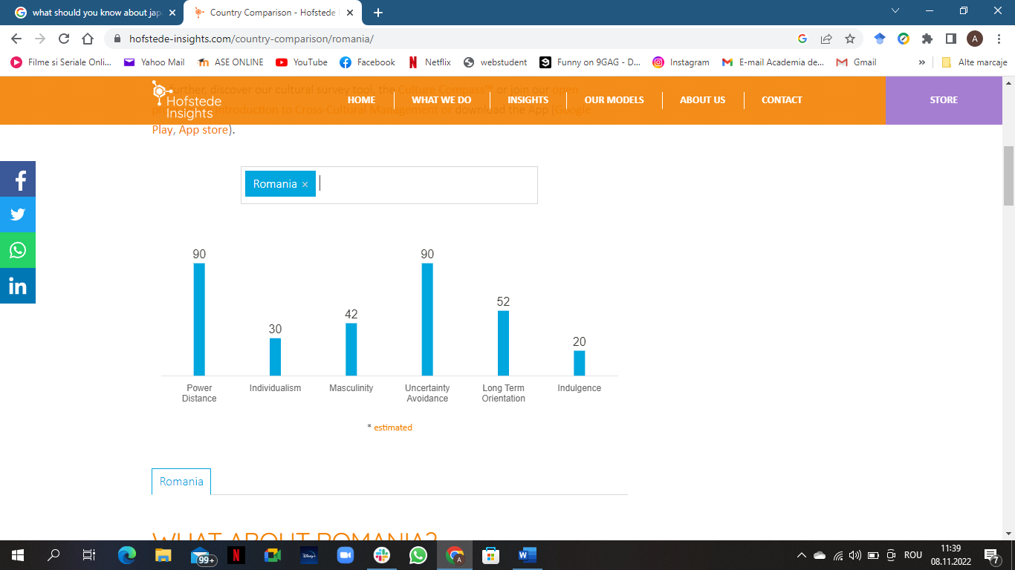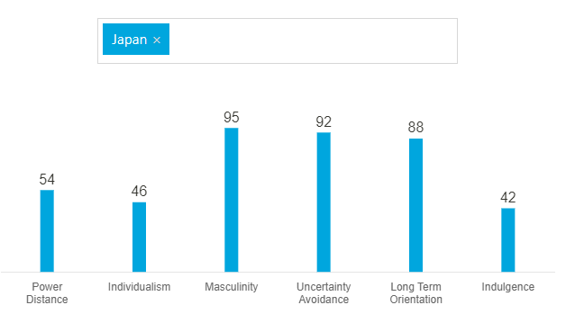
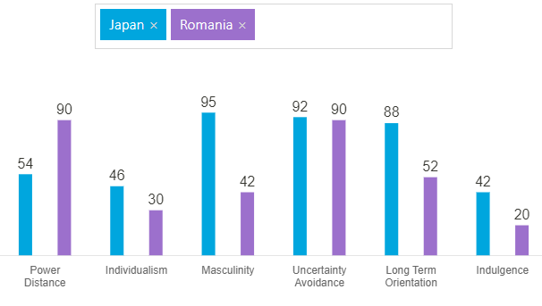

As it can be seen in the comparison image above, the difference between both countries regarding Power Distance is considerable. This contrast is present in three more pillars, Masculinity, Long Term Orientation, and Indulgence. Both countries obtained an almost even score at the Uncertainty Avoidance pillar.

At the first dimension, Power Distance, which can be interpreted as the perspective of the culture on power discrepancies in society, Romania obtained a very high score which means that Romanian culture doesn’t encourage equal opportunities for everyone. Japan, although has a lower score than Romania, it is still considered a High Power Distance culture.
The second dimension, Individualism, is the level of dependency a society's members have. Romania here obtained a low score. That means that the country’s culture circles around family or groups, and people will put a great accent on the well-being of every member of the group rather than individual wellbeing. Japan obtained a score that classifies the country as being a Low Individualism Culture as well.
Masculinity, the third cultural dimension, depicts the differences between the roles of the traditional genders in a culture. As it can be seen in the images above, Romania is a Feminine Culture. Being a feminine culture means that the roles of men and women in society can overlap. Japan, on the other hand, is a very Masculine Culture, which means that the masculine and feminine roles are very well defined. It can be said about Romania that the culture is orientated toward quality of life, rather than success and competitiveness which is more characteristic of Japan, in this case.
The fourth pillar, Uncertainty Avoidance, is, according to Hofstede, a society's response to the knowledge that the future is always uncertain. Japan, as well as Romania, have really high scores. This can be translated to high intolerance to the unknown and the uncertain. Both cultures try to minimize the unknown by having instated many rules in order to leave as little room for uncertainty as possible.
Long Term Orientation, the fourth element in the Hofstede Cultural Dimensions, refers to whether a culture is orientated to the future, or if it leans more towards the past. Both Romania and Japan are long-term orientated cultures, but Romania seems to be situated somewhere in the middle. This means that, even though the culture is focused on the future, people still show respect for tradition.
The last cultural dimension is Indulgence, and it shows the degree to which individuals from a culture attempt to restrain their instincts and impulses. Both Japan and Romania are restrained cultures. People from these cultures will most likely not spend money on whatever they desire, but rather save it in case of need.

In order for the hotel employees to offer their international visitors the best experience at the Roterra hotel, they should be aware of some gestures and actions that may be acceptable to them but are considered rude or offensive to them.
Hotel Handbook
Action | Romania | Japonia
Eye contact | Is a form of respect when having a conversation with someone. | It is considered rude to maintain eye contact instead they prefer to be looked at on their necks.
Addresing to someone | Romanians usually prefer to be addressed by their first name, and in formal situations by their last name. | Japanese consider being addressed by their first name rude, therefore the staff, especially those who come often in contacts with them, such as front office, housekeeping, and food and beverage, should only address them by their last name or their full name.
Tipping | In Romania, tipping is not mandatory, but it is accepted when offered. | For Japanese people, tipping isn’t mandatory, nor is it acceptable. Their culture is against tipping. Japanese people do not give and do not accept tips as it is considered to be offensive and rude.
Pointing | Romanians use many gestures in their communication in order to make their interlocutors understand better and appear more friendly. | On the other hand, the Japanese find pointing at someone or something to be rude. Instead of using their finger, they are more likely to show something using their hand or elbow. Therefore, employees should use their hands when trying to show Japanese tourists something, for example, the restaurant menu, the elevator, or the exit.
Hand shake | Romanians shake their hands the traditional way. | Japanese do not usually shake their hands, instead, they bow and it differs from man to woman. Men keep their arms to the side, and women unite their hands. In order to show respect for Japanese culture, the hotel staff should take into consideration adopting this type of handshake when they come in contact with Japanese people.
Touching | Romanians show their gratitude and love by hugging and kissing. | Japanese people find touching to be rude. Therefore, hotel employees should strictly avoid touching Japanese visitors and not stand close to them.
Nodding | To show interest in what someone is saying, romanians usually nod their heads and say words like ‚, yes’’, ,,right’’, ,,of course’’, and more. | When maintaining a conversation, Japanese nod to show that they understand, but they remain silent while the other person speaks.
Leaving an empty glass | Leaving an empty glass in Romania means that you finished your drink. If you would like more, you are expected to ask or to wait to be offered more. | For Japanese, leaving an empty glass means that they want more beverage.

In conclusion, although Romania and Japan may have similar cultural dimensions, they also show many cultural differences in terms of communication and behavior. Actions such as tipping, pointing using your finger, eye contact, touching, and addressing someone by their first name are perceived as rude by the Japanese people, unlike Romanian people who find these normal and even respectful when in contact with people.

References
- Nickerson, C. (2022). Hofstede’s Cultural Dimensions Theory. [online] Simply Psychology. Available at: https://www.simplypsychology.org/hofstedes-cultural-dimensions-theory.html.
‌
- Hofstede Insights (2022). Hofstede Insights. [online] Hofstede Insights. Available at: https://www.hofstede-insights.com/.
‌
- LIVE JAPAN. (n.d.). Japanese Customs and Manners | LIVE JAPAN travel guide. [online] Available at: https://livejapan.com/en/article-a0000247/.
‌
- www.japan-guide.com. (n.d.). Etiquette. [online] Available at: https://www.japan-guide.com/e/e622.html.
‌

