Engineering Management
ACHA5012
Mark Sandford
Mikel Olaberria
2416696

Content page:

Page 1: Title page
Page 2: Content page
Page 3: Introduction & Task 2
Page 4: Task 3
Page 5: Task 3
Page 6: Task 4
Page 7: Task 4
Page 8: Task 4
Page 9: Task 6
Page 10: Task 7
Page 11: Task 7 & Task 5
Page 12: References

Write a report to introduce the project to your managing director.
Your report should include:
- An Introduction to the project

The group project consists of making an active-aero wing which will react and change its angle depending on the data which is given to it. The group members will each be given different jobs to complete to make sure the project comes together. This includes, programming, designing, control systems, research, vehicle simulation and final specs. The wing will work by using an Arduino, which the group will programmed in MATLAB Simulink to change the angle of the wing depending on the value of the data inputted. By creating a model, aerodynamic tests can be done on it using a wind tunnel and SolidWorks simulations. These tests will allow the group to calculate the effects of the wing such as downforce and drag.

- List all team member’s roles and responsibilities within the project. Identify the skills and personality traits required for your role, make reference to ‘Belbin’s’ model.

Team leader: Callum FB
Research: Mikel
Prototype Design: Oscar
Control Systems: Callum T
Algorithm Selection: Group
Vehicle Simulation: Group
Final Specifications: Group
Project Management: Callum FB

My role in the group project is to research areas such as wing design, manufacturing, materials, to help the group make decision on what will work best for the product we are making.

For this role, teamwork is very important as I am continuously communicating to the group about my findings and the steps required to implement those ideas into the work of the other members. This links to the Belbin model (Belbin Associates (2025)) as the resource investigator role. Finding ideas and bringing them back to the team is very important, as without it, inefficient decisions could be made which will affect the outcome for the project.

Other characteristics such as Belbin’s specialist role, is important to have for researching, is having in depth knowledge of key areas will be important for decision making. This is because by knowing all the options and how they work, it will be easier to help the group decide in the choices they will make for the project.

- A list of overall group tasks and associated timings

Tasks:
- Write the code for the Arduino [5/11/25-7/11/25]: The code for the Arduino will initially start of simple but will become more complicated with more variables as the project goes on. The initial code will require the Arduino to change the angle of the wing depending on the input voltage, which will change depending on the data provided.

- Test the code is working [7/11/25-9/11/25]: Once the code has been finished, it must be tested using a servo motor, to make sure the angle of the output is correct and matches the result expected from the input.

- Choose components [5/11/25-10/11/25]: To choose the components that will be used in the model, research will have to be done to make sure the parts chosen will work correctly for their assigned task. This requires looking into other designs and options, and comparing factors such as, weight, cost, availability.

- Design the wing [11/11/25-14/11/25]: Initially a simple self-made wing design will be used to save time. However, after testing is completed, research will be done on specific wing profiles, to make sure the drag, and downforce of the wing works and provides and advantage on track. After conducting research, a new wing profile will be chosen to replace the prototype wing, and this wing will be used for testing using the wind tunnel and further flow simulations.

- Simulation [14/11/25-16/11/25]: The first test we did on the active aero wing, was to use the cad model of the wing to run a flow simulation. The flow simulation allows the group to see how the air will flow across the wing, while also providing the group with useful data such as forces, velocity, pressure and fluid flow. The flow simulation data can later be compared to data gathered from wind tunnel testing using a real model.

- Print/build the wing [17/11/25-18/11/25]: To print the wing, a 3d printer will be used as it’s simple to make and requires only one material therefor making the process easier. In addition, 3D printing requires

- Assemble it all together and connect it with the Arduino [19/11/25-19/11/25]: once the wing and the Arduino are assembled, testing can begin to see if the wing mechanism is working as intended and to see if the motor type was a good design choice for its application. By having a working model, the angle of wing can be tested to see if there is a limit on the maximum and minimum angle the wing can take with the chosen mechanism. This paired with the simulation stage, will allow the group to decide the chosen angles for breaking/accelerating.

- Use data from chosen vehicle to simulate lap [20/11/25-21/11/25]: For lap simulations, the lap data used will be from the university tesla. The tesla data contains many variables such as braking and steering, which will be inputted into the Arduino. The Arduino will then output a voltage between 0-5 depending on the importance of each variable set by the code. Depending on the voltage output, the wing, will change angle depending on if downforce is required or speed.

- A detailed list of your tasks including
-Hours required to perform the task
-Task duration
-Preliminary ‘Bill of Materials’ with approx (estimated) costs and purchase lead times
-List of any specialist equipment required
(if your project is primarily research based still include costs of equipment as if you were to produce a prototype or purchase specialist equipment) 5) Identify significant milestones for the whole project.

Personal Tasks:
- Research
  - Types of motors [5/11/25-10/11/25] 30 hours: For the Active-Aero wing, a motor must be used to control the angle of the wing. Therefor I was assigned to research different types of motors and figure out which type would best fit for the application required.

  - Wing profiles [11/11/25-14/11/25] 50 hours: For the wing profile, a wing design had to be researched which would give the car the most downforce possible while braking and minimising drag as much as possible when accelerating. The wing design would be researched from real life applications as much testing has gone into the designs allowing the team to get an optimal performance from the wing.

  - Method/Materials [5/11/25-10/11/25] 25 hours: When making the wing and platform, there are multiple methods we can use to make this including laser cutter, 3D printing or by cutting metal components. After researching the options for the prototype model, 3D printing was decided as it allowed for easy production of solid plastic parts which could then be assembled. By being able to create parts quickly and easily, it allows the group to be able to quickly change any modifications done to the model. This includes factors such as alternate wing profile or a different structure to hold the wing. However, for a real-life application more realistic materials such as carbon fibre would be used as it is strong when under stress, while remaining lightweight improving the maximum performance we can get from the wing.

  - Prepare for presentation [1/12/25-8/12/25] 35 hours: lots of time is required to prepare for the presentation as the team must work together to get all the important information in the slides. In addition, much time will be spent rehearsing the presentation in front of peers to make sure it runs smoothly and everything is explained clearly

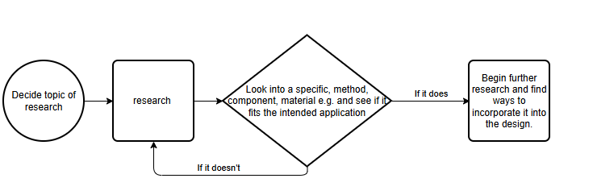
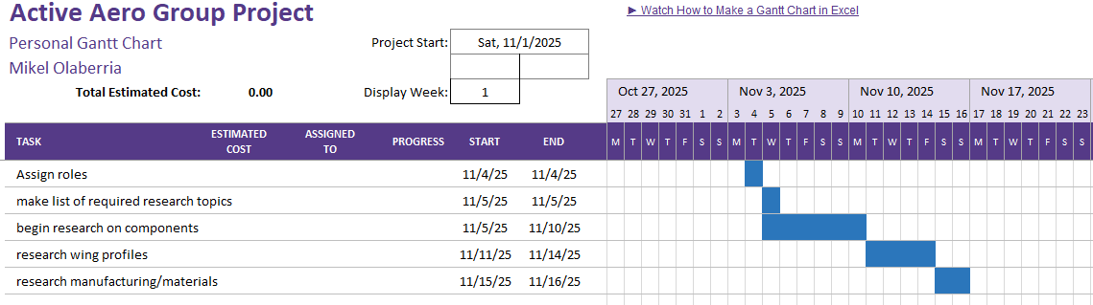
Personal Gantt Chart:

Bill of materials:

Software:
- SolidWorks Professional annual subscription: £1,560.00 (SolidX Ltd. (2025))
- MATLAB: £105.00 (MathWorks (2025))
- Simulink: £29.00 (MathWorks (2025))

The software required for this project will be most of the cost. This is because programs such as SolidWorks and MATLAB are powerful tools which can be used to create almost anything. SolidWorks will be used to produce the wing and structure of the model. In addition to this, it will also be used during the simulation stage, to perform flow simulations and gather data before doing any practical tests.

MATLAB/Simulink is used to program the Arduino which will be used to control the motor in the wing. This program allows the team to code the Arduino using a very simple function block system, which is easy to learn and use making it very effective for the project.

Hardware:
- Servo motor: £6.23 (Rapid Electronics (2025))
- Arduino uno rev 3: £16.72 (Arduino (2025))

For hardware, the group requires a servo motor and an Arduino. The servo motor will be used to control the angle of the wing using data provided. The Arduino will take the data provided, and depending on the code, it will output a change of angle in the wing.

3D printer:
- 3D printer: £200
- Material: £15 for full reel. 10% used so model cost is £1.50

The 3D printer is required to create the model of the wing and its stand. The 3D printer will allow for simple manufacturing as the SolidWorks file can be imported to the printer. In addition to this, the materials required to print out the model are inexpensive and easy to use allowing for multiple iterations of the design as the project advances.

Labour:
- Uk average pay for entry level engineer: £15/hour (National Careers Service (2025))
  - 15 x 200 hours = £3000 labour costs
For the project labour costs, each group member will be paid as an entry level engineer. The cost for labour will be calculated for the expected 200 hours it will take for the project to be completed.

- Identify two areas of concern within your section of the project and suggest suitable methods to mitigate the risk.

Throughout the project, each member of the must ensure to mitigate all risks to ensure the project is carried out to the best of their abilities and as efficiently as possible. My part of the project is to research key areas such as wing profiles and components to make sure the best choices are made when implementing them into the model. For this reason, it is important that all data I research and choose to include must be correct and relevant.

For the research section of the project, a concern is using incorrect or invalid data. This means that while researching for a specific component or part, the data is incorrect therefor creating issues or errors when applying them to the model. To mitigate such an error, it is important to gather information from multiple reputable sources and comparing the data to build an idea of the realistic expectations of that component.

Another potential error that may arise is researching information that the group does not require. To mitigate this risk, regular group meetings are important to keep the group informed on the tasks you are undertaking. By keeping the group informed then anyone can remind members of tasks that are required at specific times and what is not necessary.

- Generate an overall summary Gantt chart for the whole project and generate a second more detailed plan for the section of the project that you are responsible for. The plan should identify significant milestones and gateways.

Throughout the project, the group had a number of milestones to make sure that the project was running smoothly, and work was being completed. For the initial stage of the project, the milestones:

- Initial working code
- Build the model
- Complete a working model
- Use model to test lap data
- presentation

The first milestone we set was to get a working initial code for the Arduino. For this to be completed, the group took an hour class to learn how to use the Simulink software. After learning the basics, a simple code was to be written that would alter the angle of the servo motor depending on the input. Once the initial was done, the next milestone was to have a built model.

The second milestone was to design and build a prototype model, where the group would be able to test the functionality of the design. This stage required for measurements of both the Arduino and motor so that they would fit and work in the wing assembly. After manufacturing the wing and stand, the next stage was to assemble it with the Arduino and motor and begin testing.

The third milestone was to have a wing model that would work with the initial code. Once the model had been assembled with all components connected, the group ran the code allowing us to see it working for the first time. The initial code was simple, and so the software inputted a sin wave to the Arduino which resulted in the wing travelling up and down. Once we had seen that the design did work, it was time to begin using real data.

The final milestone was to run the tesla lap data with the wing, and that would show that we were able to build a working model. This stage was done by feeding the data to the Arduino by a separate device which stores all the tesla data. This is done as the Arduino does not have enough memory to store all the data. The wing responded to the data by applying an airbrake and downforce for breaking and cornering, while laying flat for straights and speed.

Gateways: | Description: | Evidence/proof | status
Goal | Verify the manufacturing process, wing profiles and components. | Compare the components, wing profiles, manufacturing methods to get best option. | complete
motors | To choose the best motor for quick wing-angle adjustment, compare servo, stepper, and linear actuators. | compare torque, weight and price for each component. | complete
Wing profiles | Look at NACA wing profiles for minimum drag on straights and high downforce during braking and cornering. | Gather data from real life applications or separate wing profile data. | complete
manufacturing | Choose a practical method for manufacturing the model. Compare 3d printing, laser cutting or manual construction | Create a comparison sheet. | complete
Data check | Make sure that the sources used are trustworthy and in line with data from other reliable sources. | Make sure to use 2 reliable sources per topic. | complete
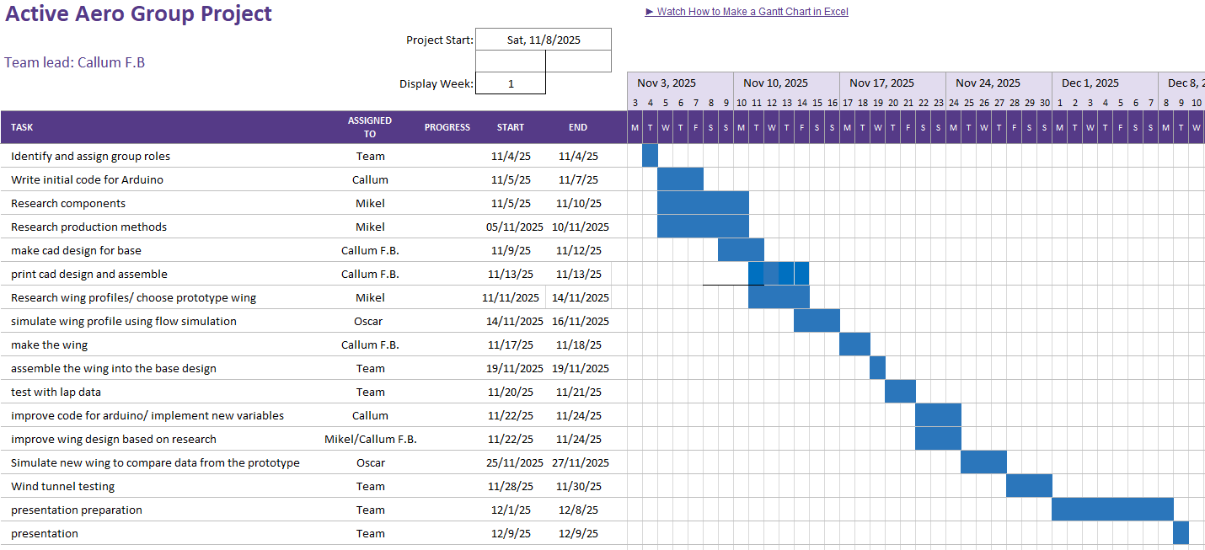

References:

Arduino (2025) Arduino Uno Rev3 Product Page. Available at: https://store.arduino.cc/collections/boards-modules/products/arduino-uno-rev3

Belbin Associates (2025) Belbin Team Roles – Overview. Available at: https://www.belbin.com/about/belbin-team-roles

MathWorks (2025) MATLAB Home – Product Page. Available at: https://uk.mathworks.com/store/link/products/home/ML

National Careers Service (2025) Mechanical Engineer Job Profile. Available at: https://nationalcareers.service.gov.uk/job-profiles/mechanical-engineer

Rapid Electronics (2025) Rapid Pro SG90 Mini Servo. Available at: https://www.rapidonline.com/rapid-pro-sg90-mini-servo-37-1330

SolidX Ltd. (2025) Instant SOLIDWORKS Price UK. Available at: https://www.solidx.co.uk/pricing/

