ECAD7004
Professional and Pedagogic Studies: Researching the Learning: what, how and why am I teaching?

Research Question:
What is the learner’s perspective of using check-ins to support well-being for pupils in a Year One class?
Introduction: Aim, focus and purpose of the research / Research Context (300)
The aim of the essay presented is to research into understanding well-being and potential influences implementing morning check-ins may have for pupils. My initial findings came from PTE1 where well-being was identified as an area of improvement as a whole school approach. This is something that upon visiting PTE2 I was curious to explore whether the same findings were visible within the setting. As a school there is currently a well-being activity that is carried out once a week. I am curious to explore how implementing a daily activity may impact pupils’ well-being in comparison to one activity a week. Based on this information it allowed a starting point for my wider research and analysis for my research project, an aspect that supports Welsh Government (2017) whose set objective is to enhance educators to become ‘Research-engaged, well informed and learning from excellence’. Alongside opening avenues to support my Personal Learning Passport allowing me to research and implement interventions, this will support areas within the thirty-two strands that are expected to be covered within the QTS Standards.
The school that will be utilised in this study project is a primary school in an affluent area of South Wales with approximately four hundred students aged three to eleven (Estyn,2023). The focus of my research will be conducted in a Year One classroom of approximately twenty-five children who are seventy-fiver per cent boys. The classroom environment is designed as an open plan and interlinking rooms amongst a second Year One class and a further two Year Two classrooms in which all four have continuous access to a communal shared area. The class in focus has one class teacher and a support assistant who is shared between both Year One classrooms whose primary support is pupils with Individual Development Plans (IDP). Based on the information, the research question I propose is what is the learner’s perspective of using check-ins to support well-being for pupils in a Year One class?

Overview of relevant literature. (800)
NHS Wales (2021) and reports completed by Welsh Government (2022) both highlight the increase requirement of support needed for children between the ages of five and eleven with emotional and well-being needs in comparison to 2019. Following this, the Department for Education have imbedded encouraging and facilitating mental health and wellness in educational settings ensuring for learners’ access to a tranquil, secure, and stimulating environment that is created based on a whole-school approach (Gov.uk, 2024). Since the significant increase in figures well-being has become a high priority since 2021 where it is now mandatory that Emotional and Mental Well-being is embedded within guidance of maintained settings within Wales due to Welsh Government Publications supporting both pupils and practitioners (Welsh Government, 2023). These findings developed the starting point for the proposed research question. Health and Well-being is the foundations for Wales’s curriculum designed for children aged three to sixteen, as it is one of the six main Areas of learning and experience that is mandatory by practitioners to support pupils learning with a focus on self-regulation (Welsh Government, 2020). This indicates that within settings self-regulation is a key factor within supporting pupils well-being. Self-regulation is often used as an intervention tool to develop these skills, alongside improving students’ academic performance as well as their general well-being (Babinski and Hamm, 2023) Suggesting a positive impact set by Welsh Government’s implementation of focusing on well-being and mental health within settings.
Research found that the use of Zones of Regulation is a is a frequently utilised tool to support self-regulation for pupils, through its simplistic manner allows for adaptability for a range of ages and stages of individuals development using four areas of colour or ‘Zones’ to interpret and provide secure, encouraging spaces that promote and education alongside wellbeing (The Zones of Regulation, 2023). This may support the implementation of a whole-school strategy supporting well-being in Wales as Welsh Government (2021) outline the essential role practitioners play in embedding a collaborative approach to emotional and mental well-being for all pupils within an educational setting including the implementation of the curriculum to do so. Romanowycz, et al (2021) and Lalor (2020) further this viewpoint as evidence suggests that both researchers conclude through independent studies in both cases individuals who participated in the use of Zones of Regulation found that through its use the capacity for self-regulation among primary school pupils has increased. These findings support The Zones of Regulation (2023) as its aim is to support and improve well-being of individuals.
A further impact the use of Zones of Regulation has on pupils is the tendency to support behaviour. A beneficial tool that is utilised to support and decrease behaviour in pupils to support self-regulation and the ability to support emotional understanding through interventions, this saw a decrease in behaviour within pupils and an increase in the ability to attain education and well-being factors (Quale, 2019). Supporting this Ohlbock, et al. (2023) demonstrates that within settings due to funding and support within classrooms there is a higher level of disruption and needs within the classroom that practitioners experience. The use of Zones of Regulation to support these needs was a beneficial tool that allowed independence and its simplistic manner to allow for practitioners to follow and support those within the classroom. This is a beneficial factor to consider as demonstrated it can be implemented in a whole-class approach which can allow for practitioners to provide inclusivity for all.
However, there are many strengths to using Zones of Regulation within settings to support individuals it is also acknowledged that there is a wide gap in research concluding its effectiveness as a whole-school approach. Although agreed by Mason, et al. (2024) the purpose of Zones of Regulation is a frequently utilised application to support well-being. A factor that is noted is the insufficient evidence to demonstrate the effectiveness of the Zones of Regulation. Ochocki, et al (2020) supports Mason, et al. (2024) findings concluding similar views that the use of Zones of Regulation intervention results did not conclude in a high increase of well-being due to its minority of evidence based to support it. Based on these findings it has intrigued my findings into implementing my own research using The Zones of Regulation (2023) to support pupils well-being within educational settings to conclude gaps within research as evidence suggested is based upon interventions in comparison to whole-school approaches which as noted by Welsh Government (2021) is a fundamental to supporting emotional and mental well-being for individuals.
Explanation of Case Study (600)
A case study is demonstrated as a comprehensive evaluation, using one or more methodologies thorough analysis of a limited sampling therefore allowing for comprehensive knowledge of a particular subject and produce insights to a proposed topic (Tight, 2010; Thomas, 2011). Thomas (2021) outlines that a case study is validated within two sections, its purpose and its framework for analyse. By identifying these aspects noted by Thomas (2021) it can provide direction for developing an analysis plan and creating a technique to assess. For the purpose of this case study, the intention is to examine a group of pupils situated within a Year One class with my purpose for analysing being to understand the effect of using check-ins to support pupils’ well-being over the course of two weeks where data collection will take place within short periods using the perspective of observation and direct perspective of participants.
The use of case study research can provide a variety of strengths to the overall research project. A strength that can be factored is the flexibility in using various strategies for gathering information. This can be demonstrated through the use of qualitative research techniques (Yazan, 2015). Opportunities that are provided to gather and examine a range of data collection methods, can provide a wider opportunity to gain thorough and wider information to be able to analyse to support the research (Schoch, 2020). The use of multiple data collection methods can enable a more dependable result, suggesting that the use of varied techniques to support research can lead to a broader findings. A beneficial factor when creating research-based evidence for a case study (Gov.uk, 2020 and Takahashi and Araujo, 2020). Secondly, a beneficial factor the use of case studies may present is its ability to be flexible. Case studies can be completed at numerous points of the research allowing for changes and the ability to be adjustable to suit the needs of the researcher (Murphy, 2014). Due to the fact pace and continuously changing environment within the classroom, a beneficial factor that the use of case studies presents when supporting research tasks. It can also be considered that the use of case studies can enhance the researcher’s curiosity through their findings. The findings that transfer from the case study open opportunities for further development and ability to question further in their findings (Liquin and Lombronzo, 2020). Allowing for growth in personal and professional development of both the researcher to enhance practice.
Research has found that taking into consideration the range of benefits that a case study may present, there are also limitations. The intended outcome for research could be influenced by a researcher’s opinions and viewpoints. This is something that can happen unintentionally or purposefully, causing the case study to be inaccurate due to its potential to be inaccurate and providing deceptive information for researchers (Simundic, 2013). A factor that when creating a case study must be considered carefully as this can impact the overall results intended by the research. As further demonstrated by Galdas (2017) bias views or opinions often transport from the review of peers, finding that commonly the method in which information is collected and data is viewed can be influenced by the relationship between the researcher and those who participate in data collection.
Research methods (1000)
For the purpose of the research task, observations and questionnaires will be used to support my findings. Observations allow individuals to gain a deeper understanding of a person’s thoughts and attitudes as this can often be limited through different research methods such as interviews as individuals deem to provide the ‘correct answer’ they believe we are looking for (Hurst, 2023). Supported by Nasri (2023) who demonstrates similar views who also acknowledges the impact observations can have allowing for identification of patterns and averages determined by the data collected. This is a beneficial factor both authors demonstrate as it may provide opportunities to engage with individuals in closer detail, through the observations that will be completed it will allow for opportunities in which I am able to dive deeper into the understand of the pupils within my class.
The use of systematic direct observations is a tool primarily used within primary education with its main purpose to analyse and to evaluate the behaviour of pupils, with its main objective is to determine specific behaviours and patterns Hojnoski, et al. (2020). A beneficial factor that can support the research element within the research task as observation can allow me to assess pupils’ engagement and emotion during morning check ins and how this can be impacted through interventions before completing a second observation during week two as shown in Appendix 2. A positive aspect outlined by Becker et,al (2023) who also acknowledges the positive impact observations may have. Believing that children who are observed within their natural environment can often portray a realistic viewpoint for the observer as children are often more comfortable within their own environment. Observations can also open avenues for practitioners to further research into gaining a wider understanding to a person or set task and support greater development. Shaha, et al. (2015) demonstrates that research found within observations performed by practitioners enabled opportunities to identify areas of support for pupils, this also required the ability to allow for personal professional development in order to meet the needs to support pupils effectively. Overall resulting in increased academic performance of students.
On the other hand, it must be considered there are limitations to using observations to assess pupils’ engagement. The children within the research project are aged between five and six with a range of abilities including additional learning needs. The understanding and independence of pupils at a young age can impact the outcomes of the research task as pupils can often mimic behaviours of friends and those around them. This is illustrated within Bandura’s theory whose findings outline social behaviour and patterns that are replicated from those around them. Stewart and Krivan (2021) Demonstrated by Stengelin, et al. (2022) whose findings support Bandura recognising children of a young age follow and replicate patterns from peers. Studies conducted found that children over three mimic behaviour of peers and adults. In conclusion, finding that the level of physical interaction did not affect the level of interaction and ability to mimic another person. As noted, due to the age and stage of pupils an aspect that must be considered when completing observations reflecting on both Steward and Krivan (2021) and Strengelin, et al. (2022) findings.
A second method I will use to further consolidate my findings will be Likert Scale questionnaires, these will be completed once all observations have been completed and pupils have had an opportunity to engage with the proposed intervention. The purpose of this chosen method allows for simple and closed questions to be used to gather relevant key information. A beneficial factor due to the age of the proposed audience. Assigning codes to the responses makes it simple to organise, record and analyse the collected data. The use of codes has been used within my scale as shown in appendix 4, this allowed for simplicity for participants but also to analyse the gathered data (Colosi, 2006). Jones et, al. (2013) supporting (Colosi, 2006) who emphasise understanding the overall purpose of the proposed questionnaire and what I am looking for as the researcher. The questionnaire created within appendix 4 shows clear and non-complex questions, this will be a beneficial factor for participants as it can be completed without support as it requires participants to tick the relevant face that they believe suits best. To further this, it will enable me to comprehend the main focus of my intended research question.
In contrast, it must be noted that the selected method used for questionnaires can also demonstrate limitations to the overarching intended research. Considering this, the closed style questions presented may limit the in-depth research opportunities that may be open to explore, it may also present as challenging to gain understanding to the findings and apply opportunities of improvement within future practice due to the nature of the Likert scale (Ho,2017). This is an aspect that I must take into consideration when presenting the questionnaire to participants, however due to the age of the participants simplistic and closed style questionnaire can allow for easy interaction on an appropriate level. A second factor to take into consideration is the reliability Likert scale presents, as demonstrated by SmartSurvey (2024) despite a range of options for participants to choose from it is often found that participants often include towards selecting the option that is most extreme rather than giving a true opinion. Rationale behind this can be due to the lack of balance between each choice. Providing a balanced option for participants can provide for equal opportunities to reflect on the proposed question and the response that will be given (Bishop and Herron, 2015). As demonstrated within appendix 4 the questionnaire conflicts these beliefs however, due to the age range of the participants being between five and six the choice of three options and use of faces to detect responses demonstrates appropriate and suitable for engagement.

Data Presentation and Analysis Method(s) (400)

For the use of observations, I have previously sent out fifteen consent forms to parents explaining the purpose of the research and to gain consent, in total I have received a total of ten back acknowledging the research project and providing consent to observe their child. For the purpose of the proposed research, I will carry out the observation process twice both observations to be carried out first thing in the morning as pupils enter, as shown in appendix 2 one prior to class interventions and one subsequent to completion of class interventions. Alongside parental consent ensuring pupils understanding assent and able to withdraw at any point during the observation process. This will allow for trustworthiness to be built between the researcher and the participants as Gibson and Manuel (2003) demonstrate can provide value and an element of self-worth to those included. Also demonstrated within appendix 2 when presenting data to ensuring confidentiality all participants will be presented with ‘Child A’ as example to ensure this. Both observations will take place of the course of a week as this will allow for wider understanding to the individuals. Completion of observations of the course of a week in comparison to a one of observation will allow for a more accurate and broader viewpoint in order of analysis and understanding. Noted by Vaux, et. al (2012) through the use of multiple observations it can provide a range of evidence to assess and view including a broader range of data to be looked at. This will allow me to identify any emerging patterns that may occur.
The use of questionnaires will provide me with quantitative data that will allow for simple analysis using structured data and statistics. Based on (Cohen et al., 2011) who outlines data analysis should be ‘fit for purpose’ with its intended outcome to meet the needs of the research. Through the use of my questionnaire this can be demonstrated in simplistic data collection as the use of Likert Scales simplicity will allow for easy interpretation of data to fulfil the research aims as I am able to highlight and pinpoint similarities or differences between completed questionnaires. A beneficial factor noted by Marshall (2005) who demonstrates that the use of physical and interactive questionnaires provides high volume of interaction rates from participants which can allow for a wider scope of data to be collected. This has been demonstrated within the research project as for all ten participants who took part returned the questionnaires completed.

Ethical considerations (300)

Taking into account ethical considerations it is my responsibility relevant guidelines are followed (Education Workforce Council, No date) To ensure that I have ethical considerations throughout my study, within my questionaries and observations I have followed British Education Research Association (BERA) (2019) and University of Wales Trinity Saint David: Code of Practice (2022). Prior to conducting my research, I ensured that an Ethics Form that I had completed had been accepted by the University as shown within Appendix 5. Upon approval I proceeded to consider anonymity and confidentiality within my research. BERA (2019) and UWTSD (2022) indicate researchers should acknowledge that organisations and participants have a right to privacy.
Ensuring that measures are put in place to prevent opportunities of exposing individuals. Anonymity and considering storage of data and personal information is paramount to avoid information disclosure ensuring confidentiality. Within my study I have ensured that these guidelines are followed within both research methods used. To ensure anonymity for participants all names of individuals participated are not used and will be referred to based on an individual identifier such as ‘Child A’. Similarly, the setting in which the research will be based on will also be kept anonymous and provide a general understanding of the setting which will give no identifiable factors to the individual setting.
Confidentiality is also considered. All information collected within my research task will be stored following the correct procedures outlined by UWTSD (2022) demonstrated within Appendix 5, to ensure confidentiality all data is stored within a password-protected computer alongside this, paper copies of signed consent forms will be stored in a secure filing cabinet which upon marking and feedback of the assignment will then be destroyed, to conclude this also allows me to follow the Data Protection Act 2018 (Gov.uk, No date).
I then created consent forms for participants acknowledging the purpose of the task and indicating anonymity and confidentiality that will be implemented. For pupils I gained assent through simple explanation of what I will be doing and why based on the age and stage of the children. Article 12 (Unicef, no date) Children are entitled to voice their thoughts and have their opinions taken into consideration. Therefore, during gaining pupil assent and consent forms it was made clear that participants can withdraw at any point during the research.

Results/Analysis of results/Discussion (700)
Once collected the data from my research methods and reviewed and analysed the data allowed me to reflect on my findings and conclude my findings along with research that I had completed.
As demonstrated within the literature review, health and well-being is a high priority in many schools within Wales due to its significance within Curriculum for Wales (Welsh Government, 2020) within the placement of the research project Zones of Regulation was already implemented as a whole-school approach as a class check in each morning for pupils. This opened an avenue for research as pupils had previously been using the system prior to the observations taking place.
During initial observations carried out on pupils, there was a clear similarity in the pattern that emerged from what I had identified. Almost all pupils presented themselves as in the ‘Green Zone’ implying that they felt happy, content or calm. The same pupils who presented as the ‘Green Zone’ also came into the classroom first presenting as chatty towards peers and staff. An observation that was made during the initial observation process was that pupils would check what zone friends had placed themselves into, this would then influence the outcome of their own choices and where they would place themselves. Child C initially placed themselves into the ‘Blue Zone’ however once noticing that Child E had placed themselves into ‘Green Zone’ they quickly moved their own peg to follow suit. This indicated that peers have an influence in how pupils view themselves and their emotions. Noted within the research methods a potential barrier that may have occurred during my research as literature by Stewart and Krivan (2021) identified. However, based on this it allowed me to identify a further research point as a research aspect that can be considered as this allowed me to consider the viewpoint from observation two. A second aspect that had been discovered from the analysis was that once placing pegs into the relevant sections no further action were taking by pupils or practitioners to discuss these zones.
During observation two that was completed upon introducing pupils to understanding of the purpose of Zones of Regulation through implementation of small interventions I had identified a change within the observations taken. The second observation completed allowed me to focus on the same group of participants during the same time of day for consistency within my results. Initially all children presented within the same manner during entering the classroom. However, upon observation pupils showed a higher level of independent engagement with the use of Zones of Regulation. Although more than half of the pupils still presented within the ‘Green Zone’ pupils did not present as relying on peers for support when placing their peg in the correct area. Within the original observation Child C relied on Child E to make their choice however, during this observation Child C placed their peg within the ‘Yellow Zone’ independently and began to discuss openly with the class teacher to their reasoning behind the placement of the peg. As demonstrated within the literature review, Romanowycz et al. (2021) and Lalor (2020) display the impact of practitioner input can impact the overall self-regulation for individuals.
Similarly, the questionnaire that was completed by all ten participants prior to the intervention showed clear indication to the lack of understand of the purpose of ‘Zones of Regulation’ and its ability to support self-regulation prior to the interventions. An aspect to consider as noted by Welsh Government (2023) its use is a mandatory factor however for some individuals within the research is not used effectively and lacks pupil understanding as six of the ten participants indicated they do not know its purpose. However, once completion of interventions this then increased to nine of the ten pupils understanding its purpose. Likewise, the information gathered prior to intervention indicated that only four of the ten noted that they liked using the Zones of Regulations, this also increased to seven once completion of interventions. This shows that implementing interventions for understanding and support has a positive impact on those who participated.

Conclusions (200)

During the preparation of my research, I have examined and identified a range of factors to consider for my research study. The methods that I have chosen to use for the purpose of the task would be a beneficial factor due to the age and stage of the participants, it is a simplistic way to engage participants within the research project ensuring an understanding to what is proposed and for me to interoperate data in an effective manner which can allow me to act upon and use for further research and findings. However, taking into account that due to the age of pupils, a mindful factor that I had identified during observations carried out relayed the case of individuals following the lead of peers due to lack of understanding of the purpose of Zones of Regulation. This can limit the ability for findings to be generalised to conclude a wider summary and overarching conclusion. In future research, I would like to adapt my research on a wider scale as this is something that I identified limited the outcomes of my research as it was based on a small scale of pupils, increasing the scale of my research methods would provide for more accuracy and broader data collection. I would consider extending my proposed question to a whole-class enquiry before considering expanding to a year group enquiry to enable a wider understanding and a greater in-depth understanding to the outcomes that may be portrayed.
Based on my research findings I would consider implementing interventions to support pupils and practitioners to how settings explore Zones of Regulation for pupils to gain understanding as this was a factor that demonstrated a weakness within its findings.
The findings I have concluded can allow for opportunities to support further research as it allows for exploration of understanding in greater depth ways to support self-regulation through the use of Zones of Regulation. The findings can be presented to the settings senior management and leaders to allow insight to supporting pupils effectively and for both staff and pupils to work efficiently to support the emotional and mental well-being.
By completing further findings and research it will allow for opportunities to support my Professional Standards as it will provide beneficial opportunities for professional learning of a practitioner. A key element that will allow me to enhance my personal and professional ability to support learners.

Reference List

Babinski, L.M., Murray, D.W. and Hamm, J.V. (2023) ‘Self-Regulation Challenges and Supports in Middle Level Education: Health Education Teachers’ and School Counselors’ Views’, RMLE Online, 46(6), pp.1-16. DOI: doi.org/10.1080/19404476.2023.2204780 (Accessed: 23rd April 2024).

Becker, I., Rigaud, V.M. and Epstein, A. (2023) ‘Getting to know young children: Alternative assessments in early childhood education’, Early Childhood Education Journal, 51(5), pp.911-923. DOI: doi.org/10.1007/s10643-022-01353-y (Accessed 20th April 2024).

Bishop, P.A. and Herron, R.L. (2015) ‘Use and misuse of the Likert item responses and other ordinal measures’, International journal of exercise science, 8(3), p.297. Available at: https://www.ncbi.nlm.nih.gov/pmc/articles/PMC4833473/ (Accessed: 20th April 2024).

Colosi, L. (2006) Designing an effective questionnaire. Research brief available online at: http://parenting. cit. cornell. edu/documents/Designing an Effective Questionnaire. pdf. Available at: https://engagement.uiowa.edu/sites/engagement.uiowa.edu/files/2020-11/Colosi%20-%202002%20-%20Designing%20an%20Effective%20Questionnaire.pdf (Accessed: 20th April 2024).

Education Workforce Council (No date) Code of Professional Conduct and Practice. Available at: https://www.ewc.wales/site/index.php/en/fitness-to-practise/code-of-professional-conduct-and-practice (Accessed: 13th March 2024).

Estyn (2023) A report on Crynallt Primary. Available at: https://www.estyn.llyw.cymru/system/files?file=2023-10/Inspection%20report%20Crynallt%20Primary%202023.pdf (Accessed: 5th March 2024).

Galdas, P. (2017) ‘Revisiting bias in qualitative research: Reflections on its relationship with funding and impact’, International Journal of Qualitative Methods, 16(1), p.1609406917748992. DOI: 10.1177/1609406917748992 (Accessed: 21st April 2024).

Gibson, C.B. and Manuel, J.A. (2003.) ‘Building trust’, Virtual teams that work, pp.59-86. Available at: http://communicationcache.com/uploads/1/0/8/8/10887248/virtual_teams_that_work_creating_conditions_for_virtual_team_effectiveness.pdf#page=84 (Accessed: 24th April 2024).

Gov.uk (No date) Data Protection Act. Available at: https://www.gov.uk/data-protection (Accessed: 13th March 2024).

Gov.uk (2020) Mixed methods study. Available at: https://www.gov.uk/guidance/mixed-methods-study#:~:text=Benefits%20include%3A,results%20than%20each%20individual%20method (Accessed: 21st April 2024).

Gov.uk (2024) Promoting and supporting mental health and wellbeing in schools and colleges. Available at: https://www.gov.uk/guidance/mental-health-and-wellbeing-support-in-schools-and-colleges (Accessed: 24th April 2024).

Ho, G.W. (2017) ‘Examining perceptions and attitudes: A review of Likert-type scales versus Q-methodology’, Western journal of nursing research, 39(5), pp.674-689.

Hojnoski, R.L., Missall, K.N. and Wood, B.K. (2020) ‘Measuring engagement in early education: Preliminary evidence for the behavioral observation of students in schools–early education’, Assessment for Effective Intervention, 45(4), pp.243-254. DOI: doi.org/10.1177/1534508418820125 (Accessed: 20th April 2024).

Hurst, A (2023) ‘Participant observation’, Introduction to Qualitative Research Methods. Available at: https://open.oregonstate.education/qualresearchmethods/chapter/chapter-13-participant-observation/ (Accessed: 17th March 2024).

Jones, T.L., Baxter, M.A.J. and Khanduja, V. (2013) ‘A quick guide to survey research’, The annals of the royal college of surgeons of England, 95(1), pp.5-7. DOI: doi.org/10.1308/003588413X13511609956372 (Accessed: 20th April 2024).

Lalor, A. (2020) An evaluation of the effectiveness of the Zones of Regulation cognitive behavioural intervention on emotional regulation outcomes for school aged children with Autism Spectrum Disorders in Ireland. Available at: https://dspace.mic.ul.ie/handle/10395/2911 (Accessed: 24th April 2024).

Liquin, E.G. and Lombrozo, T. (2020) ‘A functional approach to explanation-seeking curiosity’, Cognitive Psychology, 119, p.101276. DOI: doi.org/10.1016/j.cogpsych.2020.101276 (Accessed: 21st April 2024).
Marshall, G. (2005) ‘The purpose, design and administration of a questionnaire for data collection’, Radiography, 11(2), pp.131-136. DOI: doi.org/10.1016/j.radi.2004.09.002 (Accessed: 25th April 2024).

Mason, B.K., Leaf, J.B. and Gerhardt, P.F. (2024) ‘A Research Review of the Zones of Regulation Program’, The Journal of Special Education, 57(4), pp.219-229.DOI: doi.org/10.1177/00224669231170202 (Accessed: 24th April 2024).

Murphy, M (2014) Social Theory Applied. Available at: https://socialtheoryapplied.com/2014/05/24/benefits-drawbacks-case-study-research/ (Accessed: 21st April 2024).

Nasri, U. (2023) ‘Exploring Qualitative Research: A Comprehensive Guide to Case Study Methodology’, Al-Hikmah: Jurnal Studi Islam, 4(3), pp.72-85. DOI: https://doi.org/10.51806/al-hikmah.v4i3.5627 (Accessed: 17th March 2024).

Ochocki, S., et al. (2020) ‘Evaluating the Zones of Regulation® intervention to improve the self-control of elementary students’, International Journal of School Social Work, 5(2), p.2. Available at: https://newprairiepress.org/ijssw/vol5/iss2/2/?fbclid=IwAR1HbkQXV_4x98lhuXJDWmDZ6ndOE8fKCIpvHlJmPk4xEfA_1cXOnqsyykk (Accessed: 24th April 2024).

Öhlböck, E. et al. (2024) ‘Evaluating the effectiveness of key components of Zones of Regulation™ curriculum training on teachers' self‐efficacy at managing self‐regulation needs in autistic pupils’, British Journal of Special Education, 51(1), pp.111-122. DOI: doi.org/10.1111/1467-8578.12501 (Accessed: 23rd April 2024).

Public Health Wales (2021) Children and young people’s mental well-being during the COVID-19 pandemic. Available at: https://phw.nhs.wales/publications/publications1/children-and-young-peoples-mental-well-being-during-the-covid-19-pandemic-report/ (Accessed: 24th April 2024).

Quale, M. (2019) Effectiveness of components of the zones of regulation on student behaviors (Doctoral dissertation, Minot State University). Available at: https://www.proquest.com/openview/1cda57cc52b358bef37203adb0eb37dc/1?pq-origsite=gscholar&cbl=18750&diss=y (Accessed: 24th April 2024).

Romanowycz, L., et al. (2021) The effectiveness of the Zones of Regulation curriculum in improving self-regulation and/or behaviour in students. The Allied Health Scholar, 2(2). Available at: https://ojs.unisa.edu.au/index.php/tahs/article/view/1595 (Accessed: 24th April 2024).

Schoch, K. (2020) ‘Case study research’, Research design and methods: An applied guide for the scholar-practitioner, pp.245-258.

Shaha, S. H., Glassett, K. F., and Copas, A. (2015) ‘The Impact Of Teacher Observations With Coordinated Professional Development On Student Performance: A 27-State Program Evaluation’, Journal of College Teaching & Learning (TLC), 12(1), 55–64. Accessed: 20th April 2024. DOI: https://doi.org/10.19030/tlc.v12i1.9070.

Simundic, A.M. (2013) ‘Bias in research’, Biochemia medica, 23(1), pp.12-15. DOI: 10.11613/BM.2013.003 (Accessed: 21st April 2024).

SmartSurvey (2024) Likert Scale Questions. Available at: https://www.smartsurvey.co.uk/survey-questions/likert-scale (Accessed: 20th April 2024).

Stengelin, R., et al. (2023) ‘Children over‐imitate adults and peers more than puppets’, Developmental Science, 26(2), p.e13303. DOI: doi.org/10.1111/desc.13303 (Accessed: 20th April 2024).

Stewart, R.A.C. and Krivan, S.L. (2021) ‘Albert Bandura: December 4, 1925-July 26, 2021’, Social behavior and personality, 49(9), pp. 1–2. Available at: https://doi.org/10.2224/sbp.11082. (Accessed:20th April 2024).

The Zones of Regulation (2023) A Simple Approach to Developing Self-Regulation. Available at: https://zonesofregulation.com (Accessed: 23rd April 2024).

Thomas, G. (2017) How to do your research project A guide for students (3rd ed). Sage Publications.
Thomas, G. (2021) How to do your case study. Sage.
Tight, M. (2010) ‘The curious case of case study: a viewpoint, International Journal of Social Research Methodology’, 13:4, 329-339, DOI: 10.1080/13645570903187181 (Accessed: 1st May 2024).

UNICEF (no date) The Right to Participation. Available at: https://www.unicef.org.uk/rights-respecting-schools/the-right-to-participation/#:~:text=Article%2012%20says%20that%20every,times%20throughout%20a%20child's%20life. (Accessed: 13th March 2024).

University of Wales Trinity Saint David (2022) Research Ethics & Integrity Code of Practice.

Vaux, D.L., Fidler, F. and Cumming, G. (2012) ‘Replicates and repeats—what is the difference and is it significant? A brief discussion of statistics and experimental design’, EMBO reports, 13(4), pp.291-296. DOI: 10.1038/embor.2012.36 (Accessed: 26th April 2024).

Volpe, R.J. et al. (2012) ‘Integrating Classwide Early Literacy Intervention and Behavioral Supports: A Pilot Investigation’, Journal of positive behavior interventions, 14(1), pp. 56–64. Available at: https://doi.org/10.1177/1098300711402591. (Accessed: 20th April 2024).

Welsh Government (2017) Education in Wales: Our national mission. Available at: https://www.gov.wales/sites/default/files/publications/2018-03/education-in-wales-our-national-mission.pdf (Accessed: 13th March 2024).

Welsh Government (2021) Framework on embedding a whole-school approach to emotional and mental well-being. Available at: https://www.gov.wales/sites/default/files/publications/2021-03/framework-on-embedding-a-whole-school-approach-to-emotional-and-mental-well-being.pdf (Accessed: 24th April 2024).

Welsh Government (2020) Area of Learning and Experience. Health and Well-being. Available at: https://hwb.gov.wales/curriculum-for-wales/health-and-well-being/ (Accessed: 20th April 2024).

Welsh Government (2022) Wellbeing of Wales, 2022: children and young people’s wellbeing. Available at: https://www.gov.wales/sites/default/files/pdf-versions/2022/9/4/1664441022/wellbeing-wales-2022-children-and-young-peoples-wellbeing.pdf (Accessed: 24th April 2024).

Welsh Government (2023) Whole-School Approach to Emotional and Mental Wellbeing. Available at: https://www.gov.wales/sites/default/files/statistics-and-research/2023-11/whole-school-approach-to-emotional-and-mental-wellbeing-research-bulletin.pdf (Accessed: 24th April 2024).
Yazan, B. (2015) ‘Three Approaches to Case Study Methods in Education: Yin, Merriam, and Stake’, The Qualitative Report, Vol 20, pp.134-152.

Appendices

Appendix 1: Parental Consent Letter
Appendix 2: Observation Schedule
Appendix 3: Methods to gain pupil assent
Appendix 4: Pupil Questionnaire
Appendix 5: Ethics Form

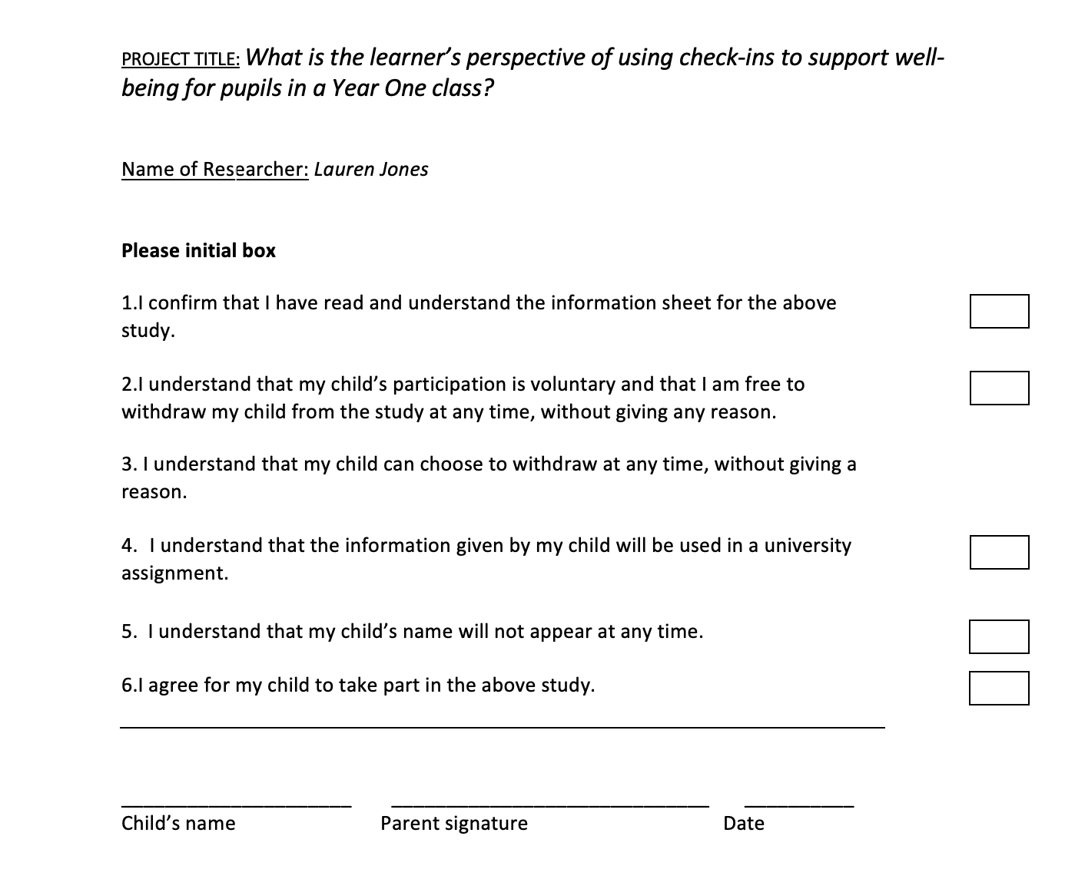
Appendix 1: Parental Consent Letter.

Appendix 2: Observation Schedule.
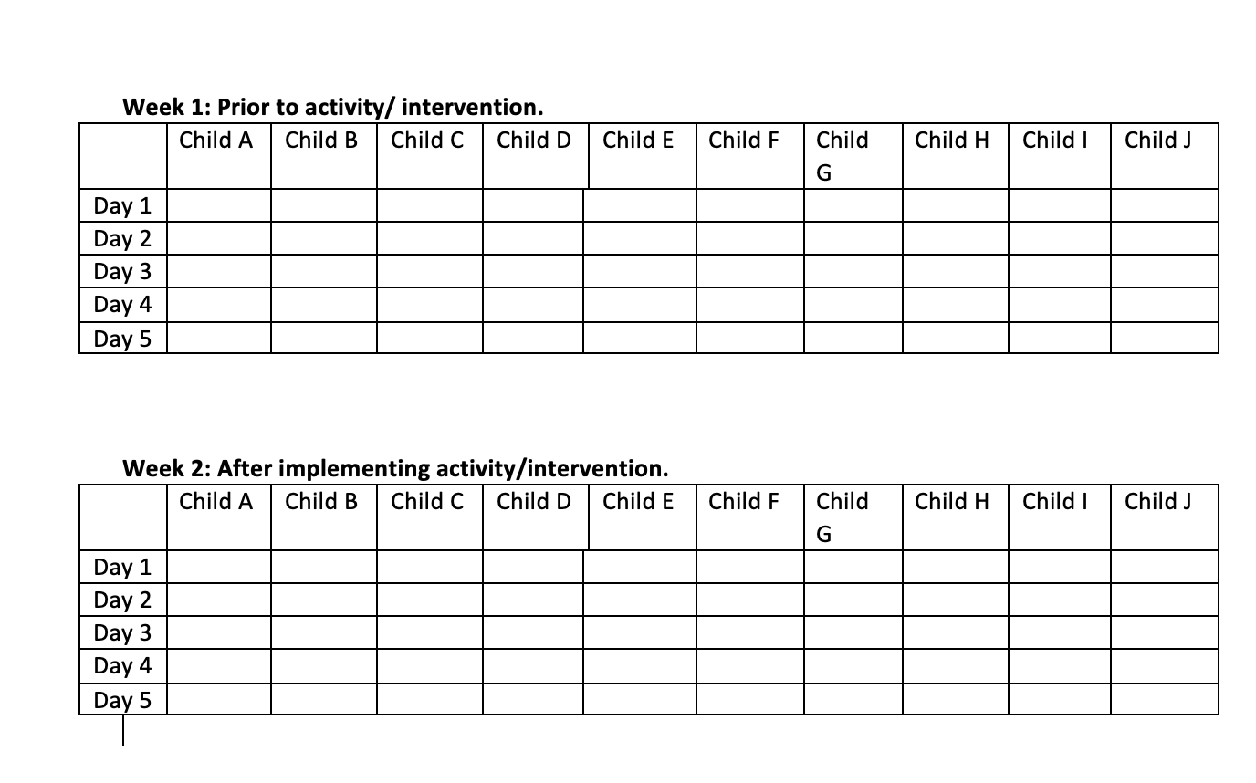

Appendix 3: Methods to gain pupil assent.
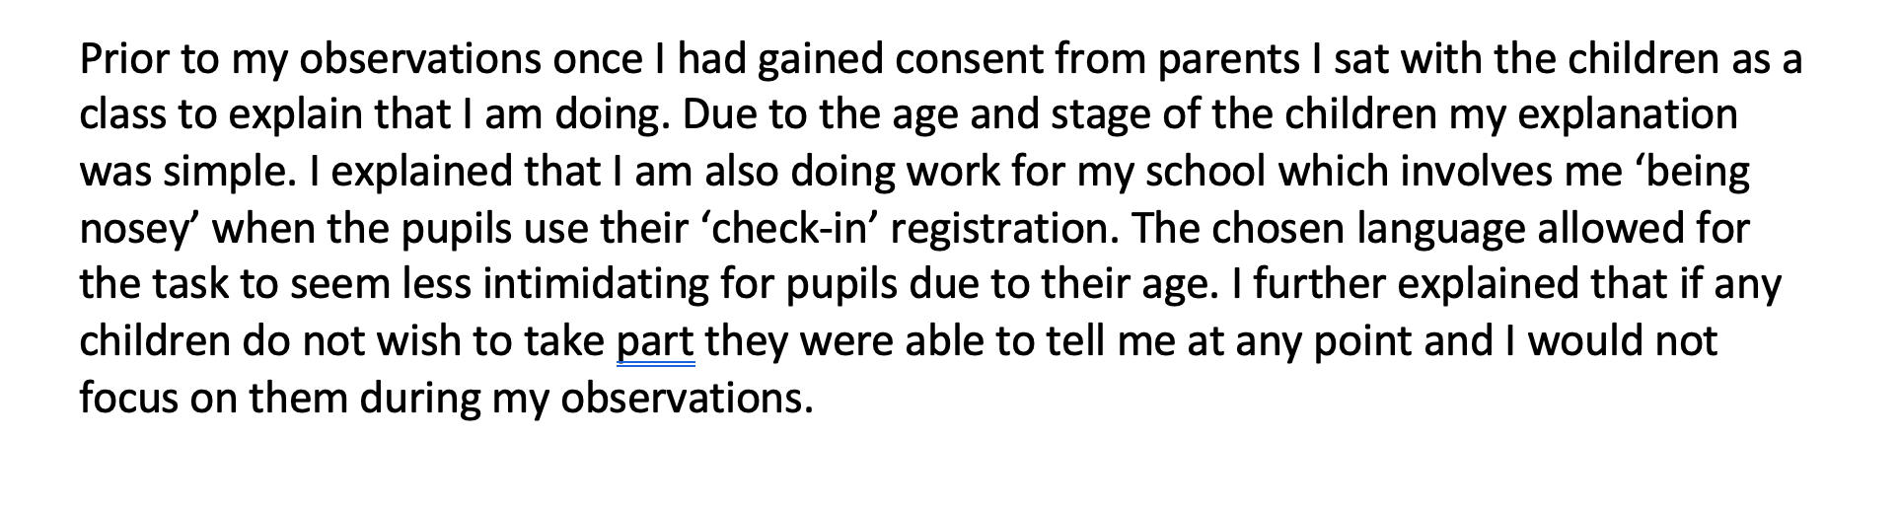

Appendix 4: Pupil Questionnaire.

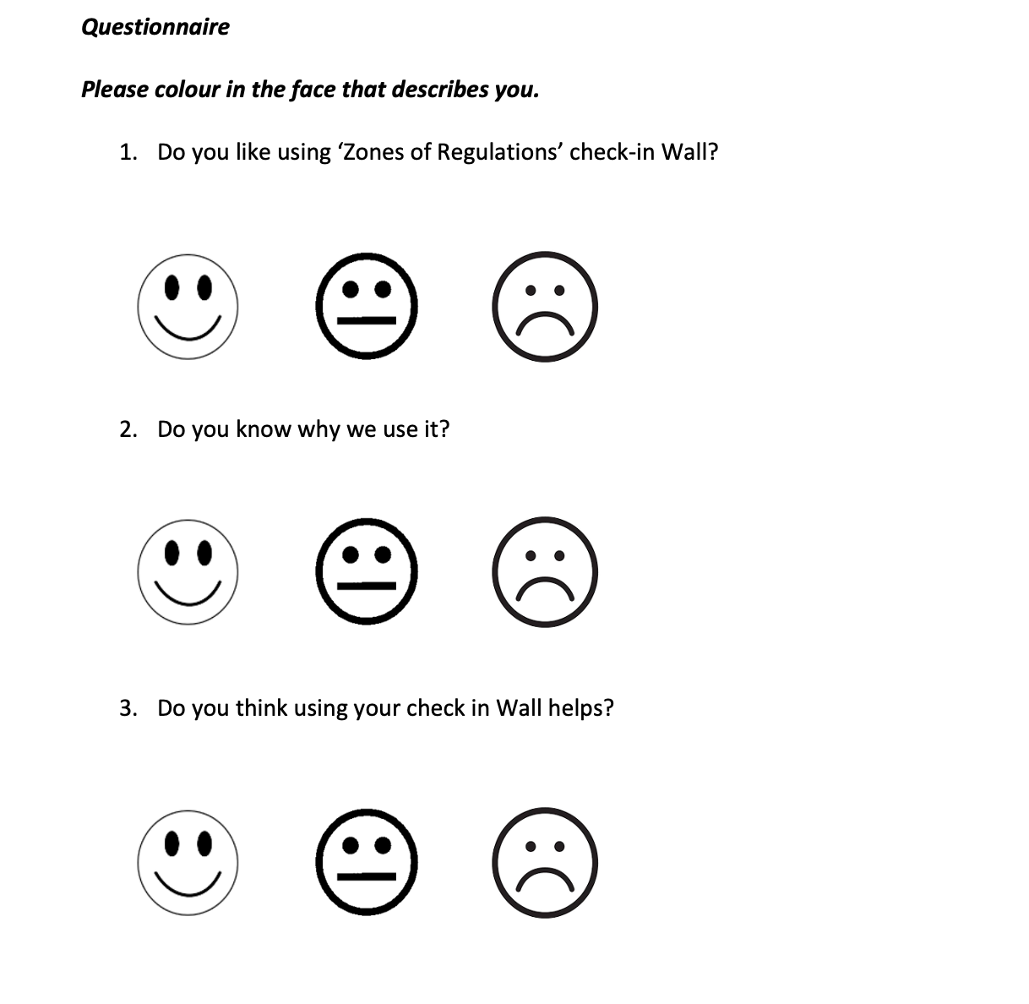

Appendix 5: Ethics Form

Appendix 5: Ethics Form.




