Module Code: LCLM5006
C1- Individual Poster Presentation
Developing Emotional Intelligence Skills
Muhammad Abdul Jalil
Student ID: 2026580
Lecturer: Chinomso Nwagboso

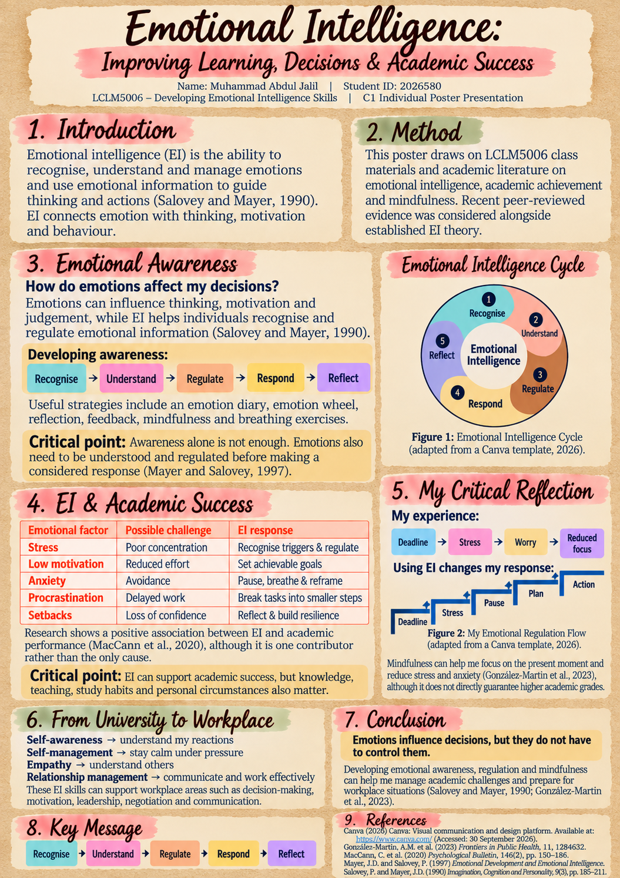

Refrences:
Canva (2026) Canva: Visual communication and design platform. Available at: https://www.canva.com/ (Accessed: 30 September 2026).
González-Martín, A.M., Aibar-Almazán, A., Rivas-Campo, Y., Castellote-Caballero, Y. and Carcelén-Fraile, M.C. (2023) ‘Mindfulness to improve the mental health of university students: A systematic review and meta-analysis’, Frontiers in Public Health, 11, 1284632. https://doi.org/10.3389/fpubh.2023.1284632
MacCann, C., Jiang, Y., Brown, L.E.R., Double, K.S., Bucich, M. and Minbashian, A. (2020) ‘Emotional intelligence predicts academic performance: A meta-analysis’, Psychological Bulletin, 146(2), pp. 150–186. https://doi.org/10.1037/bul0000219
Mayer, J.D. and Salovey, P. (1997) ‘What is emotional intelligence?’, in Salovey, P. and Sluyter, D.J. (eds.) Emotional Development and Emotional Intelligence: Educational Implications. New York: Basic Books, pp. 3–31.
Salovey, P. and Mayer, J.D. (1990) ‘Emotional intelligence’, Imagination, Cognition and Personality, 9(3), pp. 185–211. https://doi.org/10.2190/DUGG-P24E-52WK-6CDG

