Table of Contents
Task 2: Individual Assignment 3
Introduction 3
Emergence of Virtual organisation 3
Challenges 4
Opportunities 5
Implementation of Virtual management within the organisation (With examples) 7
Conclusion and Recommendation 8
Conclusion 8
Recommendation 9
References 11
Precis of the selected paper………………………………………………………………………14
Individual summary of chosen paper…………………………………………………………….15
Analysis of the conclusion……………………………………………………………………….16
References………………………………………………………………………………………..19

Task 2: Individual Assignment

Introduction
The concept of Virtual Organisation has revolutionised the way firms operate in a globally competitive world. The drastic advancement of technology and its usage to ensure better productivity, shared knowledge and less cost has given rise to the concept of virtual organisation. In the present assignment, the critical emergence of the virtual organisation and its practice in real-life organisation is done. The choosen company is IBM (International Business Machines Corporation) a leading provider of global hybrid cloud, consulting expertise, and AI offering customer support in more than 175 countries capitalised from the data insights. The company was founded in 1911, with its headquarters located in Armonk, New York (Britannica, 2024).
The practice of VO in IBM has transformed traditional business functions, acquiring digital technology for geographical connectivity across dispersed teams. The brand uses VO technology to tap into new geographical areas, improve collaboration, and acquire cost efficacy. In this regard, the evaluation of the challenges due to VO in planning, leading, and designing operations in the firm faced by IBM is discussed in the coursework. The pivotal opportunities gained by IBM due to the VO has been discussed as well. The emphasis on examining the particular strategies and practices employed by IBM to manage the VO is explained.

Emergence of Virtual organisation
In the current workplace scenario, it is turning more people-centric instead of place-centric. The strategic need for virtual teams as an important operational tool for competitive advantage is associated with developing digital technology, global networks, and trade internationalisation (Opute, 2022). However, firms need to meet the newly developed challenges that help firms to remain flexible, de-demarcated, de-differentiated, and multi-skilled, adding value to better performance using virtuality. Collectively, the evolution leads to flexible, efficient, and interconnected work environments creating a transformative shift in IBM’s planning, design, and leading in the global competitive business scenario.

Challenges
Planning
The widespread use of IBM's operation in 170 countries requires proper coordination across different time zones. However, geographical distance and changes in time zones create difficulties for scheduled meetings and timely communication. This leads to collaboration challenges by the virtual teams (Morrison-Smith and Ruiz, 2020). Reliance on digital communication tools increases in VO, which might sometimes create miscommunication and misunderstandings. Van Zoonen et al., (2023), suggest that the isolation faced by virtual workers and their reliance on lean communication media enhances the likelihood of miscommunication and distrust. On the other hand, the inability to rely on the physical interaction between the employees creates operational challenges in the virtual work environment. For example, the lack of face-to-face interaction hinders the development of interpersonal associations. Managing and resource allocation in the absence of physical presence is challenging. It is required to ensure that all team members have the necessary tools and support to manage meticulous planning and coordination. This can develop challenges like ineffective leadership and inefficient resource planning (Swart et al., 2022). Thus, responding to the challenges IBM meticulously plans to ensure that diversified teams coordinate and collaborate instead of time zone differences.
Designing
The vast data accessibility of employees from different geographic locations might affect data security and concerns. Security breaches and operational security turn out to be substantial issues (Gaur and Singh, 2023). Hence, preserving sensitive information becomes highly challenging for IBM. Developing a cohesive organisational culture in the virtual environment is complex. In particular, the essence of remote work challenges the traditional notion of the workplace that affects the culture while adjusting to the changing dynamics of the workplace (Adeniyi et al., 2024). In the absence of physical interaction, it becomes difficult to instill organisational values and develop a sense of community within the workers.
Leading
The management style of IBM has become different and needs effective supervision to motivate employees in remote working setups. Team leadership highlights the certain ways that technology might condition develop and shape the leadership in firms (Larson and DeChurch, 2020). In this regard, IBM provides stringent training for virtual environments focussing on trust, communication, and performance management viable for remote working. Virtual work arrangements affect the boundaries between professional and personal lives creating challenges to maintain the employees' work-life balance.
In the technological era, the success and viability of Virtual organisation rely on robust technology and network infrastructure. Thus, the disruption in the digital platforms or tools significantly impacts collaboration and productivity capacity. With the increase in the prevalence of remote working after the pandemic, the shift in communication due to digital technologies affects the norms and perceptions creating hindrances in effective communication and information exchange (Van Zoonen et al., 2023). Apart from that, assessing the employees' performance in virtual working can be difficult.
There are several serious challenges as well as helpful opportunities in the VO arrangement at IBM. First, there is a high degree of coordination needed across 170 countries, making it hard to schedule and have an appropriate time zone for communication, hence impacting collaboration in the delivery of projects (Morrison-Smith and Ruiz, 2020). Secondly, when there is over-reliance on tools of digital communication, miscommunication may arise and the isolation of virtual teams may happen, which eventually encourages bad forms of teaming up and distrust (Flores, 2019). Added to these are data security concerns, wherein ensuring protection from various locations employees could access the data becomes increasingly tricky. Building up an organisational culture into one entity is also difficult in a virtual environment. Physical interaction is lacking in this environment, making it hard to promote corporate values and build a sense of community within the organisation (Adeniyi et al., 2024). Moreover, effective assessment of remote work requires robust technologies and compliance mechanisms that ensure trust and integrity of data.

Opportunities
Planning
In a recent study, more than half of C-suite employees reported that they intend to tap anywhere and anytime talent pools for specialised skills for the next three years. Although virtualisation has created opportunities and challenges for firms and employees, 14% of the accumulated workforce will need retraining and reskilling (IBM, 2024). This creates a culture of continuous and extended learning to attract, develop, and retain quality talents. The accessibility of a diverse pool of talent globally is available to IBM. It adds skillful professionals from different locations and expertise in IBM which is difficult in local regional operations. The proposition of reduced expenses is available to the management with the hybrid working workspace (IBM, 2021). In this regard, IBM can feasibly allocate resources more effectively towards strategic initiatives, talent development, and R&D.
Designing
The presence of VO in IBM offers strategic opportunities for optimising operations and leveraging global talent. Based on the research work of Allioui and Mourd (2023), the involvement of AI has created new enhanced reliability in digital offerings. Optimization in the supply chain and real-time processes offer access to invaluable data and analytics. The firm gets advantages such as lead times, revolutionise customer insights, and fresh customer insights.
Strategic management develops a smooth transition to the virtual work models, organisational development, and increasing employee adoption. The investment in scalable IT infrastructure like high network speed, scalable cloud computing, and support data accessibility and processing. Based on the views of Williams and Chen (2023), critical infrastructure focuses on optimising speed, storage capacity, and managing workload management. In this infrastructure development, IBM can handle large piles of data developed by virtual teams and its application without any sort of performance depletion.
Leading
The culture of innovation and improved productivity helps to extend the market reach of IBM. The motivational aspect creates social facilitation effects specifically observed in employees who tend to work harder (Morrison-Smith and Ruiz, 2020). Although cultivating motivation in remote working is difficult particularly to ensure collaboration. The inclusion of cultural diversity within Virtual management helps IBM to understand and use varied viewpoints and cultural insights which helps in continuous improvement and adaptability. The promotion of environmental sustainability with the help of remote working adds to reducing carbon footprint initiatives. Apart from this, technological facilitation makes a substantial contribution to transparency allowing workers to feel aware of their colleagues and developing a shared workspace through video connections.
Moreover, IBM’s ability to tap into the global talent pool helps to access the diversified expertise and skills for improvement of strategic advantages and drive innovation for reduction of operational costs (IBM, 2024a). Furthermore, the communication platforms like Zoom and Slack paired with AI technology helps to improve collaboration and streamline workflows with boosted productivity. Hybrid workplaces are found to present IBM with cost saving opportunities helping the organisation to allocate resources efficiently for strategic research initiatives (Ezeigweneme et al., 2023). Moreover, investments within scalable IT infrastructure helps in effective management of large volumes of data with improved operational efficiency levels necessary for global operations of IBM (IBM, 2024b). In addition, virtual work develops a diversified workforce that aids in sustainability through the reduction of carbon footprint further aiming to improve IBM’s market reach and competitive edge.

Implementation of Virtual management within the organisation (With examples)
The growth of advanced communication and collaborative technologies has been the cornerstone for the emergence of Virtual organisation. High-speed internet, sophisticated software platforms, and cloud computing allow teams to interact and make real-time collaboration. Digital channels are the primary source of engagement in IBM, helping to enter potential markets and access and developing new challenges to recreate empathy, sense of belonging, and human association (IBM, 2024).
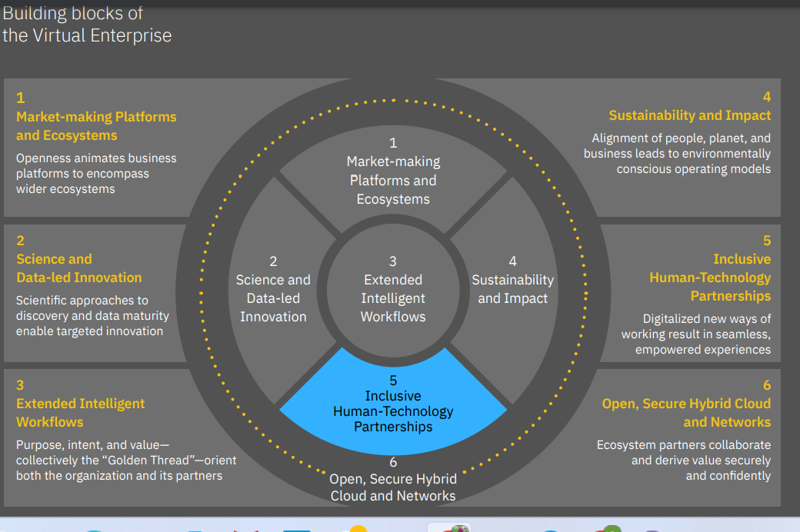
Figure 1: Building Blocks of Virtual Organisation
(Source: IBM, 2024)
For improved communication, IBM utilises platforms like Microsoft Teams, WebEx, and Slack that offer seamless communication exchange within the team. The tools are highly supportive of video conferencing, messaging, and document exchange. Concerning the advantages of the tools improved communication efficiency. This has helped to quicker decision-making and highly effective problem-sharing. The collaborative tools used by IBM like Watson and Trello facilitate project management and team collaboration. During the year 2014, BIM Watson was established helping to collaborate customers with the team (Strickland, 2019). The tools help in providing real-time updates, resource sharing, and task tracking.
IBM has even integrated agile methodologies inclusive of regular stand-ups, retrospectives, and sprints to keep the organisational teams focussed and adaptable. The inclusion of the methodology helps in managing projects while segregating them into smaller components and manageable tasks. The outcome of the agile method has been profoundly seen in increased flexibility and adapt to the nearby changes for successful project delivery. However, on the other hand, the employment of robust security protocols and encryption for preserving data exposes to higher chances of data breaches and risk. The customer assistance in the management is successful because of the geographically distributed teams.
For example, the “Follow the sun” model for customer support operations. In this approach, customer inquiries and assistance through technical support are promptly offered at any time of day (IBM, 2023). If the customer in New York submits a ticket during any course of the day, this can be received by the team in Bangalore, where the business just began. With the virtual support of virtual teams across different time zones, IBM can ensure 24-hour customer support without the extended support of night shift work. Thus, the opportunities obtained by IBM include global talent, collaborative platforms, cost savings due to remote working, and even environmental advantages.

Conclusion and Recommendation

Conclusion
IBM has established itself as a leader in the technology industry due to the inclusion of AI to enhance dependability, and optimisation in operations using real-time communication tools. The inclusion of VO in IBM has presented a drastic change in the way the company operates in the globally competitive scenario. With the amalgamation of advanced communication and collaborative technology, IBM has been successful in navigating the complexities faced during planning, leading, and designing virtual teams in different geographic regions. In this regard, the organisation’s productivity has increased with less cost incurred and geographically tapping into varied markets. However, a few challenges faced by IBM are developing a remote corporate culture in a virtual setting requires data security protocols and an emphasis on higher scalability. Managing virtual teams has made work-life balance and implementing efficient training and performance management tools necessary. IBM's customer support operations "Follow the Sun" approach is a prime example of the company's dedication to offering excellent and consistent service to its clients. Thus, the strategies have allowed IBM to sustain itself in the dynamic environment and operate its tasks across different geographical regions.

Recommendation
- IBM must keep funding extensive training courses emphasising communication techniques, virtual cooperation, and cultural awareness.
- The utilisation of artificial intelligence and automation in the remote operations of IBM to optimise processes, improve productivity, and minimise labor-intensive tasks.
- Invest in dependable and scalable IT infrastructure to meet the expanding needs of virtual businesses. It includes cloud computing capabilities, fast internet, and collaborative teamwork tools.
- Develop cultural strengthening programmes in the company that support VO using social media platforms.

References
Adeniyi, I.S., Al Hamad, N.M., Adewusi, O.E., Unachukwu, C.C., Osawaru, B., Onyebuchi, C.N., Omolawal, S.A., Aliu, A.O. and David, I.O., 2024. Organizational culture and leadership development: A human resources review of trends and best practices.
Allioui, H. and Mourdi, Y., 2023. Unleashing the potential of AI: Investigating cutting-edge technologies that are transforming businesses. International Journal of Computer Engineering and Data Science (IJCEDS), 3(2), pp.1-12.
Asatiani, A., Hämäläinen, J., Penttinen, E. and Rossi, M., 2021. Constructing continuity across the organisational culture boundary in a highly virtual work environment. Information systems journal, 31(1), pp.62-93.
Britannica (2024) IBM Available at: https://www.britannica.com/money/International-Business-Machines-Corporation [Accessed on 10th July 2024]
Ezeigweneme, C.A., Umoh, A.A., Ilojianya, V.I. and Oluwatoyin, A., 2023. Telecom project management: Lessons learned and best practices: A review from Africa to the USA.
Flores, M.F., 2019. Understanding the challenges of remote working and it’s impact to workers. International Journal of Business Marketing and Management (IJBMM), 4(11), pp.40-44.
Gaur, N. and Singh, S., 2023. A Behaviour Study on Cloud Eco-System: Data Security Perspective. International Journal on Recent and Innovation Trends in Computing and Communication, 11(6), p.177.
IBM (2021) The advantages and challenges of implementing a hybrid workspace for your employees Available at: https://www.ibm.com/blog/implementing-a-hybrid-workplace-for-your-employees/ [Accessed on 10th July 2024]
IBM (2023) Operations Available at: https://cloud.ibm.com/docs/mas-ms?topic=mas-ms-operations [Accessed on 10th July 2024]
IBM (2024) The Virtual Enterprise Available at: https://www.ibm.com/thought-leadership/institute-business-value/en-us/report/virtual-enterprise [Accessed on 10th July 2024]
IBM, (2024a). Talent acquisition and skills development Available at: https://www.ibm.com/consulting/talent-acquisition [Accessed on: 09/08/2024]
IBM, (2024b). IBM Transforms the Storage Ownership Experience with IBM Storage Assurance Available at: https://newsroom.ibm.com/2024-04-25-IBM-Transforms-the-Storage-Ownership-Experience-with-IBM-Storage-Assurance [Accessed on: 09/08/2024]
Larson, L. and DeChurch, L.A., 2020. Leading teams in the digital age: Four perspectives on technology and what they mean for leading teams. The leadership quarterly, 31(1), p.101377.
Morrison-Smith, S. and Ruiz, J., 2020. Challenges and barriers in virtual teams: a literature review. SN Applied Sciences, 2(6), pp.1-33.
Opute, A.P., 2022. Virtual teams: The new work norm for the post Covid-19 era. In Digital Service Delivery in Africa: Platforms and Practices (pp. 305-326). Cham: Springer International Publishing.
Strickland, E., 2019. IBM Watson, heal thyself: How IBM overpromised and underdelivered on AI health care. IEEE Spectrum, 56(4), pp.24-31.
Swart, K., Bond-Barnard, T. and Chugh, R., 2022. Challenges and critical success factors of digital communication, collaboration and knowledge sharing in project management virtual teams: a review. International Journal of Information Systems and Project Management, 10(4), pp.84-103.
Van Zoonen, W., Sivunen, A.E. and Blomqvist, K., 2023. Out of sight–Out of trust? An analysis of the mediating role of communication frequency and quality in the relationship between workplace isolation and trust. European Management Journal.
Williams, N. and Chen, D., 2023. Optimizing Infrastructure Performance and Cost Efficiency for Big Data Processing on High Performance Compute Clusters. Emerging Trends in Machine Intelligence and Big Data, 15(7), pp.18-27.

Strategic Management Group Task Presentation
Precis of the selected paper
"The Future of Commerce," co-authored by Adrian Slywotzky, Clayton M. Christensen, Richard S. Tedlow, and Nicholas G. Carr, published in the Harvard Business Review in January 2000, examines the transformative impact of the internet on the business landscape as the world entered the 21st century. The article brings together perspectives from four distinguished observers of e-commerce, each exploring different facets of this transformation.
Purpose: The article aims to explore the rapid changes in commerce driven by internet technologies and to provide insights into how businesses can adapt to these changes. The authors analyze the evolving dynamics between suppliers and customers, the shift in business models, and the strategic implications for companies aiming to thrive in the digital era.
Methodology: The authors employ a multi-faceted analytical approach, combining theoretical insights with practical examples to illustrate the impact of e-commerce. Each author brings a unique perspective:
- Adrian Slywotzky contribution centers on the inefficiency of the traditional push model in supplier-customer interactions, where suppliers dictate the terms of product offerings. He predicts a shift towards a pull model facilitated by the internet, where customers will actively engage in designing their own products through "choiceboards"—interactive online systems that allow customization of attributes, prices, and delivery options. Slywotzky argues that this transformation will fundamentally alter the competitive dynamics of various markets as companies adapt to the new, empowered role of customers as active designers rather than passive recipients​.
- Clayton M. Christensen & Richard S. Tedlow focus on the historical context of retail evolution to project future trends. They assert that while the core mission of retail—delivering the right product at the right place, price, and time—remains unchanged, the methods of achieving this have continually evolved through disruptive technologies. By analyzing past retail transformations, they identify patterns that suggest how retail may continue to evolve in the internet era. Their analysis highlights the importance of understanding these disruptive cycles to anticipate and navigate the ongoing changes in retail​.
- Nicholas G. Carr challenges the prevalent belief that the internet will lead to "disintermediation," where producers bypass wholesalers and retailers to connect directly with customers. Instead, Carr argues that the opposite phenomenon, which he terms "hypermediation," is occurring. Transactions over the web increasingly involve various intermediaries who add value at different stages of the transaction process. These middlemen, Carr posits, are well-positioned to capture significant profits in the evolving e-commerce landscape. This perspective underscores the complexity of the digital economy and the critical role of intermediaries in facilitating efficient and profitable transactions​.

Findings: The article collectively provides a comprehensive examination of how the internet is reshaping commerce. It emphasizes the need for businesses to adapt to new customer roles, understand historical patterns of retail disruption, and recognize the evolving role of intermediaries in the digital marketplace. As a whole, it presents a forward-looking analysis that prepares businesses to navigate the challenges and opportunities presented by the internet-driven transformation of commerce. "The Future of Commerce" is not just a speculative piece but a strategic guide for businesses aiming to thrive in the new economy. It highlights the critical importance of leveraging technology to empower customers, adapt to disruptive changes, and strategically position within the network of intermediaries that define modern commerce. The insights offered by Slywotzky, Christensen, Tedlow, and Carr provide valuable foresight for businesses poised to compete in the rapidly evolving e-commerce landscape.

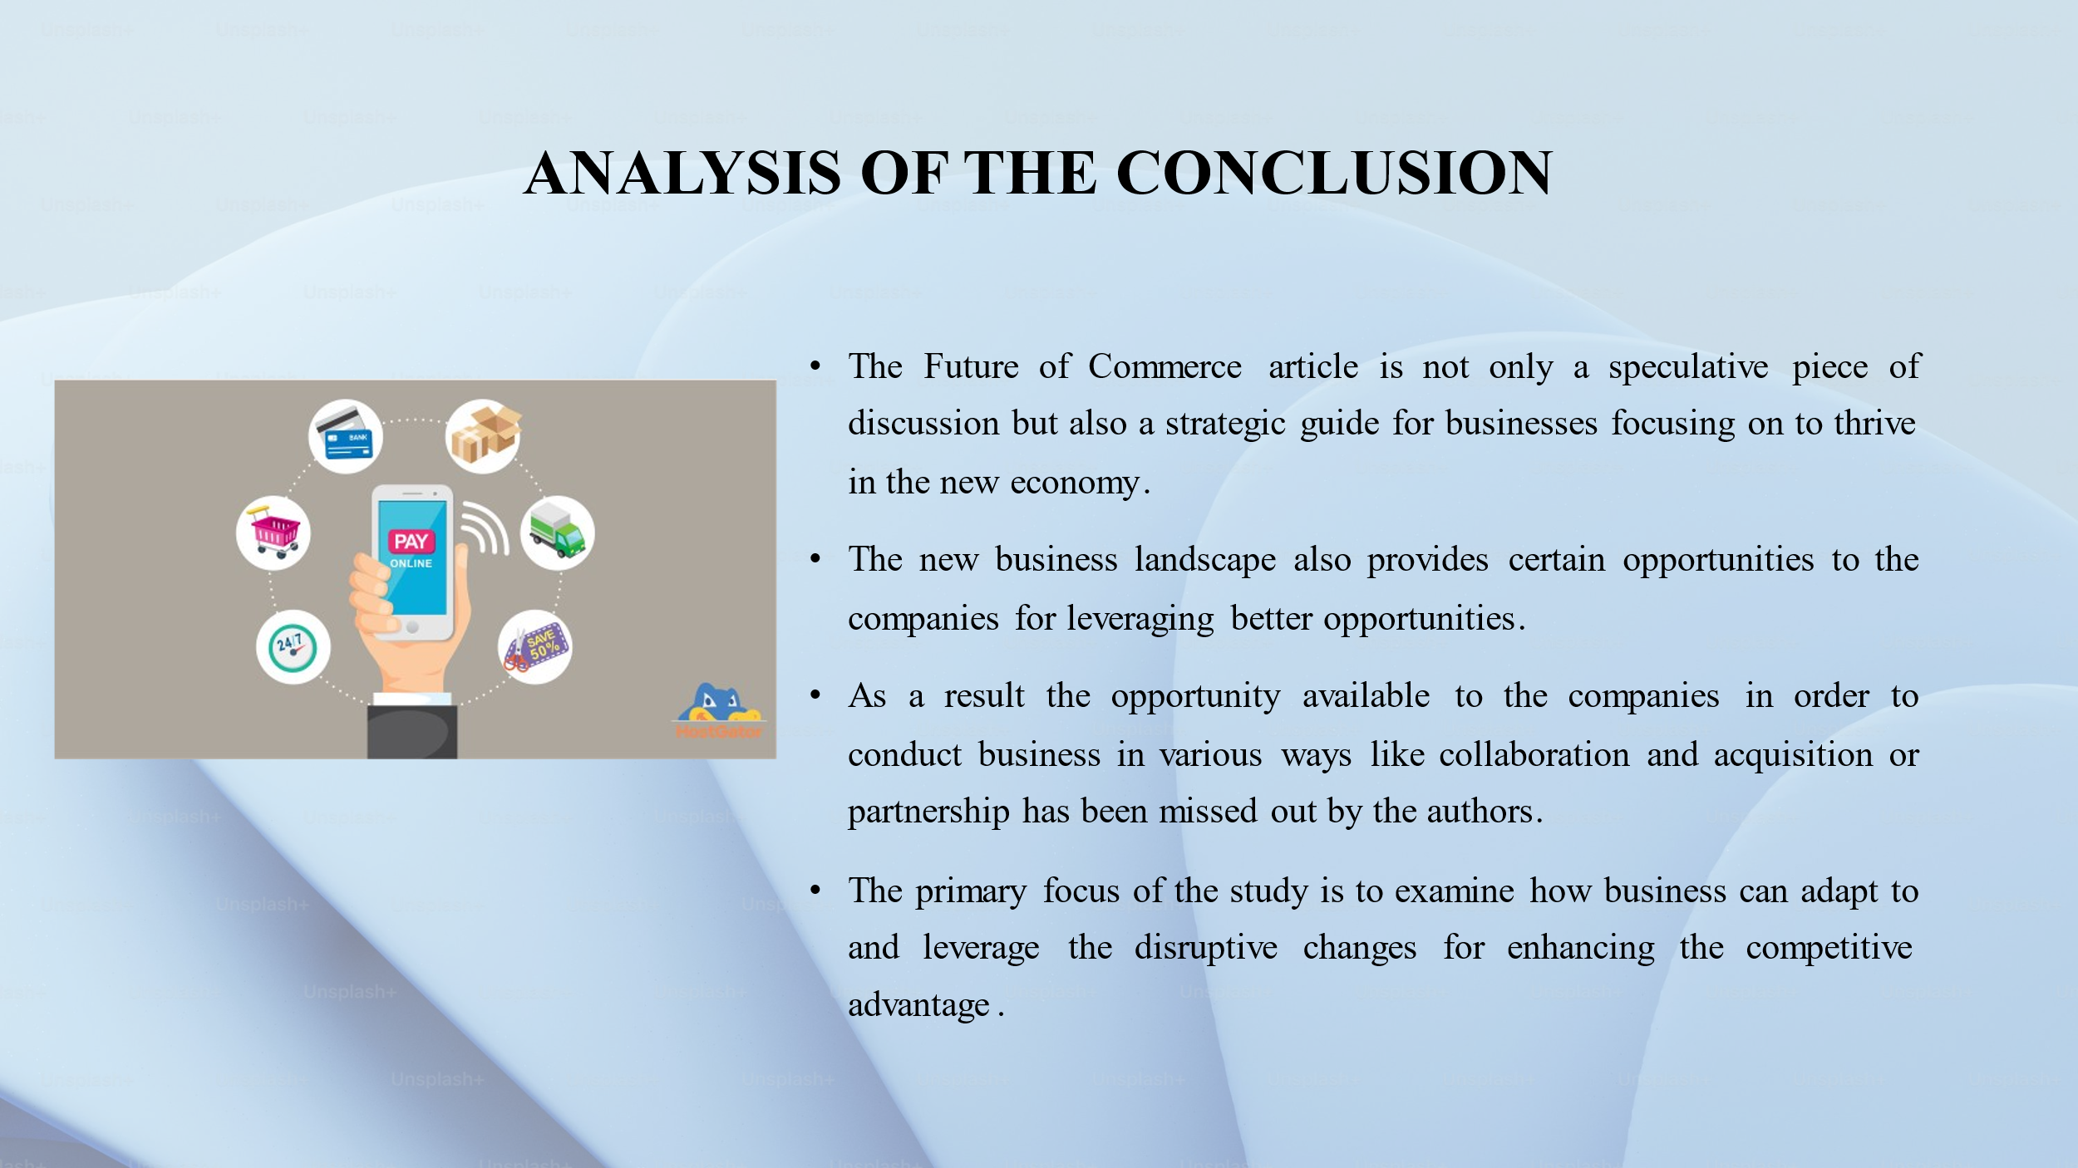
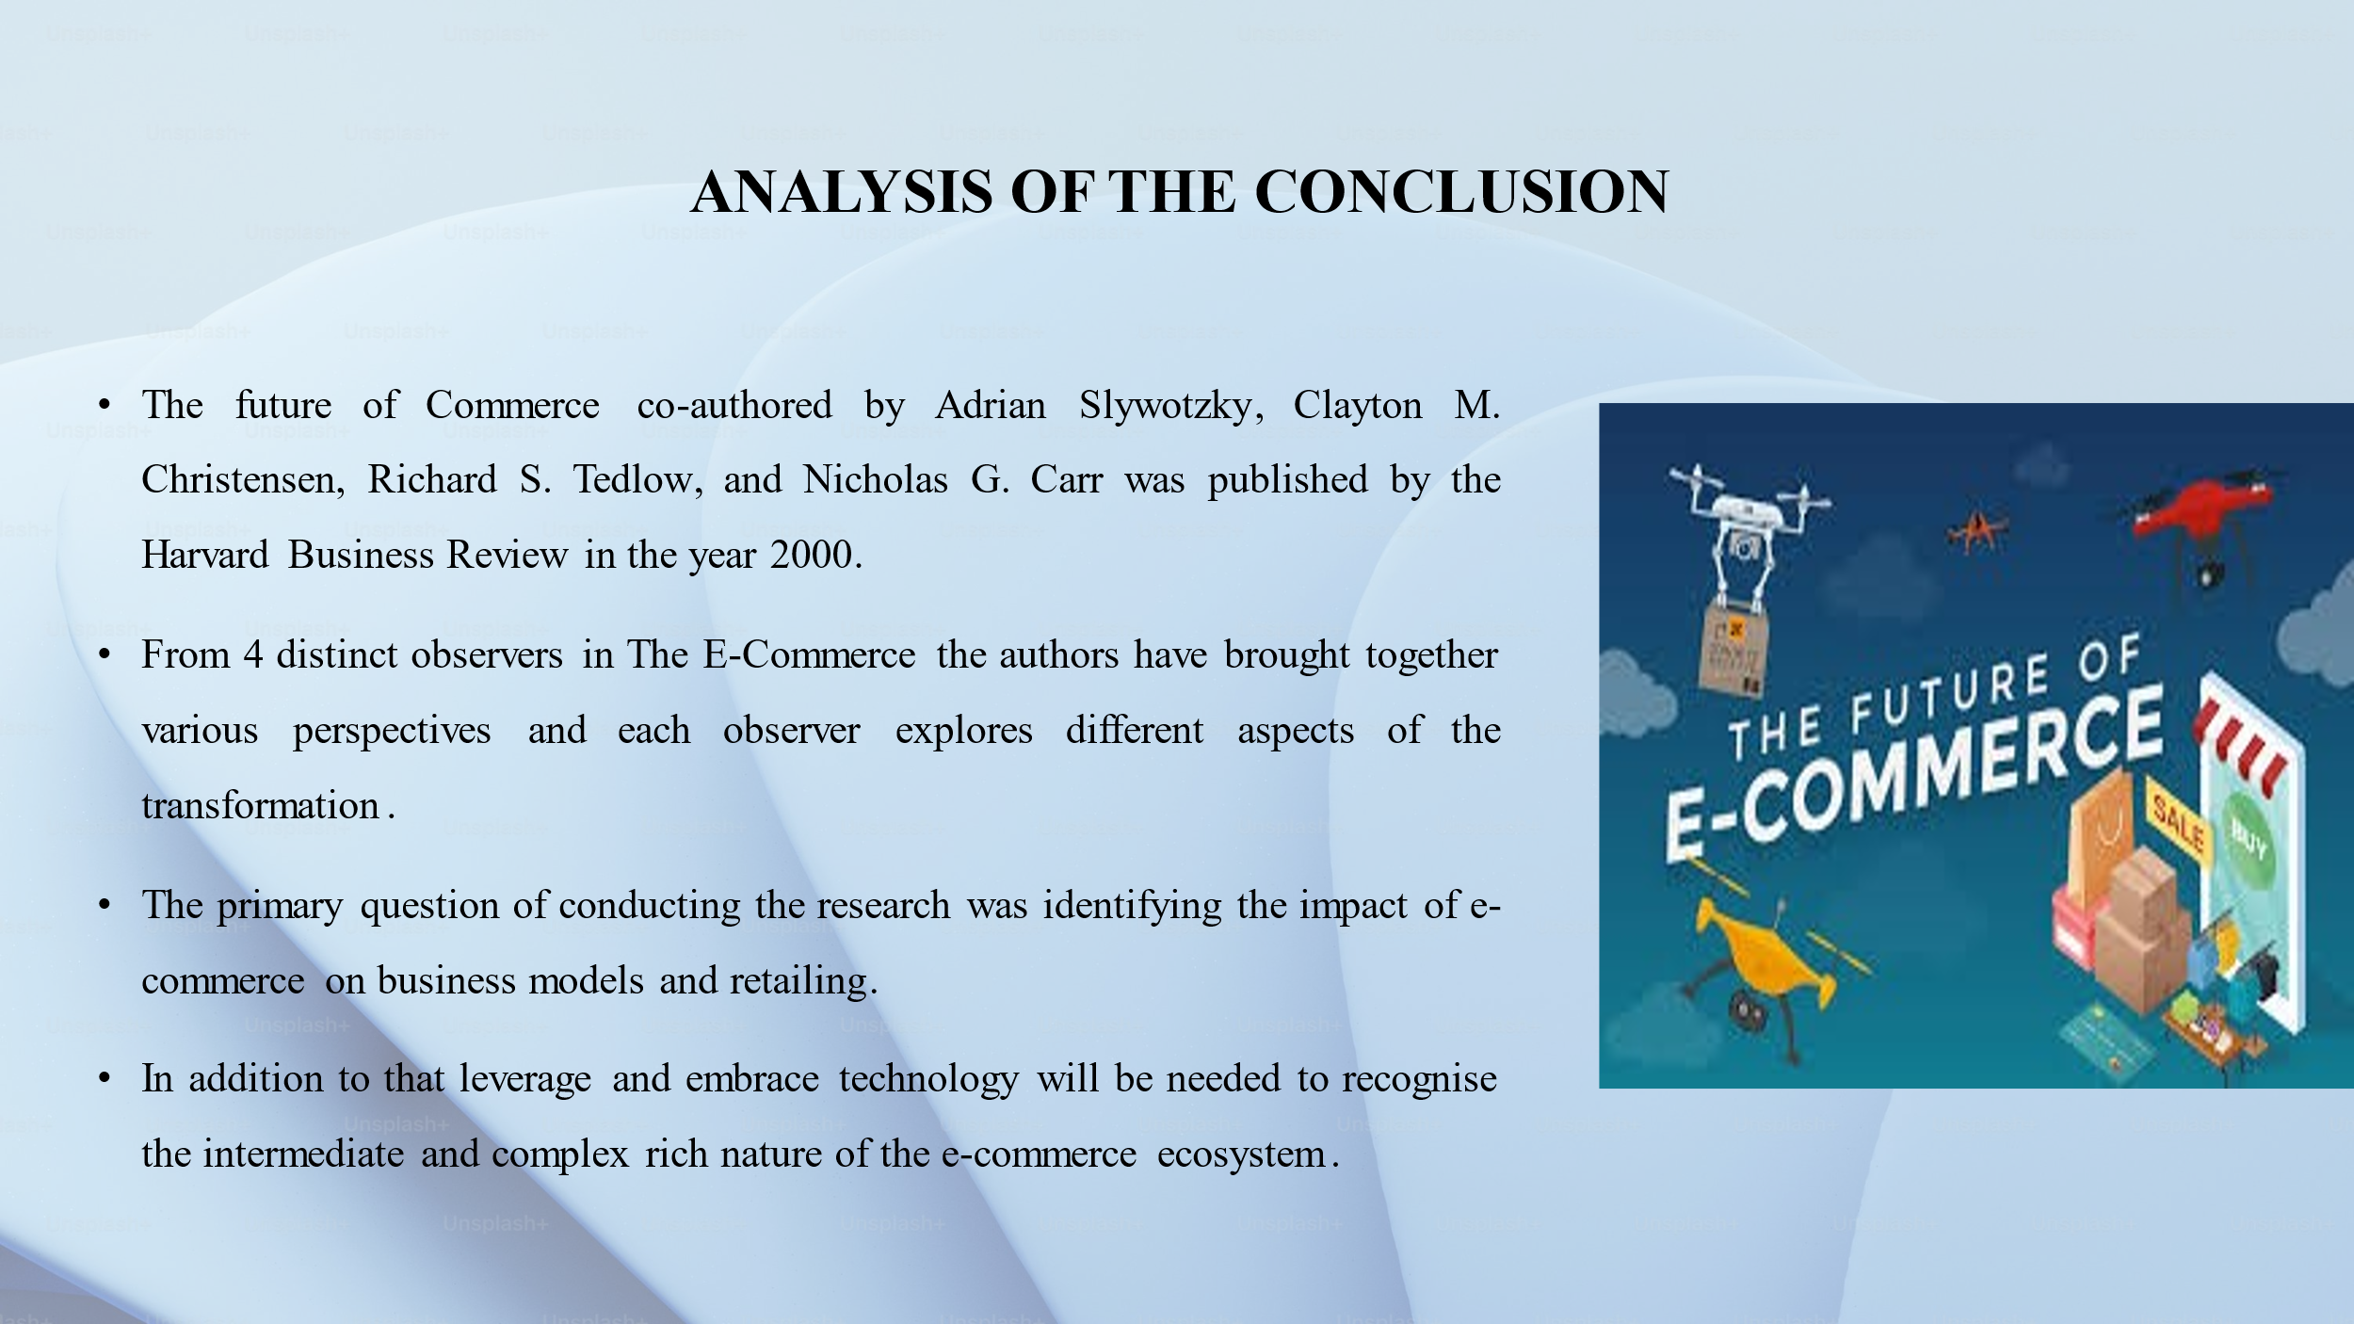

Strategic management
Individual summary of chosen paper

Analysis of the conclusion
The future of Commerce co-authored by Adrian Slywotzky, Clayton M. Christensen, Richard S. Tedlow, and Nicholas G. Carr was published by the Harvard Business Review in the year 2000. The author critically examines the transformative impact of Internet and Technical Advancement on the business landscape as the world and businesses enter the 21st century. From 4 distinct observers in The E-Commerce the authors have brought together various perspectives and each observer explores different aspects of the transformation. A collective examination of the ways in which the internet is responsible for shaping E-Commerce has collectively been provided in the article Slywotzky et al., (2000) also emphasises the requirement of the businesses operating in the 21st century to adapt the new customer role and also understands the historical pattern in the retail disruption for recognising the evolving role of intermediates in the digital market and landscape. Slywotzky et al., (2000) also presents forward looking and opportunistic analysis preparing the modern day businesses for navigating to opportunities and challenges presented by the internet driven transformation in The E-Commerce industry.
The primary question of conducting the research was identifying the impact of e-commerce on business models and retailing. The diverse perspective of the author collectively provides a rich understanding about the challenges and opportunities presented due to the internet in the current digital age of business operation. Due to the continuously evolving nature of e-commerce businesses are able to adapt to the changes by leveraging technology and embracing the customer centric approach which can help the businesses for positioning and driving in the future of the commerce. In addition to that, the significance of the historical pattern and contacts has been highlighted by the authors to anticipate and understand the future Trend. This aspect and findings of the study, also associates with, the research question of studying the past retail transformation, and effectiveness of the businesses, to gain valuable understanding into how the current and future disruption can be brought by the e-commerce companies. By using the historical perspective a framework to develop the strategies that are resilient and innovative in the face of on-going problems can be incorporated by the businesses. Significant take away based on the findings made by the authors in the article is the need of the business in the current situation to evolve and adapt in response to the changing dynamics of Commerce. By associating with the Research question it will require the businesses to conduct a customer centric business approach prioritising flexibility and personalisation. In addition to that leverage and embrace technology will be needed to recognise the intermediate and complex rich nature of the e-commerce ecosystem.
The Future of Commerce article is not only a speculative piece of discussion but also a strategic guide for businesses focusing on to thrive in the new economy. As Slywotzky et al., (2000) highlights critical significance of leverage in the technology to empower the customers and encourage businesses to adapt the disruptive change and strategically position themselves in the network of intermediaries defining the modern commerce insights offered by the authors are also a valuable site for the businesses focusing on to compete in the rapidly evolving business landscape. However there are certain limitations that are evident in the article that limits the application of the recommended strategy and adaptation of new business models by the companies to compete in the current and evolving business landscape. For example the push model that has been identified by the author is an extremely traditional and supplier driven model that might be out-dated for the company operating in the current business landscape. However recommendations regarding the introduction of choice Board have been made by the author but it will also need an interactive online platform to enable the customer driven product design. In order to eliminate this limitation companies will need to empower the consumer and deal with the changes in the competitive dynamic for adopting the customer centric strategy.
The new business landscape also provides certain opportunities to the companies for leveraging better opportunities. Certain aspects have been critically discussed by the authors but some points also have been missed out. In the current era of globalisation countries are providing easier accessibility to the international platform for the businesses to conduct operations in the cross border nations. As a result the opportunity available to the companies in order to conduct business in various ways like collaboration and acquisition or partnership has been missed out by the authors. Recommendations regarding the collaboration with the intermediate and integration of the service in the cross border nation can enable the businesses to explore the intermediate role for generating additional revenue.
The primary focus of the study is to examine how business can adapt to and leverage the disruptive changes for enhancing the competitive advantage. As a result there is an opportunity to examine Rapid and profound transformation of Commerce due to e-commerce. By analysing the core problem and exploring the motivation the authors focus on understanding the broader implications. As a result for future scope there is opportunity to understand the ways in which the E-Commerce industry currently influences the direction of online businesses. There is also an opportunity to present the customer decision making process and its implication due to the change in the digital Marketplace. For conducting future research in this aspect, provides opportunity to understand and examine the historical pattern of the retail disruption that can provide valuable insight for adapting to the current and future changes. Considering the implication and findings made in the article businesses can remain innovative and agile to maintain the competitive advantage in the rapidly evolving marketplace.
The overarching motivation behind the research presented in the future of Commerce by the author provides businesses with comprehensive understanding about the transformative impact of e-commerce and also offers strategic understanding to navigate through the new business landscape. I highly agree with the strategies recommended by the authors to address the challenges and uncertainty in the business field and there is an extreme need for adaptability and innovation for the businesses to conduct customer centric approaches. The research has motivated me with a desire to equip businesses with tools and knowledge for navigating through the future and current changes effectively.

References
Slywotzky, A. et al. (2000) The Future of Commerce, Harvard Business Review. Available at: https://hbr.org/2000/01/the-future-of-commerce (Accessed: 18 July 2024).

