How do students use technology to collaborate at UWTSD?

Student Name: Rehana Younas
Student Number: 2208268
Lecturer Name : Matthew Brian
Module code : LCHS
Assignment section: Task 2

CONTENTS
- Introduction
- Research design
  - Research Question
  - Method
  - Ethical considerations
- Results
- Discussion
- Conclusion
- Reference Lists
- Appendix

- Introduction
The purpose of this research is to determine whether the students of UWTSD are having difficulty in using the technology or they are happy with the technology and if they need the training for how to use the technology. As some of the students of the UWTSD are not fresh graduates they are elders and graduated decades ago and may be more than that. Changing technology constitutes an important aspect, both of changes in everyday life and impact of everyday-life activities. (lnge Ropke,2001). Technology is changing day by day. For new generation getting along with technology is easy. But for elders it’s not easy For elders, change in technology is difficult to understand and absorb. Being an older student it’s very hard for the students to catch the new features and to use the technology. This research is conducted to determine that if students need the training for how to use the technology. In this study a questionnaire was used as a tool of data collection. Questionnaire was filled by the 12 students of the UWTSD. All of them filled the questionnaires willingly. Age of the students starts from the 20-54. There are also some recommendations.
- Research Design
- Research question
Is there a need to provide training on how to use technology to collaborate at UWTSD?
- Method
In this study a questionnaire was used as a tool of data collection. Questionnaire were get filled by direct contact with the students.
• Ethical Consideration
Ethical Considerations are one of the most important parts of the research. Studies may even be fated to failure if ethical considerations are missing (Bryman , Bell 2007). We took a good care of all the ethics. Research was conducted by making sure the privacy and safety of the participants. It is not the forced research every participant voluntarily filled the questionnaires. There is a surety of their privacy that we are going to keep the information confidential.

Results
The research was conducted at the UWTSD. In this study a questionnaire was used as a tool of data collection. Questionnaire were get filled by direct contact with the students.12 Students filled the questionnaire. Age varies between 20 to 54. They were asked whether they find difficulty in using the application. 5 among them said yes and 7 among them said no. And those who said no was older generation and the other yes were between the age 20-35.

The pie chart is shown in figure below.
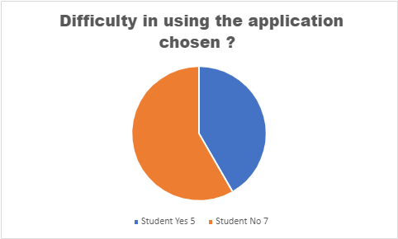

Rationale
Survey was conducted between the 1000 UK office workers. Survey was about if they need any Microsoft training and 72% people were in favour of getting the Microsoft office training. Likewise, in the UWTSD 5 students out of 12 have said they need more training due to inexperience. After getting training they will be the smart user and will do the assignment work easily. Because human
can learn anything at any age and there is no restriction of learning and there is no age of learning, at any age you can learn. What requires is the effort and the determination.

Discussion
This research was conducted to find out that how many students need training for the application use. As it is hard for the older students to get used to application as they are not used to the usage of technology. For them understanding new features and technology is hard. Some of them are graduated decode ago and in their time applications were different. They were used to old version of application of the Microsoft word. But for them learning new application is difficult. Few of them have never used the technology before. For them everything is new. Human can learn anything at any age and there is no restriction of learning and there is no age of learning, at any age you can learn. What requires is the effort and the determination.

Conclusion
The aim of this study is to find whether the students are facing the difficulty in using the application or not. The result of this study shows that some of the students are facing the problem in using the application and those are older students. But the younger students are very relaxing and enjoying using this. Those students who don’t know how to use the application are willing to take trainings for their betterment. Technology is changing day by day. For new generation getting along with technology is easy. But for elders it’s not easy. No one can deny the power of getting knowledge. At any age everyone can learn if that person is willing to learn.

References
Bryman, A. & Bell, E. (2007) “Business Research Methods”, 2nd edition. Oxford University Press.
Inge Ropke.(2001)“New technology in everyday life – social processes and environmental impact”, Volume 38,403-422

Appendix
Question was contacted in UWTSD Sparkbrook between 12 students.
- do you agree to take part in this questionnaire?
- Age of students 20, 24 32 ,34, 35, 36, 40, 49, 50, 54
- what application do you use to cooperate with students at UW TSD
during assessment?
- Do you find any difficulty in using the application you choose?
- do you know UWTSD has a one hour help on basic IT skills on Wednesdays between 1:00 PM to 2:00 PM?

