

Programme: BA (Hons) Leadership and Management Skills in the Workplace
Module: Project Management
Module code: LCLM5003

RECONSTRUCTION OF LOCAL INFRASTRUCTURE THAT HAVE BEEN DAMAGED

Name: Francesca Morosanu
ID:

Executive summary
This is a project that concentrates on the rebuilding and improvement of infrastructure that is weakened by flooding in the West Midland which specifically covers Worcester, Shrewsbury and Kidderminster. The plan incorporated the important project management tools such as scope definition, Work Breakdown Structure (WBS), Gantt chart, stakeholder analysis, and risk management to deliver in a structured and efficient manner. Results emphasised the need to balance time, cost and quality alongside prioritising stakeholders and resources allocation. Significant risks like extreme weather and delays in funding are managed under mitigation measures. Comprehensively, the project will help to restore the necessary services, enhance flood resilience, and facilitate long-term and sustainable community recovery and development.
Table of Contents
Part A: Project proposal poster 5
Part B: Reflection on Feedback 6
Part C: Project Management Plan 8
3.1 Introduction 8
3.2 Project Description 8
3.3 Scope of the project 9
3.4 Work Breakdown Structure 11
3.5 Quad Chart 11
3.6 Gantt Chart 13
3.7 Stakeholders’ involvement 16
3.8 Allocation of resources 19
3.9 Risk Analysis 21
3.10 Conclusion 23
References 24

List of Figures
Figure 1: Rofle’s Reflective Model 6
Figure 2: Vic Haddock's boat house is underwater on the River Severn following wet weather and high winds in Ironbridge 9
Figure 3: Components of Project Triangle 10
Figure 4: Work Breakdown Structure (WBS) 11
Figure 5: Gantt chart 15
Figure 6: Stakeholder mapping 18
Figure 7: Communication approaches with the stakeholders 19

List of Tables
Table 1: QUAD Chart 12
Table 2: Stakeholder analysis 17
Table 3: Allocation of all resources 20
Table 4: Risk analysis for the reconstruction project of local infrastructure 22
Table 5: Risk Register 22

Part A: Project proposal poster
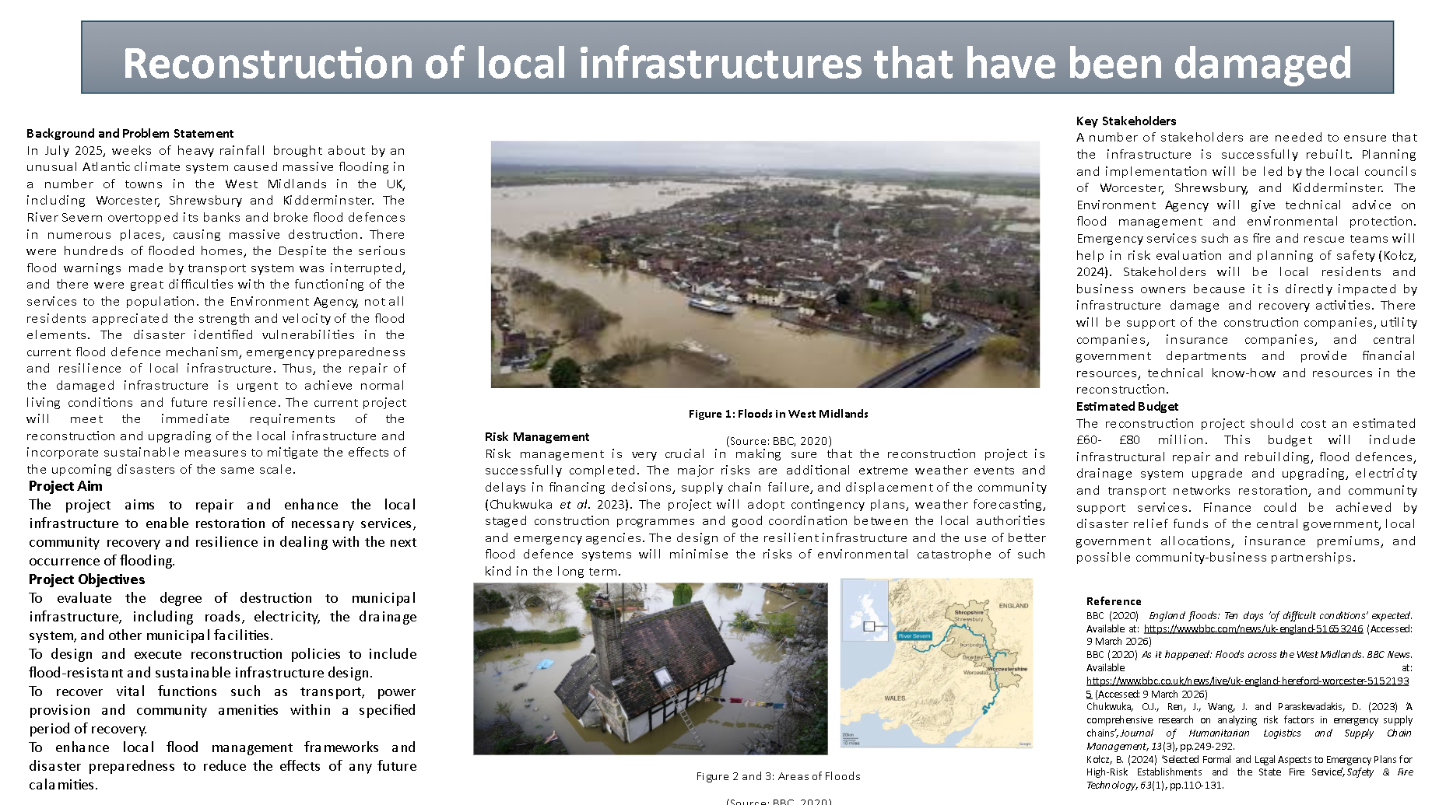

Part B: Reflection on Feedback
The 3 stages of Rolfe’s Reflective Model help in reflecting on the self-experience, action, feelings and improving practice appropriately to develop skill gaps and enhance the performance in the future context (Rolfe, Freshwater and Jasper, 2001) (Refer to Figure 1). The application of this model is analysed in the section below to analyse my reflection on the feedback gathered from the professors based on the proposal of part A.
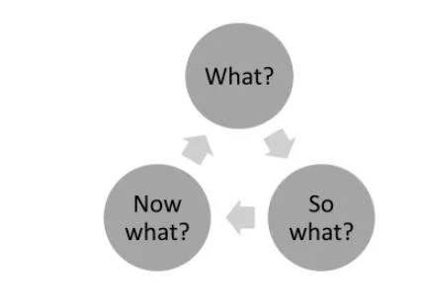

Figure 1: Rofle’s Reflective Model
(Scott and Hafenstein, 2021)
- What?:
The professor and peer comments on my project proposal on the reconstruction of flood-damaged infrastructure in the West Midlands have identified some key areas of improvement. As the general concept was deemed applicable and organised, it was recommended that I be more specific about the scope of the project and offer a more targeted project idea. The tutor pointed out the importance of clearly including project management tools like the Quad Chart and Gantt Chart, and outlining important aspects of the project more explicitly. Furthermore, I received an incentive to offer a more tangible solution, such as the development of certain infrastructure, such as the reconstruction of bridges or restoration of highways, instead of maintaining a broad proposal.
- So what?:
It was this feedback that allowed me to realise that whilst my project has a good foundation, it was unspecific in some aspects. In this context, Kutasi (2023) mentioned that the primary goal of the feedback is to helps the students in the academic context to reach their learning objectives appropriately while addressing strengths and areas of improvement. As a result, through this feedback from my professor, I have gained information that I specifically outlined infrastructure reconstruction, yet I had not outlined the specific deliverables or prioritised the solutions, such as the development of transportation or electricity facilities and others. This may lower the efficiency of the project plan, and it may also be hard to make stakeholders appreciate the intended results. The idea to add such tools as the Quad Chart and Gantt Chart brought to light the significance of visual and systematic planning methods in illustrating the feasibility and organisation of the project. In addition, the process of locating project elements, which may include, but is not limited to, restoring transport systems or enhancing flood defences, can be used to match objectives with the real results. Another message supported in the feedback was the need to connect theory, such as project management tools, to reality.
- Now What?:
I will meet these requirements in the final project management plan by ensuring that the scope of the project is set and that the scope is narrowed down to a particular solution to the infrastructure, such as building roads, bridges and a drainage system. I will clearly include and examine such tools such as the Quad Chart, Gantt Chart, Stakeholder mapping and others to make the process more transparent and display an organised planning. Moreover, I will emphasise the main project elements, such as stakeholder roles, risk management, and resource allocation, better. I will also make sure that the project is offering realistic and viable solutions that directly relate to the problems that have been identified. All these will enhance the overall quality, readability and applicability of the project to satisfy academic standards and practical applicability.

Part C: Project Management Plan

3.1 Introduction
Rebuilding the local infrastructure that has been destroyed by the July 2025 floods in the West Midlands is a vital measure towards the restoration of community functions and resilience. The catastrophe revealed the severe vulnerability of food defences, transport infrastructure, and vital utilities, which required a systematic and strategic response. This project management plan is going to offer detailed methodologies, tools and processes that are essential to successfully complete the reconstruction project. The utilisation of project management concepts, the plan offers a high level of resource coordination, stakeholder involvement and risk reduction, which ultimately will provide sustainable redevelopment and increase the preparedness to extreme weather events in the future.

3.2 Project Description
The suggested project and attention are on rebuilding and improving infrastructure in flood-affected regions such as Worcester, Shrewsbury and Kidderminster after severe flooding caused by the overflow of the River Severn. It has been found that the severe flooding along the River Severn in February 2022 was caused by multiple storms that led to evacuations, transport disruptions, and major incidents in affected towns and highlighted the risk to infrastructure and communities across the regions (Refer to Figure 2) (BBC, 2022). The project will reinstate essential facilities, such as transport infrastructure, power supply, drainage, and community facilities, that were damaged or destroyed.
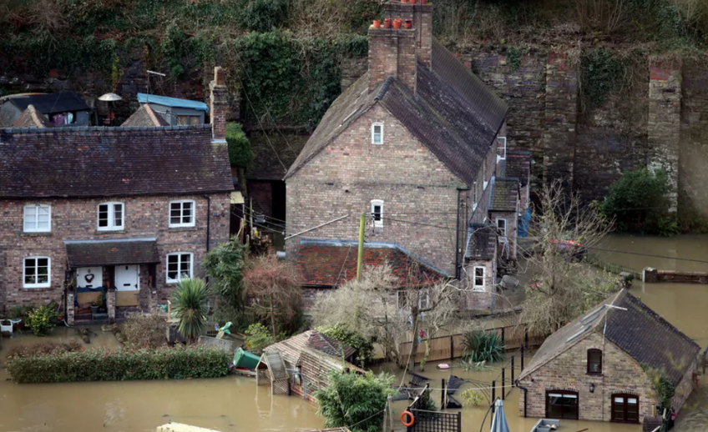

Figure 2: Vic Haddock's boat house is underwater on the River Severn following wet weather and high winds in Ironbridge
(Source: BBC, 2022)
This project will start with a thorough damage assessment to determine areas of priority to allocate the resources efficiently. Reconstruction activities of this project will be based on the basis of the modern engineering practices that incorporate sustainable design-based and flood resistance practices. The project will furthermore include the partnership with major stakeholders, including local councils, emergency services, environmental agencies, contractors and the community representatives. Their coordination will make sure that reconstruction will be efficient, besides being in concurrence with environmental regulations and community needs. Lastly, the project aims to ensure normal living conditions and increase long-term resiliency, minimise vulnerability to subsequent floods, and promote sustainable development of the region.

3.3 Scope of the project
The project triangle is the core of project management as it sets the basic constraints of project delivery while focusing on the quality by considering project scope, cost and time (Oyebode et al. 2023) (Refer to Figure 3). The scope denotes what is covered in the project, cost refers to the allocated budget, and time represents the schedule of the project for completion within the time. In this case, the scope of the reconstruction project is defined by the project triangle limitation. Under the budget of between £60-£80 million, and the time slot of recovery (time), the project will provide complete restoration and improvement of infrastructure (scope). In particular, the scope will be involved in the evaluation of the damage to infrastructure, roads, bridges, drainage systems, electricity networks, and public facilities; the restoration and reconstruction of the infrastructure; and the incorporation of flood-resilient and sustainable design.
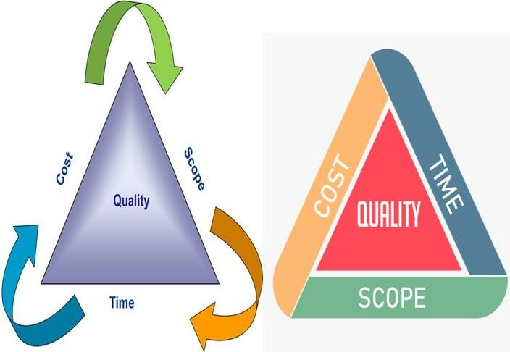

Figure 3: Components of Project Triangle
(Source: Oyebode et al. 2023)
In addition, the upgrading of flood defence structures, introduction of better drainage schemes and resumption of services such as power supply and transport are also covered in this project. These also include the support programs, coordination of stakeholders, and environmental regulations. However, the scope does not cover unrelated urban development projects that are not associated with flood recovery. The systematic solution will help in the prompt recovery, mitigate future risks, and enhance the sustainability of the affected communities in the long term.

3.4 Work Breakdown Structure
The work breakdown structure is an essential part of the scope management process and a technique in project planning (Odedairo, 2024). In addition, Motahar, Fauth and Melzner (2025) mentioned that the work breakdown structure (WBS) is the backbone of completing a project by assembling stages, processes, and activities. Therefore, the WBS of this project is offered in the section below:
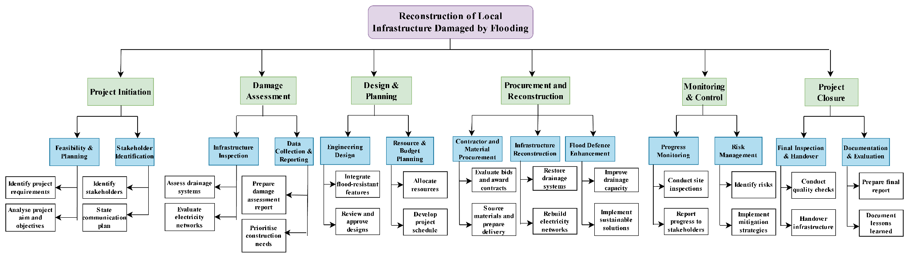

Figure 4: Work Breakdown Structure (WBS)
The WBS structure presents a clear hierarchical decomposition of the reconstruction process, progressing logically from initiation to closure. It guarantees the coverage of the major activities such as assessment, planning, procurement, execution and monitoring. The hierarchical structure enhances clarity of tasks, accountability and coordination among the stakeholders. Also, the incorporation of flood defence improvements emphasises the proactive method, which guarantees recovery, as well as long-term infrastructure resilience and sustainability.

3.5 Quad Chart
The Quad chart is an effective framework that is used to briefly analyse the potential for reinforcing technical communication fundamentals (Ford and Wei, 2015). The four quadrants of this chart for this project are provided in the section below:
Title: Reconstruction of the local infrastructure that has been damaged
Purpose | Customers
- Restore transportation, electric and drainage systems  - Reconstruct flood-damaged infrastructure  - Integrate flood-resistance and sustainable design  - Support the community to offer safety and recovery supports  - Enhance future disaster preparedness | - Local councils, including Shrewsbury, Worcester, and Kidderminster  - Environmental agency  - Construction and utility companies  - Central governmental bodies  - Emergency services  - Residents and businesses
Desired and Result | Measures of success
- Restored infrastructure systems  - Completion within time and budget  - Improve flood defence capacity  - Minimal disruption to communities  - Long-term sustainability and resilience | - Delivering the project within £60–£80 million budget  - Timely completion of key milestones  - Reduce future flood risk impact  - Restoration of essential services  - Stakeholders’ satisfaction  - Compliance with environmental standards

Table 1: QUAD Chart
The above Quad chart also gives a planned structure of the project by organising the purpose, stakeholders, the expected outcomes and the measures of performance. It shows clearly how the rejection is motivated by the necessity of restoring important infrastructure and increasing the resilience of these facilities to floods in the long run. The chart, which connects goals to stakeholder requirements, makes sure that project activities are dedicated to the provision of tangible community benefits, especially to the residents and businesses impacted by the disaster. In addition, there is the notion of critical success factors, which indicates the significance of the balance between quality, time, and cost, which are the fundamental aspects of successful project management.
The focus on sustainability and flood-resistant design is an aspect that allows viewing the matter as forward-thinking, as reconstruction is not merely a means to restore the state of affairs, but to make it better. The success metrics give objective indicators that enable the project managers to track progress and examine the results. These standards also embrace accountability since the stakeholders will be able to determine where the project is achieving its desired objectives. Therefore, the Quad chart promotes better understanding, communication, and orientation among stakeholders and is a useful tool to improve the decision-making process and the successful implementation of the reconstruction project.

3.6 Gantt Chart
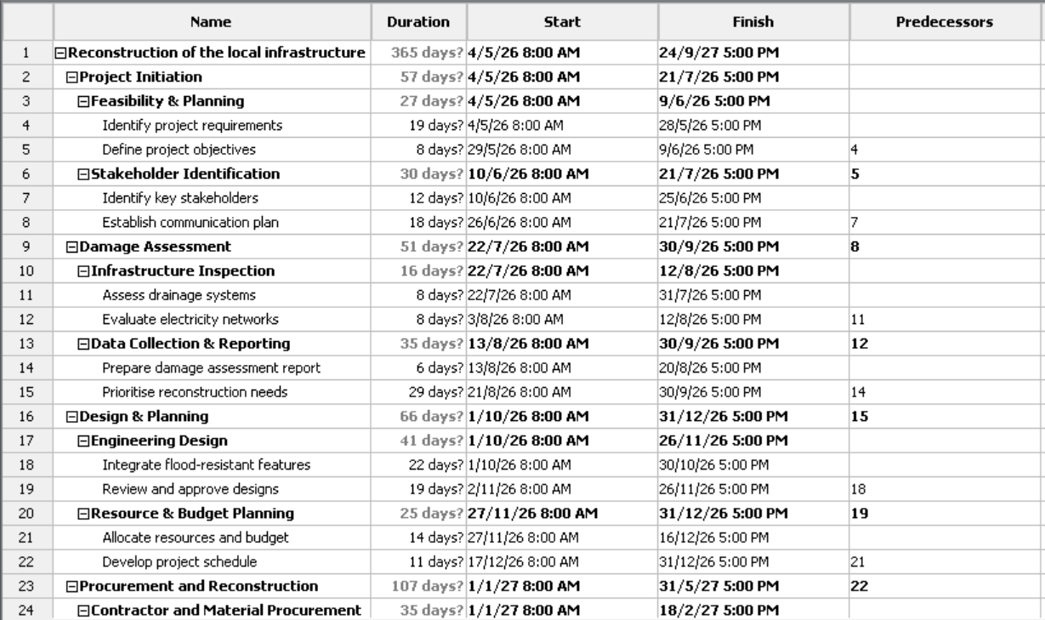
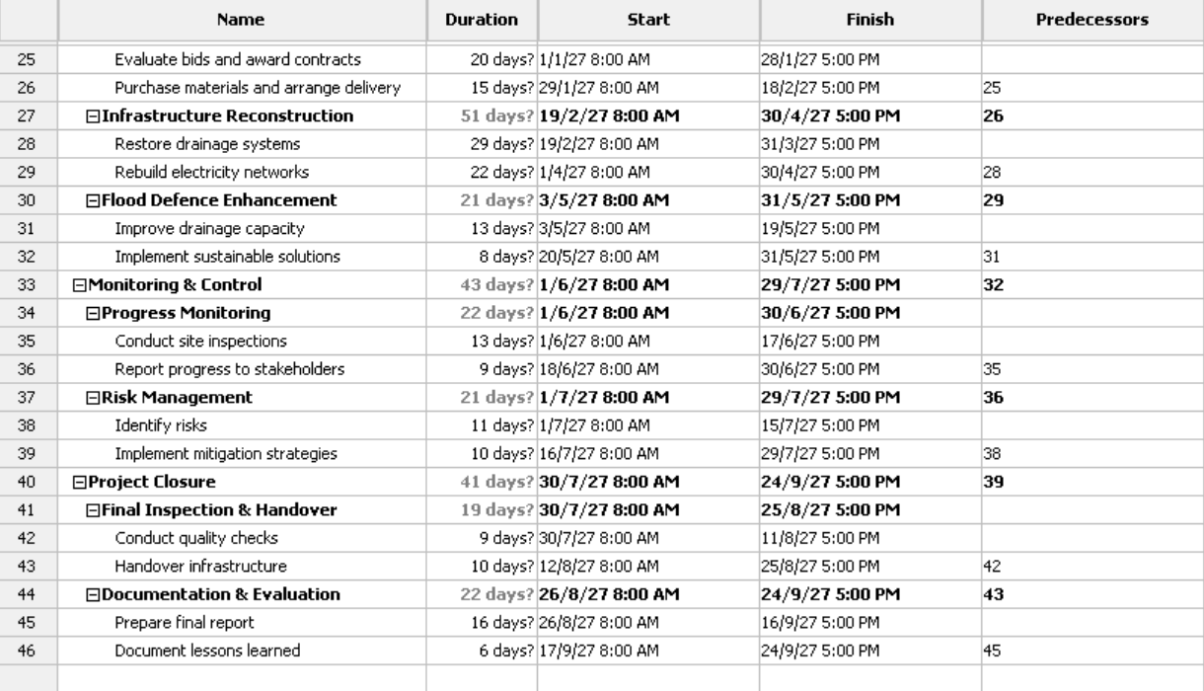
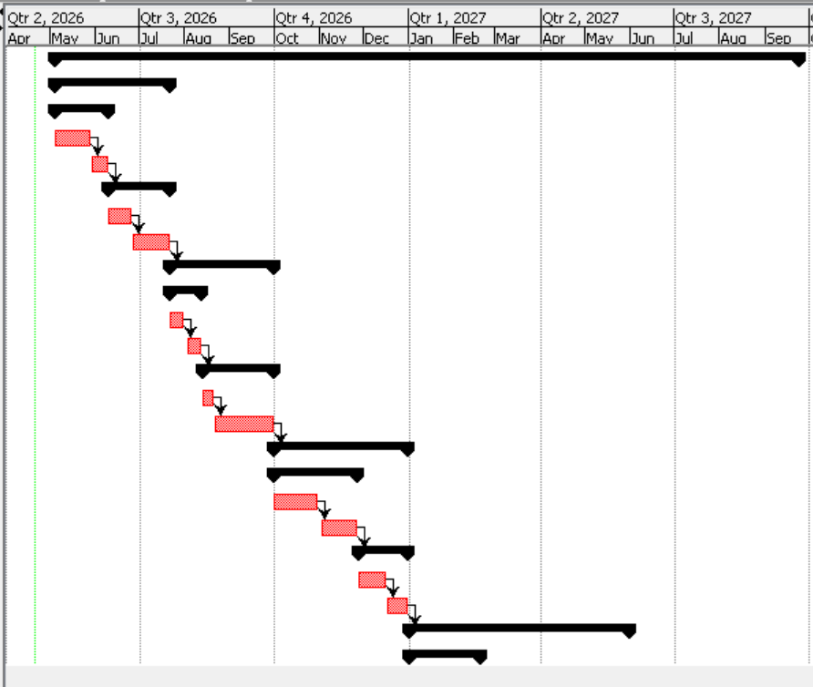
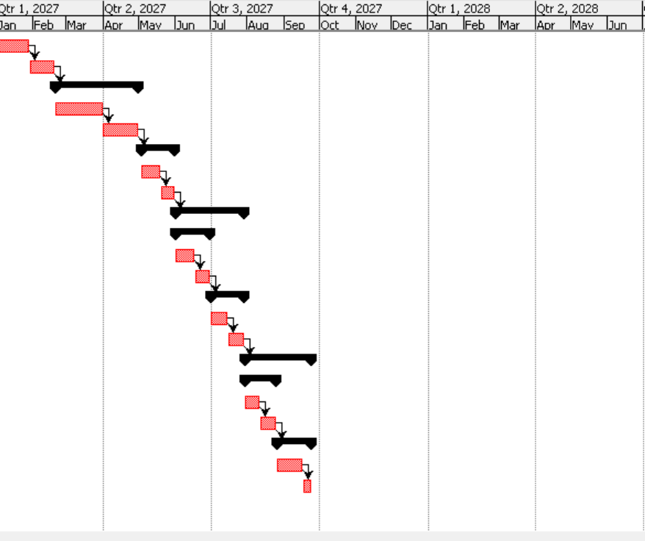

Figure 5: Gantt chart
Gantt charts are essential for the multi-step, complex and/or multi-person-based project with strict deadlines that encourage project management to monitor the schedule to complete the entire project within the time (Levin and Levin, 2019; Geraldi and Lechter, 2012). In addition, the success of the project is ensured if the project is completed within the time and budget, while meeting the quality of the project outcomes (Guide, 2008). According to the above image, the project of reconstruction of the local infrastructure that has been damaged will be completed by 24.09.2027 (Refer to Figure 4). The activities of this project indicate a chronological and rational workflow in accordance with the classic project management stages. It starts with initiation and planning, which helps to set clear goals and involvement of stakeholders, and continued damage assessment to prioritise needs. The design stage incorporates the aspect of resilience with flood-resistant characteristics, which make it sustainable in the long run. Procurement and reconstruction are concerned with the effective utilisation of resources and the reconstruction of infrastructure. Monitoring and control are used to ensure tracking of progress and to reduce risks at the same time. Project closure focuses on quality assurance and documentation. In general, the systematic task process increases the level of coordination, responsibility and effective completion on time and budget.

3.7 Stakeholders’ involvement
Analysis of the stakeholders is essential for projects, as it helps in identifying key stakeholders to prioritise their requirements to ensure the success of the project. In this context, Tampio, Haapasalo and Ali (2022) mentioned that the stakeholder analysis is essential in the stakeholder management procedure as it helps the teams to gain information about their needs and improve the appropriate engagement strategies. However, Zhu et al. (2024) claimed that the stakeholder analysis helps to recognise and determine the characteristics of the stakeholders, such as their position, roles, interests, expectations and attitudes. Therefore, the analysis of the stakeholders is effective in identifying the important stakeholders to prioritise their requirements to enhance engagement strategies. According to Banchoff et al. (2025), the stakeholder mapping used two axes, such as the “Power Vs Interest” matrix of Mendelow, to categorise the stakeholder groups to address the most influential or powerful stakeholders. Hence, the application of stakeholder analysis has been applied for this study to recognise the influential stakeholders for this project based on the reconstruction of the local infrastructure that has been damaged.
Stakeholders | Interest (High/ Low) | Importance | Influence (High/ Low)
Local councils such as Worcester, Shrewsbury, and Kidderminster | High | Essential for the entire leadership, approvals, planning and coordination of reconstruction activities of the project | High
Environmental agency | High | Helps in ensuring environmental protection, flood risk management, and compliance with regulations | High
Central government of the UK | Low | Offers key funding, authorisation and policy direction for large-scale infrastructure recovery | High
Construction companies | High | Important for offering physical reconstruction work, and by meeting the quality and schedule of the project | High
Emergency services | High | Essential for risk assessment, emergency responses and safety planning during the project execution | Low
Local residents | High | Essential as primary beneficiaries, as their feedback and needs guide project priorities and success | Low
Business owners | High | Important for economic recovery and making sure infrastructure supports commercial activities | Low
Insurance companies | Low | Supporting financial recovery through claims by minimising economic burden on stakeholders. | Low

Table 2: Stakeholder analysis
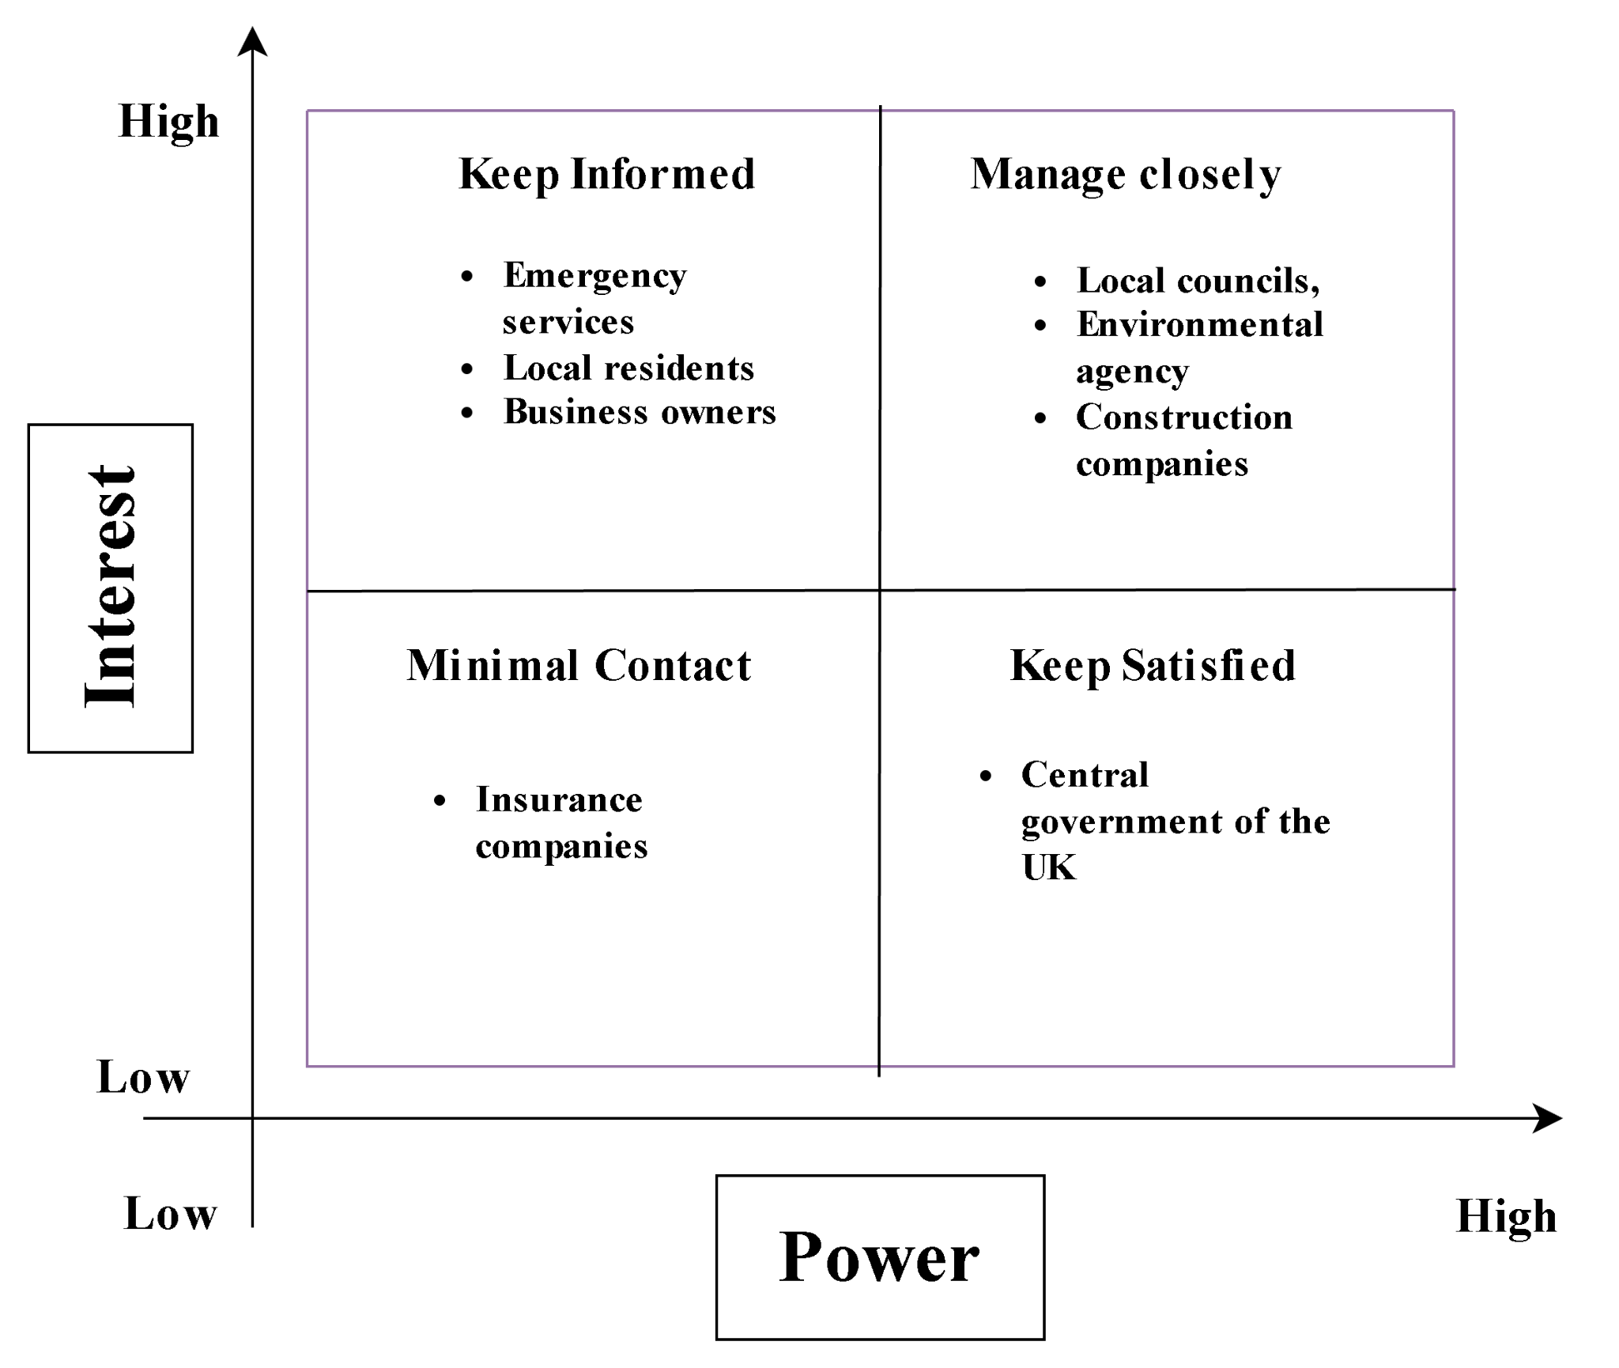

Figure 6: Stakeholder mapping
The stakeholders of this project, based on the reconstruction of local infrastructure that has been damaged, are placed in the quadrants depending on their power and interest in the project. High-power, high-interest stakeholders, including local councils and government bodies, are those that must be under tight management as they make decisions and are directly involved. In addition, there should be high-power, low-interest stakeholders, such as the regulatory bodies, who should be satisfied because they are able to affect approvals. Low–power, high–interest stakeholders, including residents and businesses, should be kept informed as they are directly affected. Low power-low interest groups, like the general masses, need minimal effort; however, they should also be tracked down to prevent unanticipated worries (Refer to Figure 6). As a result, this is effective in communicating with the stakeholders to prioritise their needs to ensure the project's success. As opined by Shakeri and Khalilzadeh (2020), effective communication builds a bridge between different stakeholders involved in the project, so it plays a significant role in ensuring the success of the project. As a result, the high-power and high-interest-based stakeholders need to negotiate carefully, whereas the high-interest and low-power-based stakeholders need to consult. Furthermore, low-power and interest-based stakeholders need to be informed, and high-power and low-interest-based stakeholders need to be enabled to transfer every update regarding the project (Refer to Figure 7).
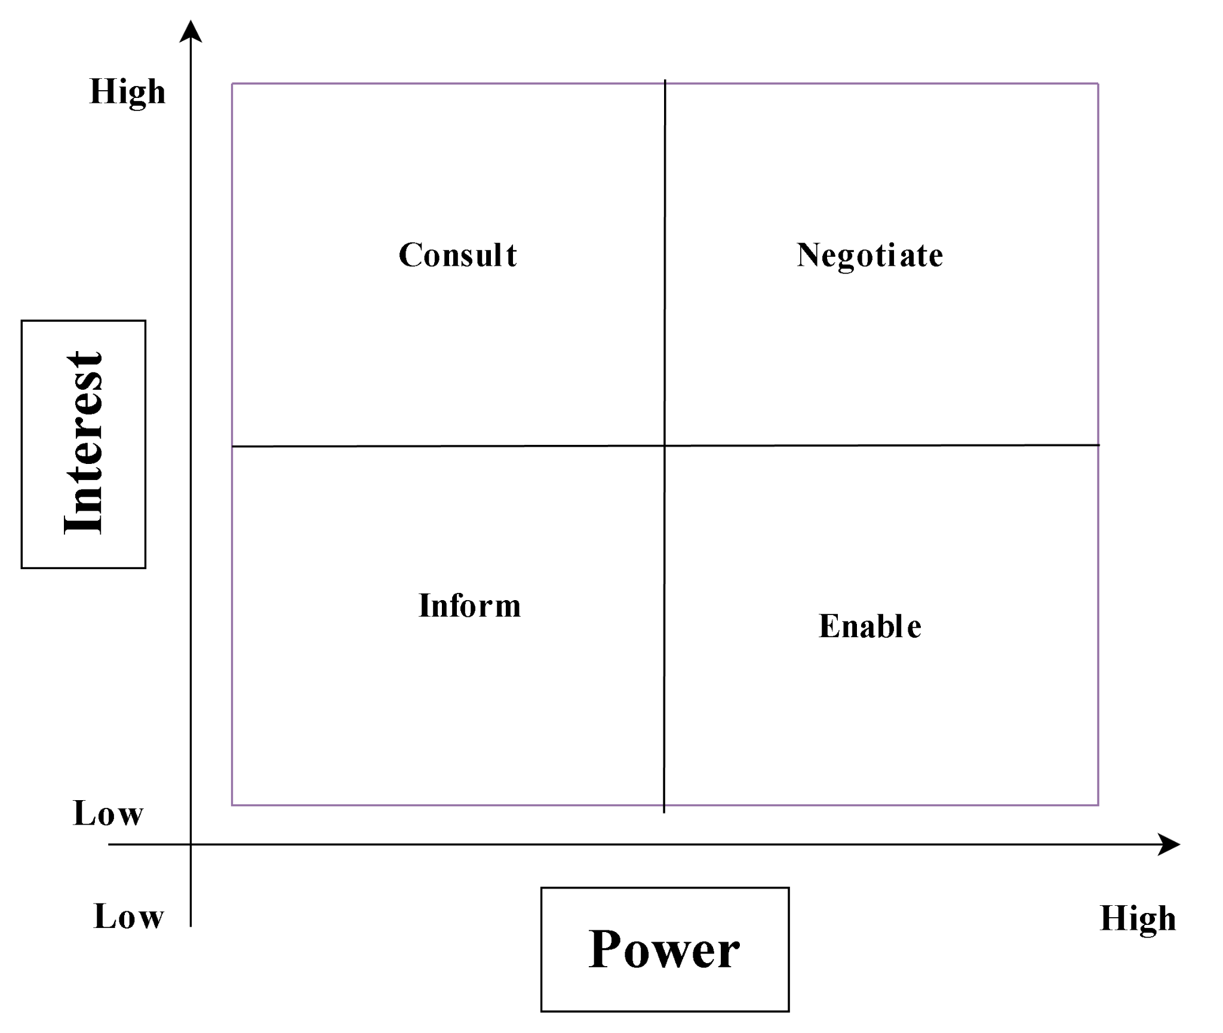

Figure 7: Communication approaches with the stakeholders

3.8 Allocation of resources
Resource type | Allocated to | Purpose | Quantity/level
Human resources | Engineers, contractors, project managers and labours | Designing, construction, supervision and planning | High
Financial resources | Government funding, partnership and insurance | Operational costs, materials and cover reconstructions | £60-£80 million
Material resources | Construction materials such as pipes, steel, concrete and others | Infrastructure repair and flood defence systems | Medium-high
Technological resources | Monitoring tools and project management software | Planning, performance tracking and scheduling of the project | Medium
Equipment | Machinery such as trucks, cranes, excavators and others | Support construction and transport activities | Medium
Time | The project timeline is 365 days | Ensure timely competition of every task | Fixed

Table 3: Allocation of all resources
The resource allocation shows that there is a balanced allocation of key inputs needed in the successful delivery of the project. The highest priority is in accordance with human resources because they form a core of planning, execution and supervision, which offer technical quality and coordination. There are a lot of financial resources, which demonstrate the magnitude and intricacy of infrastructure reconstruction. The allocation of materials and equipment will aid in the efficiency of construction processes and technology will aid in decision-making and monitoring. Time is viewed as a limited resource, which underscores the significance of time planning. Finally, the allocation corresponds with the project objectives and constraints by allowing to optimise the utilisation of resources and allowing the timely, cost-efficient and high-quality completion of a project.

3.9 Risk Analysis
Risk | Description | Severity (1= low, 3= high) | Impact (1= low, 3= high) | Overall risk | Risk owner | Mitigation strategy
Extreme weather | Additional flooding or strong delays the reconstruction activities | 3 | 3 | 9 | Environment agency/ project management | Conduct flexible scheduling, use weather forecasts to predict the weather conditions
Funding delays | Delays in the release of funds affect project progress | 2 | 3 | 6 | Finance team and the central government | Maintain contingency reserves and diversify the funding sources
Supply chain disruption | Delays or shortage of materials and equipment | 2 | 2 | 4 | Procurement managers | Contact with multiple suppliers and maintain inventory appropriateness
Community disruption | Dissatisfaction or displacement of residents | 2 | 2 | 4 | Local councils | Offer support services, promote clear communication, and engage them in decision-making
Design failures | Ineffective flood resistance designs | 3 | 3 | 9 | Engineering Team | Conduct thorough reviews, regular inspections and training
Health and safety risks | Accidents during the construction activities | 2 | 3 | 6 | Site manager | Enforce safety regulations and training
Regulatory delays | Delays in approvals and the compliance process | 2 | 2 | 4 | Regulatory authorities | Early engagement and continuous communication with regulators

Table 4: Risk analysis for the reconstruction project of local infrastructure
 |  | Severity
 |  | 1 | 2 | 3
Impact | 1 | 1 | 2 | 3
Impact | 2 | 2 | 4 (Regulatory delays, Community disruption, Supply chain disruption) | 6 (Health and safety risks)
Impact | 3 | 3 | 6 (Funding delays) | 9 (Design failures; Extreme weather)

Table 5: Risk Register
The major risks of the project, reconstruction of local infrastructure that has been damaged, have been analysed in the above table. It has been found that the Design failures, Extreme weather, Funding delays and Health and safety risks have posed a high threat to the project. However, Regulatory delays, Community disruption and Supply chain disruption have a moderate risk level on the project.

3.10 Conclusion
In conclusion, this project management plan offered an all-inclusive outline of the successful rebuilding of flood-damaged infrastructure in the West Midlands. Through the incorporation of organised planning applications like WBS, Gantt charts, stakeholder analysis, and risk management, the project is bound to achieve efficient coordination, resource usage, and delivery on time. The focus on sustainability and flood-resilience design enhances the long-term security of the community and the sustainability of infrastructures. Moreover, stakeholder engagement and risk mitigation are well defined, which augments the performance and reliability of the project. In general, the plan not only helped revive after the disaster, yet also prepared for the future, which will result in resilient and sustainable regional development.

References
Banchoff, K., Muktar, S.A., Perry, K.E., Williams, K.N., Rabary, M., Jacobs, C., Morgan, R. and Kalbarczyk, A. (2025) ‘Stakeholder mapping for a complex and diverse population: methodology for identifying leaders across sub-Saharan Africa’, BMC Public Health, 25(1).
BBC (2022) ‘River Severn Flooding: Homes and businesses evacuated’, BBC, 22 February. Available at: https://www.bbc.com/news/uk-england-shropshire-60475077 (Accessed: 12 April 2026).
Ford, J.D. and Wei, T. (2015) ‘Quad Charts in the Classroom to Reinforce Technical Communication Fundamentals’, Journal of Technical Writing and Communication, 45(3), pp. 275–284.
Geraldi, J. and Lechter, T. (2012) ‘Gantt Charts Revisited: A Critical Analysis of Its Roots and Implications to the Management of Projects Today’, International Journal of Managing Projects in Business, 5(4), pp. 578–594.
Guide, P.M.B.O.K. (2008) A guide to the project management body of knowledge.
Kutasi, R. (2023) ‘FEEDBACK: UNVEILING ITS IMPACT AND ENHANCING ITS EFFECTIVENESS IN EDUCATION’, Revista de pedagogie, LXXI(2), pp. 7–32.
Levin, S.P. and Levin, M. (2019) ‘Managing ideas, people, and projects: Organizational tools and strategies for researchers’, IScience, 20(20), pp. 278–291.
Motahar, H., Fauth, J. and Melzner, J. (2025) ‘Integrating work breakdown structure and social network analysis for stakeholder coordination in European building permitting’, Building Research & Information, pp. 1–20.
Odedairo, B.O. (2024) ‘Assessing the influence of various work breakdown structures on project completion time’, Engineering, Technology & Applied Science Research, 14(2), pp. 13773–13779.
Oyebode, O.J., Igwegbe, C.N., Elesa, B.L. and Oyebode, F.A. (2022) “Realization of Sustainable Civil Infrastructures Through Effective Project Management in a Challenging Economy”. Journal of Construction Engineering, Technology & Management, 12(3), pp.1-10p.
Rolfe, G., Freshwater, D. and Jasper, M. (2001) Critical reflection for nursing and the helping professions: A user’s guide. Palgrave Macmillan.
Scott, A.G. and Hafenstein, T. (2021) ‘Missing in action and lost in thought: a grassroots implementation of genre pedagogy by practitioner researchers in an English language classroom for adults’, Signo, 46(86), pp. 103–120.
Shakeri, H. and Khalilzadeh, M. (2020) ‘Analysis of Factors Affecting Project Communications with a Hybrid DEMATEL-ISM Approach (A Case Study in Iran)’, Heliyon, 6(8), pp. 1–18.
Tampio, K.-P., Haapasalo, H. and Ali, F. (2022) ‘Stakeholder analysis and landscape in a hospital project – elements and implications for value creation’, International Journal of Managing Projects in Business, 15(8), pp. 48–76.
Zhu, Q., Xi, J., Hu, X., Chong, H.-Y., Zhou, Y. and Lyu, S. (2024) ‘Stakeholder Mapping and Analysis of Off-Site Construction Projects: Utilizing a Power–Interest Matrix and the Fuzzy Logic Theory’, Buildings, 14(9), p. 2865.

