Abdul Shahid

0352098

Report on workplace culture and its impact on organisational efficiency

10/07/2020

Executive summery

A report on Tesco will be compiled. Looing at the PESTLE tool and 3 factors affecting Tesco. An analysis of the workplace culture will be discussed suing the cultural web and highlighting positive culture in Tesco. Tesco’s ethical stance will be looked at. Regarding ethical or unethical behaviour. The skills needed for an employee go work at Tesco will be looked at. Relating the alignment of the values and beliefs of the employee and Tesco. Recommendations will also be made to help Tesco in future recruiting.

Contents page
Introduction/procedures ………………..p4
findings ………………………
Tesco history………p5-6
pestle……….p7-10
Tesco culture…………..p11-12
the cultural web………………..p13-17
business ethics…………….p18
Tesco values…………………..p19
Conclusion……………………….p20
Recommendations …………………………..p21
References…………………………. P22-25

Introduction

This report was requested by the CEO of Tesco. The date requested was 10/06/2020. The purpose of the report it to look at Tesco’s workplace culture and ethics towards employees. This report was compiled by Abdul Shahid on 10/07/2020

Procedures

Textbooks and the use of the internet will be used to compile this report.

Tesco’s history

1919

Jack Cohen returns from war and starts a market stall
Jack Cohen began selling surplus groceries from a stall in the East End of London in 1919

1924

The name 'Tesco' is born
The first own-brand product sold, which Jack promised would bring unequalled value, was Tesco Tea - before the company was called Tesco. The name comes from the initials of TE Stockwell, who was a partner in the firm of tea suppliers, and CO from Jack's surname. (Our history, 2020)

1929

The first Tesco store
Jack Cohen opened the first Tesco store in Burnt Oak, Edgware, north London. The store sold great value dry goods and the first ever branded product, which, unsurprisingly, was Tesco Tea! (Our history, 2020)

1934

Jack builds a new headquarters
Jack Cohen bought a plot of land at Angel Road, Edmonton, north London to build a new headquarters and warehouse. It was the first modern food warehouse in the country. New ideas for stock control brought greater savings for customers.

“It was the first modern food warehouse in the country” (Our history, 2020)

1937

Growing our business
The 1930s saw Jack Cohen buying stores and growing the business. Tesco expanded across London, into the suburbs and neighbouring counties. (Our history, 2020)

1955

A rapid expansion
We bought 19 Burnards stores. Over the next five years, 500 new stores were purchased.

500(Our history, 2020)

1958

Our first supermarket
The first supermarket opened in Maldon, Essex. The new format store included a counter service selling cheese, butter and meats weighed by sales assistants. (Our history, 2020)

Our Code of Business Conduct
Our Code of Business Conduct is at the heart of how we run our business and is designed to help and protect us. It is important that we all understand the rules that we must follow, and the conduct that is expected of us, in order to look after our colleagues, do a great job for customers and protect our reputation.
Whether you are new to Tesco or have worked for our business for some time, please take the time to understand our Code and how it applies to you.
Our Code means more than just following the law and our policies. It’s about using our Values and Leadership Behaviours to guide our conduct and decision-making so that we are always doing the right thing for each other and the business.
If you ever have concerns about your own conduct or that of another person, you must speak up straight away and talk to someone you trust, starting with your line manager. Alternatively, speak to your People Partner or the Legal team. If you need to raise your concern anonymously, you can call Protector Line in complete confidence.
We should all be proud of our business and the contribution that we make and by living our Code, we can build an even stronger business for the future. (How we do business, 2020)

Core Purpose and Values

Our core purpose:
Serving shoppers, a little better every day
Our business was built with a simple mission – to be the champion for customers, helping them to enjoy a better quality of life and an easier way of living. This hasn't changed. Customers want great products at great value which they can buy easily and it's our job to deliver this in the right way for them.
That's why 'Serving shoppers a little better every day' is our core purpose. As a business, serving customers is at the heart of everything we do – from colleagues in our stores to those of us in supporting roles.
In the UK, we serve some 66 shoppers every second, so it's our goal to ensure every one of those customers experiences just a little better service on each visit.

Our Values help us to understand how to put this into practice: (Core Purpose and Values, 2020)

PESTLE
is a mnemonic-abbreviation which stands for Political, Economic, Social, Technological, Legal and Environmental. It is a fundamental business planning framework for a company to analyse macro-environment factors for determining whether to launch a new project or not. Mind mapping tool fits for PESTLE Analysis with a whole intuitive view page to see the structure anytime. Moreover, mind maps help users boost efficiency in analysing PESTLE factors to make a decision of launching plan. Before starting a PESTLE analysis with mind map tools, we should know the concept of PESTLE factors. (PESTLE Analysis with Mind Map Tools - Mind Map Software, 2020)
Political- influences the economy. New projects may be intended by companies, but research should be conducted in government policies, funds and trading policies. It is well worth entering in this field if the policy is supported in the industry. If the government in the industry restrain without incentives it may be hard to develop a project.
Economical factors – have an effect on the long-term development of a company. Inflation or deflation could be a perfect example. The product prices will fluctuate and purchasing power will be affected for the consumer, they will not buy without hesitation. Economic factors like exchange rate, inflation rate and taxation will need to be monitored before launching a product.
Social factors - Social factors are in a wide range containing culture difference, demographic analysis, ethical issues, buying trend and lifestyles, etc which influence the propaganda way and potential target customers straightforwardly. . (PESTLE Analysis with Mind Map Tools - Mind Map Software, 2020)
Technological factors a core part of technological factor is innovation ability. As technology is always changing, one has to always look out for improvements in the industry.
Legal factors – different countries may have different laws and regulations in the sense of business expansion and monopoly. The monitoring of legal facts is of vital importance in monitoring the sustainable development of the market.
Environmental factors – climate change or global warming, reduction of carbon footprint or environmental regulations influence business tendency. Therefore, environmental factors play a huge role in analysing external environments.

Below are diagrams of pestle.
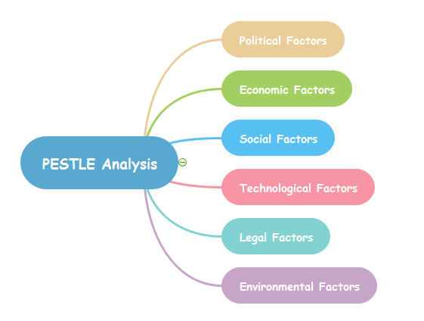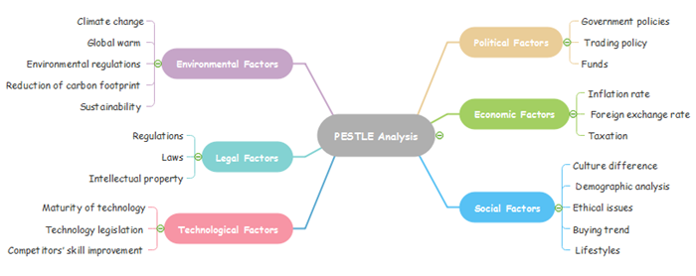

3 Pestle factors affecting Tesco

Political
factors effecting Tesco would be due to Brexit plans. Tesco is a British retailer which operates in different countries such as Hungary, Poland, Ireland, Malaysia, Slovakia, china etc. but Brexit has created a lot of uncertainty. For example, when the UK eventually leaves the EU, it will be uncertain times for Tesco as it will have to adapt to changes. Brexit will affect the import and export of goods to countries as there will be different laws when the UK leaves the EU as of now free movement is allowed but after Brexit good deals have to be made by the UK in order to get the best deals for the retail market. Also, the weak pound against other currencies due to Brexit will make a lot more expensive to trade. Tesco will have need to, like they have in previous times adapt to the new legislation and continue to trade.
Economic factors affecting Tesco.
As the global economies have been severely affected by Covid-19, it is expected that many people’s earnings are likely to go down, and many may lose their jobs. This may result in less spending by customers or switching to cheaper brands. This may severely affect the operations and profits of Tesco. Likewise, high labour cost, particularly in the UK and Ireland, costs Tesco millions of pounds every year. (Howandwhat.net. 2020)
Due to cvid-19 the whole world itself has come to a standstill. The sever devastation of the number of deaths has made it one of the worse pandemics in history.
This has had a detrimental effect on Tesco in the sense of less people being able to visit the shop as people are scared of catching the disease especially the elderly. Strict social distancing rules allow less people to addend Tesco. Also the shortening of the closing hours effect tacos sales drastically. Due to covid-19 a lot of staff have been unable to attend work as any symptoms would need to be self-isolated for 14 days.
Legal factors.
Government policies and legislation impact on Tesco directly. For instance, Davis (2018) reports that UK and EU competition law prohibit anti-competitive activities and therefore, Tesco cannot just simply merge with, or purchase another supermarket of its size in the UK as the country’s competition watchdog (The Competition and Markets Authority, CMA) can block such moves.
Tesco cannot pay any employee less than the minimum wages set by the government. Likewise, it cannot sell alcohol to underage customers.

Again, due to Brexit a lot of different legislations will be introduced, and Tesco will need to adhere to them. This will increase cost for Tesco in order to train the management in the new legislations.

Tesco’s culture
Our business was built with one simple mission - to be the champion for customers, helping them to enjoy a better quality of life and an easier way of living. This hasn't changed.
Customers want great products at great value which they can buy easily and it's our job to deliver this in the right way for them.
That's why we've chosen 'Serving Britain's shoppers a little better every day' as our new core purpose. As a business, serving customers is at the heart of everything we do, from colleagues in our stores to those of us in supporting roles.
In the UK, we serve some 66 shoppers every second, so it's our goal to make sure that every one of those customers experiences just a little better service on each visit. (Culture | Tesco Careers, 2020)

How the Tesco Values influence the way we work

Our values are central to our business and help us to understand how to put our core purpose into practice. Since we first introduced our values more than a decade ago, they have become a central part of our culture. They make sure that every person at Tesco understands what's important - from how we work together as a team to how customers are at the centre of what we do.
- No one tries harder for customers
- We treat people how they want to be treated
- Every little help makes a big difference(Culture | Tesco Careers, 2020)

Little Helps Plan

‘Every little help makes a big difference’ is a core value at Tesco. It drives what we do every day for our colleagues around the world, in the thousands of communities where we operate, and for the millions of customers we serve. It is also the idea at the heart of the Little Helps Plan, which sets out how Tesco will make a difference to the social and environmental challenges that matter most to our customers, colleagues and communities.
We can make the greatest contribution by focusing on our people, our products and our places, the three pillars of the Little Helps Plan. Underpinning these pillars are a number of areas where we remain committed to doing the right thing, which we call our Foundations, and cover important issues such as carbon reduction, health and safety, cyber security and anti-bribery.
The Plan is driving us to create a business where colleagues can get on, whatever their background; to help customers make healthier choices and enjoy good quality, sustainable products, at affordable prices; to ensure sure no food that could be eaten is wasted; to reduce the environmental impact of our packaging; and support the communities we serve. Since launching the Little Helps Plan in 2017, we have made good progress on all these areas and you can access our 2018/19 update below. (Culture | Tesco Careers, 2020)

Value in Your Town

We commissioned independent research to understand the role we play in supporting communities across the UK. Measuring our contribution helps us to understand what more we can do to serve our customers a little better. (Culture | Tesco Careers, 2020)

The cultural web
Strategy and development in an organisation are influenced heavily by the culture and environment. This is often positive, but it can also act as a hinderance, or even a barrier to growth and success. When trying to drive change, managers and other figures of responsibility may find it difficult to break out of the systems, structures and routines embedded in the company’s culture, and politics or individual relationships often play a huge role in deciding strategy.
Published by authors and academics in the fields of business, leadership and management, Kevan Scholes and Gerry Johnson in 1992, the Cultural Web is a useful tool for analysing and altering assumptions surrounding the culture of a company. It can be used to highlight specific practices and beliefs, and to subsequently align them with your company’s preferred culture and strategy. (The Cultural Web Model – BusinessBalls.com, 2020)

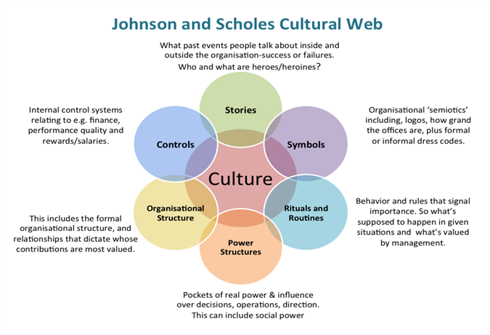

Stories
Past stories from employees encourage people to work at Tesco. The history of Tesco is great from start to the current day. Their moto in ‘every little helps’ that’s in terms of customers and employees.
Some examples from employees would be that Tesco works as a team. Employees trust and respect each other. People listen and support and always say thank you. Employees share knowledge and experience.

Symbols.
the Tesco logo is world renown. Anyone in the UK and countries where Tesco has stores will recognise the Tesco simple.
How the Tesco logo differed through the years are listed below.
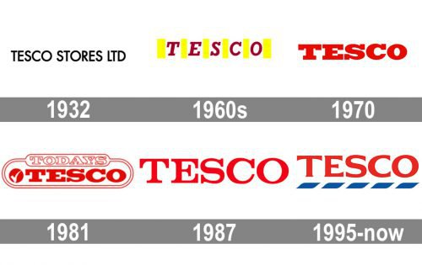
In its early years, the company used a simple black wordmark logo “Tesco Stores LTD” featuring a plain all-cap font. As the supermarket chain was growing, it went through a succession of typographic logotypes. Starting from 1970, red has been the dominating colour of the Tesco logo. The current version of the emblem introduced in 1995 sports a bright red wordmark with a blue horizontal bar placed under each letter
The Tesco logo borrows from the basic colours of the British flag.
The red colour in the logo represents prosperity and happiness, while the blue colour depicts excellence and trustworthiness.

The blue clothing of Tesco is a well renowned fact that everything with Tesco is blue.
Rituals and routines –
Has contributed to Tesco greatly in terms of keeping staff on and gaining customer.
The core belief of every little helps goes a long way to ensuring employees stay motivated and stay in Tesco. Tesco makes employees feel a part of the family.
Tesco’s values are central to our business and help us to understand how to put our core purpose into practice. Since we first introduced our values more than a decade ago, they have become a central part of our culture. They make sure that every person at Tesco understands what's important - from how we work together as a team to how customers are at the centre of what we do.
- No one tries harder for customers
- We treat people how they want to be treated
- Every little helps makes a big difference

The power cultures
Has been change recently as the management has been changed. Thus, improving working life At Tesco.
Tesco bosses have been told to be nice to staff this new change will encourage employees to join and new and fresh approach have been developed. To develop a culture and appreciate each other. This shows that Tesco cares about their colleagues and not just customers and sales.

Organisational structure.

Tesco is a British multinational grocery and general merchandise seller company. It’s headquartered in England. Tesco follows a hierarchical organizational structure. In this structure, positions and obligation are divided into many parts to ensure work will be done efficiently and smoothly. The ones at the top of the business pyramid have the maximum responsibilities and authority.
As it is shown in Figure 1 below, the Tesco organizational structure is constructed with five committees reporting to Tesco PLC Board. 11 members of Tesco Executive Committee are led by Group Chief Executive Dave Lewis. Tesco organizational structure chart is highly hierarchical showing its wide business scope. (Meng, 2020)

Tesco Board of Directors consists of 10 members and significant changes take place on the Board during the financial year 2014/2015. These changes include that John Allan is appointed as the Chairman of the Board, Dave Lewis is to be assigned as CEO, Alan Steward is to be the new Chief Financial Officer, four Non-Executive Directors are to retire and here comes the three new Non-Executive Directors. Shown by the figure below. (Meng, 2020)

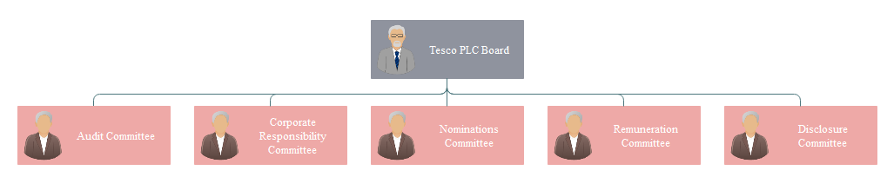

The Figure below is an organizational structure chart example at store level. It’s often questioned that four layers of management within a store can generate annoying bureaucracy with a bad effect on coordination and collaboration among managers. So it’s suggested that reducing layers of management must be done as soon as possible to create more flexibility and faster flow of information. (Meng, 2020)

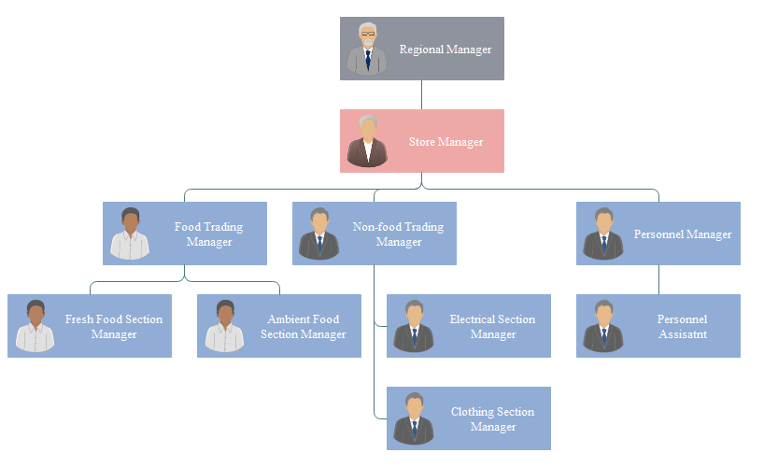
Control system

Colleague benefits include:
- Holiday pay and sick pay
- Maternity pay
- All-employee share schemes such as Buy As You Earn and Save As You Earn
- The chance to join our Retirement Savings Plan where we will match your contributions up to a maximum of 7.5%. It also gives you valuable life cover of five times your pay
- Annual Colleague Bonus Plan, offering up to 3.5% of base salary
- Colleague Clubcard offering 10% staff discount after three months’ service
- Open plan offices with shared desk space enabling colleagues to work with and learn from different colleagues
- Informal meeting spaces and project spaces for teams to collaborate
- Tea points on each floor to make free drinks, take a break and catch up with colleagues
- Restaurants offering fresh food, cooked from scratch using our own products with varied menu choices from building to building
- Health and beauty services, including a nurse, GP and massage therapists
- Free onsite car parking and a frequent free shuttle bus service from the train station

Business ethics
Business ethics is the application of ethical values to business behaviour. Business ethics is relevant both to the conduct of the individual and the conduct of the organisation as a whole=le. It applies to any and all aspects of business conduct, from boardroom strategies and how companies treat their employees and suppliers to sales techniques and accounting practice. (What is business ethics?, 2020)
Corporate social responsibility
CSR is the obligation towards stakeholders from Tesco. It could be any groups or people that have an interest or stake in the company. It could include employees or customers, suppliers. Stakeholders have varying needs. Whereas customers gather concern will be of the product purchased an employee might need a fair wage or a good working environment. Thus, CSR means minimizing the bad effects and maximizing the good effects for Tesco.
Tesco wants to help reduce food waste globally, which is ensuring the excess or surplus food goes to those in need. Tesco wants to make it easier to live healthier. Tesco wants to source great quality products which are affordable and sustainable products. Making contributions to the community where the stores operate.
Tesco are focused on global climate control change threat and protecting the eco system. Such as marine environments and the eco system.

Despite Tesco having all these good points they have in the past had bad press which may lead potential employees of thinking about joining a different company.
For example, in 2004 Tesco was branded unfair and unethical towards smaller shops as Tesco has been opening the express stores or the metro stores.
But Tesco says by opening these stores they are providing for the community in terms of new jobs etc.
In 2014 Tesco was fined £129m pounds over accounting scandals. This also shows that Tesco only has eyes on profits and making them illegally.

Tesco’s values are
No-one tries harder for customer, we treat people how we want to be treated and every little helps makes a big difference. They supply good heath and safety for employees. Equal opportunity and diversity is used to select employees. Unacceptable behaviour is unacceptable. Tesco gives presidency on human rights. Tesco wants to trade fairly. They want ethical trading.
At Tesco employees are expected to work as a team with trust and respect towards each other. Employees and managers should listen, support and always say thank you. Expedience and knowledge should also be shared where good or bad for the better of Tesco.
We know that looking after our colleagues in a culture of trust and respect is essential to the success of Tesco. Where colleagues feel recognised and rewarded for the work they do together, where they have the opportunity to get on and where they are supported in their development as they move through their careers in the business – they in turn try their hardest for customers.( www.tescoplc.com)

Conclusion
After reading all of the Tesco ethics. Any employee would want to join in with Tesco as they would be seen as a rewarding company to work for. Who not only take employees on but ensure they have bonuses if targets are reached? Tesco is seen as a family company where employees will have opportunities to further themselves.
Any people with a family-oriented approach would fit in well with Tesco as Tesco is seen as a family business which also cares for the environment. But there are some drawbacks as the articles say of unethical issues with Tesco, but this is with all companies they will have their good parts and bad.
As now Tesco has changed is hierarchy by firing all the old staff Tesco hopes they can senses in getting customers back into the stores. And employees will see Tesco as firm but fair.
If the organisations beliefs align with the potential employees it would be a match made in heaven and them employee would want to work harder with the same goals.

Recommendations
Although shop staff cannot work from home. Chief executives or CEO’s should work from home thus saving Tesco on bill, like renting office space or electricity bills. This can be done without a doubt as the recent covid-19 how shown that a lot of the work can be done from the home. This could also benefit Tesco and opened opportunities to get better employees especially the ones that need to stay home for looking after children.
Tesco should only hire employees with the same principles for them to success and in keeping long term employment. Tesco’s vision and strategies should be shared with potential employees to discover in the message can by internalised. Could the employee work in an environment where achieving Tesco’s goals is of paramount. Hiring only those with personal goals who have no desire for teamwork will be detrimental to Tesco. Only hire employees with the skill to fit Tesco’s culture.

References
Ibe.org.uk. 2020. What Is Business Ethics?. [online] Available at: <https://www.ibe.org.uk/knowledge-hub/what-is-business-ethics.html> [Accessed 10 July 2020].

Economics Discussion. 2020. Business Ethics: Introduction, Principles, Importance, Theories. [online] Available at: <https://www.economicsdiscussion.net/business/business-ethics/31798> [Accessed 10 July 2020].

Small Business - Chron.com. 2020. What Is Corporate Social Responsibility?. [online] Available at: <https://smallbusiness.chron.com/corporate-social-responsibility-11605.html#:~:text=Corporate%20social%20responsibility%2C%20or%20CSR%2C%20is%20a%20corporation%27s,suppliers%2C%20investors%20and%20the%20communities%20surrounding%20the%20business.> [Accessed 10 July 2020].

Evening Standard. 2004. Tesco Branded 'Unfair And Unethical'. [online] Available at: <https://www.standard.co.uk/news/tesco-branded-unfair-and-unethical-6949514.html> [Accessed 10 July 2020].

Tescoplc.com. 2020. [online] Available at: <https://www.tescoplc.com/media/1239/tesco-code-of-business-conduct-2018.pdf> [Accessed 10 July 2020].

Ruddick, G. and Kollewe, J., 2017. Tesco To Pay £129M Fine Over Accounting Scandal. [online] the Guardian. Available at: <https://www.theguardian.com/business/2017/mar/28/tesco-agrees-fine-serious-fraud-office-accounting-scandal> [Accessed 10 July 2020].

Ethical Consumer. 2020. How Ethical Is Tesco Plc? | Ethical Consumer. [online] Available at: <https://www.ethicalconsumer.org/company-profile/tesco-plc> [Accessed 10 July 2020].

Howandwhat.net. 2020. [online] Available at: <https://www.howandwhat.net/pestel-analysis-tesco/> [Accessed 8 July 2020].

Tesco-careers.com. 2020. Benefits | Tesco Careers. [online] Available at: <https://www.tesco-careers.com/explore-our-world/benefits/> [Accessed 10 July 2020].

Tesco Underwriting. 2020. Rewards & Benefits - Tesco Underwriting. [online] Available at: <https://www.tescounderwriting.com/join-us/benefits-rewards/> [Accessed 10 July 2020].

Incentive & Motivation. 2020. Tesco Release Biggest Reward Scheme In A Decade. [online] Available at: <http://incentiveandmotivation.com/tesco-release-biggest-reward-scheme-decade/> [Accessed 10 July 2020].

Lovewell-Tuck, D., 2007. Employer Profile: Tesco - Employee Benefits. [online] Employee Benefits. Available at: <https://employeebenefits.co.uk/issues/february-2007/employer-profile-tesco/> [Accessed 10 July 2020].

Butler, S., 2016. Manners Maketh Management: Tesco Bosses Told To Be Nicer To Staff. [online] the Guardian. Available at: <https://www.theguardian.com/business/2016/mar/16/tesco-managers-polite-new-initiative> [Accessed 10 July 2020].

Leadershipcentre.org.uk. 2020. Cultural Web | Art Of Change Making. [online] Available at: <https://www.leadershipcentre.org.uk/artofchangemaking/theory/cultural-web/#:~:text=The%20Cultural%20Web%20is%20a%20tool%20used%20to,the%20culture%20need%20to%20look%20like%20to%20make.> [Accessed 10 July 2020].

Tesco-careers.com. 2020. Culture | Tesco Careers. [online] Available at: <https://www.tesco-careers.com/explore-our-world/our-culture/> [Accessed 10 July 2020].

Tesco PLC. 2020. Our History. [online] Available at: <https://www.tescoplc.com/about/our-history/> [Accessed 8 July 2020].

Lurie, J., 2014. [online] Bizjournals.com. Available at: <https://www.bizjournals.com/houston/blog/2014/12/5-methods-to-align-company-and-personal-goals.html> [Accessed 10 July 2020].

Hr.toolbox.com. 2020. How Do You Align Employee And Organisational Interests?. [online] Available at: <https://hr.toolbox.com/question/how-do-you-align-employee-and-organisational-interests-021211> [Accessed 10 July 2020].

Tesco PLC. 2020. How We Do Business. [online] Available at: <https://www.tescoplc.com/about/how-we-do-business/> [Accessed 8 July 2020].

Tesco PLC. 2020. Core Purpose And Values. [online] Available at: <https://www.tescoplc.com/about/how-we-do-business/core-purpose-and-values/> [Accessed 8 July
2020].

Janse, B., 2018. What Is The Cultural Web Analysis (Johnson & Scholes) Theory | Toolshero. [online] toolshero. Available at: <https://www.toolshero.com/management/cultural-web-analysis/> [Accessed 10 July 2020].

prezi.com. 2020. Organisational Structure Of Tesco And Ty- Hafan. [online] Available at: <https://prezi.com/-l58wxtvlexb/organisational-structure-of-tesco-and-ty-hafan/> [Accessed 10 July 2020].

Meng, M., 2020. Tesco Company Organisational Structure Chart Example | Org Charting. [online] Orgcharting.com. Available at: <http://www.orgcharting.com/tesco-company-organisational-structure-chart-example/> [Accessed 10 July 2020].

Farooq, U., 2018. PESTLE Analysis Of Tesco | Marketing Tutor. [online] Marketing Tutor. Available at: <https://www.marketingtutor.net/tesco-pestle-analysis/> [Accessed 8

PESTLE Analysis. 2014. PESTLE Analysis For Tesco Discusses Its Business Environment. [online] Available at: <https://pestleanalysis.com/pestle-analysis-tesco/> [Accessed 8 July 2020].

Mind Map Software. 2020. PESTLE Analysis With Mind Map Tools - Mind Map Software. [online] Available at: <http://www.mindmapsoft.com/pestle-analysis-mindmap/> [Accessed 10 July 2020].

Linkedin.com. 2016. How To Effectively Conduct A PESTLE & SWOT Analysis. [online] Available at: <https://www.linkedin.com/pulse/how-conduct-pestle-swot-analysis-byron-gray> [Accessed 10 July 2020].

Positive Negative Effects. 2020. Positive And Negative Effects Of Culture - Essay And Speech. [online] Available at: <https://www.positivenegativeeffects.com/culture> [Accessed 10 July 2020].

Rodger, J., 2020. This Is Why Supermarket Logos Are Certain Colours. [online] birminghammail. Available at: <https://www.birminghammail.co.uk/whats-on/shopping/supermarket-logos-certain-colours-12772238> [Accessed 10 July 2020].

: Businessballs.com. 2020. The Cultural Web Model – Businessballs.Com. [online] Available at: <https://www.businessballs.com/strategy-innovation/cultural-web-johnson-scholes/> [Accessed 10 July 2020].
1000logos.net. 2020. Tesco Logo And Symbol, Meaning, History, PNG. [online] Available at: <https://1000logos.net/tesco-logo/> [Accessed 10 July 2020].

Bing.com. 2020. The Cultural Web - Bing. [online] Available at: <https://www.bing.com/images/search?view=detailV2&ccid=nW5XBGl%2b&id=3D66C39D35271683C726847ED06098B779F065D0&thid=OIP.nW5XBGl-Ugo_8FyFGnPpngHaFD&mediaurl=http%3a%2f%2fwww.managementcentre.co.uk%2fwp-content%2fuploads%2f2016%2f03%2fJohnson_and_Scholes_Cultural_web-50792.png&exph=461&expw=675&q=the+cultural+web&simid=607989896629323876&ck=61397C34429D75575C7967C8510DC13B&selectedIndex=0&ajaxhist=0> [Accessed 10 July 2020].

Mindtools.com. 2020. The Cultural Web: Aligning Your Organization's Culture With Strategy. [online] Available at: <https://www.mindtools.com/pages/article/newSTR_90.htm> [Accessed 10 July

