

Module Name: Marketing Management
Module Code: LCMB7024
Title: The Strategic Brand Development and Marketing Mix Implementation for ELECTRA by Samsung

Submitted to
Dr Laila Maazouz
Lecturer,
University of Wales Trinity Saint David, London Campus

Submitted by
Student Name: Gulam Kibria
Student ID: 2431573

Term 1
Word Count: 2298
Submission Date: 17th December 2025
Executive Summary
The new brand, called Electra, the luxury electric vehicle (EV) produced by Samsung, is a combination of the latest technological advancements, eco-friendliness, and high design that will rebrand the driving experience. As Samsung has a track record of excellence in electronic products, Electra will target technological, wealthy, and ecologically-conscious buyers who desire a high-performance car that fits into the digital life. The main distinguishing characteristics of Electra are AI-based safety systems, smartphone connectivity, and zero-emission vehicle operation, which make it better than such models as Tesla and BMW. The brand will be concentrated on the high-end design, high connection, and sustainability and will establish itself as a market leader in the emerging luxury EV market. The marketing plan will include the segmentation, targeting, positioning and marketing mix that will lead to the success of Electra in making a strong presence in both automotive and tech industry.

Table of Contents
1.0 Introduction 4
2.0 Segmentation, Targeting, Differentiation, and Positioning (STDP) Analysis 4
2.1 Segmentation 4
2.2 Targeting 5
2.3 Differentiation 6
2.4 Positioning 6
3.0 Marketing Mix (4Ps) 7
3.1 Product 8
3.2 Price 9
3.3 Place 9
3.4 Promotion 10
4.0 Reflection 11
4.1 Brand Development 11
4.2 Presentation Skill 11
6. Conclusion 12
References 13

1.0 Introduction
Electra is a brand of Samsung new luxury electric vehicle (EV) that will be a combination of sustainability, advanced technology, and luxurious design. Electra is another electronic company with technology and innovation capabilities that redefine the driving experience: it has AI-driven safety, a full-integration smartphone with Electra, and even environmentally friendly features. The brand is designed to serve consumers who are concerned with the sustainability of the environment as well as performance. This is aimed at creating an all-embracing marketing plan that will entail segmentation, targeting, positioning and the marketing mix, and making Electra a top luxury EV brand. It will attract tech-savvy and environmentally conscious car consumers with a desire to experience a premium connected driving experience.

2.0 Segmentation, Targeting, Differentiation, and Positioning (STDP) Analysis
The Samsung Electra is a brand that involves an attempt to enter the competitive electric vehicle (EV) market and provides a high-quality, sustainable, and technologically enhanced driving experience. With the help of the STDP framework, Segmentation, Targeting, Differentiation, and Positioning, the marketing strategy of Electra is aimed to attract the attention of environment-conscious, technologically advanced customers who want to have the luxury EV that will be able to combine the features of the latest technology with the elements of environmental friendliness.

2.1 Segmentation
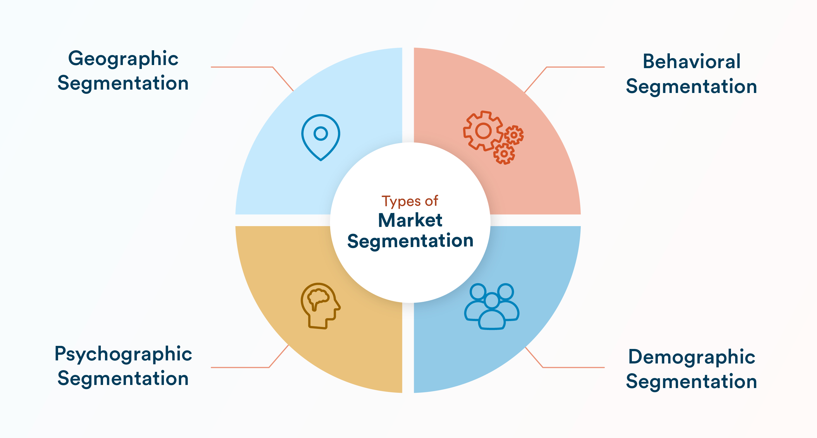
Figure: Segmentation (Banerjee , 2024)
Geographic
Electra will target the urban markets in UK, USA and Russia where EV penetration is growing very fast. The areas also have a well-developed EV infrastructure, such as charging points, and have a large proportion of high-income urban professionals (Dalkic-Melek, Saltik and Tuydes-Yaman, 2024). These customers are better equipped to adopt electric mobility and are becoming more interested in sustainable living and new technology.
Psychographic
Electra targets the consumer who takes into account the innovation, luxury, and sustainability. These visionary people are driven by the need to have less carbon footprint even as they experience high-quality technology (Tasneim Aldhanhani et al., 2024). They love environmentally-friendly products and demand to experience what can satisfy their values, and Electra is the right place to be to those who want to combine luxury and sustainability as part of their daily routine.
Demographic
Electra is aimed at the middle to high-income client aged 25-55, who is tech-savvy and requires luxury in his/her lifestyle. This entails young professionals and the high-income earners who are ready to invest in high-performance cars that are luxurious and also rich in technology (Diaconu-Cerceloiu and Mădălin Lucian Cerceloiu, 2025). Features of Electra, including AI safety systems and intelligent connectivity, are congruent with the needs of this group of people, who appreciate innovation as well as exclusivity.
Behavioral
Electra is aimed at early adopters of technological innovations who are looking to have a high-end driving experience. These environmentally friendly people value intelligent, connected gadgets and want cars that allow them to drive ethically and have a car that integrates with their digital environment, thus Electra is the best option (Vermesan et al., 2021).

2.2 Targeting
The key target market of Electra is urban professionals aged 25-55 who are concerned with luxury, technologies, and sustainability. This group is usually well-off, tech-sophisticated, and eco-friendly, which makes them the perfect target audience of a high-end electric vehicle that would incorporate the modern technology and a luxurious design (Barakati et al., 2024). Electra is targeted at the consumer with a need to be status-aware, innovative, and mobile in an environmentally friendly way. They are encouraged by the need to become early users of the advanced technology, especially that of the electric cars. This target market is interested in an interlinked driving experience, a blend of the car with their own digital life, and in products that demonstrate their values of sustainability and style.

2.3 Differentiation
Electra will stand out among other brands such as Tesla, BMW, and Audi due to the technological skills of Samsung and its distinct combination of luxury and sustainability.
- The Technological Leadership of Samsung: Exchanging the experience of Samsung as a consumer electronics company, Electra is an AI-controlled safety, smartphone connectivity, and connectivity-oriented car, which offers a seamless and connected driving experience (Zulfitri and Sari, 2024). It is a part of Samsung product ecosystem, which makes it much easier.
- AI Safety Features: Electra has both safety and technology options and has AI-driven safety features with intelligent sensors that anticipate threats and help a driver to avoid accidents (Sultanova, 2024).
- Luxury Design and Sustainability: Electra follows the combination of luxury minimalism design and environmentally friendly materials, which provide an ideal ratio of beauty and sustainability, unlike other vehicles of the luxury EV segment.

2.4 Positioning

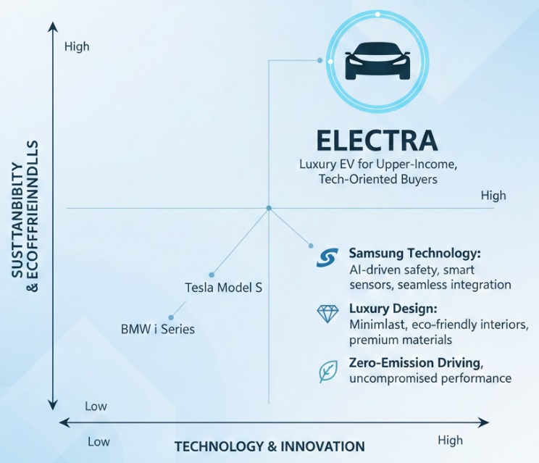
Figure: Positioning
Electra will be placed as the luxury electric vehicle of upper-income, technology-oriented buyers who want to enjoy a luxury driving experience without violating their environmental values. With its AI-enhanced safety, smartphone connectivity, and zero-emission engine, Electra will attract customers that require high-performance, luxury design, and high-tech equipment (Lensari Embarka et al., 2024). The Electra has a reason to exist in the market because Samsung technology and the increased need of sustainable, innovative vehicles, can be seen as the distinctive selling point of the product, which will help it attract the interest of people, who seek a connected, sustainable, and luxurious driving experience.

3.0 Marketing Mix (4Ps)
The Electra brand of Samsung has found itself in the competition of the luxury electric vehicle (EV) market that is highly competitive with the aim of attracting eco-conscious and tech-savvy consumers through a comprehensive marketing mix. The 4Ps model including Product, Price, Place, and Promotion will be used to develop a unified approach to Electra in a way that all components of the marketing mix will be consistent with the brand image of a luxury, innovative and sustainable vehicle.
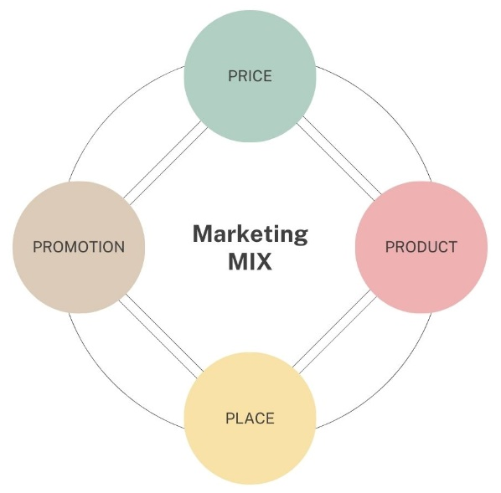
Figure: Marketing Mix (Author)

3.1 Product
- Product Value
Electra is being marketed as a performance luxury electric car with a combination of new technology, a more sustainable environment, and style to stand out in the competitive electric vehicle (EV) market. The brand aims at providing high quality driving experience to tech-savvy, affluent, and environmentally conscious customers. Introducing the latest technologies, including AI-driven safety features and smartphone connectivity, makes Electra an excellent driving experience, and its zero-emission engine also contributes to sustainability. This luxury and innovativeness give considerable value to the performance-demanding people without compromising on environmental responsibility.
- Actual Product
Electra has a long battery life and rapid charging, which makes it convenient to use both in long-distance movement and commute to the city. Electra competes with the best EVs, such as Tesla Model S, offering the same performance and range, but including luxury features (Ishigai, Pereira and Scavroni, 2021). It will also be associated with AI-driven safety features like collision avoidance and adaptive cruise control which will take the driving experience to the next level. The propulsion system of the car is zero-emission, which means that a consumer can cut their carbon footprint without losing performance or convenience, which is also attractive to environment-conscious consumers.
- Augmented Product
Electra provides a smooth smartphone experience with Samsung products where the users can manage key features such as navigation and climate control. The interior design is minimalist luxury with sustainable materials, which offer a comfortable and fashionable atmosphere. This mixture of innovative technology and the high-end design makes Electra a high-end option in the EV marketplace, which is both innovative and sustainable.

3.2 Price
Electra will have a premium pricing strategy which will position itself as a luxury product in the market of electric vehicles, with a high price. The innovation and high-quality of the electronic gadgets produced by Samsung will make sure that Electra has a price that matches its advanced features, luxury design and premium technology (Lau, 2025). The high cost will also be based on the position and prestige of the possession of a luxury car.
Justification for Premium Pricing: The prices of Electra are reasonable due to its AI safety systems, long-range batteries, smart sensors, and the use of sustainable and environment-friendly design. The brand equity of Samsung adds to the perceived value of the vehicle, as it has better features than other competitors such as Tesla Model S and BMW i Series. The pricing will be pegged at the premium EV segment and provide superior luxury and technology integration.

3.3 Place
The distribution strategy of Electra will be based in the form of exclusive showrooms, online stores and luxurious dealerships where Samsung is strong in terms of its global presence and reputation as an innovative company.
- Exclusive Showrooms: Electra will be marketed in Samsung branded stores in major cities with a well-developed EV infrastructure. The showrooms will provide an interactive experience to the customers where they can see the design, technology, and performance of the car but retain the high-end image of the brand (Mahmudur Rahman, 2015).
- Online Sales Platforms: Samsung will provide online the possibility to purchase through its web site, and this will be convenient to tech-savvy customers, allowing them to shop and buy with ease. The platform will enable one to set up vehicle configurations, have access to details information and work together with Samsung offerings such as Samsung Pay and Galaxy app (Mahmudur Rahman, 2015).
- Partnerships with High-End Dealerships: Samsung will collaborate with upmarket car dealers in key cities like Seoul, Tokyo, San Francisco, and London to expand the presence of Electra and provide clients with high-quality purchasing experience.

3.4 Promotion
The promotion strategy Electra will use will be digital marketing, influencer partnership, and experiential test-drive and PR to create brand awareness and attract potential clients.
- Digital Marketing: The social media, targeted ads, and content marketing will help Samsung mention the main features of the Electra, including sustainability, luxury, and high-technological features. The campaign will also focus on environmentally-friendly characteristics and intelligent connectivity, narrating the story of the brand (Simplilearn, 2023).
- Influencer Collaborations: Samsung will partner with tech influencers, Samsung will collaborate with technological influencers, motor industry enthusiasts, and environmentally friendly celebrities to demonstrate the luxury and technological power of Electra as a device that needs to be owned by technology-sensitive consumers.
- Experiential Test-Drive Events: Samsung will also conduct special test drives across the key cities where customers can get an opportunity to drive Electra, features and its eco-friendly drive.
- Public Relations: PR campaigns will also play on the reputation of Samsung in the field of technology and emphasize the contribution of Electra in sustainable mobility and innovative product to the automotive market.

4.0 Reflection

4.1 Brand Development
The Electra brand development had a strategic orientation to define its target market, positioning, and develop a viable marketing mix. The choice of urban professionals who are tech-savvy and conscious about the environment, with the 2555 age bracket, was based on the increased sales of luxury electric cars and the heightened concern over the environment. Defining Electra as a high-quality EV with advanced technology and environmentally-friendly driving had to find a balance between the technological dominance of Samsung and the luxury car demands. Furthermore, the marketing mix was defined with the help of premium pricing strategy to experiential promotions, which guaranteed that the brand appeared in the competitive luxury EV market. One of the most important issues was to distinguish Electra among other well-developed competitors, such as Tesla and BMW, which occupy the electric vehicle niche already. It was a special challenge to make sure that Electra would provide luxury and innovations as well as to preserve the brand name of Samsung.

4.2 Presentation Skill
Strengths
My presentation skills that made it one of the strongest were the capacity to reduce complicated information regarding Electra to simple and appealing points. I largely communicated the most prominent aspects of the brand, including its AI-powered safety, luxurious design, and sustainability. I used emphasis on storytelling to relate the product features to the lifestyle of the target audience, so the product was more relatable. I also had a chance to provide the information confidently and clearly and with the help of visual aids that assisted me in demonstrating my points and were an assuring factor that the audience could easily follow.
Weaknesses
One of the weaknesses during the presentation was time management. The issue of explaining all the necessary information in the time needed resulted in hasty descriptions of the strategies, particularly those that were more complex and related to the marketing mix and target audience. There were some crucial aspects that I do not remember, and I felt that I could have given more depth. Also, the presentation was interesting, but some graphics were not polished, and this could have served to provide more data on my side and improve the clarity of the message.
Action Plan
In order to deliver better presentations in the future, I would pay more attention to time management and make sure that each part is discussed in detail and is presented in a brief manner. My visual aids will also be made more informative and understandable. Also, I will do additional rehearsals to make the delivery smooth and consult other peers on further improvement.

6. Conclusion
The electronic marketing of the Electra is a well-crafted method of positioning the brand as a high-end luxury electric car, with a focus on the tech-focused, environmentally-conscious urban professionals. Using the advantage that Samsung has in terms of technology and innovations, Electra can be noticed in the competitive EV market with its exclusive combination of advanced AI functions, sustainability, and luxury design. The marketing mix strategic use with emphasis on the high price, exclusive distribution channels, and computer-based promotion will see that Electra will be able to satisfy the changing needs of the rich, sustainability conscious consumers. This approach prepositions Electra to become one of the most popular brands in an emerging electric vehicle market, which confirms Samsung as an innovative and sustainable company.

References
Banerjee , A. (2024). Target Market vs. Market Segmentation: Key Differences Explained. Available at: https://clevertap.com/blog/target-market-vs-market-segmentation/.
Barakati, P., Bertini, F., Corsi, E., Gabbrielli, M. and Montesi, D. (2024). Luxury Car Data Analysis: A Literature Review. Data (Basel), 9(4), pp.48–48. doi:https://doi.org/10.3390/data9040048.
Dalkic-Melek, G., Saltik, E.C. and Tuydes-Yaman, H. (2024). Electric Vehicle (EV) Market Penetration in Countries with Rising Motorization Rates. International Journal of Civil Engineering. doi:https://doi.org/10.1007/s40999-024-01039-z.
Diaconu-Cerceloiu, V.I. and Mădălin Lucian Cerceloiu (2025). Consumer Buying Behavior Through the Lens of Luxury Brands. Palgrave studies in cross-disciplinary business research, in association with EuroMed Academy of Business, pp.195–219. doi:https://doi.org/10.1007/978-3-031-96676-7_8.
Ishigai, P.A., Pereira, L.H. and Scavroni, C.M.S. (2021). Standardization and adaptation in multinationals corporations: Case study on Samsung’s marketing mix strategy. International Journal of Business and Marketing, [online] 6(1), pp.77–99. Available at: https://ijbmkt.org/ijbmkt/article/view/193.
Lau, S. (2025). Samsung Pricing Strategy: Balancing Value-Based and Competitive Pricing - NewswireJet. [online] NewswireJet. Available at: https://newswirejet.com/samsung-pricing-strategy/.
Lensari Embarka, Abdellatif, H., Reggani Lalla Fatma and Salima, M. (2024). Leveraging artificial intelligence for competitive advantage: a case study of Samsung. Brazilian Journal of Business, 6(4), pp.e76085–e76085. doi:https://doi.org/10.34140/bjbv6n4-064.
Mahmudur Rahman (2015). Case Study of Samsung Electronics by Mahmudur Rahman. [online] Academia.edu. Available at: https://www.academia.edu/32574246/Case_Study_of_Samsung_Electronics_by_Mahmudur_Rahman.
Simplilearn (2023). How Samsung Marketing Strategy Solidifies Its Brand Value | Simplilearn. [online] Simplilearn.com. Available at: https://www.simplilearn.com/tutorials/marketing-case-studies-tutorial/samsung-marketing-strategy.
Sultanova, M. (2024). What Samsung teaches us about antifragility in the AI era. Mesterséges intelligencia, 6(2), pp.9–32. doi:https://doi.org/10.35406/mi.2024.2.9.
Tasneim Aldhanhani, Abraham, A., Wassim Hamidouche and Shaaban, M. (2024). Future Trends in Smart Green IoV: Vehicle-to-Everything in the Era of Electric Vehicles. IEEE open journal of vehicular technology, pp.1–20. doi:https://doi.org/10.1109/ojvt.2024.3358893.
Vermesan, O., John, R., Pype, P., Daalderop, G., Kriegel, K., Mitic, G., Lorentz, V., Bahr, R., Sand, H.E., Bockrath, S. and Waldhör, S. (2021). Automotive Intelligence Embedded in Electric Connected Autonomous and Shared Vehicles Technology for Sustainable Green Mobility. Frontiers in Future Transportation, [online] 2. doi:https://doi.org/10.3389/ffutr.2021.688482.
Zulfitri, F. and Sari, F.P. (2024). The Influence of Digital Leadership on the Performance of Millennial Employee through Coaching at Digital Technology-Based Companies of Samsung Research and Development Indonesia (SRIN). [online] www.atlantis-press.com. doi:https://doi.org/10.2991/978-94-6463-394-8_26.

Appendices


